**NGO Management System for Soft Tech IT Limited**

A Practicum Report Submitted By

**Most.Nusrat Jahan**

ID # 17203084

In Partial Fulfillment of the Requirements for the Award of

Bachelor of Computer Science and Engineering



**Department of Computer Science and Engineering**

College of Engineering and Technology

IUBAT – International University of Business Agriculture and Technology

**Fall-2022**

**NGO Management System for Soft-tech it Limited**

Most.Nusrat Jahan ID#17203084

A practicum report submitted in partial fulfilment of the requirements for the degree of Bachelor of Computer Science and Engineering (BCSE)

The practicum has been examined and approved,

Dr. Utpal Kanti Das Chairman and Professor

Dr. Hasibur Rashid Chayon Coordinator and Associate Professor

Ehsan Ahmed Niloy

Lecturer

Department of Computer Science and Engineering College of Engineering and Technology

IUBAT – International University of Business Agriculture and Technology

**Fall-2022**

# Abstract

A Non-Governmental Organization (NGO) Management System this system is designed for the needy student for their better future. The NGO Management System is developed for the student who has a financial problem for their study and also developed for those who wants to donate. In this system, the donor can give money and also give books and students can apply for the scholarship, for donation and also can apply for books. As technology is growing rapidly, most of the manual systems are being replaced and becoming automated. In this context, I am going to create an easy system that helps donors and those who need donations. The objective of this system is to make the management system easy, reliable, user friendly, and effective. The main objective of this system is to manage a donation system and an easy platform for student scholarship and donation. I have plans to implement other features in future. I could not add all of them just because of the time limitation. At the end of the day, what I can say is I’ve given my best effort and hard work to implement the system as efficiently as possible. It is an Online base system. In this system, I use the framework Laravel version 8, PHP, Bootstrap-5, HTML and CSS for design, MySQL for the database.

# Letter of Transmittal

May 12 2022,

Chairman,

Practicum and Placement Board College of Engineering and Technology - CEAT IUBAT — International University of Business Agriculture and Technology

4 Embankment Drive Road, Sector – 10, Uttara Model Town, Dhaka-1230, Bangladesh

Subject: Letter of Transmittal.

Sir,

With due respect, I would like to approach you that it is a great opportunity as well as immense pleasure for me to submit this report titled ―NGO Management System for the fulfilment of my Practicum course.

It was undoubtedly a splendid opportunity for me to work on this project to actualize my theoretical knowledge and have enormous exposure to the corporate culture of a renowned company. Now I am looking forward to your kind appraisal regarding this practicum report.

I shall remain deeply grateful to you if you kindly go through this report and evaluate my performance.

Thanking you

Most.Nusrat Jahan ID# 17203084

# Student’s Declaration

I am Nusrat Jahan student of BCSE - Bachelor of Computer Science and Engineering program, under the College of Engineering and Technology (CEAT) of IUBAT- International University of Business Agriculture and Technology declaring that this report on the topic of NGO Management System has been prepared for the fulfilment of the internship CSC 490, Practicum as well as the partial requirement of BCSE- Bachelor of Computer Science and Engineering degree.

The report and the project on NGO Management System were originally prepared by me. All modules and procedures of this project are being made after proper inspection and internet information.

It has not been prepared for any other purposes, rewards or presentations.

Most.Nusrat Jahan ID #17203084

Program: BCSE

# Acknowledgements

In the name of ALLAH, who is the most merciful and the most graceful.

It’s my pleasure to take this occasion to thank a few people, who have assisted, encouraged, directed and supported me throughout my practicum program.

First of all, I want to thank my parents, who have endowed their immeasurable-innumerable support and encouragement to attain this exquisite event of my life.

My sincere thanks to our Vice-Chancellor Dr Abdur Rab for allowing me to submit this report.

My atmost and sincere gratitude goes to Prof. Dr Hasibur Rashid Chayon, Coordinator of the Department of Computer Science and Engineering, IUBAT– International University of Business Agriculture and Technology for allowing me to work on the project.

I would like to pay my gratitude to my faculty supervisor Ehsan Ahmed Niloy Lecturer of Computer Science & Engineering Department, who has allowed me to make such a report for not only in this semester but also throughout my education life at IUBAT–

International University of Business Agriculture and Technology by giving her valuable suggestions and advice at any time, at any situation. I would be able to make this report effectively and properly only for her right direction.

Last but not least, I sincerely would like to thanks Abdullah Al Mamun(Technical Lead, Soft- tech limited) for allowing me to complete my internship and project at Soft tech.

Their continuous encouragement and contribution gave me the courage and determination needed to complete the internship and project properly.

# Supervisor’s Certification

This is to certify that the Practicum report on “NGO Management System” has been carried out by Most.Nusrat Jahan bearing ID# 17203084, of IUBAT – International University of Business Agriculture and Technology as partial fulfilment of the requirement of practicum defence course. The report has been prepared under my guidance and is a record of the accomplished work carried out successfully. To the best of my knowledge and as per her declaration, no parts of this report have been submitted anywhere for any degree, diploma or certification.

Now she is permitted to submit the report. I wish her success in all her future endeavours.

Practicum Supervisor

Ehsan Ahmed Niloy

Lecturer

Department of Computer Science and Engineering IUBAT- International University of Business Agriculture and Technology

# Department Certification

May 04, 2022

IUBAT – International University of Business Agriculture and Technology 4 Embankment Drive Road Sector -10 Uttara Model Town, Dhaka-1230

Subject: Letter of Authorization

Dear Most.Nusrat Jahan,

You will be happy to know that a project on the “NGO Management System” has been assigned to you. Based on your proposal you will have to submit it as soon as possible. We hope you will complete the project on time. After successful completion of the project, you are requested to write a report based on the project.

For any kind of needs, don’t hesitate to contact us.

Coordinator Supervisor

Dr Hasibur Rashid Chayon Ehsan Ahmed Niloy

Coordinator and Associate Professor Lecturer

Department of Computer Science and Engineering Department of Computer

Science and Engineering

# Internship Certificate

# 319142507_514041004011933_5574930345059936531_n.jpg

# Table of Contents

[Abstract iii](#_bookmark0)

[Letter of Transmittal iv](#_bookmark1)

[Student’s Declaration v](#_TOC_250004)

[Acknowledgements vi](#_TOC_250003)

[Supervisor’s Certification vii](#_TOC_250002)

[Department Certification viii](#_bookmark2)

[Internship Certification ix](#_bookmark3)

[Table of Contents x](#_bookmark4)

[List of Figures xi](#_bookmark5)

[List of Tables xii](#_TOC_250001)

Chapter 1 Organization part 1

* 1. [Organizational Overview 2](#_bookmark6)
  2. [Organization Services 2](#_bookmark7)
  3. [Organization Location 2](#_bookmark8)
  4. [Organization Vision 3](#_bookmark9)
  5. [Organization Mission 3](#_bookmark10)
  6. [My position in this Organization 4](#_bookmark11)
  7. [Organizational Structure 5](#_bookmark12)

Chapter 2 Project Introduction 6

* 1. [Introduction 7](#_bookmark13)
  2. [Project Overview 7](#_bookmark14)
  3. [Background of Study 8](#_bookmark15)
  4. [Objectives 9](#_bookmark16)
  5. [Proposed System Benefits 10](#_bookmark17)
  6. [Methodology 11](#_bookmark18)
  7. [Limitation of the Project 11](#_bookmark19)
  8. [Process Model 10](#_bookmark20)
  9. [Feasibility Study 12](#_bookmark21)

[Chapter 3: Requirement Engineering 13](#_TOC_250000)

[3.1 Requirement Analysis 14](#_bookmark22)

[3.2. Requirements Engineering 19](#_bookmark23)

[3.3 Use Case Diagram 21](#_bookmark24)

[Chapter 4 System Planning 22](#_bookmark25)

[4.1.1 Function Description 23](#_bookmark27)

[4.2 System Project Planning 25](#_bookmark28)

[Chapter 5 Risk Management 42](#_bookmark43)

* 1. [Risk Analysis 43](#_bookmark44)
  2. [The RMMM Plan 44](#_bookmark45)

[Chapter 6 Analysis Modeling 55](#_bookmark56)

* 1. [Analysis Modeling 56](#_bookmark57)
  2. [Activity Diagram 56](#_bookmark58)
     1. [Activity Diagram of Admin 57](#_bookmark59)
     2. [Activity Diagram of Donor 58](#_bookmark60)
     3. [Activity Diagram of Students 59](#_bookmark61)

[6.43 ER Diagram 60](#_bookmark62)

[6.4 Data Flow Diagram (DFD) 65](#_bookmark63)

Chapter 7 Designing 66

* 1. Database Field Design 67
  2. Interface Design: 72

[Chapter 8 Quality Assurance 73](#_bookmark65)

* 1. [System testing 74](#_bookmark66)
  2. [System Testing Methodology 75](#_bookmark67)
* [Black-box Testing 77](#_bookmark68)
* [White-box Testing 78](#_bookmark69)
  1. [Testing and Quality Assurance Design 79](#_bookmark70)

[Chapter 9 Conclusion 80](#_bookmark77)

* 1. [Preface 81](#_bookmark78)
  2. [Future Plan 82](#_bookmark79)
  3. [Limitation: 82](#_bookmark80)
  4. [Conclusion: 83](#_bookmark81)

[REFERENCES 84](#_bookmark82)

# List of Figures

Figure 1.1: Organization Structure of Soft tech… 4

Figure 1.2: Incremental Process… 5

Figure 1.3: Use Case Diagram… 6

Figure 4. 1: Effort Based Estimation 36

Figure 4. 2: Project Schedule Chart 37

Figure 6.1:Activity Diagram of Admin… 57

Figure 6.2:Activity Diagram of Donar… 58

Figure 6.3:Activity Diagram of Student… 59

Figure 6.4: ER Diagram of NGO Management System 60

Figure 6.5:Context level Diagram… 62

[Figure 6. 9: Level-1DFD 63](#_bookmark64)

Figure 6. 11: Level-3 DFD… 64

Figure 6. 14: Level 2-DFD (Notices Process) 65

Figure 7. 1: User Table Structure 67

Figure 7. 2: Table Structure 67

Figure 7. 3: Table Structure 67

Figure 7. 4: Table Structure 67

Figure 7. 5: Table Structure 68

Figure 7. 6: Stock Table Structure 68

Figure 7. 7: Interface design of the home page (Admin) 69

Figure 7. 8: Interface design of registration new 69

Figure 7. 9: Interface design of login page 70

Figure 7. 10: Interface design of 71

Figure 7. 12: Interface design of… 71

Figure 7. 13: Interface design of Report page 72

Figure 7. 14: Interface design of 72

Figure 7. 15: Interface design of… 72

Figure 7. 16: Interface design of 72

# List of Tables

[Table 4. 1: Functions of NGO 23](#_bookmark26)

[Table 4. 2 Productivity 28](#_bookmark29)

[Table 4. 3: Complexity Matrix 28](#_bookmark30)

[Table 4. 4: Complexity Matrix for UFP 28](#_bookmark31)

[Table 4. 5: Identifying complexity of transition function 29](#_bookmark32)

[Table 4. 6 Identifying Complexity for Data Function 30](#_bookmark33)

[Table 4. 7: Unadjusted function point contribution of transition function 31](#_bookmark34)

[Table 4. 8: Unadjusted function point contribution for data functions 31](#_bookmark35)

[Table 4. 9: Performance and environmental impact 32](#_bookmark36)

[Table 4. 10: Process Based Estimation 34](#_bookmark37)

[Table 4. 11: Personnel cost 39](#_bookmark38)

[Table 4. 12: Hardware cost 39](#_bookmark39)

[Table 4. 13: Software Cost 40](#_bookmark40)

[Table 4. 14: Other cost 40](#_bookmark41)

[Table 4. 15: Total cost 41](#_bookmark42)

[Table 5. 1: Project Risk (P01) 45](#_bookmark46)

[Table 5. 2: Project Risk (P02) 46](#_bookmark47)

[Table 5. 3: Project Risk (P03) 47](#_bookmark48)

[Table 5. 4: Project Risk (P04) 48](#_bookmark49)

[Table 5. 5: Technical Risk (TR01) 49](#_bookmark50)

[Table 5. 6: Technical Risk (TR02) 50](#_bookmark51)

[Table 5. 8: Business Risk(B01) 52](#_bookmark52)

[Table 5. 9: Business Risk (B02) 52](#_bookmark53)

[Table 5. 10: Business Risk (B03) 53](#_bookmark54)

[Table 5. 11: Business Risk (B04) 54](#_bookmark55)

|  |  |
| --- | --- |
| [Table 8. 1: Testing Scenario No: 1](#_bookmark71) | [………………………………………………………77](#_bookmark71) |
| [Table 8. 2: Testing Scenario No: 2](#_bookmark72) | [………………………………………………………77](#_bookmark72) |
| [Table 8. 3: Testing Scenario No: 3](#_bookmark73) | [………………………………………………………78](#_bookmark73) |
| [Table 8. 4: Testing Scenario No: 4](#_bookmark74) | [………………………………………………………78](#_bookmark74) |
| [Table 8. 5: Testing Scenario No: 5](#_bookmark75) | [………………………………………………………78](#_bookmark75) |
| [Table 8. 6: Testing Scenario No: 6](#_bookmark76) | [………………………………………………………79](#_bookmark76) |

**Chapter: 1**

**Organization part**

Chapter 1 represents the organizational overview, mission, vision and the company's various services. In this chapter, a detailed organizational overview is discussed along with the organizational hierarchy and my position over there as an intern.

### Organizational Overview

Soft tech is a full-featured web solution, software development, mobile application, graphic & multimedia, domain hosting and digital marketing service providing company in Bangladesh. It's core with the highly qualified Designers and Developers having experience of more than 5 years in various and complex designs and development.Soft tech has satisfied the clients with the services like Web design and development, Mobile app design and development, Software development, SEO and Social Media Designing & Development. This company is customer-centric and divert our efforts to act as a one-stop solution provider in the area of IT. In every area of our, operations we work hard in understanding the Client’s requirement and providing the Soft tech solution. We firmly believe in the philosophy of ‘Our vision is to make every youth skilled & employed’. We take pride in a team of highly qualified, skilled and motivated Professionals who are encouraged to lead, innovate and excel. Our team consists of top professionals who share a common vision and passion, providing our clients with critical insights and advice to succeed in today’s competitive environment. We believe in delivering Expertise, Excellence Services through our Experience and providing the highest and best end use of services to our client.

### Organization Services

Soft tech is an Information Technology service provider organization that provides all kinds of professional and creative software, Enterprise software integration, Management info system, Ecommerce, Game development, Web development & Mobile app solutions globally.

**Web Development**: At Soft tech we focus on creating search engine friendly, aesthetically appealing and interactive website designs. It is a known fact that to build a strong web presence and to secure the countless marketing opportunities available on the internet, a good website is imperative, thus triggering a race for website design while designing and developing your website, our professionals keep in mind key factors like easy-navigation, overall consistency and content quality, stipulated timeframes and budget and backend support.

**Mobile Application:** We have a strong mobile application development team of expert engineers who have the experience to build versatile mobile applications for various industries. All of our expert engineers working in the android and IOS platforms for more than five years. We

Work on native android which provides the faster response of the app and ensures quality. We can design, build, prototype and implement your idea through a process of planning, building, testing, and deployment.

**Domain and Hosting Service Provider: Soft tech** offers unbeatable, unlimited & lowest cost web hosting in Bangladesh, Complete with all the tools and apps you need. Make life easy with everything under one roof. We are offering shared hosting packages like Linux shared hosting and Windows shared hosting packages. Shared hosting is a good choice for new websites. If you are having a new website then you should use shared hosting. We are offering these packages at a reasonable price. You can choose any of them as your preference.

**Digital Marketing: Soft tech** offers various kinds of packages to make your company the best in the internet world. Digital Marketing means promoting a product or brand which is very much essential to making a business successful. It increases visibility on the web to your potential customers. As much as you are visible, you are getting closer to your business goal. It’s your most important strategy to expand your business.Soft tech is a full-service digital agency that has clients ranging from renowned companies to innovative startups.

### Organization Location

House 4, Road 1/A, Sector 9, Uttara, Dhaka – 1230

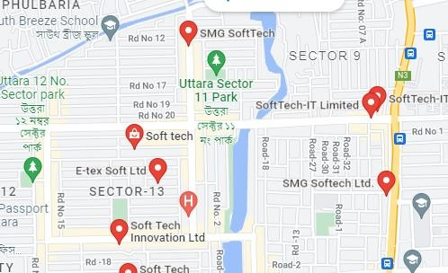

Figure 1.1: organization Location

### Organization Vision

The mission of soft tech is to become a top leading IT company in Bangladesh and its vision is to empower the youth and become a successful IT company of digital Bangladesh Soft tech achieves a competitive edge and has gained operational effectiveness and efficiency through the innovative use of technology.

### Organization Mission

Soft tech was born as a one-stop skills development platform provider. Their offerings coupled with the impeccable team behind them ensure the satisfaction of client needs concerning their characteristics.

### My position in this Organization

I am an intern developer for this organization. I am guided by a supervisor in this organization. He is very helpful and informative. I learn a lot from him. I completed my project in time. It was only possible by the guidance of my supervisor. It was also a big experience to maintain the office time for me. I also maintain the other rules of this organization. I am really

happy to work with this office. It’s really made me prepare for the beginning of my career.

### Organizational Structure

The structure of my organization is drawn below:

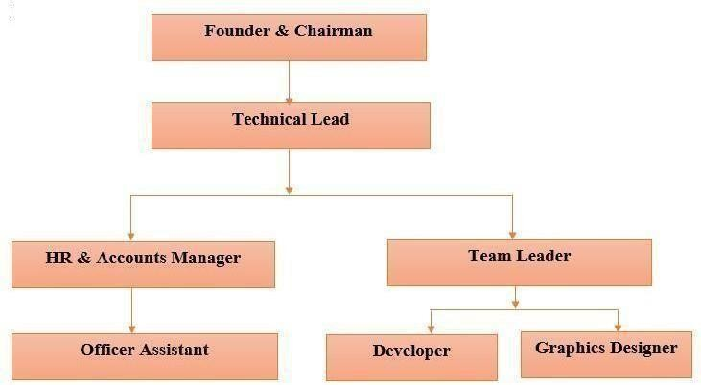

#### Figure 1.2: Organization Structure of Soft tech

**Chapter: 2 Introduction Part**

### Introduction

The internship is a practical experience of theoretically gained knowledge and can be measured as a groundwork trial to be aware of any organization and to make oneself confident enough to enter into service life and start building a career. Also, a wonderful and effective way to connect academic experience with the professional work arena. It allows gaining valuable experience in the workplace, provides the opportunity for skill development, and gives a competitive edge in the job search. This chapter attempts to describe the objectives, scope and all topics of the initialization period of this project. In our country, so many brilliant students can’t study for their financial problems. And the result is that they study at normal universities or national universities and destroy their initiative ideas. They have no other options. And the other side there are also kind heart rice people who want to give donations fro help poor students with their studies they can't find good sources to give their money. In this project, donors use this system to give money and student used it to take donations ad scholarships. This system is to overcome such problems and inconvenience for the student and donors.

### Project Overview

NGO management system is a web-based application that works online through the internet. This project presents a review of the software program **NGO Management System** as should be used to create, organize, and join tours online. It maintains all donor details, student details, and donation details. The Project is named an **“NGO Management System”**. It is a web-based and database-based application. This report is based on my internship, I completed this project at the Soft tech office. In this report, I will describe how I developed this system and how it will work.

### Background of Study

Today, we may find a variety of management tools to help us manage our daily activities efficiently and effectively. The organization where I interned is primarily focused with the creation of regular life and financial management software. As a result, I've decided to create a ngo management system that anybody can use to give donation and studentcan use for scholarship and apply for loan. This project, " Development of Donation & student scholarship ,loan Management System " is a system to effectively manage. There will have three users. Admin and Student & Donar. Admins have all the access in the system. Admin can manage transaction, add Student/Donar and can do confirm/cancel student request for

application and admin can also generate 5 report. In this system, student are allowed to request for book add read pdf books, and donar can see how mach amount added.This is the system of communicate with organization. This system manages different kinds of donar at a time and student can choose their expected book,scholarship,loan.

* 1. **Objectives**
     1. **Broad Objectives**

The broad objective of this project is to use my formal education in a real-world working setting by building for donar and student Ngo Managment System.

### Objectives

It is an easiest platform for all Money Donation system & where student can easily apply for donation,loan,and books. **NGO Management System** is a dynamic website for managing donation systems. It is dynamic and responsive web design.

* + 1. **Broad Objective**

Broad objective of this system can be defined as this system is a computerized system. This system will do all the donation management process. This system makes the manual task easier and saves time.

* + 1. **Specific Objective**

1. Admin can handel all the information.
2. Admin can manage donar list.
3. Admin can add new notice and scholarship.
4. Admin can Approve all donation,scholarship & books request.
5. Admin and Donar can see the amount.
6. Donar also can see the event.
7. Student can see new notice and scholarship.
8. Student can read for her/his requested books.
9. Donar can see her/his profile.

### Proposed System Benefits

* Helps to see the information from anywhere.
* Helps to see the important notice.
* Helps to make register new donar through system.
* All the information is safe and protected.
* Easy to manage donation.
* Easliy user get Loan.
* Can store all the information of users

### Methodology

The development process on ― NGO Management System through Incremental Model‖ will complete following the structure described later on Software Analysis & Design. It aims to develop a management System. The variables identified to manipulate through a handy inspection and from primary and secondary data.

* + 1. **Data Sources**

For this project in data collection phase I collected two types of data

* **Primary Data:** Primary data has been collected from scholarship application,loan application,book application and observation.
* **Secondary Data:** Secondary data has been collected from Google, facts and statistics.

### Limitation of the Project

One of the limitations of this internship project is constraints of time. After applying the software engineering procedures, it is very difficult to develop the complete software within short time. For this reason, the scope of the internship project has become short. And specific limitation is

* Data backup - There is no data backup way. Once a storage device is crashed, all the data will be lost.
* Security–The system is not that secure. The system can be attacked by crackers with some particular harmful software to crack the system password. In this software there is no forgetting password and change password function.

### Process Model

In my project I am using the Incremental Model. Incremental Model is a process of software development where requirements are broken down into multiple standalone modules of the software development cycle.

Each iteration passes through the **requirements, design, coding and testing phases**. And each subsequent release of the system adds function to the previous release until all designed functionality has been implemented. That is why I have chosen this type of process Model.

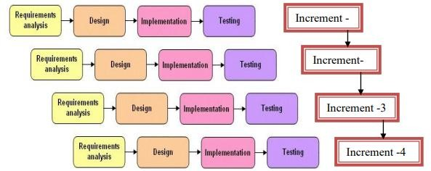

**Figure 2.1: Incremental Process**

* + 1. **Why Incremental Model**

In this model users can respond to each build. Lowers initial delivery cost.

Software will be generated quickly during the software life cycle.  It is flexible and less expensive to change requirements and scope.

Though the development stages changes can be done. Errors are easy to identify.

Generates working software quickly and early during the software life cycle.

### Feasibility Study

Feasibility study determines whether that solution is feasible or achievable for the organization. This means that the tasks that we will perform are worth enough or not. There are three major areas of investigation and generating ideas about a new system. On studying the feasibility of the system, three major considerations are dealt with, to find whether the automation of the system is feasible.

Technical feasibility Economic feasibility Operational feasibility

* + 1. **Technical feasibility**

Technical feasibility addresses concerns about hardware capability, reliability and availability and the skills of the development team. So, I found that this model is technically feasible, because this can be developed by the following lines.

To develop this project, I need a high-level programming language like HTML, CSS, Bootstrap, and the Laravel Framework of PHP. For databases such as Xampp Server. To store data and an IDE (Visual Studio Code) need a cloud server and a computing device like a computer with a simple configuration and data connection. All the technology which is mentioned above is ready to use.

So, our project is technically feasible.

* + 1. **Economic feasibility**

Economic feasibility determines to what extent a new system is cost effective. My software is economically feasible. As I mentioned, I need only one operating system and a browser. So, the cost will be less. On the other hand, this will reduce our paper cost. Because I am using a database to store all the data. For creating and viewing packages as users, they do not need any money to pay. From the admin side, when the admin will operate the system, they do not need to pay any money.

So, I can say that this software is economically feasible.

* + 1. **Operational feasibility**

Operational feasibility concerns about user acceptance, management support, and the requirements of entities and factors in the organization’s external environment. It is operationally feasible. Anyone can easily understand the process of our website. They need not have any extra training to understand it. Users can create or view packages and book packages by register and log in our site. So, it is operationally feasible.

**Chapter: 3 Requirement Engineering**

### 3.1 Requirement Analysis

Requirement analysis provides the software designer with a representation of information, function and behavior that can be translated to data, architectural, interface and component level designs. In the following task phases the requirement analysis was done.

### Requirements Engineering

Requirements engineering is, as its name suggests, the engineering discipline of establishing user requirements and specifying software systems. There are many definitions of Requirements Engineering; however, they all share the idea that requirements involve finding out what people want from a computer system, and understanding what their needs mean in terms of design. Requirements engineering is closely related to software engineering, which focuses more on the process of designing the system that users want.

* User requirements
* System requirements
* Functional requirements
* Non-Functional requirements
* Specification for each requirement
  + 1. **User Requirements**

1. User can log in/out for see the notice
2. User details can be stored
3. Admin can add/remove request.
4. Register new donar.
5. Update/manage scholarship,notice.
6. Provide notice
7. Add/Check stock update
8. Admin can generate report.
   * 1. **System Requirements**

* Admin/Donars/Students can Login.

✔ If User id and password is valid then the home page will open

✔ System will take input and check it with database

✔ System will display login form

* Admin Can add/delete request.
* Admin can add new notice.
* Admin can add new scholarship.
* Admin can add new books.
* Admin can approve loan.
* Admin can generate report.
* User can see the notice and scholarship.
  + 1. **Functional Requirements:**

**Admin**: Admin has the permission through all over the module.

**Donar**: Admin is able to add new donar.

**New Scholarship**: Admin is able to add new scholarship.

**Member**: Admin is able to add new member.

**Book**: Admin can add new book. **Schedule**: Admin can update schedule. **Notice**: Admin is able to add new notice

**Report Generate**: There will be expense report in PDF. Real time searching will be there in the monthly report.

* + 1. **Non-Functional Requirements:**
       - **Performance** – Easy tracking of records and updating can be done.
       - **Reliability** – If any hardware, software and even office LAN fails or system being down due to failure of software or hardware, the database will be ok.
       - **Availability** – The software will be available only for the admin. Rest of the user will login through online and see the schedule and notice.
       - **Security** – The security requirement deals with the primary security. The software should be handled only by the administrator and authorized users. Only the administrator has the right to assign permission. Only authorized users can access the system with username and password.
       - **Portability** – The software is a web based application and is built in ASP.Net Core and SQL Server. So the system is platform independent. And it does not require a high configuration computer to maintain the system.
    2. **Specification of Each Requirement**
       1. **Admin specification**
* **Function:** Log in, add information, edit information and delete information.
* **Description:** All the access of the system.
* **Input:** Admin input his information in his criteria.
* **Output:** Information submitted successfully.
* **Side effects:** None
  + - 1. **User specification**
* **Function:** Log in, add information, edit information.
* **Description:** Easily use the system for his useful purpose.
* **Input:** User input his information in his criteria
* **Output:** Information submitted successfully.
* **Side effects:** None
  + - 1. **Database specification**
* **Function:** Store whole information.
* **Input**: Assign data
* **Output:** Progress and provide information
* **Action:** Support Data
* **Side effects**: None
  1. **Use Case Diagram of the system**
     1. **Use Case Symbol**

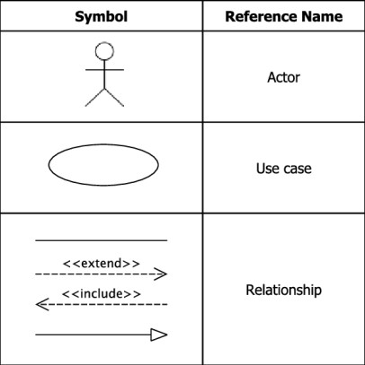

**Figure 3.1: Use Case Diagram Symbols**

**Actor:** An actor represents a set of roles that users of use case play when interacting with these use cases. Actors can be human or automated systems.

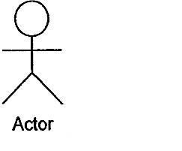

**Use Case:** A use case represents a user goal that can be achieved by accessing the system or software application. A use case is the specification of a set of actions performed by a system, which yields an observable result that is typically of value for one or more actors of the system.

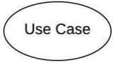

**Assocition:** Actor and use case can be associated to indicate that the actor participates in that use case. Therefore, an association corresponds to a sequence of actions between the actors and use case in achieving the use case.

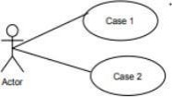

**Include:** An include relationship specifies how the behavior for the inclusion use case is inserted into the behavior defined for the base use case.



**Extend:** An extend relationship specifies how the behavior of the extension use case can be inserted into the behavior defined for the base use case.



**System:** The use cases of the system are placed inside the system shape, while the actor who interact with the system are put outside the system. The use cases in the system make up the total requirements of the system

* + 1. **Use Case Diagram**

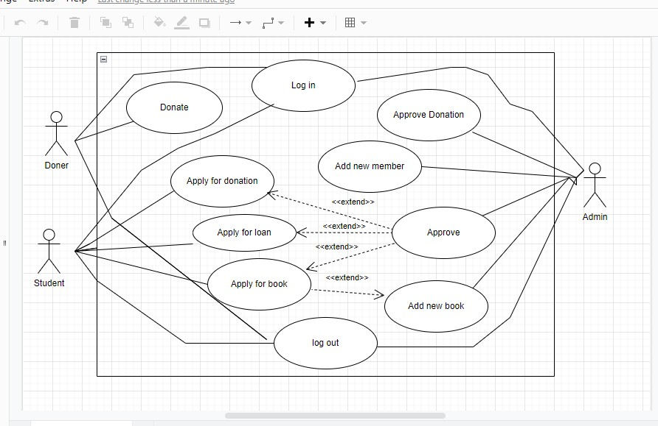

Figure 3.2: Use Case Diagram for NGO System

**3.3.1. Use Case Text Use Case Title: Login**

**Actor:** Admin, Donar, Student

**Description:**

User will get login page to get access into the system. Users have to give email and password. Then system will match it with user role and then redirect them to their respective user home page. If email and password do not match, the system will display a message.

**Use Case Title: Manage Donar Actor:** Admin

**Description:**

Admin able to register new donar or delete donar.

**Use Case Title: Manage Donation Actor:** Admin

**Description:**

Admin can approve donation . Admin and donar can view the amount.

**Use Case Title: Manage Scholarship Actor:** Admin,Student

**Description:**

Admin can add scholarship.Student can see scholarship and apply foe scholarship. .

**Use Case Title: Manage Notice Actor:** Admin, student **Description:**

Admin can update and deleted notice. Student can view notice.

**Use Case Title: Manage Loan Actor:** Admin,Student

**Description:**

Admin can Appove Loan. Student can apply for loan.

**Use Case Title:Manage Book Actor:**Admin,Student

**Description:**

Admin can add new books.Student Can apply for books and Print books.

**Chapter 4 System Planning**

* 1. **Functions of Proposed System:**

**Table 4. 1: Functions of NGO**

|  |  |
| --- | --- |
| Login | F1 |
| Add Donar | F2 |
| Approve Donation | F3 |
| Add Student | F4 |
| Add Notice | F5 |
| Add Scholarship | F6 |
| Add Book | F7 |
| Apply For Scholarship | F8 |
| Apply For Loan | F9 |
| Apply For Book | F10 |
| Report generate | F11 |
| Notification | F12 |

### Function Description

Function description describes the function in detail. It concerns three factors: what is the possible input, possible output for a particular function and which table of the database is used by that function.

***Login into the System**

Input: Email address and Password

Output: If login data is valid then set authorization as admin/donar/student to the login person as defined in the database otherwise will show error message.

Use table of the database: user table

***Add New Member**

Input: id, name, email, address, phon\_no, occupation Output: Display added member List

Use table of the database:members

* **Add New scholarship**

Input: id, ,plot,scholarship

Output: Display added scholarship Use table of the database: scholarships

***Add Book**

Input: id, book\_name,writer\_name,email

Output: Display added stock, available stock, if book is not available show massage when try

.

Use table of the database: books.

***Add Donor**

Input: id, User\_id, reg\_no, Gender, Contact\_no, Email\_Address, Address, , file.

Output: Display added donor list or delete if necessary. Use table of the database: donors

***Add Loan**

Input: id, user\_id, reg\_no, fathers\_name, mothers\_name, gender, contact\_nbr, address, Date, amount

Output: Display amount admin approve. Use table of the database: loans.

***Update Donation**

Input: id, amount,trancesion\_id,type. Output: Amount added if admin approve. Use table of the database: donations.

***Add Notice**

Input: id, date, title, body, file Output: able to post and view notice Use table of the database: notices

### System Project Planning

Before starting any project, it is compulsory to estimate the work to be done, the resources that will be required, the time that will elapse from start to finish and to analyze the project to determine whether it is feasible or not.

The following activities of software project planning that have followed in this project are:

System Project Estimation Function Oriented Metrics Process Based Estimation

Effort Distribution Task Scheduling Project Schedule Chart Cost Estimation

* + 1. **System Project Estimation**

The accuracy of a software project estimate predicted based on a number of things:  Properly estimated the size of the product to build.

 The ability to translate the size estimation into human effort, calendar time and money.

 The degree to which the project plan reflects the abilities of the software team or engineer.

 The stability of the product requirements and the environment that supports the software engineering effort.

Software size estimation is the most important matter that I have to consider during the software project. If the software size is not calculated properly, then this will cause various problems such as scheduling problems, budget problems etc. As the project goes on before estimating the software size, I have to confirm that software scope is bounded.

* + 1. **Function Oriented Metrics**

Function point-based estimation focuses on information domain values rather that software values. Function points are computed by comparing five information domain characteristics. The information domain values are as follows

**Number of external inputs (EI)** – Each user input that provides distinct application oriented data to the software is counted inputs should be distinguished from inquiries.

**Number of external outputs (EO)** – Each user output that provides application oriented information to the user is counted.

**Number of external inquiries (EQ)** – An inquiry defined as an on-line input that results in the generation of some immediate software response in the form of an on-line output. Each distinct inquiry counted.

**Number of Internal logical files (ILF) –** Each logical master file counted. Database table where input goes for modification by application.

**Numbers of external interfaces files (EIF)** – All machine-readable interfaces that used to transmit information to another system counted.

The weights of the domains are fixes, which are provided in appropriate table location.

Weights can be divided into three categories according to the functionality of the system. They are simple, average and complex. The total system is a complex system but part of the total system. Once this data has been collected, a complexity value is associated with each count. To find out the FP count the following formula is used,

Value Adjustment Factor (VAF) = (0.65+ (.01X TDI)) UFP = UFP (Data Fn) + UFP (Transaction Fn) Adjusted Function Point Count (AFP) = UFP X VAF Effort for PHP = AFP x Productivity

**Table 4. 2 Productivity**

|  |  |  |  |
| --- | --- | --- | --- |
| **EI** | **1-4 DETs** | **5-15 DETs** | **16 or more DETs** |
| 1 FTR | Low | Low | Average |
| 2FTRs | Low | Average | High |
| 3 or more FTRs | Average | High | High |

**Table 4. 3: Complexity Matrix**

|  |  |  |  |
| --- | --- | --- | --- |
| **EO/EQ** | **1-5 DETs** | **6-19 DETs** | **20 or more DETs** |
| 1 FTR | Low | Low | Average |
| 2 to 3 FTRs | Low | Average | High |
| 4 or more FTRs | Average | High | High |

|  |  |  |  |
| --- | --- | --- | --- |
| **ILF/ELF** | **1-19 DETs** | **20-50 DETs** | **50+ DETs** |
| 1 RET | Low | Low | Average |
| 2 to 3 RETs | Low | Average | High |
| 6 or more RETs | Average | High | High |

**Table 4. 4: Complexity Matrix for UFP**

**Source: (Point, Estimation Techniques – FP Counting Process)**

|  |  |  |
| --- | --- | --- |
| **Functional Complexity (Transaction)** | **Transaction Function Type** | |
| **EI** | **EO/EQ** |
| L (Low) | 3 | 4 |
| A (Average) | 4 | 5 |
| H (High) | 6 | 7 |

|  |  |  |
| --- | --- | --- |
| **Functional Complexity (Data)** | **Data Function Type** | |
| **ILF** | **ELF** |
| L (Low) | 7 | 5 |
| A (Average) | 10 | 7 |
| H (High) | 15 | 10 |

* + 1. **Function Point Estimation**
       1. **Identifying complexity of transition function**

**Table 4. 5: Identifying complexity of transition function**

|  |  |  |  |
| --- | --- | --- | --- |
| **Transition Function** | **Field/File Involve** | **FTR**  **s** | **DET**  **s** |
| Login to the system  (EI) | Fields: email, password File: users | 1 | 2 |
| Add Member (EI) | Fields: id,v \_name, N\_of\_doses, time\_difference, starting\_time  File: member | 1 | 6 |
| Add Book (EI) | Fields:id, User\_id, reg\_no, dob, Gender, Contact\_no, Email\_Address, book\_name,write\_name, file.  File: book\_ists | 3 | 10 |
| Add New Donor (EI) | Fields: id, user\_id, reg\_no, fathers\_name, mothers\_name, dob, gender, contact\_nbr, address,Occupaion, regDate, category  File: patientLists | 3 | 12 |
| Update  Scholarship (EI) | Fields: id, cv-id, students\_id, rcv\_date File: student\_scholarship | 3 | 4 |
| Add Notice  (EI) | Fields: id, date, title, body, file  File: notices | 1 | 5 |
| Delete scholarship  (EI) | Fields: id, User\_id, reg\_no, dob, Gender, Contact\_no, Email\_Address, Address.  File: Lists | 3 | 10 |
| Add Donation (EI) | Fields: id,v \_name, disease, N\_of\_doses, time\_difference, starting\_time  File: donation | 1 | 6 |
| Add Loan (EI) | Fields: id, V\_d\_Name, disease,  File: loan | 1 | 4 |
| Add Student (EI) | Fields: id, user\_id, reg\_no, fathers\_name, mothers\_name, dob, gender, contact\_nbr, address,Occupaion, regDate, category | 1 | 6 |

* + - 1. **Identifying Complexity for Data Function**

**Table 4. 6 Identifying Complexity for Data Function**

|  |  |  |  |
| --- | --- | --- | --- |
| **Data Function** | **Field/File Involve** | **RETs** | **DETs** |
| Login to the system (EI) | Fields: email, password File: users | 1 | 2 |
| Add Member (EI) | Fields: id,v \_name, N\_of\_doses, time\_difference, starting\_time  File: member | 1 | 6 |
| Add Book (EI) | Fields:id, User\_id, reg\_no, dob, Gender, Contact\_no, Email\_Address, book\_name,write\_name, file.  File: book\_ists | 2 | 10 |
| Add New Donor (EI) | Fields: id, user\_id, reg\_no, fathers\_name, mothers\_name, dob, gender, contact\_nbr, address,Occupaion, regDate, category  File: patientLists | 1 | 4 |
| Update Scholarship (EI) | Fields: id, cv-id, students\_id, rcv\_date File: student\_scholarship | 2 | 5 |
| Add Notice (EI) | Fields: id, date, title, body, file File: notices | 3 | 10 |
| Delete scholarship (EI) | Fields: id, User\_id, reg\_no, dob, Gender, Contact\_no, Email\_Address, Address.  File: Lists | 3 | 12 |
| Add Donation (EI) | Fields: id,v \_name, disease, N\_of\_doses, time\_difference, starting\_time  File: donation | 1 | 5 |
| Add Loan (EI) | Fields: id, V\_d\_Name, disease,  File: loan | 3 | 6 |
| report (EIF) | Fields: sildebar, generate report  File: reports | 1 | 2 |

* + - 1. **Unadjusted function point contribution**

**Table 4. 7: Unadjusted function point contribution of transition function**

|  |  |  |  |  |
| --- | --- | --- | --- | --- |
| **Transition Function** | **FTRs** | **DETs** | **Complexity** | **UFP** |
| Login to the system (EI) | 1 | 2 | Low | 3 |
| Add Member (EI) | 1 | 6 | Low | 3 |
| Add Book (EI) | 1 | 4 | Low | 3 |
| Add Loan (EI) | 3 | 6 | Average | 4 |
| Add Donor(EI) | 3 | 10 | Average | 4 |
| Add New book(EI) | 3 | 12 | Average | 4 |
| Add Notice (EI) | 1 | 5 | Low | 3 |
| Update Scholarship (EI) | 3 | 4 | Low | 3 |
| Delete Notice(EI) | 3 | 10 | Average | 4 |
| Delete Donation (EI) | 1 | 6 | Low | 3 |
| Delete Loan (EI) | 1 | 4 | Low | 3 |
| Total= | 76 | | | |

**Table 4. 8: Unadjusted function point contribution for data functions**

|  |  |  |  |  |
| --- | --- | --- | --- | --- |
| **Data Function** | **RETs** | **DETs** | **Complexity** | **UFP** |
| Login to the system (ILF) | 1 | 2 | Low | 7 |
| Tota Donation (ILF) | 1 | 6 | Low | 7 |
| Book Application list(ILF) | 2 | 10 | Low | 7 |
| Donation application list (ILF) | 1 | 4 | Low | 7 |
| Loan Application list (ILF) | 2 | 5 | Low | 7 |
| Scholarship application List (ILF) | 3 | 10 | Low | 7 |
| Member List(ILF) | 3 | 12 | Low | 7 |
| Notices (ILF) | 1 | 5 | Low | 7 |
| Stocks (EIF) | 3 | 6 | Low | 5 |
| report (EIF) | 1 | 2 | Low | 5 |
| Total= | 66 | | | |

**Table 4. 9: Performance and environmental impact**

|  |  |
| --- | --- |
| **GSC (General System Characteristics)** | **TDI** |
| 1. Data Communications | 4 |
| 2. Distributed Data Processing | 1 |
| 3. Performance | 4 |
| 4. Heavily Used Configuration | 2 |
| 5. Transaction Rate | 2 |
| 6. On-Line Data Entry | 1 |
| 7. End-user Efficiency | 2 |
| 8. Online Update | 1 |
| 9. Complex Processing | 2 |
| 10. Reusability | 2 |
| 11. Installation Ease | 4 |
| 12. Operational Ease | 3 |
| 13. Multiple Sites | 3 |
| 14. Facilitate Change | 1 |
| Total Degree of Influence (TDI) (Range 0 to 70 -> influence size ± 35%) | 32 |

|  |  |
| --- | --- |
| Language | Hours Per Function Point |
| ASP\* | 06.1 |
| Visual Basic | 08.50 |
| Java | 10.6 |
| SQL | 10.8 |
| C++ | 12.4 |
| C | 13.0 |
| C# | 15.5 |
| PHP | 15.5 |

Counting Adjusted Function Point:

UFP = UFP (Data function) + UFP (Transaction Function)

= 66+76 = 142

Adjusted Function Point Count = UFP \* VAF

= 142 \* 0.97

= 137.74

Effort for PHP = AFP x Proximity

= 137.74 \* 15.5 [Productivity for PHP 15.5]

= 2134.97 person-hours / 6 hours [office = 6 hour]

= 355.83 person’s days / 26 days

= 13.68 months/3 Person

= 4.56 Month per 1 person (4 Month Approximately)

* + 1. **Process Based Estimation**

In process-based estimation, the process is decomposed into a relatively small set of tasks and the effort required to accomplish each task is estimated. Process based estimation begins with a delineation of software functions obtained from the project scope. A series of software process activities must be performed for each function.

**Table 4. 10: Process Based Estimation**

|  |  |  |  |  |  |  |  |  |
| --- | --- | --- | --- | --- | --- | --- | --- | --- |
| **Activity Function** | **CC** | **Planning** | **Engineering** | | **Construction** | | **Imp.** | **Total** |
| **Analysis** | **Design** | **Code** | **Test** |
| **F1** | 0.011 | 0.053 | 0.115 | 0.104 | 0.133 | 0.021 | 0.032 | 0.0 |
| **F2** | 0.010 | 0.051 | 0.165 | 0.129 | 0.164 | 0.052 | 0.024 | 0.0 |
| **F3** | 0.016 | 0.030 | 0.102 | 0.175 | 0.139 | 0.031 | 0.016 | 0.0 |
| **F4** | 0.013 | 0.023 | 0.049 | 0.192 | 0.238 | 0.057 | 0.025 | 0.0 |
| **F5** | 0.015 | 0.016 | 0.102 | 0.147 | 0.297 | 0.018 | 0.012 | 0.0 |
| **F6** | 0.016 | 0.021 | 0.151 | 0.113 | 0.234 | 0.063 | 0.026 | 0.0 |
| **F7** | 0.010 | 0.039 | 0.123 | 0.121 | 0.232 | 0.039 | 0.027 | 0.0 |
| **F8** | 0.012 | 0.032 | 0.112 | 0.295 | 0.136 | 0.016 | 0.022 | 0.0 |
| **F9** | 0.014 | 0.061 | 0.125 | 0.192 | 0.215 | 0.032 | 0.029 | 0.0 |
| **F10** | 0.013 | 0.064 | 0.185 | 0.282 | 0.233 | 0.061 | 0.047 | 0.0 |
| **F11** | 0.010 | 0.025 | 0.117 | 0.105 | 0.135 | 0.014 | 0.014 | 0.0 |
| **F12** | 0.011 | 0.022 | 0.128 | 0.125 | 0.142 | 0.025 | 0.021 | 0.0 |
| **F13** | 0.012 | 0.052 | 0.043 | 0.172 | 0.176 | 0.020 | 0.018 | 0.112 |
| **F14** | 0.010 | 0.035 | 0.122 | 0.185 | 0.240 | 0.032 | 0.021 | 0.125 |
| **F15** | 0.013 | 0.016 | 0.106 | 0.112 | 0.134 | 0.044 | 0.019 | 0.185 |
| **F16** | 0.010 | 0.012 | 0.102 | 0.104 | 0.014 | 0.010 | 0.011 | 0.117 |
| **F17** | 0.015 | 0.016 | 0.102 | 0.147 | 0.297 | 0.018 | 0.012 | 0.1 |

|  |  |  |  |  |  |  |  |  |
| --- | --- | --- | --- | --- | --- | --- | --- | --- |
| **F18** | 0.016 | 0.021 | 0.151 | 0.113 | 0.232 | 0.039 | 0.027 | 0.0 |
| **F19** | 0.011 | 0.015 | 0.050 | 0.139 | 0.134 | 0.051 | 0.021 | 0.2 |
| **Total** | **0.29** | **0.83** | **2.56** | **3.62** | **4.01** | **0.79** | **0.55** |  |
| **Effort** | **2%** | **8%** | **20%** | **25%** | **35%** | **6%** | **4%** | **100%** |

* + 1. **Effort Based Estimation**

The project estimation technique leads to estimates of work units required to complete the software development. A recommended distribution of effort across the definition and development phases is referred to as the 40-20-40 rule. Forty per cent of all effort is allocated to front-end analysis and design, twenty per cent allocated to coding and the remaining forty per cent allocated to back-end testing. This rule is used as a guideline only.

In this project, 17% of full software development has been allocated to analysis and design,

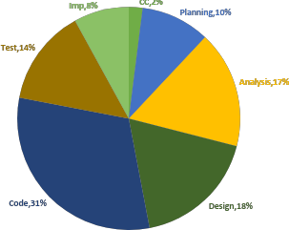31% has been allocated to coding and the remaining 14% is allocated to software testing and support.

#### Figure 4. 1: Effort Based Estimation

**Description:**

* + - * 1 (2% - Customer Communication)
      * 2 (10% - Planning)
      * 3 (17% - Analyzing)
      * 4 (18% - Designing)
      * 5 (31% - Coding)
      * 6 (14% - Testing).
      * 7 (8% - Implementation).
    1. **Task Scheduling**

Project scheduling is the activity of distributing the estimated efforts within the planned project duration. There are some basic rules for project scheduling. They are as follows –

**Compartmentalization** – The project must compartmentalize into some manageable activities and tasks.

**Interdependency** – The interdependency of each compartmentalized activity or task must be determined. Some tasks must occur in sequence while others can occur in parallel.

**Time allocation** – Each task to be scheduled must be allocated some number of work units.

**Effort validation** – Every project has a defined number of staff members. It should ensure that no more than the allocated number of people have been scheduled at any given time.

**Defined responsibilities** – Every task that is scheduled should be assigned to a specific team member.

**Defined outcomes** – Every task that is scheduled should have a defined outcome. The outcome is normally a work product or a part of a work product.

* + 1. **Project Schedule Chart**

Total system development is a combination of a set of tasks. This set of tasks should be done sequentially and timely. The project schedule works as the guideline of the system developer. The following is the schedule chart of this project:

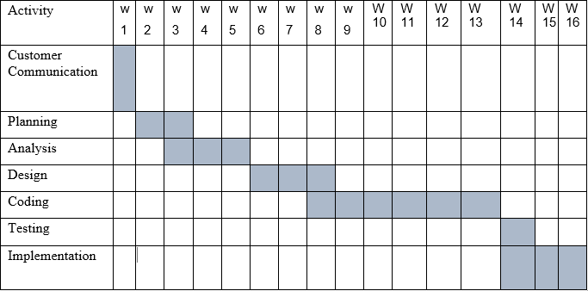

#### Figure 4. 2: Project Schedule Chart

* + 1. **Cost Estimation**

The approximation of the cost of a program is cost estimation. In this project, there are five factors to analyze and calculate the cost. Given bellow,

* + - * Personal cost
      * Software cost
      * Hardware cost
      * Others cost

**Personnel cost**

* Number of days in a year = 365
* Number of government holidays in a year =24
* Number of weekly holidays in a year =52
* Total number of working days to develop the project =365-(52+24) =289 days
* Total number of working days per month to develop the project =289/12

=24.083 days

* Organization working hours per day = 8 hours • Organization working hours per month=24.083\*8= 192.66 hours

**Table 4. 11: Personnel cost**

|  |  |  |  |
| --- | --- | --- | --- |
| **Type** | **No. of Members** | **Months** | **Salary** |
| System Analyst & Designer | 1 | 1 | 57,000.00 |
| Coder, Tester & Customer Communicator | 1 | 1 | 65,000.00 |
| **Total** | | | **122000** |

**Hardware Cost**

Cost of the computer that used to complete the project.

**Table 4. 12: Hardware cost**

|  |  |  |  |  |
| --- | --- | --- | --- | --- |
| Name | Number | Price | Description | Total |
| Computer | 1 | 45,000 | 45,000 / 24 \* 4 | 65000 |

Total Hardware Cost = 7,500.00 TK

**Software Cost**

It is the cost of the software which is used in this project.

**Table 4. 13: Software Cost**

|  |  |  |  |  |
| --- | --- | --- | --- | --- |
|  | **Software** | **Number** | **Amount** | **Total** |
| 1 | OS (Windows 10) | 1 | 100 Tk. | 50000 Tk. |
| 2 | MS Office 2010 | 1 | 100 Tk. |
| 3 | Notepad++ | 1 | 40800 Tk. |  |
| 4 | XAMP | 1 | Free |  |

**Other Cost**

**Table 4. 14: Other cost**

|  |  |
| --- | --- |
| **Name** | **Price** |
| Pen and paper | 300 Tk. |
| Mobile | 200 Tk. |
| Transport | 500 Tk. |
| **Total** | **1000 Tk.** |

**Accounts table**

**Table 4. 15: Total cost**

|  |  |
| --- | --- |
| **Particular cost** | **Taka** |
| Personal cost | 122000 |
| Hardware cost | 65000 |
| Software cost | 50000 |
| Others cost | 1000 |
| **Total** | **2,38000 Tk.** |

**Chapter 5 Risk Management**

### Risk Analysis

Risk analysis and management are a series of works that help a system development team to understand and manage uncertainty. Many problems can arise while developing a system. A risk is a potential problem – it may happen or may not. There are several steps to analyze and manage risks. The first step is risk identification. Next, each risk is analyzed to determine the likelihood that it will occur and the damage that it will do if it does occur. Once this information is established risks are remarked. Finally, a plan is developed to manage those risks with high probability and impact.

**There are different Stages of risks. The area:**

* + - **Risk identification:** Risk identification is the process of detecting potential risks or hazards through data collection. A range of data collection and manipulation tools and techniques exists. The team is using both automated and manual techniques to collect data and begin to characterize potential risks to Web resources. Web crawling is one effective way to collect information about the state of Web pages and sites.
    - **Risk classification:** Risk classification is the process of developing a structured model to categorize risk and fit observable risk attributes and events into the model. The team combines quantitative and qualitative methods to characterize.
    - **Risk assessment:** Risk assessment is the process of defining relevant risk scenarios or sequences of events that could result in damage or loss and the probability of these events. Many sources focus on risk assessment. Rosenthal describes the characteristics of a generic standard for risk assessment as "transparent, coherent, consistent, complete, comprehensive, impartial, uniform, balanced, defensible, sustainable, flexible, and accompanied by suitable and sufficient guidance.
    - **Risk analysis:** Risk analysis determines the potential impact of risk patterns or scenarios, the possible extent of loss, and the direct and indirect costs of recovery. This step identifies vulnerabilities, considers the willingness of the organization to accept risk given potential consequences, and develops mitigation responses.
    - **Risk management implementation:** defines policies, procedures, and mechanisms to manage and respond to identifiable risks. The implemented program should balance the value of assets and the direct and indirect costs of preventing or recovering from damage or loss.

There are different categories of risks that should be considered in any software project. The following categories of risks have been considered in this software project.

***Project risks:** These risks threaten the project plan. If these risks become real, it is likely that the project schedule will slip and that costs will increase. Project risks identify potential budgetary, schedule, personnel, resource, customer and requirement problems and their impact on the software project.

***Technical risks:** These risks threaten the quality and timeliness of the software to be produced. If a technical risk becomes a reality, implementation may become difficult or impossible. Technical risks identify potential design, implementation, interface, verification and maintenance problems. Moreover, specification ambiguity, technical uncertainty, technical obsolescence are also risk factors.

***Business risks:** These risks threaten the viability of the software to be built. The business risks can be market risks, building a system that no one really wants. Strategic risks, building a system that no longer fits into the overall business strategy for the company. Management risks, losing the support of senior management due to a change in focus or a change in people. Budget risks, losing budgetary or personnel commitment.

### The RMMM Plan

**Risk Mitigation:** Proactive planning for risk avoidance.

**Risk Monitoring:** Assessing whether predicted risks occur or not, ensuring preventive steps are being properly applied, collecting information for future risk analysis, and attempting to determine which risks caused which problem.

**Risk Management:** Actions to be taken in the event that mitigation steps have failed and the risk has become a live problem.

**Type of Impact:** Catastrophic (1), Marginal (2), Tolerable (3), Critical (4).

**Table 5. 1: Project Risk (P01)**

|  |  |
| --- | --- |
| **isk (P01)** | |
| Name | Changes the requirements |
| Probability | Low (25%) |
| Impact | Marginal (2) |
| Description | Customer may change their requirements |
| Mitigation & Monitoring | Requirements are redefined by the company due to time or business needs. Meetings will be held with the company regularly. This ensures that the product we are producing solves a problem. |
| Management | Emergency meeting between both parties to identify new project requirements and goals. |
| Status | Not occur |

**Project Risks:** Threaten the project plan. In my system, the below mentioned projects are risks I need to manage.

**Table 5. 2: Project Risk (P02)**

|  |  |
| --- | --- |
| **Project Risk (P02)** | |
| Name | Poor Quality Documentation |
| Probability | Low (15%) |
| Impact | Catastrophic (1) |
| Description | Poor quality documentation of the members. |
| Mitigation & Monitoring | Meetings will be held routinely to offer documentation suggestions and topics. The progress on documentation will also have a Monitor in each meeting. |
| Management | The addition of new topics or removal of unnecessary topics into the documentation will be assigned to the responsible person. |
| Status | Monitoring it. |

**Table 5. 3: Project Risk (P03)**

|  |  |
| --- | --- |
| **Project Risk (P03)** | |
| Name | Lack of Development Experience. |
| Probability | Moderate (30%) |
| Impact | Catastrophic (1) |
| Description | Lack of developmental experience of the members. |
| Mitigation & Monitoring | Each member of the team should watch and see areas where another team member may be weak. |
| Management | The members who have the most experience in a particular area will be required to help to overcome problems that arise for this risk. |
| Status | We have not encountered such issues yet |

**Table 5. 4: Project Risk (P04)**

|  |  |
| --- | --- |
| **Project Risk (P04)** | |
| Name | Poor Comments in Code. |
| Probability | Low (15%) |
| Impact | Marginal (2) |
| Description | Code of the developed system is not up to the mark. |
| Mitigation & Monitoring | A formal written standard must be established to ensure quality of comments in all code. |
| Management | We should call a meeting with the development team to get rid of this problem and improve the quality of comments in code. |
| Status | We are monitoring the issue. |

**Technical Risks:** threaten product quality and the timeliness of the schedule. As this is my practicum project, therefore these types of risks need to be taken care of properly.

**Table 5. 5: Technical Risk (TR01)**

|  |  |
| --- | --- |
| **Techn** | **ical Risk(TR01)** |
| Name | Computer Crash |
| Probability | Moderate (25-40%) |
| Impact | Catastrophic (1) |
| Description | Computers may crash due to several reasons. |
| Mitigation & Monitoring | We should take proper follow-up of computers. We also take regular data backup every day, we can use IPS to stop unexpected shutdown. |
| Management | If our computer has crashed then we will restore backup. |
| Status | We have not encountered such issue yet |

**Table 5. 6: Technical Risk (TR02)**

|  |  |
| --- | --- |
| **Technical Risk (TR02)** | |
| Name | Technology Doesn’t Meet Specifications. |
| Probability | Low (25%) |
| Impact | Catastrophic (1) |
| Description | Customers don't have the technology to their desired specification. |
| Mitigation & Monitoring | That ensures that the product we are producing and the specifications of the customers are equivalent. |
| Management | The customer should be immediately notified and whatever steps necessary to rectify this problem should be done. Preferably a meeting should be held between the development team and the customer to discuss at length this issue. |
| Status | We have not encountered such issue yet |

**Table 5.7: Technical Risk (TR03)**

|  |  |
| --- | --- |
| **Technical Risk(TR03)** | |
| Name | Poor Training Skill in Team Members. |
| Probability | Moderate (30%) |
| Impact | Catastrophic (1) |
| Description | Poor Training Skill in Team Members to Train the Client. |
| Mitigation & Monitoring | The training team should have a clear knowledge about the entire functionality of the software. System analyst need to ensure  and monitor it while the training session starts. |
| Management | We should arrange a meeting with the train team and come to a point to solve this problem. |
| Status | We have not encountered such issue yet |

**Business Risk:** Threaten the viability of the software to be built (market risks, strategic risks, management risks, budget risks). As I am developing it as my

practicum project by myself, classic business risks won’t be encountered here. The Probability of all type of Business Risks is therefore, determined as Low.

**Table 5. 7: Business Risk(B01)**

|  |  |
| --- | --- |
| **Business Risk(B01)** | |
| Name | Insufficient Budget |
| Probability | Low (10%) |

|  |  |
| --- | --- |
| Mitigation & Monitoring | The project needs a streaming server that is costly to set-up. We found several alternative streaming services to reduce the budget risk. |
| Management | Refinement in project goal. A new plan for regulating the budget. |
| Status | Not encountered |

**Table 5. 8: Business Risk (B02)**

|  |  |
| --- | --- |
| **Business Risk(B02)** | |
| Name | End Users Accept System |
| Probability | Low (10%) |
| Impact | Critical (4) |
| Description | The system fails to gain the user's faith |

|  |  |
| --- | --- |
| Mitigation & Monitoring | In order to prevent this from happening, the software will develop with the end user in mind. The user-interface will design in a way to make use of the program convenient and pleasurable. |
| Management | Training the users to familiarize them with  the new system. Releasing patches/bug fixes for greater user satisfaction. |
| Status | The risk has not arisen yet. |

**Table 5. 9: Business Risk (B03***)*

|  |  |
| --- | --- |
| **Business Risk (B03)** | |
| Name | Not pay the installment of Software Cost. |
| Probability | Very Low (05%) |
| Impact | Catastrophic (1) |
| Description | Customer doesn‘t pay for the installment of Software Cost. |
| Mitigation & Monitoring | We should make good communication between customers and ensure that the entire Installment will be completed. |
| Management | The only course of action available would be to find out the reason and come in a solution. |
| Status | Not encountered. |

**Table 5. 10: Business Risk (B04)**

|  |  |
| --- | --- |
| **Business Risk (B04)** | |
| Name | Late delivery of the project |
| Probability | Very Low (05%) |
| Impact | Catastrophic (1) |
| Description | The project may take more time to complete what was estimated. |
| Mitigation & Monitoring | Steps have been taken to ensure a timely delivery by determining the scope of the project. |
| Management | The only course of action available would be to request an extension to the deadline from customer. |

**Chapter 6 Analysis Modeling**

Analysis modelling uses a combination of text and diagrammatic forms to depict requirements for data, function, and behaviour in a way that is relatively easy to understand, and more important, straightforward to review for correctness, completeness and consistency. This section presents resources for conventional and object-oriented analysis (OOA) methods as well as resources for UML.

## Analysis Modeling

Objectives of an analysis model

Domain Analysis

Describe what the client requires

Establish a basis for the creation of a software design

Define a set of requirements that can be validated once the software is built.

## Activity Diagram

Activity diagrams are graphical representations of workflows of stepwise activities and actions with support for choice, iteration and concurrency. In the Unified Modeling Language, activity diagrams are intended to model both computational and organizational processes. Activity diagrams show the overall flow of control.

### Activity Diagram of Admin

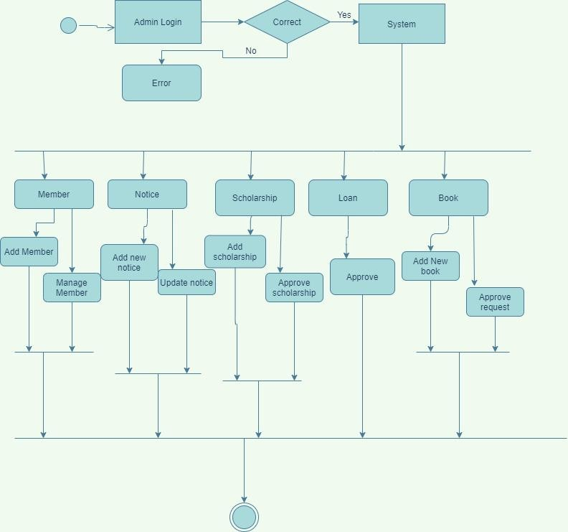

#### Figure 6. 1: Activity Diagram of Admin

* + 1. **Activity Diagram of Donor**

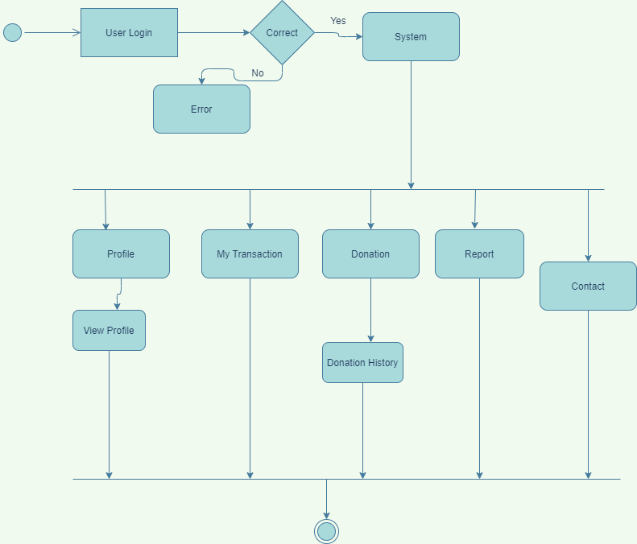

#### Figure 6. 2: Activity Diagram of Donor

* + 1. **Activity Diagram of Student**

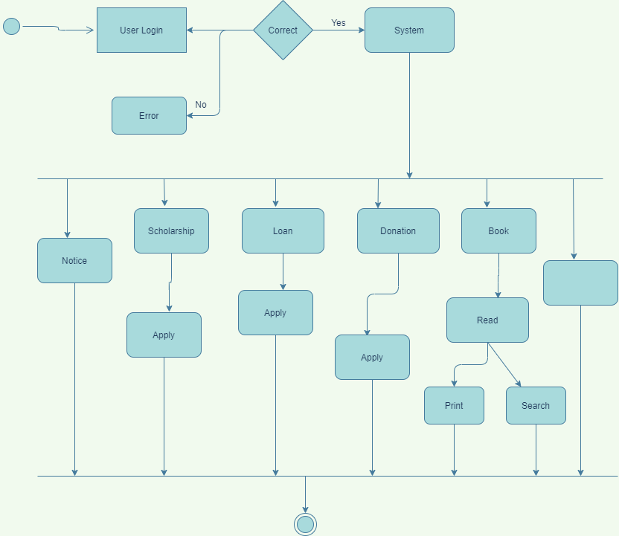

#### Figure 6. 3: Activity Diagram of student

* 1. 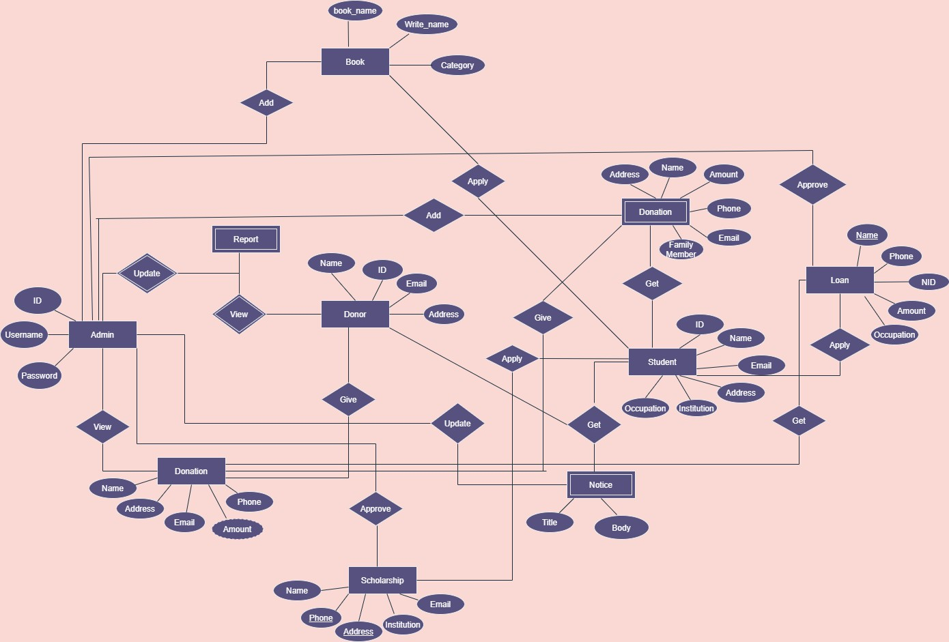**ER Diagram**

#### Figure 6. 4:ERD Diagram for NGO Management System

* 1. **Data Flow Diagram (DFD)**

A data flow diagram (DFD) is a graphical representation of the "flow" of data through an information system, modelling its process aspects. A DFD is often used as a preliminary step to create an overview of the system, which can later be elaborated DFDs can also, be used for the visualization of data processing.

A DFD shows what kind of information will be input to and output from the system, where the data will come from and go to, and where the data will be stored. It does not show information about the timing of the processor information about whether processes will operate in sequence or parallel.

* + 1. **Context Level Diagram**

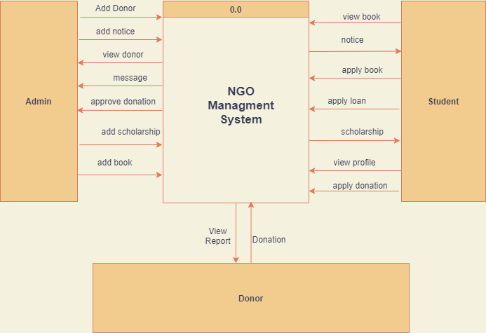

* + 1. **Level 1 DFD**

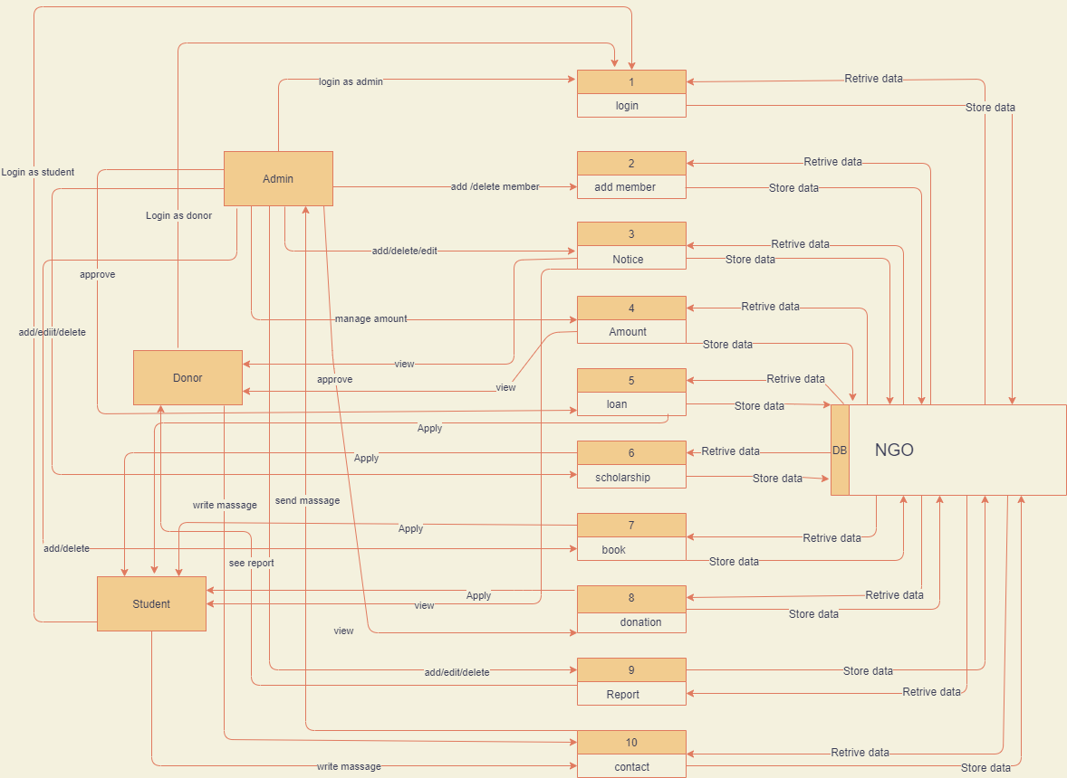

#### Figure 6. 4: Level-1DFD

* + 1. **Level 2 DFD Procces 1**

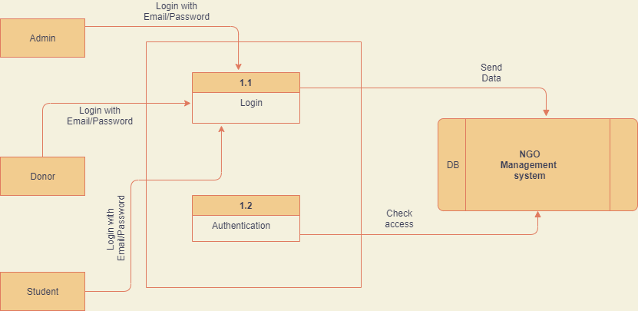

#### Figure 6. 5: Level-2 DFD Process 1

* + 1. **Level 2 DFD Procces 2**

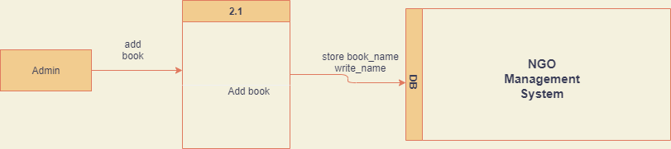

#### Figure 6. 5: Level-2 DFD Process 2

* + 1. **Level 2 DFD Procces 3**

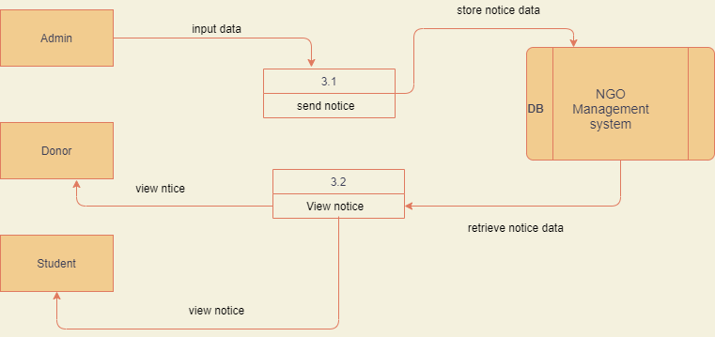

#### Figure 6. 5: Level-2 DFD Process 3

**Chapter: 7 Interface Design**

**Admin Login:**

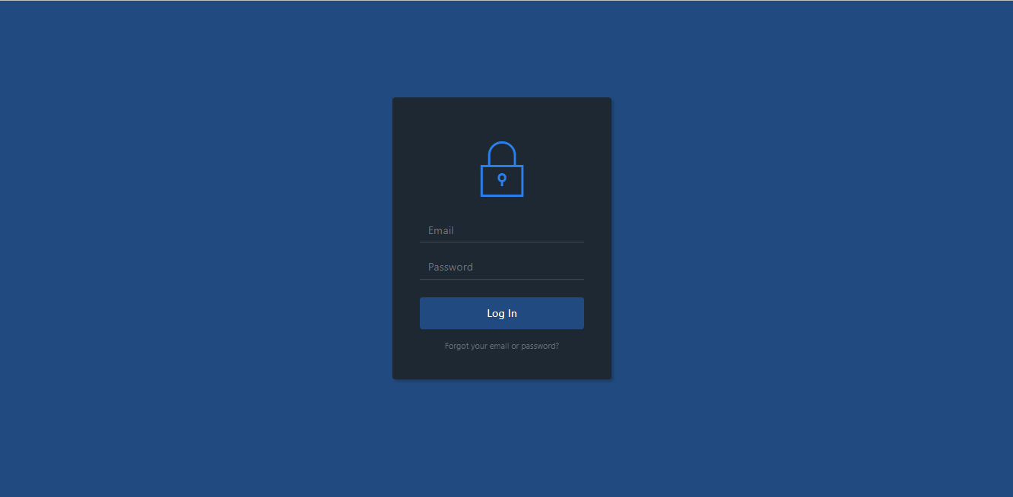

**Figure7.1:Admin Login**

**Admin panel:**

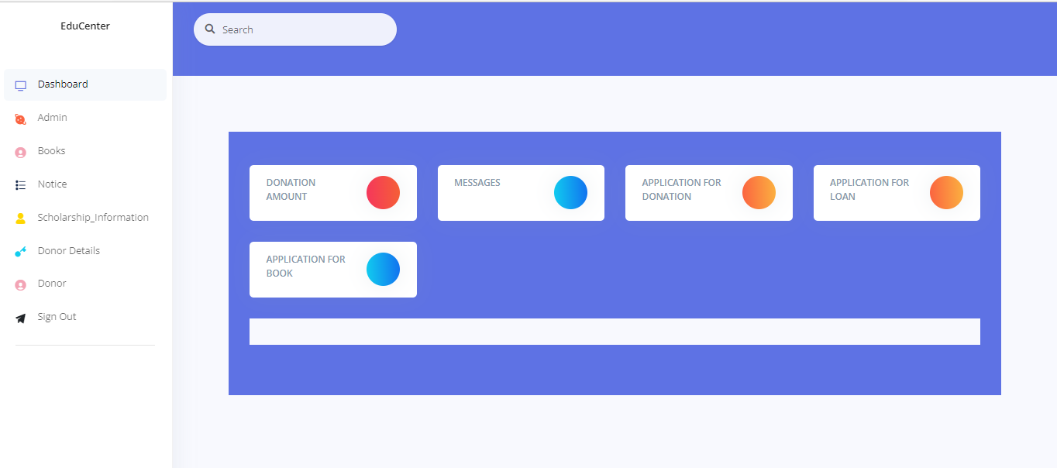

**Figure 7.2:Admin panel**

**User Panel:**



**Figure7.3: User panel**

**Donation Panel:**

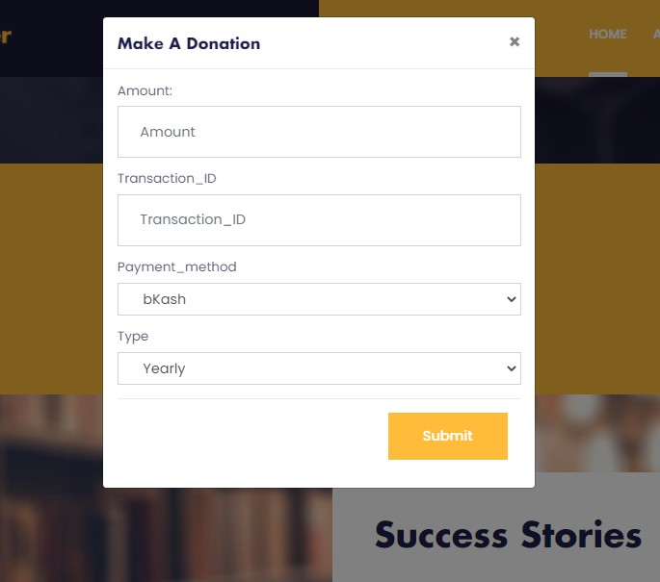

**Figure 7.4 :Donation panel**

**Registration Panel:**

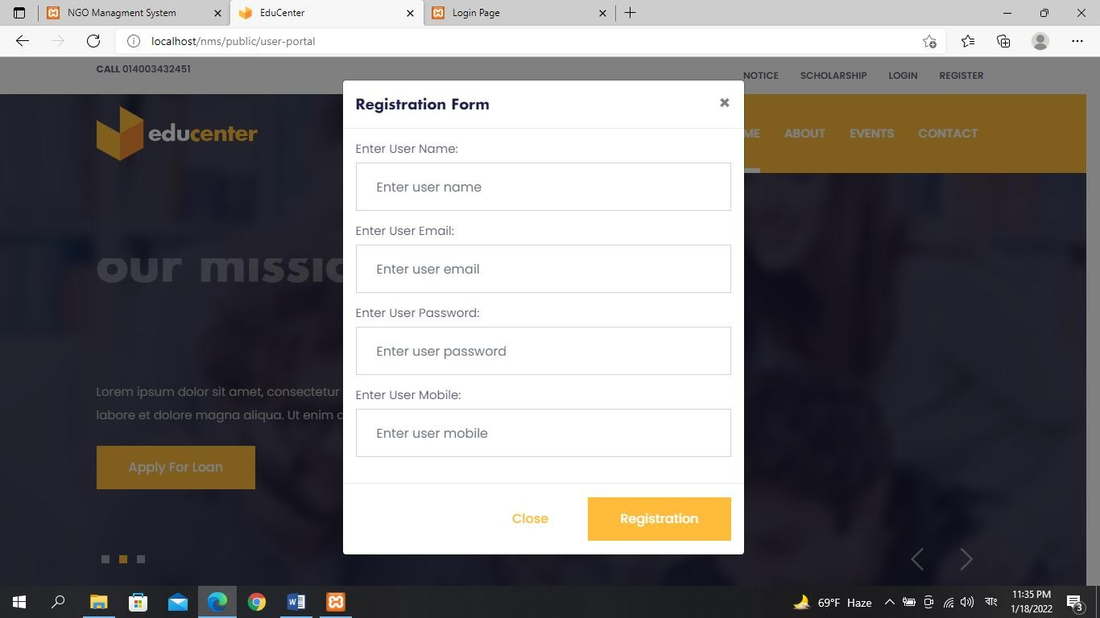

**Figure 7.5:Registration panel**

**User Login Panel:**

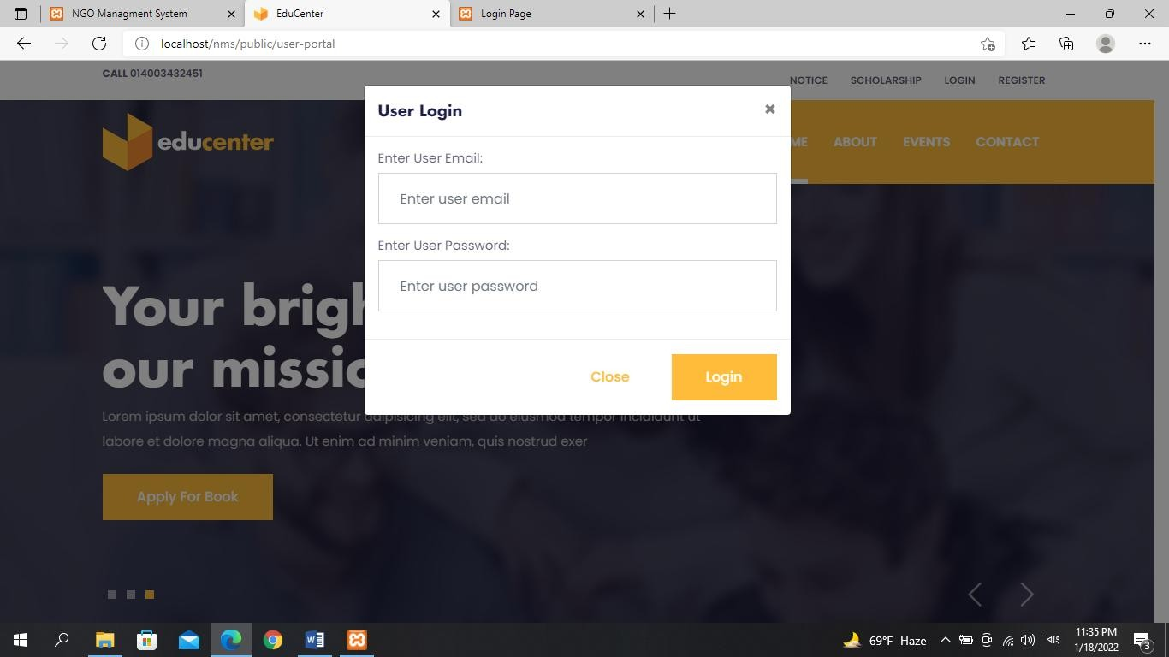

**Figure 7.6:User login panel**

**Books Panel:**

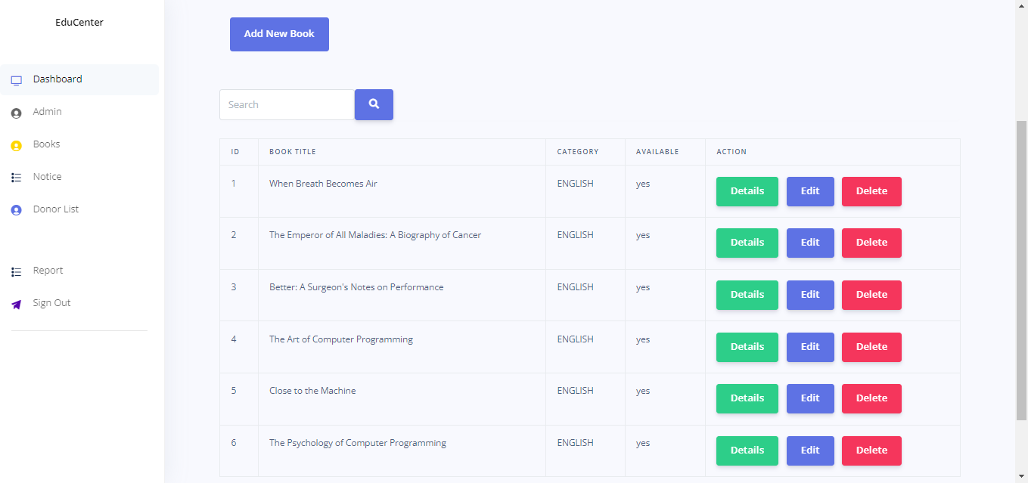

**Figure 7.7:Books panel**

**Notice Panel:**

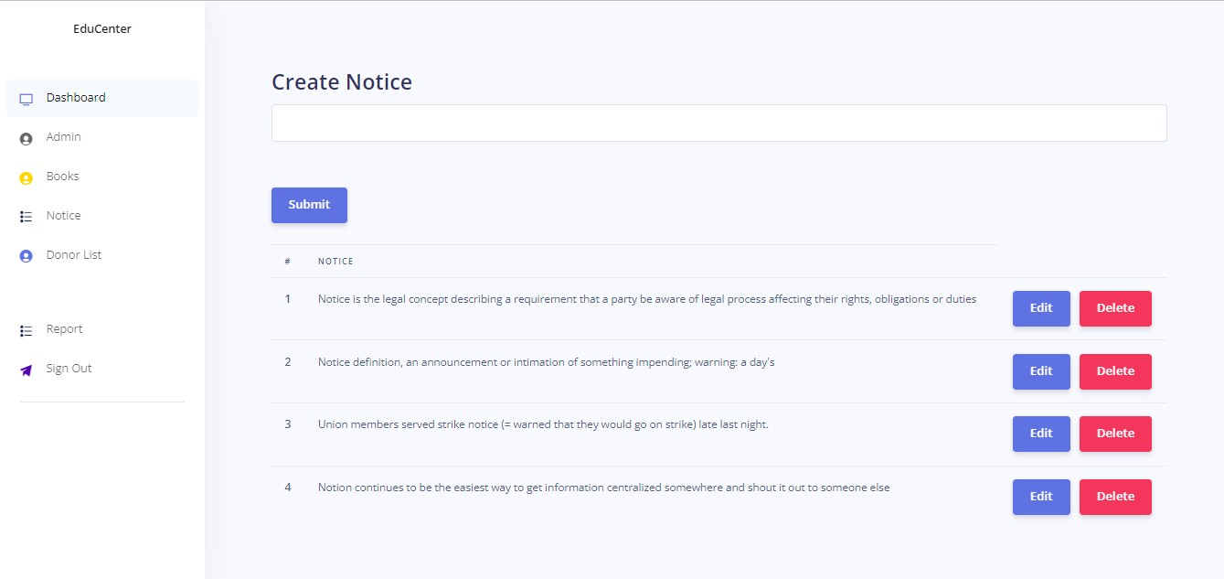

**Figure 7.8:Notice panel**

**Contact Panel:**

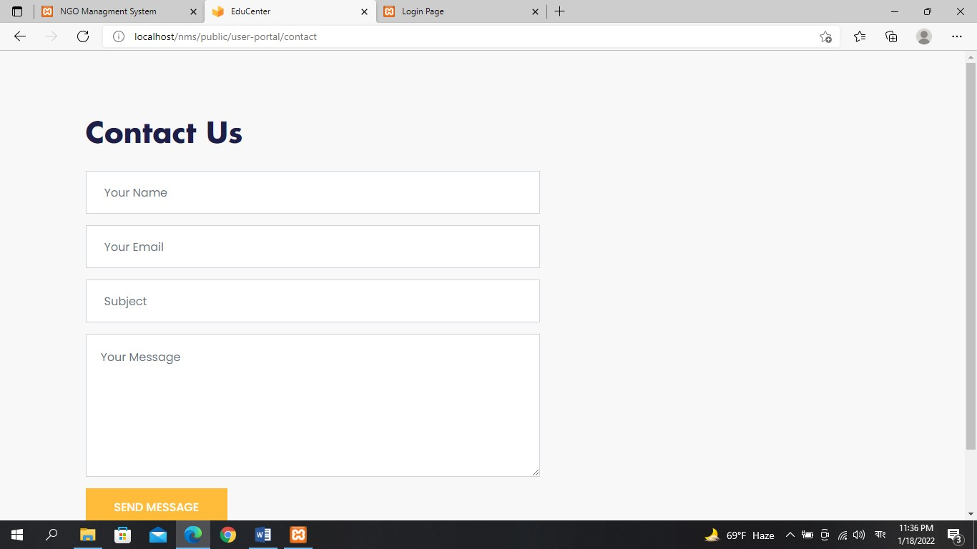

**Figure 7.9:Contact panel**

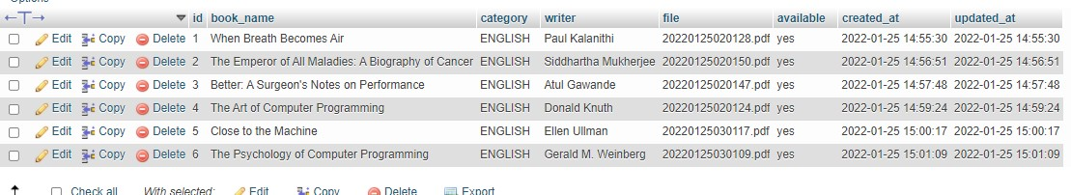

**Figure 7.10:Booklists Database**

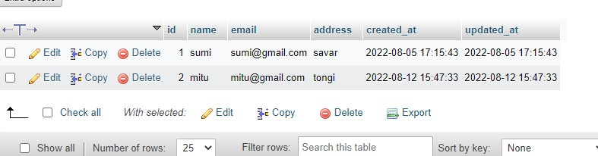

**Figure 7.11:Members Database**

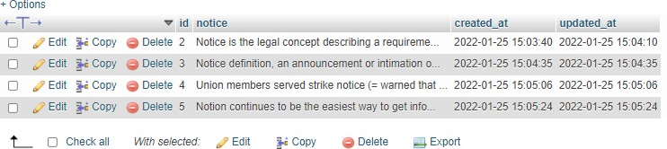

**Figure 7.12:Notices Database**

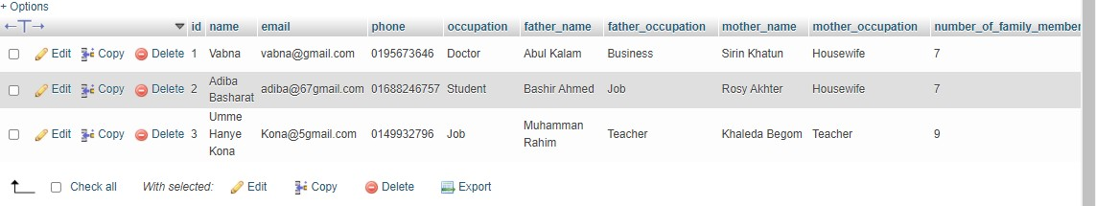

**Figure 7.13:Scholarships Database**

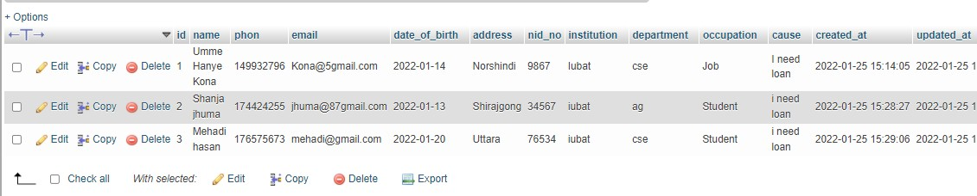

**Figure 7.14:Loans Database**

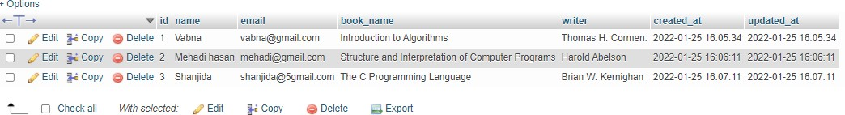

**Figure7.15:Books Database**

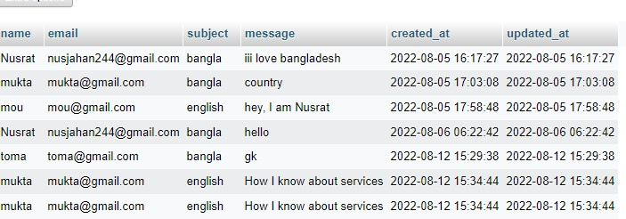

**Figure7.16:Contacts Database**

**Chapter 8 Quality Assurance**

### System testing

Software testing is the process of evaluating a software item to detect differences between given input and expected output. Also, to assess the feature of A software item. Testing assesses the quality of the product. Software testing is a process that should be done during the development process. In other words, software testing is a verification and validation process. **Verification:** Verification is the process to make sure the product satisfies the conditions imposed at the start of the development phase. In other words, to make sure the product behaves the way we want it to.

**Validation:** Validation is the process to make sure the product satisfies the specified requirements at the end of the development phase. In other words, to make sure the product is built as per customer requirements.

The objectives of software testing are:

* + - Testing is the process of executing a program with the intent of finding an error.
    - A good test case has a high probability of finding an as-yet-undiscovered error.
    - A successful test uncovers an as-yet-undiscovered error.

The design of tests for software can be challenging as the initial design of the product itself. The software can be tested in one of two ways:

*Knowing the specified function that the software has been designed to perform, tests can be conducted that demonstrate each function fully while at the same time searching for errors in each function. This approach is known as black-box testing.

*Knowing the internal workings of software, tests can be conducted to ensure that internal operations are performed according to specifications and all internal components have been adequately exercised. This approach is known as white-box testing.

**8.1.1 Software Testing Strategy**

A strategy for software testing integrates software test case design methods into a well- planned series of steps that result in the successful construction of software. The strategy provides a road map that describes the steps to be conducted as part of testing.

The testing strategy that will be followed in this software project –

* Unit testing
* Integration testing
* Validation testing

The first step in software testing is unit testing. Unit testing concentrates on each unit of the software as implemented in the source code. Unit testing focuses on each component individually. The unit test is white-box oriented. Thus, unit testing of this library software will be done after the completion of every module or component.

The next step is integration testing. Integration testing is a systematic technique for constructing the program structure while at the same time conducting tests to uncover errors associated with interfacing. The objective of integration testing is to take unit tested components and build a program structure that has been dictated by design.

The integration testing strategy that has been chosen for this project is top-down testing. The black-box testing method is the most prevalent for integration testing. A top-down integration strategy will be used to perform integration testing. Top-down integration will be done in a breadth-first manner. Breadth-first integration incorporates all components directly subordinate at each level, moving across the structure horizontally.

After the software has been integrated, a set of high order tests are conducted. Hence, the validation criteria that have been mentioned in requirements engineering should be tested. Validation testing provides final assurance that software meets all functional, behavioural and performance requirements. The black-box testing method is exclusively used invalidation.

### System Testing Methodology

### Black-box Testing

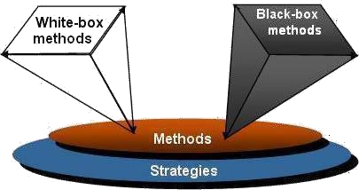Black-box testing which is also known as behavioural testing focuses on the functional requirements of the software. It enables the software engineer to derive sets of input conditions that will fully exercise all functional requirements for a program. The black-box testing method will be applied to test the modules of LMS.

**Figure 8.1:** Black

box and White box

testing

* + **White-box Testing**

White-box testing, which is also known as *glass-box testing*, is a test case design method that uses the control structure of the procedural design to derive test cases. Using white-box testing methods, the software engineer can derive test cases that,

1. Guarantee that all independent paths within a module have been exercised at least once
2. Exercise all logical decisions on their true and false sides
3. Execute all loops at their boundaries and within their operational bounds
4. Exercise internal data structures to ensure their validity.

The modules that contain some complex calculations or decisions making code such as checking the availability of the library item will be tested using the white-box method.

### Testing and Quality Assurance Design

**Table 8. 1: Testing Scenario No: 1**

|  |  |
| --- | --- |
| Testing scenario No: 1 | |
| Scenario | Login testing scenario of our system |
| Input’s | email, the password for Login |
| Desired Output | When entering an email, the password then gets the access level defined. |
| Actual Output | For login, our system works correctly |
| Verdict | Getting results from Desired Output and Actual Output Is decided this system is successful for login. |

**Table 8. 2: Testing Scenario No: 2**

|  |  |
| --- | --- |
| Testing scenario No: 2 | |
| Scenario | Admin can add and delete scholarships, donations, books. |
| Input’s |  |
| Desired Output | When entering all basic info correctly, students will be registered in the system. |
| Actual Output | For registration our system work correctly |
| Verdict | Getting results from Desired Output and Actual Output’s decided this system is successful for registration. |

**Table 8. 3: Testing Scenario No: 3**

|  |  |
| --- | --- |
| Testing scenario No: 3 | |
| Scenario | Admin can add and delete Donor. |
| Input’s | Donor basic info registered and deleted by the admin |
| Desired Output | When changed basic information for the donor by the admin. |
| Actual Output | For adding and deleting donorr info our system works  correctly. |
| Verdict | The process is worked correctly and successfully. |

**Table 8. 4: Testing Scenario No: 4**

|  |  |
| --- | --- |
| Testing scenario No: 4 | |
| Scenario | Admin can register new students details. |
| Input’s | Students basic info added by the admin and . |
| Desired Output | When changed basic information for the student by the admin. |
| Actual Output | For register students info our system work correctly |
| Verdict | The process is worked correctly and successfully. |

**Table 8. 5: Testing Scenario No: 5**

|  |  |
| --- | --- |
| Testing scenario No: 5 | |
| Scenario | Admin can Add Books |
| Input’s | Basis information oo books |
| Desired Output | When enter all basic info correctly, books will be added in the system. |
| Actual Output | I check this process and get actual outputs. |
| Verdict | The process is worked correctly and successfully. |

**Table 8. 6: Testing Scenario No: 6**

|  |  |
| --- | --- |
| Testing scenario No: 6 | |
| Scenario | Give Notice to the Donor and Students. |
| Input’s | Admin can give Notice |
| Desired Output | Notice save in the database. |
| Actual Output | I check this process and get actual outputs |
| Verdict | The process is worked correctly and successfully. |

**Chapter 9 Conclusion**

### Preface

Today is the age of modern science and information and online communication, which is critical to the development of more effective operational and management processes. To provide better and uninterrupted services to the employees of Soft tech a group of Software specialists working together to keep the service all time. I was fortunate and blessed to get this lucky break to work with some of these efficient hard-working friendly engineers. My earnest thanks, gratitude and salutations to these wonderful people from deep down inside my heart.

* + 1. **Practicum and Its Value**

In your career development as with most life issues, there is a direct relationship between effort and reward. To me, practicum can be seen as a transition from engineering college study life to a real-world workplace through hands-on experience of engineering practices.

The four years of undergraduate engineering studies give a student theoretical and practical knowledge. Using that knowledge and observing live operational systems, the practicum program clarifies those subjects’ matters to another level blessed with practical working skills. Considering this fact, it gives us immense pleasure to say that my practicum was a successful event.

Practical work experience doesn’t have any other alternatives. Before getting into the job, students should have real-world work experiences in a major field of study. Nowadays, a day’s recruiter no longer considers just high grades, good communication skills, and part-time work experiences. They highly consider the work experiences of an applicant. Students with better work experiences are getting better job opportunities.

Soft tech gives us the opportunity of working in a professional working environment. During the internship period, I have tried my level best to make my system efficient. I followed the lessons, methods, tools and techniques that I have learned during my study period at IUBAT. Successful software development is a blend of standard development practices, proper theoretical knowledge and the developer’s creativity.

Students of the College of Engineering and Technology (CEAT) at IUBAT go for this practicum program carrying 6 credit hours, which goes for a semester-long and usually after the completion of the course work. A report was submitted after the completion of the practicum followed by a presentation and a comprehensive examination on the overall four years education.

### Future Plan

Update donor profile

Add new features and processes like when the new notice came student can get the notification.

More effective panel for Admin and User. Make a mobile version.

### Limitation:

* Donar and students can not able to update their profile information
* Forget password system yet not been implemented
* Database backup system needs to be developed

### Conclusion:

My biggest experience working at soft tech is indeed being a part of designing and implementing software. My most experience was around the designing issue. I have learnt a lot of new things which was so much unknown to me. I have also learnt some technical issues which help to do better in future life. The following indicator will indicate some of the technical issues which I have learn and implemented from this project.

* The designing strategy of a web-based project.
* The analyzing strategy of a web-based project.
* The new environment of programming languages.
* Developing a new project using the existing project.
* How to code MY SQL and design PHP, HTML and CSS.

I faced some limitations in this area in Bangladesh. Most Bangladeshi people do not understand the benefits of an online system. It is a big problem for the next generation. Therefore, the government should take proper steps to spread beneficial information about online systems to the country's people.

# REFERENCES

1. Rapporteur 1, E. G. I. (29 October 2019). ["Europe in a suitcase: Oliver Wardrop](https://egi.ge/en/archives/5187) [Discussions".](https://egi.ge/en/archives/5187) Europe-Georgia Institute. Retrieved 31 March 2021.
2. [**^**](https://en.wikipedia.org/wiki/Non-governmental_organization#cite_ref-UCB-LibraryGuide-NGOs_2-0) Church, Jim (26 August 2021). ["Library Guides: Non Governmental Organizations (NGOs):](https://guides.lib.berkeley.edu/c.php?g=496970&p=3401867) [Introduction"](https://guides.lib.berkeley.edu/c.php?g=496970&p=3401867). guides.lib.berkeley.edu. Archived from the original on 26 August 2021. Retrieved 26 August 2021.
3. [**^**](https://en.wikipedia.org/wiki/Non-governmental_organization#cite_ref-%3A3_3-0) ["NGO",](http://www.macmillandictionary.com/dictionary/american/ngo) Macmillan Dictionary
4. Silberschattz, Abraham, Korth, Henry F., &Sudrashan S. (2002). Database System
5. Meyer, Bertrand. (1997), *OOSC2: The Use Case Principle.*

(Accessed on 25 October ,2018)Retrieve From [http://www.elj.com/elj/v1/n2/bm/usecases.](http://www.elj.com/elj/v1/n2/bm/usecases)

1. Longstreet, David. (2005). *Fundamentals of Function Point Analysis.*

(Accessed on 20 November, 2018)Retrieve from [http://www.softwfaremetrics.com/fpafund.html.](http://www.softwfaremetrics.com/fpafund.html)

1. *Function Point Overview.* (Accessed on 20 November, 2018)

Retrieve from <http://www.csee.umbc.edu/~mgrass2/cmsc645/function_point.html>

1. *How to calculate function points.* (Accessed on 20 November, 2018)

Retrieve from <http://stackoverflow.com/questions/34473698/how-to-calculate-functionpoints>

1. The RMMM Plan. url: <http://www.tutorialride.com/software-engineering/risk-> management-insoftware-engineering.html(Accessed on 25 November, 2018)
2. Methods of System quality testing. url:

https://en.wikipedia.org/wiki/Software\_testing (Accessed on 26 November, 2018)

1. System quality assurance. url: https://en.wikipedia.org/wiki/Software\_quality\_assurance (Accessed on 01 December, 2018)