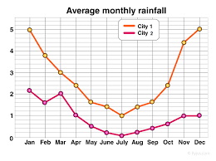

Model

Phase for state

Model 1

Model 2

SRN Model

UML

collaboration

Deployment

Function

SRN Model

Model

SRN Model

Performance modeling view

Dependability modeling view