**Overview**

This project aims to donate medicine which are unused.The unused medicine can be dnated for further utilization by a needy person.This application helps the user to donate unused medicines to NGO.In this system there are three entity namely ,Admin,NGO and member.Admin will login and manage membersby deleting and blocking the users providing improper and expired medicines.Admin also has authority to approve the appointment requested by NGO.admin has monthly report of medicines which has been donated.NGO can register and login using credentials.NGO manages the stock which helps to maintain the record of the available medicine.Members can register and login using credentials.They can donate medicine by providing medicine details and raising request ,further it will be approved by admin ,they will scheduling the donating date.Members can also check theai previous data of medicine transactions.

**Working of the project**

This medicine donator project is to prapare a portal for the collection of unused medicine for further utilization by a needy person.The website must be likw user can donate the unused medicine to NGO.That NGO can help needy people.The user can donate the medicine .Many poor people who do not afford to buy their own medicines,with help of the website people can get the treatment and medicinesnto cure the respective diseases,the unused medicine will be utilized.

**Project Life Cyecle**

The waterfall model is a classical model used in system development life cycle to create a system with a linear and sequential approach. It is termed as waterfall because the model develops systematically from one phase to another in downward fashion. The waterfall approach does not define the process to go back to the previous phase to handle changes in requirement. The waterfall approach is the earliest approach that was used for software development. Here the phases do not overlap with each other. The different sequential phases of the classical waterfall model are shown in the below figure:

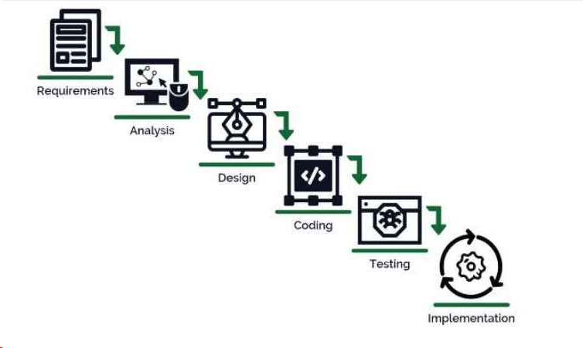

Fig:Waterfall Model