**Restaurant Management System(RMS)**

**Data Flow Diagram(DFD)**

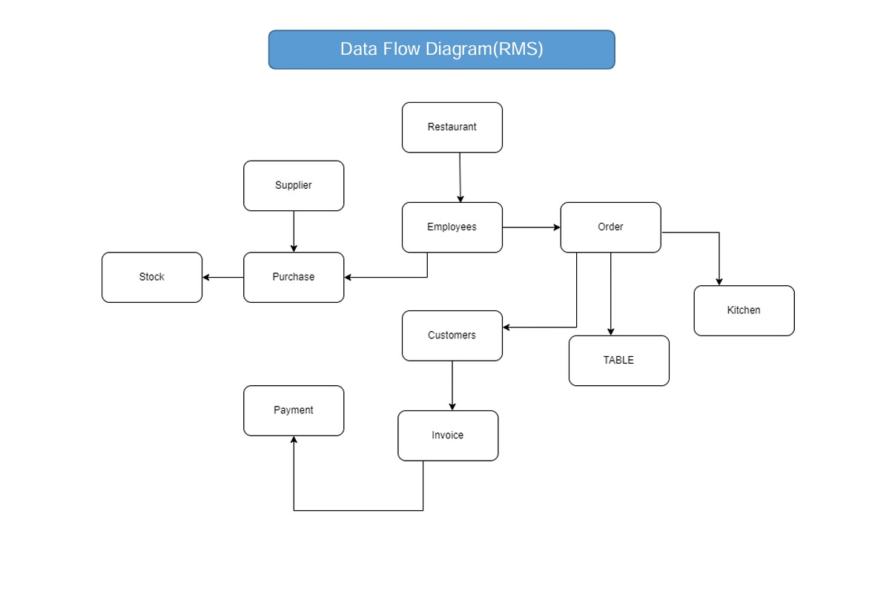

**Entity Relationship Diagram(ERD)**

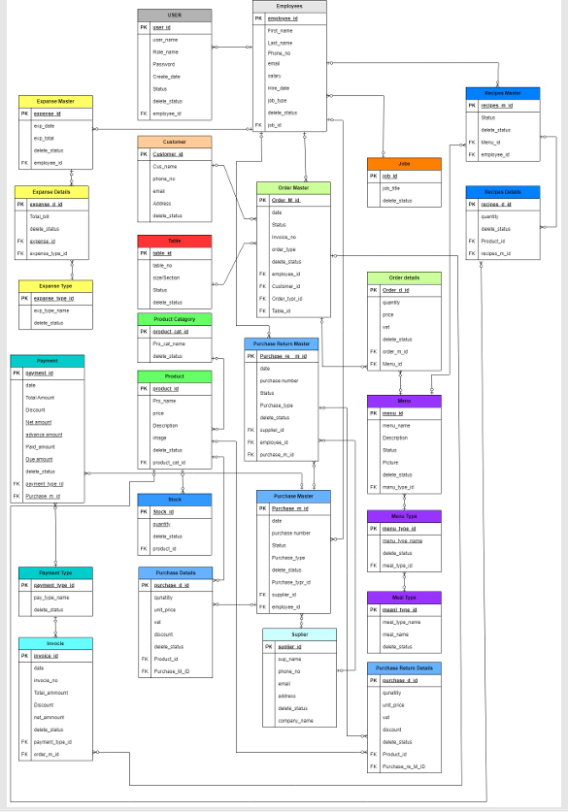

**Project Description**

**Title:** **Restaurant Management System**

* **Description:** The Restaurant Management System (RMS) is a comprehensive and automated software solution designed to streamline daily restaurant operations. It facilitates order processing, inventory management, billing, payment handling, and seamless communication between kitchen staff and management. The system enhances efficiency, accuracy, and customer satisfaction by integrating key operational processes into a single platform. IsDB-BISEW IT Scholarship Project.
* **Key Features & Modules:**

✔ **Order Management System** – Manage customer orders, track order status, and ensure timely service.

✔ **Table Management** – Manage table status, reservations, and seating.

✔ **Menu Management** – Maintain and update menu items, categories, and pricing.

✔ **Inventory Management** – Track stock levels, monitor usage, and automate supply reordering.

✔ **Billing & Payment Processing** – Generate invoices, process payments, and support multiple payment methods.

✔ **Employee Management** – Manage staff schedules, roles, and performance tracking. ✔ Report & Analytics – Generate real-time reports on sales, expenses, and operational efficiency.

✔ **Kitchen Management** – Improve coordination between front-of-house and kitchen staff for smooth service.

* **Benefits:**

✅ Automation & Efficiency **– Minimizes manual effort and accelerates workflows.**

✅ Real-Time Monitoring – Track orders, inventory, and revenue on a single platform.

✅ Data-Driven Insights – Get analytical reports to optimize business performance.

✅ Cost & Waste Management – Control inventory levels to minimize food waste and expenses.

✅ Enhanced Customer Experience – Faster service, accurate billing, and flawless order handling.

✅ User-Friendly Interface – Simple dashboard for easy navigation.

* **Development Tools:** Built using Oracle Fusion Middleware & Oracle APEX for a scalable and secure solution.
* **Access Demo(**Oracle APEX**):** **User:** demo

**Password:** demo123

* **For details go to:** [**https://tinyurl.com/bdftr5jp**](https://tinyurl.com/bdftr5jp)
* **Export file of Restaurant Management System Application (Oracle Apex) :**

