Healthcare Analytics
Power BI Build Guide
DAX Measures · Power Query M · Dashboard Layout & Wireframes
This guide is a ready-to-build companion to Healthcare_Admissions_Analysis_Dashboard.pbix. It contains every DAX measure, Power Query transformation, and page layout spec needed to assemble the four dashboards in Power BI Desktop.

A Note on This Deliverable
This package is a build guide and design spec, not a compiled .pbix file. A .pbix bundles a compiled Analysis Services data model that only Power BI Desktop's engine can build and validate — it can't be hand-authored reliably outside that tool. Everything below is copy-paste ready: paste the Power Query M into the Advanced Editor, paste the DAX into new measures, and follow the layout specs to reproduce each page exactly as mocked up in the attached PNGs.
Source table referenced throughout: Admissions (from healthcare_dataset.csv — Name, Age, Gender, Blood Type, Medical Condition, Date of Admission, Doctor, Hospital, Insurance Provider, Billing Amount, Room Number, Admission Type, Discharge Date, Medication, Test Results).

1. Power Query Transformations
Applied in Power Query Editor, in this order, on the Admissions query.

1.1 Remove Duplicates & Trim Text
let
Source = Csv.Document(File.Contents("healthcare_dataset.csv"), [Delimiter=",", Encoding=65001]),
PromotedHeaders = Table.PromoteHeaders(Source, [PromoteAllScalars=true]),
Deduplicated = Table.Distinct(PromotedHeaders),
TrimmedText = Table.TransformColumns(Deduplicated, {
{"Gender", Text.Trim, type text}, {"Blood Type", Text.Trim, type text},
{"Medical Condition", Text.Trim, type text}, {"Insurance Provider", Text.Trim, type text},
{"Admission Type", Text.Trim, type text}, {"Test Results", Text.Trim, type text}
})
in
TrimmedText

1.2 Standardize Name Casing
= Table.TransformColumns(TrimmedText, {{"Name", Text.Proper, type text}})
// Source names arrive in random casing ("LesLie TErRy") — Text.Proper normalizes to "Leslie Terry"

1.3 Fix Negative Billing Amounts
= Table.TransformColumns(Previous, {{"Billing Amount", Number.Abs, type number}})
// ~0.2% of records have negative billing values (data entry errors) — corrected to absolute value

1.4 Parse Dates & Add Length of Stay Column
= Table.AddColumn(Previous, "Length of Stay", each
Duration.Days([Discharge Date] - [Date of Admission]), Int64.Type)

1.5 Age Group (Conditional Column)
= Table.AddColumn(Previous, "Age Group", each
if [Age] <= 18 then "0-18"
else if [Age] <= 35 then "19-35"
else if [Age] <= 50 then "36-50"
else if [Age] <= 65 then "51-65"
else "66+", type text)

1.6 Date Dimension Table
Add a separate Date table (Home → New Source → Blank Query) for time-intelligence DAX to work correctly:
let
MinDate = List.Min(Admissions[Date of Admission]),
MaxDate = List.Max(Admissions[Discharge Date]),
Dates = List.Dates(MinDate, Duration.Days(MaxDate - MinDate) + 1, #duration(1,0,0,0)),
ToTable = Table.FromList(Dates, Splitter.SplitByNothing(), {"Date"}),
AddYear = Table.AddColumn(ToTable, "Year", each Date.Year([Date]), Int64.Type),
AddMonth = Table.AddColumn(AddYear, "Month", each Date.MonthName([Date]), type text),
AddMonthNum = Table.AddColumn(AddMonth, "MonthNum", each Date.Month([Date]), Int64.Type),
AddDOW = Table.AddColumn(AddMonthNum, "DayOfWeek", each Date.DayOfWeekName([Date]), type text)
in
AddDOW
Mark this table as a Date Table (Table tools → Mark as Date Table) and relate Date[Date] → Admissions[Date of Admission] (1-to-many).

2. DAX Measures
Organized into measure groups matching the dashboard pages. Create a dedicated "_Measures" table to hold all of these for a clean Fields list.

2.1 Core Measures (used across all pages)
Total Patients
Total Patients = DISTINCTCOUNT(Admissions[Name])
Total Visits
Total Visits = COUNTROWS(Admissions)
Use when a patient can appear more than once — Total Patients de-dupes by name.
Total Revenue
Total Revenue = SUM(Admissions[Billing Amount])
Avg Billing per Patient
Avg Billing per Patient = AVERAGE(Admissions[Billing Amount])
Avg Length of Stay
Avg Length of Stay = AVERAGE(Admissions[Length of Stay])

2.2 Time Intelligence (Executive & Financial)
Revenue PY
Revenue PY =
CALCULATE([Total Revenue], SAMEPERIODLASTYEAR('Date'[Date]))
Revenue YoY %
Revenue YoY % =
DIVIDE([Total Revenue] - [Revenue PY], [Revenue PY])
Patients PY
Patients PY =
CALCULATE([Total Patients], SAMEPERIODLASTYEAR('Date'[Date]))
Patients YoY %
Patients YoY % =
DIVIDE([Total Patients] - [Patients PY], [Patients PY])

2.3 Department / Condition Analysis
Revenue % of Total
Revenue % of Total =
DIVIDE([Total Revenue], CALCULATE([Total Revenue], ALL(Admissions[Medical Condition])))
Top Condition by Revenue
Top Condition by Revenue =
CALCULATE(
SELECTEDVALUE(Admissions[Medical Condition]),
TOPN(1, ALL(Admissions[Medical Condition]), [Total Revenue], DESC)
)
Avg LOS by Condition
Avg LOS by Condition =
AVERAGEX(VALUES(Admissions[Medical Condition]), [Avg Length of Stay])

2.4 Financial / Billing
Revenue by Payer Rank
Revenue Rank (Payer) =
RANKX(ALL(Admissions[Insurance Provider]), [Total Revenue], , DESC)
High-Value Claim Flag
High-Value Claims =
CALCULATE([Total Visits], Admissions[Billing Amount] > 40000)
Billing IQR Outlier Count
Billing Outliers (IQR) =
VAR Q1 = PERCENTILE.INC(Admissions[Billing Amount], 0.25)
VAR Q3 = PERCENTILE.INC(Admissions[Billing Amount], 0.75)
VAR IQR = Q3 - Q1
VAR Upper = Q3 + 1.5 * IQR
VAR Lower = Q1 - 1.5 * IQR
RETURN
CALCULATE([Total Visits], FILTER(Admissions, Admissions[Billing Amount] > Upper || Admissions[Billing Amount] < Lower))

2.5 Operations
Bed Occupancy Rate
Bed Occupancy Rate =
DIVIDE(DISTINCTCOUNT(Admissions[Room Number]), 500)
500 = total licensed rooms — replace with your facility's actual bed count, or a dimension table if it varies by hospital.
Avg Patients per Doctor
Avg Patients per Doctor =
DIVIDE([Total Patients], DISTINCTCOUNT(Admissions[Doctor]))
Readmission Count (30-day proxy)
Readmissions (30d) =
VAR CurrentPatients = VALUES(Admissions[Name])
RETURN
COUNTROWS(
FILTER(
Admissions,
CALCULATE(
COUNTROWS(Admissions),
ALLEXCEPT(Admissions, Admissions[Name]),
DATESINPERIOD(Admissions[Date of Admission], Admissions[Date of Admission], -30, DAY)
) > 1
)
)
Proxy measure: flags patients with more than one admission within a trailing 30-day window.

2.6 Waiting Time (requires a new source field)
The uploaded dataset has no admit-to-bed timestamp, so a true wait-time measure can't be built from it as-is. Two options:
- Best: add a Wait_Time_Minutes column at the source (Registration_Time → Bed_Assigned_Time) and load it through Power Query.
- Interim: approximate using Length of Stay as a throughput proxy, clearly labeled as illustrative (as done on the Operations dashboard mockup).
Avg Wait Time (once field exists)
Avg Wait Time (min) =
AVERAGE(Admissions[Wait_Time_Minutes])
Wait Time SLA Breach %
Wait Time SLA Breach % =
DIVIDE(
CALCULATE([Total Visits], Admissions[Wait_Time_Minutes] > 60),
[Total Visits]
)
60 = target SLA in minutes — adjust to your department's target.

3. Dashboard Layout & Build Guide
All four pages share the same chrome: a left navigation rail (page tabs), a header with page title and filter chips, and a KPI card row. Wireframe mockups are provided as separate PNGs; specs below map each visual to its DAX measure and source field.

3.1 Executive Dashboard
Network-wide performance at a glance — for hospital leadership.
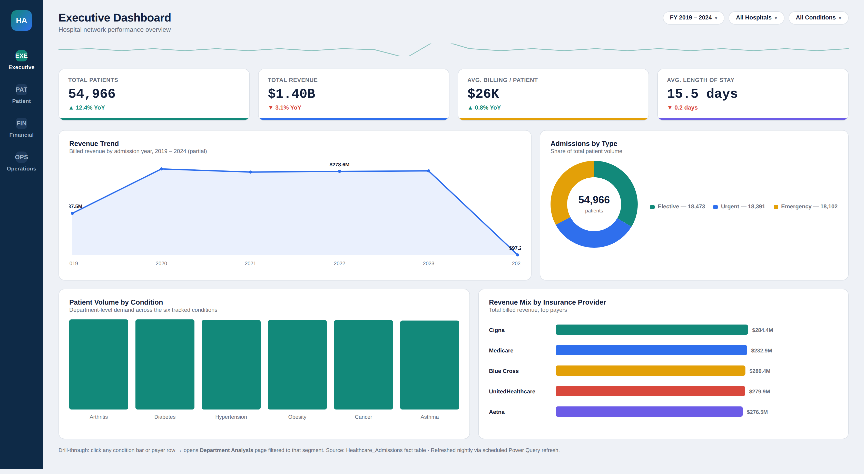

KPI Cards
Card | Measure | Format
Total Patients | [Total Patients] | Whole number, comma
Total Revenue | [Total Revenue] | Currency, $, 1 decimal (M/B)
Avg Billing / Patient | [Avg Billing per Patient] | Currency, $
Avg Length of Stay | [Avg Length of Stay] | Decimal, 1 place, "days" suffix

Visuals
Visual | Type | Fields / Measures
Revenue Trend | Line chart | Date[Year] (axis), [Total Revenue] (values)
Admissions by Type | Donut chart | Admissions[Admission Type], [Total Patients]
Patient Volume by Condition | Column chart | Admissions[Medical Condition], [Total Patients]
Revenue Mix by Payer | Bar chart | Admissions[Insurance Provider], [Total Revenue]

Slicers
Year (Date[Year]), Hospital (Admissions[Hospital]), Medical Condition — placed as chips in the header, synced across all 4 pages via Sync Slicers.

Drill-Through
Right-click any condition bar or payer row → Drill through → Department Analysis page, filtered to the selected Medical Condition / Insurance Provider.

3.2 Patient Dashboard
Demographics, case mix, and outcomes — for clinical & quality teams.
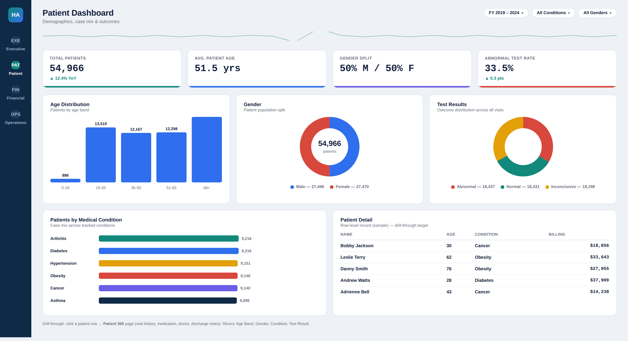

KPI Cards
Card | Measure | Format
Total Patients | [Total Patients] | Whole number, comma
Avg Patient Age | AVERAGE(Admissions[Age]) | Decimal, 1 place
Gender Split | DIVIDE males / [Total Patients] | Custom text measure
Abnormal Test Rate | DIVIDE abnormal visits / [Total Visits] | Percentage, 1 decimal

Visuals
Visual | Type | Fields / Measures
Age Distribution | Column chart | Admissions[Age Group], [Total Patients]
Gender | Donut chart | Admissions[Gender], [Total Patients]
Test Results | Donut chart | Admissions[Test Results], [Total Visits]
Patients by Condition | Bar chart | Admissions[Medical Condition], [Total Patients]
Patient Detail table | Table (drill-through target) | Name, Age, Medical Condition, Billing Amount

Slicers
Age Group, Gender, Medical Condition, Test Results.

Drill-Through
Click a row in Patient Detail → Drill through → Patient 360 page (full visit history, doctor, medication, discharge notes, all filtered to that patient's Name).

3.3 Financial Dashboard
Revenue, billing patterns, and payer mix — for finance & revenue-cycle teams.
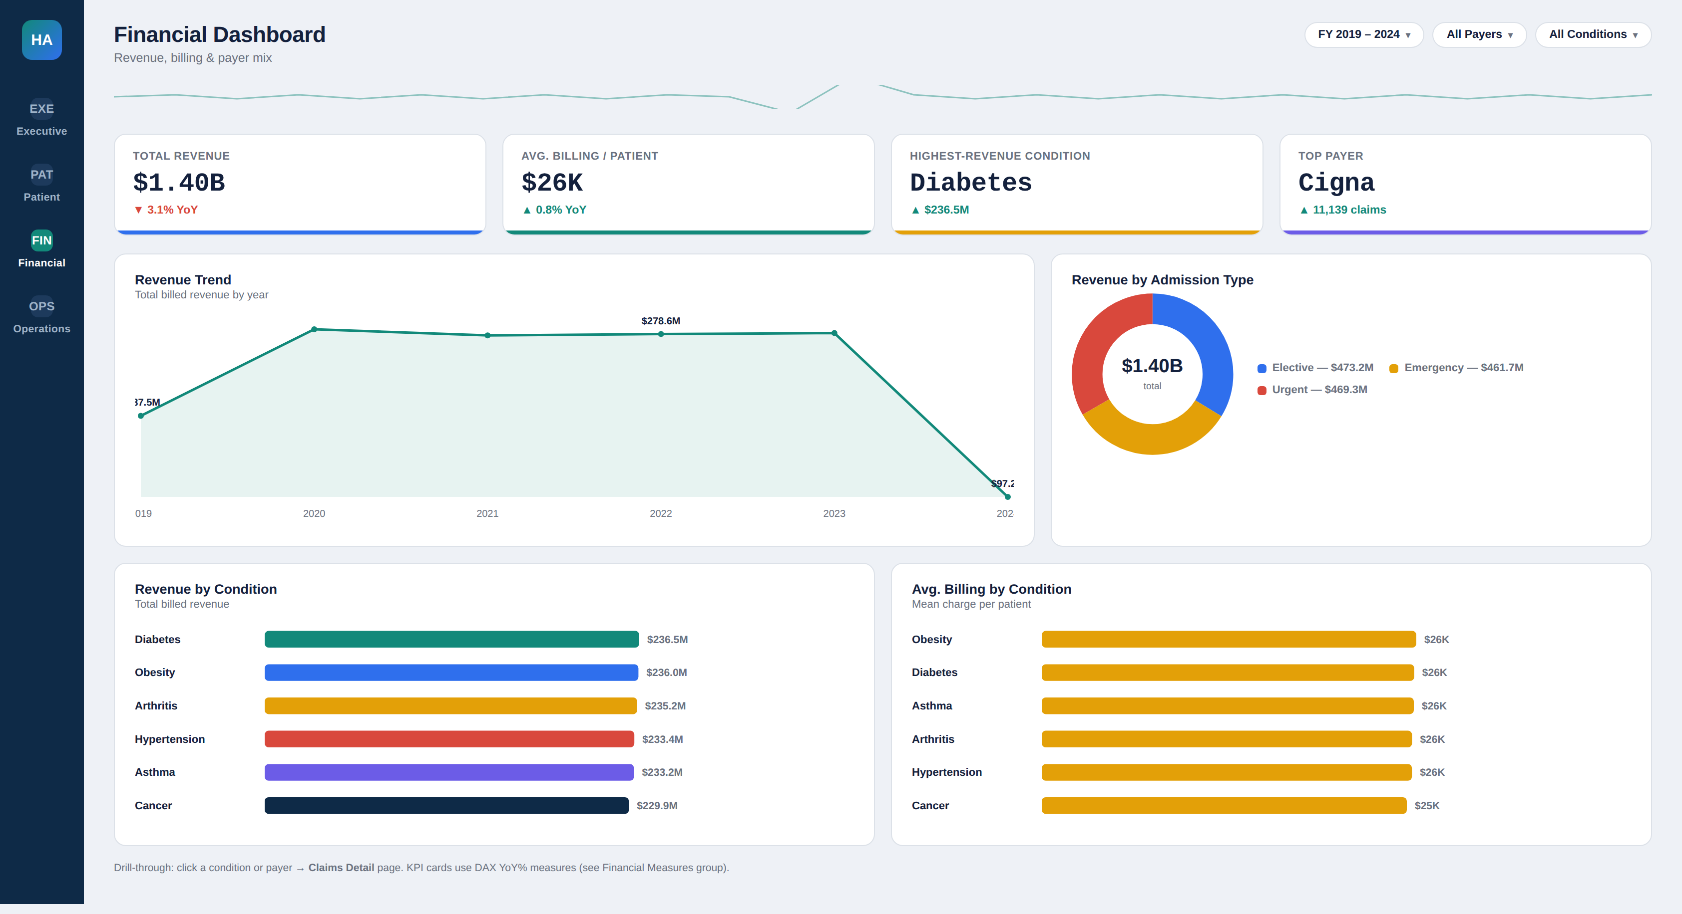

KPI Cards
Card | Measure | Format
Total Revenue | [Total Revenue] | Currency, $
Avg Billing / Patient | [Avg Billing per Patient] | Currency, $
Highest-Revenue Condition | [Top Condition by Revenue] | Text + [Total Revenue] sub-label
Top Payer | RANKX on Insurance Provider | Text + claim count sub-label

Visuals
Visual | Type | Fields / Measures
Revenue Trend | Line chart | Date[Year], [Total Revenue]
Revenue by Admission Type | Donut chart | Admissions[Admission Type], [Total Revenue]
Revenue by Condition | Bar chart | Admissions[Medical Condition], [Total Revenue]
Avg Billing by Condition | Bar chart | Admissions[Medical Condition], [Avg Billing per Patient]

Slicers
Year, Insurance Provider, Medical Condition, Admission Type.

Drill-Through
Click a condition or payer bar → Drill through → Claims Detail page (row-level billing records, [Billing Outliers (IQR)] flag highlighted).

3.4 Operations Dashboard
Throughput, staffing, and capacity — for hospital operations teams.
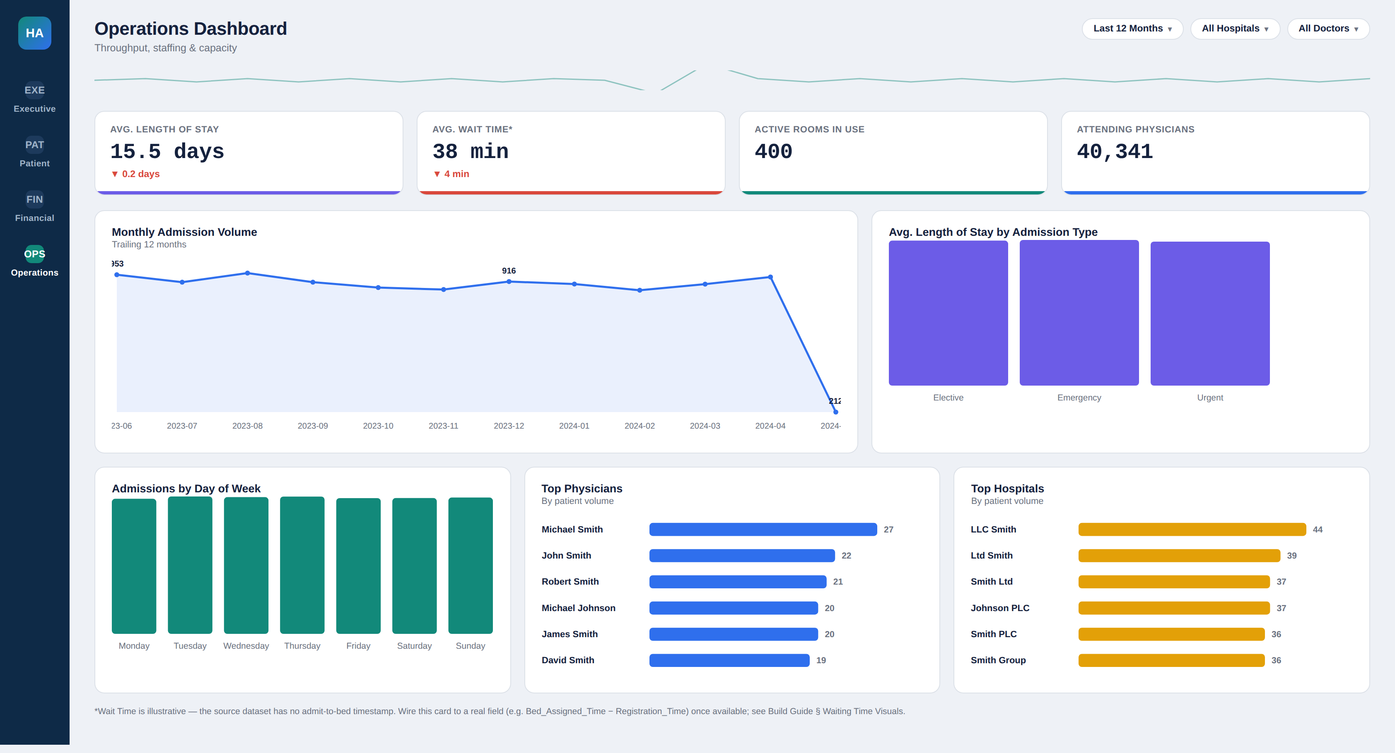

KPI Cards
Card | Measure | Format
Avg Length of Stay | [Avg Length of Stay] | Decimal, 1 place, "days"
Avg Wait Time* | [Avg Wait Time (min)] | Whole number, "min" suffix
Active Rooms in Use | DISTINCTCOUNT(Admissions[Room Number]) | Whole number
Attending Physicians | DISTINCTCOUNT(Admissions[Doctor]) | Whole number

Visuals
Visual | Type | Fields / Measures
Monthly Admission Volume | Line chart | Date[Year-Month], [Total Visits]
Avg LOS by Admission Type | Column chart | Admissions[Admission Type], [Avg Length of Stay]
Admissions by Day of Week | Column chart | Date[DayOfWeek], [Total Visits]
Top Physicians | Bar chart | Admissions[Doctor] (Top N=6), [Total Patients]
Top Hospitals | Bar chart | Admissions[Hospital] (Top N=6), [Total Patients]

Slicers
Month/Year, Hospital, Doctor, Admission Type.

Drill-Through
Click a physician or hospital bar → Drill through → Staffing Detail page. *Wait Time card requires the Wait_Time_Minutes field — see § 2.6.

4. Assembly Checklist
- Import healthcare_dataset.csv and apply the Power Query steps in § 1, in order.
- Build the Date dimension query and mark it as a Date Table; relate it to Admissions[Date of Admission].
- Create a _Measures table; paste in all DAX from § 2.
- Build each page per § 3 — match visual type, fields, and formatting exactly for a consistent look across pages.
- Add the header filter chips as a synced slicer panel (Format → Edit interactions → Sync slicers across all 4 pages).
- Wire drill-through pages per the specs above; set drill-through filters to "Keep all filters."
- Add a Wait_Time_Minutes field at the source before enabling the Operations wait-time card for real.

