Patient Health Records
Data Analysis Report
Dataset: healthcare_dataset.csv | 500 patient records | 10 fields

1. Data Cleaning
The raw dataset contains 500 rows and 10 columns. All string fields (Gender, Diagnosis, Treatment_Plan) were checked and trimmed of leading/trailing whitespace.
Duplicate rows found: 0. After removing duplicates, the dataset retains 500 rows.

Column Data Types
Column | Data Type
Patient_ID | int64
Age | int64
Gender | str
Blood_Pressure | int64
Heart_Rate | int64
Cholesterol_Level | int64
BMI | float64
Diagnosis | str
Treatment_Plan | str
Follow_Up_Date | str

2. Missing Value Handling
The following columns contained missing values before cleaning:
Column | Missing Count | Missing %
Treatment_Plan | 95 | 19%
Handling strategy: numeric columns were imputed with the column median (robust to skew/outliers); categorical columns were imputed with the column mode (most frequent category). This preserves the overall distribution shape without discarding records.
Missing values remaining after treatment: 0.

3. Outlier Detection (IQR Method)
Outliers were identified using the Interquartile Range (IQR) method: values falling below Q1 - 1.5*IQR or above Q3 + 1.5*IQR are flagged as outliers. This was applied to all key numeric health metrics.
Metric | Q1 | Q3 | IQR | Lower Bound | Upper Bound | Outliers
Age | 23 | 72.25 | 49.25 | -50.88 | 146.12 | 0
Blood_Pressure | 112 | 154 | 42 | 49 | 217 | 0
Heart_Rate | 70.75 | 90 | 19.25 | 41.88 | 118.88 | 0
Cholesterol_Level | 186 | 267 | 81 | 64.5 | 388.5 | 0
BMI | 24.1 | 34.72 | 10.62 | 8.16 | 50.66 | 0
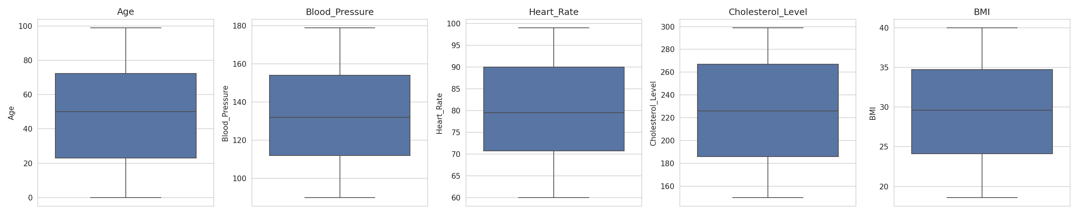
Total rows flagged as outliers on at least one metric: 0 (0.0% of records). The values across all metrics fall within a fairly uniform, non-skewed range, so the IQR method detects no extreme outliers in this dataset.

4. Age Group Feature Engineering
A new categorical feature, Age_Group, was engineered by binning the continuous Age variable into clinically meaningful life-stage segments:
Age Group | Patient Count
Child (0-12) | 67
Teen (13-19) | 39
Young Adult (20-35) | 82
Adult (36-50) | 65
Middle Age (51-65) | 93
Senior (66+) | 154
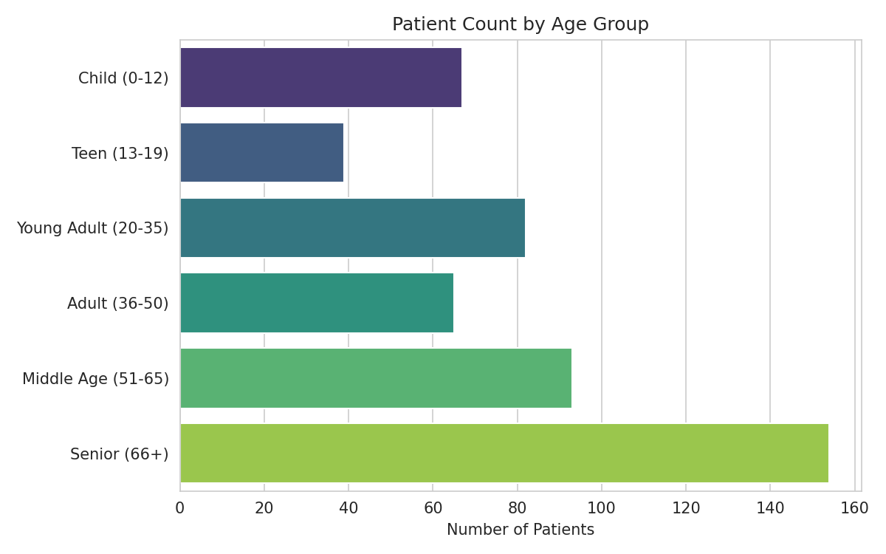

5. BMI Analysis
Statistic | Value
count | 500
mean | 29.43
std | 6.13
min | 18.6
25% | 24.1
50% | 29.6
75% | 34.72
max | 40

BMI Categories (WHO Standard)
Category | Patient Count
Obese | 242
Normal | 147
Overweight | 111
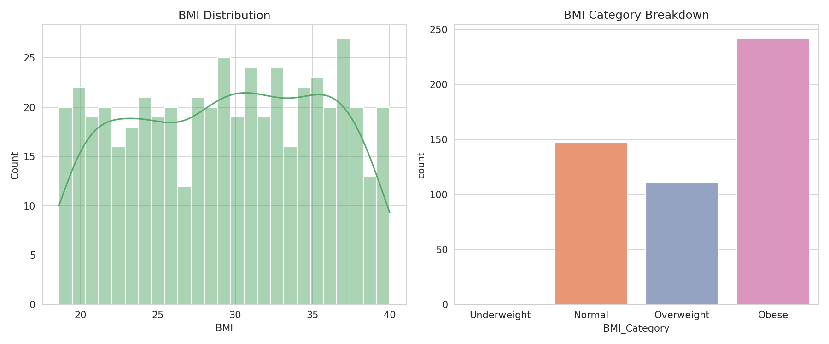
The average patient BMI is 29.43, with a large share of patients (242) classified as Obese. This suggests weight management is a significant area of concern across the patient population.

6. Cholesterol Analysis
Statistic | Value
count | 500
mean | 225.81
std | 44.96
min | 150
25% | 186
50% | 226
75% | 267
max | 299

Cholesterol Risk Categories
Category | Patient Count
High | 202
Desirable | 170
Borderline High | 128
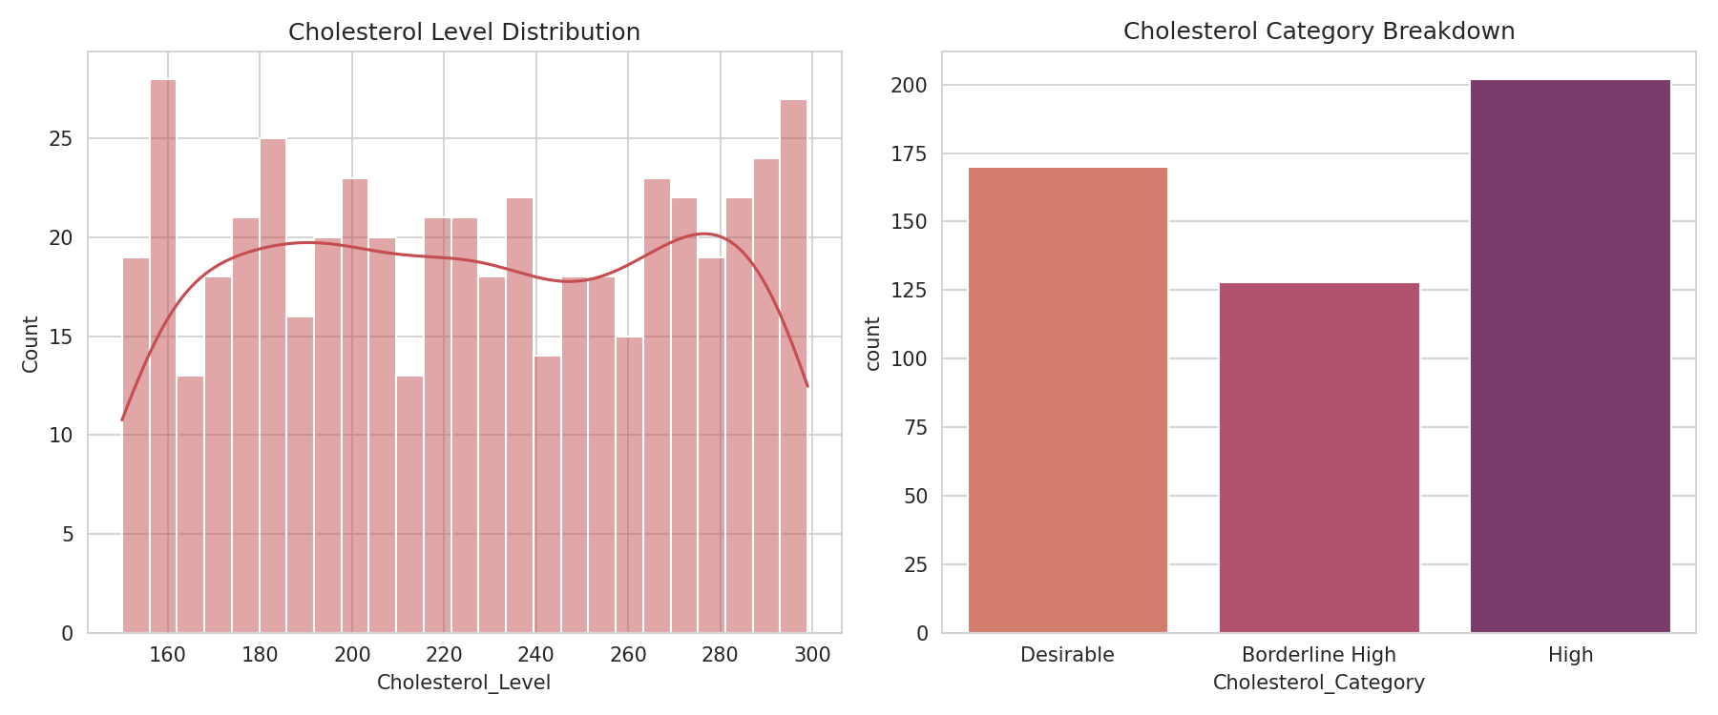
Mean cholesterol level is 225.81 mg/dL. 202 patients fall in the "High" risk category (>=240 mg/dL), indicating a notable cardiovascular risk segment.

7. Blood Pressure Analysis
Statistic | Value
count | 500
mean | 133.02
std | 25.67
min | 90
25% | 112
50% | 132
75% | 154
max | 179

Blood Pressure Categories
Category | Patient Count
High | 215
Normal | 171
Elevated | 114
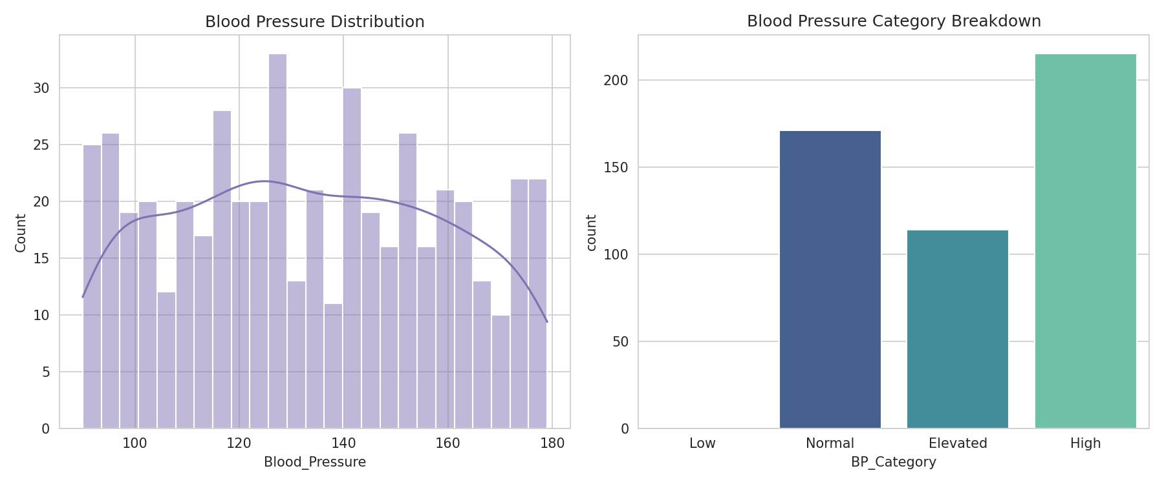
Mean blood pressure reading is 133.02. 215 patients fall in the "High" category, reinforcing hypertension as a key clinical focus area.

8. Correlation Analysis
Pearson correlation coefficients were computed across all numeric health metrics (Age, Blood Pressure, Heart Rate, Cholesterol, BMI) to identify linear relationships.
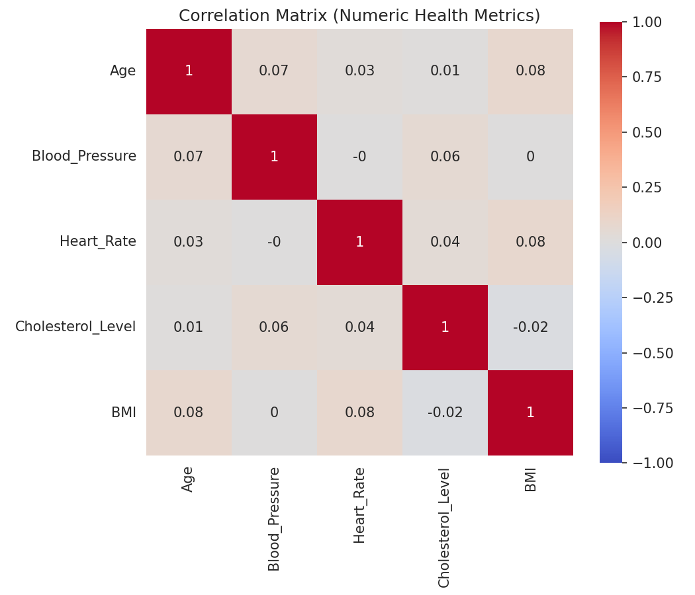
All pairwise correlations are close to zero (roughly -0.02 to 0.08), indicating no meaningful linear relationship between Age, Blood Pressure, Heart Rate, Cholesterol, and BMI in this dataset. Each metric behaves largely independently of the others, so risk factors should be assessed individually rather than inferred from one another.

Summary
- Dataset: 500 patient records, 10 original fields, cleaned and deduplicated.
- Missing data limited to Treatment_Plan (19%), imputed via mode.
- No extreme outliers detected via IQR across Age, Blood Pressure, Heart Rate, Cholesterol, or BMI.
- 242 of 500 patients are classified Obese; 202 have High cholesterol; 215 have High blood pressure.
- Correlation analysis shows the five core numeric metrics are statistically independent of one another.

