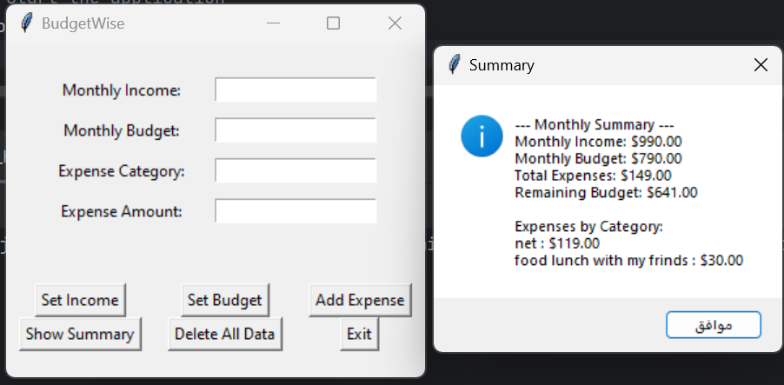

import json

import os

import tkinter as tk

from tkinter import messagebox

from datetime import datetime

# Initial data setup

data_file = "budget_data.json"

# Load data or initialize an empty data structure

if os.path.exists(data_file):

with open(data_file, "r") as f:

data = json.load(f)

else:

data = {

"income": 0.0,

"budget": 0.0,

"expenses": []

}

# Save data function

def save_data():

with open(data_file, "w") as f:

json.dump(data, f, indent=4)

# Helper function to format currency

def format_currency(amount):

return f"${amount:,.2f}"

# Set monthly income

def set_income():

income = float(income_entry.get())

data["income"] = income

save_data()

messagebox.showinfo("Success", f"Monthly income set to {format_currency(income)}.")

# Set monthly budget

def set_budget():

budget = float(budget_entry.get())

data["budget"] = budget

save_data()

messagebox.showinfo("Success", f"Monthly budget set to {format_currency(budget)}.")

# Add an expense

def add_expense():

category = category_entry.get()

amount = float(amount_entry.get())

date = datetime.now().strftime("%Y-%m-%d")

expense = {

"category": category,

"amount": amount,

"date": date

}

data["expenses"].append(expense)

save_data()

messagebox.showinfo("Success", f"Added expense: {format_currency(amount)} for {category} on {date}")

check_budget()

# Check if budget is exceeded

def check_budget():

total_expenses = sum(expense["amount"] for expense in data["expenses"])

if total_expenses > data["budget"]:

messagebox.showwarning("Budget Exceeded", f"You have exceeded your budget by {format_currency(total_expenses - data['budget'])}!")

# Show summary of expenses

def show_summary():

total_expenses = sum(expense["amount"] for expense in data["expenses"])

summary = f"--- Monthly Summary ---\n"

summary += f"Monthly Income: {format_currency(data['income'])}\n"

summary += f"Monthly Budget: {format_currency(data['budget'])}\n"

summary += f"Total Expenses: {format_currency(total_expenses)}\n"

summary += f"Remaining Budget: {format_currency(data['budget'] - total_expenses)}\n\n"

categories = {}

for expense in data["expenses"]:

if expense["category"] in categories:

categories[expense["category"]] += expense["amount"]

else:

categories[expense["category"]] = expense["amount"]

summary += "Expenses by Category:\n"

for category, amount in categories.items():

summary += f"{category}: {format_currency(amount)}\n"

messagebox.showinfo("Summary", summary)

# Delete all recorded data

def delete_all_data():

confirm = messagebox.askyesno("Confirm Deletion", "Are you sure you want to delete all recorded data?")

if confirm:

data["income"] = 0.0

data["budget"] = 0.0

data["expenses"] = []

save_data()

messagebox.showinfo("Success", "All data has been deleted.")

# Create the main window

root = tk.Tk()

root.title("BudgetWise")

# Layout

frame = tk.Frame(root)

frame.pack(pady=20)

# Income entry

income_label = tk.Label(frame, text="Monthly Income:")

income_label.grid(row=0, column=0, padx=10, pady=5)

income_entry = tk.Entry(frame)

income_entry.grid(row=0, column=1, padx=10, pady=5)

# Budget entry

budget_label = tk.Label(frame, text="Monthly Budget:")

budget_label.grid(row=1, column=0, padx=10, pady=5)

budget_entry = tk.Entry(frame)

budget_entry.grid(row=1, column=1, padx=10, pady=5)

# Category entry

category_label = tk.Label(frame, text="Expense Category:")

category_label.grid(row=2, column=0, padx=10, pady=5)

category_entry = tk.Entry(frame)

category_entry.grid(row=2, column=1, padx=10, pady=5)

# Amount entry

amount_label = tk.Label(frame, text="Expense Amount:")

amount_label.grid(row=3, column=0, padx=10, pady=5)

amount_entry = tk.Entry(frame)

amount_entry.grid(row=3, column=1, padx=10, pady=5)

# Buttons

button_frame = tk.Frame(root)

button_frame.pack(pady=20)

set_income_button = tk.Button(button_frame, text="Set Income", command=set_income)

set_income_button.grid(row=0, column=0, padx=10)

set_budget_button = tk.Button(button_frame, text="Set Budget", command=set_budget)

set_budget_button.grid(row=0, column=1, padx=10)

add_expense_button = tk.Button(button_frame, text="Add Expense", command=add_expense)

add_expense_button.grid(row=0, column=2, padx=10)

show_summary_button = tk.Button(button_frame, text="Show Summary", command=show_summary)

show_summary_button.grid(row=1, column=0, padx=10)

delete_data_button = tk.Button(button_frame, text="Delete All Data", command=delete_all_data)

delete_data_button.grid(row=1, column=1, padx=10)

exit_button = tk.Button(button_frame, text="Exit", command=root.quit)

exit_button.grid(row=1, column=2, padx=10)

# Start the application

root.mainloop()