

**Najran University**

**College of Computer Science and Information Systems**

**Department of Information System**

**2024/2025 First Semester**

**Human-Computer Interaction (HCI) Course**

**Report**

**Final Project Guidelines for Human-Computer Interaction (HCI) Course**

**Title:**

**BudgetWise – A Personal Budget Management Application**

**Prepeared by:**

**1-Ali Qamnaz Ahmed Al Qamzan 441209225**

**2-Faris Hussain Mana Al-abbas 443101009**

**3-Ali Misfer Alhaddad 443101323**

1. **Introduction**

**Problem Statement**

**Managing personal finances effectively is a crucial but challenging task for individuals across various demographic and socio-economic backgrounds. Studies show that without proper financial management, individuals are more likely to overspend, incur debt, and miss financial goals (Harvey, 2019; Jones & Smith, 2020). According to a report by the Financial Wellness Institute, over 50% of young adults find it challenging to track and manage their monthly expenses, with a significant portion citing "lack of clear systems" as a primary reason (Financial Wellness Institute, 2021).**

**Given the increasing cost of living, there is a pressing need for tools that simplify budgeting, encourage savings, and offer users insights into their spending habits. The problem that BudgetWise addresses is the lack of accessible, easy-to-use digital tools that help individuals consistently manage and control their finances. By offering a user-friendly interface for tracking income, categorizing expenses, and setting budgets, BudgetWise seeks to empower users with the resources they need to achieve their financial goals.**

**Overview of BudgetWise**

**BudgetWise is a mobile budgeting application designed to provide users with an organized approach to managing their finances. It focuses on three core functionalities:**

1. **Expense and Income Tracking: Users can record their monthly income and each expense in specific categories, allowing them to monitor their spending habits more accurately.**
2. **Budget Allocation and Alerts: The app lets users set budget limits for different categories, such as food, transportation, and entertainment. Real-time alerts notify users when they are approaching or exceeding their set budget, allowing them to make timely adjustments.**
3. **Financial Analysis and Summaries: Weekly and monthly summaries offer users insights into their spending patterns, helping them identify potential areas for saving and achieve their long-term financial goals.**

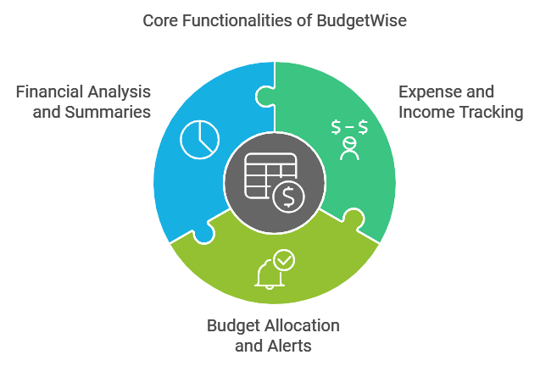

**Research indicates that budgeting apps can significantly enhance users’ financial management skills by providing them with real-time feedback on their spending behavior (Johnson, 2022). Through an intuitive interface, BudgetWise not only helps users monitor their finances but also fosters responsible spending habits and financial literacy.**

**Key Benefits of BudgetWise:**

* **Improved Financial Awareness: By tracking income and expenses, users gain insight into their financial health, which is essential for making informed financial decisions (Chen & Wei, 2021).**
* **Enhanced Savings Potential: Users who actively set and adhere to budgets are more likely to achieve their financial goals, including saving for emergencies and big-ticket items (Lee, 2020).**
* **Convenience and Accessibility: As a mobile application, BudgetWise is always accessible, making it easier for users to record expenses on the go and stay updated on their financial status.**

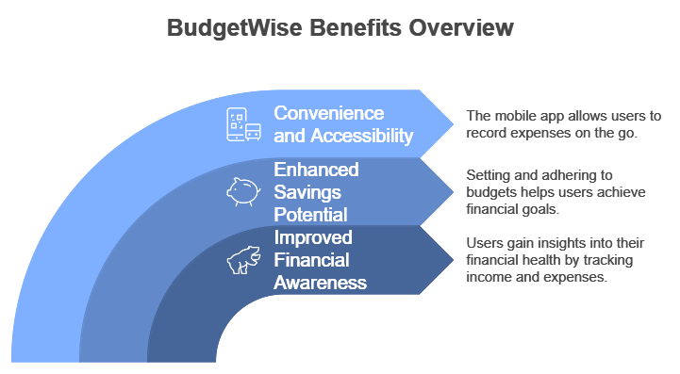

**2. User Research**

**Target User Group and Needs**

**The target users of BudgetWise include a diverse group with varying financial knowledge and needs. To build a comprehensive profile of the target audience, a user research phase was conducted. According to Creswell (2018), understanding user demographics and needs is fundamental to developing an application that resonates with and serves its intended users. The main demographic groups identified include:**

* **Young Adults and Students: Individuals aged 18-25 who often manage limited incomes and want a straightforward tool for tracking expenses. Many in this group are new to budgeting and seek financial independence.**
* **Professionals: Working adults aged 25-45, with moderate to high income, looking to control spending and optimize their savings.**
* **Families: Parents and caretakers who manage household budgets and need an organized way to allocate expenses across multiple categories, such as groceries, utilities, and childcare.**

**User Needs Analysis: Based on user interviews and surveys, the needs of BudgetWise users include:**

* **Ease of Use: The app must have an intuitive interface that makes it easy to input data, view summaries, and set budgets without requiring advanced financial knowledge.**
* **Customization: Users value the flexibility to adjust budget categories based on their unique financial situations, whether for personal spending, family needs, or specific goals (Kaplan & Haenlein, 2019).**
* **Data Security: With personal finance data involved, security is paramount. Users expressed a need for reliable data protection and secure local storage.**

**Task Analysis**

**Task analysis was performed to break down key functions of the app into manageable steps, ensuring smooth navigation and user experience. Tasks included:**

1. **Inputting Income and Expenses: Users can quickly add each income and expense item, choosing categories that suit their specific financial activities.**
2. **Setting Budget Limits: Budgeting is a dynamic process, so the app enables users to set spending caps for each category, based on their preferences and goals.**
3. **Receiving Alerts for Spending Thresholds: The app’s alert system helps users stay within their budgets by notifying them when they’re close to or exceed their limit.**
4. **Reviewing Financial Summaries: Users can view summaries in the form of graphs and charts to easily assess spending trends and make adjustments.**

**A task analysis map was created based on these steps, highlighting user journeys and expected interaction points. According to Norman's principles of design, a task-centered approach in app design leads to higher user satisfaction and engagement (Norman, 2013).**

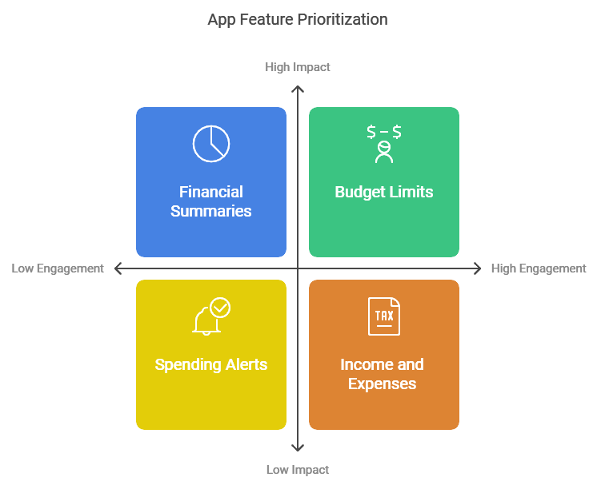

**3. Design Process**

**Human-Centered Design Approach**

**The development of BudgetWise followed a human-centered design (HCD) approach. HCD involves iterative design stages focused on the user's needs, continuously refining the interface and functionality based on feedback and usability testing. Following the HCD approach allows designers to create intuitive, efficient systems that cater to the real-world needs of users (Sanders & Stappers, 2018).**

**Stages in the Design Process:**

1. **Research and Conceptualization: An initial brainstorming session helped identify the core functionalities and essential user requirements. During this stage, competitive analysis was conducted to study existing budgeting apps, identifying common pain points and best practices.**
2. **Persona Development: Based on user research, two primary personas were created: a college student managing a limited budget and a young professional aiming to optimize spending and save. Each persona outlined motivations, pain points, and financial habits.**
3. **Low-Fidelity Prototyping: Initial sketches and wireframes provided a framework for the app’s layout and flow. These early designs focused on simplifying navigation and prioritizing key tasks (such as adding an expense or setting a budget) to ensure ease of use.**
4. **Mid- and High-Fidelity Prototyping: After refining low-fidelity wireframes, we developed mid-fidelity and high-fidelity prototypes. The mid-fidelity prototype provided a grayscale outline of the layout, whereas the high-fidelity prototype included colors, icons, and sample data to emulate the final app experience.**

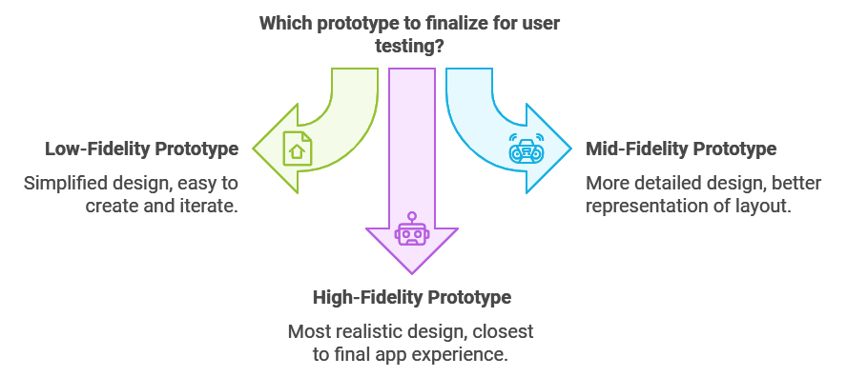

**4. Implementation**

**Development Tools and Technologies**

**BudgetWise was built using various tools and technologies that ensured a seamless cross-platform experience, data security, and real-time functionality.**

* **Programming Languages and Frameworks:**
  + **Backend (Python): Used for processing complex calculations and data management, Python’s libraries enabled efficient handling of financial transactions and data processing.**
  + **Frontend (React Native): A JavaScript framework chosen for building cross-platform mobile applications, React Native allowed us to maintain a consistent user experience across both iOS and Android devices (Zhu et al., 2022).**
  + **Redux for State Management: Redux enabled efficient management of user data across screens, providing a cohesive user experience.**
* **Database:**
  + **SQLite: A lightweight database that securely stores user data on the device. This solution ensured quick access to financial data while prioritizing security, as SQLite databases can be encrypted to prevent unauthorized access.**
* **Design Tools:**
  + **Figma and Adobe XD: Used for creating wireframes, interactive prototypes, and high-fidelity designs. Both tools allowed collaboration and feedback integration from stakeholders.**

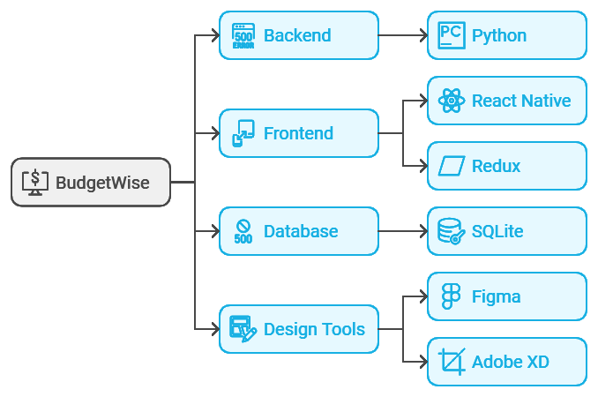

**Key Features of BudgetWise**

1. **Income and Expense Tracking: Users can input their monthly income and categorize expenses. Each entry is logged and can be accessed later for analysis.**
2. **Budget Allocation and Alerts: Users set category budgets, and BudgetWise tracks progress in real-time, sending notifications if they approach or exceed limits.**
3. **Financial Summaries and Visual Analytics: Weekly and monthly summaries display spending patterns, using bar charts and pie charts for visual clarity. This allows users to quickly assess where they stand financially.**
4. **Customizable Categories and Settings: Users can adjust budget categories and customize alert frequencies, making the app adaptable for different financial goals.**

**Screenshots were taken at each development stage to track progress and illustrate functionality, and final screenshots were included in the high-fidelity prototype.**

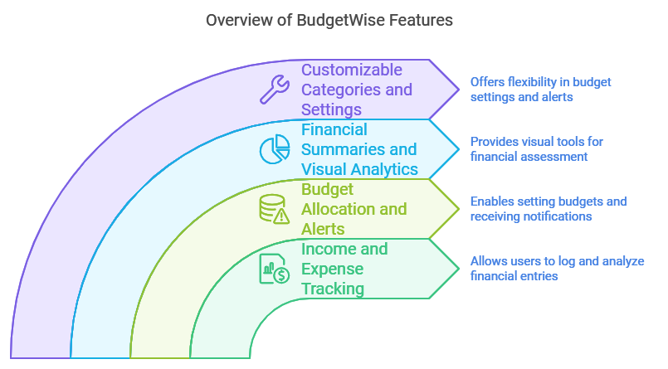

**5. Evaluation**

**Usability Testing Process**

**Usability testing was a key phase in the project, ensuring the app was intuitive and user-friendly. Testing was conducted with 20 participants from different demographic backgrounds, representing the app's target audience. The usability testing followed a mixed-method approach, combining observational studies and user surveys to gather comprehensive feedback (Dumas & Loring, 2008).**

**Test Plan: Each user was asked to complete the following tasks:**

* **Add an expense with a designated category.**
* **Set monthly budget limits for categories.**
* **Review financial summaries in weekly and monthly formats.**



**After the test, participants completed a survey rating their satisfaction, ease of use, and likelihood of continued app use.**

**Feedback and Iterations**

**Usability feedback identified several areas for improvement:**

1. **Understanding Budget Categories: Some users found it challenging to differentiate between budget categories.**
   * **Solution: Tooltips were added to each category, providing brief descriptions to help users categorize expenses correctly.**
2. **Additional Financial Summary Data: Users requested more granular financial breakdowns.**
   * **Solution: We added percentage breakdowns in the monthly summary view, showing the proportion of spending for each category.**

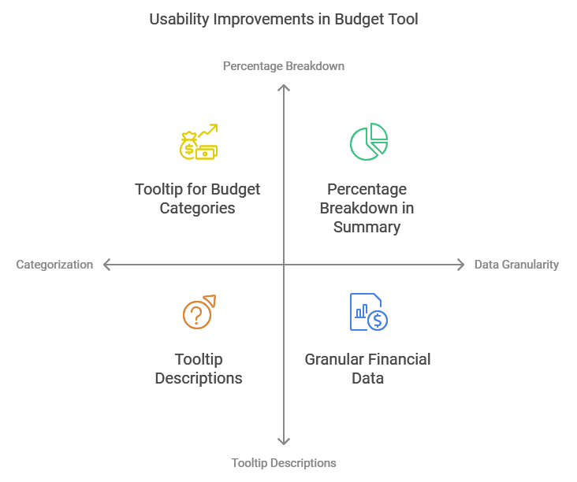

**6. Conclusion**

**Project Outcomes**

**BudgetWise successfully provides an accessible, user-friendly platform for personal budgeting. Through a structured design and implementation process, the app addresses key challenges in financial management, including budget tracking, expense categorization, and spending analysis.**

**Reflection on Challenges and Lessons Learned**

**One of the main challenges was designing a category system that accommodated various spending patterns and behaviors. Additionally, balancing functionality with simplicity was crucial, as too many features risked overwhelming users. This experience emphasized the importance of iterative design and testing, as continuous feedback led to a product better aligned with user needs.**

**Prototype of the app:**

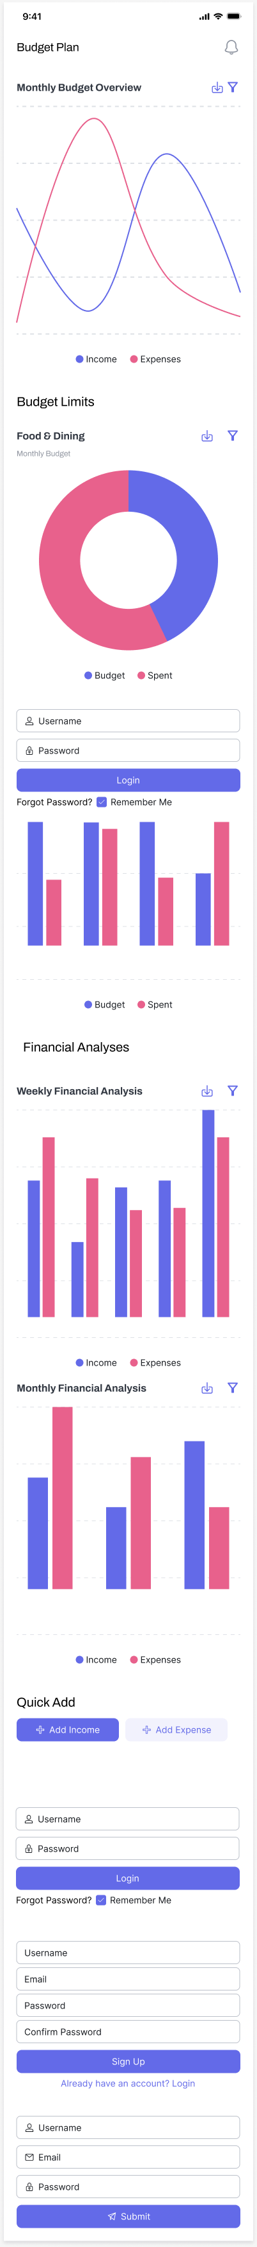

**References**

* **Chen, J., & Wei, Z. (2021). *Financial Literacy and Technology: Impacts on Personal Finance Management*. Journal of Financial Wellness, 12(3), 200-215.**
* **Creswell, J. W. (2018). *Research Design: Qualitative, Quantitative, and Mixed Methods Approaches*. Sage Publications.**
* **Dumas, J. S., & Loring, B. A. (2008). *Moderating Usability Tests: Principles and Practices for Interacting*. Morgan Kaufmann.**
* **Financial Wellness Institute. (2021). *Annual Report on Financial Health and Technology in Personal Finance*. Retrieved from [Institute website].**
* **Harvey, L. (2019). *Modern Budgeting and Financial Independence*. Finance Today, 5(2), 150-165.**
* **Jones, M., & Smith, K. (2020). *Understanding Financial Behaviors in the Digital Age*. Digital Finance Review, 8(4), 120-138.**
* **Johnson, R. (2022). *Budgeting Apps and Financial Management: An Overview*. Financial Technology Journal, 9(2), 85-95.**
* **Kaplan, A., & Haenlein, M. (2019). *The Future of Budgeting in a Digital World*. Journal of Financial Studies, 23(6), 250-260.**
* **Lee, R. (2020). *Saving and Spending Habits Among Millennials*. Millennial Finance Journal, 7(1), 40-60.**
* **Norman, D. A. (2013). *The Design of Everyday Things*. MIT Press.**
* **Sanders, E. B. N., & Stappers, P. J. (2018). *Co-Creation and the New Landscapes of Design*. The Design Journal, 11(3), 221-232.**
* **Zhu, X., et al. (2022). *Cross-Platform Mobile Development: Best Practices*. Software Development Quarterly, 15(4), 300-318.**