# Application For Export/ Transfer Permit/ No Decision

### Shipper (Address)

o

EOgl-Numbe

DE545204764542810 OOOC

1. Application NumDer

DE / 2593616

1. Application Date

14.02.2023

AG

Thales Deutschland GmbH

### Thalesplatz 1

DE 71254 Ditzinaen

1. Contact Person

Herr Bohmler Andreas.BOEHMLER@thal esgroup.com

Telephone Number

+49 7156302 30026

5. Consignee (Address) Datagate Co., Ltd.,

Thakolsuk Place 115 Terddumri Rd, Dusit TH 10300 Bangkko

Antrag

6a.

Federal Office of Economics and export control(BAFA) Frankfurter StraBe 29-35

65760 Eschborn

Notice

The Information is lhis application is based on section 21 paragraph 2 of the Foreign Trade Ordinance (AM) raised The application dala may be used in accordance with seclion 24 of the Foreign Trade Acl(AWG) from BAFA to Other are transmitted to federal public, As far as this is

ye e e purposes of section 4 Paragraph As is requeeh

1. Agent/ Representative(Address) (If it isn't identify with shipper)

6b. IC / EVE § 9 AWV technische KrWaffKontrG- Sonstige

Oatenblatter Genehmigung

Attached Investments

° 1 °

End User (If II's not identify to Consignee/Address)

Signal Department Royal Thai Army

Dusit

1. Country of origin (If known)

DEUTSCHLAND

1. Member State Mich Ihe goods are or Wjll be located

DEUTSCHLAND

1. Member State Which the export declaration is to be submihed

**DEUTSCHLAND**

1. Country of Final Deslination

Country Code

DE

oun try Code

DE

Counlry Code

DE

Country Code

0 TH 10300 Bangkok

1. DescñpionofGoQds

Ground Surveillance Radar BOR-A 680 After Upgrading from BOR-A550

THAILAND

Ifd. Nr.

1

1. Country of origin (if known)

DEUTSCHLAND

1'i. Commodity code 85261000

TH

country code

DE

6. AL-Position OOOSB

*- Description of Goods

Parts/Accessories for Ground Surveillance

Ifd. Nr.

17. Currency and value 18. Menge

3.000.000 EUR

14. Country of origin (if known) DEUTSCHLAND

div

Country code

DE

Radar BOR-A 680

10% of running for replacement / Guarantee Delivery

IS. Commodity code 85299097

6. AL-Position OOOSB

19. End use

Border surveillance/security: return here. n. Upgrade of the former AG 3076016 supplied BOR-A550

17. Currency and value 18. Menge

300.000 EUR

20 Date of the contract 21 Export Type.

10

div

* 1. Additional Product Sheets

0

* 1. Further information

Contract and EUC attached The application value is higher lhan lhe order value because additional the import value of the devices must also be taken into account Export value = import +

Order value

23a.Total Value

3.300.000 EUR

23b. Type of Requested Permit E

Extra cost: Reason:

23c. Order number/file number of the applicant TDIS/FO - Andreas Bohmler

* 1. Are you aware that the goods are intended for a purpose wilhin lhe meaning of Article 4 or Article 5 of EU Regulation 2021/821? (If yes, please describe on a separate sheef)

++ I (we), the applicant(s) named in field 1, apply as exporter/transferr for an authorization for the export/transfer of the goods listed in the

Ja If’” Nein

I (we) certify that all information provided in this application and its attachments is correct, in compliance with the instructions for completing this application.Application for specified goods (goods, software and technology).

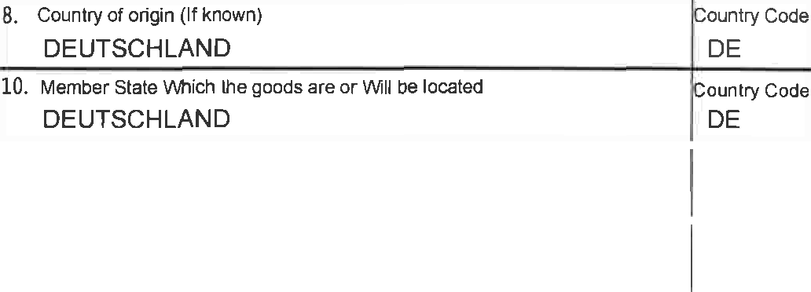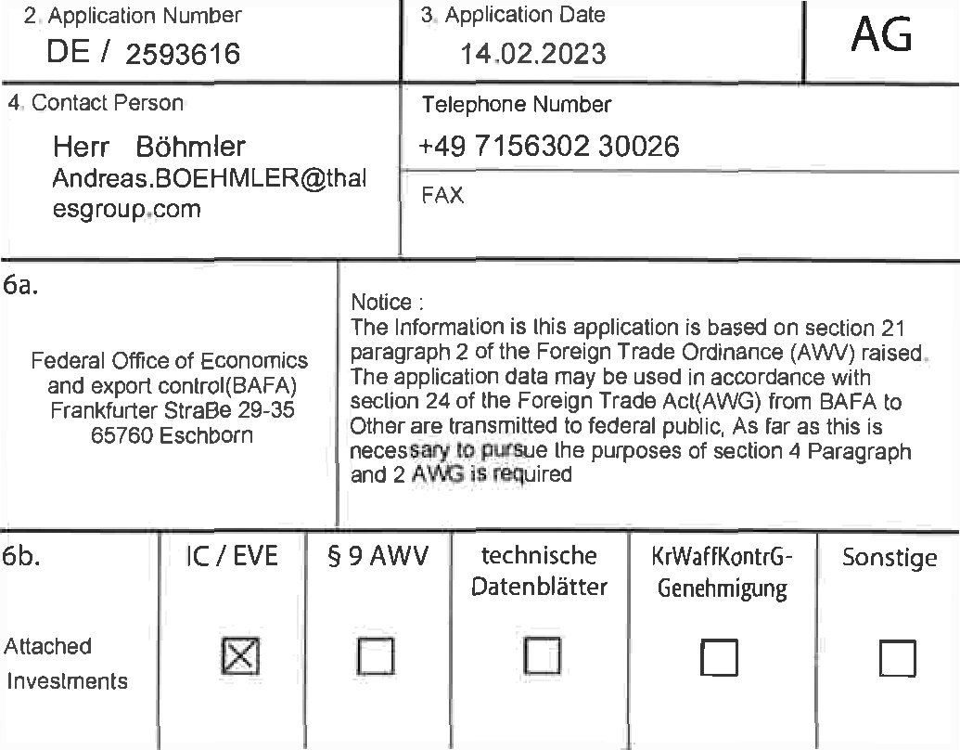

were stated completely and truthfully. All questions were answered truthfully to the best of our knowledge. I (we) declare that I (we) have not applied for an authorization for the export/transfer transaction applied for in any other member state of the European Union have)

Signature and company stamp not required Signature cif Applicant /

authorized representatives

# National Supplementary sheet for the application for Export/Transfer License/Nagative Certificate

* + 1. S hipper (Address)

0

Thales Deutschland GmbH

EORl-Number

DE545204764542810-OOOC

8• Application Number DE / 2593616

1. Application Date

## 14.02.2023

AG / E1

* 1. Consortium leader (address)

Federal Office of Economics

**Nolice**

The Infomation is this application is based on section 21 paragraph 2 of the Foreign Trade Ordinance (AWV) raised.

LU B

F u yrE aBe 2A 35 ‘ e o.

The application dala may be used in accordance with

section 24 of the Foreign Trade Acl(AWG) from BAFA to Other are transmitted lo federal public, As far as this is necessary to pursue the purposes of section 4 Paragraph and 2 AWG is required

* 1. Additional information about the recipient (see field 5)

### Phone: o06sto)oss80949

Internet:

Antrag

Are you aware that this is a military/police facility?

Do you know that this is the operator of a nuclear facility?

* 1. Additional information about the end user (see field 9) Phone:

Internet

Are you aware that this is a military/police facility?

Do you know that this is the operator of a nuclear facility?

* 1. Buyer (address) (if not identical to recipient and/or end user)

FAX:

Order number:

FAX:

Order number :

+66(0)06680949

Yes No f$'

Yes No

Yes NO

Yes I” No

0 Telephone :

FAX:

### Internet ”

Order number:

Are you aware that this is a military/police facility?

Do you know that this is the operator of a nuclear facility?

* 1. Additional information on the export/transfer transaction applied for
     1. Are you aware that the subject of the application:
        + is forwarded unchanged by the recipient?
        + is forwarded after editing, processing or use?
     2. Are you aware that the requested delivery represents a contribution to a specific project/facility? If yes, please state the project name or short name (project description on a separate sheet):
        + please process no. if you have already applied for approvals for other deliveries for this project:

g) Have you received approval, rejeclion or approval for the same or a comparable application subject within lhe last 3 years?

received a zero decision with regard to: - the same end user (see field 5 or 9)?

- same country of end use?

### Yes No f'°

Yes {” No

### Yes/ No {g

Yes I"’ No

Yes/ No

Yes {g’ No C

Yes No C’

- If yes, please process no. of the maximum 4 most recent notifications: 40525483, 40567636, 40478867

1. If you have already received an approval, a rejection or a zero decision due to other approval requirements,

which has a direct economic connection with the subject of the application? If yes, please provide processing number. indicate:

1. If you have valid information on the goods list in relation to the subject of the application, please provide the corresponding processing number. at:
2. Scheduled start of delivery:

Yes {g’ No

40525483, 40567636, 40478867

01.07.2023



* 1. Declaration of signatory authority within the framework of the assumption of responsibility of the "export responsible person" in accordance with the principles of the Federal Government of July 25, 2001 in the currently valid version.

The export manager appointed to the BAFA in accordance with the Federal Government's principles for checking the reliability of exporters of war weapons and armaments-related goods has submitted this application himself.

This application for export/transfer authorization has been submiked by an authorized person of the above-mentioned applicant.

The person responsible for exporting to BAFA assumes responsibility for the accuracy and completeness of this application, knowing that they cannot deny responsibility in the sense of the above-mentioned principles by referring to the person who signed the application.

* 1. Space for other comments