**THE BEAUTY OF FRACTALS**

ABSTRACT

Fractals are a recurrent, never-ending pattern, which continues to form an infinitely complex and similar self across different scales. To look at and to see these, they're pictures or diagrams or designs that seem amazing and elegant. It is the branch of science, which in addition to being used by scientists, artists, researchers, and other professionals who work on these issues, also includes a variety of basic concepts relating to mathematics and geometry. The idea of fractals was first brought to our attention in 1975 by Benoit Mandelbrot. In addition, they are utilized for the observation of asymmetrical model structures in natural environments, virtual reality ideas, inherent patterns of tree branch and leaf venation, etc.

They are also categorized as Fractional Dimensional sets, Julia sets, and Mandelbrot sets. Although fractals are intriguing mathematical structures, it's important to keep in mind that their properties and applications usually extend beyond the realm of pure mathematics. Chaotic systems have a highly sensitive dependency on beginning circumstances, making them valuable for research. In the subject of complex systems, they are very frequently used as models.

INTRODUCTION

Chaotic phenomena, ranging from little water droplets to the vastness of galaxies, captivate individuals from all backgrounds and societies worldwide. At first look, the natural chaos exhibited by lightning, tree branches, and coastlines may appear entirely chaotic. On the other hand, self-similarity in these occurrences is far more structured than it seems. Fractals are patterns that repeat themselves and show self-similarity on several levels. They may be seen in a wide range of natural processes and things. Numerous scientific fields, including computers, telecommunications, biology, and medicine, have benefited from the study of fractals in both pure mathematics and nature. It presents fresh, creative viewpoints on technology and human science. Fractals have been called patterns of chaos, but they may also be called patterns of change, as almost everything in the cosmos is always changing. Fractals are a strong framework in science and mathematics that may be used to represent and comprehend complicated phenomena. They provide an understanding of phenomena that were previously challenging to explain with conventional mathematical techniques. Applications of fractal geometry may be found in a wide range of domains, including biological organism growth modeling and the study of chaotic systems behavior. This mathematical paradigm has completely changed the way we think about and analyze complex, nonlinear processes.

EXISTING LITERATURE

Benoit Mandelbrot popularized the notion of fractals, which have attracted a great deal of interest in a wide range of fields because of their complexity and self-similarity. Mandelbrot's seminal book, "The Fractal Geometry of Nature" (1982), highlighted the self-replicating and self-sustaining qualities of irregular shapes and patterns in nature, revolutionizing our knowledge of them.

Fractals have their roots in recursive equations and repetitive processes from a mathematical standpoint. Mandelbrot's contributions established the groundwork, including the Julia set and Mandelbrot set. These ideas were expanded upon by mathematicians such as Michael Barnsley to include fractal compression and iterated function systems (IFS). Applications for these developments may be seen in data visualization and picture compression.

Natural phenomenon modeling has benefited greatly from fractal geometry. Studies conducted on fractal patterns found in tree branching systems, cloud formations, and coastlines have shown that these patterns are self-similar at several sizes. Fractals have been used by physicists to study chaotic systems and turbulent fluid flows, having implications for chaos theory and the behavior of complex systems.

Fractal principles have been widely embraced by technological areas. Fractals are useful in signal processing for creating realistic images and compressing data, especially in computer graphics. Fractals have also made their way into the banking sector, where they help simulate stock market price swings and may even disclose underlying patterns and trends.

Fractals are used in biology to simulate complex structures seen in living things, such as the anatomy of the lung and the branching patterns of blood arteries. Fractal analysis has demonstrated potential in the medical domain for identifying anomalies, particularly in the evaluation of heart rate variability and the analysis of medical imaging for the early identification of illness.

The fractal literature demonstrates the broad importance of fractals and provides a flexible framework for comprehending and modeling complex systems. The exploration of fractals spans a wide range of fields, including science, art, and technology, with ongoing research pushing the boundaries of their applications and implications.

TOPIC OF STUDY

History

Although fractals have been around since the late 19th and early 20th centuries, mathematician Benoit Mandelbrot did not invent the name "fractal" until the 1970s. Mathematicians investigating seemingly uneven and self-repeating geometric patterns created the foundation for fractal geometry. Karl Weierstrass challenged accepted ideas of smoothness in mathematical functions in the 1870s when he provided the first example of a function that is continuous everywhere but differentiable nowhere. Helge von Koch later created the well-known Koch snowflake curve in the early 20th century, which is an example of a geometric shape with infinite complexity in its early form.

When Benoit Mandelbrot combined several mathematical ideas and observations from previous mathematicians in his groundbreaking work "The Fractal Geometry of Nature" (1982), the term "fractal" became well-known. Beyond only characterizing fractals, Mandelbrot also devised the Mandelbrot set, a graphic representation of complex numbers with endlessly precise patterns, and established the idea of self-similarity across scales. Mandelbrot's contributions established the groundwork for the widespread use of fractals in a variety of disciplines, including mathematics, physics, computer science, and the arts, in addition to offering a unified framework for comprehending irregular forms observed in nature.

Fractals are significant and versatile patterns that have applications in many different industries. They are known for their complicated and self-repeating patterns. Here are several distinct disciplines in which fractals are used extensively.

Fractals in different fields

1. **Mathematics**: Fractals are a central focus in mathematical research, particularly in the realm of fractal geometry. Mathematicians study the properties and equations governing various fractals, delving into the fascinating world of self-similarity and infinite detail.

2. **Physics**: In physics, fractals provide a framework for modelling and understanding complex natural phenomena. They are used to describe irregular shapes in the natural world, such as coastlines and cloud formations. Fractals also contribute to the study of chaotic systems and turbulence.

3. **Virtual Reality**: Fractals play a crucial role in virtual reality (VR) by contributing to the creation of visually stunning and immersive environments. In VR applications, fractals generate intricate landscapes, simulate natural phenomena, and provide aesthetic appeal to virtual spaces. Their self-replicating patterns and complex geometry enable the development of dynamic and visually engaging VR content.

4. **Biology**: Fractals play a vital role in modeling the structures of living organisms. Biological systems often exhibit self-similar patterns, and fractal geometry helps describe the branching patterns of blood vessels, the complexity of neural networks, and other intricate biological forms.

5. **Medicine**: Fractal analysis is applied in medicine to study physiological processes. It is used to assess heart rate variability, analyze medical images for diagnostic purposes, and identify irregularities in biological systems, offering valuable insights for medical research and diagnosis.

6. **Environmental Science**: Fractals are utilized to model and understand natural landscapes and environmental processes. They contribute to the simulation of ecosystems, the study of vegetation patterns, and the analysis of geological formations, aiding environmental scientists in understanding complex natural systems.

7. **Economics and Finance**: Fractals are employed in financial modeling and analysis. They provide a unique perspective on the dynamics of financial markets, helping researchers and analysts understand the complexity of price movements and identify patterns and trends in economic data.

8. **Art**: Fractals serve as a wellspring of inspiration for artists. Fractal art involves the creation of visually stunning images using mathematical algorithms. Artists explore the aesthetic appeal of self-similar patterns and complex geometries, resulting in captivating and intricate artworks.

9. **Education**: Fractals serve as engaging educational tools, especially in mathematics. Their visual appeal, combined with mathematical concepts, makes them valuable for teaching complex ideas to students at various educational levels, fostering an appreciation for the beauty of mathematics.

10. **Communication and Information** **Theory**: Fractals play a role in data compression and transmission. Fractal-based algorithms efficiently represent complex information, contributing to applications in image compression, signal processing, and the optimization of data storage and transmission in the field of information theory.

The interdisciplinary nature of fractals underscores their broad impact, offering valuable insights, applications, and inspiration across mathematics, science, art, and technology.

Mathematical part

Fractals/Iterations

In mathematics, iteration refers to repeating a procedure such that the output from one step becomes the input for the subsequent one. Repeating a basic rule, like as adding or multiplying, can produce intricate and challenging results.

Iteration theory: "In dynamics, chaos, analysis, recursive functions, and number theory, iteration is fundamental." Integer iteration, or iteration where the iteration parameter is an integer, is often the type of iteration needed for these subjects. Continuous iteration, however, is essential to the solution of some systems in the study of dynamical systems.

Iteration types can be categorized in the following ways:

* Discrete Iteration

>       Integer Iteration

>     Fractional Iteration or Rational Iteration

* Non-analytic Fractional Iteration
* Analytic fractional Iteration
* Continuous Iteration

This can be better understood with the example:

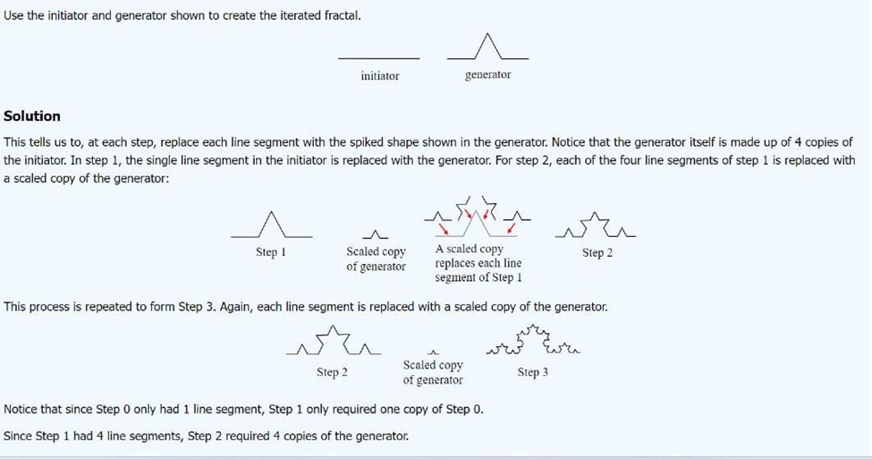

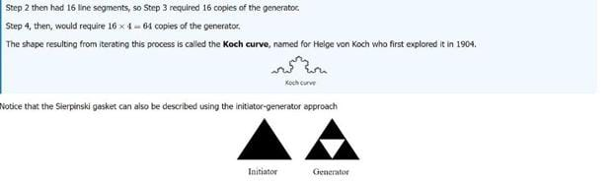

Origin Of Fractals

Benoit Mandelbrot is considered to be the father of fractal geometry. He has said that the first thing that made him start to even think about the idea of fractals was when he was trying to figure out how long the coast of Britain was. What he discovered was that if you look at a map and keep on zooming in on it, repeated patterns will appear. [Hoffman 2010]. The idea that he used to get the most accurate measure of the coastline of Britain was determined by what length of ruler he would use. He showed that smaller rulers are more accurate because they ca fit better into the irregular patterns of the coast, rather than using one large ruler. He concluded that as the scale of measurement he used decreased in size, the actual length of the coastline increased [Laubender 1999]. This shows that we can zoom into the coastline an infinite number of times, using a smaller unit of measurement and keep getting a more accurate estimate. Mandelbrot always said to not think about what you see, but what it took to make what you see. “The key to fractal geometry…is that if you look on the surface, you see complexity and it looks very non-mathematical” [Jersey and Shwarz 2008]. His studies about the Britain coastline lead into one of the main ideas of fractals, known as self-similarity. “A set S is called self-similar if S can be subdivided into k congruent subsets, each of which can be magnified by a constant factor M to yield the whole set S” [Shapiro 2010]. By looking at the coastline of Britain from a far distance and then zooming up extremely close, the images would look similar. Self-similarity is one huge principal idea when classifying what a fractal is. Although Mandelbrot was the one to coin the term “fractal geometry” in 1975, there were many mathematicians before his time that noticed this property of self-similarity. A simple start to understanding the formation of fractals is to look at the Sierpinski Triangle. WacLaw Sierpinski was a polish mathematician whose most important work was in the fields of set theory, number theory, and point set topology [Riddle 2010]. What Sierpinski came up with was to first look at a large equilateral triangle. He then started to divide that large triangle into four smaller equilateral triangles. This action is repeated over and over again leaving the center triangle open each time [Lauwerier 1991]. Looking at this triangle and dividing it up an infinite number of times displays the idea of self- similarity, upon which fractals are based upon. By looking at the design of the Sierpinski triangle, it can be concluded that if the number of triangles is increased, the length and area of the triangles will decrease. If we let Nk denote how many triangles we have within the main triangle, Ls denote the length of the sides of each triangle, and as be the area of the triangle, we have the following equations:

Nk = 3k

Lk = = 2-k

Ak = (Lk)2 x Nk =

We have to understand that we can take one portion of this divided up triangle and it will look exactly like the whole triangle itself, and as the number of iterations tends to infinity, the area of each triangle tends to zero, however will never equal zero. The German mathematician, Greg Cantor, who was one of the founders of set theory, discovered the Cantor fractal. This fractal is similar to the Koch Curve. Similar to the Koch curve, we start out with one straight-line segment and divide it into three parts. Then remove the middle third, but keep the end points. So we started out with one line and two endpoints, and turned it into two lines and four endpoints. This process is to be repeated over and over, and the outcome after many times, would be points.

The iterative process is to be consistently applied, leading to the emergence of points over numerous iterations. The following table summarizes the relationship between the number of steps (n) the corresponding number of line segments (2^n), and the length of these line segments (1/3^-n)

We will call this number n. We also need to know the scale or how many times we have magnified into the entire fractal itself, which we will call M. We can then define the fractal dimension to be:

$$D=\frac{\log\left(n\right)}{\log\left(M\right)} \left[Shapiro 2010\right]$$

Using this equation, we can apply it to the fractal that was just discussed, the Koch curve. First, we can look at the dimension of the Koch curve after doing the process just one time.

Fractals and the fractal dimensions

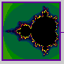

**Mandelbrot and Nature**

"Clouds are not spheres, mountains are not cones, coastlines are not circles, and bark is not smooth, nor does lightning travel in a straight line."(Mandelbrot, 1983).

The concepts of dimension

The Concept of Dimension

So far, we have used "dimension" in two senses:

• The three dimensions of Euclidean space (D=1,2,3)

• The number of variables in a dynamic system

Fractals, which are irregular geometric objects, require a third meaning:

**The Hausdorff Dimension**

If we take an object residing in Euclidean dimension D and reduce its linear size by $\frac{1}{r}$ in each spatial direction, its measure (length, area, or volume) would increase to N = r * D times the original. This is pictured in the next figure.

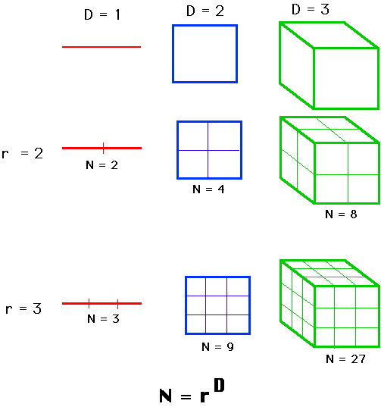

We consider N=r * D, take the log of both sides and get log(N) = D * log(r). If we solve for D. $$D=\frac{\log\left(N\right)}{\log\left(r\right)}$$ 
The point: examined this way, D need not be an integer, as it is in Euclidean geometry. It could be a fraction, as it is in fractal geometry. This generalized treatment of dimension is named after the German mathematician, Felix Hausdorff. It has proved useful for describing natural objects and for evaluating trajectories of dynamic systems.

Fractals in pascal’s triangle

Simple principles may generate fascinating patterns from arrays of numbers.

For instance, begin with the number 1 and position it at the tip of the resulting numerical triangle. Note down two 1s in the second row. Put 1s at the ends of each line after adding the neighboring numbers from the previous row and writing the sums in the new row for each line that follows.

What you receive for the first eight rows is as follows:

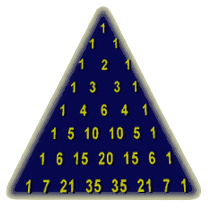

If the numbers are placed in cells and the cells are coloured in accordance with whether the number is 1 or 0, the pattern becomes more noticeable.

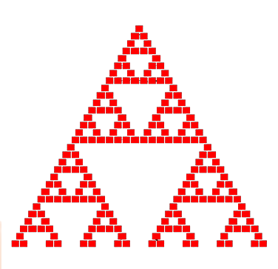

Similar, though more complicated designs appears if you replace each number of the triangle with the remainder after dividing that number by 3. Thus, you get:

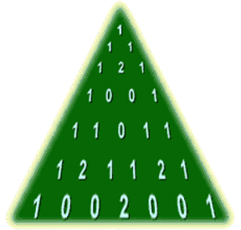

This time, to see the patterns of triangles imbedded in the array, you would need three distinct colors. Other prime integers can also be used as the divisor (or modulus), with the same notation of merely the remainders in each slot.

CONCLUSION

In conclusion, studying fractals has been likened as deciphering an engrossing tale of forms that perpetually recur in both nature and art. We started out by giving an overview of the intriguing field of fractals and highlighting how they may be found in many different facets of our environment. The abstract, or summary, captures the essence of our investigation, emphasizing the key ideas of dimensions, iterations, and the unexpected relationship with Pascal's Triangle. We discovered that fractal dimension provides a novel approach to quantify complexity by challenging conventional notions of size and form. The concept of iterations demonstrated to us how, as in the Mandelbrot Set and in natural landscapes, the repetition of basic laws may result in extraordinarily complex patterns. Finally, the surprising discovery of fractal-like patterns in Pascal's Triangle illustrated how versatile fractals are in several mathematical domains. Essentially, the study of fractals discovers deep mathematical concepts that are woven throughout the rich fabric of mathematical investigation, in addition to captivating our eyes with captivating graphics.