**Assignment-1**

**Connect and disconnect with login Access**

**· What happens when you login a non-existent user or username?**

**o Provide Screenshot and What you understand, explain in short brief?**

**Answer -**

i . When a user login it creates a unique identity in the system. The login name is looked up in a file called /etc/passwd. After successful login, the user gets all the privileges associated with that individual account. A user can be the part of multiple groups

Ii. When you try to switch a user which is not available in the system terminal shows the user does not exist. Also when trying to change the password using command passwd it returns that the user does not exist. Make sure to use the correct username of the person you intend to change the password for.

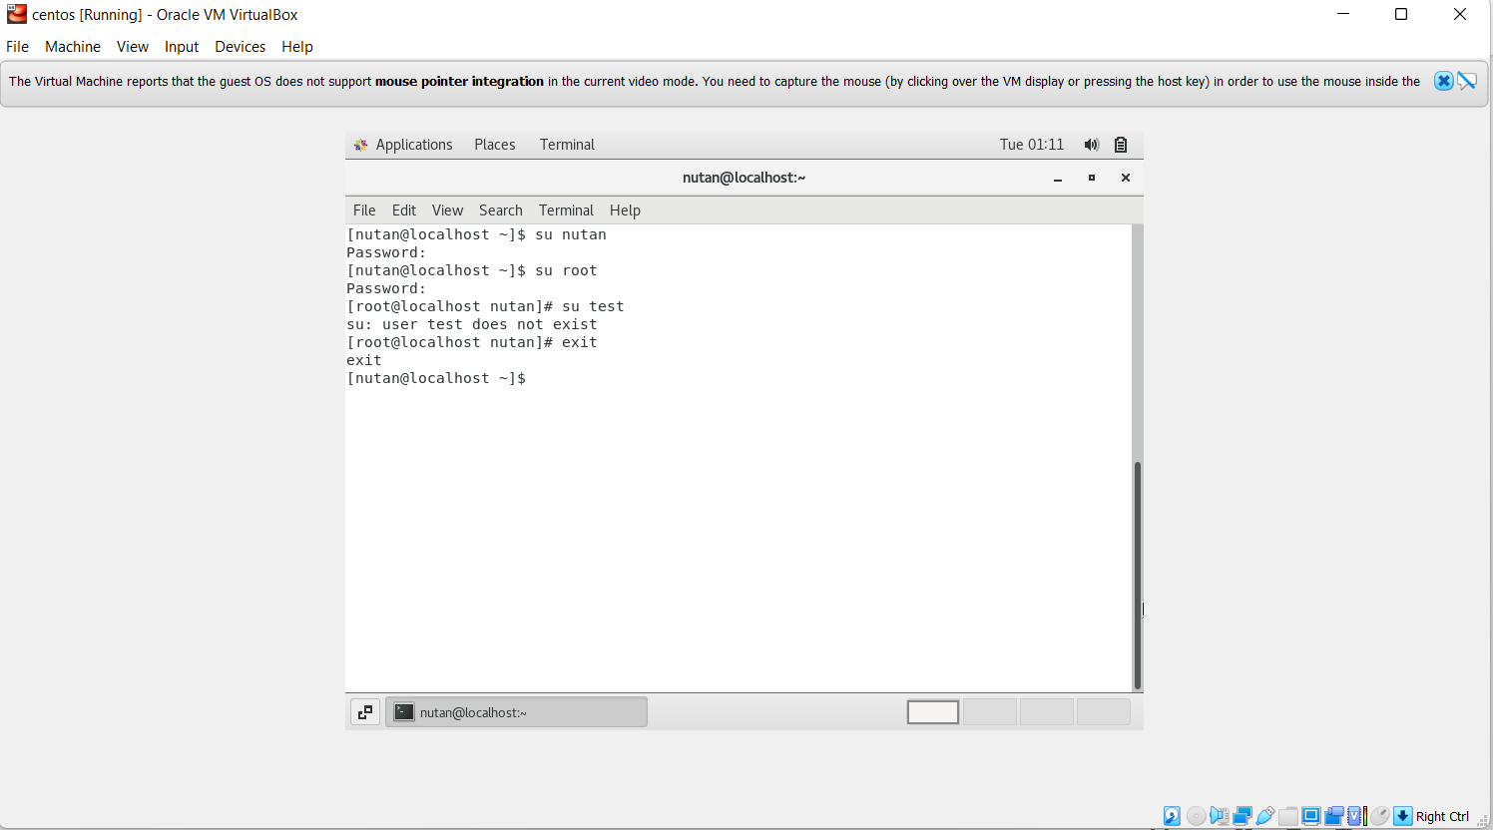

__________________________________________________________________________

**Assignment-2**

**Password changing**

**· Login into your account and then change password?**

**o Change your password into IneuR0n#42 and hit the Enter key**

**§ Explain what happen and give screenshot?**

**o Try again to change password but use like password 1234 or abcd**

**§ Explain what happen and give screenshot?**

**o Try again to change password but now don’t use any password just hit Enter key**

**§ Explain what happen and give screenshot?**

**Answer -**

i. A normal user can change the password for his own account by simply entering the password command on their terminal as below. When you type a password, nothing is displayed on the screen, which is the expected behavior in Linux/UNIX.

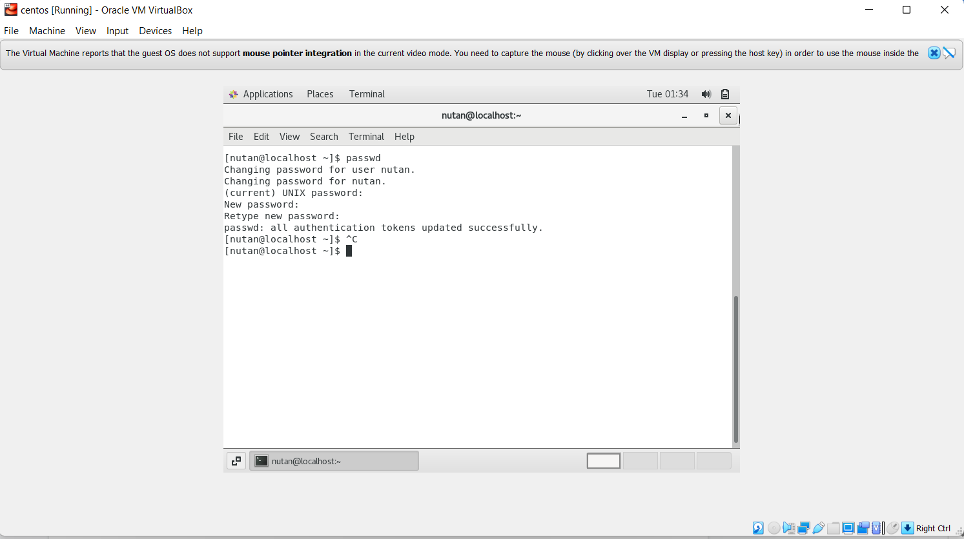

ii. BAD PASSWORD: The password is shorter than 8 characters

For CentOS 7, the /etc/security/pwquality.conf or /etc/pam.d/system-auth configuration file is used.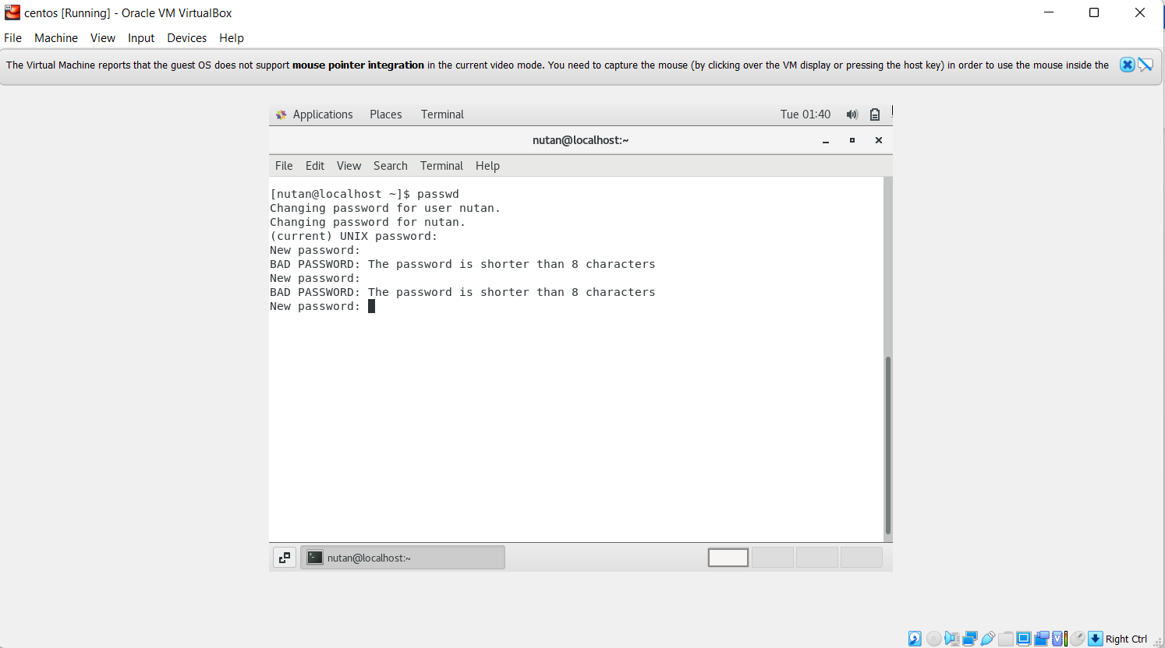

Iii. BAD PASSWORD: No password supplied

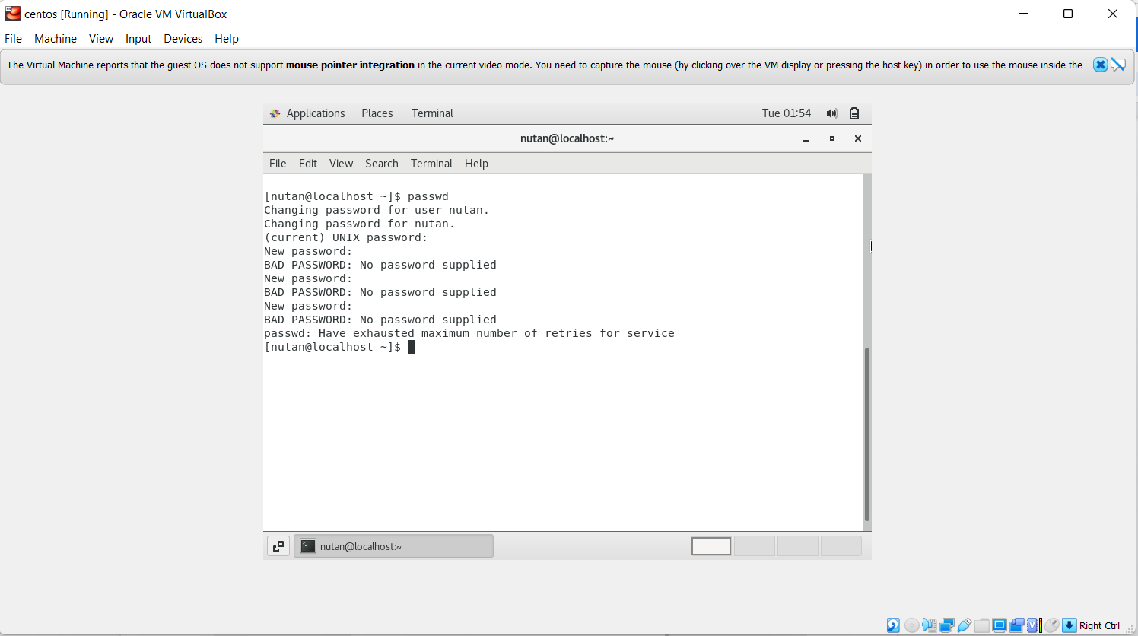

**Assignment-3**

**Working with Directories**

**· Enter the command cd / and then ls and then hit Enter key**

**o Take screenshot and explain what output we got?**

**· Enter the command now cd /home and then hit Enter key**

**o Do ls, provide screenshot and explain what is /home directory used for?**

**· Enter cd .. and hit Enter key [ Note: here we have space after cd then use double dot]**

**o Check what happened and give a screenshot?**

**· Now enter cd /var/www/html and then type cd and hit Enter key**

**o Explain what happen and give screenshot?**

**· Now type cd /root and then hit Enter key**

**o Do ls, check any output we have on screen if yes then take a screenshot?**

**Answer -**

i. To change the present directory to root directory we use slash symbol (/) to the cd command to move into systems working directory. And we use ls command to list the content(files and repositories) from that directory.

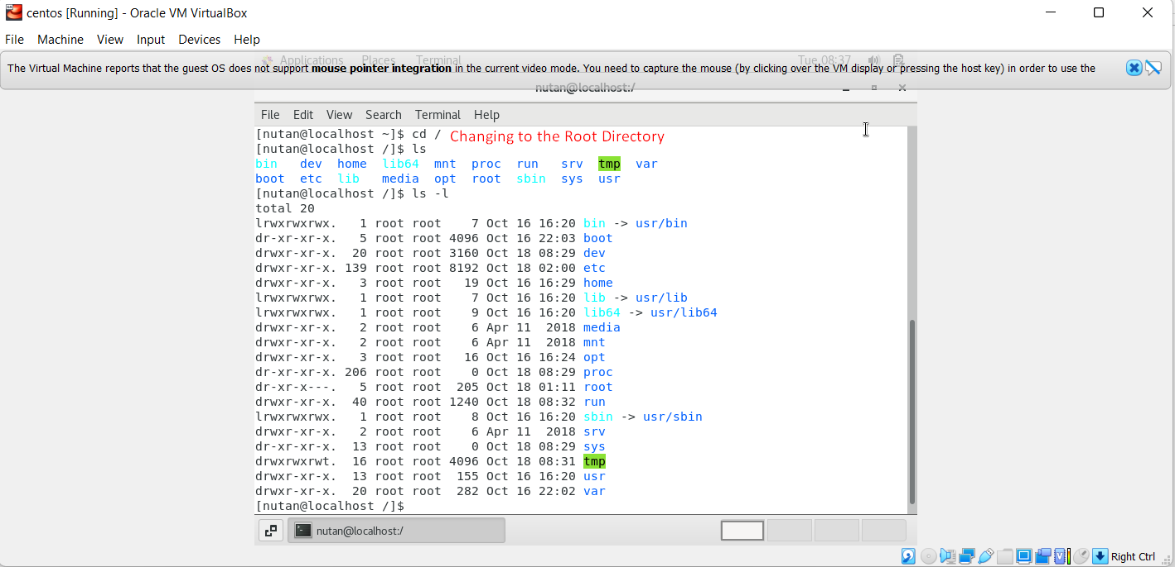

ii. To change the present directory to home directory we use slash symbol (/) to the cd command with the directory name to move into home directory. And we use ls command to list the content(files and repositories) from that directory.

/home directory - This is the first place that occurs after logging into a system. It is automatically created as /home for each user in the directory. It is a directory for a particular user of the system and consists of individual files. It is also referred to as the login directory.

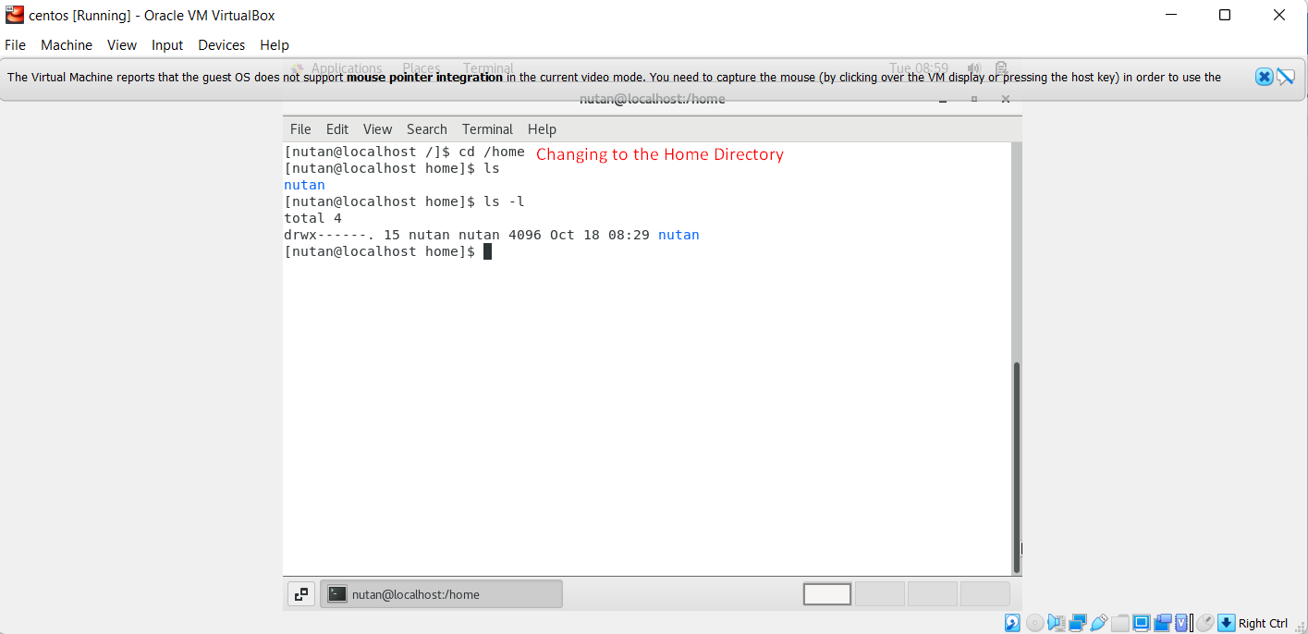

iii. cd .. command is used for making the directory one level up from the current directory.

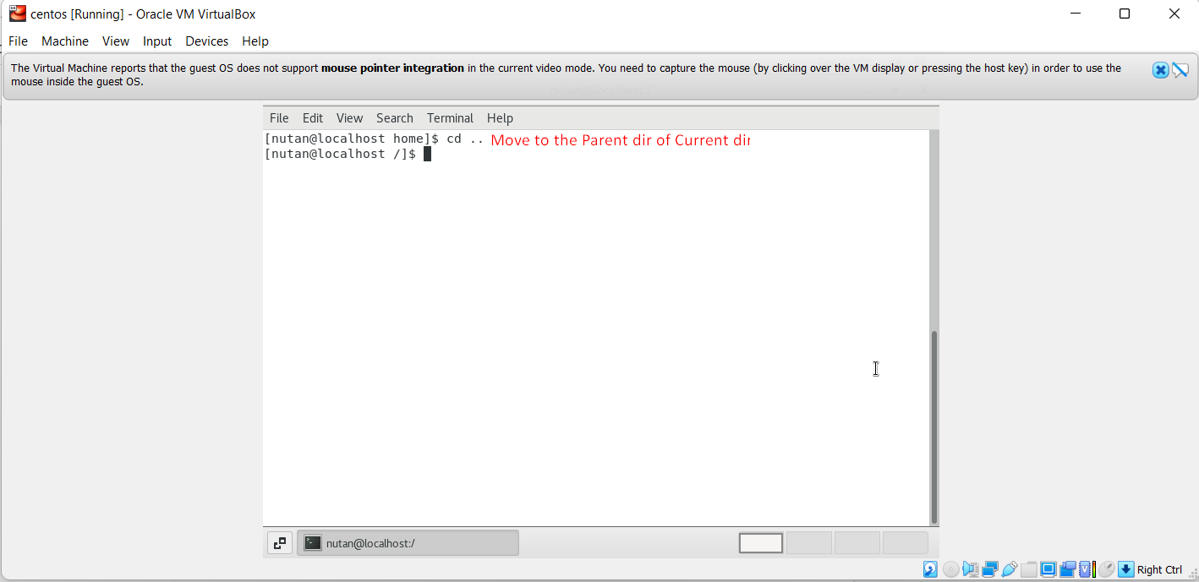

iv. The path /var/www/html is created when you install Apache HTTP server.

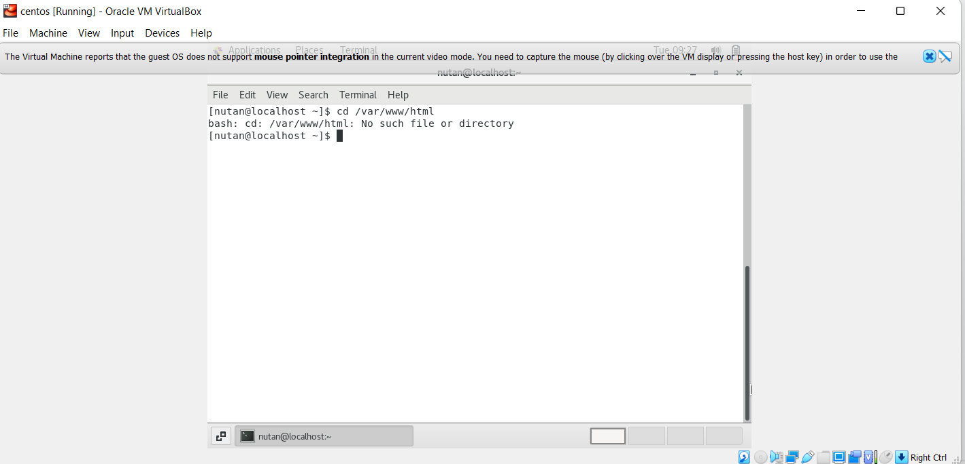

v. permission denied error occurs when the user does not have the privileges to make edits to a file. Only root or users with sudo privileges can change permissions for files and repositories. In this scenario we got an error because the user is not the owner of /root folder. Hence cannot change the permission of the folder other than the root user. We need to switch to a root account to run the respective commands.

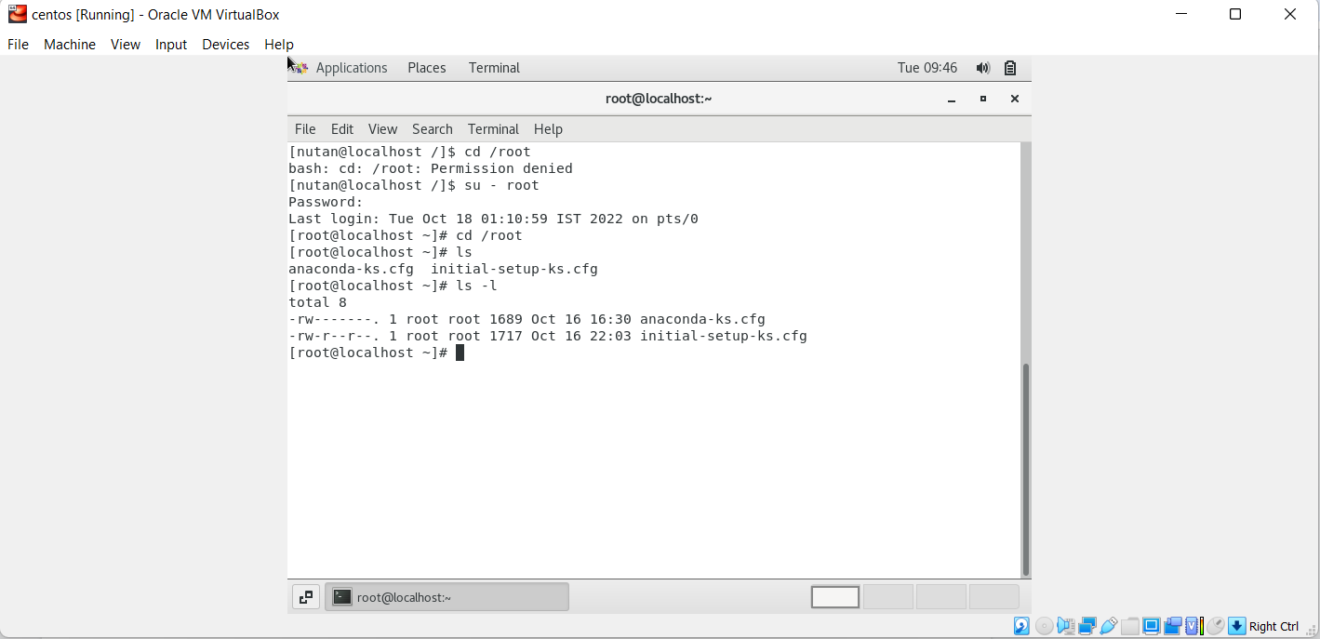

**Assignment-4**

**Working with File Listing**

**· Go to cd /etc and type ls**

**o Take screenshot and explain what files you have seeing?**

**o Take screenshot and explain what different output you found compare to previous command you used?**

**· Then type ls -al and hit Enter key**

**o Take screenshot and explain what new file or directory you found?**

**· Then use ls -i and hit Enter key**

**o Now see what different output its shows and take screenshot?**

**· Then use ls –help and see other options about ls command**

**o Explore it and try with other attribute we can use with ls command**

**Answer -**

i. The /etc refers to a folder in the root called etc. The /etc directory contains system configuration information. It contains a "configuration file" which is a local file used to control the operation of a program; it must be static and cannot be an executable binary. Many networking configuration files are in /etc as well.

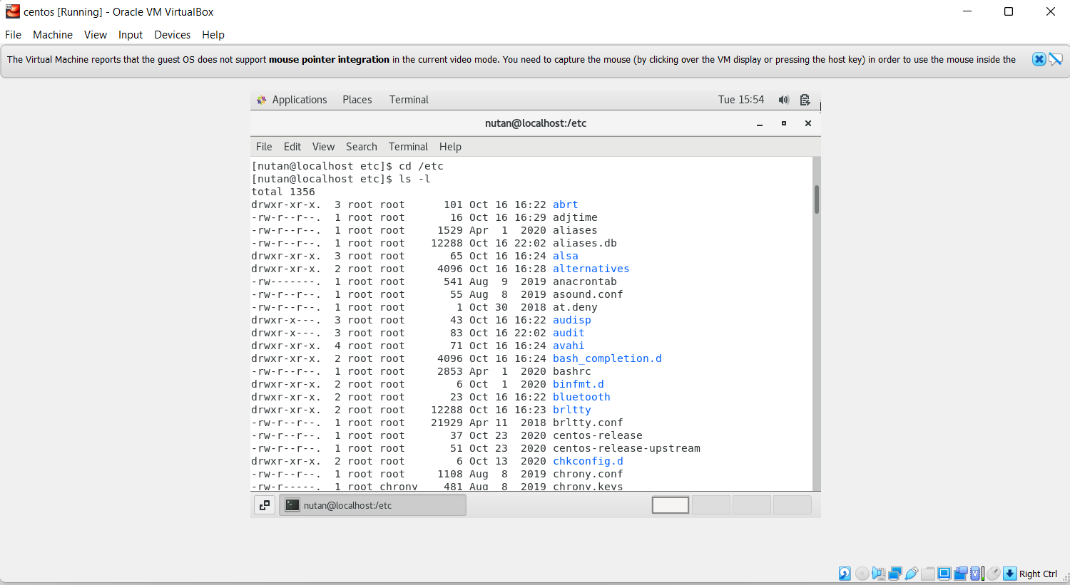

ii. List all files including hidden files starting with a dot (.) A hidden file is a file which has the hidden attribute turned on so that it is not visible to users when exploring or listing files. Hidden files are used for storage of user preferences or for preservation of the state of utilities.

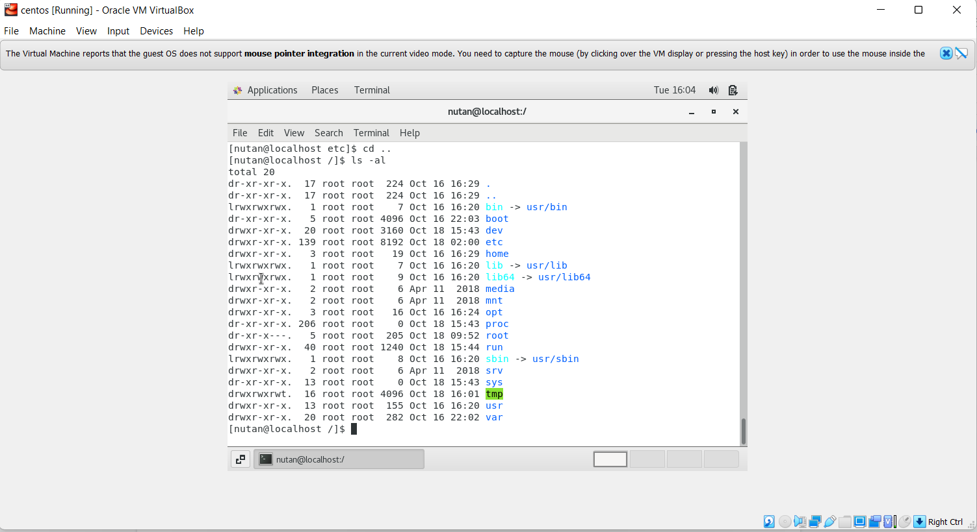

iii. Display Inode number of File or Directory. An inode is a data structure in UNIX operating systems that contains important information pertaining to files within a file system. When a file system is created in UNIX, a set amount of inodes is created, as well.

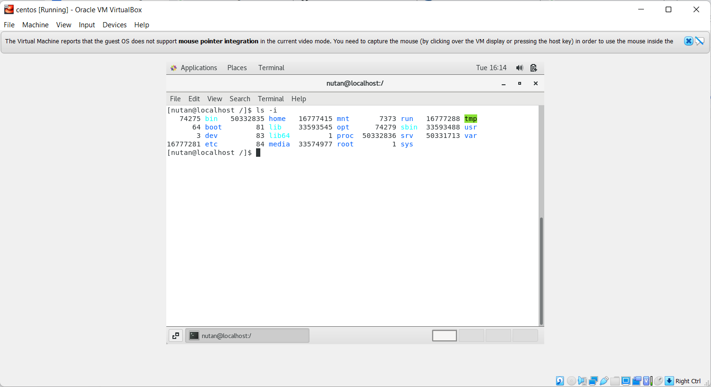

iv. The help command is the simplest way to get information regarding a built-in shell command.

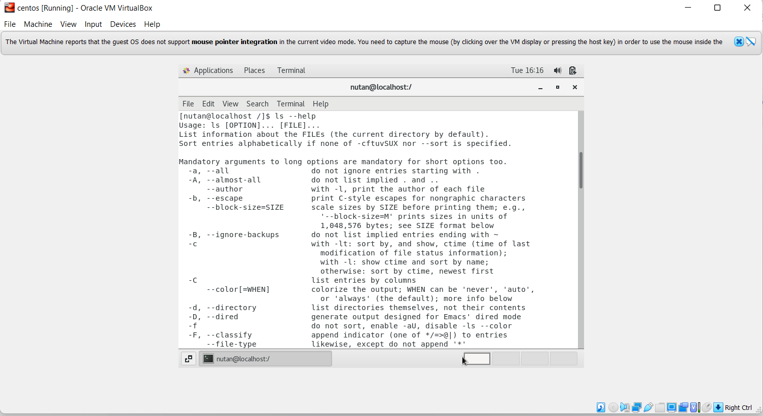

**Assignment-5**

**Know where you are and where you working**

**Here we use pwd, cd and ls as a combined task to understand where you are working on the terminal and how you can switch from one directory to another one.**

**· Open terminal after restart the linux**

**o Check which location you working, type pwd and take screenshot**

**· Now use cd /var and hit Enter key**

**o Do ls, and see what output comes, give screenshot?**

**· Do explore other help options of each command to learn more other things we can do with these commands**

**Answer -**

i. pwd stands for Print Working Directory. It prints the path of the working directory, starting from the root. All directories are separated by a slash (/).

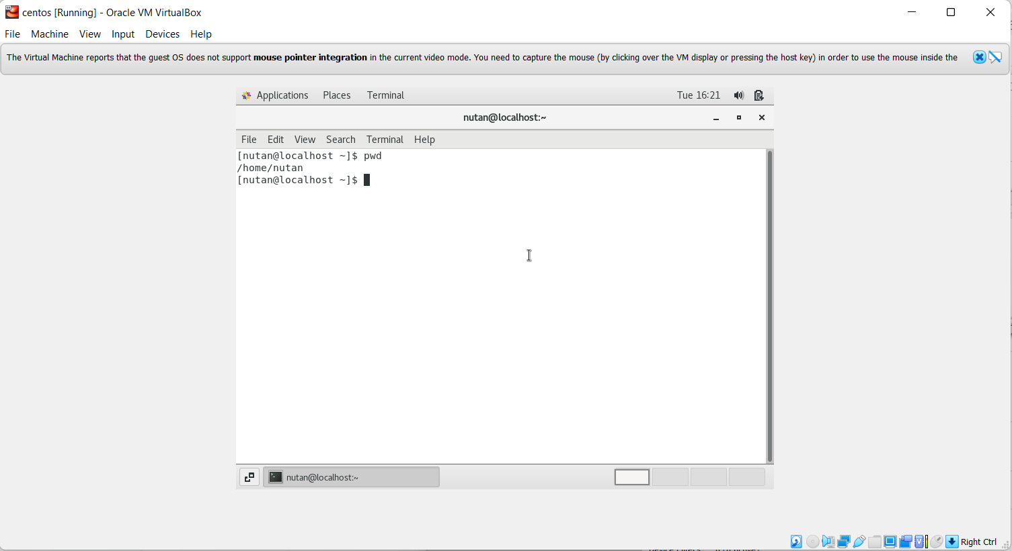

ii. /var is a standard subdirectory of the root directory. /var contains variable data files. This includes spool directories and files, administrative and logging data, and transient and temporary files. Some portions of /var are not shareable between different systems. For instance, /var/log , /var/lock , and /var/run .

