Task 4 — Deployment Screenshots & Working Steps
Automated Deployment of Dockerized Application on Cloud VM with Nginx Reverse Proxy
Nutan Meena | Maincrafts Technology Internship | June 10, 2026

Step 1: Writing Nginx Reverse Proxy Configuration
After SSHing into the EC2 VM, the Nginx reverse proxy configuration file was created at /etc/nginx/sites-available/docker-app using the nano text editor. The configuration tells Nginx to listen on port 80 (public HTTP port) and forward all incoming traffic to the Docker container running internally on port 8080. The proxy_set_header directives pass the original host and client IP to the container.
Screenshot 1 — Nginx config file open in nano editor
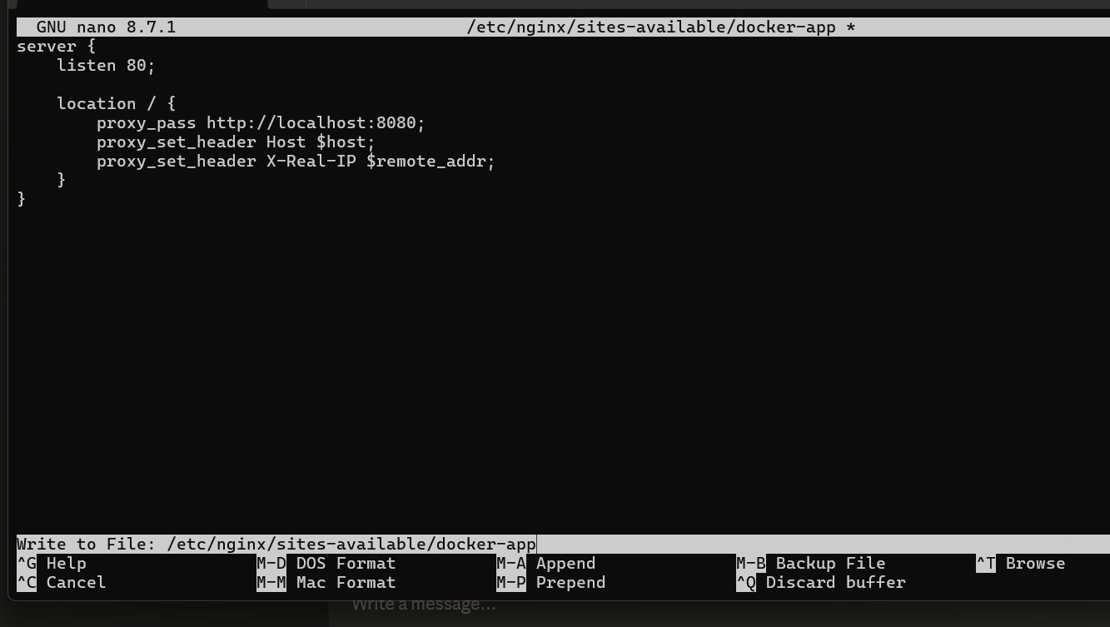
Command used: sudo nano /etc/nginx/sites-available/docker-app

Step 2: Error — Nginx Directory Did Not Exist
When attempting to save the config file, nano threw an error: "No such file or directory". This happened because the /etc/nginx/sites-available/ directory was missing, indicating Nginx was not properly installed. The fix was to create the directories manually and reinstall Nginx using sudo apt install nginx -y.
Screenshot 2 — Nano error: directory not found
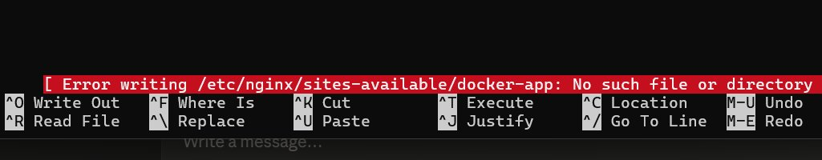
Fix applied: sudo mkdir -p /etc/nginx/sites-available && sudo apt install nginx -y

Step 3: Nginx Successfully Installed — Default Page Visible
After reinstalling Nginx, the default page was visible at the VM public IP, confirming Nginx was correctly installed and running on port 80. The default site needed to be removed and the docker-app reverse proxy config needed to be enabled.
Screenshot 3 — Default Nginx welcome page at http://13.201.32.196
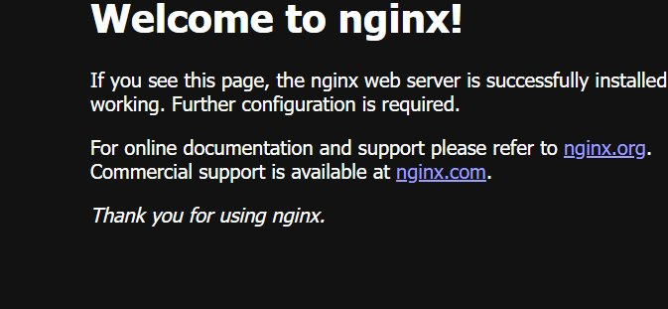
Next step: remove default site and enable docker-app config

Step 4: 403 Forbidden After Enabling Reverse Proxy
After removing the default Nginx site and reloading Nginx, a 403 Forbidden error appeared. This was coming from inside the Docker container itself — the container nginx could not find an index.html file because the HTML file had a typo in its name (insdex.html instead of index.html).
Screenshot 4 — 403 Forbidden error from container nginx
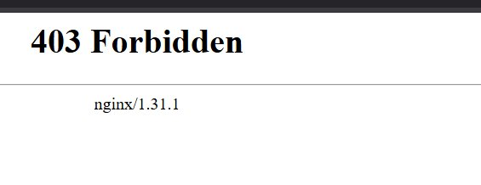
Fix applied: docker exec app mv /usr/share/nginx/html/insdex.html /usr/share/nginx/html/index.html

Step 5: Portfolio Website Live via Nginx Reverse Proxy
After renaming the HTML file inside the container, the portfolio website loaded successfully at http://13.201.32.196. The complete reverse proxy chain was now working: Public Internet → Nginx on port 80 → Docker container on port 8080 → Portfolio website. This is the industry-standard production deployment architecture.
Screenshot 5 — Portfolio website live at http://13.201.32.196
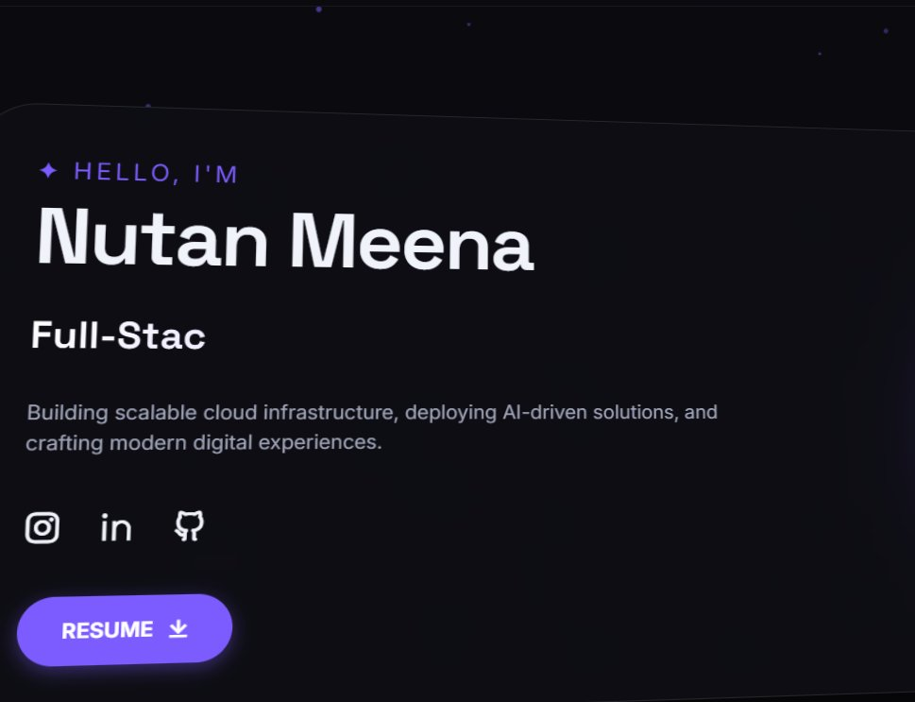
Live URL: http://13.201.32.196 | Architecture: Nginx (port 80) → Docker container (port 8080)

Step 6: Generating SSH Key Pair for CI/CD Authentication
On the local Windows machine, an RSA 4096-bit SSH key pair was generated using ssh-keygen. This key pair is required for GitHub Actions to securely SSH into the EC2 VM during automated deployment. No passphrase was set so that GitHub Actions can use the key without user interaction. The public key was then copied to the VM authorized_keys file.
Screenshot 6 — SSH key generation on local Windows machine
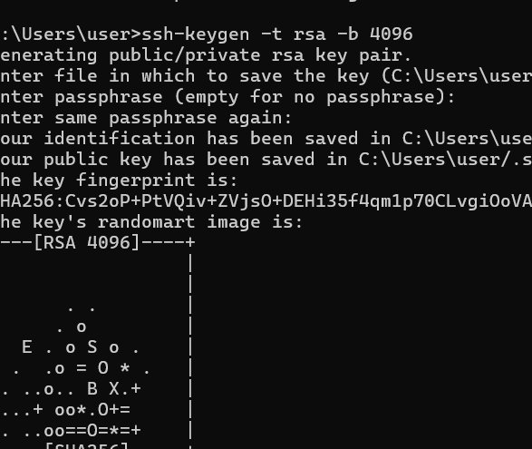
Command: ssh-keygen -t rsa -b 4096 | Private key: C:\Users\user\.ssh\id_rsa | Public key: id_rsa.pub

Step 7: Project Directory Structure and SSH Key Copy to VM
The task2 project directory was verified to contain all required files: Dockerfile, HTML source, nginx.conf, img folder, and the .github folder with the CI/CD workflow. The public SSH key was then copied to the VM using the EC2 pem key for initial authentication, adding it to the VM authorized_keys file for future passwordless access.
Screenshot 7 — Task2 directory listing and SSH key copy command
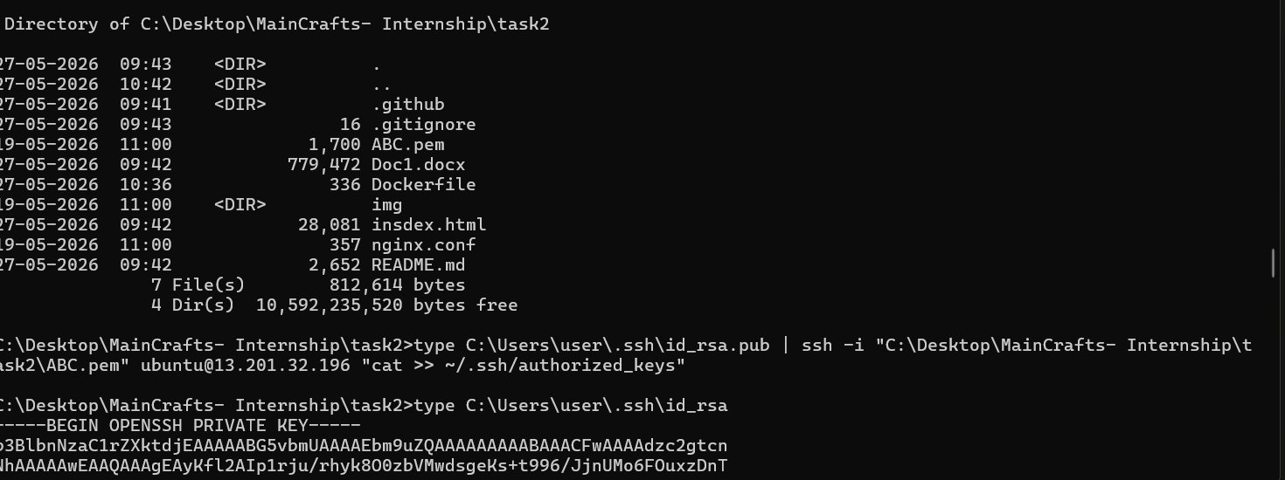
Key copy command: type id_rsa.pub | ssh -i ABC.pem ubuntu@13.201.32.196 "cat >> ~/.ssh/authorized_keys"

Step 8: GitHub Workflows Directory Confirmed
The .github/workflows directory was confirmed to contain the docker-ci.yml workflow file. This file defines the entire CI/CD pipeline and was updated to add the CD deployment job. The workflow file is 642 bytes and triggers on every push to the main branch.
Screenshot 8 — GitHub workflows directory showing docker-ci.yml
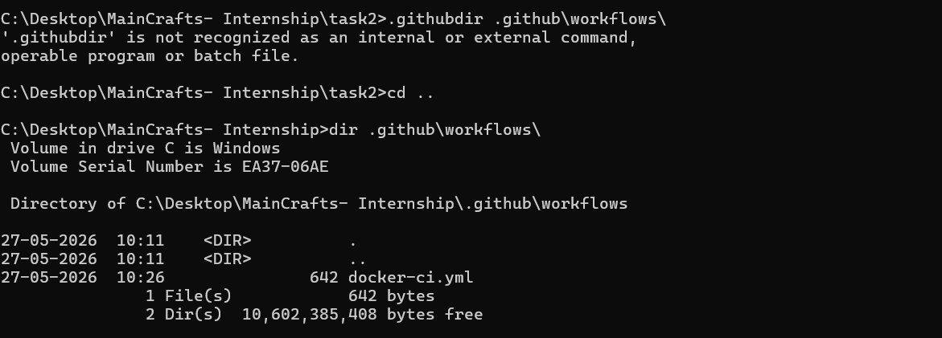
File: .github/workflows/docker-ci.yml | Trigger: on push to main branch

Step 9: GitHub Repository Secrets Added
Five secrets were added to the GitHub repository under Settings → Secrets and variables → Actions. These secrets are encrypted and securely injected into the workflow at runtime. They allow the pipeline to authenticate with Docker Hub and SSH into the EC2 VM without exposing any credentials in the code.
Screenshot 9 — GitHub Secrets: VM_HOST, VM_USER, VM_SSH_KEY, DOCKER_USERNAME, DOCKER_PASSWORD
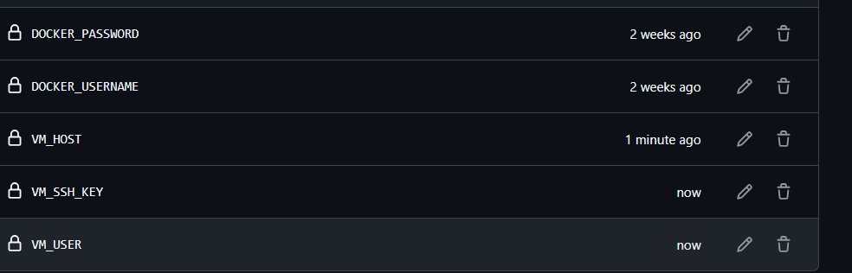
VM_HOST = 13.201.32.196 | VM_USER = ubuntu | VM_SSH_KEY = RSA private key content | Docker credentials for image push/pull

Step 10: Old Container Stopped, Nginx Started on Port 80
An old Docker container (competent_black) was occupying port 80, preventing Nginx from starting. It was stopped and removed using docker stop and docker rm commands. After confirming port 80 was free with sudo lsof -i :80, Nginx was started successfully and confirmed as active and running.
Screenshot 10 — docker stop competent_black, port 80 freed, Nginx starts successfully
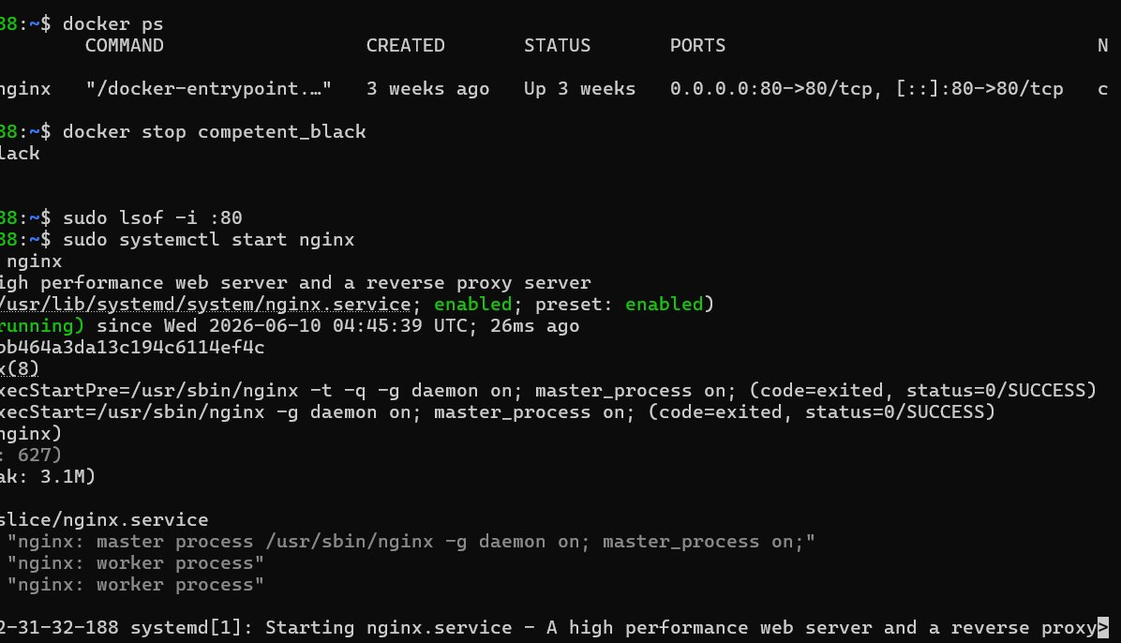
Commands: docker stop competent_black → docker rm competent_black → sudo lsof -i :80 (empty) → sudo systemctl start nginx

Step 11: Nginx Reverse Proxy Config Active, Container on Port 8080
The Nginx reverse proxy configuration was confirmed active in sites-enabled, showing the correct proxy_pass to localhost:8080. The new Docker container named "app" was running on port 8080. A curl test was run to verify the connection, which initially returned 403 due to the missing index.html inside the container.
Screenshot 11 — Nginx config verified active, app container running on 8080
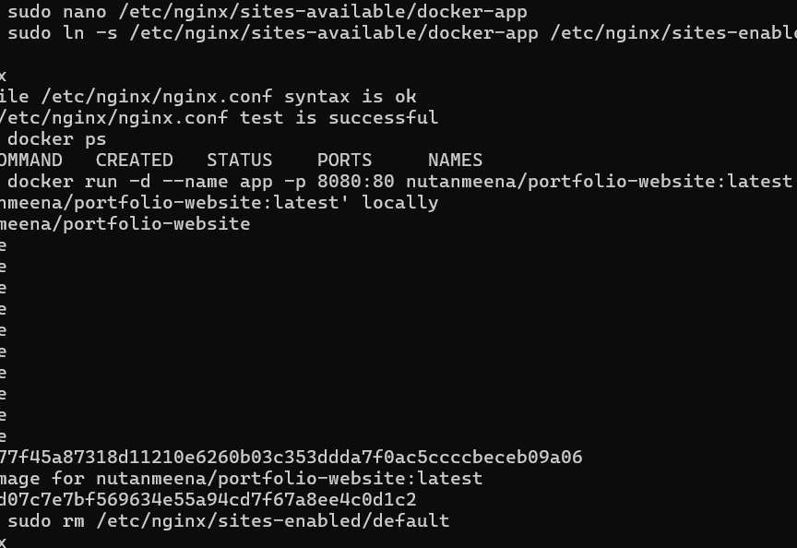
Container: nutanmeena/portfolio-website:latest on 0.0.0.0:8080→80/tcp | Name: app

Step 12: Debugging 403 — Missing index.html Inside Container
Running docker logs app revealed the root cause of the 403 error: the container nginx could not find index.html in /usr/share/nginx/html/. Running docker exec app ls confirmed the file was named insdex.html (with a typo). Renaming the file with docker exec fixed the issue and the website loaded successfully.
Screenshot 12 — docker logs showing 403 from missing index.html inside container
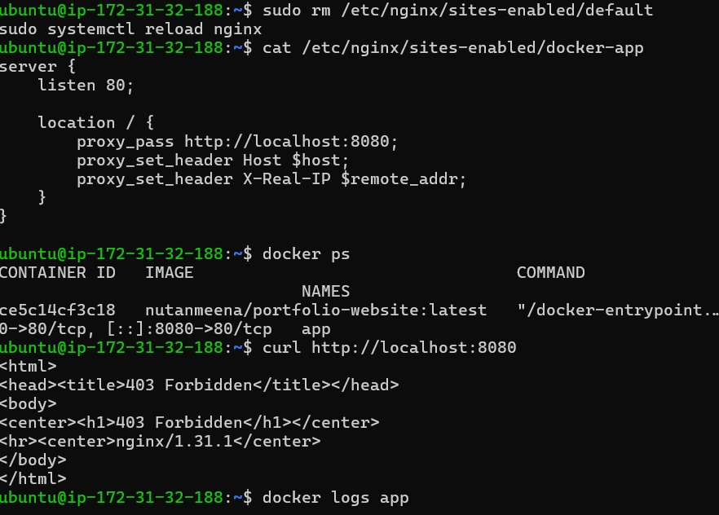
Root cause: insdex.html (typo) instead of index.html | Fix: docker exec app mv insdex.html index.html

Step 13: Git Commit and Push to Trigger CD Pipeline
After updating the GitHub Actions workflow file to include the deploy job, all changes were committed and pushed to the main branch. This push automatically triggered the CI/CD pipeline. The ABC.pem private key was also removed from the repository for security — private keys should never be stored in git.
Screenshot 13 — git commit and push triggering the automated pipeline
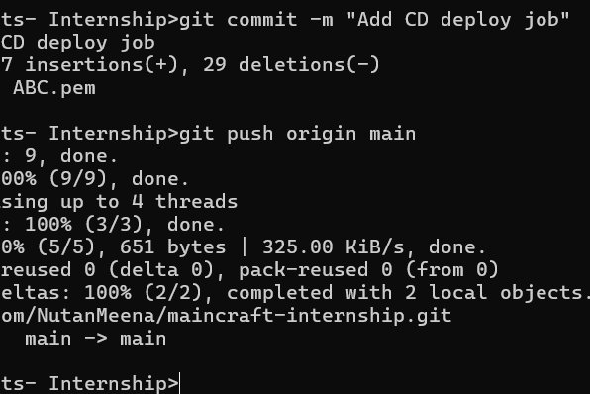
Commit message: "Add CD deploy job" | ABC.pem removed from repo for security | Push to: main branch

Step 14: GitHub Actions — Pipeline Run #8 Succeeded
The GitHub Actions pipeline was triggered by the push and completed successfully. The pipeline is identified as Docker CI Pipeline #8, triggered by commit f16b532 pushed by NutanMeena. The green checkmark confirms the entire workflow — both build and deploy — completed without any errors.
Screenshot 14 — GitHub Actions Pipeline #8 showing overall success
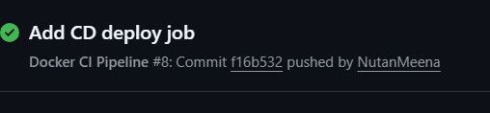
Pipeline: Docker CI Pipeline #8 | Commit: f16b532 | Triggered by: NutanMeena pushing to main

Step 15: Both CI and CD Jobs Completed with Green Checkmarks
The pipeline graph shows both jobs completing sequentially. The docker-build job (13 seconds) ran first — checking out code, logging into Docker Hub, building the Docker image, and pushing it. The deploy job (16 seconds) ran after — SSHing into the EC2 VM, pulling the latest image, stopping the old container, and starting the new one. This is the complete automated DevOps loop.
Screenshot 15 — docker-build (13s) and deploy (16s) both succeeded
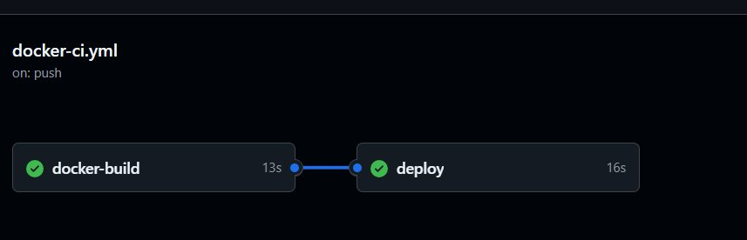
docker-build (13s): build + push to Docker Hub | deploy (16s): SSH → pull → stop → run new container

Step 16: CI/CD Pipeline Flow — Final Confirmation
The final pipeline view confirms both jobs passed. From this point forward, every git push to the main branch will automatically trigger the full pipeline: build the Docker image, push it to Docker Hub, SSH into the EC2 VM, and deploy the latest container — all without any manual steps. This completes the end-to-end DevOps automation loop.
Screenshot 16 — Final pipeline view: docker-build → deploy both green
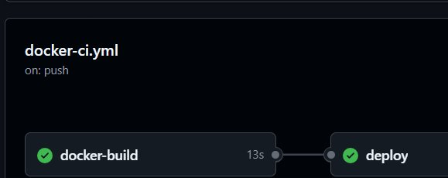
Workflow: on every push to main → CI builds image → CD deploys to VM → site live at http://13.201.32.196

Task 4 Summary
This task successfully implemented a complete end-to-end automated DevOps deployment pipeline:
- EC2 VM prepared with Docker and Nginx installed and configured
- Nginx configured as reverse proxy: port 80 forwards to Docker container port 8080
- RSA 4096-bit SSH key pair generated and public key added to VM
- Five GitHub Secrets added for secure credential management
- GitHub Actions workflow updated with deploy job using appleboy/ssh-action
- Pipeline triggered on push — both docker-build (13s) and deploy (16s) passed
- Portfolio website live at http://13.201.32.196 served via Nginx reverse proxy
Task 4 Complete

