REPORT

1.In your notebook, describe which one was easier to train for this problem.

Tanh activation functions generally outperform sigmoid in XOR problem training because of their zero-centred outputs and larger gradients. These advantages allow for faster learning of XOR's non-linear patterns and reduce the impact of the vanishing gradient problem, resulting in more efficient and effective training results.

2.Trip Prediction

The code prepares data for predicting trip durations and trains a neural network model. It computes distances between locations using the Haversine formula and extracts useful time details like month and hour from pickup times. These features help understand when and where trips occur. By analysing both time and location data, the model gets travel patterns, which helps predict trip durations accurately.

The Statistics For all the model variants are:

[[1, 0.001, 64, 108646.61124342073, 66201982.45863798],

[1, 0.001, 128, 169210.14968200182, 66186919.021982156],

[1, 0.01, 64, 190314.3384143567, 66249453.413205616],

[1, 0.01, 128, 164054.54537145176, 66251250.48698573],

[2, 0.001, 64, 155939927.21322158, 66267540.34420649],

[2, 0.001, 128, 186186.17110115706, 66231308.82104677],

[2, 0.01, 64, 450809.70798930095, 66467423.667048976],

[2, 0.01, 128, 273466.62678158854, 66355127.50706374],

[3, 0.001, 64, 221755.98861288457, 66395819.61456017],

[3, 0.001, 128, 316225.07408962847, 66395933.47523317],

[3, 0.01, 64, 411875.0722503581, 66442413.59512292],

[3, 0.01, 128, 474738.3910036189, 66447595.81156326]]

Row with Minimum Validation Loss:

[learning_rate, batch_size, train_losses[-1], validation_losses[-1]

[1, 0.001, 128, 169210.14968200182, 66186919.021982156]

Graph of having minimum validation loss:

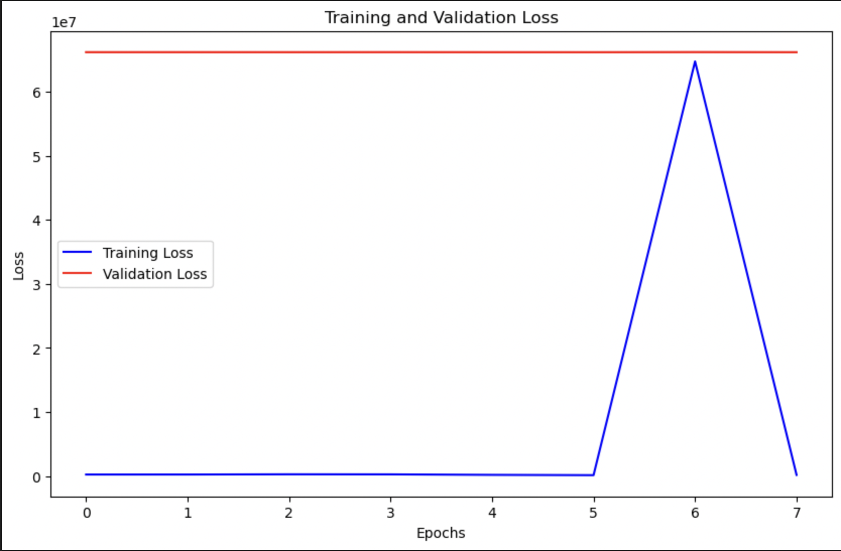

Loss Vs Learning Rate Graph

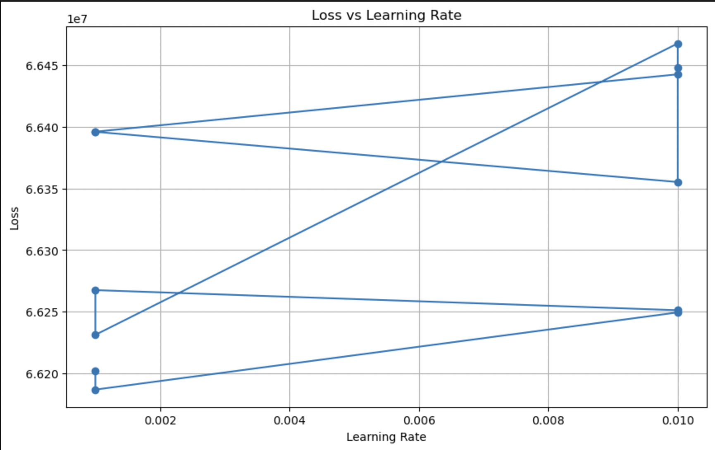

Test Accuracy:

Use mean squared error for calculating the test accuracy on test data

MSE: 10824939.194169391