## **1.6 Regression with a single output**

**1.Input : Petal length , Sepal width**

**target variable : Petal width**

Model Parameters:

{"weights": [[0.6673768464414255], [-0.027518116477821902]], "bias": [1.1298474793010151]}

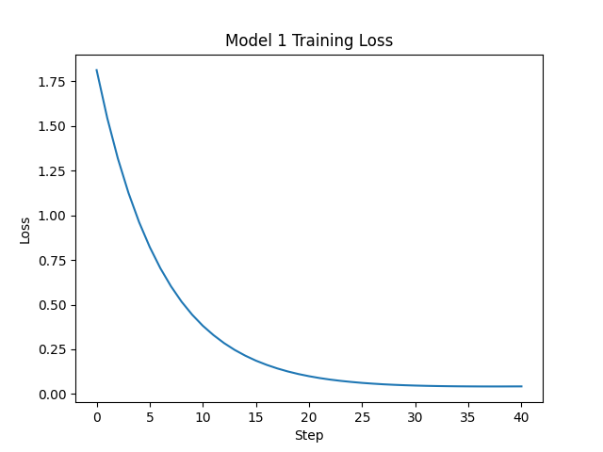

**Model 1 with regularization:**

{"weights": [[0.6689395771083055], [-0.025965246981741606]], "bias": [1.1348658735513237]}

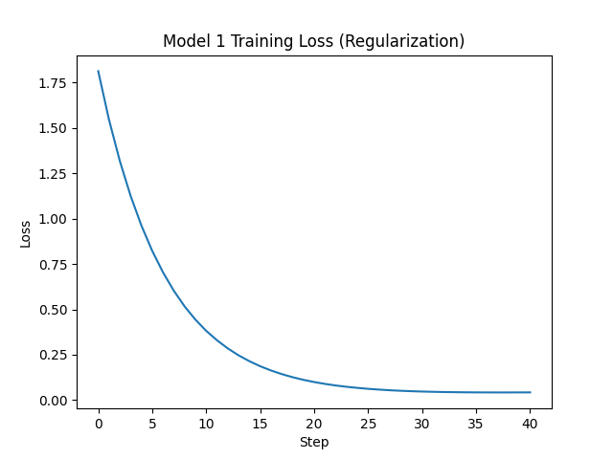

**2.Input : Petal Width , Petal Length**

**target variables : Sepal Length**

**{"weights": [[0.4389442409964833], [0.24543135982445083]], "bias": [5.834840009631595]}**

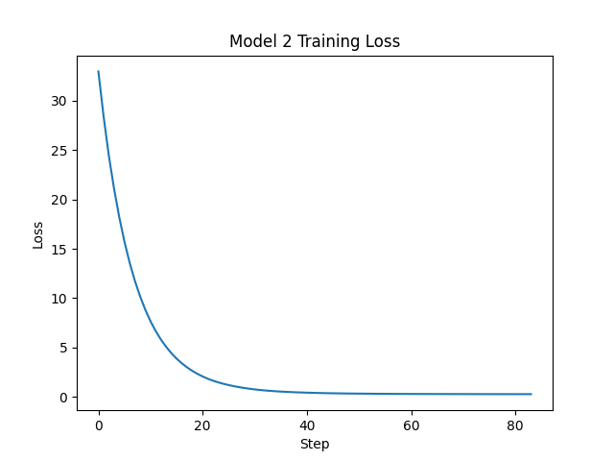

**3.Input features : Petal length ,sepal Length**

**target variables : Sepal width**

{"weights": [[-0.41881425603484623], [0.290685406642618]], "bias": [3.0388686028291936]}

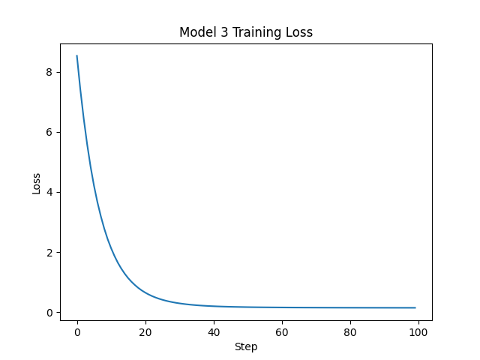

**4.Input Features : Sepal length , Sepal Width**

**target variables : Petal width**

{"weights": [[0.5773785998535894], [-0.1854374837748093]], "bias": [1.1350626869135758]}

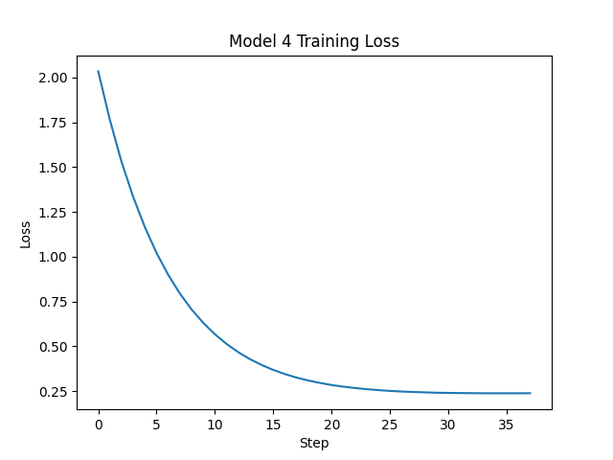

**1.6.4. In your report, briefly describe which input feature is most predictive of its corresponding output feature based on your experiments.**

Effectiveness in **modeling** is often measured through metrics like Mean Squared Error (MSE), where lower values indicate better predictive performance. A model with the lowest mean square error (MSE) typically has better predictive properties. In the context of the four experiments, when predicting petal width, the combination of petal length and sepal width resulted in the highest MSE, notably with model1 producing an MSE of 0.061515025402951014

**1.7 Regression with a Multiple output**

**In this section, you will create a single model that predicts the petal length and width given the sepal length and width.**

{"weights": [[1.4086159636646876, 0.6427893040467841], [-0.4975332129003244, -0.23511518229043094]], "bias": [2.5112038138715365, 2.5112038138715365]}

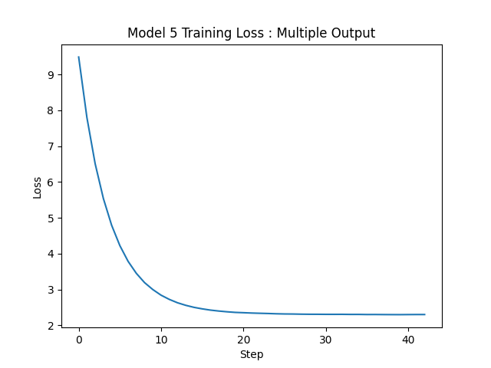

**2.Classification**

**Input:Petal Length and Width**

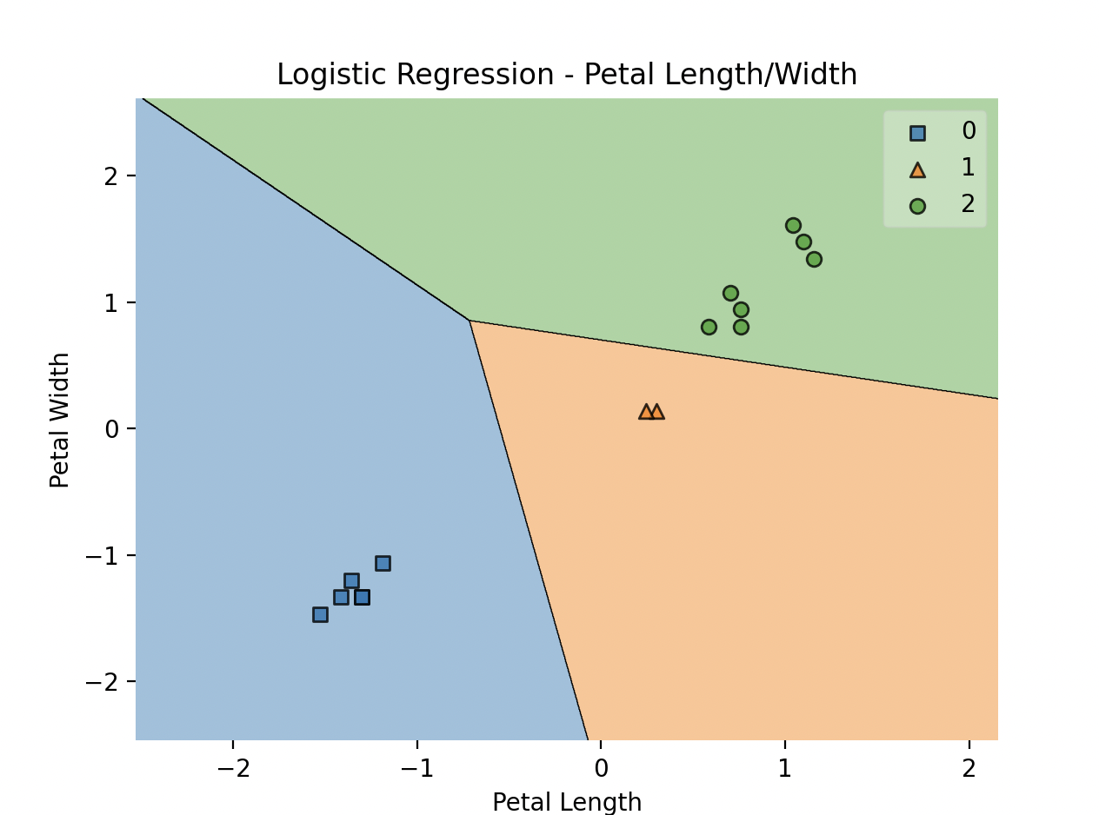

Accuracy:1.0

**Input:Sepal Length and Width**

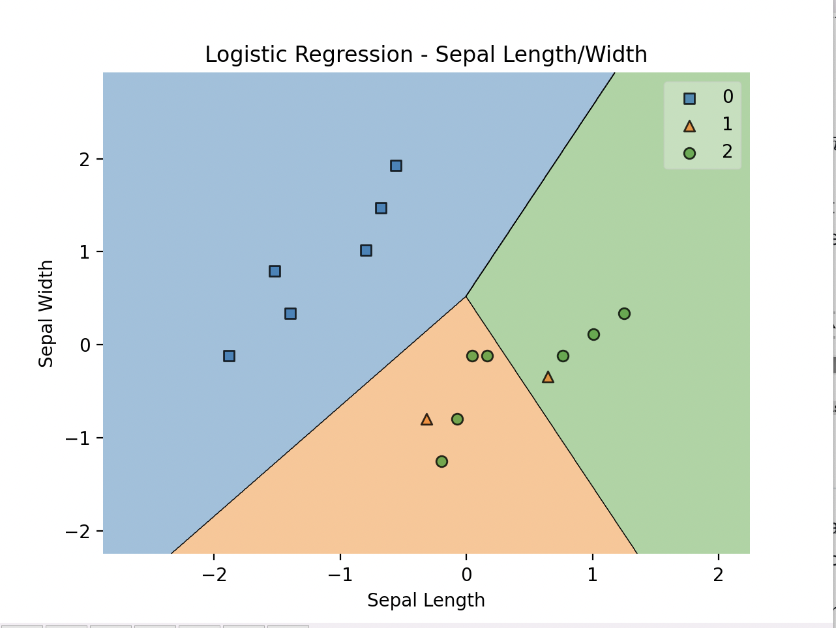

Accuracy:0.6666