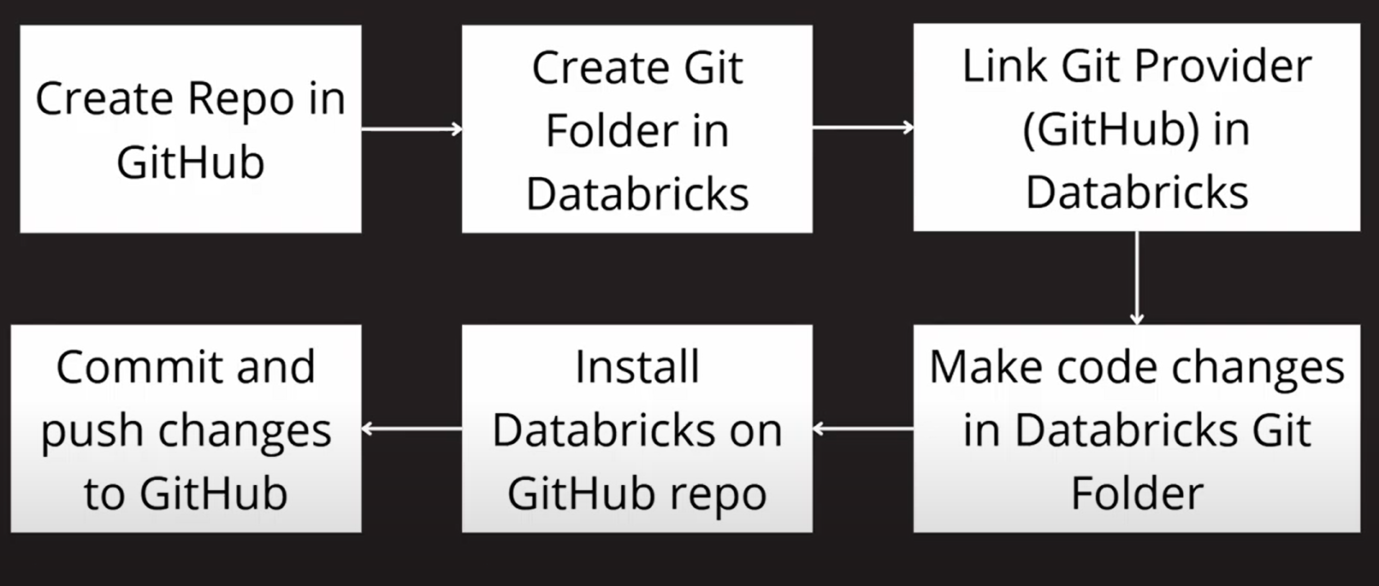

Step 1: Create a Github Environment within your Github repo.
Step 2: Create Git Folder in Databricks
Clone a repo connected to a remote Git repository​
- In the sidebar, select Workspace and then browser to the folder where you want to create the Git repo clone.
- Click the down arrow to the right of the Add in the upper right of the workspace, and select Git folder from the dropdown.
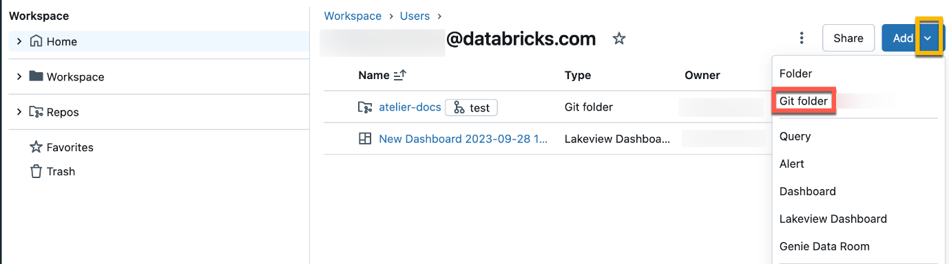
- In the Create Git folder dialog, provide the following information:
  - The URL of the Git repository you want to clone, in the format https://example.com/organization/project.git
  - The Git provider for the repository you want to clone. Options include GitHub, GitHub Enterprise, GitLab, and Azure DevOps (Azure Repos)
  - The name of the folder in your workspace that will contain the contents of the cloned repo
  - Whether or not you will use sparse checkout, in which only a subset of your repository’s directories are cloned, specified using a cone pattern. This is useful if your repository is larger than Databricks supported limits.
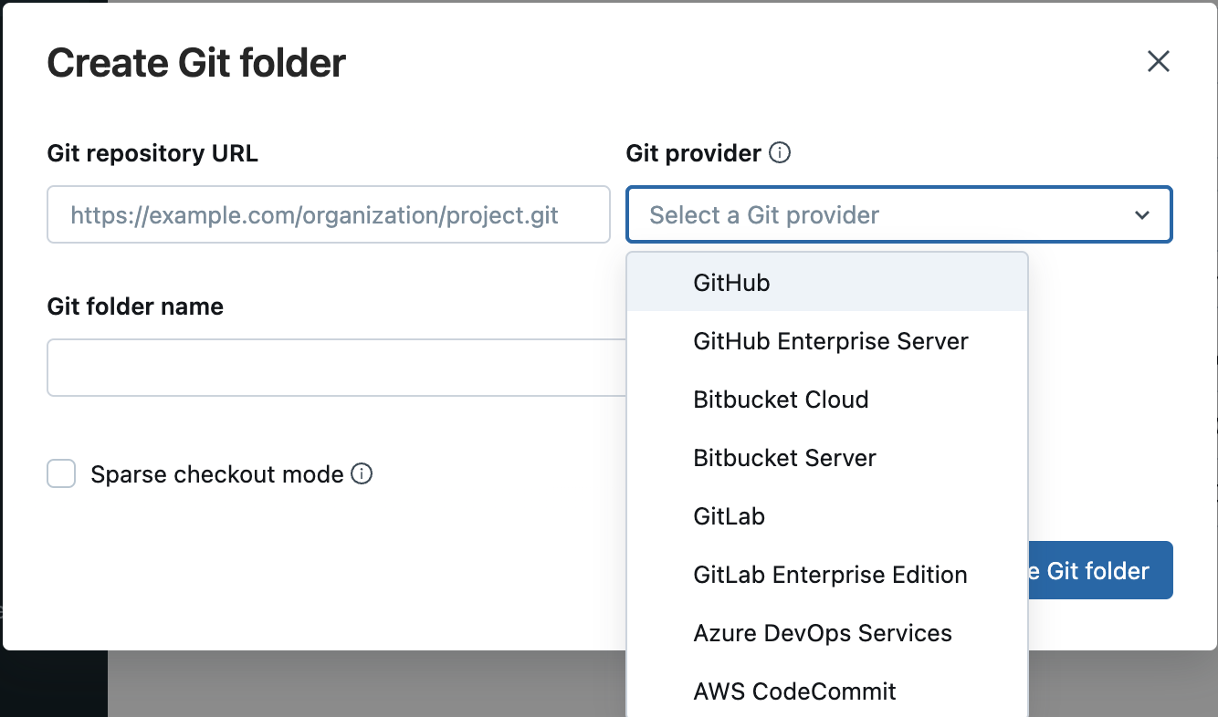
- Click Create Git folder. The contents of the remote repository are cloned to the Databricks repo, and you can begin working with them using supported Git operations through your workspace.
This is how repo created:
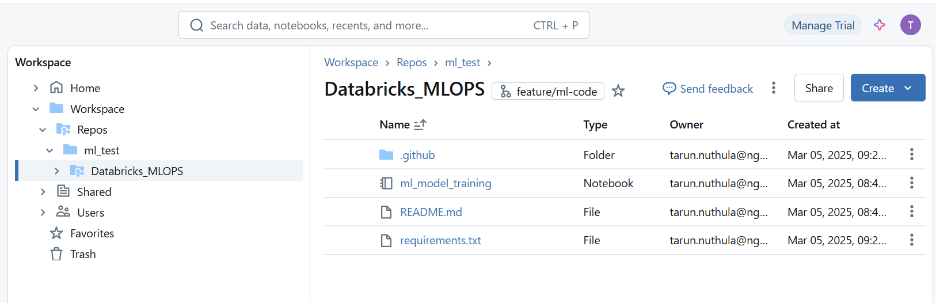
It has github actions file, model training script inside notebook.
Follow below link for databricks repo git operations :
https://docs.databricks.com/aws/en/repos/git-operations-with-repos

Generate a Databricks token as below.
Goto setting under profile, then click on developer and manage under access tokens to create.
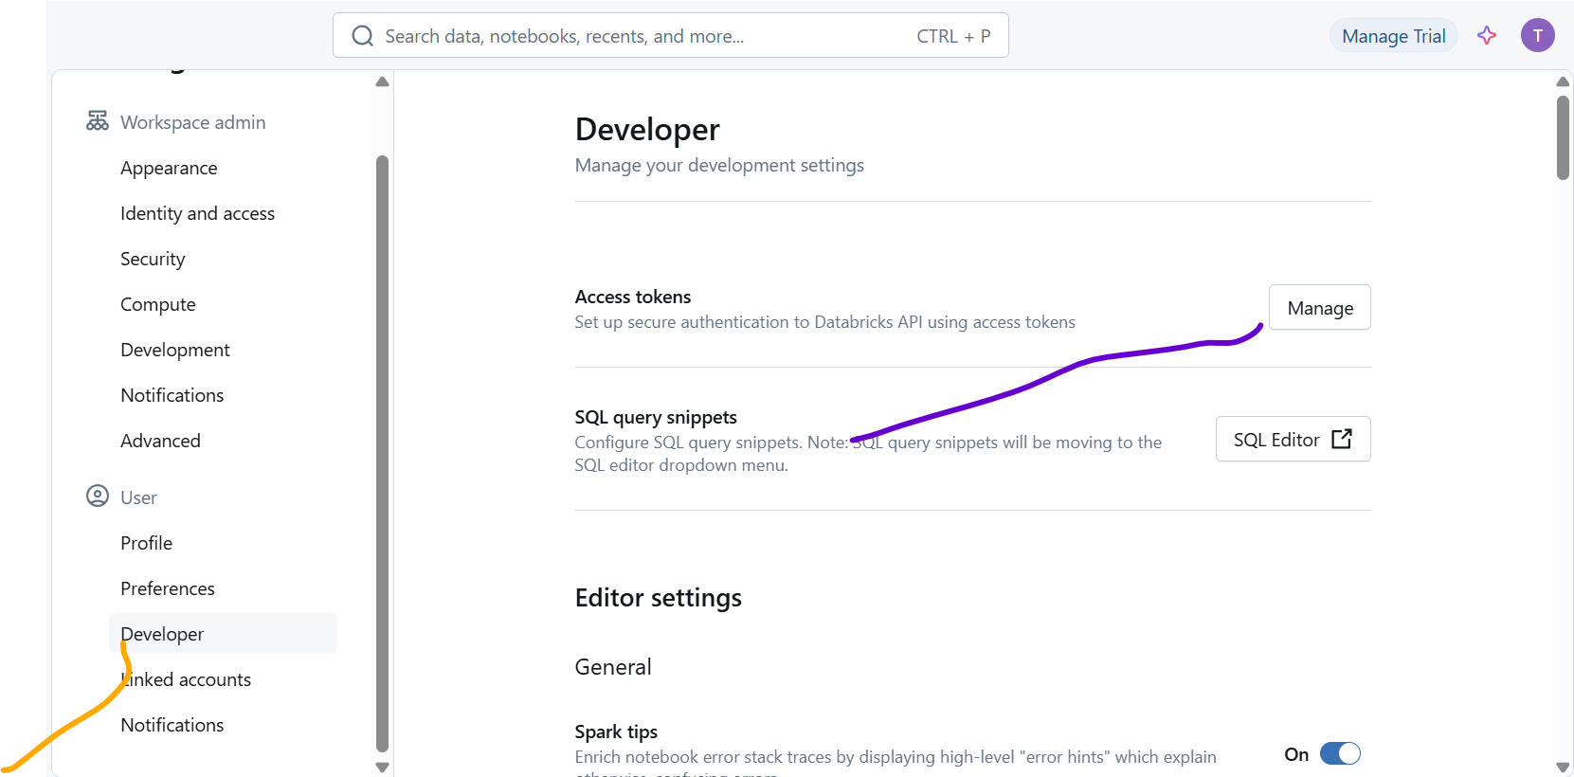

- Save the Databricks token as a secret named DATABRICKS_TOKEN in the Github Environment.
- Get the Databricks workspace URL as per the officinal docs. Add the URL as an environment variable named DATABRICKS_HOST in the Github Environment.

Set the databricks host and access token in github secrets
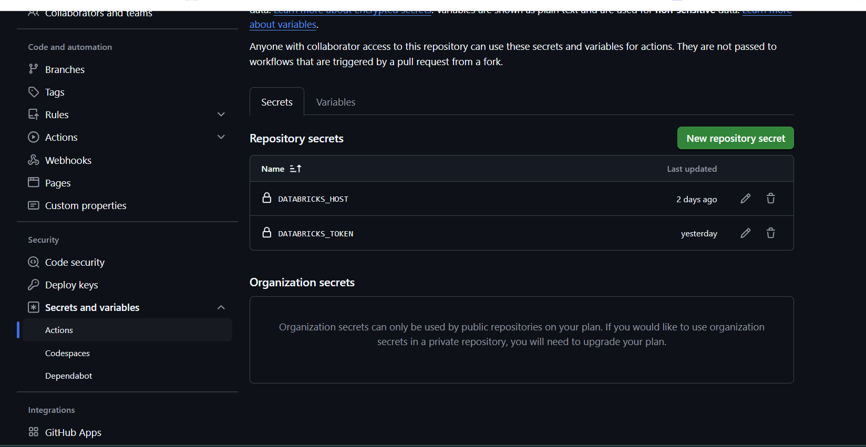

Created job by going through jobs section which will run the ml_model_training notebook in main branch.
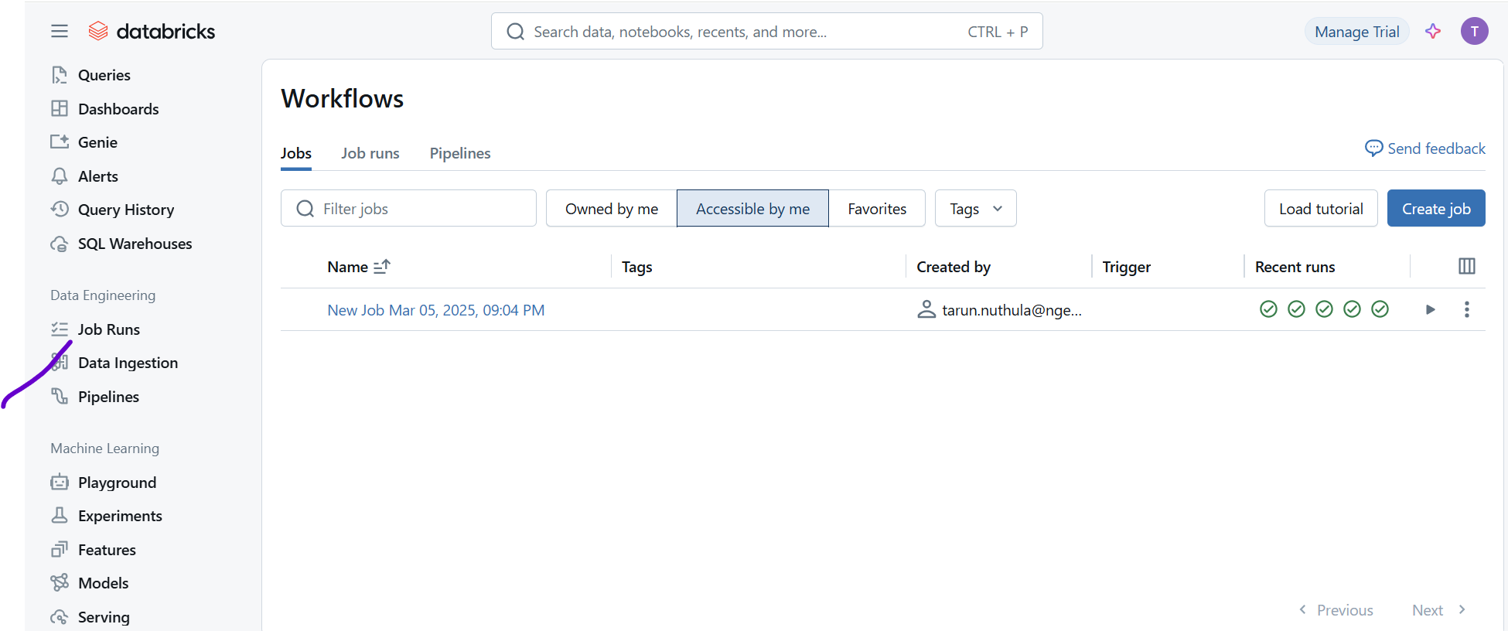
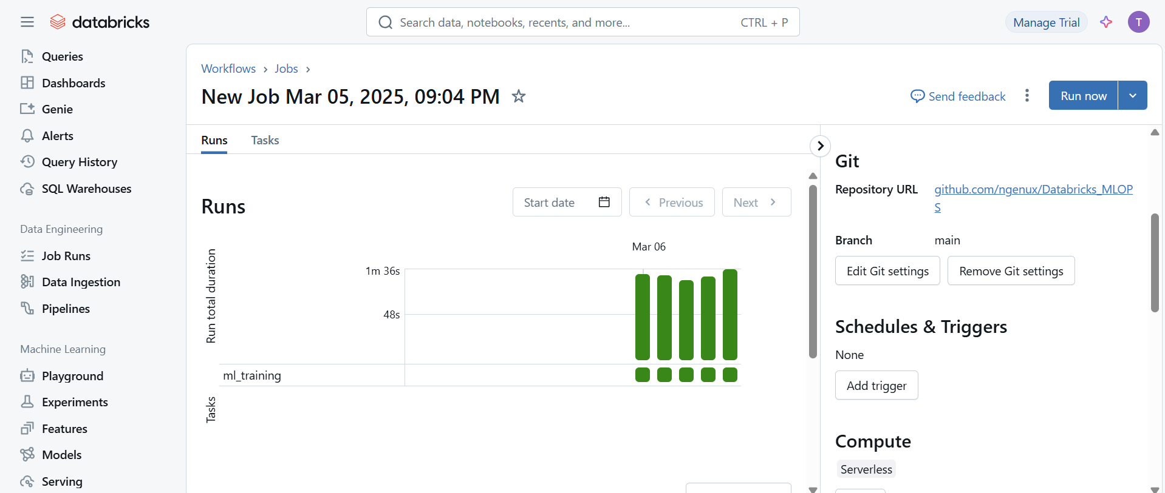

Before running end to end solution, we can cross check whether we are able to access databricks using host and token values from local system as below.
Below link to install databricks cli.
https://docs.databricks.com/aws/en/dev-tools/cli/install#winget-install

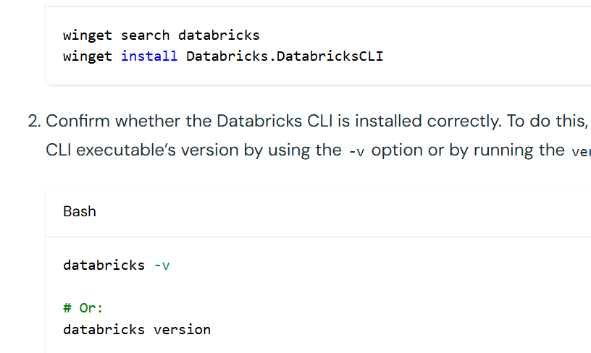
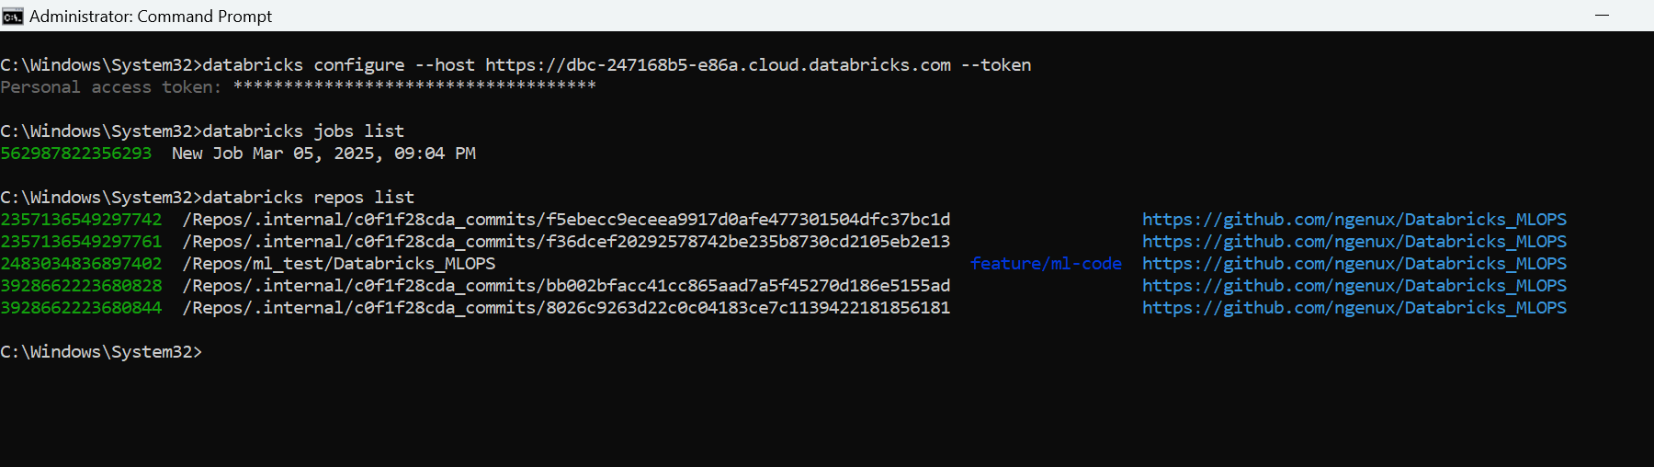
Below is the github actions cicd code, which sets up the databricks access run the model training notebook, then store the model in mlflow model registry
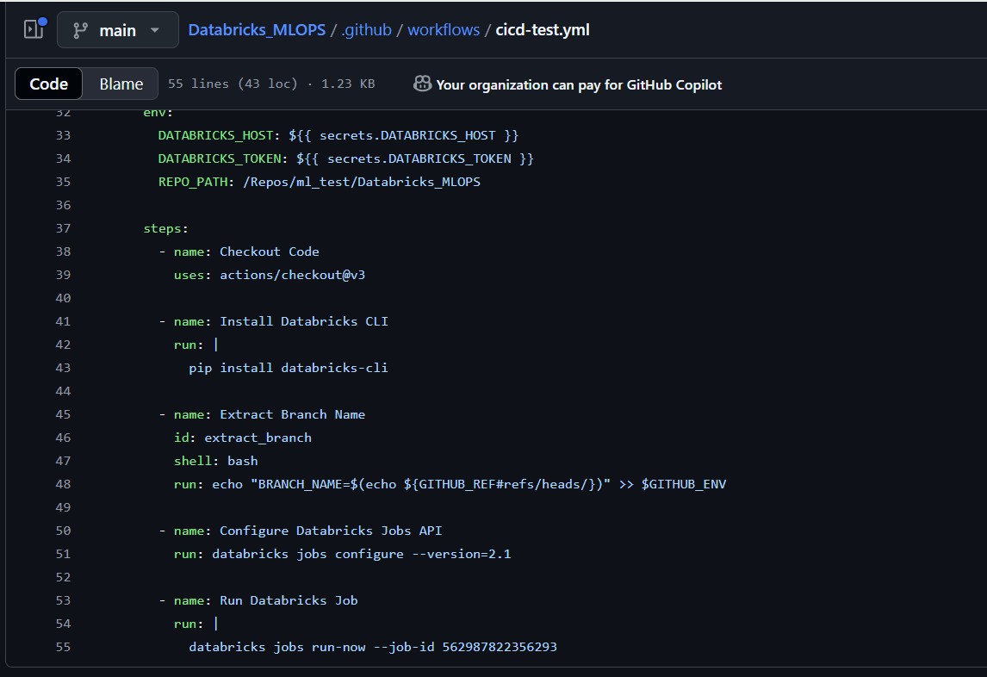

Run a Databricks job using Github Actions
Another typical example would be running a Databricks job after new code is merged to your main branch, probably after updating the Databricks repo as per the previous example.
You can run a job with the databricks jobs run-now command of the CLI.
- This is a little more complicated than the previous example, because the command expects the job ID, while most likely you would like to use the job name.
- You can use the databricks jobs list command and extract the job ID from the JSON response using jq
All ml experiments are stored under experiments
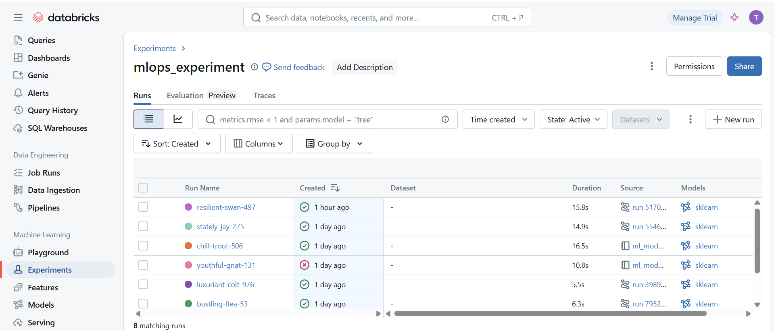
ML flow models are stored under model registry
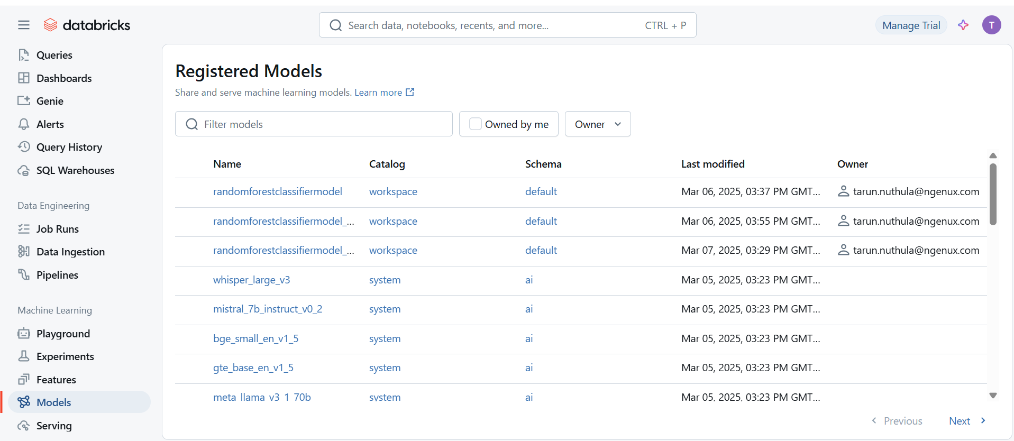
References:
https://docs.databricks.com/aws/en/repos/ci-cd-techniques-with-repos
https://medium.com/@danieljimgarcia/github-actions-for-databricks-ci-cd-ab6335bfd521
https://github.com/databricks/mlops-stacks
https://www.youtube.com/watch?v=J5w2PdJGTnU&t=481s&ab_channel=convg-ai

