

The Notebook

v7.2.7

TABLE OF CONTENTS

I. How to play Normal Blackjack ..................................................................... 2
II. Kami North’s Blackjack ..................................................................................... 4
III. Essences and Powerups ................................................................................ 7
IV. Powerup Directory ............................................................................................. 8
V. Perk Collection ...................................................................................................... 13
I. How to play Normal Blackjack

In blackjack, both you and the Dealer draw two cards at the beginning. Your goal is to get a higher hand value than the Dealer without going over 21. Exceeding 21 is referred to as a Bust, and busting is an instant loss. Cards that are drawn have ranks, where the value of the card is listed on it. There are 13 ranks, and 9 are self-explanatory.

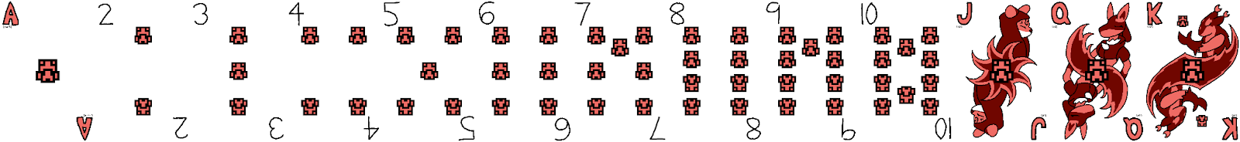

The J, Q and K are considered Face Cards, and function identically to a 10. The A is an Ace. The ace’s value is either an 11 or a 1, whichever is better for you. If the ace is worth 11, you will have what is known as a soft number, which means going over 21 will let the ace be worth 1 instead. A soft 18 and a regular 18 are the same, but you will not bust when you hit with a soft number.
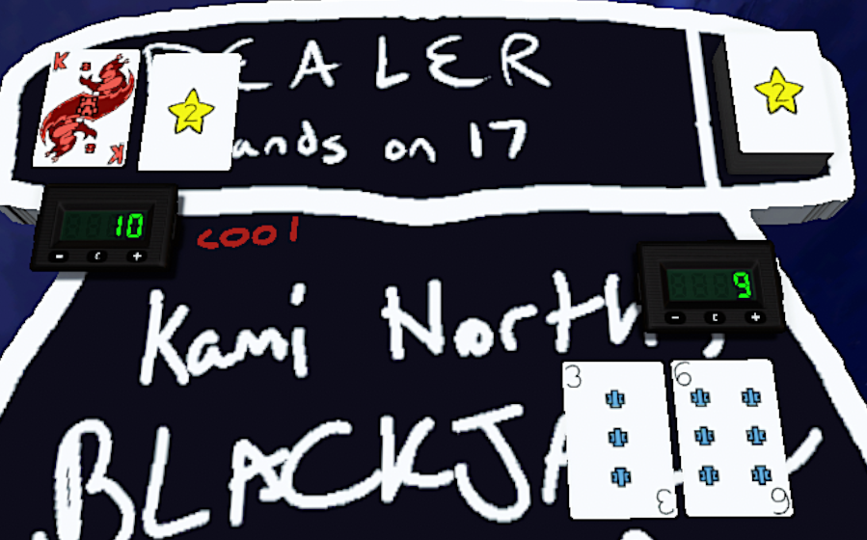
When it is your turn, you will see the value of your cards as well as one of the dealer’s cards.
On your turn, you can do the following actions below. You can only Double Down or Split if you have not Hit or Stood.

Hit | Stand | Double Down | Split
Draw an additional card. | End your turn. | Double your bet, hit once, and end your turn. | If you have a pair, play each card as a hand of its own.
Kami North’s Blackjack uses Tabletop Simulator’s Line Tool to shorthand actions. To hit, press Tab while hovering over your cards. An arrow will appear and a ding sound will play. This tells me you’re hitting. To stand, hold Tab and drag a line over your hand.

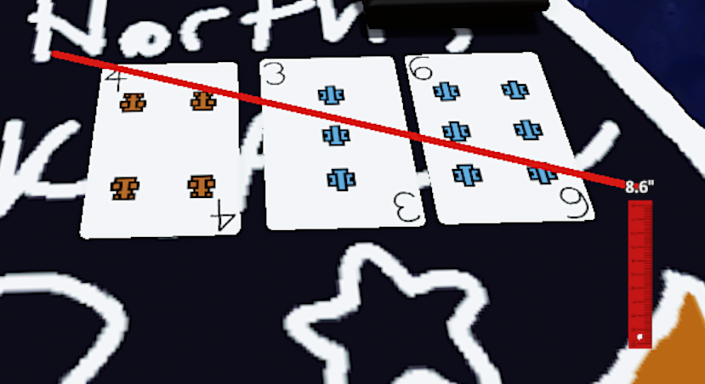
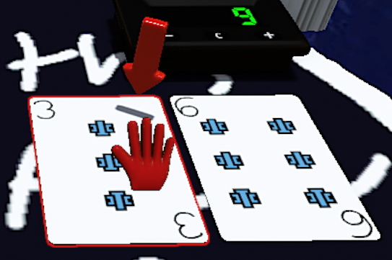
Hit | Stand

NOTE: If you are stuck with the ruler, you can either hit F1 or click the Cursor Tool on the top left corner of the screen.

After everyone completes their turn, it is time for face-off, where the Dealer plays their turn. They first reveal their hidden card, and if their hand value is below 17, they will hit until it is greater than or equal to 17. From there, the value is compared to your hand. If your hand is smaller than the Dealer’s hand, then you lose. If it is larger, then you win. If they are the same, then you Push, which means you get your money back. A player loss is higher priority than dealer loss, so if both bust, the player loses. If you have an Ace and a Face (i.e. 21 in 2 cards), you have a Blackjack, a guaranteed win.
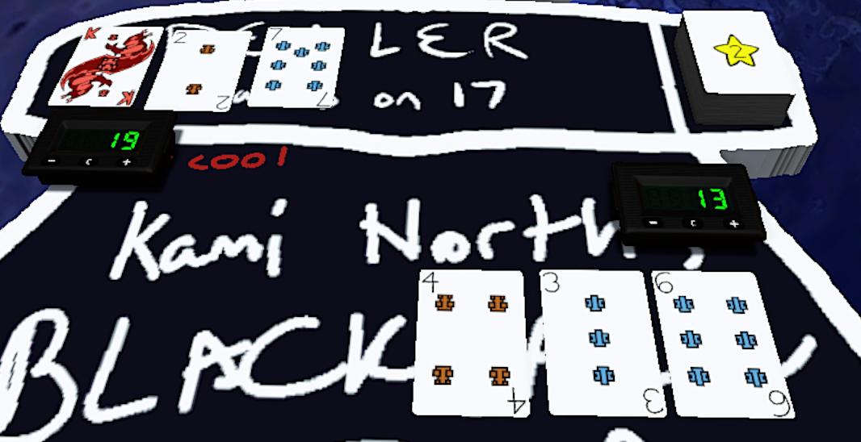
II. Kami North’s Blackjack

Kami North’s Blackjack differs from regular blackjack by adding various mechanics to it. The most prominent additions are the Essences and Powerups, which will be elaborated on in the next chapter. If you get overwhelmed by everything, don’t worry! It’ll come naturally quicker than you’d expect. The other notable features include:

Card Tricks
Card tricks are made by drawing 5 or more cards without busting. These are difficult hands to obtain, but if done, are treated equal or better to getting a Blackjack. If you manage to pull off a Card Trick, you are guaranteed victory.

Pulls
There are several conditions to earning pulls, which are how you obtain Essences, which are crucial to making Powerups. The most common examples include:

Blackjacks and Card Tricks — These typically net 1 pull, sometimes more for larger tricks.
Jokers — Drawing a joker will guarantee 1 pull.
The Pull Timer — Every 727 seconds, the pull timer goes off, giving everyone a pull.

You can also earn them through various other means, though they’re less frequent. When you obtain a Pull, you are given a white bag, to which you draw one essence from it. If you gain multiple pulls, you get a bag for each Pull and only take 1 from each bag.

Jokers
The deck consists of 105 cards, 8 of each rank and 1 Joker. Drawing the Joker counts as a value of 0, so your total does not change, making it great for card tricks. Drawing the Joker does not guarantee victory, but you are guaranteed a Pull, even if you lose.

The Lottery
Players often take part in the Lottery, a special system based on Mario Party 4, where they pay 25 chips or a Garbage (see: Essences and Powerups) to draw a colored ball from a bag. Every time you play the lotto in the same round, the price increases by base cost.
There are 5 outcomes:
Log Token |  | Pulls | Cost ($) | Cost (G)
0.5% |  | 1 | 25 | 1
$100 | 1 Pull | 2 | 75 | 3
~5-10% | ~10-15% | 3 | 150 | 6
1 Garbage | Try Again | 4 | 250 | 10
~10-20% | ~55-75% | 5 | 375 | 15

Scratch Tickets
At the end of every Pull timer, you obtain a pull but also draw a Scratch Number. These are then placed on the LOTTO bar located by your table. You can obtain a maximum of 5 per session. At the end of every session, the Winning Numbers are announced, where you can win money and pulls. If you have to leave before then, your Scratch Numbers are still compared to the winning numbers, and you will receive your rewards at the start of your next session.

The Bounty Board
Between sessions, everyone’s total earnings is compared. The three players with the most wealth will have Bounties. If a player has a bounty over their head, then players are rewarded extra for attacking the player. First place will have a Double Bounty, where the reward is doubled. Typically, screwing someone over will reward you with taking their bet and getting a Pull. A bounty will reward one additional pull, a double bounty will reward you with two additional pulls.

Log Tokens
Upon reaching $1000, you will divide your money by 10 (rounding down to the nearest 5) and obtain what is known as a Log Token. They are an alternative currency that cannot be bet, but symbolize that your money has additional value. For the bounty board, Log Tokens multiply your balance by 10 each. For example, if you have $200 and 2 log tokens, then you have “$200e2,” thus $20 000.

Belts, Perks and Shops
When you receive your first Log Token, you will be given the White Belt. This medal is an achievement of progress and opens you up to new features, including Perks and Shops. With each belt you obtain, you will be able to gain 1 perk, chosen from 3 random options. Shops will also be unlocked on a belt-by-belt basis, where the higher your belt the more options you’ll have. The shop can be found by the top right side of the table. The last benefit of Belts is that you get to contribute to the ever-growing background, custom designed and rendered!

Bankruptcy
If you run out of chips, you will go Bankrupt. This does not mean your journey is over, however, far from it! While bankrupt, you must forfeit any Log Tokens you currently possess (a balance of 0 * 10^x is still 0, after all), but start collecting Bankruptcy Tokens. You gain 1 Bankruptcy Token each turn, and can play with them. If you obtain 10 or more of them, you can convert them back into chips at a value of $10 each.
III. Essences and Powerups

The primary gimmick of Kami North’s Blackjack is the use of Powerups, which are created by Essences. These powerups can have various effects and are useful in different situations. With the new addition of Crafting, you can favor certain powerups over others to develop a unique playstyle.

To start obtaining powerups, you first earn Pulls through various means, most easily the Pull Timer. As you play, you’ll find yourself building a collection of essences that can quickly be used to your advantage or traded with other players for ones you desire.

Once you have obtained essences, you can then combine them by placing them on your Crafting Flower and notifying me. You cannot craft during a round, but you can freely craft as much as you’d like between rounds. The next section will have a list of the publicly shared powerups, as well as their recipes and functions.

You have a private area at your personal table, where you can craft and store powerups and essences in secret. A big theme of this season is discovery, so you do not have to publish your findings, though you can if you wish. All 3-essence powerups have been published so everyone has access to them.

If you craft using an invalid recipe, then what you will craft is known as Garbage. Garbage is most commonly used to participate in the lottery, though it can also be used to craft the secret Force Water powerup using 3 of them.
IV. Powerup Directory

Here’s a comprehensive list of the powerups currently known and their recipes, if published. The public crafting repository can be found behind the table, showing undiscovered powerups.

3-Essence PUs
  Addition 1 |   Subtraction 1 |   Clairvoyance |   Gimme
 |  |   OR | OR
Add 1 to your hand's value.  Can be used any time. | Subtract 1 from your hand's value.  Can be used any time. | Peek at the next card in the deck.  Can be used during your turn. | Hit at any time outside of your turn.  Can be used any time.
  Blade |   Cube |   Split Anyway
  OR | OR | OR
Lower the value of your next drawn card by 2.  Can be used during or before your turn. | Gain 1 additional PU slot for the round. Does not use a slot.  Can be used any time. | Split even if you don't have a pair.  Can be used as the first action of your turn.

  PvP Add 1 |   PvP Subtract 1 |   Try Again |   Snowflake
  OR | OR | OR | OR
Add 1 to another player's hand's value.  Can be used any time. | Subtract 1 from another player's hand's value.  Can be used any time. | The player's last drawn card is deleted and a new one is drawn in its place.  Can be used any time. | Increase the value of the opponent's next drawn card by 2.  Can be used during or before the target's turn.
  Broken Add 1 |   Broken Sub 1 |   Card Link |   Zap
  OR | OR | OR | OR
Add 0.5 to both your and your target's hands.  Can be used any time. | Subtract 0.5 from both your and your target's hands.  Can be used any time. | The value of your last card and your target's last card is averaged.  Can be used any time. | Occupy one of your target's Powerup slots.  Can be used any time.

  Lift |   Dig |   Double Check |   Bubble
  OR | OR | OR | OR
The bottom card in every player's hand is moved to the top.  Can be used any time. | The top card in every player's hand is moved to the bottom.  Can be used any time. | Circle back to White's turn. Everyone plays their turn again.  Can be used before the dealer's turn. | The next PU each player plays takes up 2 slots.  Can be used any time.

4-Essence PUs
  Addition 2 |   Subtraction 2 |   PvP Add 2 |   PvP Sub 2
? ? ? ? | ? ? ? ? | ? ? ? ? | ? ? ? ?
Add 2 to your hand's value.  Can be used any time. | Subtract 2 from your hand's value.  Can be used any time. | Add 2 to another player's hand's value.  Can be used any time. | Subtract 2 from another player's hand's value.  Can be used any time.

  Redraw |   +-1 |   1/2 |   3/2
 | ? ? ? ? | ? ? ? ? | ? ? ? ?
Redraw your hand.  Can be used before dealer shows their cards. | Can be used as EITHER an Addition 1 or Subtraction 1.  Can be used any time. | Cut the value of your last card in half.  Can be used any time. | Add half its current value to your last card.  Can be used any time.
  Trash Can |   Force Hit |   Force Stand |   Robbery
? ? ? ? |  | ? ? ? ? | ? ? ? ?
Delete the last card from your hand.  Can be used any time. | Force a player to Hit for their next move.  Can be used during or before the target's turn. | Force a player to Stand for their next move.  Can be used during or before the target's turn. | Steal another player's final card and add it to your hand.  Can be used any time.
  Repeat |   Shield |   Card Swap |   Mirror
? ? ? ? |  | ? ? ? ? | ? ? ? ?
Repeat the effect of the last 3-essence PU you played this turn.  Can be used any time the repeated PU can. | Nullify the effects of a PvP powerup targeting you as it is being played.  Use after attacked. | Swap your last card with your target's last card.  Can be used any time. | Copy the attack you have received, and send the copy back to the sender.  Use after attacked.
5-Essence Pus
  Addition 3 |   Subtraction 3 |   PvP Add 3 |   PvP Sub 3
? ? ? ? ? | ? ? ? ? ? | ? ? ? ? ? | ? ? ? ? ?
Add 3 to your hand's value.  Can be used any time. | Subtract 3 from your hand's value.  Can be used any time. | Add 3 to another player's hand's value.  Can be used any time. | Subtract 3 from another player's hand's value.  Can be used any time.
  Chain Shield |   Swap Hands
? ? ? ? ? | ? ? ? ? ?
Nullify the effects of a PvP powerup targeting you and/or your target as it is being played. The shield stands guard until either it is attacked or the round ends.  Can be used immediately in response to an attack. | Swap your hand with your target's hand.  Can be used any time.

V. Perk Collection
This is a list of all Perks owned by a player.
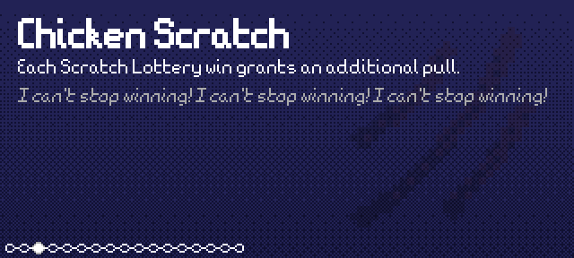 | 
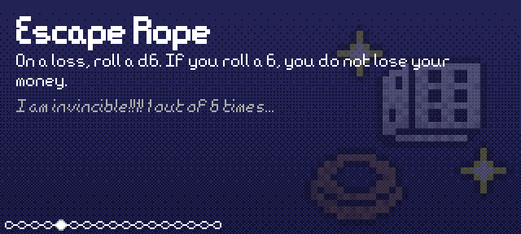 | 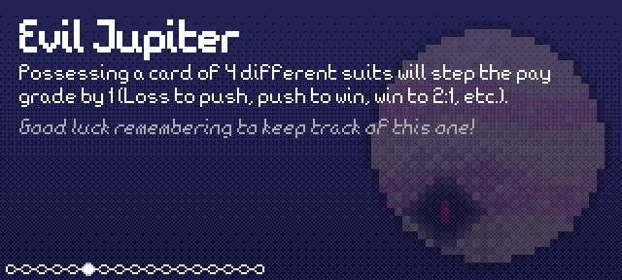
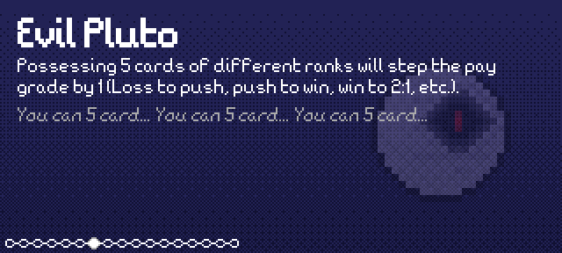 | 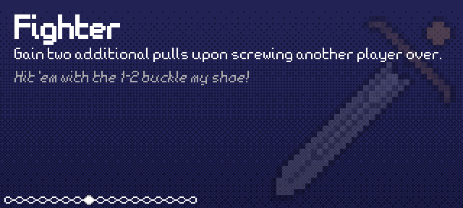
 | 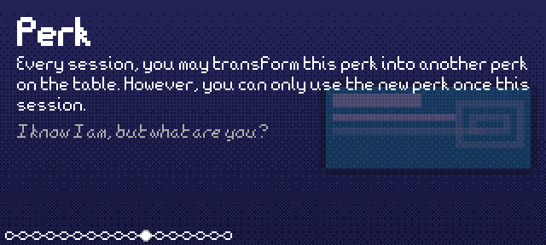
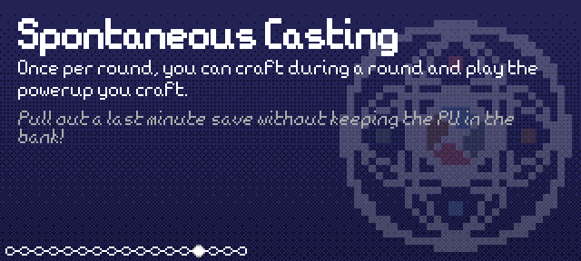 | 