CPE 545 Control Theory III Lecture III
Digital control systems:
A digital control system can be represented by the block diagram of Figure 12.
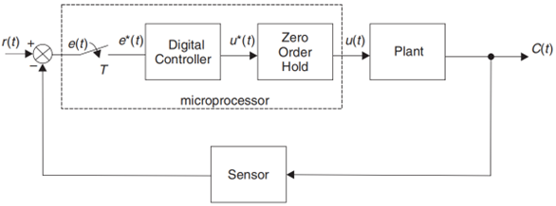
Figure 12: Digital control system
Example: For a simplified block diagram of a digital control system shown in Figure 13, when controller gain K is unity and the sampling period, T is 0.5 seconds, determine:
- the open-loop pulse transfer function
- the closed-loop pulse transfer function
- the difference equation for the discrete time response
- a sketch of the unit step response assuming zero initial conditions
- the steady-state value of the system output
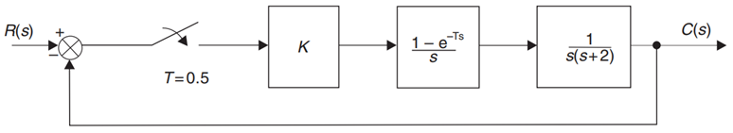
Figure 13: Digital control system for the example
Solution:
$G\left(s\right)=K\left(\frac{1-e^{-sT}}{s}\right)\left\{\frac{1}{s\left(s+2\right)}\right\}$ (29)
Given that $K=1$
$G\left(s\right)=\left(1-e^{-sT}\right)\left\{\frac{1}{s^{2}\left(s+2\right)}\right\}$ (30)
Partial fraction expansion
$\frac{1}{s^{2}\left(s+2\right)}=\left\{\frac{A}{s}+\frac{B}{s^{2}}+\frac{C}{\left(s+2\right)}\right\}$ (31)
$1=s\left(s+2\right)A+\left(s+2\right)B+s^{2}C$ (32)
Equating coefficients gives
$A=-0.25$
$B=0.5$
$C=0.25$
Substituting these values in equations (31) gives
$G\left(s\right)=\left(1-e^{-sT}\right)\left\{\frac{-0.25}{s}+\frac{0.5}{s^{2}}+\frac{0.25}{\left(s+2\right)}\right\}$ (33)
$G\left(s\right)=0.25\left(1-e^{-sT}\right)\left\{\frac{-1}{s}+\frac{2}{s^{2}}+\frac{1}{\left(s+2\right)}\right\}$ (34)
Taking z-transform equation (34) becomes
$G\left(z\right)=0.25\left(1-z^{-1}\right)\left\{\frac{-z}{z-1}+\frac{2Tz}{{\left(z-1\right)}^{2}}+\frac{z}{\left(z-e^{-2T}\right)}\right\}$ (35)
For T=0.5 seconds
$G\left(z\right)=0.25\left(z-1\right)\left\{\frac{-1\left(z-1\right)\left(z-0.368\right)+\left(z-0.368\right)+{\left(z-1\right)}^{2}}{{\left(z-1\right)}^{2}\left(z-0.368\right)}\right\}$ (36)
$G\left(z\right)=0.25\left\{\frac{-z^{2}+1.368z-0.368+z-0.368+z^{2}-2z+1}{\left(z-1\right)\left(z-0.368\right)}\right\}$ (37)
Which simplifies to give the open-loop pulse transfer function
$G\left(z\right)=\frac{0.092z+0.066}{z^{2}-1.368z+0.368}$ (38)
The closed-loop pulse transfer function from equation (26) is

$\frac{C\left(z\right)}{R(z)}=\frac{\frac{0.092z+0.066}{z^{2}-1.368z+0.368}}{1+\frac{0.092z+0.066}{z^{2}-1.368z+0.368}}$ (39)
Which simplify to give the close-loop pulse transfer function
$\frac{C\left(z\right)}{R(z)}=\frac{0.092z+0.066}{z^{2}-1.276z+0.434}$ (40)
$\frac{C\left(z\right)}{R(z)}=\frac{0.092z^{-1}+0.066z^{-2}}{1-1.276z^{-1}+0.434z^{-2}}$ (41)
From equation (41) the difference equation is
$C\left(kT\right)=1.276c\left(k-1\right)T-0.434c\left(k-2\right)T+0.092r\left(k-1\right)T+0.066r\left(k-2\right)T$ (42)
Using the difference equation of equation (42) and assuming zero initial conditions, the unit step response is shown in Figure 14.
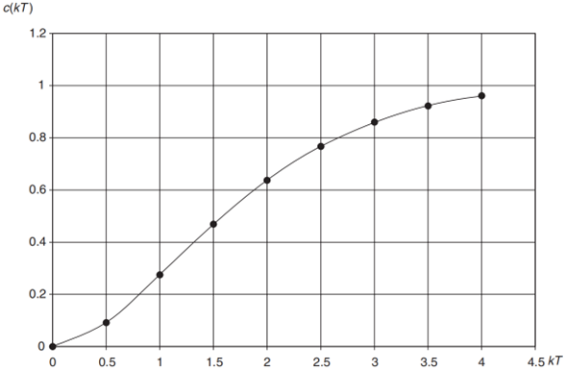
Figure 14: Unit step response for the example
The response of Figure 14 is constructed solely from the knowledge of the two previous sampled outputs and the two previous sampled inputs
Using the final value theorem, we have
$C\left(∞\right)=\lim_{z→1}\left[\left(\frac{z-1}{z}\right)\frac{C\left(z\right)}{R(z)}R(z)\right]$ (43)
$C\left(∞\right)=\lim_{z→1}\left[\left(\frac{z-1}{z}\right)\frac{0.092z+0.066}{z^{2}-1.276z+0.434}\left(\frac{z}{z-1}\right)\right]$ (44)
$C\left(∞\right)=\left(\frac{0.092+0.066}{1-1.276z+0.434}\right)=1$ (45)
Which means there is no steady-state error.

