NutriAI on AWS EKS
Infrastructure Guide — ALB Exposure, Istio Service Mesh & kubectl Command Reference
CGI-NutriAI repository · prepared 2026-08-14
Everything under alb-ingress/ and istio-service-mesh/ described here is ready-to-apply YAML that has NOT been deployed to any cluster. This document is both the reference for what was built and the runbook for applying it when you're ready.

Contents
- 1. Purpose & scope
- 2. Architecture diagram
- 3. What already exists vs. what's new
- 4. kubectl command reference — inspecting every component
- 5. Getting the URLs
- 6. Deployment order — exact commands, in sequence
- 7. Verifying the canary traffic split
- 8. Rollback
- 9. Placeholder values to replace before applying anything

1. Purpose & scope
This document accompanies two new, additive folders in the CGI-NutriAI repository:
- alb-ingress/ — a single shared AWS Application Load Balancer, provisioned by the AWS Load Balancer Controller, host-routing to kgateway (the app) and to ArgoCD's UI.
- istio-service-mesh/ — a separate, self-contained Istio service mesh demo (its own namespace, its own ALB) showing mTLS, weighted canary traffic distribution, mesh-level authorization, and Kubernetes RBAC.
Neither folder has been applied to a cluster. Both are reviewed, offline-validated YAML — see §6 for the exact apply order and §8 for rollback. Nothing about the existing bastion-tunnel-only design (docs/06-gateway-routing.md, docs/09-argocd-gitops.md) is changed; these are opt-in layers on top of it.
A quick environment check while preparing this guide found the active kubeconfig context pointed at a DIFFERENT cluster/account than the one documented in this repo (arn:aws:eks:ap-south-1:492162559936:cluster/Murali-Test-Cluster, vs. the repo's documented us-east-1 / account 733236986490). All commands and manifests below use the repo's documented values as placeholders — confirm which cluster you actually mean to target before running anything, and see §9.

2. Architecture diagram
Full traffic, GitOps, IAM/RBAC and secrets flow across the VPC, subnets, NAT gateways, EKS cluster, and every namespace. A live interactive version (hover-free, but pannable in-browser) is checked in at docs/assets/architecture-diagram.html; the static export below is this same diagram.
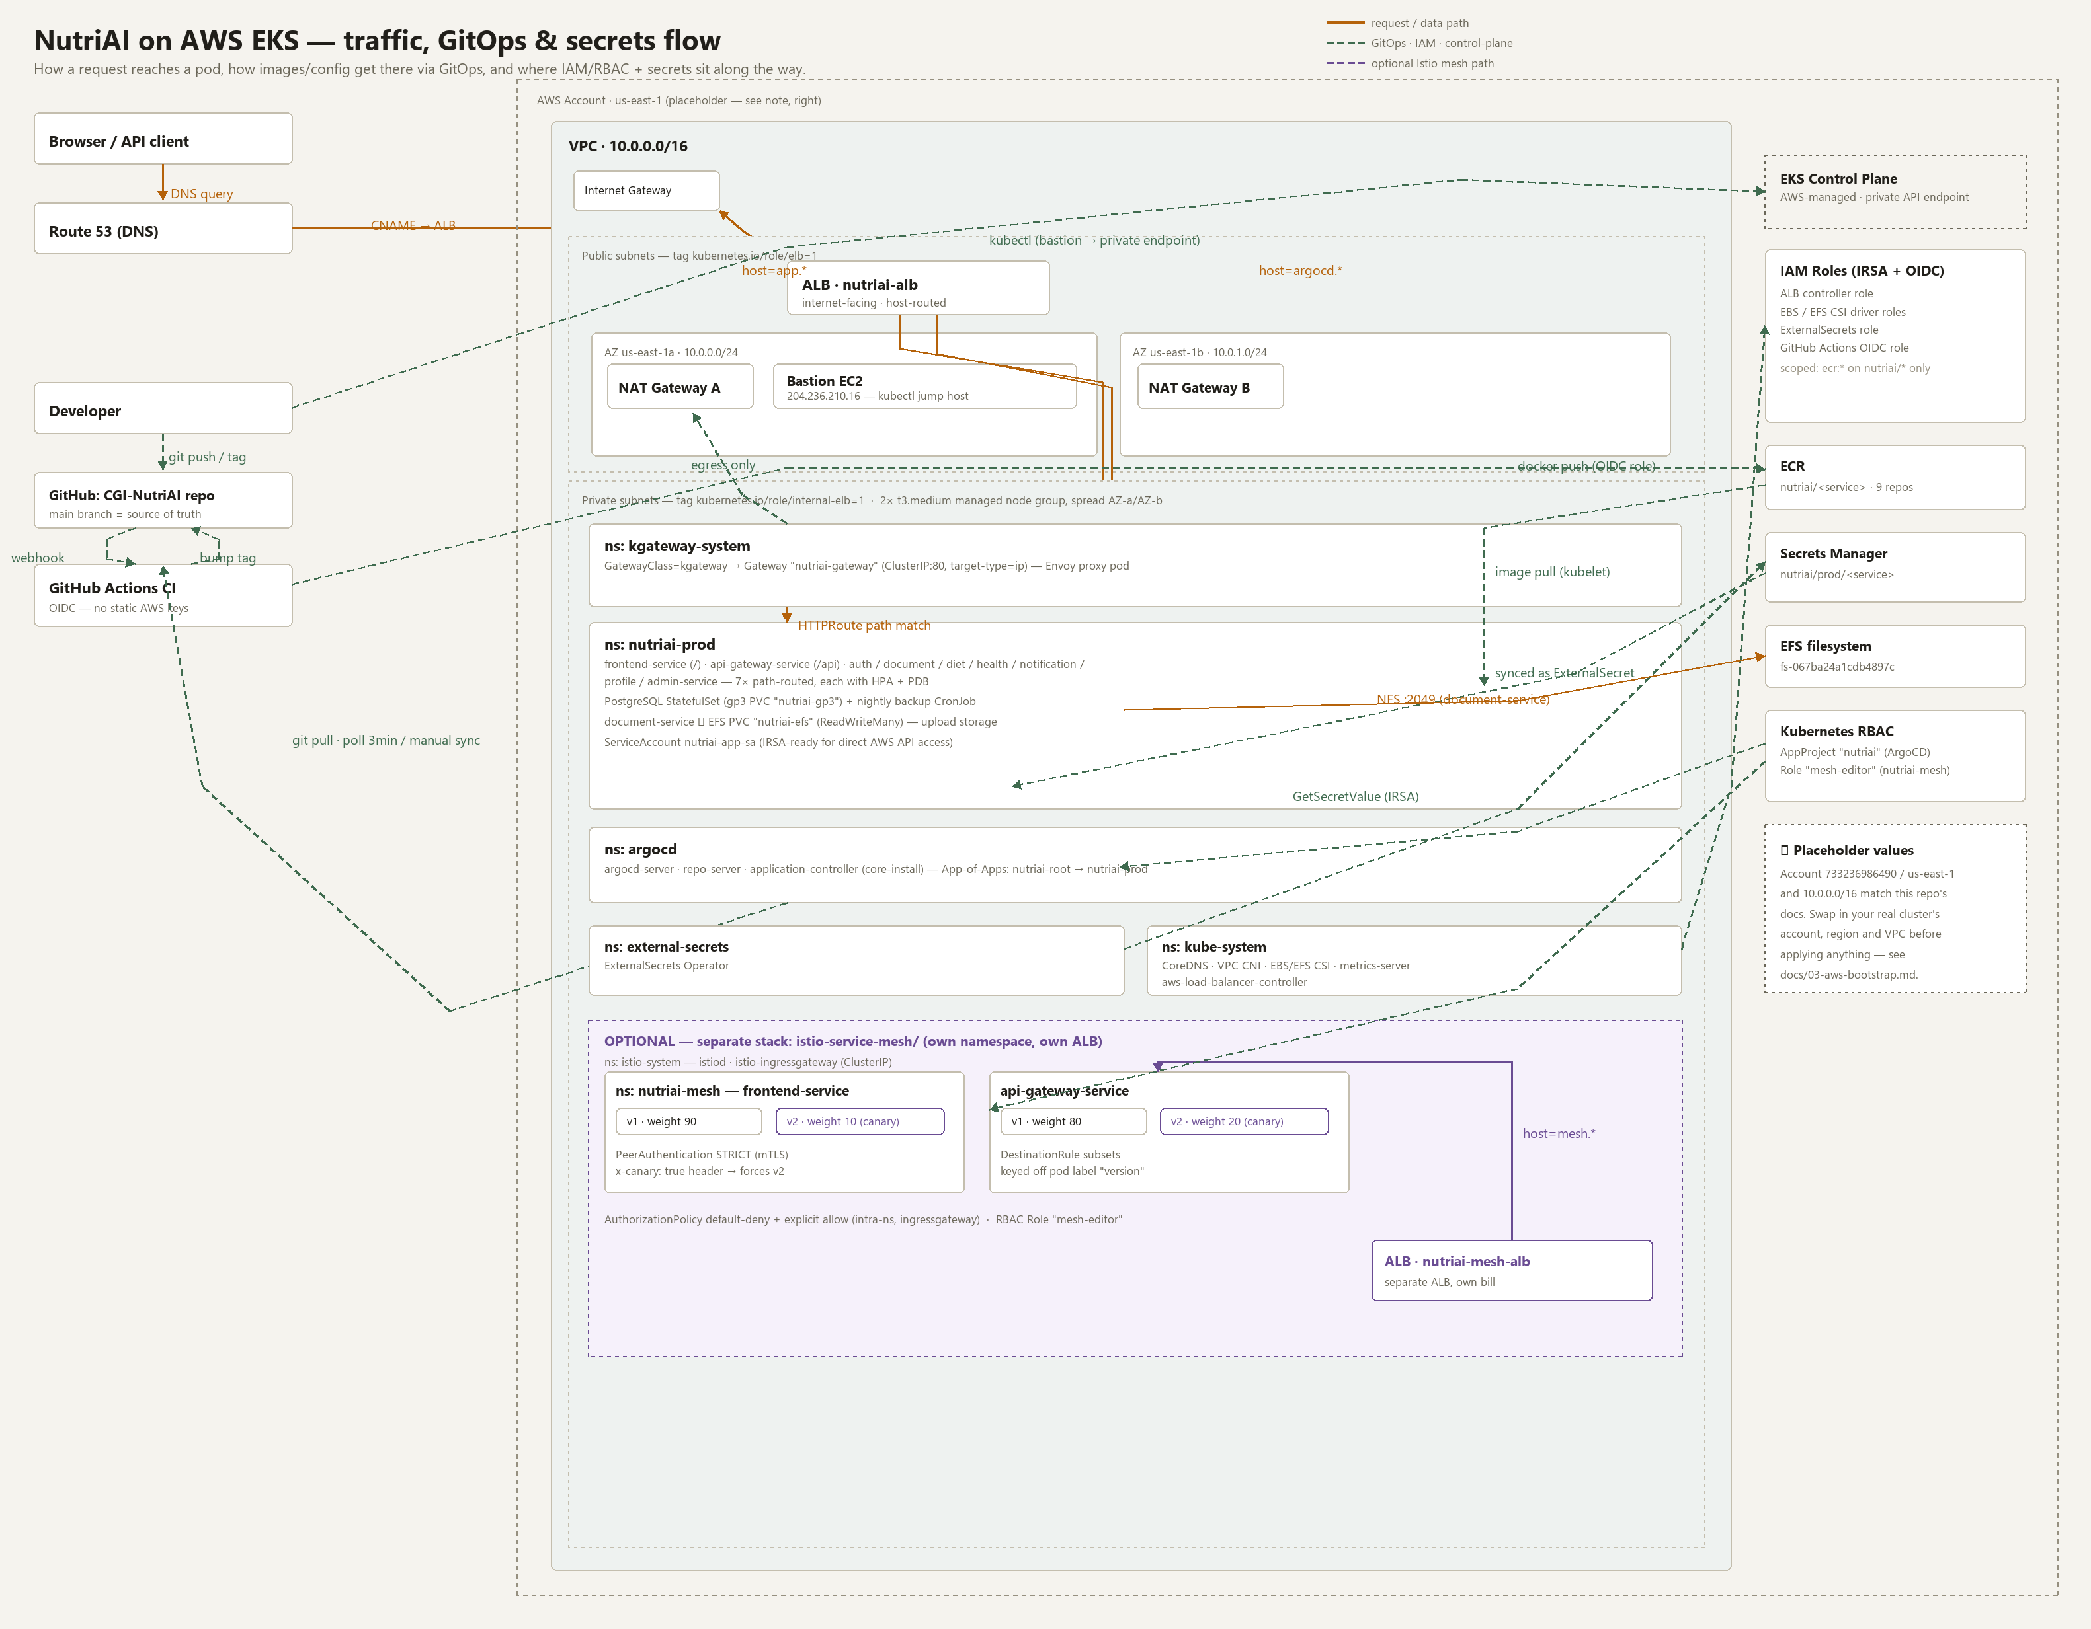
Legend: solid amber = request/data path. Dashed green = GitOps, IAM, or other control-plane traffic. Dashed violet = the optional Istio mesh path.

3. What already exists vs. what's new

3.1 Already in the repo (unchanged)
Path | What
helm/nutriai/ | The one Helm chart — kgateway Gateway+HTTPRoutes, 9 service Deployments, Postgres, backup CronJob, HPA/PDB.
argocd/ | App-of-Apps GitOps bootstrap — nutriai-root watches argocd/apps/.
scripts/03-install-cluster-addons.sh | CSI drivers, metrics-server, Gateway API + kgateway, ArgoCD core-install, External Secrets Operator.
docs/06-gateway-routing.md | Why kgateway's Service stays ClusterIP, and the bastion-tunnel / NodePort access options.
docs/09-argocd-gitops.md | ArgoCD install, SecretStore, AppProject, App-of-Apps bootstrap, sync policy.

3.2 New (this change)
Path | What
alb-ingress/ | IAM policy + controller install script, IngressClass, two Ingress objects (kgateway + ArgoCD) sharing one ALB.
istio-service-mesh/ | IstioOperator, namespace, mTLS, canary v1/v2 Deployments, DestinationRules, VirtualServices, AuthorizationPolicy, RBAC Role, its own ALB Ingress.
docs/11-alb-exposure.md | Narrative walkthrough for alb-ingress/.
docs/12-istio-service-mesh.md | Narrative walkthrough for istio-service-mesh/, including how to verify the canary split.
docs/assets/architecture-diagram.{html,png} | The diagram in §2.

4. kubectl command reference — inspecting every component

4.1 Cluster & nodes
kubectl config get-contexts
kubectl config use-context <your-eks-context>
kubectl get nodes -o wide
kubectl top nodes
kubectl get namespaces

4.2 Everything, at a glance
One-shot inventory across every namespace this repo touches.
kubectl get all -A
kubectl get pods -A -o wide
kubectl get deployments,statefulsets -A
kubectl get pvc -A
kubectl get hpa -A
kubectl get pdb -A
kubectl get events -A --sort-by=.lastTimestamp | tail -40

4.3 kgateway (Gateway API) — existing
kubectl get gatewayclass
kubectl get gatewayparameters -n kgateway-system
kubectl get gateway -n nutriai-prod
kubectl describe gateway nutriai-gateway -n nutriai-prod
kubectl get httproute -n nutriai-prod
kubectl describe httproute auth-service -n nutriai-prod

4.4 ArgoCD — existing
kubectl get pods -n argocd
kubectl get applications -n argocd
kubectl get appprojects -n argocd
argocd app list
argocd app get nutriai-prod
argocd app get nutriai-root

4.5 ALB Ingress — new (alb-ingress/)
Requires alb-ingress/01-install-aws-load-balancer-controller.sh to have been run first (see §6).
kubectl get pods -n kube-system -l app.kubernetes.io/name=aws-load-balancer-controller
kubectl logs -n kube-system deploy/aws-load-balancer-controller --tail=50
kubectl get ingressclass
kubectl get ingress -A
kubectl describe ingress nutriai-gateway -n nutriai-prod
kubectl describe ingress argocd-server -n argocd

4.6 Istio service mesh — new (istio-service-mesh/)
kubectl get pods -n istio-system
kubectl get pods -n nutriai-mesh --show-labels
kubectl get virtualservice -n nutriai-mesh
kubectl get destinationrule -n nutriai-mesh
kubectl get peerauthentication -n nutriai-mesh
kubectl get authorizationpolicy -n nutriai-mesh
kubectl get ingress -n istio-system nutriai-mesh-ingress
istioctl proxy-status
istioctl analyze -n nutriai-mesh
istioctl proxy-config secret <frontend-service-v1-pod> -n nutriai-mesh

4.7 Secrets & storage — existing
kubectl get externalsecrets -A
kubectl get clustersecretstore,secretstore -A
kubectl get pvc -n nutriai-prod
kubectl get storageclass
aws secretsmanager list-secrets --query "SecretList[?starts_with(Name,'nutriai/')].Name"

4.8 RBAC — existing + new
kubectl get role,rolebinding -n nutriai-mesh
kubectl get clusterrole,clusterrolebinding | grep -i nutriai
kubectl -n nutriai-mesh auth can-i update virtualservices \
--as=system:serviceaccount:nutriai-mesh:default
kubectl get appproject nutriai -n argocd -o yaml

5. Getting the URLs

5.1 Public ALB URLs (after alb-ingress/ is applied)
# Shared ALB — same hostname answers both, host header decides the app
kubectl get ingress nutriai-gateway -n nutriai-prod \
-o jsonpath='{.status.loadBalancer.ingress[0].hostname}{"\n"}'

kubectl get ingress argocd-server -n argocd \
-o jsonpath='{.status.loadBalancer.ingress[0].hostname}{"\n"}'

# Test before DNS is even set up:
curl -sk -H "Host: app.nutriai.example.com" https://<alb-hostname>/
curl -sk -H "Host: argocd.nutriai.example.com" https://<alb-hostname>/

5.2 Istio mesh ALB URL (after istio-service-mesh/ is applied)
kubectl get ingress nutriai-mesh-ingress -n istio-system \
-o jsonpath='{.status.loadBalancer.ingress[0].hostname}{"\n"}'

5.3 No-public-URL fallback (bastion tunnel — always available)
# On the bastion:
kubectl -n nutriai-prod port-forward svc/nutriai-gateway 8080:80 --address 0.0.0.0 &
kubectl -n argocd port-forward svc/argocd-server 8443:443 --address 0.0.0.0 &

# From your workstation:
ssh -i murali-cgi-key.pem -L 8080:localhost:8080 -L 8443:localhost:8443 ec2-user@204.236.210.16
# then open http://localhost:8080/ and https://localhost:8443/

6. Deployment order — exact commands, in sequence
Run everything below from the bastion host (or anywhere with kubectl/helm/eksctl/aws-cli access to the private EKS API endpoint). Nothing here has been run for you.

6.1 Baseline platform (if not already done — docs/10-runbook-end-to-end.md)
ssh -i murali-cgi-key.pem ec2-user@204.236.210.16
aws eks update-kubeconfig --name <your-eks-cluster-name> --region us-east-1
cd CGI-NutriAI/scripts
./01-create-ecr-repos.sh
./02-setup-github-oidc-role.sh
CLUSTER_NAME=<your-eks-cluster-name> ./03-install-cluster-addons.sh
kubectl apply -f ../argocd/projects/nutriai-project.yaml
kubectl apply -f ../argocd/bootstrap/root-app.yaml
argocd app sync nutriai-prod && argocd app wait nutriai-prod --health

6.2 alb-ingress/ — public ALB for kgateway + ArgoCD
cd ../../alb-ingress
CLUSTER_NAME=<your-eks-cluster-name> ./01-install-aws-load-balancer-controller.sh
kubectl apply -f 02-ingressclass.yaml
kubectl apply -f 03-nutriai-gateway-ingress.yaml
kubectl -n argocd patch configmap argocd-cmd-params-cm --type merge \
-p '{"data":{"server.insecure":"true"}}'
kubectl -n argocd rollout restart deployment argocd-server
kubectl apply -f 04-argocd-ingress.yaml
# then §5.1 to fetch the ALB hostname and §9 to point real DNS at it

6.3 istio-service-mesh/ — separate mesh demo with canary traffic
cd ../istio-service-mesh
CLUSTER_NAME=<your-eks-cluster-name> ./02-install-istio.sh
kubectl apply -f 00-namespace.yaml
kubectl apply -f 03-peerauthentication-mtls.yaml
kubectl apply -f canary-deployments/
kubectl apply -f destinationrules/
kubectl apply -f virtualservices/
kubectl apply -f 06-istio-gateway.yaml
kubectl apply -f 07-authorizationpolicy.yaml
kubectl apply -f rbac/
kubectl apply -f 08-alb-ingress-for-istio.yaml

7. Verifying the canary traffic split
Send a batch of requests through the mesh ALB and confirm the ~90/10 split lands, then force the canary path with the override header:
ALB_HOST=$(kubectl get ingress nutriai-mesh-ingress -n istio-system \
-o jsonpath='{.status.loadBalancer.ingress[0].hostname}')

for i in $(seq 1 20); do
curl -s -H "Host: mesh.nutriai.example.com" "http://${ALB_HOST}/" | grep -o 'version.*'
done | sort | uniq -c

# Force 100% v2 regardless of weight:
curl -s -H "Host: mesh.nutriai.example.com" -H "x-canary: true" "http://${ALB_HOST}/"

# Confirm mTLS is actually active:
istioctl proxy-config secret <a-frontend-pod> -n nutriai-mesh

# Confirm the default-deny AuthorizationPolicy actually denies cross-namespace traffic:
kubectl run -n default probe --rm -it --image=curlimages/curl --restart=Never -- \
curl -s -o /dev/null -w "%{http_code}\n" \
http://api-gateway-service.nutriai-mesh.svc.cluster.local:8000/health
# expect connection refused/reset, NOT 200

Shifting the canary weight (day-2)
kubectl -n nutriai-mesh patch virtualservice frontend-service --type merge -p \
'{"spec":{"http":[{"route":[
{"destination":{"host":"frontend-service","subset":"v1"},"weight":50},
{"destination":{"host":"frontend-service","subset":"v2"},"weight":50}
]}]}}'

8. Rollback

8.1 istio-service-mesh/
kubectl delete -f 08-alb-ingress-for-istio.yaml
kubectl delete -f rbac/ -f 07-authorizationpolicy.yaml -f 06-istio-gateway.yaml
kubectl delete -f virtualservices/ -f destinationrules/ -f canary-deployments/
kubectl delete -f 03-peerauthentication-mtls.yaml -f 00-namespace.yaml
istioctl uninstall -y --purge
kubectl delete namespace istio-system

8.2 alb-ingress/
kubectl delete -f 04-argocd-ingress.yaml -f 03-nutriai-gateway-ingress.yaml -f 02-ingressclass.yaml
helm uninstall aws-load-balancer-controller -n kube-system
# Confirm in the EC2 console (Load Balancers) that the ALB(s) were actually removed
# before assuming billing has stopped — the controller deletes it a few minutes
# after the last referencing Ingress is gone.

9. Placeholder values to replace before applying anything
Placeholder | Where | Replace with
<your-eks-cluster-name> | every install script | your actual EKS cluster name
733236986490 / us-east-1 | helm/nutriai/values-prod.yaml, canary-deployments/*, diagram | your account ID / region — see the note in §1
app.nutriai.example.com  argocd.nutriai.example.com  mesh.nutriai.example.com | alb-ingress/*.yaml, istio-service-mesh/*.yaml | your real hostnames
<ACM_CERTIFICATE_ARN> | alb-ingress/03-*, 04-*, istio-service-mesh/08-* | an ACM cert ARN in the same region (§ TLS in docs/11)
nutriai-platform-team | istio-service-mesh/rbac/mesh-editor-role.yaml | your real IAM-mapped Kubernetes group
fs-067ba24a1cdb4897c | helm values / diagram | your actual EFS filesystem ID

End of document.

