1. Intricate Architectural Blueprint
This diagram maps out the microservices boundaries, the structural network ports, database synchronization, and how the Human-in-the-Loop (HITL) retraining engine hooks into your storage layers.
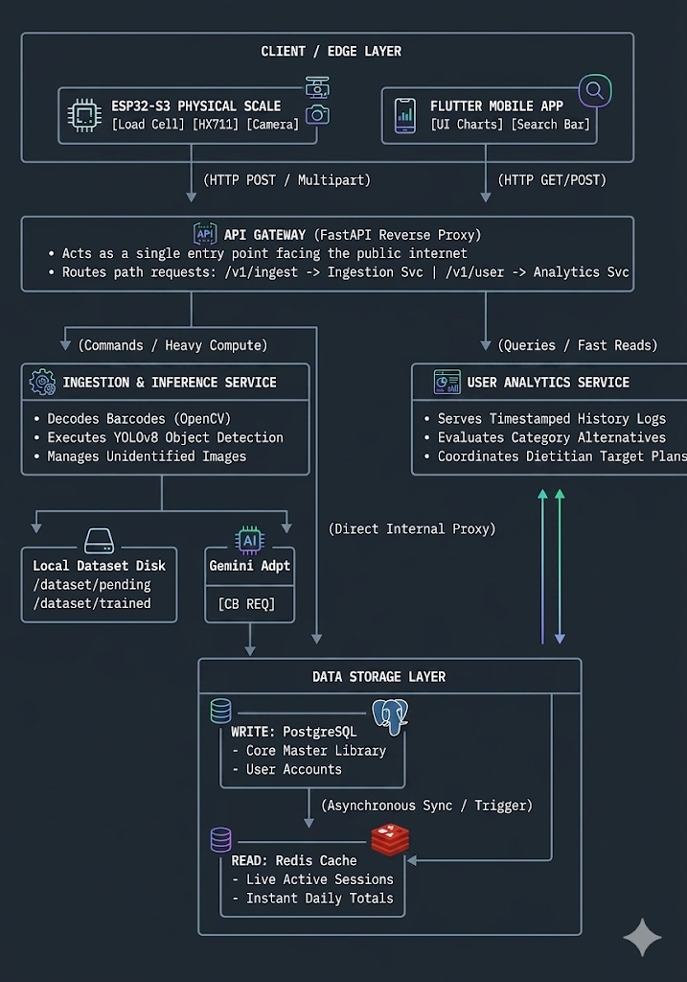

2. Deep Dive Into the Core Components

A. The Edge Tier (ESP32-S3 Network Node)
The physical scale doesn't run your database or AI model; it acts as an intelligent sensor collector.
- The Scale Logic: It polls the 24-bit HX711 analog-to-digital converter continuously. Once the standard deviation of weight variations drops below 0.5g for a sustained window of 500ms, it flags the state as STABLE.
- The Network Payload: The ESP32 immediately turns on its camera, grabs an image frame buffer, and wraps the image along with the stable weight value into an HTTP Multipart Form-Data request. It maps this directly to your API Gateway.

B. The API Gateway (The Structural Front Door)
Instead of exposing your individual backend services to the public internet, you hide them behind a single Gateway service.
- Role: It checks incoming client requests, manages user access tokens, and performs path routing.
- If a request comes in as POST /v1/ingest/weight-frame, it seamlessly forwards it internally to the Ingestion & Inference Service. If a request comes in as GET /v1/user/daily-summary, it forwards it directly to the User Analytics Service.

C. Ingestion & Inference Service (The "Write" Command Pipeline)
This service handles high-compute, transactional tasks. It is completely stateless, meaning it can scale endlessly on your server frame.
- Computer Vision Routing: When a plate frame arrives, it strips the image data and pushes it through the local YOLOv8 model running via Python.
- Confidence Management:
  - High Confidence >80%): The item is automatically matched to your PostgreSQL reference library (e.g., White Bread).
  - Low Confidence <80%): The service skips auto-assignment, names the transaction unidentified_item, and drops the raw image file directly into your server's /dataset/pending/ storage directory while sending a configuration notification to the Flutter app.

D. User Analytics & Query Service (The "Read" Query Pipeline)
This service is intentionally isolated from the Ingestion service to satisfy CQRS (Command Query Responsibility Segregation).
- Why split them? Running a YOLOv8 image model or calling a Gemini API scraping workflow can tie up thread loops for seconds at a time. If your mobile app attempted to query historical calorie graphs from that same system, the charts would lag or freeze.
- Solution: The Analytics service only reads from a hyper-fast Redis in-memory cache layer. It has one job: deliver instant UI responses to the phone under 10ms

3. The Intricate Failure Protection Mode: Circuit Breaking
When a user introduces a completely foreign ingredient that isn't found inside your local SQL database, your Ingestion Service utilizes an adapter calling the external Gemini API to run a live web search scrape. Because external network requests can fail or suffer lag spikes, we implement a Circuit Breaker structure directly inside the adapter code loop.

How the Circuit Breaker Operates:
- Closed State (Normal Functioning): Every time a new food search request is handled, the code passes the name to Gemini. The API behaves normally, and transactions succeed.
- The Failure Trigger: If your internet environment drops, or Gemini experiences severe rate-limiting issues, the requests begin timing out or returning 500 errors. The Circuit Breaker keeps a count of these consecutive failures.
- Open State (The Safety Net): If 5 failures occur consecutively, the circuit trips open. For any subsequent unknown ingredients, the system completely stops trying to hit Google’s servers. It bypasses the API call entirely, immediately dropping an alternative fallback message down the pipe: "Remote nutrition search engine offline. Defaulting to local temporary placeholder data."
- Half-Open State (Recovery Verification): After a cooldown reset timer (e.g., 60 seconds), the circuit enters a hybrid "Half-Open" state. It lets a single trial request slip through to Gemini. If it succeeds, the circuit closes back down safely; if it fails again, it opens right back up to shield your application threads from crashing.

4. The Data Tracking Synchronization Loop (CQRS Setup)
To make your live scale display update its total calories in real time as you place items on it, your databases use a high-speed synchronization bridge.
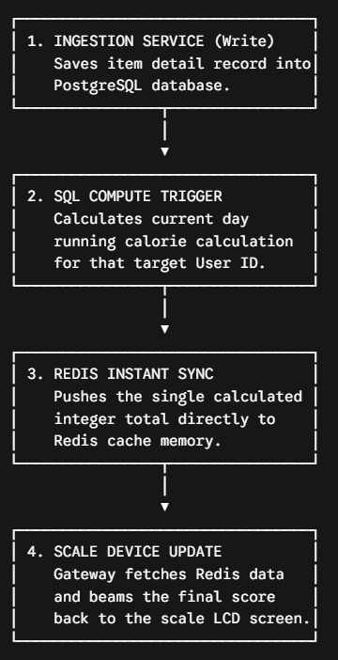
└─────────────────────────────────┘
Because PostgreSQL handles the relational integrity (tracking names, weights, timestamps, exact metrics) and Redis handles raw, high-velocity reading values (storing a simple string like user_101_cal_total: 420), your data pathways remain incredibly organized and performant.

Workflows
