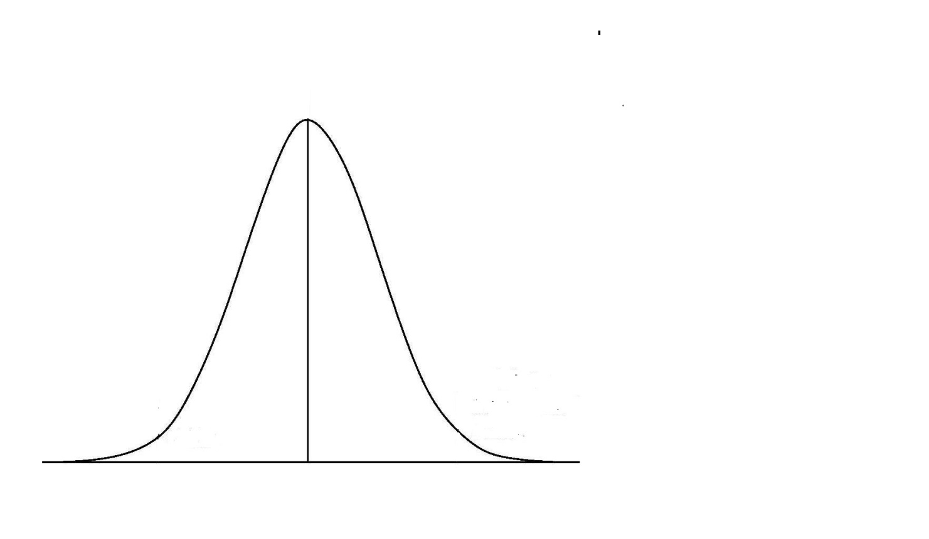

Requirement of Nutrient X

6.0

EAR

Woman A requires 3.0 mg of nutrient X

Woman B requires 7.0 mg of nutrient X to demonstrate the same level of normal function of the endpoint chosen to denote adequacy

EAR = Estimated Average Requirement = 6mg.

10.0

7.0

B

3.0

A