TambonX — User Manual (English)
  - Oct 18, 2026
Contents

1. Getting started
This manual covers every menu in the current system. Button and menu names are given in Thai as they appear on screen, with an English gloss.

Sign in
- Open the system’s website (test server: http://localhost:3000).
- Enter your username (not an email address) and the password your administrator gave you.
- If you see “บัญชีนี้ยังไม่ได้กำหนด role หรือขอบเขตพื้นที่ดูแล” (no role or area assigned), ask your administrator to set your role and area.
- Sign out with “ออกจากระบบ” (Sign out) at the bottom of the left sidebar.

Left sidebar
The top shows “ขอบเขตการดูแล” (your area), followed by 13 main menus. A red number on a menu is the count of items waiting to be acknowledged.
Menu (Thai) | English | Used for | Section
ภาพรวมเมือง | City overview | Situation summary, open tasks, weather, population | 2
แผนที่เมือง | City map | Area analysis and flood simulation | 2
เหตุการณ์ทั่วไป | Incidents | Take and track reports | 4
ภัยพิบัติ | Disasters | Assessment and response plans | 4
กฎการประเมินทรัพยากร | Resource rules | Formulas that estimate required resources | 4
กิจกรรมในพื้นที่ / ข่าวประชาสัมพันธ์ / กล้องวงจรปิด / โครงการ | Events / Public news / CCTV / Projects | Day-to-day records (public news: section 7) | 5
นำเข้าข้อมูล | Data import | Base data and custom datasets | 3
ผู้ช่วย AI | AI assistant | Ask questions, get charts and reports | 6
จัดการผู้ใช้ / ตั้งค่าระบบ | Users / Settings | Administrators only | 8

User roles
Task | System admin | Sub-district admin | Sub-district staff
Area visible | Whole country | Own office only | Own office only
Record and acknowledge incidents | Yes | Yes | Yes
Escalate an incident to a disaster | Yes | Yes | —
Create events, CCTV and projects | Yes | Yes | Yes (edit own only)
Import and edit datasets | Yes | Yes | Read only
Manage users | Everyone | Own office | —
Settings | System + AI | Office settings | —
Every page shows a pop-up “มีเหตุการณ์แจ้งเข้ามาใหม่” (new incident reported) when something new arrives. Click “เปิดดูเหตุการณ์” (view incident) to open it.

2. City overview and maps

City overview (ภาพรวมเมือง)
The first page after sign-in, top to bottom:
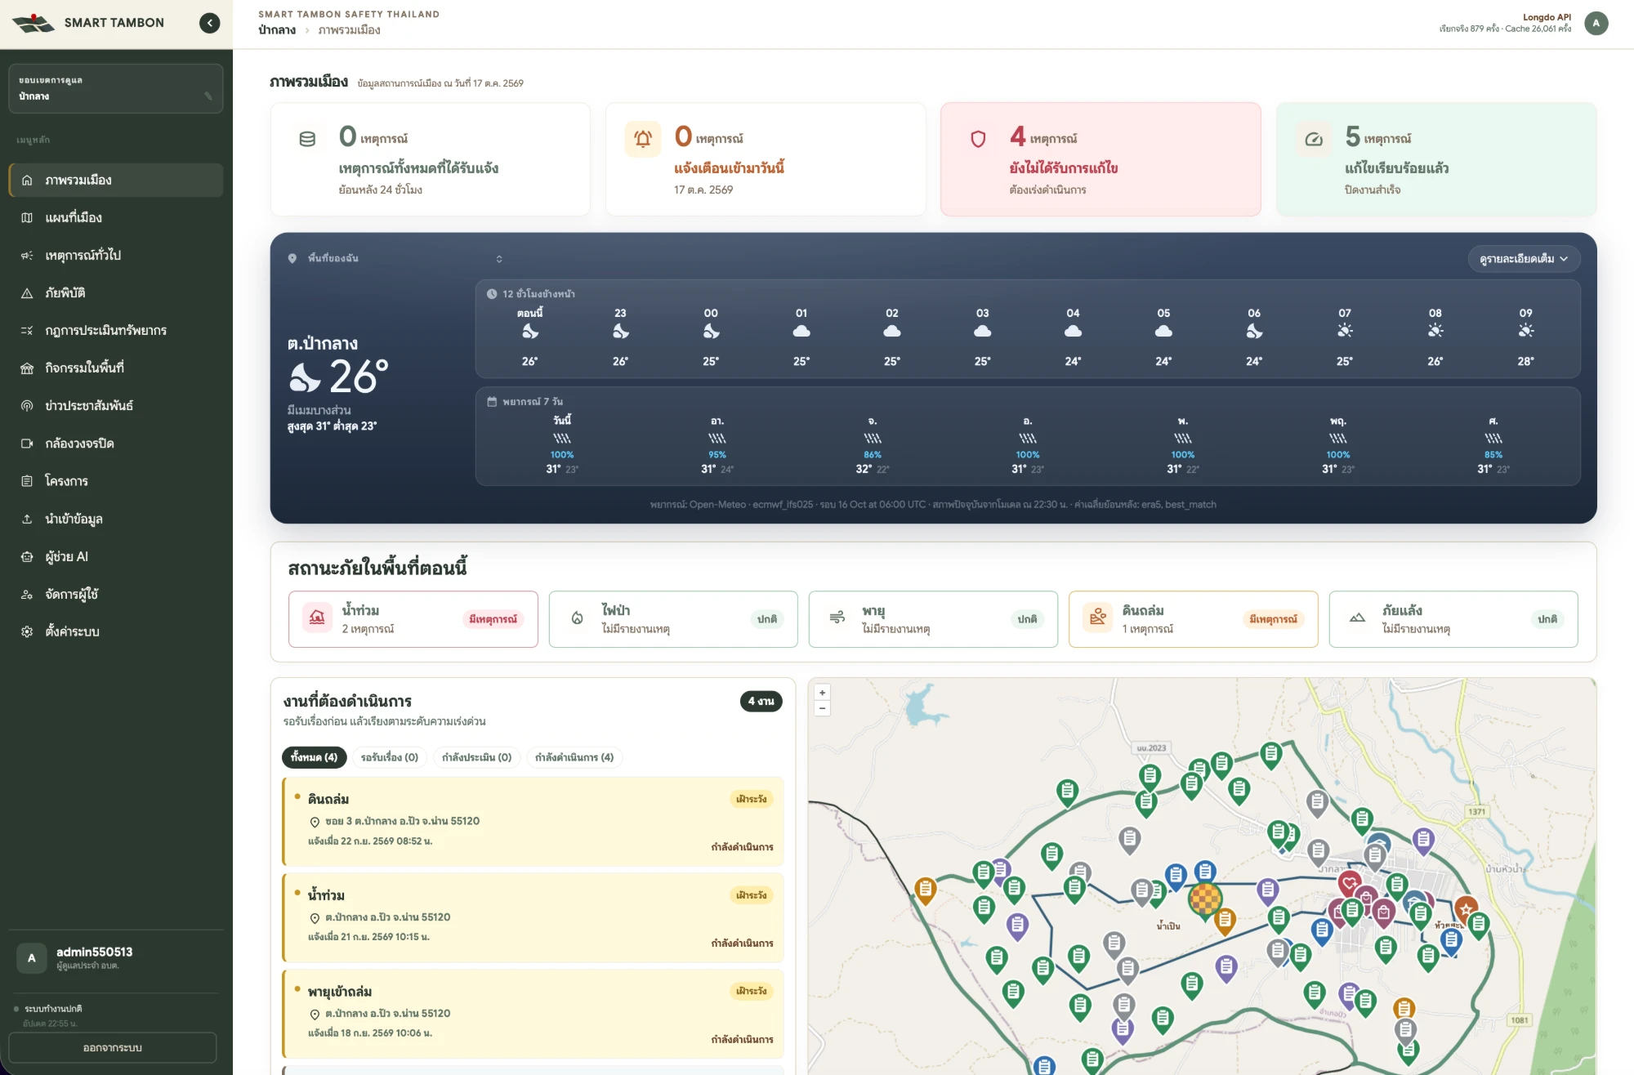
City overview: incident summary cards, weather forecast, hazard status, open tasks and map
- Summary cards: incidents reported in the last 24 hours, alerts received today, unresolved, resolved
- Weather: current conditions, next 12 hours and a 7-day forecast for your sub-district
- Hazard status now (สถานะภัยในพื้นที่ตอนนี้): active incidents by type — flood, wildfire, storm, landslide, drought
- Open tasks (งานที่ต้องดำเนินการ): filter All / Pending / Assessing / In progress, then click a task for details
- Area map: switch Street (ถนน) / Satellite (ดาวเทียม) and toggle layers: water and rain stations, CCTV, fire hotspots (24 h / 48 h / 7 days), events, projects, village boundaries, and 8 place categories
- Weather and air quality: PM2.5, temperature and rain per sub-district with the data source
- Sub-district basics: area (km²), villages, population per village, resources and teams (ready / not ready) — filled in once you import data (section 3)
System administrators pick a province, district or sub-district from the search box and the area tree in the sidebar. Office accounts open on their own area automatically.

City map: area analysis (แผนที่เมือง)
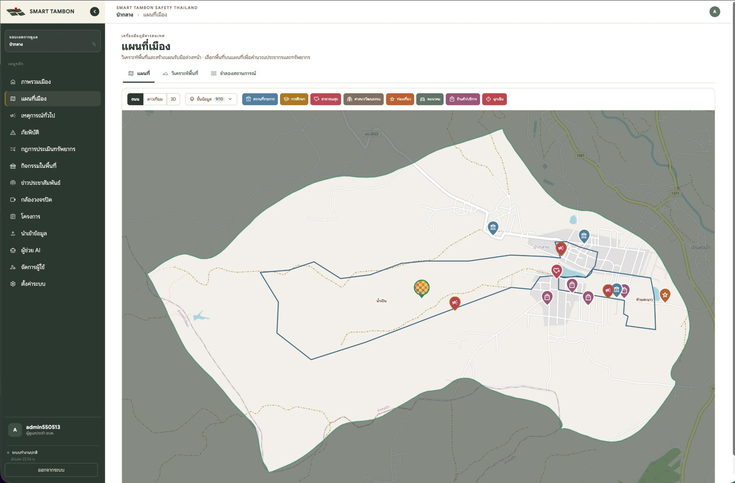
City map: sub-district boundary, village boundaries and key places by category
- Open แผนที่เมือง and choose the วิเคราะห์พื้นที่ (Area analysis) tool.
- Choose Point / Line / Area and set a buffer in metres if needed.
- Pick the hazard type to plan for and draw on the map.
- Read the result: affected area (km² / rai / m²), estimated population and households, matched rules, resources needed against resources on hand, and affected key places.

Flood simulation
- Choose จำลองสถานการณ์ (Simulation); floods are currently supported.
- Set water rise (cm) and rainfall (mm).
- Click the start button and pick a point on the map; the system uses terrain elevation to compute the flooded area.
- Click clear to start again.
Note: estimated population is proportional to the share of the total area you drew. Treat it as a first estimate.

3. Data import (นำเข้าข้อมูล)
This menu holds your office’s base data; every other page (overview, assessment, incident intake, AI) reads from it. Staff accounts are read-only; administrators add and edit.
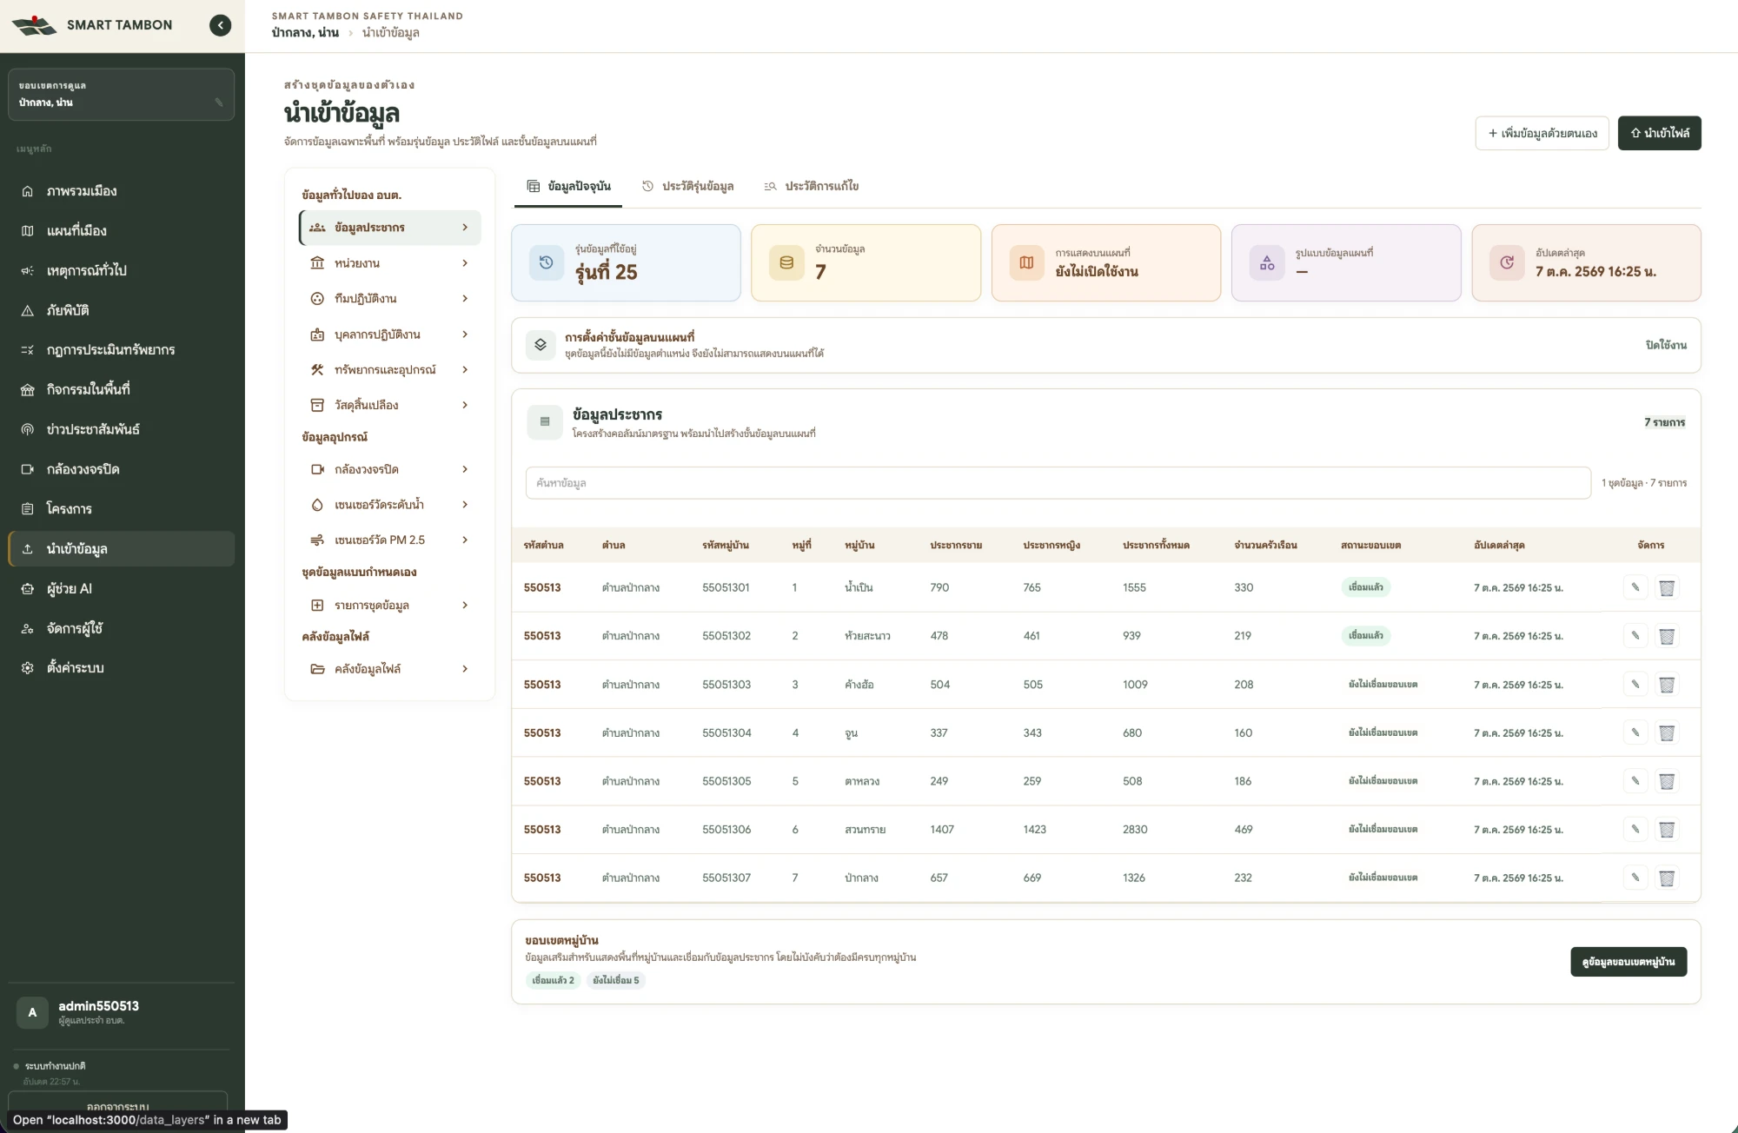
Data import: population for 7 villages, version 25, with village-boundary link status

Data types
Group | Dataset | Main fields
Office base data | Population | Village no., village name, male / female / total population, households
 | Agencies | Name, type, contact, phone, email, map location
 | Teams | Team name, leader, area covered, team status
 | Personnel | Full name, position, skills, team, readiness
 | Resources and equipment | Name, registration, type, readiness, storage location
 | Consumables | Unit, quantity on hand, low-stock threshold
Devices | Water-level / PM2.5 sensors | Sensor ID, coordinates and a generated token to configure on the device
Custom datasets | Dataset list | Define up to 50 columns of your own
File library | — | The original of every imported file, downloadable

Import a file (6 steps)
- Pick a dataset and click ⇧ นำเข้าไฟล์ (Import file). The first time, click ดาวน์โหลด Template to get a file with Thai column headers.
- Upload a CSV / XLS / XLSX / PDF file of up to 20 MB and 25,000 rows.
- Map columns: the system matches columns automatically; check and adjust.
- Validate: review errors (up to 30 shown); fix the file and upload again if needed.
- Preview the data before saving.
- Version and layer: choose replace (ใช้ข้อมูลจากไฟล์แทนข้อมูลเดิม) or append (เพิ่มข้อมูลจากไฟล์ต่อจากข้อมูลเดิม), name the version, decide whether to show it on the map, then Finish.
An unfinished import expires after 2 hours.

Add or edit single records
- Click ＋ เพิ่มข้อมูลด้วยตนเอง (Add manually) to fill in a form. Agencies can be pinned on the map; village boundaries can be drawn or uploaded as GeoJSON.
- The ข้อมูลปัจจุบัน (Current data) tab lets you search, edit and delete rows.
- Population: click จับคู่ข้อมูลประชากรกับขอบเขตหมู่บ้าน to link rows to village boundaries by village code or sub-district + village number.
- Consumables: click บันทึกความเคลื่อนไหว to record receive / issue / return / stock-count adjustment; the history is under “ประวัติรับเข้า–เบิกออก”.
- Turn on แสดงในชั้นข้อมูล to show a dataset with coordinates on the map.

Versions and history
- Version history (ประวัติรุ่นข้อมูล): every import or edit creates a new version you can view, download as the original file, or restore.
- Edit history (ประวัติการแก้ไข): who added, changed or deleted what, with before and after values.

4. Incidents, disasters and public reporting
Incident statuses · 3 statuses + disaster escalation
Pending | → | In progress | → | Completed
 |  | ↓ admin may escalate
 |  | Disaster (assessment + response plan)
Every case starts as Pending. Acknowledging it moves it to In progress, and from there an admin can escalate it to a disaster.
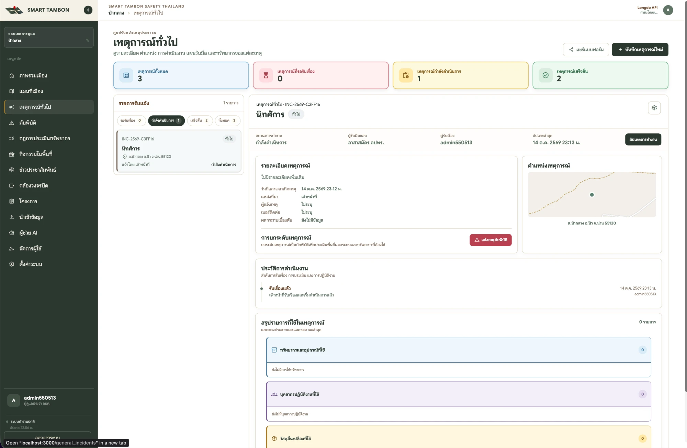
Incidents page: status summary cards, the report list and incident details

Record a new incident (staff)
- Open เหตุการณ์ทั่วไป (Incidents) → บันทึกเหตุการณ์ใหม่ (Record new incident).
- Enter a title, choose the type (flood, wildfire, storm, landslide, drought, other) and urgency (critical → general).
- Add details, reporter, phone and initial impact.
- Click the map to pin the location and attach up to 8 photos (JPG/PNG/WebP, 10 MB each).
- For a past event, tick “เป็นการบันทึกเหตุการณ์ย้อนหลัง” (backdated) and set the date and time. The system issues a reference like INC-2569-XXXXXX (Buddhist-era year).

Acknowledge and track
- Pick an incident from the list (filter All / Pending / In progress / Completed).
- Click รับเรื่อง (Acknowledge) and choose the responsible team (import teams first, section 3).
- Click อัปเดตการทำงาน (Update progress) to log progress, the person responsible and resources used. Consumables are deducted from stock automatically; you cannot use more than is available.
- Set the status to Completed when the work is done. Every step is logged in the action history (ประวัติการดำเนินงาน).
ลบข้อมูล (Delete) hides a case from the list; the original record stays in the database.

Disasters and response plans (admins)
- On an acknowledged incident, click แจ้งเหตุภัยพิบัติ (Report disaster); it moves to the Disasters menu.
- Click ประเมินสถานการณ์ (Assess), draw the affected area, then save the result as a new version.
- In the response plan, compare resources needed / on hand / sufficient or insufficient, then click “เลือกใช้ Version นี้” (use this version). Edit lines with “แก้ไขทรัพยากร”.

Resource rules (กฎการประเมินทรัพยากร)
Rules let an assessment compute resources on its own, for example “flood with more than 500 people → 1 sandbag per 2 households” (an illustration, not a built-in rule).
- Open the menu → สร้างกฎใหม่ (New rule).
- Rule details: name, hazard type, severity (watch / urgent / critical).
- Conditions: water level, rain, wind, hotspots, population, households, area. At least one must be population or area; the rule fires when any condition is true.
- Formula: resource + amount per N people / households / villages / area.
- Review and save. Turn a rule on or off with the active switch.

Public incident report form
Staff share the link: Incidents → แชร์แบบฟอร์ม (Share form) → pick the source (residents, agencies, health centre) → copy or share. Each source has its own permanent link, so you know where each report came from.
Residents report (no login):
- Open the link on a phone.
- Fill in type, urgency and details; attach up to 8 photos.
- Tap the map or “ใช้ตำแหน่งปัจจุบัน” (use current location); the pin must be inside the sub-district.
- Enter name and phone, tick consent and tap “ส่งข้อมูลแจ้งเหตุ” (submit).
- A confirmation page appears and the case arrives as Pending straight away.

5. Events, projects, CCTV and monitoring data

Local events (กิจกรรมในพื้นที่)
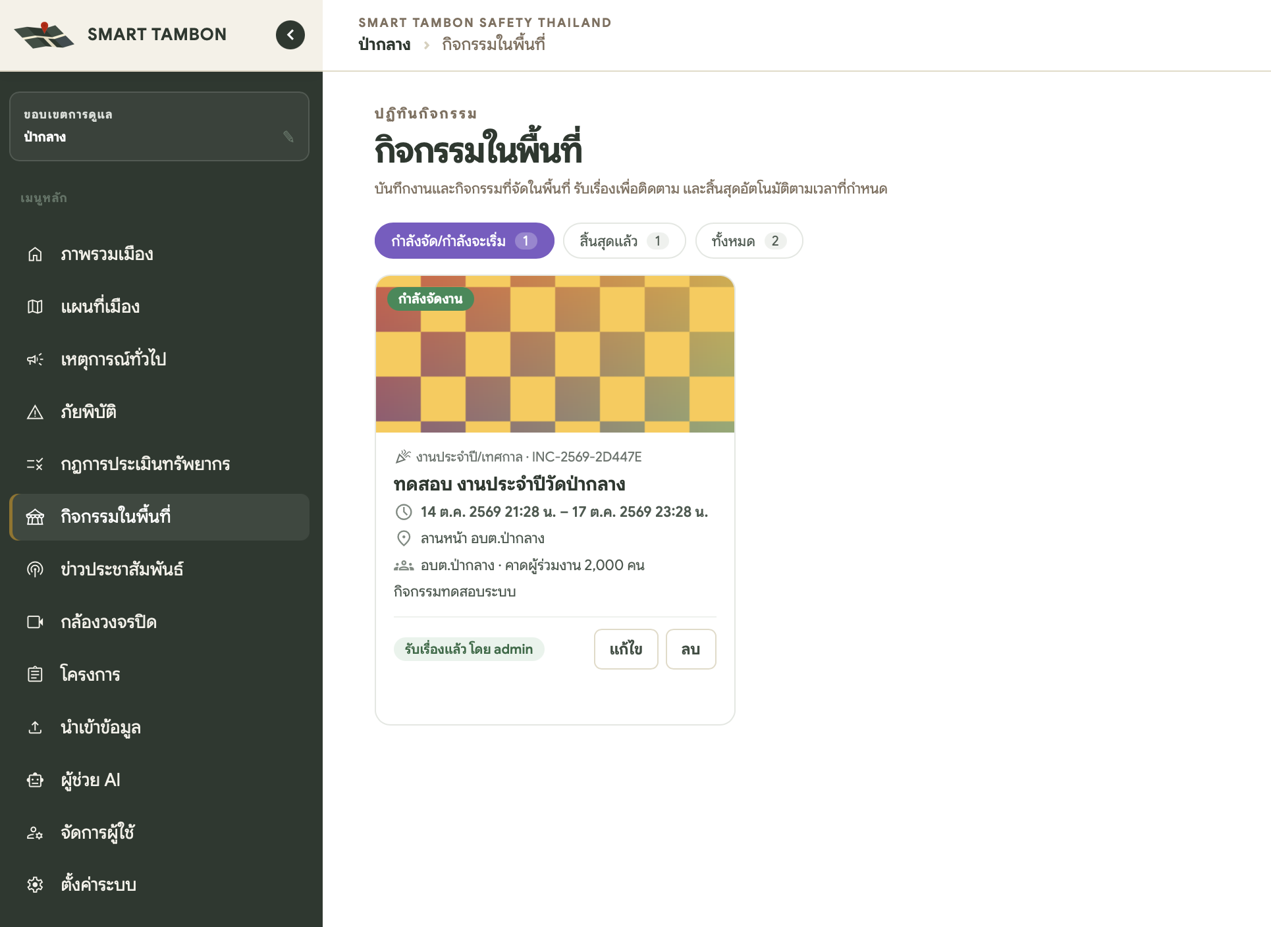
Local events: a card for an event in progress with dates, venue and expected attendance
- Open กิจกรรมในพื้นที่ → add an event.
- Enter the name, type (annual festival, religious / tradition, sports, market fair, meeting / training, mobile service unit, other) and start / end time.
- Add the organiser, expected attendance, coordinator and phone.
- Add a main photo (shown as the map icon) and pin the venue (it must be inside your sub-district).
Events have three phases — upcoming, in progress, ended — and close automatically at their end time.

Projects (โครงการ)
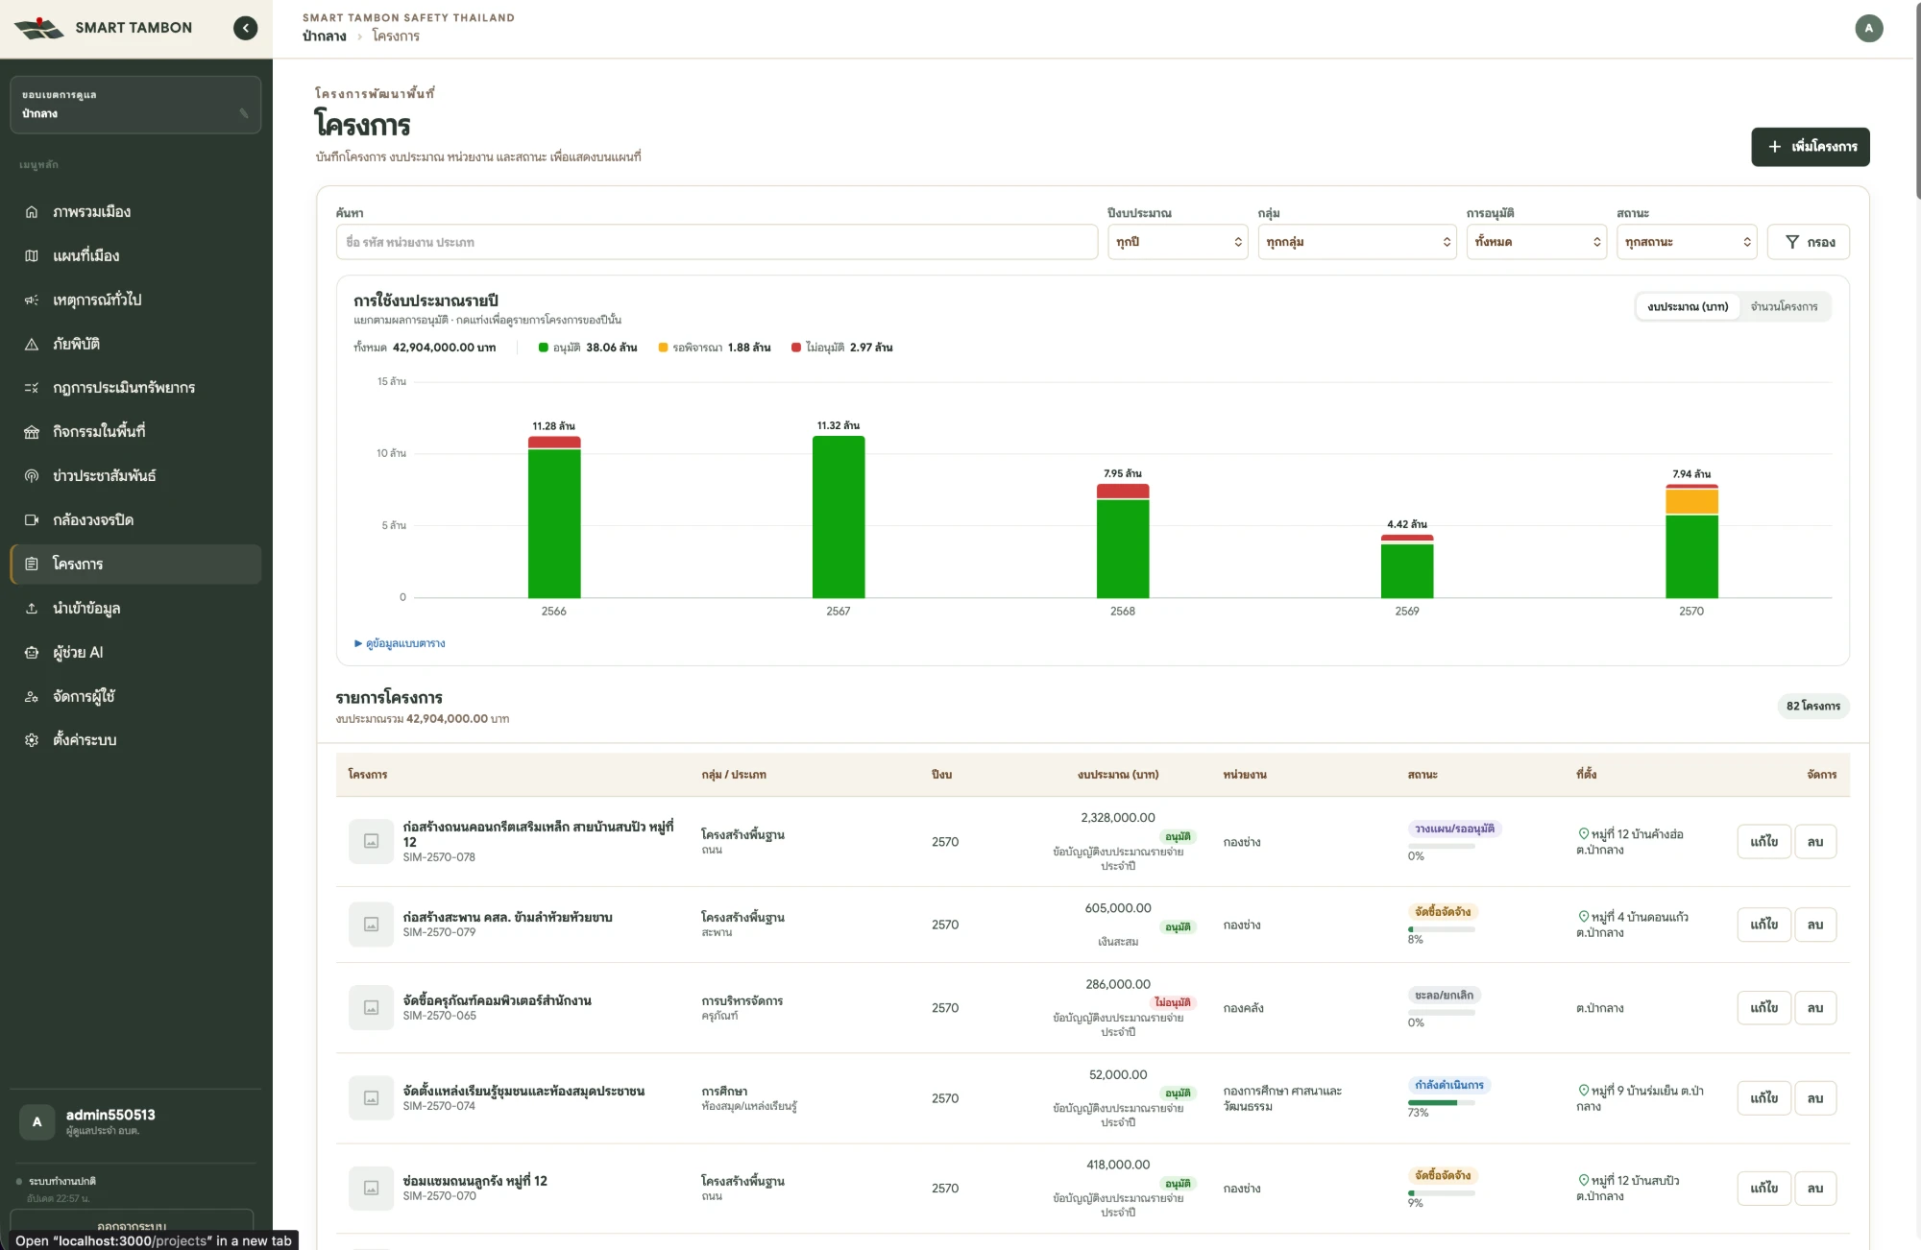
Projects: yearly budget chart by approval status and the project list
- Open โครงการ → เพิ่มโครงการ (Add project).
- Enter the name, project code (e-plan / contract no.), group (10 groups such as infrastructure, water and agriculture, public health) and responsible unit.
- Enter the fiscal year (Buddhist era, starting 1 October), budget (THB), approval result, funding source, status and progress (%).
- Attach photos and pin a location (optional).
The yearly budget chart switches between baht and number of projects; click a bar to filter that year, or open the table view. Filter the list by search / fiscal year / group / approval / status.

CCTV (กล้องวงจรปิด)
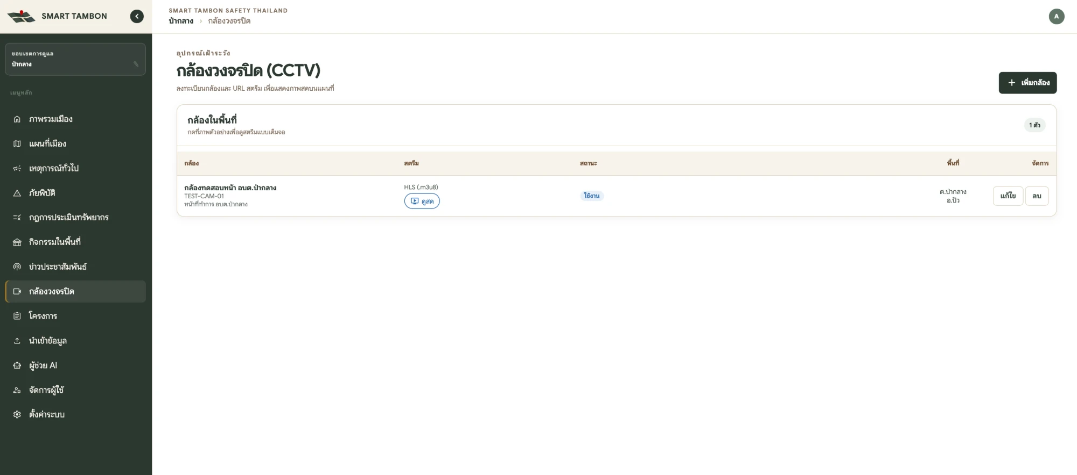
CCTV: camera list with stream type, status and a live-view button
- Open กล้องวงจรปิด → เพิ่มกล้อง (Add camera).
- Enter the name, camera code, status (active / maintenance / disabled) and place name.
- Paste the stream URL; the type is detected (HLS .m3u8 / MJPEG / MP4-WebM / Embed). Click ทดสอบสตรีม (Test stream).
- Pin the location and save. Watch live with ดูสด (Live).
RTSP/RTMP links cannot be played directly; ask IT to convert them to HLS with MediaMTX or go2rtc first.

Monitoring data (automatic)
Data | Where to see it | Source
PM2.5, temperature, rain | City overview (per sub-district) | Your own sensors → ThaiWater → GISTDA
Water and rain stations | Map layer | Dept. of Water Resources, ThaiWater
Fire hotspots | Map layer (24 h / 48 h / 7 days) | NASA FIRMS
Weather forecast | City overview | Open-Meteo
Your own sensors | PM2.5 card and AI assistant | Register under Data import → Devices, then set the token on the device

6. AI assistant (ผู้ช่วย AI)
Ask in plain Thai and the system searches your area’s data, then answers with text, charts or tables. If you see “ยังไม่ได้เปิดใช้ผู้ช่วย AI” (AI not enabled), a system administrator must set up a provider first (section 8).
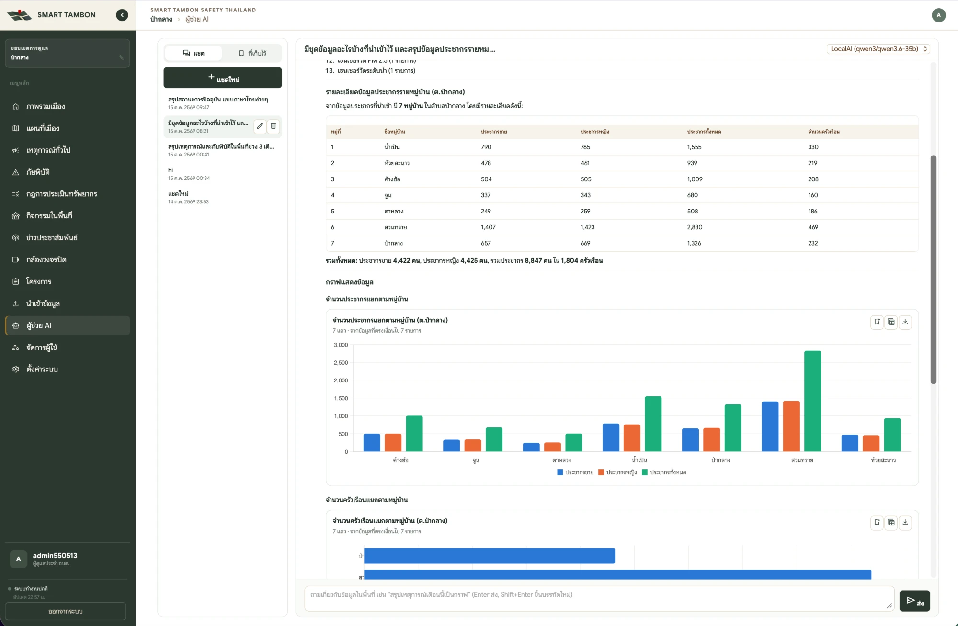
AI assistant answering a question about population by village with a table and chart

Ask a question
- Open ผู้ช่วย AI → the แชต (Chat) tab and choose a model from “เลือกโมเดล AI”.
- Type a question or click a suggested one.
- Wait for the answer; it appears in one go when complete and can take a few moments.
- On a chart, click “สลับกราฟ/ตาราง” (chart/table) or “ดาวน์โหลด CSV” (download CSV). Print or copy the whole answer with “พิมพ์ / PDF” or “คัดลอก”.
Example questions
- Summarise incidents for the last 3 months by status as a chart
- Project budget per fiscal year by group
- Latest PM2.5 and water-level report
- Compare population across villages

Keep a report for reuse
- Click “เก็บผลลัพธ์” (keep the whole answer) or “เก็บกราฟนี้ไว้รันใหม่” (keep this chart).
- Open the ที่เก็บไว้ (Saved) tab, set a from / to date range and re-run it for fresh data — good for monthly reports.
- Click “ให้ AI สรุปใหม่” to have the AI rewrite the summary from the new data.
- Click “แชร์ใน อบต.” to share it with colleagues in your office.
The AI sees only what your account can see and never sees reporters’ names or phone numbers. Check key figures before using them in official documents.

7. Public news, village PA and notification channels
The AI drafts news from real data in the system; staff review it, generate a read-aloud voice, and publish to the village loudspeakers, Facebook, Instagram and chat groups from one place.
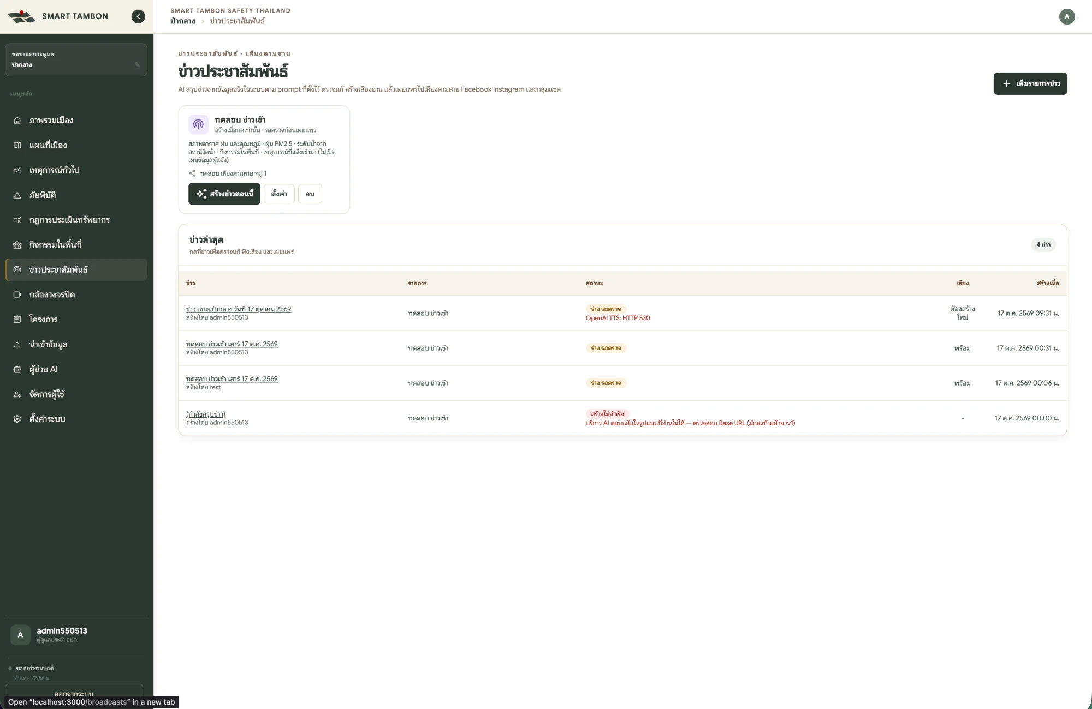
Public news page: news programmes, the create-now button and the latest bulletins with status

Set up a news programme (e.g. a 07:00 morning bulletin)
- Open ข่าวประชาสัมพันธ์ (Public news) → เพิ่มรายการข่าว (Add programme).
- Name it, edit the prompt (the instruction the AI writes from) and choose data sources: weather, PM2.5, water levels, fire hotspots, events, incidents (reporters never disclosed), disasters, projects.
- Set the days and times to generate automatically, or choose “สร้างเมื่อกดเท่านั้น” (on demand only).
- Pick the AI model, the voice (TTS), the maximum length (50–1,000 words) and the publishing channels.
- Choose auto-publish, or keep each bulletin as a draft for review (recommended).

Review and publish a bulletin
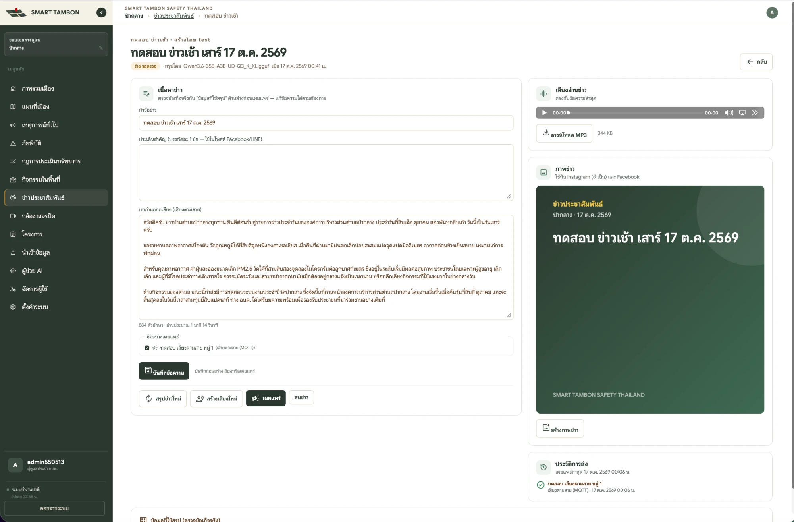
News review screen: content, read-aloud script, MP3 voice, news image and delivery history
- Click สร้างข่าวตอนนี้ (Create now) or wait for the scheduled time, then open the bulletin from the latest-news table.
- Check the headline, key points (one per line, used in Facebook/LINE posts) and the read-aloud script against “ข้อมูลที่ใช้สรุป” (source data) at the bottom.
- Edit the text and click บันทึกข้อความ (Save text) — always save before generating voice or publishing.
- Click สร้างเสียงใหม่ (Generate voice) and listen in the audio box (MP3 download available). Click สร้างภาพข่าว (Create image) if posting to Instagram, which requires an image.
- Tick the channels and click เผยแพร่ (Publish). The result for each channel appears in the delivery history.
If a bulletin shows “สร้างไม่สำเร็จ” (failed) or a TTS error, ask a system administrator to check the AI or voice provider settings (for example, the Base URL must end in /v1).

Notification channels (sub-district admins)
Set these up under ตั้งค่าระบบ (Settings) → the ช่องทางแจ้งเตือน (Channels) tab. Each channel chooses what it receives: new incidents, new disasters, new events, announcements or public news. Edit message wording in the เทมเพลตข้อความ (Templates) tab and send a test from ทดสอบการส่ง (Test send).
Channel | What you need
LINE OA (group) | Group ID (starts with C) — invite the system’s LINE OA to the group and type “groupid” there
Telegram | Chat ID (groups are usually negative); use the shared bot or your office’s own bot
Signal | Group ID (group.…) or a +66… number
Facebook Page | Page ID and Page Access Token — posts text with the news image
Instagram (Business) | Instagram User ID and Access Token — every post needs an image
Village PA (MQTT) | MQTT topic — the loudspeaker device downloads the audio file and plays it
Webhook (other systems) | Target URL — the system POSTs JSON signed in the X-SmartTambon-Signature header

8. Administrator tasks

Manage users (จัดการผู้ใช้)
- Open จัดการผู้ใช้ → add a user.
- Enter a username (lowercase a–z, digits, dot, _ and -), a password and its confirmation.
- Choose the role (สิทธิ์ผู้ใช้งาน).
- System admins also set the area: area name, organisation type (SAO / municipality), then either pick sub-districts (search and select several) or upload a boundary file (KMZ / KML / GeoJSON / Shapefile ZIP).
Sub-district admins can create accounts only inside their own office; the area is inherited, and at least one admin must remain. Rename your area with the “✎” button in the sidebar.

Office settings (ตั้งค่า อบต., sub-district admins)
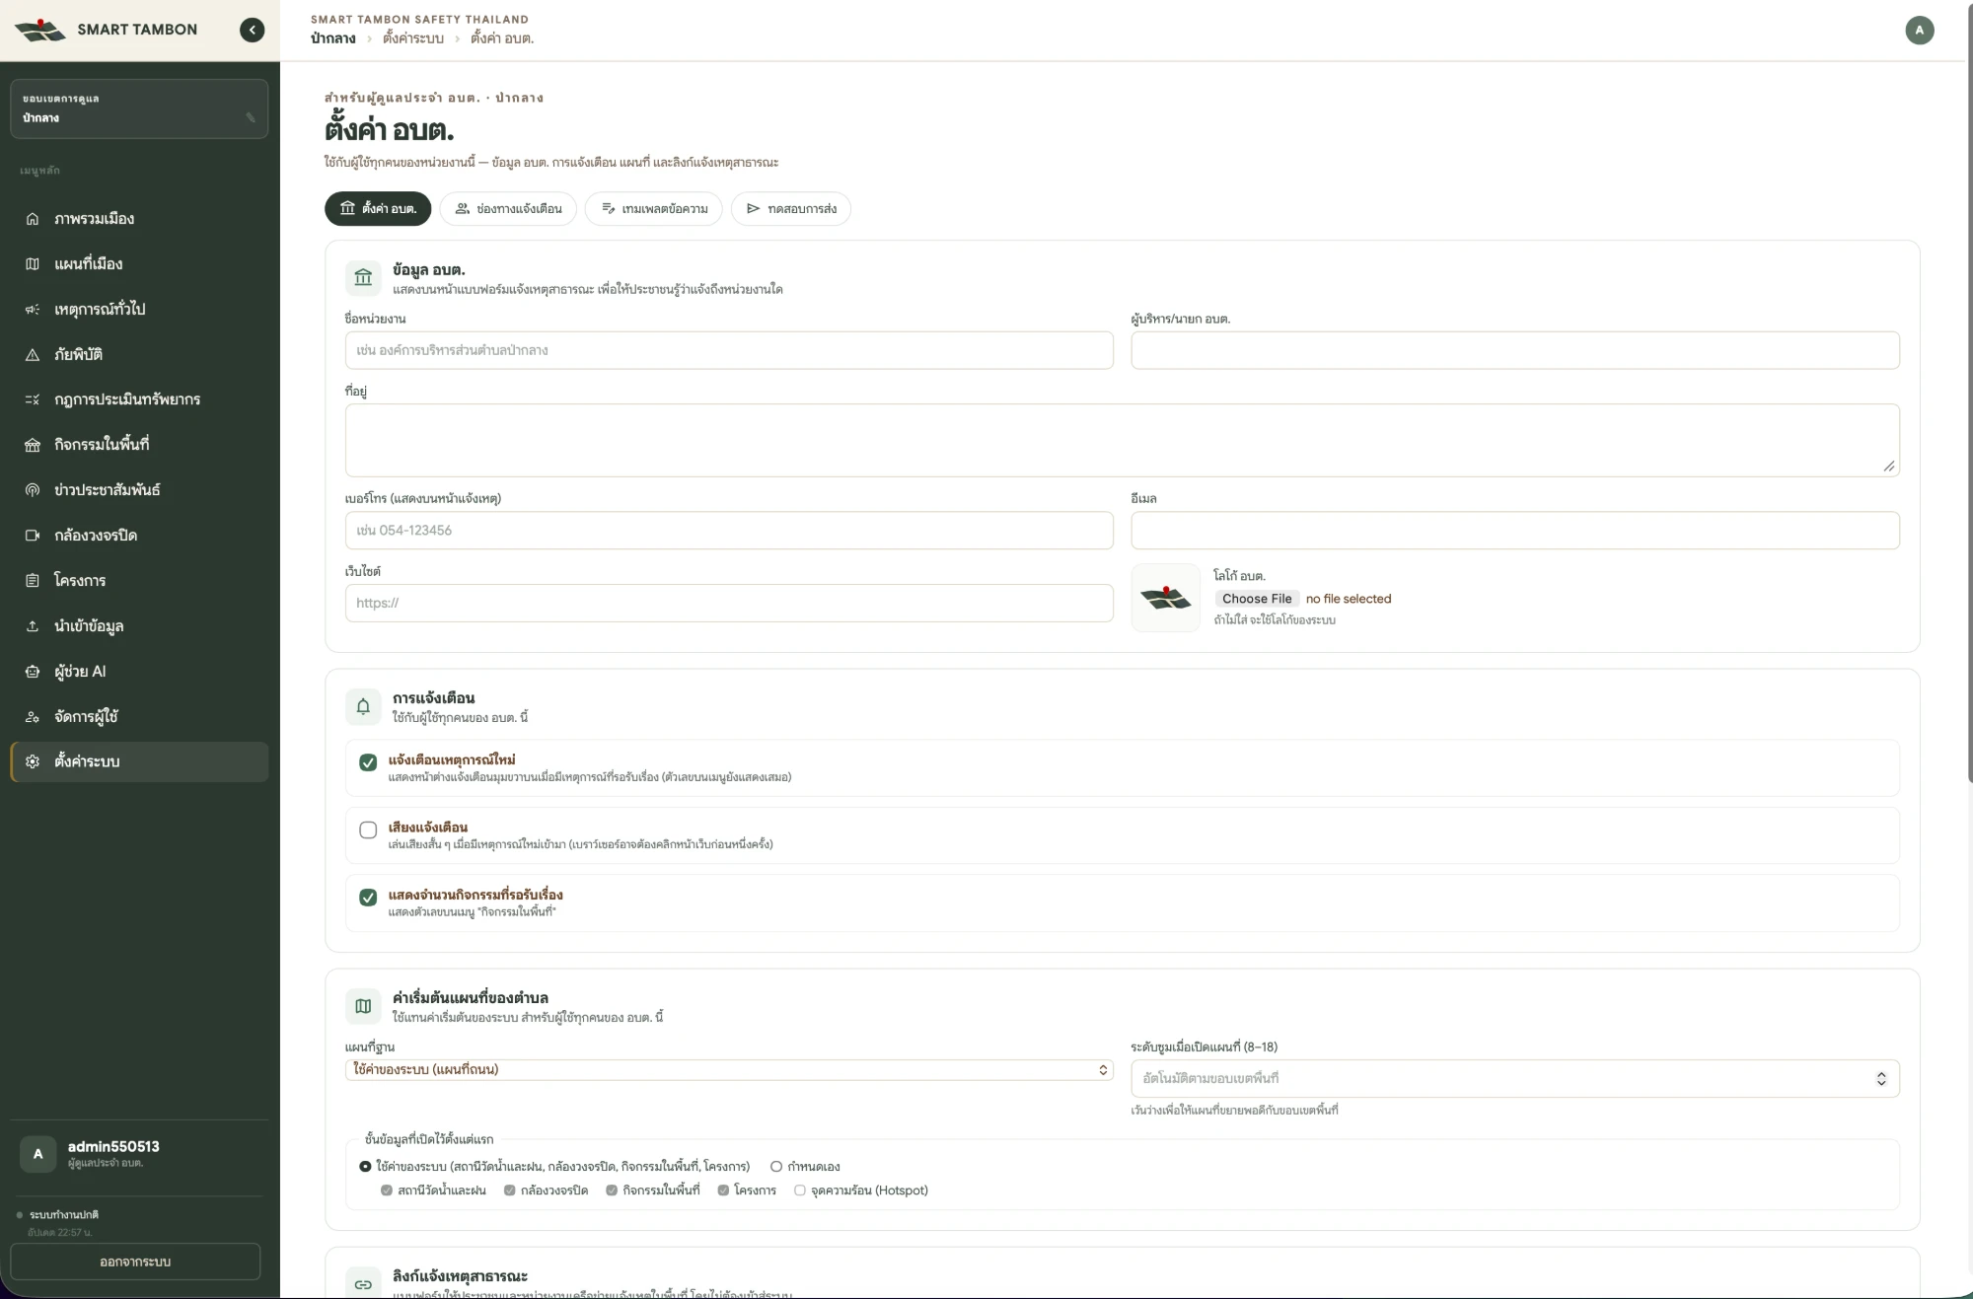
Office settings: office details, alerts and map defaults
Area | What you can set
Office details | Name, executive, address, phone (shown on the public form), email, website, logo
Alerts | New-incident pop-up, alert sound, pending-events badge
Map | Basemap, zoom level (or fit to boundary), layers shown by default
Public report link | Open / close reporting, welcome text, sources (one per line), and “สร้างลิงก์ใหม่” (new links — old links stop working at once)
Channels, templates, test send | See section 7

System settings (system admins)
- System-wide settings: system name, short name, logo, login message, Longdo / MapTiler keys, geocoder URL and map defaults.
- System status: checks the databases, MinIO, MQTT, Longdo, the geocoder and the sync jobs, shown as OK / check / error.
- AI providers: add Claude (Anthropic API) or an OpenAI-compatible endpoint (OpenAI, Ollama, vLLM, LM Studio, Typhoon, OpenRouter, LocalAI). Enter the model, Base URL and API key, then click “ทดสอบ” (Test) and “ตั้งเป็นค่าเริ่มต้น” (Set as default). The model must support tool calling. A local model keeps all data in-house.

9. FAQ and troubleshooting
Problem | Cause / fix
Signed out immediately after signing in | The account has no role or area yet; ask an admin to set it under Users
No “Import file” button | Sub-district staff accounts are read-only; use an admin account
Cannot acknowledge — no team to choose | Teams have not been imported yet under Data import
Population on the overview shows 0 | Population data has not been imported yet
A resident cannot submit a report | The pin is outside the sub-district, or the office has closed reporting (the page then shows the office phone or 1669/191)
An old report link no longer works | Someone clicked “new links”; share the new link again
CCTV shows no picture | The link is RTSP/RTMP and must be converted to HLS first; use “Test stream” to check
A file import fails | Use the system’s template, keep files under 20 MB / 25,000 rows, and fix the errors listed in the Validate step
Wrong dataset imported, need the old data back | Version history → pick the earlier version → restore
A news bulletin failed or has no voice | Check the AI and TTS provider settings (Base URL ending in /v1, valid key), then click Generate voice again
The village loudspeaker did not play | Check the MQTT topic on the channel and that the device is online, then use Test send
AI assistant unavailable | No AI provider is enabled; a system admin must set one up and click Test
Need an Excel export of incidents or projects | There is no direct export button yet; ask the AI assistant and click “Download CSV”

