**Inspiration:**

Inspiration project 1: "silk"  
 <http://weavesilk.com/>

Silk is an interactive and free, generative art internet program and app that can be used for create very neat patters, this program has inspired me to make my program include a drawing element, in my generative art project, you can control the shape that is drawing using the arrow keys to change the shapes direction/velocity and mouse button the change the shapes colour.  
  
inspiration project 2: "DVD screensaver"   
<https://www.youtube.com/watch?v=x949Kl3k5Do&feature=youtu.be>

This is a screensaver of an old DVD player, it is displayed when there has been a lot of inactivity while using the device, all it really is is the words "DVD video" bouncing around the screen and changing colours, my project also includes a simple object (a random shape in my case) bouncing off walls of the canvas area, and changing colours each time. However, this alone does tell me that something like this is or at least was commercially viable on its own  
  
inspiration project 3 "Paperboy"

<https://www.youtube.com/watch?v=DAKnKCVrs7c>

Paperboy is an old video game on the NES (Nintendo entertainment system) from this game I have got the inspiration for general retro graphics, as well as a fake 3D effect using 2D sprites, where in Paperboy the developers used a kind of fake isometric effect, I used fake lighting by changing the brightness to add a kind of depth to my shapes, such as on my cross shape, the direction the shape is traveling combined with slowly getting lighter allows you to see the whole shape, and it looks a bit like its slowly popping out the screen, similar thing happens with my box that slowly gets darker. Also all the random colours creates a lot of contrast and general brightness, resembling a lot of old retro style games.

**Development:**

I Started by making the canvas the required size (594x841). Then I created the background, using a for loop to make the background blue and yellow lines, and a black rectangle on top of that to make the "work space".

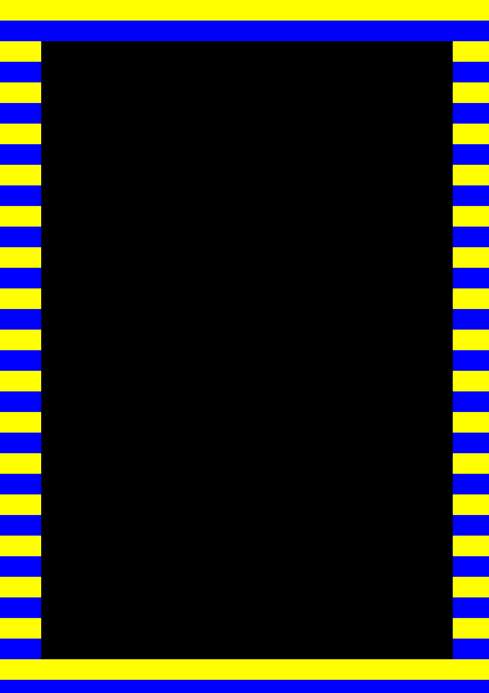

Next, I had to create my individual shapes, them being a donut shape, a cross, and a box with a whole in, and added t their size and colour. I used functions to create these shapes.

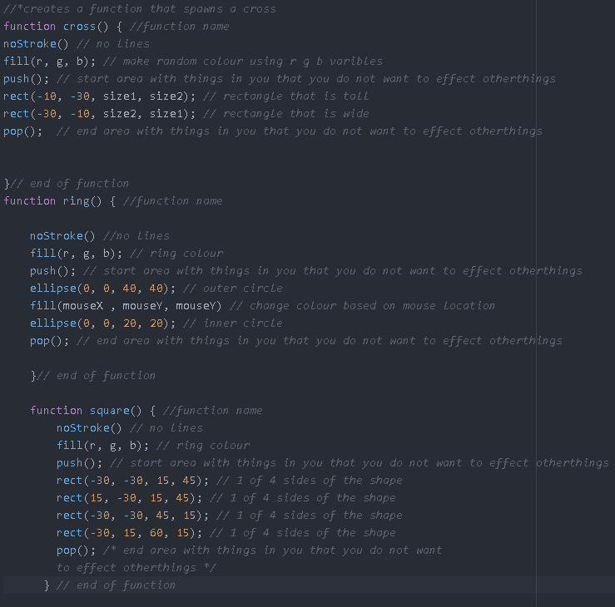

I started off by just using the cross, and added animation to this shape first, I added random movement to begin with as well as making the shape change colour on impact with the walls and when I hold down the mouse button.

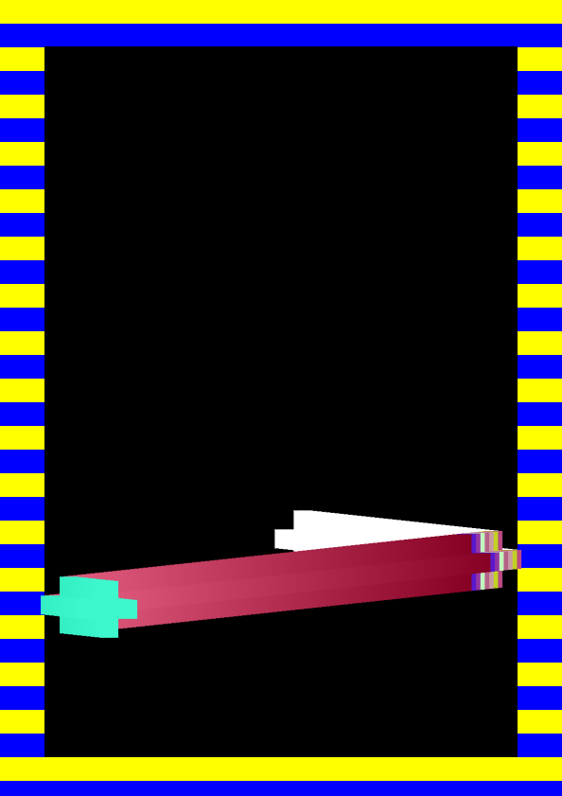

After I got one shape working, I made a system to random choose a shape each time the page is refreshed using a similar system to the random colour, but with 3 numbers added together and then divided by, this system caused me a lot of problems that I will get to later.

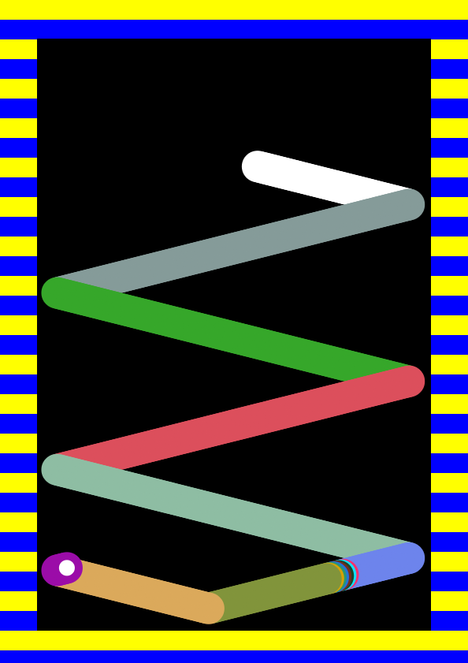

Despite the shape changing, the system was still a little boring, so I decided to add a bit more organic motion into my project, for this I made my box constantly veer off towards the bottom left corner and pick up momentum for every frame that it is not touching a wall of the rectangle, this creates a pseudo -gravity effect as well as helps to make each shape different.

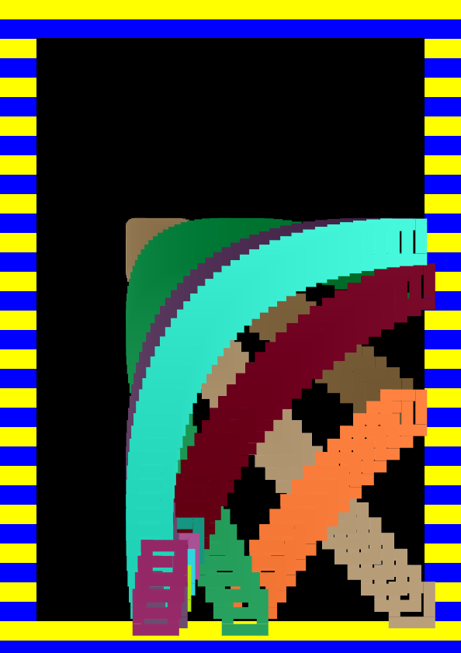

Lastly, I added away for user to be able to control the shapes, because while I was happy from the art side was concerd I felt that the program was a bit empty and slow without any input form the user other than the ability to change the shapes colour, so I added controls for the user to be able to move the shape using the arrow keys.

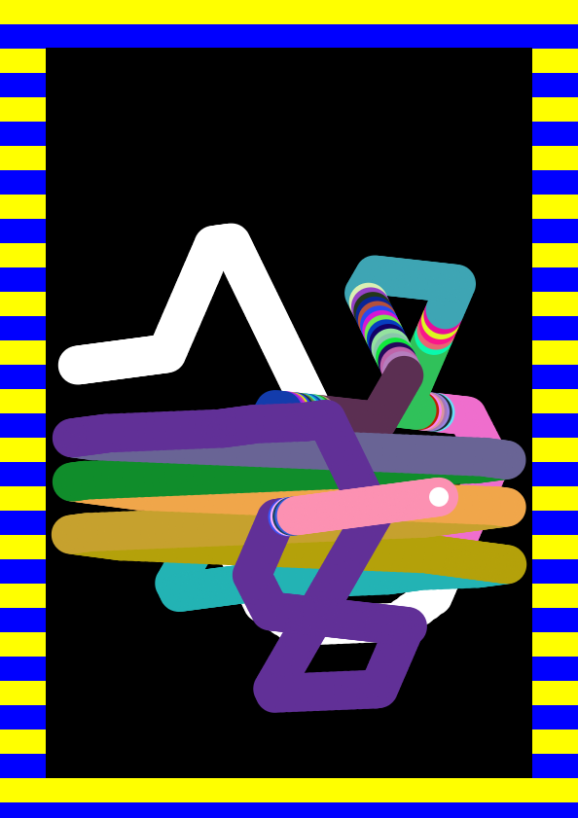

**Problems:**

1 big problem I had was trying to get my program to randomly select a shape, there where multiple factors for this, one of which is that I had my ring function inside of the cross function to begin with, and also my code was flawed on a fundamental level, as I had 3 numbers combine and then divide by 3, so it always printed very close to the average, so one shape only every really showed up, but with the help of debugging in the console I managed to get a more even spread.

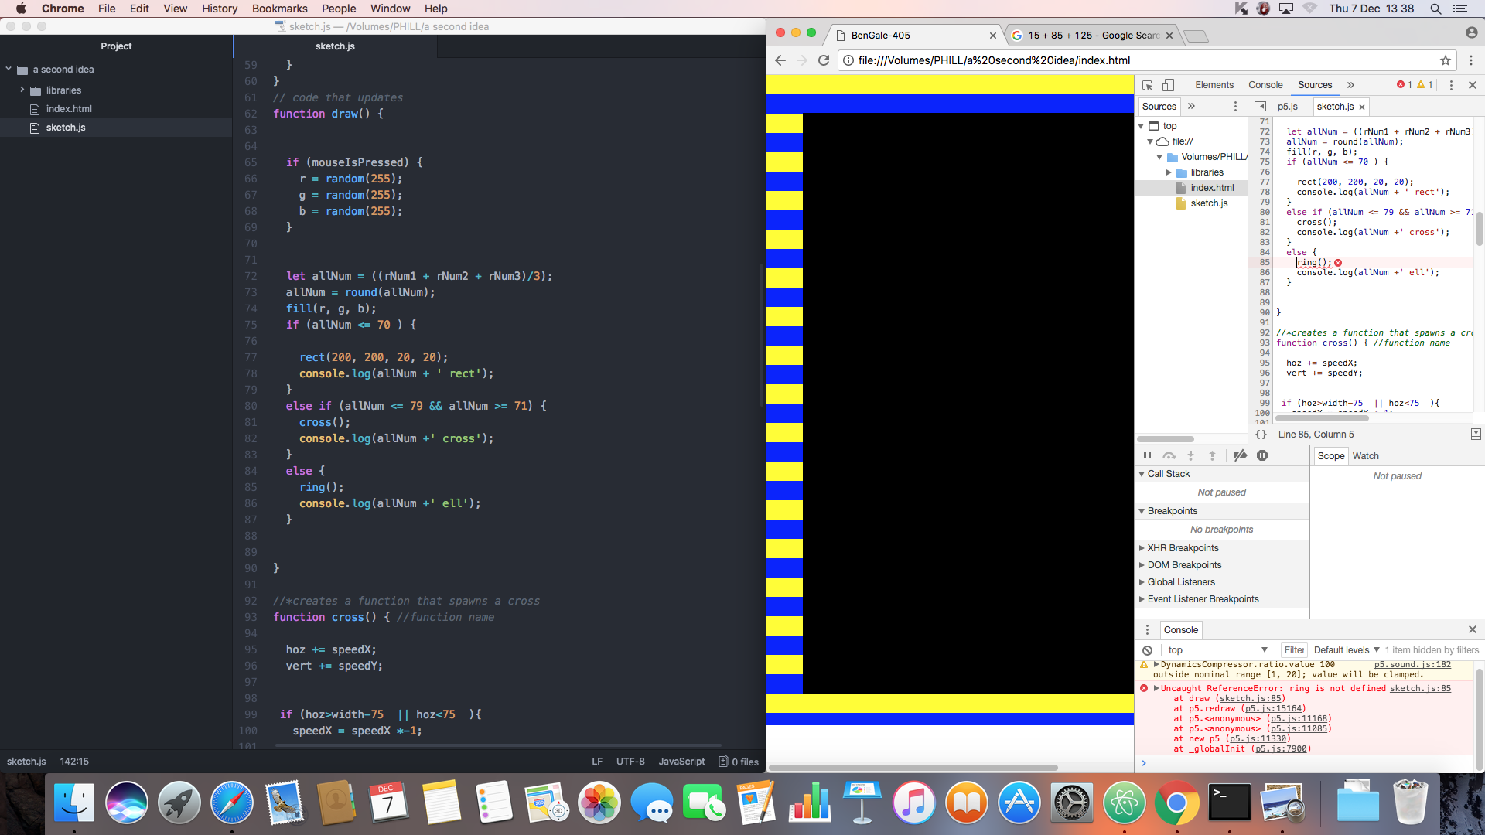

Another problem I didn’t really solve was that sometimes my shape would spawn outside of the black square, eventually using the controls I made a work around, so you can just move the shape into the black square area, but also the effect eventually grew on me, as it looks like a retro style computer glitch with its constant flashing and bouncing in the area very quickly.

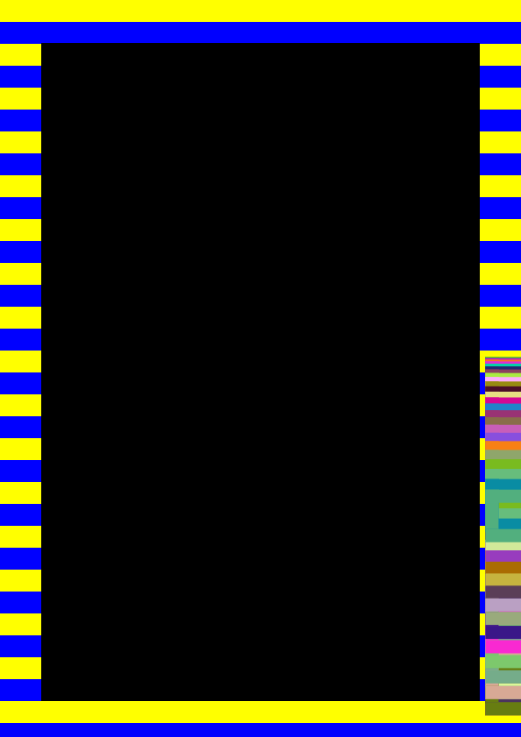

One thing I wanted from the beginning was the have the lines behind you change colours (the blue and yellow ones) however I couldn’t find a practical way of doing so, as I would have needed those lines to be in draw instead of setup, and if I did that, I would need the back square to also be in draw otherwise it would print once and then be behind the lines, but doing this would have meant that my shapes wouldn’t leave a trail, and would just float around bumping into things and changing colors, but not really generating any kind of art.

**Upgrades.**

If I was to continue this project, I would upgrade it with smother controlling, and more randomized shapes for a little more Varity, as well as a way to wipe the screen clear without having to refresh the page.

**References.**

<http://weavesilk.com/>

<https://www.youtube.com/watch?v=x949Kl3k5Do&feature=youtu.be>

<https://www.youtube.com/watch?v=DAKnKCVrs7c>