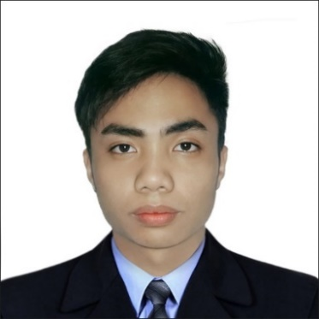

 Chris Jhovin C. Cabral

Location: Cainta Rizal, Philippines Contact Number: 09567980605 Email: [chrisjhovincabral26@yahoo.com](mailto:chrisjhovincabral26@yahoo.com)

**Professional Profile**

Professional and diligent technician authorized, with a tract record of delivering excellent customer experience and commanding front of house operations for highly regulated environments and high-profile corporate organizations.

My objective is to look for a job that will help me enhance my skills and also for some other benefits of the company. Experienced working with at risk young people and adults, with genuine interest in making positive difference in the lives of others.

**Core Skills**

* Business Administration
* Reception
* Security
* Customer Experience.
* Call Handling.
* Knowledgeable in using Firewall (PFSENSE).
* Installing different types of phones (eyebeam, Zoiper and etc.).
* Knowledgeable in Google forms and Documents.
* Knowledgeable in Hardware, Software and Internet Connection.
* Knowledgeable in Cs6 Photoshop and Adobe Premiere.
* Knowledgeable in Microsoft Office Word, Excel & PowerPoint.
* Typing speed above 50 words per minute.
* Knowledgeable in CCTV installing and Maintenance.

**Knowledge in Programming Language.**

* Introduction of Programming (C – Language)
* C++
* C# (Microsoft.NET(Visual Basic)
* JavaScript (React JS, Monggo DB)
* PHP (Laravel)
* Structured Query Language (MySQL, Firebase)
* Native Python

**________________________________________________________________________________**

**Career Summary**

**Software Design Engineer 12/2021-Present**

Unit 814 West Tektite Tower, PSE Center. Exchange Rd. Ortigas Center, Pasig City, Metro Manila

* Web design and development.

**Shuttle Car Driver 08/2020-07/26/2021**

5 Eastwood Mall Ave, Quezon City, Metro Manila

* Driving 4 wheels car.

**Computer Technician and Dealer 07/2019-01/2020**

Lot 2, Blk. 126 K66 Karangalan Village Cainta, Rizal, Philippines

Self-Employed

* Reseller.
* Computer Repairman hardware to software.

**Sage One Global Solution Inc. IT Officer 12/2017-01/2019**

21st Floor Tycoon Centre Ortigas, Pearl Drive Ortigas Center,

San Antonio Pasig City 1605

* Maintenance Worker.
* Installing different types of phones (eyebeam, Zoiper and etc.).
* Using Firewall (PFSENSE).
* CCTV installing and Maintenance.

**Tech Mahindra Call Center Agent 08/2017-12/2017**

Felina, 5 Eastwood Ave, Quezon City, Metro Manila

* Globe Network
* Technical Support
* Customer Care

**Jollibee Dinning Crew 08/2016-12/2016**

Marikina-Infanta Hwy, Antipolo, 1870 Metro Manila

* Cleaning the facility.
* Cashier.

**Educational Attainment.**

* **Coding Bootcamp**
  + Full-Stack Web Development
    - KodeGo
* **College**
  + CSDP (Computer System Designing & Programming)
    - AMA Computer Learning Center.

**Attended seminars, and training programs.**

* CS6 Photoshop Free Training (ACLC Cainta)
* Adobe Premiere (Micro Cadd)
* On the Job training (IT Staff) in Sta. Lucia East Grand Mall
* Awareness Seminar and Fire Prevention Trainings

**Character Reference.**

* **Frances Aileen Abing**
  + Wilking Global Inc. Office staff
  + 0906-503-4922
* **Romnick Agluba**
  + D.I.Y. Hardware Supervisor
  + 0906-273-3408
* **John Oliver Enriquez**
  + Hinduja Global Solution Customer Service Representative
  + 0975-178-6231