

A MINOR PROJECT REPORT ON
“CONTEXT- AWARE SURVEILLANCE SYSTEM FOR
INTRUSION AND THREAT DETECTION”

Submitted in the Partial Fulfillment of the Requirements for the Degree of
Bachelor of Computer Engineering
Awarded by Kathmandu Engineering College
Affiliated to Tribhuvan University

Submitted By:
Samip Shrestha [KAT080BCT066]
Shreeya Shrestha [KAT080BCT077]
Sudarshan Baral [KAT080BCT082]
Suyasa Sigdel [KAT080BCT085]

Department of Computer Engineering
Kathmandu Engineering College
Tribhuvan University

June 2026

ACKNOWLEDGEMENT
We would like to express our sincere gratitude to the Department of Computer Engineering, Kathmandu Engineering College, for providing us the opportunity and resources to complete this minor project. We are deeply thankful to our project supervisors, Er. Riju Bajracharya, Er. Sharad Chandra Joshi, for the continuous guidance, valuable feedback, and encouragement throughout the development of this work.
We are also grateful to the Minor Project Coordinator, Krista Byanju, for the coordination and support during the project, and all the faculty members of the department whose suggestions helped us shape the direction of the project. Finally, we thank our friends and families for their constant motivation and support.
Submitted By:
Samip Shrestha [KAT080BCT066]
Shreeya Shrestha [KAT080BCT077]
Sudarshan Baral [KAT080BCT082]
Suyasa Sigdel [KAT080BCT085]

ABSTRACT
Conventional Closed-Circuit Television (CCTV) systems are largely passive: they record continuous footage but rely on human operators to watch the feeds and identify threats. This makes monitoring labor-intensive, prone to fatigue, and ineffective at scale, while automated systems that do exist tend to generate a high number of false alarms that erode operator trust.
This project presents a real-time surveillance system that focuses on understanding activities through detection and context. The system processes video frames in real time and uses the YOLOv8 object detection model: a pretrained model is used for person detection, while a custom model was fine-tuned on a domain-specific weapon and violence dataset of approximately 7,400 images using transfer learning, achieving a mean Average Precision (mAP@50) of 85.5%, with the weapon (gun) class reaching 97.5%.
A key limitation of detection-only systems is their inability to interpret context. For example, a knife displayed for sale in a shop versus a knife used as a threat. To address this, the proposed system introduces a context-aware decision layer that evaluates contextual factors such as time, zone, and situation before raising an alert. Detected events are intended to be logged for operator review, and alerts are delivered through on-screen and sound notifications. The system is implemented in Python using OpenCV and is designed to run in real time on consumer hardware, demonstrating a more reliable, context-sensitive, and privacy-preserving approach to automated surveillance.
Keywords:
Real-Time Surveillance, Context-Aware Analytics, Weapon Detection, Violence Detection, False-Alarm Reduction, YOLOv8, Privacy-Preserving Surveillance

TABLE OF CONTENTS
ACKNOWLEDGEMENT i
ABSTRACT ii
TABLE OF CONTENTS iii
LIST OF FIGURES iv
LIST OF TABLES v
ABBREVIATIONS vi
CHAPTER 1: INTRODUCTION 1
1.1. Background Theory 1
1.2. Problem Statement 3
1.3. Objectives 3
1.4. Scope and Applications 3
1.4.1. Scopes 3
1.4.2. Applications 3
CHAPTER 2: LITERATURE REVIEW 5
2.1. Review of Existing Systems 6
2.2 Research Gap and Motivation 7
CHAPTER 3: METHODOLOGY 9
3.1. Process Model 9
3.2. System Block Diagram 10
3.3. Algorithm 12
3.4. Flowchart 13
3.5. Use Case Diagram 14
3.6. Sequence Diagram 15
3.7. Activity Diagram 16
3.8. ER diagram 18
3.9. Tools Used 19
3.10. Verification and Validation 19
3.10.1 Verification 19
3.10.2 Validation 20
4.1. Task completed 21
4.2. Remaining Tasks 21
REFERENCES 23
BIBLIOGRAPHY 25
SCREENSHOTS 25

LIST OF FIGURES
Figure 3.1: Iterative and Incremental Process Model……………………………………...….9
Figure 3.2: System Block Diagram…………………………………….…………………….11
Figure 3.3: Flowchart…………………………………….…………………..………………14
Figure 3.4: Use Case Diagram…………………………………….…………………..……..15
Figure 3.5: Sequence Diagram……………………………………………………………….16
Figure 3.6: Activity Diagram………………………………………………………………...17
Figure 3.7 ER Diagram………………………………………………………………………18
Figure 5.1: Gantt Chart………………………………………………………………….……22

LIST OF TABLES
Table 1: Comparison of Surveillance Approaches…………………………………………….4
Table 2: Verification and Validation Results..….…………………………………………….11

ABBREVIATIONS
Abbreviation | Full Form
AI | Artificial Intelligence
API | Application Programming Interface
CCTV | Closed-Circuit Television
CNN | Convolutional Neural Network
CUDA | Compute Unified Device Architecture
FPS | Frames Per Second
GPU | Graphics Processing Unit
GUI | Graphical User Interface
mAP | mean Average Precision
NMS | Non-Maximum Suppression
ROI | Region of Interest
VLM | Vision-Language Model
YOLO | You Only Look Once

CHAPTER 1: INTRODUCTION

1.1. Background Theory
Surveillance systems are widely used in educational institutions, offices, parking areas, and restricted zones to monitor activity and maintain security. Traditional CCTV systems are mainly designed to capture and store footage for later viewing, but they do not automatically interpret what is happening in the scene. As a result, human operators must continuously watch the video feed, which is difficult in large-scale environments. This limitation has led to the development of intelligent surveillance systems that use computer vision and deep learning to analyze live video automatically. Object detection is one of the most important techniques in such systems because it allows the identification and localization of objects in each frame using bounding boxes and class labels. In surveillance applications, object detection is commonly used to detect persons and other suspicious objects in real time [1].
A major foundation of intelligent surveillance is computer vision, which allows machines to interpret visual information from images and video. One of the most important computer vision tasks in surveillance is object detection, where the system identifies objects in a frame and localizes them using bounding boxes. Each detected object is assigned a class label and confidence score, which makes it possible to detect people and other relevant objects in real time. Unlike image classification, which gives only one label for the whole image, object detection can identify multiple objects at once, making it more suitable for surveillance scenes that often contain several moving subjects [1].
Real-time object detection is commonly achieved using YOLO, a single-stage detection framework designed for speed and efficiency. YOLO detects objects in one forward pass of the neural network, which makes it suitable for applications that require low latency. Because surveillance systems must process video continuously, fast inference is a major advantage. Over time, YOLO-based detectors have become popular in security-related applications because they offer a strong balance between accuracy and runtime performance [1].
Deep learning models, especially Convolutional Neural Networks, are widely used for extracting visual features from images and video frames [2]. CNNs learn useful patterns such as edges, textures, and shapes directly from data, which makes them highly effective in vision tasks. In many practical applications, transfer learning is used to adapt a pretrained CNN to a smaller task-specific dataset. This approach is useful when labeled data is limited, because the pretrained model already contains general visual knowledge that can be reused for a new problem [3].
For video analysis, spatial information from a single frame is often not enough because many activities can only be recognized by observing motion over time. Temporal modeling is therefore an important part of intelligent surveillance. Recurrent neural networks such as LSTM are designed to process sequences and retain information across time steps [4], while BiLSTM extends this by analyzing the sequence in both forward and backward directions [5]. This helps the model understand the full context of an action across a short video clip, which is especially useful for recognizing complex behaviors such as fighting or other suspicious movements.
Another key concept in surveillance is multi-object tracking, which assigns a persistent identity to each detected object across consecutive frames. Detection alone only tells the system what is present at a specific moment, but tracking helps determine how long an object remains in the scene and how it moves over time. This is important for understanding dwell time, loitering, and repeated presence in restricted areas. Tracking methods such as ByteTrack improve identity consistency by associating detections across frames, including low-confidence detections that may still correspond to real objects [6].
Violence detection in video is a specialized type of action recognition that focuses on identifying aggressive or harmful behavior from motion patterns and temporal context. It is more challenging than object detection because violent and non-violent actions may appear similar in individual frames. For this reason, clip-based models that combine frame-level feature extraction with temporal sequence learning are widely used in violence recognition. Datasets such as RWF-2000 [7] and RLVS [8] are commonly used in this area because they provide real-world surveillance-style examples that help models learn realistic behavior patterns.
In modern surveillance systems, a single detection is often not enough to decide whether a situation is actually dangerous. Context-aware threat assessment combines multiple cues such as detected objects, crowd size, detection persistence, and time of day to reduce false alarms. This is important because the same scene may be normal in one context and suspicious in another. By combining vision outputs with simple rule-based reasoning, the system can produce more reliable alerts and make the final decision easier for human operators to interpret.

1.2. Problem Statement
Conventional CCTV is passive: it records, but leaves all interpretation to a human operator. AI was meant to fix this, but the face recognition approach rises the problem for privacy, ethical, and legal costs. Even setting identity aside, a detector that flags everything floods the operator with false alarms until the alerts are ignored. For example, a knife displayed for sale in a shop is generally harmless, whereas a knife being carried in a road at night could indicate a potential threat. Without a mechanism to incorporate this situational context, an automated surveillance system cannot reliably tell a dangerous event from a harmless one, and it is this absence of context-aware reasoning that this project sets out to address.

1.3. Objectives
The key objective is:
- To develop a real-time intelligent surveillance system that can automatically detect persons, weapons, and violent activities from video footage.
- To reduce manual CCTV monitoring by generating alerts, assessing threat levels, and supporting faster security response through a web dashboard and email notifications.

1.4. Scope and Applications

1.4.1. Scopes
This project focuses on a real-time surveillance system for intrusion and threat detection. It identifies persons, weapons, and violent activity from video input and generates alerts based on the situation. The system also tracks people across frames and uses context such as time and crowd conditions to reduce false alarms.
- Real-time detection of persons, weapons, and violent activity.
- Tracking of people across video frames.
- Context-based alerts using time and crowd conditions.
- Web dashboard for monitoring and notifications.
- Reduced dependence on manual CCTV watching.

1.4.2. Applications
This system can be used in places where security monitoring is important. It is especially useful in environments that need early detection of suspicious activity and quick response to threats.
- Schools and colleges.
- Offices and restricted areas.
- Parking areas and campuses.
- Security monitoring rooms.
- Places where early threat detection is needed.

CHAPTER 2: LITERATURE REVIEW
Recent research in intelligent surveillance has increasingly focused on deep learning methods for detecting violent behavior in video, particularly architectures that combine a convolutional feature extractor with a temporal model. Vijeikis et al. [13] proposed a lightweight architecture that uses MobileNetV2 as the spatial feature extractor followed by an LSTM for temporal classification, reporting an average accuracy of about 82% on the RWF-2000 dataset while keeping the model small enough (around four million parameters) for deployment on edge devices. Their work is closely related to the present project, as it demonstrates that pairing a lightweight MobileNetV2 backbone with a recurrent temporal model is an effective and efficient approach for surveillance-based violence detection. However, their results also show that real-world datasets such as RWF-2000 remain challenging, with accuracy noticeably lower than on staged datasets such as Hockey Fights or Movie Fights, which suggests that dataset complexity and domain variation still limit generalization.
Weapon detection has also been explored using object-detection frameworks because they support real-time inference and can localize dangerous objects directly in video streams. Early deep-learning approaches such as Olmos et al. [10] framed automatic handgun detection as a problem of minimizing false positives using a convolutional detector, showing that deep networks could flag firearms in surveillance video without human supervision. More recent studies have applied the YOLO family to this task: for example, Khin and Htaik [14] compared YOLOv8 against other detectors such as RetinaNet and EfficientDet for gun detection on a custom dataset and found YOLOv8 to be a strong real-time choice. These works confirm that YOLO-based detectors are practical for real-time weapon detection, but they also show that accuracy depends heavily on dataset quality, weapon type, and scene conditions, and that the presence of a weapon alone does not establish whether a situation is truly dangerous.
Multi-object tracking is another important part of surveillance because it allows a system to maintain object identities across consecutive frames. Zhang et al. [6] proposed ByteTrack, a tracking-by-detection method that associates almost every detection box, including low-confidence ones, to improve trajectory continuity in crowded scenes and under imperfect detections. This makes ByteTrack well suited to surveillance applications where people must be followed across frames to support intrusion monitoring, dwell-time analysis, and suspicious-movement detection. On its own, however, tracking only preserves identities and does not decide whether the observed behavior is normal or abnormal, so it must be combined with detection and contextual analysis to form a complete surveillance solution.

2.1. Review of Existing Systems
Early surveillance systems relied mainly on background subtraction and motion detection to identify moving objects in video. These methods were useful in controlled environments, but they often produced inaccurate results when the background changed because of illumination variation, camera noise, moving shadows, or small objects in the scene. To improve performance, researchers introduced adaptive background modeling and statistical techniques that could update the background over time and separate foreground objects more effectively [9]. Although these approaches improved detection in some cases, they still had difficulty handling complex real-world environments with dynamic scenes.
With the advancement of deep learning, object detection became a major area of research in intelligent surveillance. Single-stage detectors such as YOLO made it possible to detect multiple objects in real time, which is important for live monitoring systems [1]. Compared with traditional motion-based methods, YOLO-based systems can identify specific object classes such as persons, vehicles, and suspicious items with better semantic understanding. However, object detection alone only tells what is present in a frame and does not explain how the scene evolves over time.
To address the temporal aspect of video, multi-object tracking methods were developed to maintain consistent identities across frames. Tracking allows the system to follow a person or object across time and analyze movement patterns, dwell time, and loitering behavior. ByteTrack is a strong example of a modern tracking method because it associates nearly all detections, including low-confidence ones, to preserve trajectories in difficult scenes [6]. Even so, tracking by itself cannot determine whether a person's behavior is normal or suspicious without additional contextual analysis.
Another active research area is violence detection in video. Since violence is a temporal event, it cannot usually be detected from a single frame alone. Researchers have therefore used clip-based methods, 3D CNNs [12], optical flow, and recurrent models such as LSTM [4] and BiLSTM [5] to capture motion and interaction patterns over time. The availability of datasets such as RWF-2000 [7] has helped researchers evaluate violence recognition under realistic surveillance conditions. Despite these advances, many violence detection systems still struggle with false alarms when normal movement appears aggressive in short video segments.
Weapon detection has also received increasing attention in surveillance research because visible weapons can indicate immediate threat. Recent studies have shown that deep learning models can be trained to detect guns, knives, and other dangerous objects in real time [10]. These systems are useful for early warning because they can alert security personnel before a violent incident escalates. However, weapon detection alone is not enough in many cases because the presence of a weapon does not always mean the situation is dangerous unless other contextual factors are also considered.

2.2 Research Gap and Motivation
Although existing research has produced effective methods for object detection [1], tracking [6], violence recognition [7], and weapon identification [10], most systems still focus on these tasks separately. In many cases, a model can detect people or weapons accurately, but it does not evaluate the scene as a whole. This creates a gap in unified threat assessment, where different visual cues should be combined before generating an alert.
Another important limitation in existing systems is the lack of contextual reasoning. A scene that appears suspicious in one setting may be completely normal in another. For example, a crowded schoolyard during a scheduled event should not necessarily trigger an alarm, while a similar crowd after school hours may be unusual. Many existing systems do not consider time of day, event schedules, crowd persistence, or occupancy context, which can lead to unnecessary false alarms and reduced trust in the system [11].
This project is motivated by the need for a more intelligent and practical surveillance system that can combine detection, tracking, violence analysis, and context-aware decision-making in one framework. By integrating multiple vision outputs with rule-based threat assessment, the system can produce more meaningful alerts rather than reacting to each detection independently. This makes the surveillance process more reliable, more interpretable, and more suitable for real-world environments where context plays an important role in determining whether a situation is truly suspicious.

Approach | Event Understanding | Context Awareness | Privacy Preserving
Traditional CCTV | No | No | Partial
AI / Face Recognition | Partial | No | No
Behavior-Based | Partial | Limited | Yes
Proposed System | Yes | Yes | Yes
Table 1: Comparison of Surveillance Approaches

CHAPTER 3: METHODOLOGY

3.1. Process Model
The iterative and incremental process model is a widely used software development approach that combines repeated refinement with gradual feature addition. In this model, the system is not developed in a single step. Instead, it is built through a series of small, manageable cycles, where each cycle produces a working part of the system that is then tested, improved, and extended. This makes the model especially suitable for projects such as our surveillance system, where features need to be developed carefully and integrated step by step.
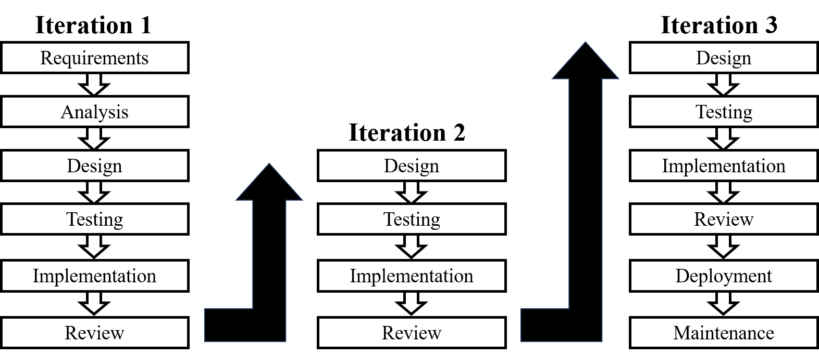
Figure 3.1: Iterative and Incremental Process Model
Initially, we begin with a clear planning phase in which the project goals, scope, and system requirements are identified. For our project, the main requirements included person detection, weapon detection, violence detection, tracking, alert generation, email notifications, and a web-based dashboard. These core features were selected and prioritized so that the system could be developed in a structured manner, with each important function added gradually.
The first iteration focused on developing the basic detection module. In this stage, the system was designed to detect persons in the video feed and identify suspicious objects such as weapons. After this initial version was completed, testing was carried out to check whether the detection results were accurate and reliable. Any issues found during this stage were corrected before moving to the next cycle.
In the subsequent iterations, additional functionality was introduced. Violence detection was integrated to identify abnormal or aggressive behavior in surveillance footage. Then, the tracking module was added so that detected persons could be monitored across consecutive frames. After that, the alert mechanism was implemented to send an email whenever unusual activity was noticed. Finally, the web dashboard was developed to display live video, detection results, and alerts in a user-friendly interface. Each new feature was built on top of the previous one, which allowed continuous improvement throughout the development process.
As each iteration progressed, the system was tested thoroughly to ensure that every module worked correctly and integrated properly with the existing components. Feedback from testing was used to refine the system in the next cycle. This iterative approach helped improve accuracy, reduce errors, and enhance overall system performance. It also made the development process more flexible, since changes could be introduced at different stages without redesigning the entire system.
The incremental nature of the model ensured that the system was delivered in small functional parts rather than as a complete product at the end. This made it easier to manage development, test individual modules, and validate results step by step. Overall, the iterative and incremental process model provided a practical and efficient framework for developing our surveillance system in a controlled and organized manner.

3.2. System Block Diagram
The proposed system follows a modular, privacy-preserving architecture. The pipeline captures live video, detects persons and weapon-like objects, applies context-aware rules, and produces explainable alerts. The overall architecture is shown below.

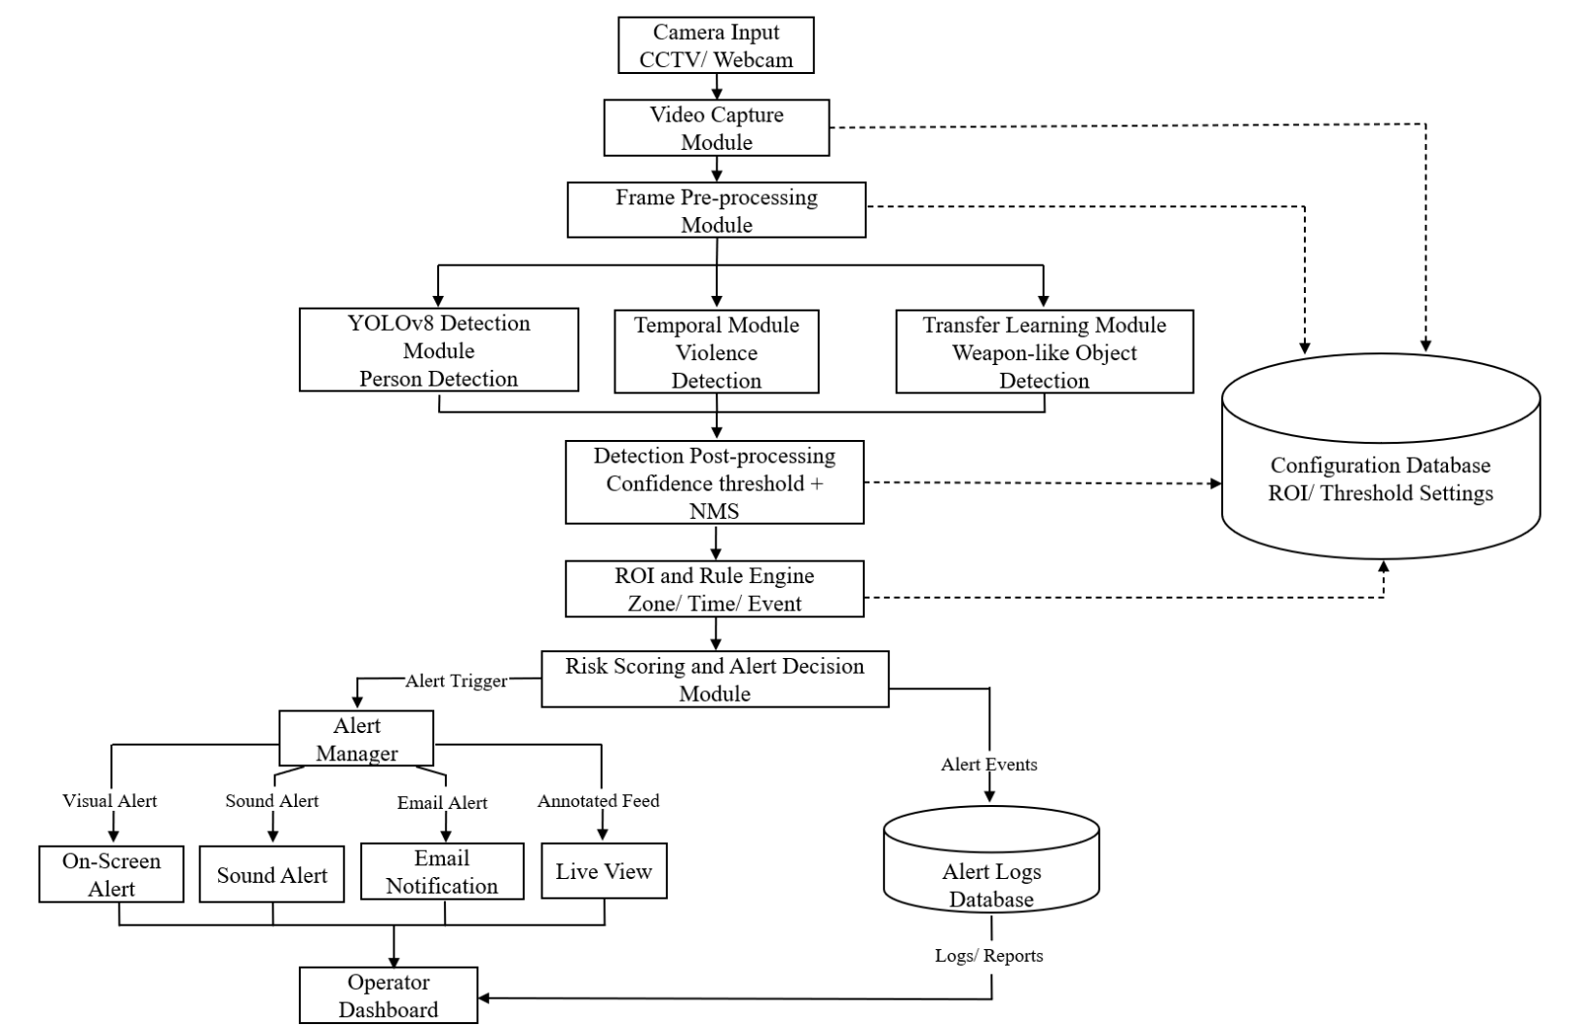

Figure 3.2: System Block Diagram of the Context- Aware Surveillance System
The surveillance system starts by capturing live video from a CCTV camera or webcam. The incoming stream is divided into frames and preprocessed before being sent to multiple analysis modules. YOLOv8 is used for person detection because it provides fast and accurate real-time object detection, while ByteTrack is used to maintain consistent identities across frames for tracking and dwell-time analysis. In parallel, a custom-trained YOLOv8 model detects weapon-like objects such as guns and knives, and a temporal deep-learning model based on MobileNetV2 and BiLSTM analyzes short clips to identify violent behavior.
The outputs from these modules are then post-processed and passed to a rule engine that combines model confidence with contextual factors such as time of day, restricted zones, number of people, persistence of detections, and known event schedules. This context-aware stage reduces false alarms by treating unusual but legitimate situations, such as a scheduled dance program, differently from genuinely suspicious activity. The final risk scoring module assigns an alert tier and triggers visual, sound, or email alerts when necessary. At the same time, all alerts and annotated events are stored in the database and displayed on the operator dashboard for monitoring and review.

3.3. Algorithm
This project uses a combination of deep-learning and rule-based algorithms. The detection of persons, weapons, and violent activity is performed using a Convolutional Neural Network (CNN)-based object detection algorithm, while the alert decision is handled by a context-aware rule-based algorithm. The main algorithms used in the project are described below.
- Convolution Neural Network (CNN)
A Convolutional Neural Network is the core deep-learning algorithm used for image analysis in this project. A CNN automatically extracts features from an image through a series of convolutional layers, where small filters (kernels) slide over the image to detect low-level features such as edges and textures, and deeper layers combine these into high-level features such as shapes and objects. Pooling layers reduce the spatial size and computation, while the final layers use the extracted features to classify and localize objects. The CNN forms the backbone of the detection model used in this system.
- YOLOv8 (You Only Look Once, version 8)
YOLOv8 is the CNN-based, single-stage object detection algorithm used for real-time detection. Unlike multi-stage detectors, YOLO processes the entire image in a single forward pass, predicting bounding boxes, class labels, and confidence scores simultaneously. This single-pass design makes it fast and well-suited for real-time surveillance. In this project, a pretrained YOLOv8 model is used for person detection, and a custom-trained YOLOv8 model is used for weapon and violence detection.
- Transfer Learning
Instead of training a model from scratch, the custom detection model is trained using transfer learning. A YOLOv8 model pretrained on a large general-purpose dataset is taken as a starting point, and its learned features are fine-tuned on the project’s custom weapon and violence dataset. During training, the model iteratively adjusts its internal parameters using backpropagation and gradient descent to minimize detection error. This approach allows an accurate model to be trained with a relatively small dataset and limited computational resources.

- Non-Maximum Suppression (NMS)
Non-Maximum Suppression is a post-processing algorithm applied to the detection output. A detector often produces multiple overlapping boxes for the same object. NMS keeps the box with the highest confidence and removes the other overlapping boxes (based on an Intersection-over-Union threshold), ensuring that each object is reported only once.
- Context-Aware Rule-Based Algorithm
After detection, a rule-based algorithm decides whether to raise an alert. Rather than alerting on every detection, the system applies conditional logic: it generates an alert only for threat-relevant classes (weapon, violence) and suppresses alerts for non-threatening detections, and it applies contextual rules such as a time-based after-hours condition with repeated-pattern detection. This rule-based layer is the key component for reducing false alarms.

- Multi-Object Tracking- ByteTrack (Planned)
For the remaining phase, a multi-object tracking algorithm (ByteTrack) is planned. It associates detection boxes across consecutive frames using overlap (IoU) and confidence, assigning a consistent identity to each object over time. This will enable behavior-over-time analysis such as loitering and dwell-time detection.

3.4. Flowchart
The control flow of the system, from video capture through detection, contextual evaluation, and alert generation, is illustrated in the flowchart below.

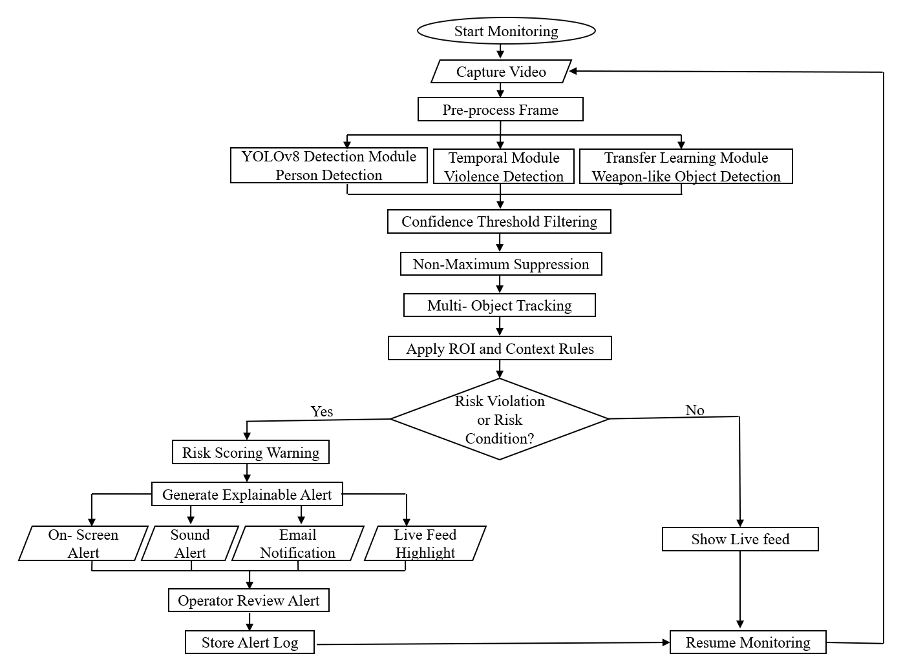

Figure 3.3: Flowchart of the Context- Aware Surveillance System

3.5. Use Case Diagram
The use case diagram below describes the interaction between the operator, the camera, and the core system functionalities such as monitoring, configuring zones, receiving alerts, and reviewing alert logs.
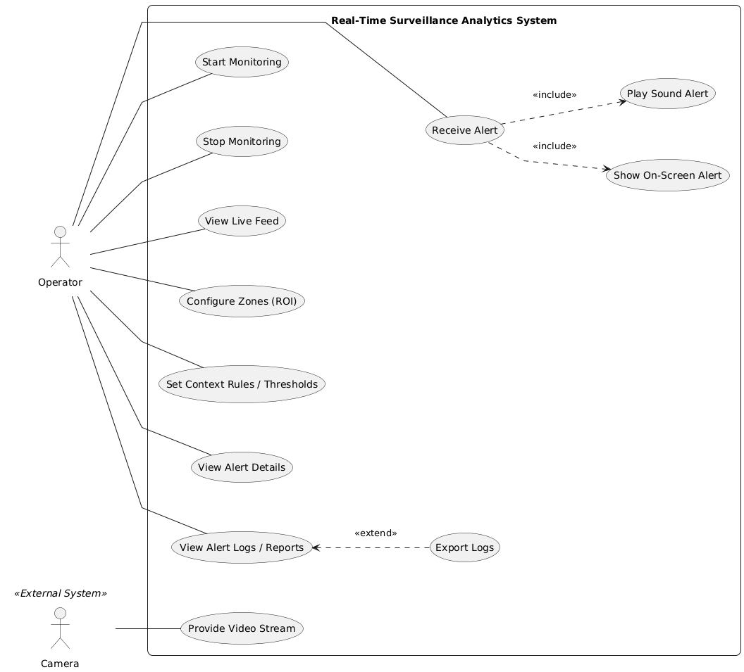
Figure 3.4: Use Case Diagram of the Real-Time Surveillance System

3.6. Sequence Diagram
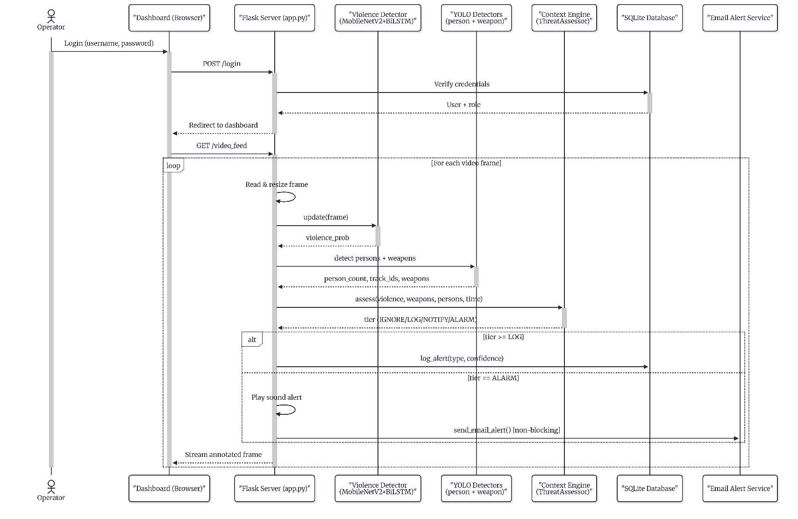
The sequence diagram represents the interaction among the main components of the proposed surveillance system. It begins with user authentication, where the operator logs in through the dashboard and the Flask server verifies the credentials. After successful login, the live video feed is requested and each frame is processed sequentially. The violence detection module, YOLO-based person and weapon detectors, and tracking module analyze the frame, while the Context Engine assesses the combined results and assigns a threat tier. Based on the tier, the system may log the event, trigger an alarm, or send an email alert. The processed frame is then returned to the dashboard for real-time monitoring. This sequence ensures efficient communication among all modules and supports timely detection and response to suspicious activity.

Fig 3.5: Sequence Diagram of Context- Aware Surveillance System

3.7. Activity Diagram
The activity diagram illustrates the operational flow of the proposed real-time surveillance system. The process starts when the operator logs into the dashboard and the system validates the credentials. If authentication is successful, the live video feed is opened and the system continuously processes incoming frames. Each frame is analyzed using two AI modules: a violence detection model based on MobileNetV2 and BiLSTM, and a YOLO-based object detection model for identifying persons and weapons. The detected outputs are fused by the context engine, which evaluates the scene according to predefined rules and determines an appropriate response tier. Depending on the severity, the system may ignore the frame, log the event, notify the operator, or trigger a full alarm with sound and email notification. The annotated frame is then displayed on the dashboard, and the system repeats the process for subsequent frames until the stream ends.
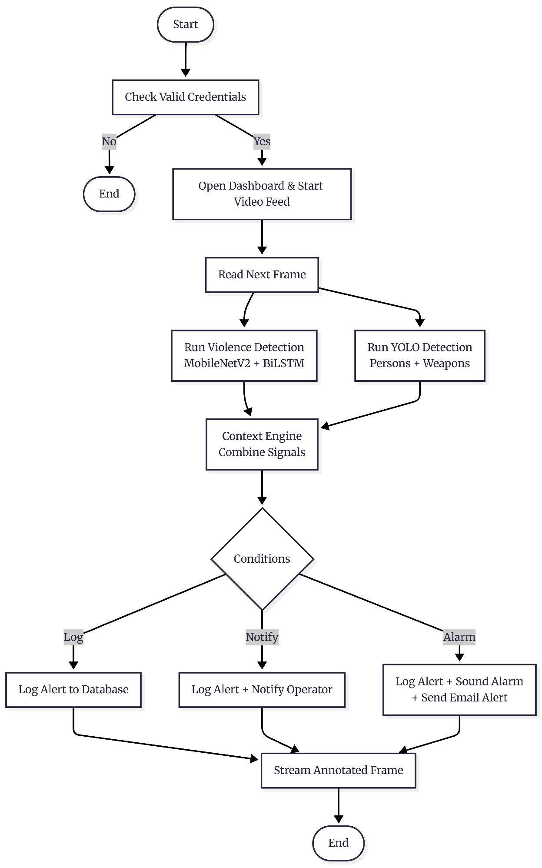

Fig 3.6: Activity Diagram of Context- Aware Surveillance System

3.8. ER diagram
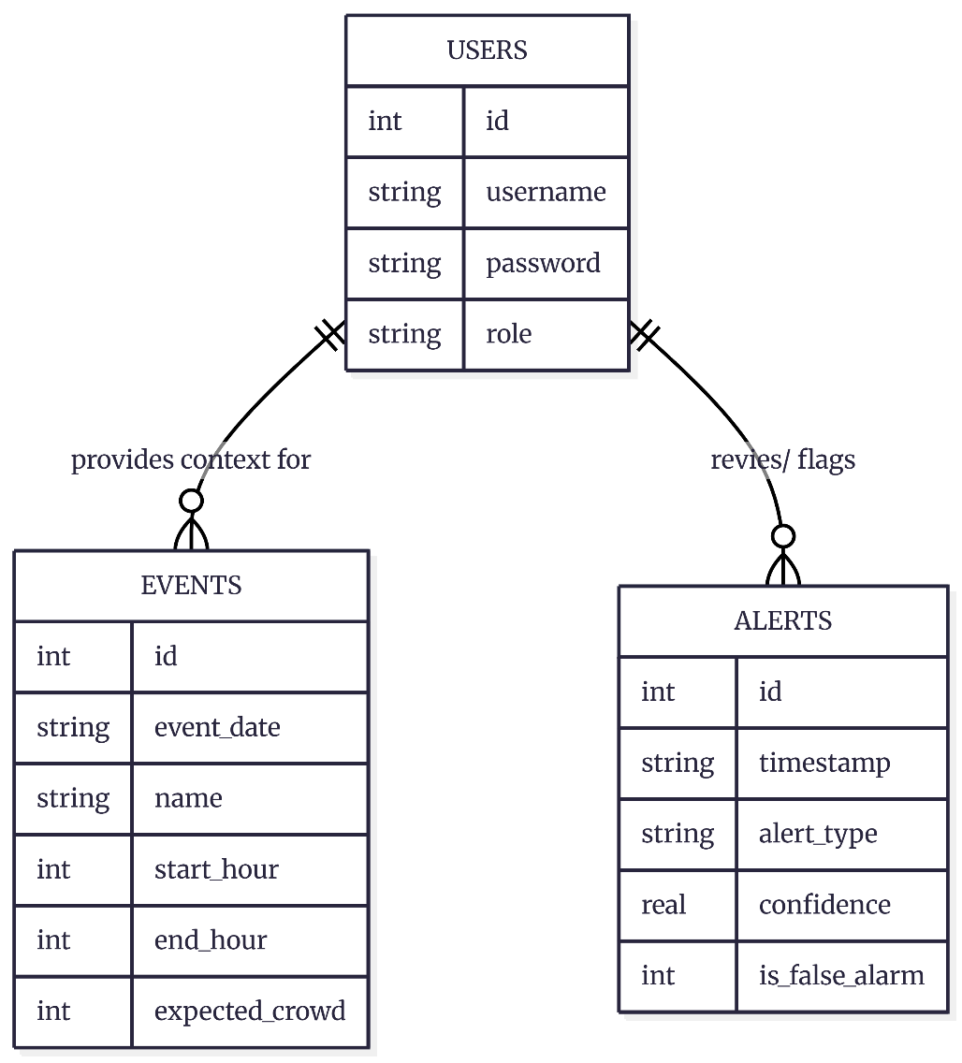
The ER diagram of the proposed surveillance system consists of three main entities: USERS, EVENTS, and ALERTS. The USERS entity stores authentication details such as username, password, and role, which are used to control access to the system. The EVENTS entity stores contextual scheduling information, including the event date, name, time range, and expected crowd size, which helps the system interpret normal and abnormal activity. The ALERTS entity stores details of detected threats, such as timestamp, alert type, confidence score, and false alarm status. The relationships among these entities support user management, context-aware threat assessment, and alert review in an organized database structure.

Fig 3.7: ER diagram of Context- Aware Surveillance System

3.9. Tools Used
The proposed system is implemented primarily in Python, using a combination of open-source libraries and platforms for detection, training, and data handling. The tools and technologies used in the project are described below:
- Python: The core development language used for the entire detection pipeline, alert logic, and integration of all modules.
- OpenCV: Used for real-time video capture, frame pre-processing, drawing detections on the feed, and reading input from both live webcam and video/image files.
- Ultralytics YOLOv8: The deep-learning object detection framework used to detect persons, weapon-like objects, and violent activity. A pretrained model is used for person detection, and a custom-trained model is used for weapon and violence detection.
- PyTorch (with CUDA): The deep-learning backend that enables GPU-accelerated model inference and training on an NVIDIA RTX 4050 GPU.
- Roboflow: Used to obtain, annotate, and export the weapon and violence dataset in YOLOv8 format for custom model training.
- Google Colab: A cloud platform providing a free Tesla T4 GPU, used to train the custom detection model without local hardware limitations.
- NumPy: Used for efficient numerical operations and handling of detection data.
- SQLite: A lightweight, serverless database used to log alert events, including timestamp, alert type, and confidence, enabling later review and false-alarm analysis.
- Git and GitHub: Used for version control and team collaboration through branching and pull requests.
The system also uses Python’s built-in winsound module to generate audible alerts. For the remaining phase of the project, additional tools are planned, including ByteTrack for multi-object tracking and a temporal (video-based) model for improved violence detection.

3.10. Verification and Validation

3.10.1 Verification
The verification process was carried out to ensure that each module of the proposed surveillance system functioned according to the design specifications. The person detection module was tested using live and recorded video feeds to confirm that humans were detected accurately. The weapon detection and violence detection modules were evaluated using sample clips from the selected datasets to verify that suspicious objects and violent actions were identified correctly. The Flask-based dashboard was also tested to ensure that the alerts, predictions, and video stream were displayed properly.

3.10.2 Validation
The validation process focused on determining whether the system satisfied the intended security purpose. The results showed that the system could reduce the need for continuous manual monitoring by automatically generating alerts when suspicious activity was detected. The use of contextual rules helped reduce false alarms by considering factors such as time of day and crowd conditions. Therefore, the system was validated as a practical tool for improving surveillance and supporting faster response to threats.
Test Case | Module | Dataset/Input | Expected Result | Actual Result | Status
TC1 | Person Detection | Live/ recorded video | Persons detected correctly | Person detected correctly | Passed
TC2 | Weapon Detection | Weapon dataset from Roboflow | Weapons identified in frames | Weapons identified successfully | Passed
TC3 | Violence Detection | RWF-2000 and RLVS | Violent clips classified correctly | Violent clips classified correctly | Passed
TC4 | Tracking | Video feed | Same person tracked across frames | Identity across frame is maintained | Passed
TC5 | Context Rule Check | After-hours crowd scene | Suspicious activity flagged | Alert generated correctly | Passed
TC6 | Email Alert System | Unusual activities | Email notification sent automatically | Email sent successfully | Passed
TC7 | Dashboard Display | Flask web interface | Live feed and alerts shown | Displayed properly | Passed

Table 2: Verification and Validation Results

CHAPTER 4: EPILOGUE

4.1. Task completed
- Developed a violence detection module using a MobileNetV2 + BiLSTM architecture and trained it on the RLVS dataset, achieving approximately 98% validation accuracy.
- Developed a custom YOLOv8-based weapon detection model and trained it to identify two weapon classes: gun and knife.
- Implemented person detection and multi-object tracking using ByteTrack to count people and track individuals across video frames.
- Designed and implemented a context-aware Threat Assessment Engine that combines violence, weapon, person-count, and time-of-day signals to generate tiered responses such as IGNORE, LOG, NOTIFY, and ALARM.
- Built a Flask-based web dashboard with role-based login for Admin and Operator, live MJPEG video streaming, an alerts panel, non-blocking email alerts, and an operator false-alarm review workflow.

4.2. Remaining Tasks
- Improve weapon detection reliability, especially for knife detection, by training on a larger and more balanced dataset and/or using a stronger model backbone.
- Reduce domain-shift false positives by fine-tuning the model on CCTV-domain footage so that performance improves on real surveillance input.
- Deploy and test the system with live CCTV or IP camera input through RTSP for real world performance evaluation.

S.N | Initiatives | 5th SEMESTER |  |  |  | 6th SEMESTER
 |  | Jan | Feb | Mar | Apr | May | Jun | Jul | Aug | Sept
1 | Requirement analysis
2 | Literature review
3 | System design
4 | Implementation
5 | Integration
6 | Testing & evaluation
7 | Documentation
8 | Deployment
Fig 4.1: Gantt Chart

REFERENCES
[1] J. Redmon, S. Divvala, R. Girshick, and A. Farhadi, "You Only Look Once: Unified, Real-Time Object Detection," in Proc. IEEE Conf. Computer Vision and Pattern Recognition (CVPR), 2016, pp. 779–788.
[2] A. Krizhevsky, I. Sutskever, and G. E. Hinton, "ImageNet Classification with Deep Convolutional Neural Networks," in Advances in Neural Information Processing Systems (NeurIPS), vol. 25, 2012, pp. 1097–1105.
[3] S. J. Pan and Q. Yang, "A Survey on Transfer Learning," IEEE Trans. Knowledge and Data Engineering, vol. 22, no. 10, pp. 1345–1359, 2010.
[4] S. Hochreiter and J. Schmidhuber, "Long Short-Term Memory," Neural Computation, vol. 9, no. 8, pp. 1735–1780, 1997.
[5] A. Graves and J. Schmidhuber, "Framewise Phoneme Classification with Bidirectional LSTM and Other Neural Network Architectures," Neural Networks, vol. 18, no. 5–6, pp. 602–610, 2005.
[6] Y. Zhang, P. Sun, Y. Jiang, D. Yu, F. Weng, Z. Yuan, P. Luo, W. Liu, and X. Wang, "ByteTrack: Multi-Object Tracking by Associating Every Detection Box," in Proc. European Conf. Computer Vision (ECCV), 2022, pp. 1–21.
[7] M. Cheng, K. Cai, and M. Li, "RWF-2000: An Open Large Scale Video Database for Violence Detection," in Proc. 25th Int. Conf. Pattern Recognition (ICPR), 2020, pp. 4183–4190.
[8] M. M. Soliman, M. H. Kamal, M. A. E. Nashed, Y. M. Mostafa, B. S. Chawky, and D. Khattab, "Violence Recognition from Videos using Deep Learning Techniques," in Proc. 9th Int. Conf. Intelligent Computing and Information Systems (ICICIS), 2019, pp. 79–84.
[9] C. Stauffer and W. E. L. Grimson, "Adaptive Background Mixture Models for Real-Time Tracking," in Proc. IEEE Conf. Computer Vision and Pattern Recognition (CVPR), vol. 2, 1999, pp. 246–252.
[10] R. Olmos, S. Tabik, and F. Herrera, "Automatic Handgun Detection Alarm in Videos Using Deep Learning," Neurocomputing, vol. 275, pp. 66–72, 2018.
[11] W. Sultani, C. Chen, and M. Shah, "Real-World Anomaly Detection in Surveillance Videos," in Proc. IEEE Conf. Computer Vision and Pattern Recognition (CVPR), 2018, pp. 6479–6488.
[12] D. Tran, L. Bourdev, R. Fergus, L. Torresani, and M. Paluri, "Learning Spatiotemporal Features with 3D Convolutional Networks," in Proc. IEEE Int. Conf. Computer Vision (ICCV), 2015, pp. 4489–4497.
[13] R. Vijeikis, V. Raudonis, and G. Dervinis, "Efficient Violence Detection in Surveillance," Sensors, vol. 22, no. 6, art. 2216, 2022.
[14] P. P. Khin and N. M. Htaik, "Gun Detection: A Comparative Study of RetinaNet, EfficientDet and YOLOv8 on Custom Dataset," in Proc. 21st IEEE Int. Conf. Computer Applications (ICCA), 2024, pp. 98–103.

BIBLIOGRAPHY
[1] G. Jocher, A. Chaurasia, and J. Qiu, "Ultralytics YOLOv8 (version 8.0.0)," 2023. [Online]. Available: https://github.com/ultralytics/ultralytics [Accessed: 12-Jul-2026].
[2] Ultralytics, "Ultralytics YOLOv8 Documentation," 2023. [Online]. Available: https://docs.ultralytics.com [Accessed: 12-Jul-2026].
[3] TensorFlow, "TensorFlow: An End-to-End Open-Source Machine Learning Platform." [Online]. Available: https://www.tensorflow.org [Accessed: 12-Jul-2026].
[4] F. Chollet et al., "Keras." [Online]. Available: https://keras.io [Accessed: 12-Jul-2026].
[5] OpenCV Team, "OpenCV: Open-Source Computer Vision Library." [Online]. Available: https://opencv.org [Accessed: 12-Jul-2026].
[6] Pallets Projects, "Flask Documentation." https://flask.palletsprojects.com [Accessed: 12-Jul-2026]. [Online]. Available: https://flask.palletsprojects.com [Accessed: 12-Jul-2026].
[7] M. M. Soliman et al., "Real Life Violence Situations (RLVS) Dataset," Kaggle, 2019. [Online]. Available: https://www.kaggle.com/datasets/mohamedmustafa/real-life-violence situations-dataset [Accessed: 12-Jul-2026].

SCREENSHOTS
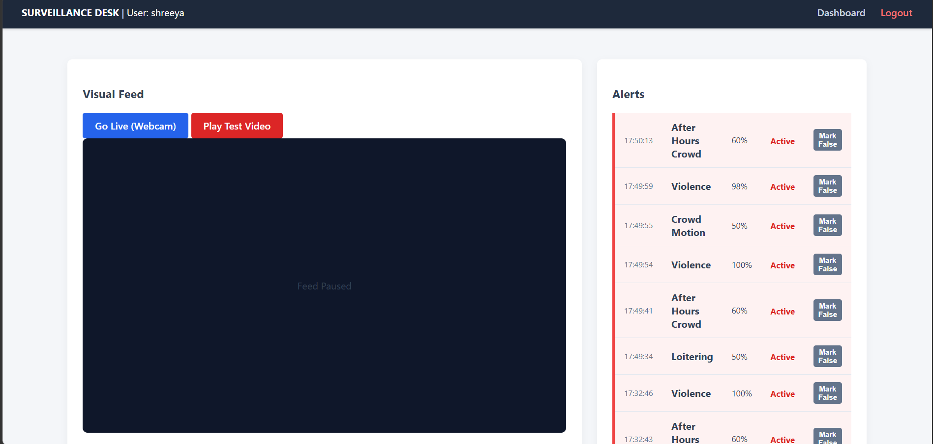
Operator dashboard
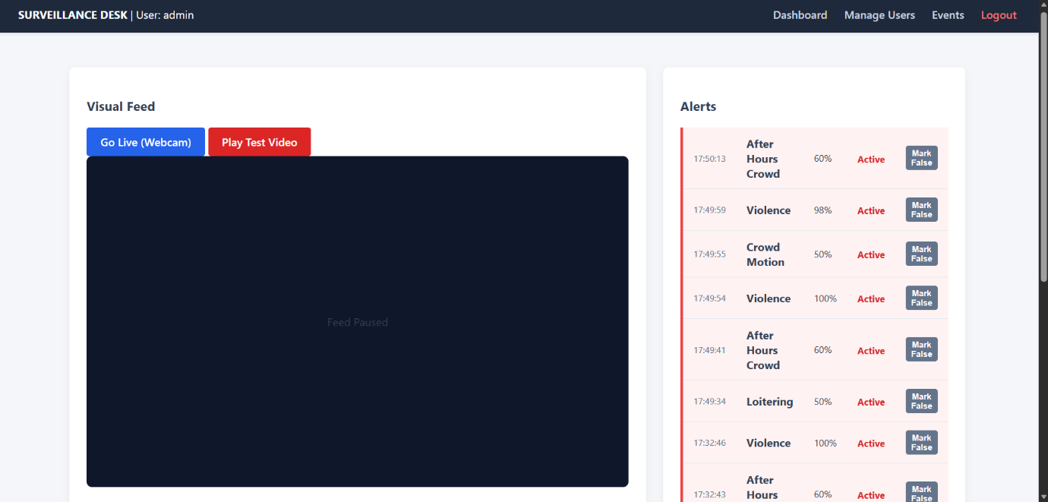

Admin Dashboard

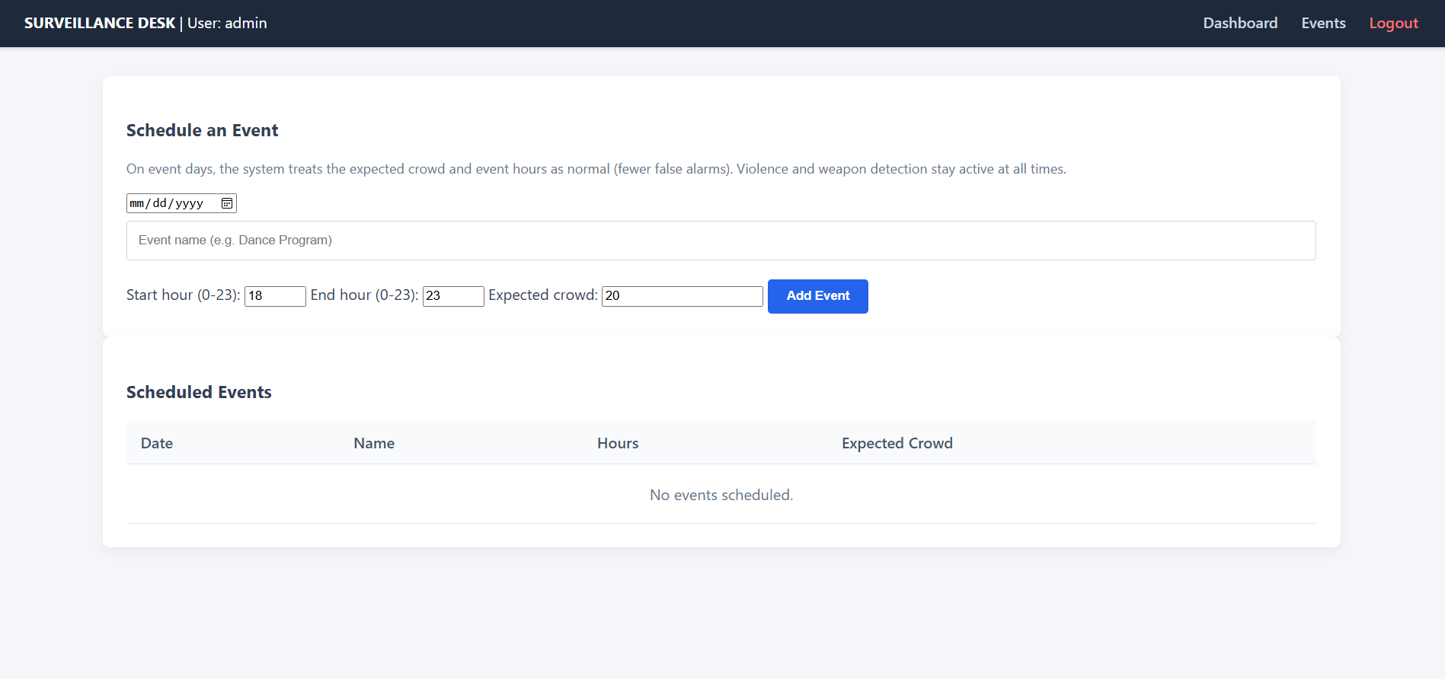
Event Logging
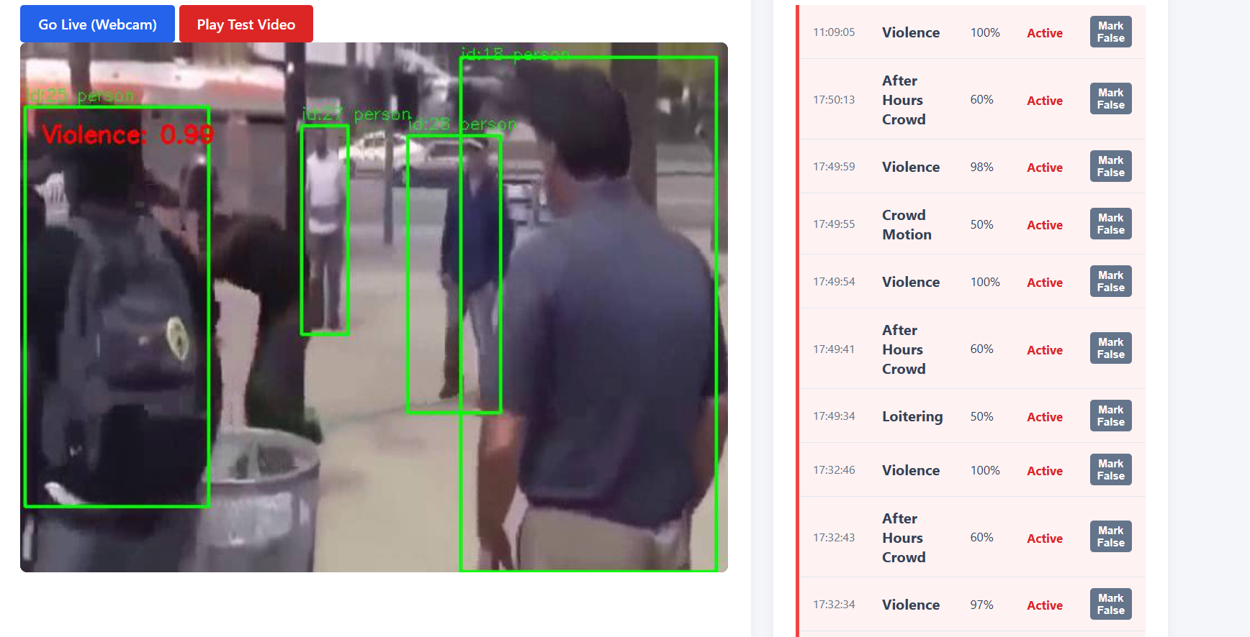
Violence Detected

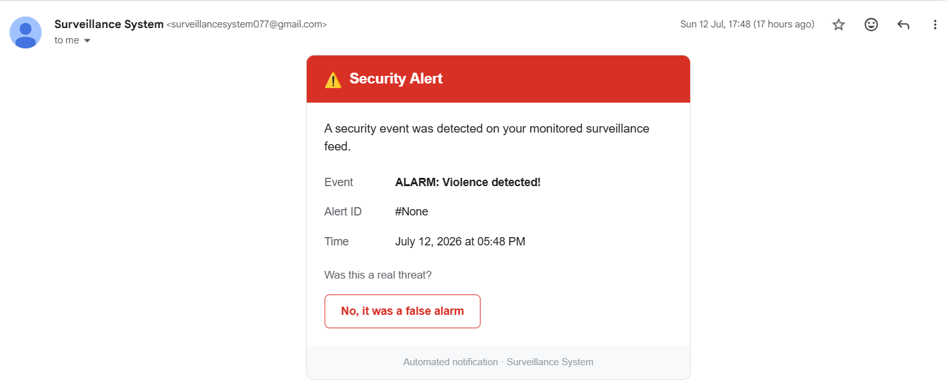
Email notification

