# Library Management System - Normalized Database Design

## 1. ER Diagram

The following ER diagram represents the entities and relationships in the Library Management System.

Entities: Books, Authors, Publishers, Categories, Members, Loans

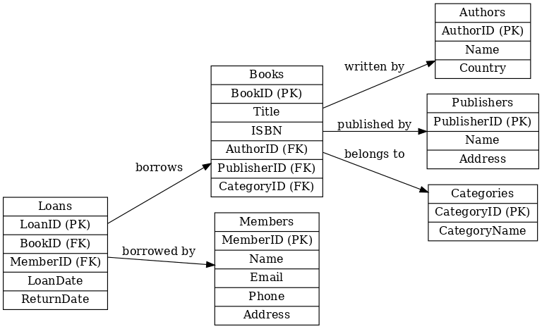

## 2. SQL Scripts for Table Creation

-- Authors Table  
CREATE TABLE Authors (  
 AuthorID INT PRIMARY KEY AUTO_INCREMENT,  
 Name VARCHAR(100) NOT NULL,  
 Country VARCHAR(50)  
);  
  
-- Publishers Table  
CREATE TABLE Publishers (  
 PublisherID INT PRIMARY KEY AUTO_INCREMENT,  
 Name VARCHAR(100) NOT NULL,  
 Address VARCHAR(200)  
);  
  
-- Categories Table  
CREATE TABLE Categories (  
 CategoryID INT PRIMARY KEY AUTO_INCREMENT,  
 CategoryName VARCHAR(50) NOT NULL  
);  
  
-- Books Table  
CREATE TABLE Books (  
 BookID INT PRIMARY KEY AUTO_INCREMENT,  
 Title VARCHAR(200) NOT NULL,  
 ISBN VARCHAR(20) UNIQUE,  
 AuthorID INT,  
 PublisherID INT,  
 CategoryID INT,  
 FOREIGN KEY (AuthorID) REFERENCES Authors(AuthorID),  
 FOREIGN KEY (PublisherID) REFERENCES Publishers(PublisherID),  
 FOREIGN KEY (CategoryID) REFERENCES Categories(CategoryID)  
);  
  
-- Members Table  
CREATE TABLE Members (  
 MemberID INT PRIMARY KEY AUTO_INCREMENT,  
 Name VARCHAR(100) NOT NULL,  
 Email VARCHAR(100) UNIQUE,  
 Phone VARCHAR(15),  
 Address VARCHAR(200)  
);  
  
-- Loans Table  
CREATE TABLE Loans (  
 LoanID INT PRIMARY KEY AUTO_INCREMENT,  
 BookID INT,  
 MemberID INT,  
 LoanDate DATE NOT NULL,  
 ReturnDate DATE,  
 FOREIGN KEY (BookID) REFERENCES Books(BookID),  
 FOREIGN KEY (MemberID) REFERENCES Members(MemberID)  
);

## 3. Normalization Report

### Unnormalized Form (UNF)

A single table storing all details: (BookID, Title, AuthorName, PublisherName, Category, MemberName, LoanDate, ReturnDate). This causes redundancy and anomalies.

### First Normal Form (1NF)

Ensured atomic values. Repeated groups split into multiple rows.

### Second Normal Form (2NF)

Removed partial dependencies. Created separate tables for Authors, Publishers, Categories, Members.

### Third Normal Form (3NF)

Removed transitive dependencies. Publisher Address moved to Publishers table. Final schema is normalized up to 3NF.