Model | Metric | Train | Test | Total Params | Training Time(s) | Model Details
Baseline | R2 Score | 0.82 | 0.82 | 2209 | 114.53 | 2 hidden layers, ReLU activation, 10 epochs, batch size 32
Three HL | R2 Score | 0.9 | 0.9 | 5953 | 115.73 | 3 hidden layers, ReLU activation, 10 epochs, batch size 32
Four HL | R2 Score | 0.93 | 0.93 | 17537 | 405.79 | 4 hidden layers, ReLU activation, 50 epochs, batch size 32
Regularized  model1 | R2 Score | 0.93 | 0.93 | 18433 | 323.97 | 4 hidden layers with batch normalization & dropout after each activation, L2 regularization, ReLU, 100 epochs, batch size 32, early stopping
Regularized  model2 | R2 Score | 0.92 | 0.91 | 6529 | 282.34 | 4 hidden layers with batch normalization & dropout after 2nd hidden layer only, L2 regularization, ReLU, 100 epochs, batch size 32, early stopping
leaky relu | R2 Score | 0.93 | 0.93 | 18433 | 416.98 | 4 hidden layers with Leaky ReLU, batch normalization & dropout after 2nd hidden layer only, L2 regularization, 100 epochs, batch size 32, early stopping
Reflection Report: Model Comparison and Improvement Analysis

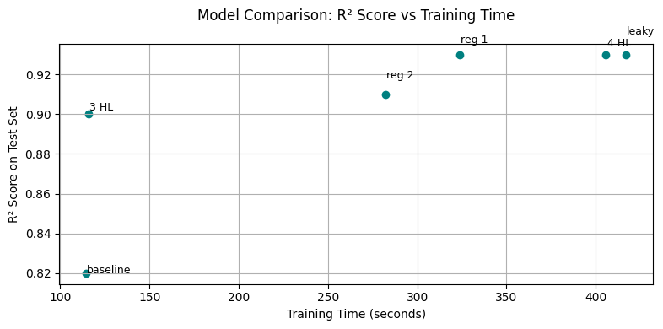
Fig 1.1. R2 Score (Test Set) VS training time
I began with a original model as baseline using 2 hidden layers, ReLU activation, and a total of 2,209 parameters. This model achieved an R² score of 0.82 on the test set with a training time of approximately 115 seconds.
To enhance performance, I experimented by gradually increasing the number of hidden layers and applying advanced techniques like batch normalization, dropout, and regularization. As seen in both the results table and scatter plot, deeper architectures led to better R² scores, although at the cost of increased training time.
Key model performance comparisons:
- Three HL (3 layers): R² = 0.90 | Time ≈ 116s
- Regularized Model 2 (4 layers): R² = 0.91 | Time ≈ 282s
- Regularized Model 1 (4 layers): R² = 0.93 | Time ≈ 324s
- Four HL (4 layers): R² = 0.93 | Time ≈ 406s
- Leaky ReLU Model: R² = 0.93 | Time ≈ 417s
Although Four HL and the Leaky ReLU model slightly outperformed others, they required noticeably more training time. Regularized Model 2, on the other hand, provided an excellent balance between performance and efficiency, making it my selected optimal architecture.
This model incorporated batch normalization and dropout layers after the second hidden layer, combined with L2 regularization. These techniques help improve model generalization by reducing overfitting:
- Dropout randomly disables neurons during training, forcing the model to learn more robust features.
- Batch normalization stabilizes and accelerates training by normalizing activations.
- L2 regularization discourages large weight values, promoting simpler models.
In conclusion, while deeper networks can capture more complex patterns, the performance gains tend to plateau. Regularized Model 2 stands out by achieving the best balance between test performance and training time. It maintains a strong R² score of 0.91, MAPE 6.9, MSE 42559.13, and while keeping training time relatively low compared to deeper, more complex models. This balance is supported by the effective use of regularization, batch normalization, and dropout, which together help prevent overfitting and enhance generalization. Among all tested architectures, Regularized Model 2 offers the most practical trade-off, making it the best choice for deployment where both performance and efficiency are critical.

