SkyRoute: Flights Graph Network

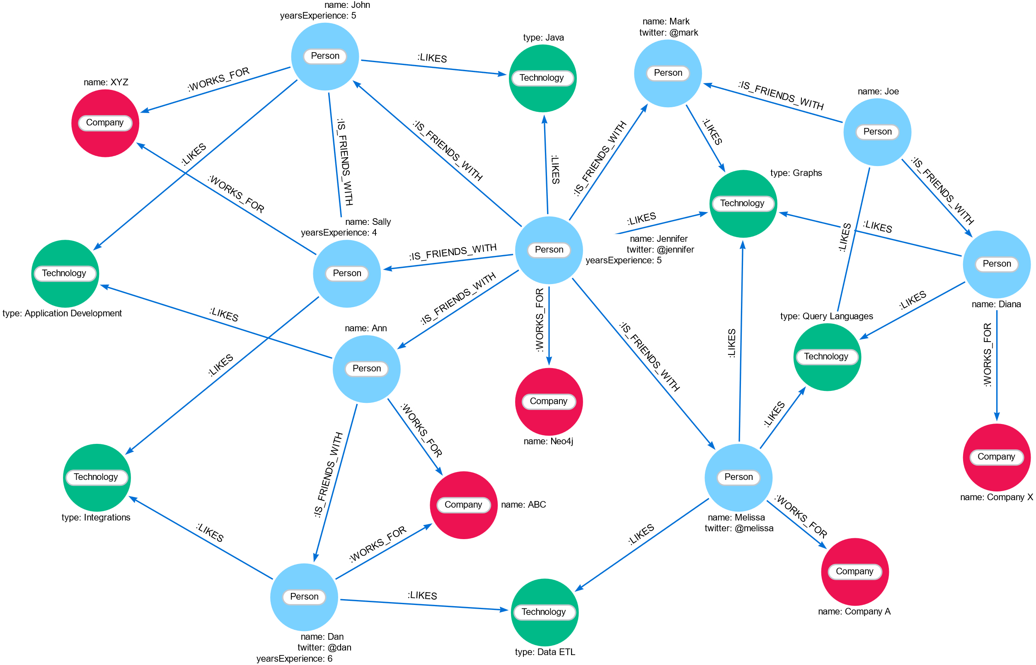



Name: Nuwan Keshara Galappaththi
Email: nuwankeshara12@gmail.com
LinkedIn: https://www.linkedin.com/in/nuwan-keshara/
Contents
1) Project Title 3
2) Objectives / Problem Statement 3
3) Tech Stack 4
4) Architecture / Design 5
Graph Data Model: 5
Workflow Overview: 5
5) Implementation Steps 6
1.Data extraction (Python) 6
2.Data Validation and Quality Checks 6
3. Data Load into Neo4j 6
4.Visualization 7
6) Scripts 8
7) Data Visualizations 14
1. Domestic Flights Overview 14
2. International Flights Overview 15
3. Find Shortest Flight Path 16
8) Summary 17

Project Title

- SkyRoute: Flights Graph Network

Objectives / Problem Statement

- A graph-based model of global flight routes built with the Neo4j graph database. It maps airports as nodes and routes as relationships, enabling domestic airlines network view, international airlines network view an shortest path finding with interactive spatial visualization using NeoDash.

- Dataset - https://openflights.org/data.php

- The problem:
  - The raw CSV data is unstructured and inconsistent.
  - It lacks direct analytical value for route analysis, network visualization or shortest path insights.
  - Traditional relational models make it complex to traverse relationships between flights data efficiently.

- Goal:
- Design and implement a graph data model and analytics system that,
- Cleans and imports the OpenFlights dataset into Neo4j.
- Models airports and routes as graph entities.
- Enables domestic and international route exploration.
- Visualizes real-world flight connectivity on a world map.
- Supports shortest path queries and airline network analytics using NeoDash.

Tech Stack

  Layer
  Tool
  Purpose
 | OpenFlights Dataset (CSV)  - Airports.dat  - Airlines.dat  - Routes.dat
  Data Source
  Source of airport and route data
 | Python (Pandas)
  Data Ingestion & Cleaning
  Load and clean CSVs before graph import
 | Neo4j (Community Edition)/ Neo4j AuraDB Managed Service
  Graph Database
  Stores airports as nodes and routes as relationships
Visualization Layer | NeoDash
  Interactive visualization of airports, airlines and routes
Query Language | Cypher
  Graph traversal and path-finding logic
 | Neo4j Browser
  Graph Utilities
  APOC Library /
  Advanced graph operations and conditional query execution
Version Control |  | Code and Cypher script management
  Git / GitHub

Architecture / Design

- Node and Relationship (Airports)-[Routes]->(Airports)
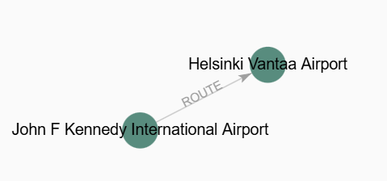

Graph Data Model:
(:Airport {iata, name, city, country, location}) -[:ROUTE {airline, updated}]-> (:Airport {iata, name, city, country, location})
(:Airline {iata, name, country})

Note: Airline nodes exist independently, while routes carry airline metadata as properties.

Workflow Overview:
- Data Ingestion (Python + Neo4j Driver):
  - Load airport, airline and route CSVs.
  - Create constraints to ensure unique IATA codes.
  - Batch load data to Neo4j using parameterized Cypher queries.
- Graph Construction:
  - Airports created as nodes.
  - Airlines created as nodes.
  - Routes created as relationships between Airport nodes, with airline info stored as a property.
- Spatial Modeling:
  - Each airport has a location property (point type) for map-based visualization in NeoDash.
- Visualization (NeoDash):
  - Interactive map views for global routes.
  - Table view to list shortest flight connections.
  - Graph view showing airport-to-airport connectivity.

Implementation Steps

1.Data extraction (Python)
- Read raw CSVs with Pandas.
- Standardize column names and handle nulls.

2.Data Validation and Quality Checks
- Validate data, transform null values, remove unwated columns
  - Checks for nulls
  - Validates non-negative numeric columns
  - Detects duplicates

3. Data Load into Neo4j
- Create Constraints
  - CREATE CONSTRAINT IF NOT EXISTS FOR (a:Airport) REQUIRE a.iata IS UNIQUE;
  - CREATE CONSTRAINT IF NOT EXISTS FOR (al:Airline) REQUIRE al.iata IS UNIQUE;
- Load into Neo4j
  - MERGE (a:Airport {iata: row.iata}) SET a.name = row.name, a.city = row.city, a.country = row.country, a.latitude = toFloat(row.latitude), a.longitude = toFloat(row.longitude), a.location = point({longitude: toFloat(row.longitude), latitude: toFloat(row.latitude)});
  - MERGE (al:Airline {iata: row.iata}) SET al.name = row.name, al.country = row.country;
  - MATCH (src:Airport {iata: row.source_airport}) MATCH (dst:Airport {iata: row.destination_airport}) MATCH (al:Airline {iata: row.airline}) MERGE (src)-[r:ROUTE {airline: row.airline}]->(dst) SET r.updated = datetime();

4.Visualization
- NeoDash dashboards were designed to show:

- Map View:
- Displays airports and connecting routes using spatial coordinates.

- Table View:
- Lists up to 5 shortest or multi-hop routes between countries with readable path strings.

- Graph View:
- Renders airports as nodes and routes as connecting relationships for visual exploration.

Scripts

- config.py – Load environment variable
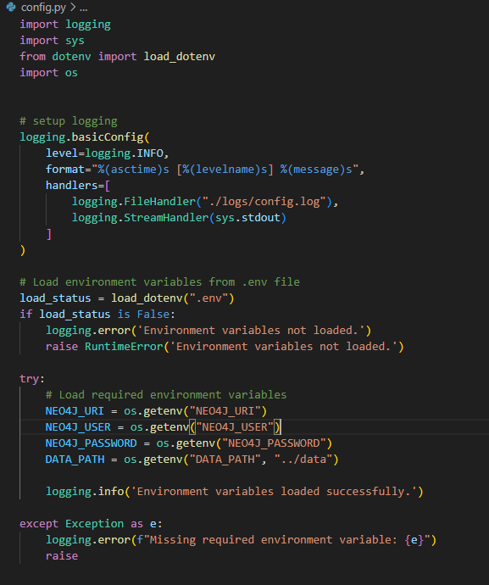

- data_quality.py - Data Quality Checks
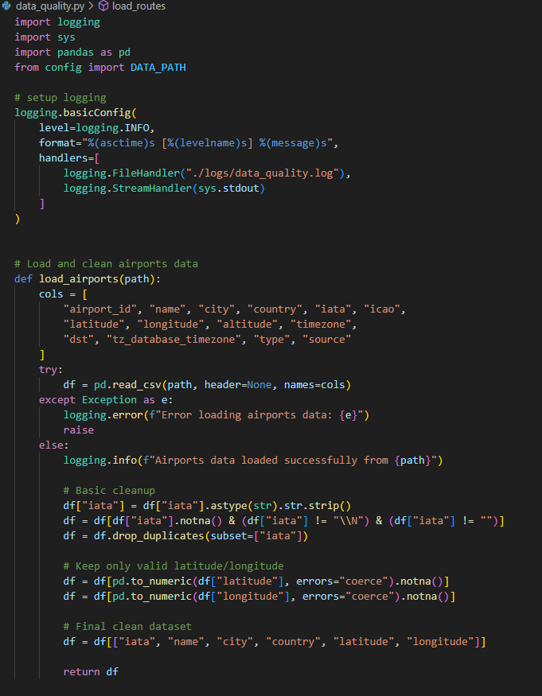

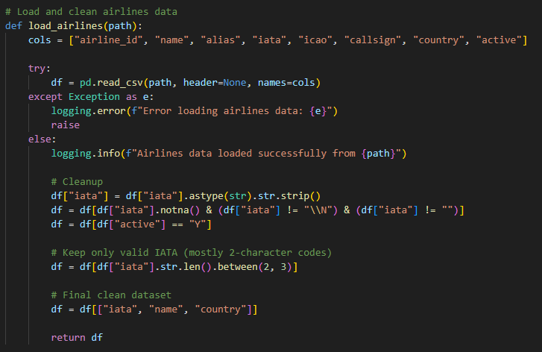
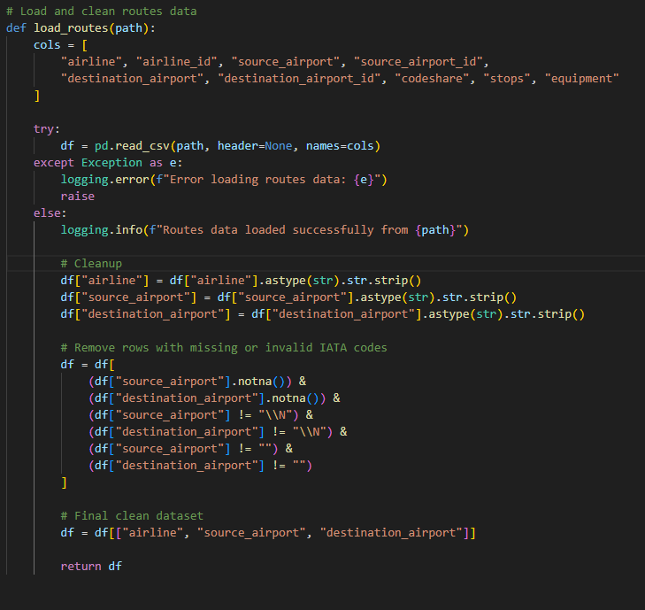
- data_ingest.py – ingest data into neo4j database
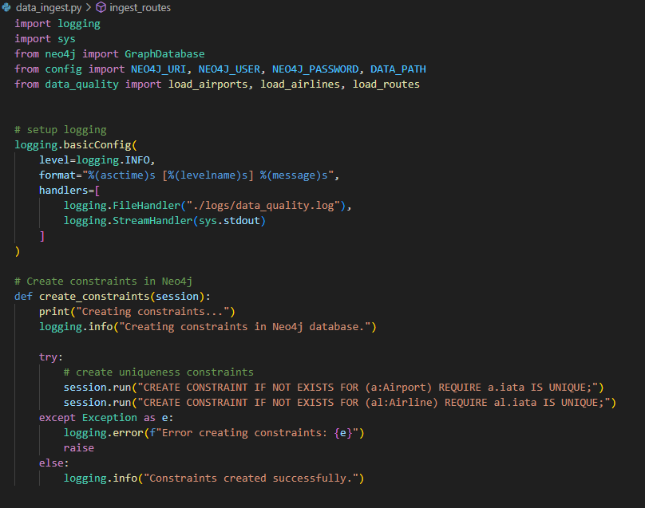

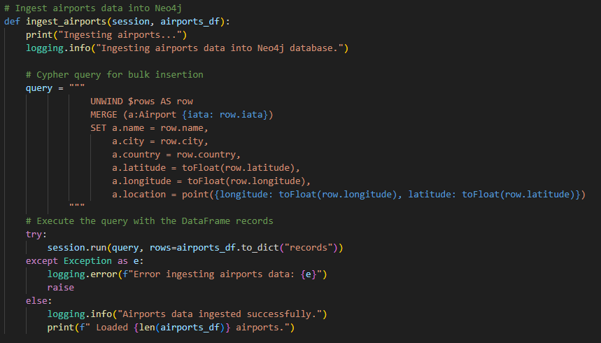
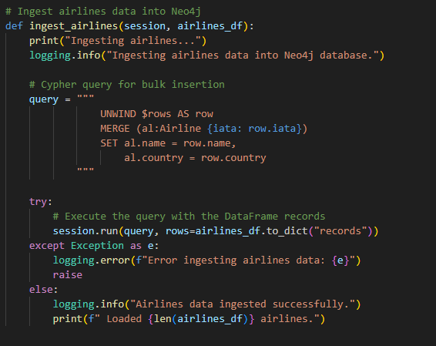

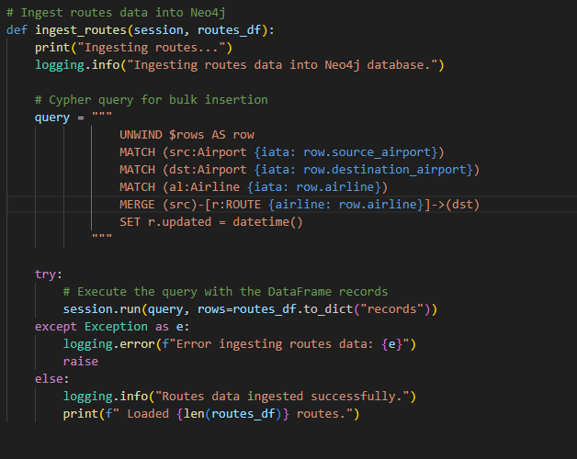
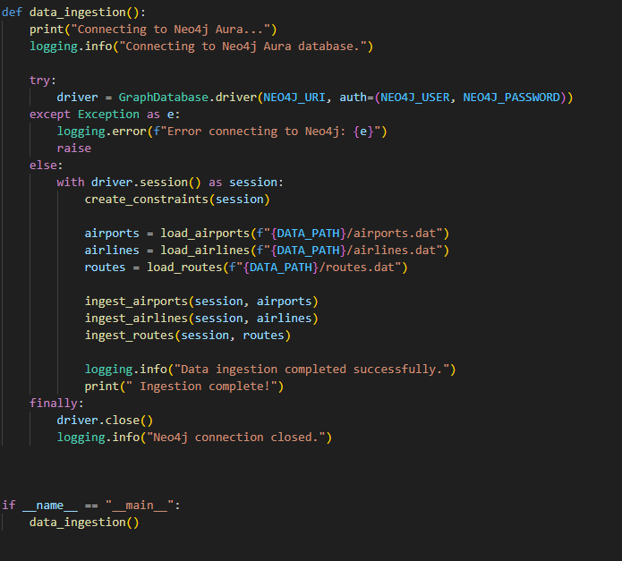

Data Visualizations

Domestic Flights Overview

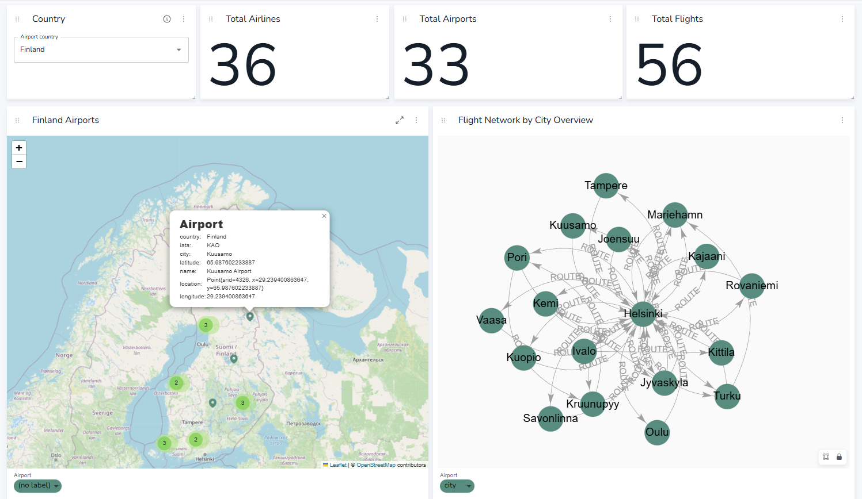

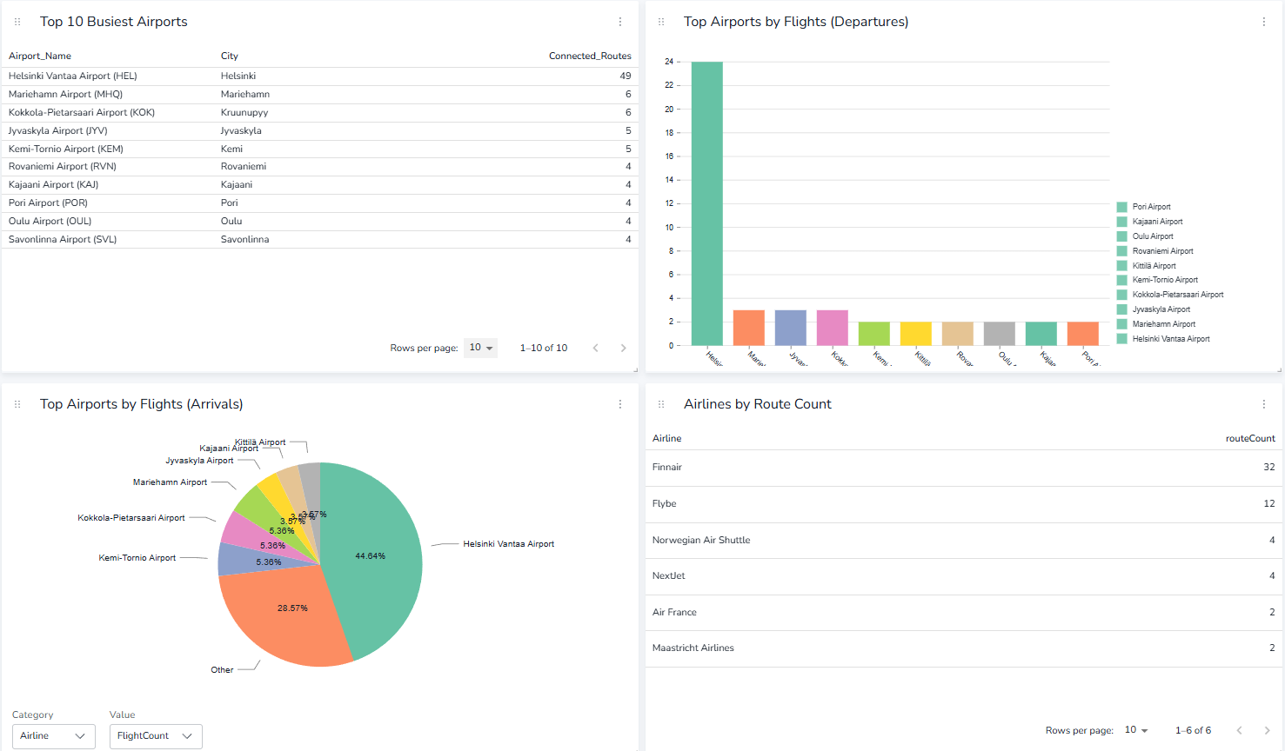

International Flights Overview

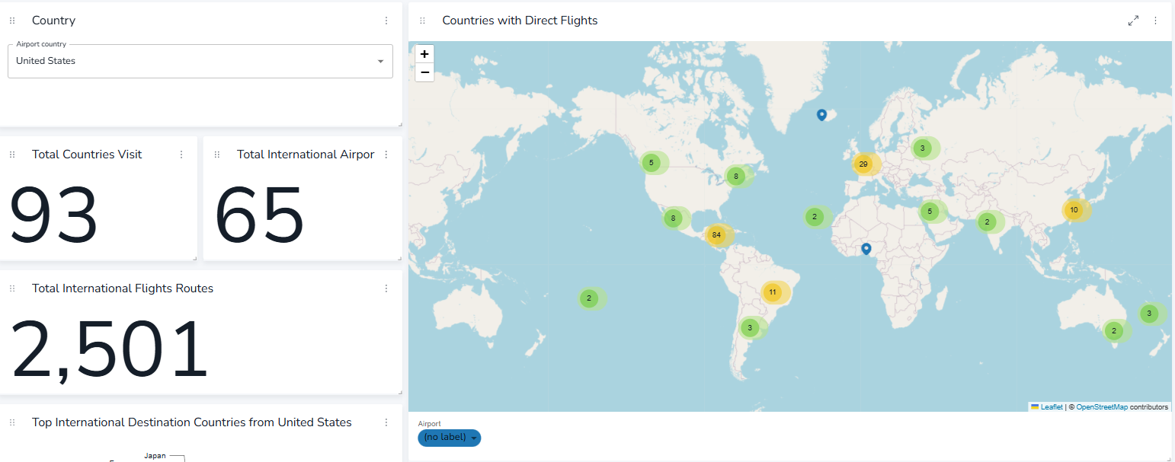

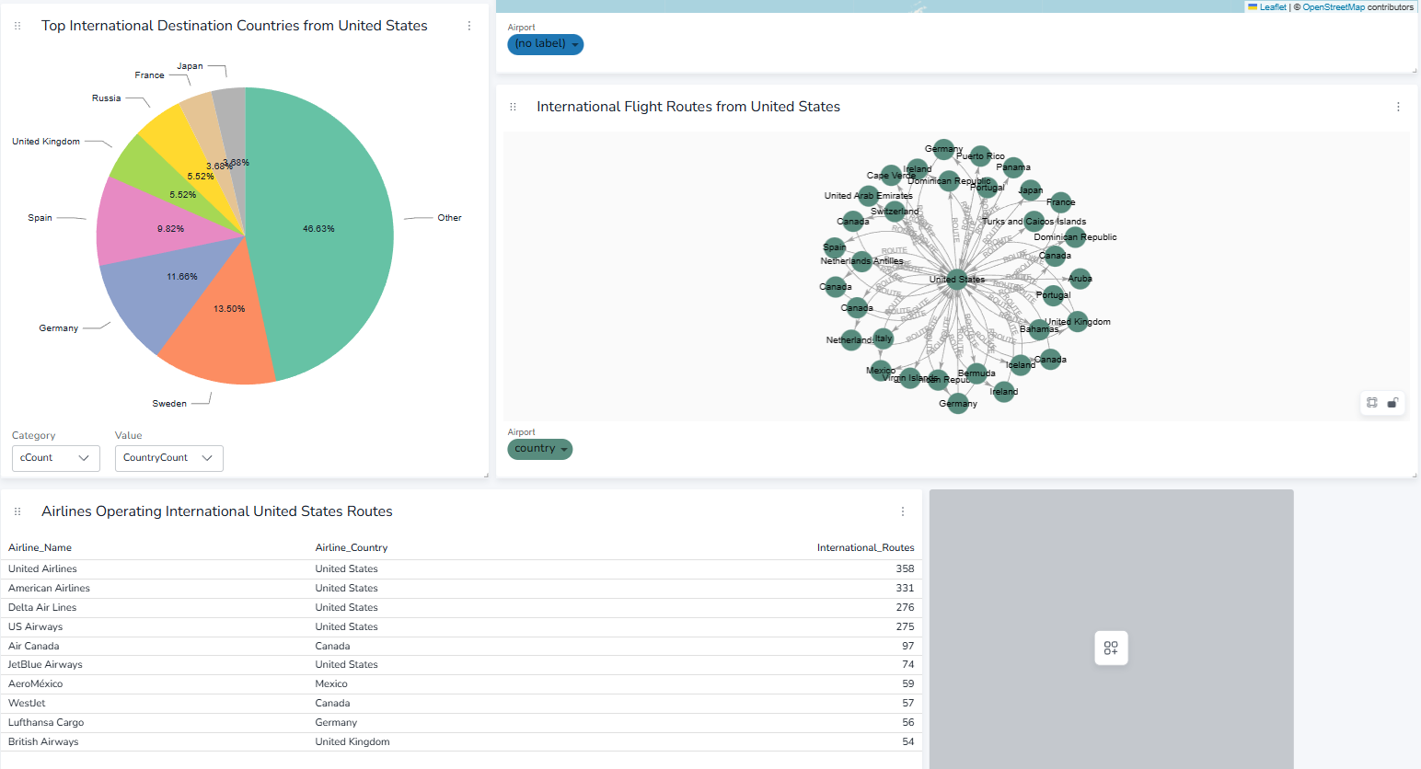

Find Shortest Flight Path

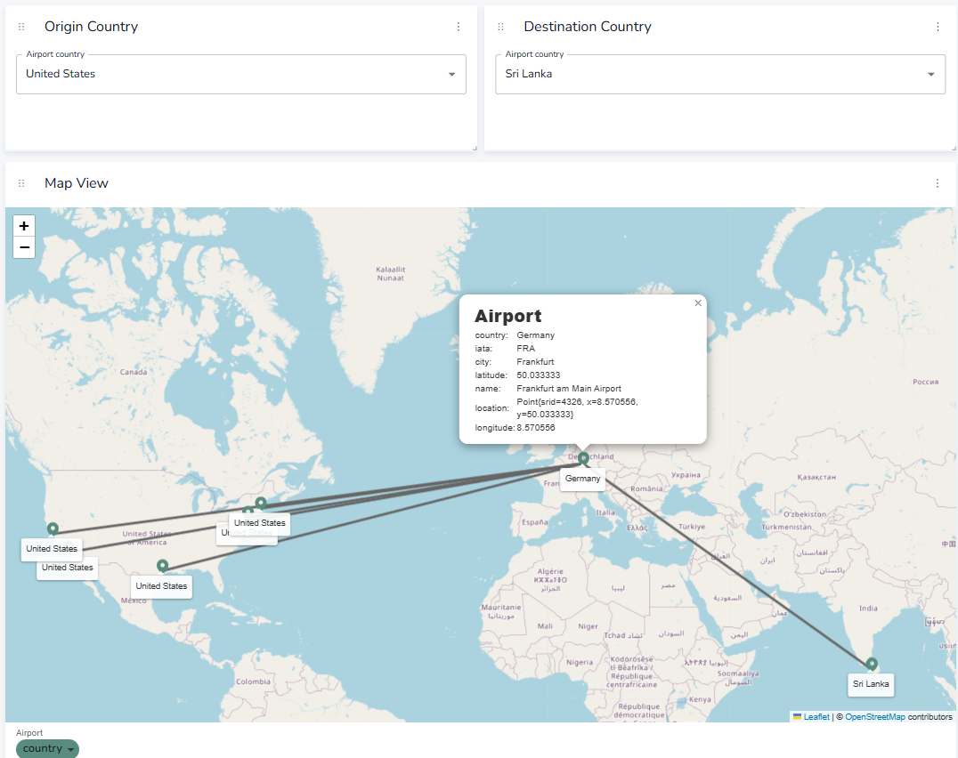

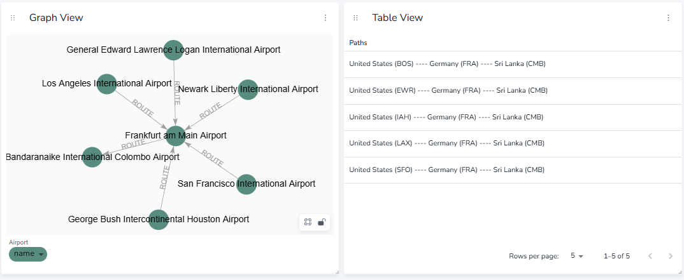

Summary

- SkyRoute demonstrates a production-grade graph-based solution for modeling global flight networks.

The project showcases:
- Neo4j for efficient graph modeling of real-world data.
- NeoDash for spatial and relational insights.
- Optimized Cypher queries with APOC for dynamic route exploration.
- Clean, scalable data ingestion with schema constraints and point-based mapping.

While airlines are modeled as separate nodes, they currently act as metadata through airline properties on relationships, future work can extend this by connecting Airline nodes directly to ROUTE relationships for more semantic querying.

- Outcome:
- A fully interactive and query-optimized global flight route network built with Neo4j, ideal for exploring airline connectivity, route density and country level flight accessibility.

- Full Code for the project can be found on following link- https://github.com/NuwanKeshara/SkyRoute

