1. | 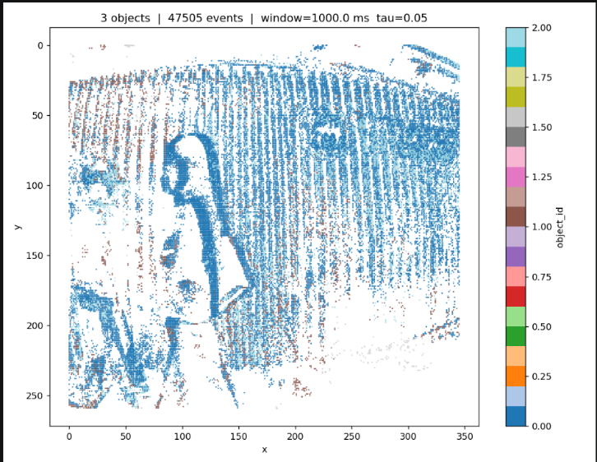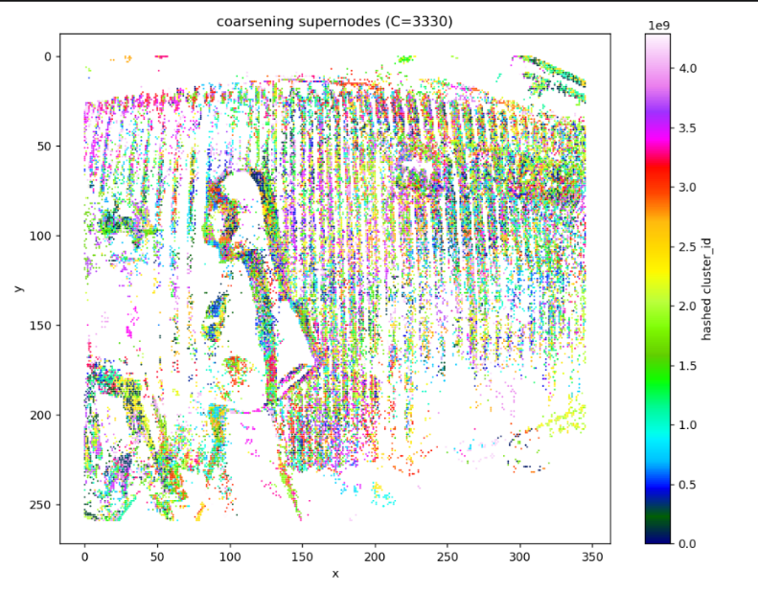 | Pooling method.  # Node bundle weights (absolute x, y, t, p only)  W_NODE_X, W_NODE_Y, W_NODE_T, W_NODE_P = 0, 0, 0.1, 0  # Spatial edge bundle weights  W_EDGE_S_DX, W_EDGE_S_DY, W_EDGE_S_DT = 0.5, 0.5, 0.3 # Short-range displacement  # Temporal edge bundle weights (velocity weighted up for motion cue)  W_EDGE_T_DX, W_EDGE_T_DY, W_EDGE_T_DT = 0.5, 0.5, 0.3 # 0.5, 0.5, 0.5 Displacement over longer Δt  W_EDGE_T_VX, W_EDGE_T_VY, W_EDGE_T_DP = 5.0, 5.0, 0.5 # 2.5, 2.5, 1.0
2 | 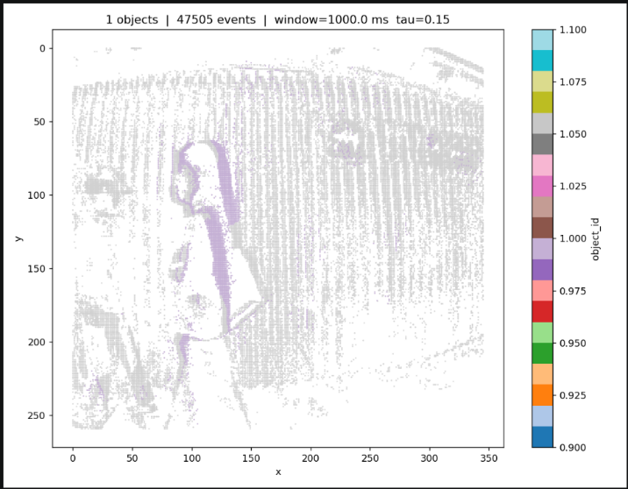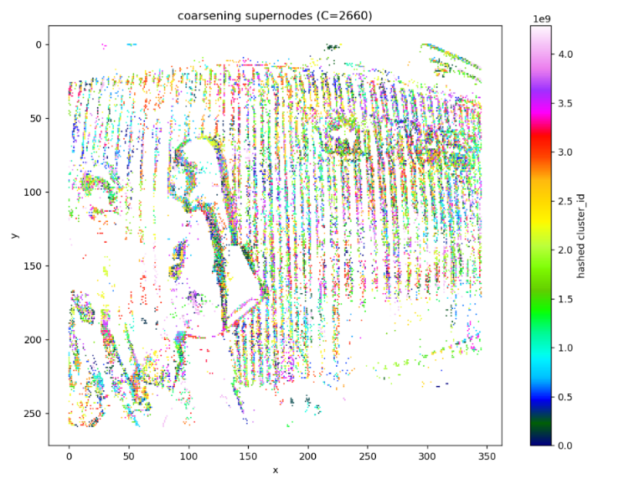 | Fable result  Commit - add fable based method

