Age and Salary depebdency Prediction using k-Means



MS20924928: S M N S K SENEVIRATNE
Department of Information System Engineering
Faculty of Computing

Problem: How does the Salary changes as per the age
Prediction is done using K-Means algorithm
Data set
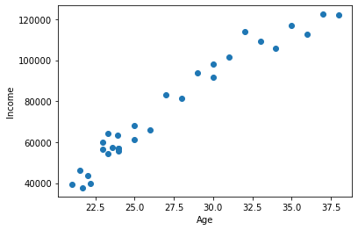
When K=3
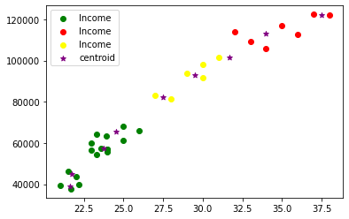
Elbow Plot
