**预约挂号微服务环境搭建**

## 一、目录总览

hospital-manage：医院接口模拟端（已开发，直接使用）

yygh-parent：根目录，管理子模块：

common：公共模块父节点

common-util：工具类模块，所有模块都可以依赖于它

rabbit-util：rabbitmq业务封装

service-util：service服务的工具包，包含service服务的公共配置类，所有 service模块依赖于它

server-gateway：服务网关

model：实体类模块

service：api接口服务父节点

service-hosp：医院api接口服务

service-cmn：公共api接口服务

service-user：用户api接口服务

service-order：订单api接口服务

service-oss：文件api接口服务

service-sms：短信 api接口服务

service-task：定时任务服务

service-statistics：统计api接口服务

service-client：feign服务调用父节点

service-cmn-client：公共api接口

service-hosp-client：医院api接口

service-order-client：订单api接口

service-user：用户api接口

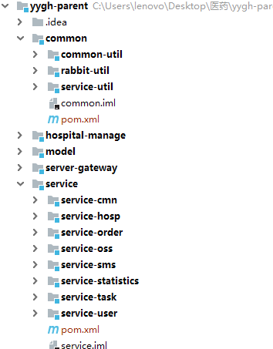

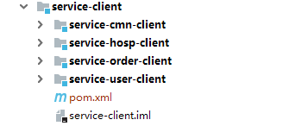

## 二、搭建

### 1、构建父工程并添加依赖

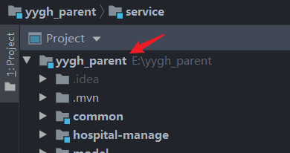

1. <?xml version="1.0" encoding="UTF-8"?>
2. <project xmlns="http://maven.apache.org/POM/4.0.0" xmlns:xsi="http://www.w3.org/2001/XMLSchema-instance"
3. xsi:schemaLocation="http://maven.apache.org/POM/4.0.0 https://maven.apache.org/xsd/maven-4.0.0.xsd">
4. <modelVersion>4.0.0</modelVersion>
5. <modules>
6. <module>common</module>
7. <module>model</module>
8. <module>service</module>
9. </modules>
10. <parent>
11. <groupId>org.springframework.boot</groupId>
12. <artifactId>spring-boot-starter-parent</artifactId>
13. <version>2.2.12.RELEASE</version>
14. <relativePath/> <!-- lookup parent from repository -->
15. </parent>
16. <groupId>com.xlh</groupId>
17. <artifactId>yygh_parent</artifactId>
18. <version>0.0.1-SNAPSHOT</version>
19. <packaging>pom</packaging>
20. <name>yygh_parent</name>
21. <description>Demo project **for** Spring Boot</description>
22. <properties>
23. <java.version>1.8</java.version>
24. <cloud.version>Hoxton.RELEASE</cloud.version>
25. <alibaba.version>2.2.0.RELEASE</alibaba.version>
26. <mybatis-plus.version>3.3.1</mybatis-plus.version>
27. <mysql.version>5.1.49</mysql.version>
28. <swagger.version>2.7.0</swagger.version>
29. <jwt.version>0.7.0</jwt.version>
30. <fastjson.version>1.2.29</fastjson.version>
31. <httpclient.version>4.5.1</httpclient.version>
32. <easyexcel.version>2.2.0-beta2</easyexcel.version>
33. <aliyun.version>4.1.1</aliyun.version>
34. <oss.version>3.9.1</oss.version>
35. <jodatime.version>2.10.1</jodatime.version>
36. </properties>
38. <!--配置dependencyManagement锁定依赖的版本-->
39. <dependencyManagement>
40. <dependencies>
41. <dependency>
42. <groupId>org.springframework.cloud</groupId>
43. <artifactId>spring-cloud-dependencies</artifactId>
44. <version>${cloud.version}</version>
45. <type>pom</type>
46. <scope>import</scope>
47. </dependency>
49. <dependency>
50. <groupId>com.alibaba.cloud</groupId>
51. <artifactId>spring-cloud-alibaba-dependencies</artifactId>
52. <version>${alibaba.version}</version>
53. <type>pom</type>
54. <scope>import</scope>
55. </dependency>
57. <!--mybatis-plus 持久层-->
58. <dependency>
59. <groupId>com.baomidou</groupId>
60. <artifactId>mybatis-plus-boot-starter</artifactId>
61. <version>${mybatis-plus.version}</version>
62. </dependency>
64. <dependency>
65. <groupId>mysql</groupId>
66. <artifactId>mysql-connector-java</artifactId>
67. <version>${mysql.version}</version>
68. </dependency>
70. <!--swagger-->
71. <dependency>
72. <groupId>io.springfox</groupId>
73. <artifactId>springfox-swagger2</artifactId>
74. <version>${swagger.version}</version>
75. </dependency>
76. <!--swagger ui-->
77. <dependency>
78. <groupId>io.springfox</groupId>
79. <artifactId>springfox-swagger-ui</artifactId>
80. <version>${swagger.version}</version>
81. </dependency>
83. <dependency>
84. <groupId>io.jsonwebtoken</groupId>
85. <artifactId>jjwt</artifactId>
86. <version>${jwt.version}</version>
87. </dependency>
89. <dependency>
90. <groupId>org.apache.httpcomponents</groupId>
91. <artifactId>httpclient</artifactId>
92. <version>${httpclient.version}</version>
93. </dependency>
95. <dependency>
96. <groupId>com.alibaba</groupId>
97. <artifactId>fastjson</artifactId>
98. <version>${fastjson.version}</version>
99. </dependency>
101. <dependency>
102. <groupId>com.alibaba</groupId>
103. <artifactId>easyexcel</artifactId>
104. <version>${easyexcel.version}</version>
105. </dependency>
107. <dependency>
108. <groupId>com.aliyun</groupId>
109. <artifactId>aliyun-java-sdk-core</artifactId>
110. <version>${aliyun.version}</version>
111. </dependency>
113. <dependency>
114. <groupId>com.aliyun.oss</groupId>
115. <artifactId>aliyun-sdk-oss</artifactId>
116. <version>${oss.version}</version>
117. </dependency>
119. <!--日期时间工具-->
120. <dependency>
121. <groupId>joda-time</groupId>
122. <artifactId>joda-time</artifactId>
123. <version>${jodatime.version}</version>
124. </dependency>
125. </dependencies>
126. </dependencyManagement>
128. </project>

### 2、搭建common父模块

common：公共模块父节点

common-util：工具类模块，所有模块都可以依赖于它

service-util：service服务的工具包，包含service服务的公共配置类，所有 service模块依赖于它

**pom.xml如下：**

1. <?xml version="1.0" encoding="UTF-8"?>
2. <project xmlns="http://maven.apache.org/POM/4.0.0"
3. xmlns:xsi="http://www.w3.org/2001/XMLSchema-instance"
4. xsi:schemaLocation="http://maven.apache.org/POM/4.0.0 http://maven.apache.org/xsd/maven-4.0.0.xsd">
5. <parent>
6. <artifactId>yygh_parent</artifactId>
7. <groupId>com.xlh</groupId>
8. <version>0.0.1-SNAPSHOT</version>
9. </parent>
10. <modelVersion>4.0.0</modelVersion>
12. <artifactId>common</artifactId>
13. <packaging>pom</packaging>
14. <modules>
15. <module>common_util</module>
16. <module>service_util</module>
17. </modules>
19. <dependencies>
20. <dependency>
21. <groupId>org.springframework.boot</groupId>
22. <artifactId>spring-boot-starter-web</artifactId>
23. <scope>provided</scope>
24. </dependency>
26. <!--mybatis-plus-->
27. <dependency>
28. <groupId>com.baomidou</groupId>
29. <artifactId>mybatis-plus-boot-starter</artifactId>
30. <scope>provided</scope>
31. </dependency>
33. <!--lombok用来简化实体类：需要安装lombok插件-->
34. <dependency>
35. <groupId>org.projectlombok</groupId>
36. <artifactId>lombok</artifactId>
37. </dependency>
39. <!--swagger-->
40. <dependency>
41. <groupId>io.springfox</groupId>
42. <artifactId>springfox-swagger2</artifactId>
43. </dependency>
44. <dependency>
45. <groupId>io.springfox</groupId>
46. <artifactId>springfox-swagger-ui</artifactId>
47. </dependency>
48. <dependency>
49. <groupId>com.alibaba</groupId>
50. <artifactId>fastjson</artifactId>
51. </dependency>
52. </dependencies>


56. </project>

### 3、搭建common-util模块

引入相关工具类：

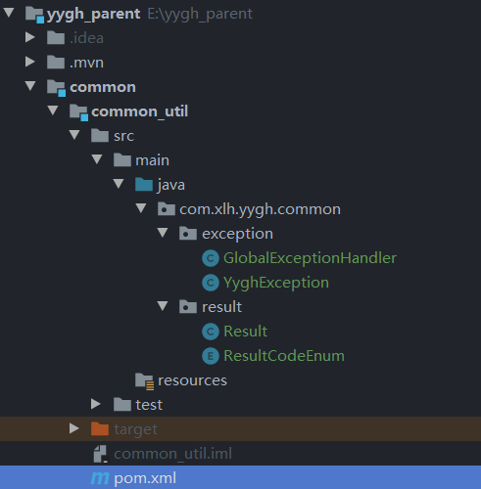

|  |  |
| --- | --- |
| YyghException | 自定义全局异常 |
| Result | API统一返回结果封装类 |
| ResultCodeEnum | API统一返回结果状态信息 |
| GlobalExceptionHandler | 全局异常处理 |

### 4、搭建service-util模块

Pom.xml文件：

1. <?xml version="1.0" encoding="UTF-8"?>
2. <project xmlns="http://maven.apache.org/POM/4.0.0"
3. xmlns:xsi="http://www.w3.org/2001/XMLSchema-instance"
4. xsi:schemaLocation="http://maven.apache.org/POM/4.0.0 http://maven.apache.org/xsd/maven-4.0.0.xsd">
5. <parent>
6. <artifactId>common</artifactId>
7. <groupId>com.xlh</groupId>
8. <version>0.0.1-SNAPSHOT</version>
9. </parent>
10. <modelVersion>4.0.0</modelVersion>
12. <artifactId>service_util</artifactId>
14. <dependencies>
15. <!-- redis -->
16. <dependency>
17. <groupId>org.springframework.boot</groupId>
18. <artifactId>spring-boot-starter-data-redis</artifactId>
19. </dependency>
21. <!-- spring2.X集成redis所需common-pool2-->
22. <dependency>
23. <groupId>org.apache.commons</groupId>
24. <artifactId>commons-pool2</artifactId>
25. <version>2.6.0</version>
26. </dependency>
27. </dependencies>

30. </project>

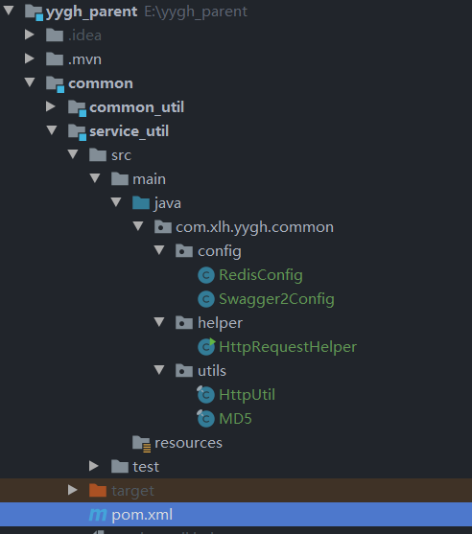

|  |  |
| --- | --- |
| RedisConfig | Redis配置 |
| Swagger2Config | Swagger配置用于调试 |
| HttpRequestHelper | 用于发送请求并接收内容 |
| HttpUtil | http发送接收的工具类 |
| MD5 | Md5加密算法 |

### 5、搭建service父模块

Pom.xml文件：

1. <?xml version="1.0" encoding="UTF-8"?>
2. <project xmlns="http://maven.apache.org/POM/4.0.0"
3. xmlns:xsi="http://www.w3.org/2001/XMLSchema-instance"
4. xsi:schemaLocation="http://maven.apache.org/POM/4.0.0 http://maven.apache.org/xsd/maven-4.0.0.xsd">
5. <parent>
6. <artifactId>yygh_parent</artifactId>
7. <groupId>com.xlh</groupId>
8. <version>0.0.1-SNAPSHOT</version>
9. </parent>
10. <modelVersion>4.0.0</modelVersion>
12. <artifactId>service</artifactId>
13. <packaging>pom</packaging>
14. <modules>
15. <module>service_user</module>
16. <module>service_hosp</module>
17. <module>service_cmn</module>
18. </modules>
20. <dependencies>
21. <!--web-->
22. <dependency>
23. <groupId>org.springframework.boot</groupId>
24. <artifactId>spring-boot-starter-web</artifactId>
25. </dependency>
26. <!--mybatis-plus-->
27. <dependency>
28. <groupId>com.baomidou</groupId>
29. <artifactId>mybatis-plus-boot-starter</artifactId>
30. </dependency>
31. <!--mysql-->
32. <dependency>
33. <groupId>mysql</groupId>
34. <artifactId>mysql-connector-java</artifactId>
35. <version>5.1.49</version>
36. </dependency>
37. <!--开发者工具-->
38. <dependency>
39. <groupId>org.springframework.boot</groupId>
40. <artifactId>spring-boot-devtools</artifactId>
41. <optional>true</optional>
42. </dependency>
43. <dependency>
44. <groupId>com.xlh</groupId>
45. <artifactId>service_util</artifactId>
46. <version>0.0.1-SNAPSHOT</version>
47. </dependency>
48. <dependency>
49. <groupId>com.xlh</groupId>
50. <artifactId>common_util</artifactId>
51. <version>0.0.1-SNAPSHOT</version>
52. </dependency>
53. <!-- 服务调用feign -->
54. <!--<dependency>-->
55. <!--    <groupId>org.springframework.cloud</groupId>-->
56. <!--    <artifactId>spring-cloud-starter-openfeign</artifactId>-->
57. <!--</dependency>-->
58. <!-- 服务注册 -->
59. <!--<dependency>-->
60. <!--    <groupId>com.alibaba.cloud</groupId>-->
61. <!--    <artifactId>spring-cloud-starter-alibaba-nacos-discovery</artifactId>-->
62. <!--</dependency>-->
63. <!-- 流量控制 -->
64. <!--<dependency>-->
65. <!--    <groupId>com.alibaba.cloud</groupId>-->
66. <!--    <artifactId>spring-cloud-starter-alibaba-sentinel</artifactId>-->
67. <!--</dependency>-->
68. </dependencies>
69. <build>
70. <plugins>
71. <plugin>
72. <groupId>org.springframework.boot</groupId>
73. <artifactId>spring-boot-maven-plugin</artifactId>
74. </plugin>
75. </plugins>
76. <resources>
77. <resource>
78. <directory>src/main/java</directory>
79. <includes>
80. <**include**>**/*.yml</include>
81. <include>**/*.properties</**include**>
82. <**include**>**/*.xml</include>
83. </includes>
84. <filtering>false</filtering>
85. </resource>
86. <resource>
87. <directory>src/main/resources</directory>
88. <includes>
89. <include>**/*.yml</**include**>
90. <**include**>**/*.properties</include>
91. <include>**/*.xml</**include**>
92. </includes>
93. <filtering>false</filtering>
94. </resource>
95. </resources>
96. </build>


100. </project>