**1：编写程序，提示用户输入两个整数，打印出这两个整数所指定范围内的所有整数。**

|  |
| --- |
| #include <iostream>  using namespace std;  int main(){      int a,b;      cout << "Enter two numbers(a&b): "<<endl;      cin >> a >> b;      if(a>b){          while(a>=b){              cout << a << " ";              a--;          }      }      else{          while(a<=b){              cout << a << " ";              a++;          }      }      return 0;  } |

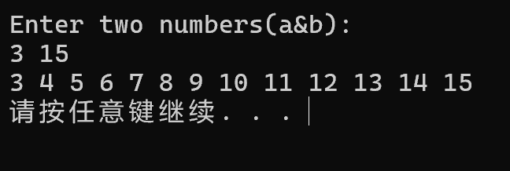

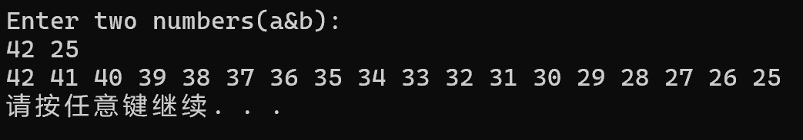

**2：编写程序，从cin读取一组整数，计算并输出这些整数的和。提示：先提示用户输入需要输入的整数的个数。**

|  |
| --- |
| #include <iostream>  using namespace std;  int main (){      int n,temp;      cout<<"Please enter the counts of integers you want to sum: "<<endl;      cin>>n;      int sum=0;      for(int i=0;i<n;++i){          cout<<"Please enter the integer(No."<<i+1<<"): ";          cin>>temp;          sum+=temp;      }      cout<<"The sum of the integers is: "<<sum<<endl;      return 0;  } |

