Three-Tier Application Deployment using Kubernetes on AWS Elastic Kubernetes Service (Amazon EKS)
Production-Style Cloud-Native Application Deployment on AWS EKS

Prepared By
Anwarullah Khan Nuzair
Cloud & DevOps Engineer

Contact
Email: myselfnuzairkhan@gmail.com
LinkedIn: https://www.linkedin.com/in/anwarullah-khan-nuzair
GitHub: https://github.com/Nuzairkhan

Project Overview
This portfolio documents a hands-on deployment of a three-tier application on Amazon EKS — covering infrastructure setup, Kubernetes configuration, containerization, networking, persistent storage, and the troubleshooting that came with getting it all working together.
Rather than demonstrating only application deployment, this project documents the complete engineering lifecycle — from infrastructure provisioning through workload deployment, validation, troubleshooting, and infrastructure decommissioning.

Technology Domains
Domain | Technologies
Cloud Platform | AWS
Container Platform | Docker
Container Orchestration | Kubernetes, Amazon EKS
Image Registry | Amazon ECR
Compute | Amazon EC2
Networking | VPC, Security Groups, Application Load Balancer, Ingress
Storage | Amazon EBS, Persistent Volumes, Persistent Volume Claims
Identity & Access | AWS IAM
Package Management | Helm
Application Stack | React, Node.js, MongoDB
Operating System | Linux
Version Control | Git, GitHub

Portfolio Objectives
This document demonstrates practical experience with:
- Production-style Kubernetes deployments
- Cloud-native application architecture
- AWS infrastructure provisioning
- Container lifecycle management
- Kubernetes networking
- Persistent storage design
- Secure workload deployment
- Infrastructure troubleshooting
- Operational best practices
- Production readiness considerations

Intended Audience
This portfolio is prepared for:
- Technical Hiring Managers
- Cloud Architects
- DevOps Engineering Teams
- Site Reliability Engineers
- Platform Engineering Teams
- Infrastructure Engineering Teams

Document Information
Item | Value
Version | 1.0
Status | Production Portfolio
Document Type | Engineering Deployment Documentation
Classification | Portfolio / Technical Demonstration
Last Updated | July 2026

Chapter 2 — Executive Summary

Project Context
I came across this three-tier application deployment as a hands-on Kubernetes and AWS EKS challenge and decided to work through it because it covered the full stack — not just spinning up a single container, but deploying a complete application with a frontend, backend, and database, wiring them together through Kubernetes networking, and exposing everything through AWS infrastructure.
My background going in included some AWS and DevOps tooling exposure, but EKS specifically was new territory. I understood individual pieces — Docker, basic Kubernetes concepts, AWS services — but hadn't put them together in a real deployment. That's what this project was for.

Business Problem
Managing a multi-service application without an orchestration platform gets complicated fast. Without something like Kubernetes, you're manually coordinating deployments across services, dealing with environment inconsistencies between machines, and handling failures by hand.
The specific challenges this deployment was designed to address:
- Maintaining deployment consistency across application components
- Providing reliable communication between frontend, backend, and database tiers
- Ensuring persistent storage for MongoDB so data survives container restarts
- Exposing the application externally through a single, controlled entry point
- Reducing the manual overhead of managing containerized workloads
- Improving resiliency so the application recovers automatically from failures

Business Objectives
The primary objective was to deploy a production-style Kubernetes environment hosting a complete three-tier application, and to validate the operational workflows that come with it — not just get containers running, but understand how the pieces connect and what happens when they don't.
Specific outcomes targeted:
- Deploy a multi-tier application using Kubernetes-native resources
- Containerize application components for consistent runtime environments
- use Amazon EKS as the managed Kubernetes control plane
- Store application images securely within Amazon ECR
- Configure internal service discovery using Kubernetes networking
- Implement persistent storage for database workloads
- Publish application traffic through an AWS Application Load Balancer using Kubernetes Ingress
- Validate complete application features from user request through database persistence
- Apply operational troubleshooting and infrastructure cleanup practices throughout the deployment lifecycle

Solution Overview
The application is a standard three-tier setup, with each tier running as an independent Kubernetes workload inside an Amazon EKS cluster.
Tier | Implementation | Primary Responsibility
Presentation Layer | React | User interface and client interaction
Application Layer | Node.js REST API | Business logic and request processing
Data Layer | MongoDB | Persistent storage for application data
External traffic enters through an AWS Application Load Balancer and is routed by a Kubernetes Ingress resource. Internal communication between services uses Kubernetes DNS-based service discovery. MongoDB persists data through Kubernetes Persistent Volumes backed by Amazon EBS, so storage survives Pod restarts independently.
The end result I could verify: opening the ALB URL in a browser, the React frontend loaded, and adding a task through the UI resulted in it being stored in MongoDB — the complete frontend → backend → database path working end to end.

Solution Highlights
Capability | Implementation
Container Orchestration | Amazon EKS
Container Runtime | Docker
Image Registry | Amazon ECR
External Traffic Management | AWS Application Load Balancer + Kubernetes Ingress
Internal Networking | Kubernetes Services & DNS
Persistent Storage | Persistent Volume & Persistent Volume Claim
Cluster Management | kubectl, eksctl, Helm
Platform | Linux on Amazon EC2 (administration host)

Project Scope
This portfolio documents the complete engineering lifecycle of the deployment.
Included within scope:
- AWS environment preparation
- Amazon EKS cluster provisioning
- Container image management
- Kubernetes resource design
- Storage configuration
- Networking configuration
- Ingress implementation
- Identity and access configuration
- Application deployment
- Operational validation
- Infrastructure decommissioning
Intentionally outside scope:
- CI/CD automation
- Infrastructure as Code
- Multi-region deployment
- Production monitoring platforms
- GitOps workflows
These are worth adding for a production environment but were deliberately excluded here. The focus was on understanding the deployment itself before layering automation on top.

Key Technologies
Category | Technologies
Cloud Platform | AWS
Compute | Amazon EC2
Container Platform | Docker
Orchestration | Kubernetes, Amazon EKS
Image Management | Amazon ECR
Networking | VPC, Security Groups, AWS Application Load Balancer, Kubernetes Ingress
Storage | Amazon EBS, Persistent Volumes, Persistent Volume Claims
Identity | AWS IAM
Package Management | Helm
Application Stack | React, Node.js, MongoDB
Operations | kubectl, eksctl
Version Control | Git, GitHub

Success Criteria
The deployment was considered complete when:
✓ Kubernetes cluster provisioned and operational on Amazon EKS
✓ Frontend, backend, and MongoDB workloads deployed successfully
✓ Kubernetes Services enabled reliable inter-service communication
✓ Application traffic routed through AWS Application Load Balancer using Kubernetes Ingress
✓ MongoDB data persisted using Persistent Volumes
✓ End-to-end features validated from browser request to database storage
✓ AWS resources decommissioned after testing to avoid unnecessary infrastructure costs

Assessment
This is a portfolio project, not a production system. The architecture reflects real patterns used in enterprise Kubernetes deployments but is intentionally scoped — single region, manually applied manifests, basic monitoring. What it demonstrates is the ability to work through a complete cloud-native deployment, debug real infrastructure issues across multiple layers, and understand how the components connect. That's the point of it.

Chapter 3 — Cloud Architecture

Overview
The deployment follows a three-tier architecture running on Amazon Elastic Kubernetes Service. Each application tier — frontend, backend, and database — runs as an independent Kubernetes workload, with internal communication handled through Kubernetes-native networking and external access managed through AWS infrastructure.
The architecture itself came from the project reference I was working through. My focus was on implementing it correctly on AWS EKS, understanding how the components interact, and working through the configuration and troubleshooting required to get it running end to end.

Architectural Principles
Principle | Design Decision | Engineering Rationale
Separation of Concerns | Independent frontend, backend, and database tiers | Simplifies maintenance and enables independent lifecycle management
Containerization | Docker images for every application component | Ensures environment consistency and reproducible deployments
Managed Control Plane | Amazon EKS | Eliminates Kubernetes control plane administration while preserving Kubernetes flexibility
Internal Service Discovery | Kubernetes Services | Decouples workloads from Pod IP addresses
Persistent Storage | Persistent Volume + Persistent Volume Claim | Preserves MongoDB data independently of Pod lifecycle
External Traffic | AWS Application Load Balancer + Kubernetes Ingress | Provides centralized HTTP entry point with path-based routing

High-Level Architecture
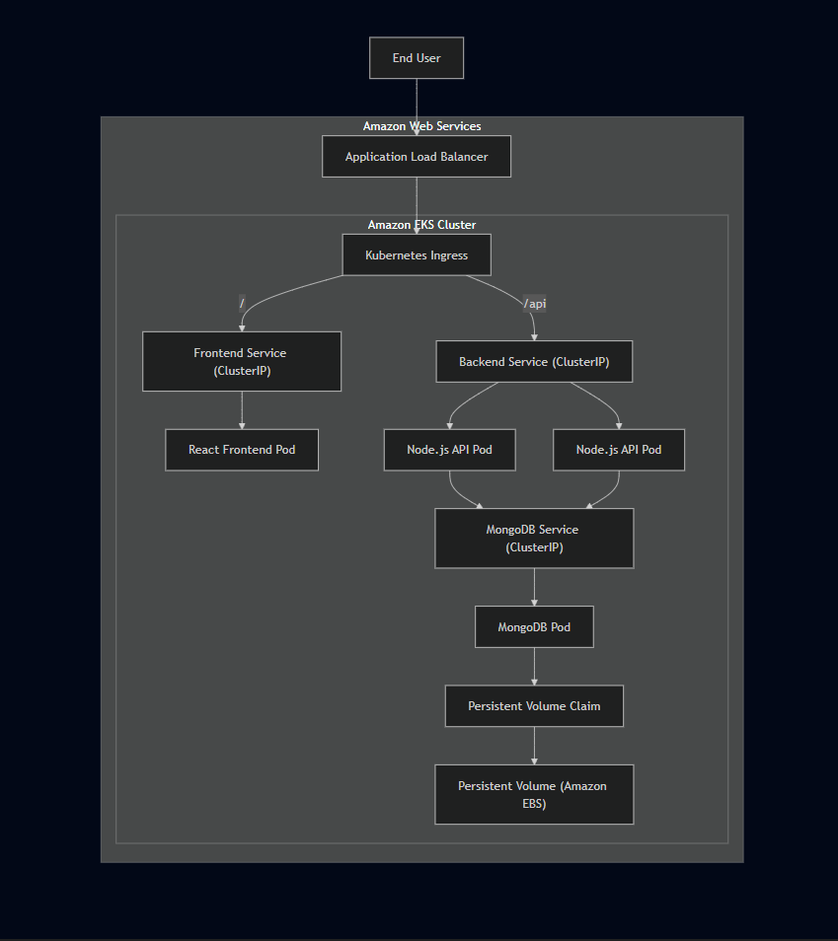
The ALB is the only component exposed to the internet. Everything inside the EKS cluster communicates through ClusterIP Services using Kubernetes DNS — no application workload is directly reachable from outside.

Component Interaction

1. Client Access
Users access the application through the DNS endpoint generated by the AWS Application Load Balancer. The ALB is the single public entry point — it receives HTTP traffic and forwards it into the cluster through the configured Ingress resource.

2. Traffic Routing
One decision I made during setup was to use path-based routing rather than host-based routing. Since the deployment didn't require a custom domain, routing on the ALB DNS name directly was simpler and sufficient for validating the full application flow.
Request Path | Destination
/ | Frontend Service
/api | Backend Service
This keeps a single public endpoint while maintaining clean separation between the presentation and application layers.

3. Frontend Processing
The React frontend runs as the presentation layer. Rather than targeting a fixed backend URL, it uses relative API paths — /api/tasks — which get resolved by the Ingress controller and routed to the backend Service. This avoids any hardcoded environment-specific configuration in the compiled frontend bundle.

4. Backend Processing
The backend runs inside a Kubernetes Deployment with two replicas. Incoming requests arrive through the backend Service, which distributes traffic between the available Pods transparently.

5. Database Communication
The backend reaches MongoDB through Kubernetes internal DNS:
mongodb-svc:27017
MongoDB is not exposed outside the cluster. All database communication stays internal to the Kubernetes network.

6. Persistent Storage
MongoDB is treated as a stateful workload. Its storage is managed through a Persistent Volume and Persistent Volume Claim backed by Amazon EBS, which means the data persists independently of the Pod lifecycle — if the MongoDB Pod restarts or gets rescheduled, the data is still there.

Network Architecture
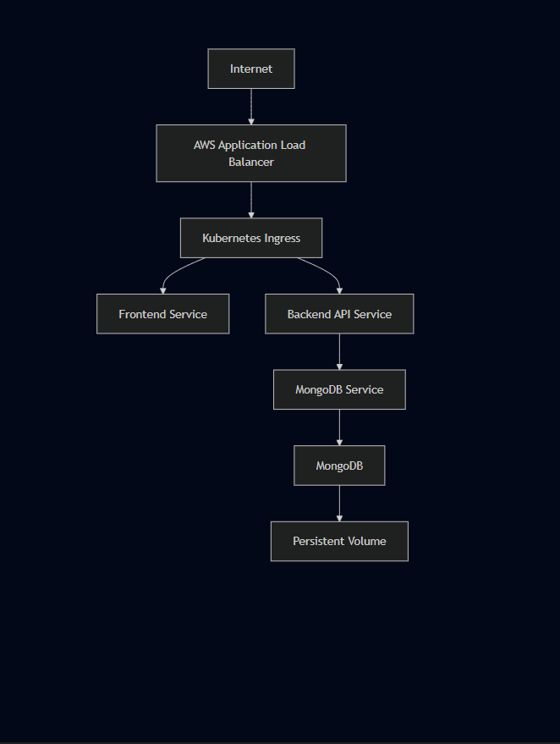

Traffic Flow

External Request Lifecycle
Browser
↓
AWS Application Load Balancer
↓
Kubernetes Ingress
↓
Frontend Service
↓
React Frontend
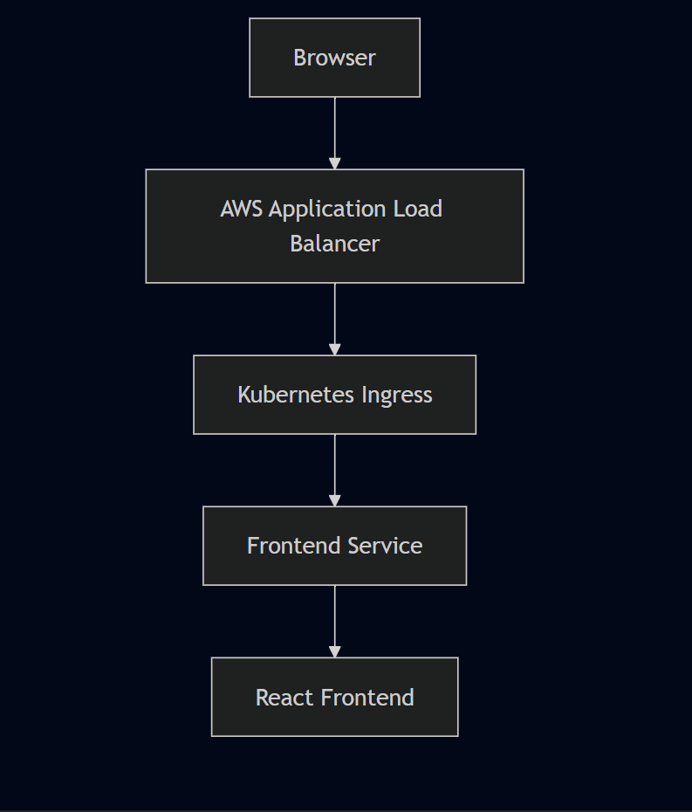

API Request Lifecycle
React Application
↓
/api
↓
Ingress
↓
Backend Service
↓
Node.js API
↓
MongoDB Service
↓
MongoDB
↓
Persistent Volume
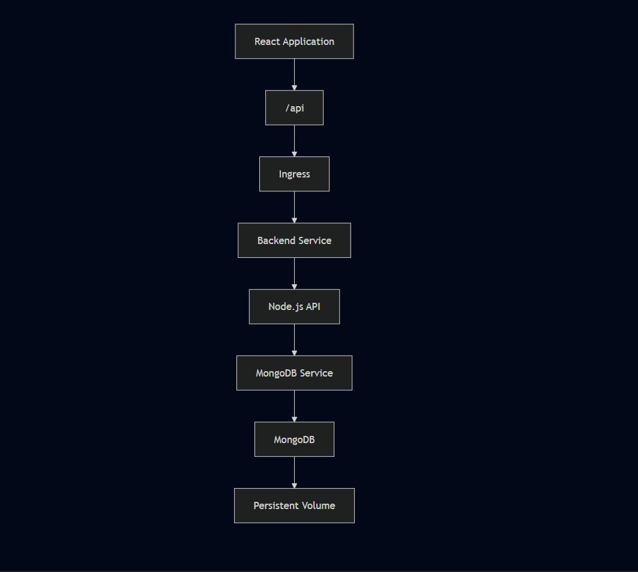

Kubernetes Resource Interaction
Resource | Responsibility
Namespace | Logical isolation of project resources
Deployment | Desired application state management
ReplicaSet | Maintains required Pod count
Pod | Executes application containers
Service | Stable internal networking
Ingress | External HTTP routing
Secret | Stores MongoDB credentials
Persistent Volume | Durable database storage
Persistent Volume Claim | Storage allocation abstraction

Design Decisions

Managed Kubernetes Platform
EKS handles the Kubernetes control plane — API server, etcd, scheduler — so the focus stays on deploying and managing workloads rather than maintaining cluster infrastructure.

ClusterIP Services
All application Services use ClusterIP, which keeps them internal to the cluster. The only externally reachable component is the ALB. This limits the attack surface and means internal service communication never leaves the Kubernetes network.

Path-Based Routing
Using a single ALB with path-based Ingress rules means one public endpoint serves the entire application. / reaches the frontend, /api reaches the backend. No custom domain was needed — the ALB DNS name was sufficient for validating the deployment end to end.

Stateless vs Stateful Workloads
The frontend and backend are stateless — Kubernetes can recreate their Pods without any impact on application behavior. MongoDB is stateful and requires persistent storage. Treating them differently in the deployment design reflects that distinction directly.

Horizontal Availability
The backend runs two replicas. If one Pod fails, the Service continues routing traffic to the other while Kubernetes schedules a replacement. It also means rolling updates can happen without taking the backend offline.

Operational Validation
The architecture was verified through end-to-end functional testing from the management EC2 instance and browser:
✓ Frontend accessible through the AWS Application Load Balancer
✓ Kubernetes Ingress correctly routing traffic based on request path
✓ Backend Services resolving through Kubernetes DNS
✓ MongoDB connectivity established from the application layer
✓ Persistent storage retaining application data across Pod lifecycle events
✓ Stable communication across all three application tiers

Chapter 4 — Infrastructure Design

Overview
The infrastructure for this deployment was built around AWS managed services rather than self-managed components. The idea was straightforward — let AWS handle the heavy lifting on things like the Kubernetes control plane and networking, so the focus could stay on actually deploying and validating the application.
I set up a dedicated Ubuntu EC2 instance first as the management environment, then used it to provision everything else — the EKS cluster, ECR repositories, and Kubernetes resources — from an SSH session throughout the project.

Infrastructure Components
Component | AWS Service | Responsibility
Identity | AWS IAM | Authentication and authorization
Compute (Management) | Amazon EC2 (t2.micro) | Cluster administration host
Container Platform | Amazon EKS | Managed Kubernetes control plane
Worker Nodes | EC2 Managed Node Group (t2.medium) | Execute Kubernetes workloads
Image Registry | Amazon ECR | Store Docker images
Load Balancing | AWS Application Load Balancer | Public HTTP entry point
Persistent Storage | Amazon EBS | Durable storage for MongoDB
Networking | Amazon VPC | Network isolation

Infrastructure Overview
flowchart TB

subgraph AWS["AWS Account"]

IAM["AWS IAM"]

subgraph VPC["Amazon VPC (auto-provisioned by eksctl)"]

IGW["Internet Gateway"]

subgraph PUBLIC["Public Subnets"]

EC2["Management EC2 (t2.micro)"]

ALB["Application Load Balancer"]

end

subgraph PRIVATE["Worker Node Subnets"]

NODE1["EKS Worker Node (t2.medium)"]

NODE2["EKS Worker Node (t2.medium)"]

end

EBS["Amazon EBS"]

end

ECR["Amazon ECR"]

end

Developer --> IAM
Developer --> EC2

EC2 --> EKS
EC2 --> ECR

Internet --> IGW
IGW --> ALB

ALB --> NODE1
ALB --> NODE2

NODE1 --> EBS
NODE2 --> EBS

NODE1 --> ECR
NODE2 --> ECR
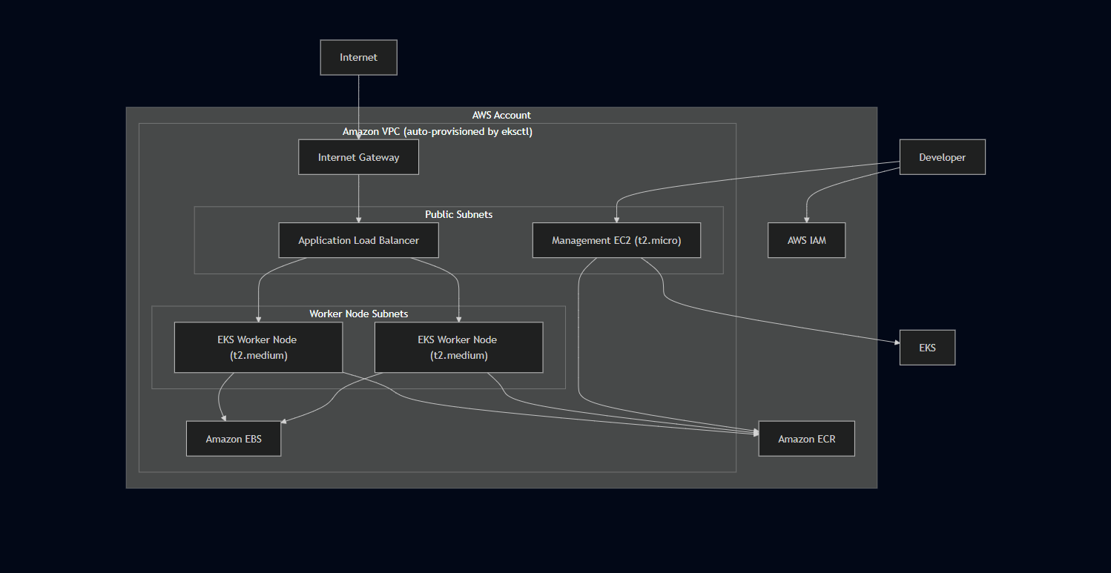

IAM Setup
Before provisioning anything else, I created a dedicated IAM user named eks-admin and attached AdministratorAccess. This gave the management environment the permissions needed to provision and manage EKS, ECR, EC2, IAM roles, and the load balancer controller without hitting authorization errors at each step.
The AWS Load Balancer Controller specifically needed its own IAM Role associated with a Kubernetes Service Account — this is the IRSA pattern. Rather than giving the controller broad permissions, it gets only what it needs to provision and manage load balancers. That distinction mattered in practice — the IAM authorization failure we hit during deployment (missing elasticloadbalancing:DescribeListenerAttributes) happened because the controller role was missing a specific permission, not because of a broad misconfiguration.
IAM responsibilities across the deployment:
- Administrative access for cluster provisioning
- EKS cluster and node group permissions
- Worker node permissions for ECR image pulls
- AWS Load Balancer Controller permissions via IRSA
- OIDC provider association for service account binding

EC2 Management Instance
I created a dedicated Ubuntu EC2 instance (t2.micro) specifically for this project before starting the EKS deployment. Everything — cluster creation, image builds, kubectl operations, Helm installations, manifest deployments — was run from an SSH session on this instance.
The instance itself runs no application workloads. It's purely an administration endpoint. Using a dedicated EC2 instance rather than running everything from a local machine kept the environment consistent and avoided issues with local tool versions or AWS credential configuration.
Tools configured on the management instance:
- AWS CLI
- kubectl
- eksctl
- Docker
- Helm
The AWS Console ran alongside for visual verification — checking EKS cluster state, load balancer provisioning, target group health, security group configuration, IAM role attachments, ECR repositories, and EBS volumes.

VPC and Networking
The VPC was not created manually. When I ran the eksctl cluster creation command, it automatically provisioned the VPC, subnets, Internet Gateway, and route tables required for the cluster. This is one of the advantages of using eksctl — the networking infrastructure comes up correctly without having to configure each component individually.
The cluster was deployed in us-west-2.
Subnet design:
Subnet Type | Purpose
Public Subnets | Application Load Balancer
Private/Worker Subnets | Kubernetes Worker Nodes
This keeps worker nodes off the public internet. The ALB sits in the public subnets and forwards traffic to the worker nodes, which are only accessible through the load balancer.

Security Groups
Security Groups acted as the firewall layer across the deployment.
Management EC2:
- Inbound: SSH (port 22)
- Purpose: administration access only
Application Load Balancer:
- Inbound: HTTP (port 80)
- Purpose: public application traffic
Worker Nodes:
- Inbound: traffic from ALB and Kubernetes control plane
- No direct public internet exposure
Pods themselves are never directly reachable from outside the cluster. All external traffic goes through ALB → Ingress → Service → Pod.

EKS Cluster
The cluster was provisioned using eksctl with the following configuration:
eksctl create cluster \
--name three-tier-cluster \
--region us-west-2 \
--node-type t2.medium \
--nodes-min 2 \
--nodes-max 2

This created:
- The managed Kubernetes control plane (API server, scheduler, controller manager)
- A managed node group with 2 x t2.medium worker nodes
- The supporting VPC and networking infrastructure
Using eksctl meant I didn't have to manually configure the control plane, node registration, or networking — it handled all of that and left me with a working cluster to deploy into.

Worker Node Design
Configuration | Value
Node Count | 2
Instance Type | t2.medium
Management | EKS Managed Node Group
Operating System | Amazon Linux (Managed by EKS)
Region | us-west-2
Two worker nodes provide basic redundancy — if one node goes down, Kubernetes can reschedule Pods on the other. It also means the backend's two replicas can potentially land on separate nodes, which improves availability.

Amazon ECR
Two private ECR repositories stored the application images:
Repository | Purpose
Frontend Repository | React application image
Backend Repository | Node.js API image
Worker nodes pull images directly from ECR during Pod scheduling. IAM permissions on the node role allow this without requiring manual credential configuration on each node.
Separate repositories per service meant frontend and backend images could be versioned and updated independently.

Persistent Storage
MongoDB needed storage that survives Pod restarts. Rather than manually creating an EBS volume, the persistent storage was handled through the Kubernetes PV/PVC workflow:
- A Persistent Volume Claim defined the storage requirement
- Kubernetes bound the PVC to an available Persistent Volume
- The Persistent Volume was backed by Amazon EBS
The EBS volume was created through this workflow rather than manually in the AWS Console. This keeps storage lifecycle tied to the Kubernetes configuration rather than requiring separate manual steps in AWS.

Infrastructure Lifecycle
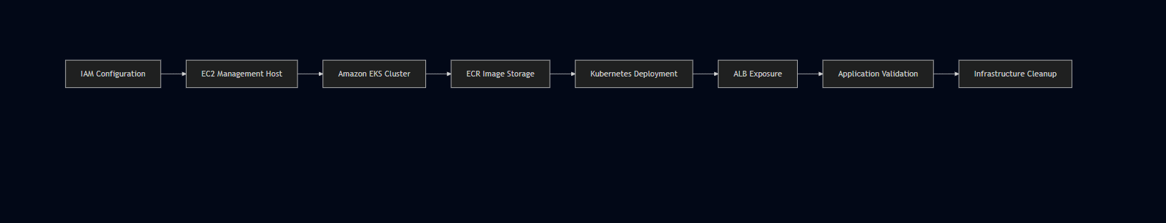

Design Rationale
Design Choice | Rationale
Managed Kubernetes (EKS) | Avoid control plane administration overhead
eksctl for provisioning | Automates VPC, subnet, and node group creation
Dedicated management EC2 | Consistent tooling environment, no local dependency
Amazon ECR | Native EKS integration, no external registry authentication needed
ALB Ingress | Single public endpoint with path-based routing
ClusterIP Services | Internal-only communication, no unnecessary exposure
Persistent Volumes | MongoDB data survives Pod recreation
Two Worker Nodes | Basic redundancy and scheduling flexibility
IAM least privilege | Controller-specific roles via IRSA pattern

Infrastructure Validation
The infrastructure was considered operational after verifying:
✓ Amazon EKS cluster provisioned and showing Active in us-west-2
✓ Worker nodes registered and in Ready state
✓ Docker images available in Amazon ECR repositories
✓ Kubernetes workloads scheduled successfully across nodes
✓ Application Load Balancer provisioned and reachable
✓ Internal service communication functioning via Kubernetes DNS
✓ MongoDB persistent storage bound and validated
✓ All AWS resources decommissioned after testing

Chapter 5 — Technology Stack

Overview
The application stack — React, Node.js, and MongoDB — was already part of the challenge project I followed. My focus wasn't on selecting these technologies but on understanding how to containerize them, wire them together through Kubernetes networking, and deploy the complete three-tier architecture on AWS EKS.
The infrastructure and tooling choices around that stack — EKS, ECR, ALB, Helm, IAM — were driven by the AWS-based deployment approach. Since everything was running in AWS, using managed AWS services was the natural path rather than a deliberate comparison exercise.

Technology Stack Overview
Layer | Technology
Cloud Platform | Amazon Web Services (AWS)
Compute | Amazon EC2
Container Orchestration | Amazon Elastic Kubernetes Service (EKS)
Container Runtime | Docker
Image Registry | Amazon Elastic Container Registry (ECR)
Application Load Balancing | AWS Application Load Balancer
Container Networking | Kubernetes Services & Ingress
Storage | Amazon EBS, Persistent Volumes (PV), Persistent Volume Claims (PVC)
Identity & Access | AWS IAM
Package Management | Helm
Application Framework | React.js
Backend Framework | Node.js
Database | MongoDB
Operating System | Ubuntu Linux
Version Control | Git & GitHub
Cluster Administration | kubectl, eksctl

Technology Evaluation Matrix
Technology | Purpose | Why Selected | Alternative
Amazon EKS | Managed Kubernetes | Native AWS integration, managed control plane | Self-managed Kubernetes, Amazon ECS
Docker | Containerization | Industry standard, reproducible environments | Podman
Amazon ECR | Image Registry | Native EKS integration, same AWS environment | Docker Hub, GitHub Container Registry
Amazon EC2 | Administration Host | Dedicated management environment | AWS CloudShell
AWS IAM | Identity & Access | Fine-grained permission management | Static credentials
Application Load Balancer | External Traffic Routing | Native Kubernetes Ingress support | NGINX Ingress, Network Load Balancer
Helm | Kubernetes Package Manager | Used for AWS Load Balancer Controller installation | Manual manifest installation
MongoDB | Database | Part of the project application stack | MySQL, PostgreSQL
React.js | Frontend | Part of the project application stack | Angular, Vue.js
Node.js | Backend | Part of the project application stack | Spring Boot, ASP.NET Core

Cloud Platform — AWS
Everything in this deployment runs on AWS. EKS, ECR, ALB, EBS, IAM — they all integrate natively with each other, which simplified the deployment significantly compared to mixing cloud providers or using external services.
The main benefit wasn't any single AWS service — it was that the services work together without requiring custom integration work. ECR authenticates with EKS automatically through IAM. The Load Balancer Controller provisions ALBs directly from Kubernetes Ingress resources. EBS volumes bind to Persistent Volume Claims without manual provisioning.
Responsibilities:
- Infrastructure provisioning
- Identity management
- Networking
- Container orchestration
- Storage
- Load balancing

Container Runtime — Docker
The Dockerfiles were already part of the project repository. My work involved building the images from those Dockerfiles, pushing them to ECR, and debugging issues that came up during that process — including the Dockerfile naming error in the backend project where the file was named Dockefile instead of Dockerfile, which blocked the entire build until caught.
Docker's role in this deployment was straightforward — package each application tier into an image that Kubernetes can pull and run consistently across worker nodes.
Responsibilities:
- Package applications with dependencies
- Ensure environment consistency
- Enable immutable deployments
- Simplify version management

Container Orchestration — Amazon EKS
I went straight to eksctl for cluster creation rather than using the AWS Console. The goal was to understand the CLI-based provisioning workflow — how the cluster, node group, VPC, and networking all get created from a single command.
EKS handles the Kubernetes control plane — API server, scheduler, controller manager — so the focus stays on deploying and managing workloads rather than maintaining cluster infrastructure.
One thing this deployment made clear: a running EKS cluster with healthy Pods is not enough on its own. IAM permissions, the Load Balancer Controller, Ingress configuration, Service port mappings, and application-level configuration all have to be correct simultaneously for the application to actually work end to end. The cluster is just the foundation.
Responsibilities:
- Pod scheduling
- Cluster management
- Control plane availability
- Workload orchestration

Container Registry — Amazon ECR
ECR was the natural choice for storing images because the cluster was already running in AWS. Worker nodes pull images from ECR using IAM-based authentication — no separate registry credentials needed.
Two private repositories were created:
Repository | Purpose
Frontend Repository | React application image
Backend Repository | Node.js API image
Separate repositories per service allow independent versioning and updates without affecting the other tier.

Networking

AWS Application Load Balancer
The ALB is the single external entry point for the application. The AWS Load Balancer Controller provisions and manages it directly from the Kubernetes Ingress resource — no manual load balancer configuration in the AWS Console required.
Path-based routing handles traffic distribution:
Request Path | Destination
/ | Frontend Service
/api | Backend Service
Responsibilities:
- HTTP request routing
- Path-based routing
- Kubernetes Ingress integration

Kubernetes Services
All application Services use ClusterIP — internal only. Nothing is directly exposed to the internet except through the ALB. Services provide stable DNS-based endpoints so Pods can communicate without depending on individual Pod IP addresses.

Storage — Amazon EBS + Kubernetes PV/PVC
MongoDB needs storage that survives Pod restarts. The PV/PVC workflow handles this — the Persistent Volume Claim defines the storage requirement, Kubernetes binds it to a Persistent Volume, and that volume is backed by an Amazon EBS block storage device.
The EBS volume was created automatically through this workflow rather than manually. If the MongoDB Pod restarts or gets rescheduled, it reattaches to the same volume and the data is still there.

Identity — AWS IAM
IAM underpins every AWS service interaction in this deployment. The eks-admin user had AdministratorAccess for provisioning. The AWS Load Balancer Controller used a dedicated IAM Role via IRSA — scoped only to the permissions it needed for load balancer management.
The IAM authorization failure during deployment — missing elasticloadbalancing:DescribeListenerAttributes — was a direct reminder that IAM permissions have to be exact. The controller was running, the Ingress was applied, but nothing happened on the AWS side until the missing permission was attached.

Package Management — Helm
Helm was used specifically for installing the AWS Load Balancer Controller inside the cluster. The application itself — frontend, backend, MongoDB — was deployed using standard Kubernetes manifests rather than Helm charts.
Helm made the controller installation straightforward — a single command handles the chart download, configuration, and deployment rather than manually applying multiple manifest files in the correct order.

Application Stack

React.js — Frontend
React serves as the presentation layer. One non-obvious behavior that surfaced during deployment: React resolves environment variables at build time, not at runtime. The backend API URL gets compiled into the JavaScript bundle when npm run build runs. Changing a Kubernetes environment variable after the image is built has no effect on the already-compiled frontend.
The fix was to use a relative API path /api/tasks instead of an environment variable, letting Ingress handle the routing rather than hardcoding a backend URL.

Node.js — Backend
Node.js powers the REST API. The backend listens on port 3500 and handles all communication between the frontend and MongoDB. Two replicas run in parallel — the Kubernetes Service distributes traffic between them transparently.

MongoDB — Database
MongoDB stores the application's task data. It runs as a stateful workload with persistent storage managed through PV/PVC. The backend reaches it through Kubernetes internal DNS at mongodb-svc:27017 — never exposed outside the cluster.

Development & Administration Tools
Tool | Purpose
kubectl | Kubernetes cluster administration
eksctl | Amazon EKS cluster provisioning
Git | Version control
GitHub | Source code management
Linux | Administration environment

Engineering Trade-offs
Decision | Benefit | Consideration
Amazon EKS | Managed control plane | Higher cost than self-managed clusters
ALB Ingress | Native AWS integration | AWS-specific implementation
Docker | Industry standard | Requires image management
MongoDB | Part of project stack | Less suitable for highly relational workloads
Helm | Simplified controller installation | Additional learning curve

What This Stack Actually Taught Me
The biggest surprise wasn't any individual technology — it was how many layers had to work correctly simultaneously for a simple application to become accessible in a browser.
A working EKS cluster wasn't enough. Healthy Pods weren't enough. The IAM permissions, Load Balancer Controller, Ingress configuration, Service port mappings, frontend API paths, and persistent storage configuration all had to be correct at the same time. When something was wrong, the symptom was often visible at a completely different layer from the actual cause — a frontend that couldn't reach the backend turned out to be a React build-time configuration issue, not a Kubernetes networking problem.
That's the practical learning this stack provided — not just how each tool works individually, but how they interact as a system.

Chapter 6 — Containerization

Overview
Containerization was the first major step before anything could run on Kubernetes. Each application tier — React frontend, Node.js backend, and MongoDB — needed to be packaged as a Docker image before EKS could schedule it as a workload. The entire build and push workflow ran from the Ubuntu EC2 management instance rather than locally, keeping the environment consistent with where the cluster was being managed.
The Dockerfiles were already part of the project repository. My work in this phase was working through the build process, fixing issues that came up, pushing images to ECR, and then referencing those images in the Kubernetes Deployment manifests.

Container Architecture
Amazon Web ServicesUbuntu EC2 Management InstanceAmazon EKSDeveloperApplication Source CodeDockerfileDocker ImageAmazon ECRFrontend PodBackend PodMongoDB PodPersistent Volume

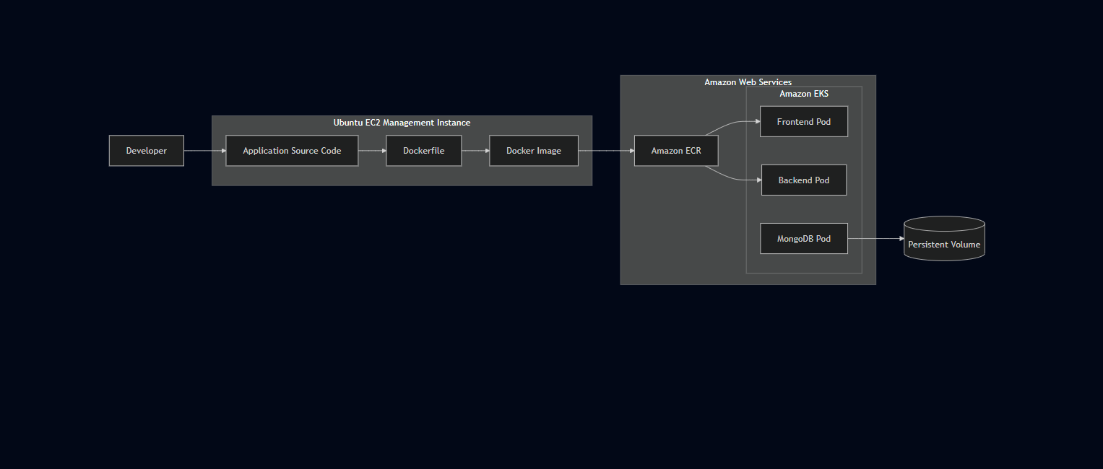

Why Containerization?
Running three separate services — frontend, backend, database — across different machines without containers means dealing with dependency conflicts, environment inconsistencies, and manual configuration on every host. Docker solves this by packaging each service with everything it needs to run, so the behavior is identical regardless of where the container executes.
For a Kubernetes deployment specifically, containers are not optional — they are the fundamental unit that Kubernetes schedules, monitors, and manages. EKS worker nodes pull container images and run them as Pods. Everything in this deployment flows from that model.
Challenge | How Docker Addresses It
Environment inconsistency | Standardized runtime image with bundled dependencies
Dependency conflicts | Each service runs in its own isolated container
Deployment repeatability | Immutable images produce identical runtime behavior
Infrastructure portability | Images run on any Docker-compatible host
Scaling | New containers start from the same image instantly

Containerized Application Components
Component | Runtime | Container Purpose
Frontend | React.js | Serves the user interface
Backend | Node.js | Handles REST API requests and business logic
Database | MongoDB | Persistent data storage — stateful workload
Each tier runs in its own container, managed independently by Kubernetes. This separation means the backend can be updated or scaled without touching the frontend, and MongoDB can be maintained as a stateful workload while the application layers remain stateless.

Docker Image Lifecycle
The complete path from source code to running container follows this sequence:
Source CodeDocker BuildDocker ImageAmazon ECREKS Worker NodeKubernetes Pod
Each step is distinct and sequential. Worker nodes never build images themselves — they only consume images that were already built and pushed to ECR. This separation between build time and runtime keeps the deployment process clean and reproducible.

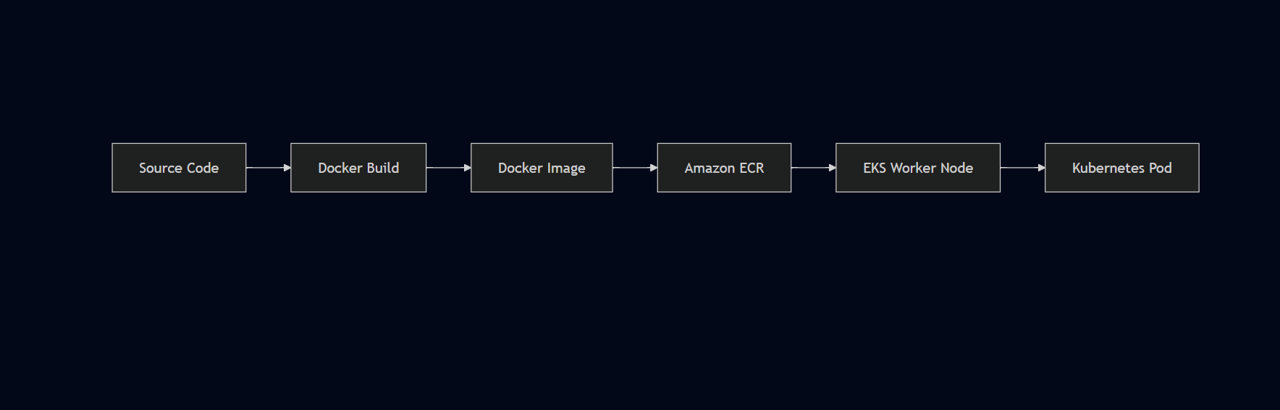

Build Environment Setup
All image builds happened on the Ubuntu EC2 management instance. After cloning the project repository onto the instance, Docker was installed and configured before starting the build process.
Docker installation on Ubuntu:
bash
sudo apt-get update
sudo apt install docker.io
Verify Docker is running:
bash
docker ps
Fix permissions to avoid running Docker with sudo on every command:
bash
sudo chown $USER /var/run/docker.sock
This last step matters in practice — without it, every Docker command requires sudo, which adds friction and can cause permission issues when commands are chained together.

Container Build Workflow

Phase 1 — Source Preparation
The project source code was cloned onto the EC2 management instance. The repository structure separated each application tier into its own directory, with each service containing its own Dockerfile alongside the application source and dependency definitions.
Each service directory contained:
- Application source code
- Dependency definitions (package.json for Node.js services)
- Dockerfile defining the container build
- Runtime configuration

Phase 2 — Image Build
Docker builds were run from inside each service directory. The build process packages the application source together with its runtime dependencies into a portable, immutable image.
The backend Dockerfile typo (Dockefile instead of Dockerfile) was caught at this stage — Docker couldn't locate the build definition and the build exited immediately. Finding the misnamed file and correcting it unblocked the backend build.
Key outcomes of the build phase:
- Application source bundled with runtime dependencies
- Immutable image produced — identical behavior on any host
- Image available locally before pushing to ECR

Phase 3 — ECR Authentication
Before pushing images to Amazon ECR, Docker needs to authenticate with the registry. This is handled through the AWS CLI:
bash
aws ecr get-login-password --region us-west-2 | docker login \
--username AWS \
--password-stdin \
<AWS_ACCOUNT_ID>.dkr.ecr.us-west-2.amazonaws.com
A successful authentication returns:
Login Succeeded
This step uses the IAM credentials configured on the EC2 instance — no separate registry password is needed. ECR authentication is entirely IAM-based, which is one of the reasons ECR integrates cleanly with EKS.

Phase 4 — Image Tagging
Before pushing to ECR, images are tagged with the full ECR repository URI:
bash
docker tag <local-image-name>:latest \
<AWS_ACCOUNT_ID>.dkr.ecr.us-west-2.amazonaws.com/<repository-name>:latest
This tag tells Docker exactly where to push the image — which AWS account, which region, and which repository.

Phase 5 — Image Push to ECR
Tagged images are pushed to their respective ECR repositories:
bash
docker push \
<AWS_ACCOUNT_ID>.dkr.ecr.us-west-2.amazonaws.com/<repository-name>:latest
Separate pushes were performed for the frontend and backend images. After pushing, the images were verified in ECR to confirm they were available before referencing them in Kubernetes Deployment manifests.

Phase 6 — Kubernetes Deployment
With images available in ECR, the Deployment manifests reference the full ECR URI:
yaml
image: <AWS_ACCOUNT_ID>.dkr.ecr.us-west-2.amazonaws.com/frontend:latest
yaml
image: <AWS_ACCOUNT_ID>.dkr.ecr.us-west-2.amazonaws.com/backend:latest
When Kubernetes schedules Pods, worker nodes pull images directly from ECR using IAM-based authentication. No manual credential configuration is needed on the nodes.

Dockerfile Design
Each application component has a dedicated Dockerfile. The general structure covers:
- Selecting an appropriate base image for the runtime
- Setting the working directory inside the container
- Installing application dependencies
- Copying application source code
- Exposing the port the application listens on
- Defining the startup command
This structure ensures the container is self-contained — everything needed to run the application is baked into the image at build time.

Frontend Container
The React frontend runs as the presentation layer, serving the user interface and forwarding API requests through Kubernetes Ingress.
Rather than using a hardcoded backend URL, the frontend was configured to use relative API paths (/api/tasks), allowing Ingress to handle routing. This was a change made during the deployment — the original configuration used a build-time environment variable (REACT_APP_BACKEND_URL) which was already compiled into the bundle by the time the container ran.

Runtime Characteristics
Property | Value
Framework | React.js
Deployment | Kubernetes Deployment
Replicas | 1
Image Source | Amazon ECR
Note: The exact frontend container port depends on the Dockerfile configuration — either port 3000 (Node dev server) or port 80 (Nginx serving the production build). Verify with cat frontend/Dockerfile from the project repository.
Frontend responsibilities:
- Serve the React application
- Handle client-side routing
- Forward API requests through Kubernetes Ingress path /api

Backend Container
The Node.js backend handles all REST API requests, processes business logic, and communicates with MongoDB.

Runtime Characteristics
Property | Value
Framework | Node.js
Container Port | 3500
Deployment | Kubernetes Deployment
Replicas | 2
Image Source | Amazon ECR
The backend port (3500) had to be correctly reflected in the Kubernetes Service targetPort. When there was a mismatch between the Service configuration and the actual port the application was listening on, frontend API requests failed even though the backend Pods were healthy. Correcting the targetPort to 3500 resolved the communication failure.
Backend responsibilities:
- Handle REST API requests
- Execute application business logic
- Communicate with MongoDB via Kubernetes internal DNS
- Return JSON responses to the frontend

Database Container
MongoDB runs as a containerized database but is treated differently from the stateless frontend and backend containers. Unlike application containers that can be freely recreated, MongoDB requires persistent storage that survives container replacement.
MongoDB storage is handled through Kubernetes Persistent Volumes backed by Amazon EBS — the container itself is stateless, but the data it writes is persisted externally and reattached when the container restarts.
Database responsibilities:
- Store application task data
- Handle CRUD operations
- Persist data independently of container lifecycle

Image Repository Strategy
Two separate private ECR repositories were maintained — one for the frontend and one for the backend.
Repository | Purpose
Frontend Repository | React application image
Backend Repository | Node.js API image
MongoDB uses the official public Docker image pulled directly during deployment rather than a custom-built image stored in ECR.
Keeping frontend and backend in separate repositories enables:
- Independent image versioning per service
- Targeted deployments — updating the backend doesn't require rebuilding the frontend image
- Simplified rollback — each service can be rolled back to a previous image independently
- Cleaner separation of concerns at the image management level

Image Pull Flow
Once images are in ECR, the pull flow during Kubernetes Pod scheduling is:
Amazon ECR
↓
EKS Worker Node (IAM-authenticated pull)
↓
Container Runtime
↓
Pod Creation
↓
Application Ready
Worker nodes authenticate to ECR automatically using the IAM role attached to the node group — no manual credential management required.

Immutable Image Model
Container images in this deployment are treated as immutable artifacts. Running containers are never modified directly. When an update is needed:
- Source code is updated in the repository
- A new Docker image is built
- The new image is pushed to ECR
- The Kubernetes Deployment is updated to reference the new image
- Kubernetes performs a rolling update — replacing old Pods with new ones progressively
This model ensures that what runs in the cluster is always a known, versioned artifact rather than a container that has been modified in place.

Operational Observations
A few practical things that came up during the containerization phase:
Dockerfile naming is exact — Docker looks for a file named exactly Dockerfile. The backend project had a file named Dockefile which caused the build to fail immediately. Renaming it unblocked the build. A simple ls -la in the directory before building would have caught this.
Container ports must match Service configuration — the port a container exposes in its Dockerfile must match the targetPort in the Kubernetes Service definition. The backend listened on 3500, and the Service had to reflect that exactly. Mismatches cause silent failures where Pods appear healthy but traffic doesn't reach them.
Images must be in ECR before applying Deployment manifests — Kubernetes will attempt to pull the image as soon as a Deployment is applied. If the image isn't in ECR yet, the Pod enters ImagePullBackOff state. The correct sequence is always build → push → deploy.
Build-time vs runtime configuration — React environment variables are resolved at build time, not runtime. Configuration that needs to change between environments should use relative paths or be handled at the routing layer rather than embedded in the image.

Benefits of Docker in This Architecture
Capability | Engineering Benefit
Portability | Identical execution across environments
Isolation | Independent runtime for each service
Version Control | Tagged, immutable deployment artifacts
Scalability | New containers start from the same image instantly
Reliability | Repeatable builds and deployments
Integration | Native compatibility with Kubernetes and ECR

Chapter 7 — Kubernetes Design

Overview
The Kubernetes manifests for this deployment were part of the reference project I followed. My work was not designing the resource architecture from scratch — it was deploying these manifests into Amazon EKS, understanding how the resources relate to each other, configuring the environment correctly, and troubleshooting the issues that came up along the way.
What this chapter documents is the Kubernetes resource architecture as deployed, the reasoning behind how the resources connect, and the practical experience of getting them working together on AWS EKS.

Kubernetes Resource Architecture
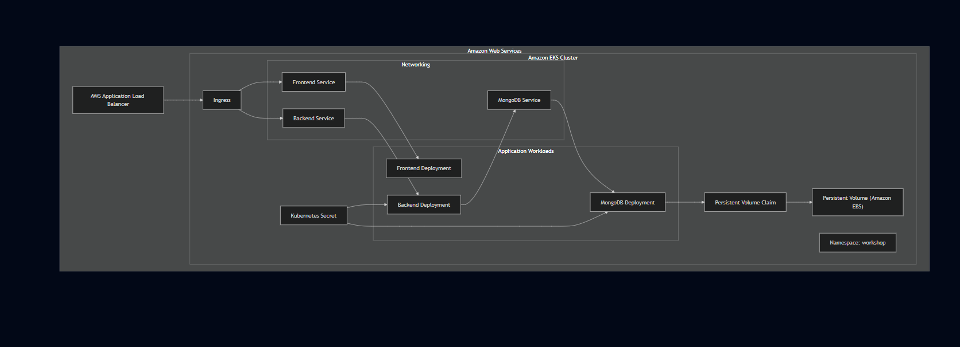

Namespace
The first step before deploying any application resources was creating a dedicated namespace:
bash
kubectl create namespace workshop
All application resources — Deployments, Services, Secrets, Persistent Volume Claims, and the Ingress — were deployed into this namespace. Keeping everything inside a single namespace makes administration straightforward: you can see all resources belonging to the application in one place and avoid accidental interaction with system-level Kubernetes resources running in other namespaces.
Resources deployed within the workshop namespace:
- Frontend Deployment
- Backend Deployment
- MongoDB Deployment
- ClusterIP Services (frontend, backend, MongoDB)
- Kubernetes Secret (MongoDB credentials)
- Persistent Volume Claim
- Ingress Resource

Applying Resources
With the namespace created, resources were applied using:
bash
kubectl apply -f .
This applied all manifest files in the current directory — Deployments, Services, Secrets, PVC, and Ingress — in a single command. Kubernetes processes each manifest and reconciles the cluster toward the desired state defined in those files.
The apply command is declarative — if a resource already exists, Kubernetes updates it to match the manifest. If it doesn't exist, Kubernetes creates it. This made iterative debugging straightforward: fix the manifest, run kubectl apply -f . again, and Kubernetes updates only what changed.

Deployment Strategy
Each application tier is managed through a Kubernetes Deployment. Deployments provide declarative state management — you define what you want running, and Kubernetes continuously works to match that state.
Deployment | Replicas | Purpose
Frontend | 1 | React user interface
Backend | 2 | Node.js REST API
MongoDB | 1 | Persistent database
The two backend replicas were defined in the reference project's manifests. What this demonstrated in practice is how Kubernetes handles multiple instances of the same workload — the backend Service distributes traffic between the two Pods transparently, and if one Pod fails, traffic continues flowing to the other while Kubernetes schedules a replacement.

ReplicaSets
Behind each Deployment, Kubernetes manages a ReplicaSet that maintains the required number of running Pods. If a Pod terminates unexpectedly — container crash, node failure, OOM kill — the ReplicaSet detects the gap between desired and actual state and schedules a replacement automatically.
This happened without any manual intervention during the deployment validation. The self-healing behavior is one of the more immediately practical aspects of Kubernetes — you don't need to monitor individual Pods and restart them manually.
Operational benefits:
- Automatic Pod replacement on failure
- Desired state continuously enforced
- No manual restart required for transient failures

Pod Design
Pods are the smallest deployable unit in Kubernetes. Each application component runs inside its own Pod, with its own IP address and isolated runtime environment.
Frontend Pod (1)
Backend Pod — Replica 1
Backend Pod — Replica 2
MongoDB Pod (1)
Total running Pods: 4
Each Pod receives:
- A unique cluster-internal IP address
- An isolated container runtime environment
- Health monitoring by Kubernetes
- Access to shared Kubernetes networking
Pod IP addresses are ephemeral — they change when a Pod is replaced. This is why Services exist: they provide stable endpoints that don't change regardless of what happens to individual Pods.

Kubernetes Services
All three application Services use ClusterIP — keeping them internal to the cluster. Nothing is directly reachable from outside except through the ALB.
Service | Port | Purpose
frontend | 3000 | React frontend
api | 8080 → 3500 | Backend API
mongodb-svc | 27017 | MongoDB database
The backend Service port mapping (8080 → 3500) is worth noting specifically — the Service accepts traffic on port 8080 and forwards it to the container's port 3500. This mismatch between external Service port and internal container port is exactly what caused the frontend-to-backend communication failure during deployment. The Node.js application was listening on 3500, but the Service targetPort wasn't correctly set to match. Fixing that value restored communication between the tiers.

Why ClusterIP?
ClusterIP Services are only reachable from within the cluster. External access comes exclusively through the Ingress and ALB. This keeps the attack surface minimal — there's no way to reach application Pods directly from the internet.
Advantages:
- Internal-only communication by default
- Stable virtual IP that survives Pod replacement
- Automatic traffic distribution across healthy Pods
- Service discovery via Kubernetes DNS

Service Discovery
Workloads communicate through Kubernetes DNS rather than Pod IP addresses. The backend reaches MongoDB using:
mongodb-svc:27017
This DNS name resolves to the MongoDB Service's ClusterIP. If the MongoDB Pod is replaced and gets a new IP, the DNS name stays the same — the backend configuration doesn't need to change.
This is one of the cleaner aspects of Kubernetes networking — internal services communicate through stable names rather than fragile IP addresses.

Ingress Design
External HTTP traffic enters through a Kubernetes Ingress resource managed by the AWS Load Balancer Controller. The Ingress defines the routing rules — which paths go to which Services.
Request Path | Destination
/ | Frontend Service
/api | Backend Service
A single ALB serves both routes. This keeps the public interface simple — one DNS endpoint for the entire application, with path-based routing handling the separation between frontend and API traffic.

Request Flow
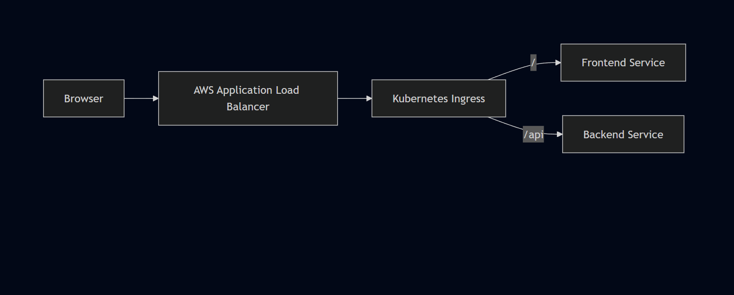
The Ingress only works if the AWS Load Balancer Controller is correctly installed and authorized. During this deployment, the controller's IAM role was missing the elasticloadbalancing:DescribeListenerAttributes permission, which prevented the ALB from provisioning. The Ingress resource existed in Kubernetes but had no external address until the IAM policy was corrected and the controller restarted.

Secret Management
MongoDB credentials are stored in a Kubernetes Secret rather than hardcoded into application manifests or container images. The backend Deployment references the Secret through environment variables, keeping credentials out of the application configuration files.
Kubernetes Secret
│
├── Backend Deployment (environment variables)
│
└── MongoDB Deployment (authentication)
Keeping credentials in Secrets rather than ConfigMaps or manifest files is a baseline security practice — it separates sensitive values from application configuration and makes credential rotation possible without rebuilding images.
Note: Kubernetes Secrets are base64-encoded by default, not encrypted at rest unless additional cluster-level encryption is configured. For a production environment, envelope encryption or an external secrets manager would add another layer of protection.

Persistent Storage
MongoDB needs storage that survives Pod restarts. The storage architecture uses two Kubernetes resources:
MongoDB Pod
↓
Persistent Volume Claim
↓
Persistent Volume
↓
Amazon EBS
The PVC defines what storage the application needs. Kubernetes binds the PVC to an available Persistent Volume. The PV is backed by an Amazon EBS block storage device that exists independently of the Pod lifecycle.
During deployment, the PVC remained in Pending state because the PV wasn't available when the claim was applied. Checking PVC status:
bash
kubectl get pvc
Showed the claim waiting indefinitely for binding. Applying the storage resources in the correct order — PV before PVC — resolved it. Once bound, the MongoDB Pod scheduled successfully and the database initialized.
Storage benefits:
- Data survives Pod recreation and rescheduling
- Storage lifecycle decoupled from container lifecycle
- EBS volume persists even if the Pod is deleted
- Simplified recovery — new Pod attaches to same volume

Health Management
Kubernetes monitors workload health through probes configured in Deployment manifests. The reference project included health probe configuration for the backend Deployment.
Health probes serve two purposes:
Liveness probes detect when a container has entered a failed state and needs to be restarted. Kubernetes restarts the container automatically when a liveness probe fails repeatedly.
Readiness probes determine when a container is ready to receive traffic. Pods that fail readiness checks are temporarily removed from Service load balancing — they don't receive requests until they pass the probe again. This is particularly useful during startup and rolling updates.
Note: The exact probe endpoint configuration (/ok or otherwise) should be verified against the actual Deployment YAML in the repository before documenting as a confirmed setup detail.

Scaling
Current replica configuration:
Component | Replicas | Scaling Characteristics
Frontend | 1 | Horizontally scalable — stateless
Backend | 2 | Horizontally scalable — stateless
MongoDB | 1 | Stateful — requires storage coordination
Scaling stateless workloads like the frontend and backend is straightforward — increase the replica count in the Deployment and Kubernetes schedules additional Pods. No application code changes required.
MongoDB scaling is more complex because it's stateful. Adding replicas without proper MongoDB replication configuration would result in multiple independent database instances rather than a coordinated cluster. For this deployment, a single MongoDB instance with persistent storage was sufficient.
Future scaling mechanisms worth adding:
- Horizontal Pod Autoscaler (HPA) — automatically adjusts replica count based on CPU/memory metrics
- Cluster Autoscaler — adds worker nodes when the cluster runs out of scheduling capacity

Self-Healing
Kubernetes automatically recovers from Pod failures without manual intervention. The recovery sequence:
- Pod fails — container crash, OOM kill, or node issue
- ReplicaSet detects the actual replica count is below desired
- Kubernetes Scheduler selects an available node
- New Pod is created and starts pulling its image
- Service continues routing traffic to healthy Pods during recovery
- Once the new Pod passes health checks, it joins the Service load balancing pool
This behavior was observable during deployment validation — deliberately or accidentally terminating a Pod resulted in Kubernetes scheduling a replacement automatically.

Rolling Updates
Kubernetes Deployments support rolling updates — replacing Pods incrementally rather than taking all instances offline simultaneously. The Deployment strategy controls how many Pods can be unavailable during an update and how many extra Pods can be created.
For this deployment, rolling updates were available through the Deployment configuration but were not explicitly validated as a separate activity. The capability exists in the deployment architecture — exercising it would require pushing an updated image and observing the rollout behavior.

Debugging Workflow
Getting all resources working required a systematic approach to checking each layer independently.
Common kubectl commands used throughout:
bash
# Check worker nodes joined the cluster
kubectl get nodes

# Check Pod status across the namespace
kubectl get pods -n workshop

# Check Service configuration
kubectl get svc -n workshop

# Check PVC binding status
kubectl get pvc -n workshop

# Get detailed resource information and events
kubectl describe pod <pod-name> -n workshop
kubectl describe svc <service-name> -n workshop
kubectl describe pvc <pvc-name> -n workshop

# Apply updated manifests
kubectl apply -f .

# Check container logs
kubectl logs <pod-name> -n workshop

# Clean up all resources
kubectl delete -f .
The general debugging pattern:
Something isn't working
↓
kubectl get pods — identify unhealthy resource
↓
kubectl describe <resource> — read Events section
↓
Identify root cause — config, scheduling, networking, IAM
↓
Fix the manifest or configuration
↓
kubectl apply -f .
↓
Verify again
The describe command was particularly useful because the Events section shows what Kubernetes actually attempted — image pulls, scheduling decisions, probe failures, volume binding attempts. Most root causes were visible there before needing to check logs.

Kubernetes Resource Summary
Resource | Quantity
Namespace | 1
Deployments | 3
ReplicaSets | 3
Pods | 4
Services | 3
Ingress | 1
Secrets | 1
Persistent Volumes | 1
Persistent Volume Claims | 1

Operational Workflow
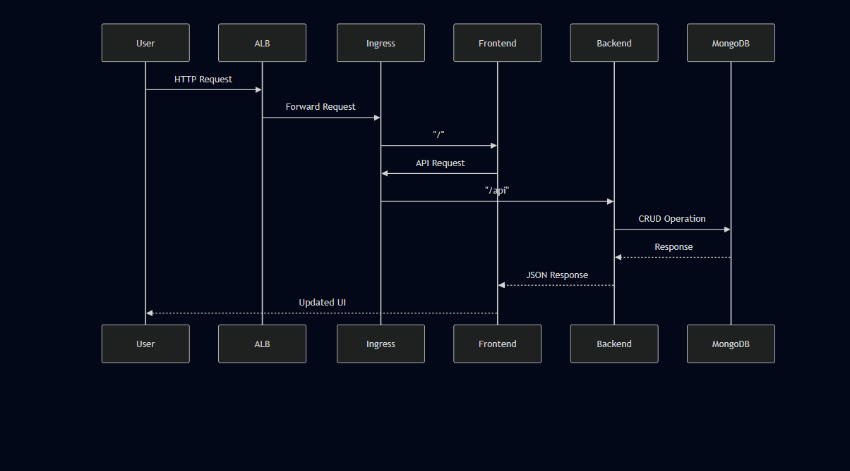

The Biggest Kubernetes Learning
What stood out most during this deployment was how interconnected everything is — and how a problem in one layer can appear as a symptom in a completely different layer.
You can have:
- ✓ EKS cluster running
- ✓ Pods in Running state
- ✓ Containers healthy
And still have:
- ✗ Frontend unable to reach backend (Service port mismatch)
- ✗ PVC stuck in Pending (resource ordering)
- ✗ ALB not provisioning (IAM permission missing)
- ✗ API requests going nowhere (React build-time configuration)
The deployment wasn't a single kubectl apply that produced a working application. It was an iterative process of checking each layer, identifying what was actually wrong, fixing it, and verifying again. Kubernetes abstracts a significant amount of infrastructure complexity, but that abstraction doesn't remove the need to understand what's happening underneath.

Chapter 8 — Deployment Workflow

Overview
This deployment was not automated through a CI/CD pipeline. It was a hands-on, sequential workflow performed entirely from a dedicated Ubuntu EC2 management instance — provisioning infrastructure, building container images, deploying Kubernetes resources, configuring AWS integrations, and validating the complete application flow step by step.
The setup was completed iteratively rather than as a single uninterrupted deployment. Infrastructure provisioning, container preparation, Kubernetes configuration, AWS Load Balancer integration, and troubleshooting happened in stages until the complete frontend → backend → database flow was operational and verified in a browser.

End-to-End Deployment Pipeline
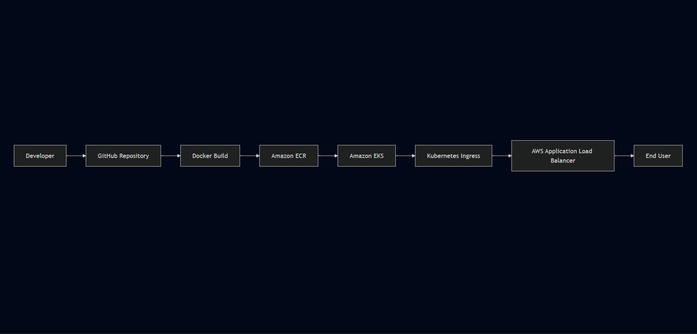

Deployment Lifecycle Overview
Phase | Objective | Primary Tool
Environment Preparation | Configure management host and credentials | EC2, AWS CLI
Cluster Provisioning | Create Kubernetes environment | eksctl
Image Build | Package application components | Docker
Image Distribution | Store images in registry | Amazon ECR
Resource Deployment | Deploy Kubernetes workloads | kubectl
Controller Installation | Enable ALB provisioning | Helm
Traffic Exposure | Publish application externally | AWS ALB + Ingress
Validation | Verify end-to-end functionality | Browser + kubectl
Cleanup | Remove AWS resources after testing | kubectl, AWS Console

Phase 1 — Environment Preparation
Before touching any AWS infrastructure, the management environment had to be set up completely. All provisioning, image building, and Kubernetes operations ran from this single Ubuntu EC2 instance throughout the project.

Step 1 — IAM User and Credentials
An IAM user named eks-admin was created with AdministratorAccess attached. Access keys were generated for this user and used to configure the AWS CLI on the EC2 instance.
Local Machine
│
│ SSH
▼
Ubuntu EC2 Management Instance (t2.micro)
│
├── AWS CLI → IAM credentials → AWS Account
├── Docker → Container builds
├── kubectl → Kubernetes management
├── eksctl → EKS provisioning
└── Helm → Load Balancer Controller

Step 2 — Launch Ubuntu EC2
A dedicated Ubuntu EC2 instance (t2.micro) was launched specifically for this project. All subsequent steps were performed over SSH from a local machine into this instance.

Step 3 — AWS CLI Installation and Configuration
The AWS CLI was installed first because every subsequent step — EKS provisioning, ECR authentication, kubeconfig update — depends on it.
bash
curl "https://awscli.amazonaws.com/awscli-exe-linux-x86_64.zip" -o "awscliv2.zip"
sudo apt install unzip
unzip awscliv2.zip
sudo ./aws/install -i /usr/local/aws-cli -b /usr/local/bin --update
Then configured with IAM credentials:
bash
aws configure
This connected the EC2 management environment to the AWS account.

Step 4 — Docker Installation
Docker was installed to build and push container images:
bash
sudo apt-get update
sudo apt install docker.io
docker ps
sudo chown $USER /var/run/docker.sock
The chown command fixes socket permissions so Docker commands run without sudo — skipping this causes permission errors when chaining commands.

Step 5 — kubectl Installation
kubectl was installed to communicate with the Kubernetes API — applying manifests, checking resource status, reading logs, and debugging:
bash
kubectl version --short --client
Verified the client was installed correctly before connecting it to a cluster.

Step 6 — eksctl Installation
eksctl was installed to handle EKS cluster provisioning. Rather than manually creating every AWS resource involved in an EKS cluster, eksctl orchestrates the entire process from a single command:
bash
eksctl version

Step 7 — Helm Installation
Helm was installed later in the process, specifically for the AWS Load Balancer Controller:
bash
sudo snap install helm --classic
The complete tool installation sequence:
IAM / AWS Credentials
↓
Ubuntu EC2
↓
AWS CLI
↓
Docker
↓
kubectl
↓
eksctl
↓
EKS Cluster
↓
Helm
↓
AWS Load Balancer Controller

Phase 2 — Amazon EKS Cluster Provisioning
With the management environment ready, the EKS cluster was provisioned:
bash
eksctl create cluster \
--name three-tier-cluster \
--region us-west-2 \
--node-type t2.medium \
--nodes-min 2 \
--nodes-max 2
This single command handled a significant amount of AWS-side provisioning automatically — the managed Kubernetes control plane, the worker node group, VPC, subnets, Internet Gateway, security groups, and IAM roles for the nodes.
Parameter | Value
Cluster Name | three-tier-cluster
Region | us-west-2
Worker Node Type | t2.medium
Minimum Nodes | 2
Maximum Nodes | 2
EKS provisioning was the longest single infrastructure step in the deployment — the managed control plane and worker nodes take several minutes to become fully operational. No application resources could be deployed until this completed.

Cluster Validation
After provisioning, kubectl was connected to the cluster:
bash
aws eks update-kubeconfig \
--region us-west-2 \
--name three-tier-cluster
Before this command, kubectl had no connection to the EKS cluster. After it, the local kubeconfig was updated with the cluster endpoint and authentication details.
Worker node registration was verified:
bash
kubectl get nodes
Expected output — both worker nodes showing Ready status:
NAME STATUS ROLES AGE
ip-xxx-xxx-xxx-xxx.ec2... Ready <none> Xm
ip-xxx-xxx-xxx-xxx.ec2... Ready <none> Xm
This confirmed three things: the cluster was reachable, IAM authentication was working, and worker nodes had successfully joined.

Phase 3 — Container Image Build
Application source code was cloned onto the EC2 management instance. Docker builds were run from there — not locally — keeping the build environment consistent with the deployment environment.
Each application tier was built independently:
React Source Code
↓
docker build → Frontend Image

Node.js Source Code
↓
docker build → Backend Image
The backend build failed initially because the Dockerfile was misnamed Dockefile instead of Dockerfile. Docker couldn't locate the build definition and exited. Identifying and renaming the file unblocked the build.
MongoDB used the official public Docker image — no custom build required.

Phase 4 — Image Distribution to Amazon ECR

ECR Authentication
Before pushing images, Docker authenticated to ECR using IAM credentials:
bash
aws ecr get-login-password --region us-west-2 | docker login \
--username AWS \
--password-stdin \
<AWS_ACCOUNT_ID>.dkr.ecr.us-west-2.amazonaws.com
Successful authentication returns:
Login Succeeded

Image Tagging and Push
Each image was tagged with the full ECR repository URI:
bash
docker tag <local-image>:latest \
<AWS_ACCOUNT_ID>.dkr.ecr.us-west-2.amazonaws.com/<repository>:latest

docker push \
<AWS_ACCOUNT_ID>.dkr.ecr.us-west-2.amazonaws.com/<repository>:latest
Separate repositories for frontend and backend:
Repository | Purpose
Frontend | React application image
Backend | Node.js API image
Images were verified in ECR before referencing them in Deployment manifests.

Phase 5 — Kubernetes Resource Deployment

Namespace Creation
bash
kubectl create namespace workshop
All application resources were deployed into the workshop namespace.

Resource Deployment
Kubernetes manifests were applied from the project directory:
bash
kubectl apply -f .
This applied all manifests simultaneously. The resources deployed included:
Resource | Purpose
Namespace | Resource isolation
Secret | MongoDB credentials
Persistent Volume | Durable storage
Persistent Volume Claim | Storage allocation
MongoDB Deployment | Database workload
Backend Deployment (×2) | REST API
Frontend Deployment | User interface
Services (×3) | Internal networking
Ingress | External routing

Deployment Dependency Order
Even though kubectl apply -f . was the deployment command, the resources have dependencies that matter:
NamespaceSecretPersistent VolumePersistent Volume ClaimMongoDB DeploymentBackend DeploymentFrontend DeploymentIngress
The PVC remained in Pending state when storage resources weren't available at binding time. Understanding this dependency — PV must exist before PVC can bind, PVC must bind before MongoDB Pod can schedule — was one of the key debugging insights from this deployment.

Post-Deployment Verification
bash
# Check all Pods are running
kubectl get pods -n workshop

# Check Services are configured
kubectl get svc -n workshop

# Check PVC is bound
kubectl get pvc -n workshop

# Check Ingress has an external address
kubectl get ingress -n workshop
Expected Pod state:
NAME READY STATUS
frontend-xxxxx 1/1 Running
backend-xxxxx 1/1 Running
backend-yyyyy 1/1 Running
mongodb-xxxxx 1/1 Running
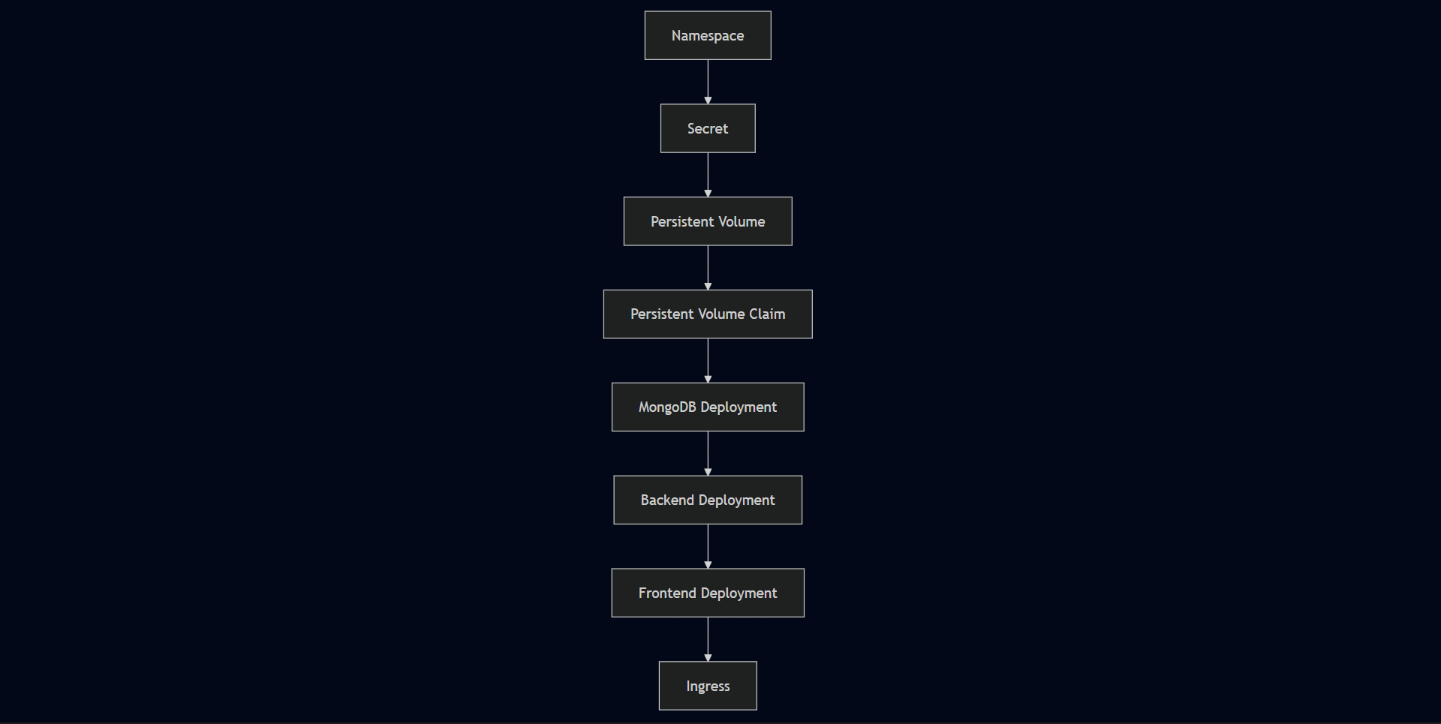

Phase 6 — AWS Load Balancer Controller
The AWS Load Balancer Controller is required for Kubernetes Ingress to provision an AWS Application Load Balancer. Without it, the Ingress resource exists in Kubernetes but no ALB gets created.

Helm Repository Setup
bash
helm repo add eks https://aws.github.io/eks-charts
helm repo update eks

Controller Installation
bash
helm install aws-load-balancer-controller \
eks/aws-load-balancer-controller \
-n kube-system \
--set clusterName=three-tier-cluster \
--set serviceAccount.create=false \
--set serviceAccount.name=aws-load-balancer-controller

Controller Verification
bash
kubectl get deployment -n kube-system aws-load-balancer-controller

ALB Configuration
bash
kubectl apply -f full_stack_lb.yaml
The controller watches Kubernetes Ingress resources and calls AWS APIs to provision and configure the Application Load Balancer:
Kubernetes Ingress Resource
↓
AWS Load Balancer Controller
↓
AWS API Calls
↓
Application Load Balancer
↓
Target Groups
↓
Kubernetes Services
During this phase, the controller failed to provision the ALB because the IAM role was missing the elasticloadbalancing:DescribeListenerAttributes permission. The Ingress existed in Kubernetes with no external address — the controller was running but couldn't complete its AWS API calls. Attaching the missing permission and restarting the controller resolved it.

Phase 7 — Application Validation
Once the ALB DNS endpoint appeared on the Ingress resource, the application was tested end to end from a browser.
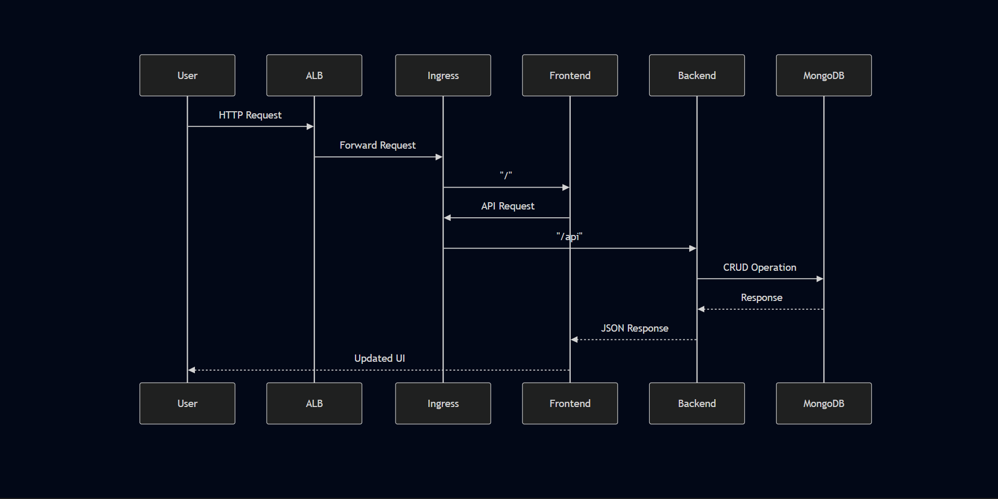
Validation checklist:
✓ Frontend accessible through ALB DNS endpoint
✓ React UI loaded in browser
✓ Task created through the UI
✓ Backend API processed the request
✓ Task stored in MongoDB
✓ Task visible on page refresh — confirming persistence
✓ No unexpected Pod restarts during testing

Phase 8 — Infrastructure Cleanup
After validation, all AWS resources were removed to avoid ongoing costs.
Kubernetes resources removed first:
bash
kubectl delete -f .
This removed all application resources deployed in the workshop namespace. Kubernetes also triggered cleanup of associated AWS resources — target groups and load balancers managed by the controller.
Remaining AWS infrastructure — the EKS cluster, worker nodes, EC2 management instance, ECR repositories, and EBS volumes — was then decommissioned.
Cleaning up in the correct order matters. Deleting the EKS cluster before removing Kubernetes-managed AWS resources like the ALB can leave orphaned AWS resources that continue generating costs.

Deployment Best Practices Applied
- Dedicated management host isolated from application runtime
- IAM least-privilege through named user and IRSA for controller
- Images built and pushed to private ECR before deployment
- kubeconfig verified before applying any Kubernetes resources
- Resource deployment verified at each stage before proceeding
- Systematic kubectl-based debugging — get → describe → logs → fix → apply
- End-to-end functional validation before considering deployment complete
- Infrastructure cleaned up after testing to prevent unnecessary AWS costs

Deployment Dependency Graph
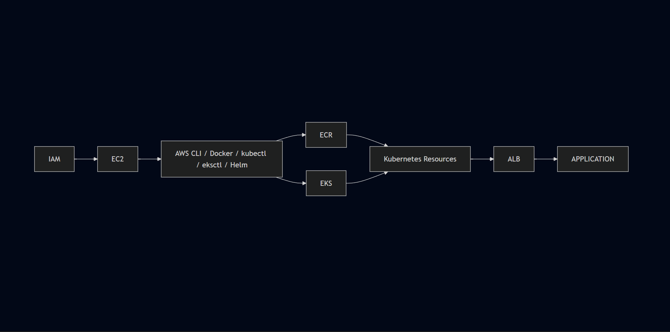

Chapter 9 — setup & Operational Validation

Overview
This chapter documents the operational commands, verification steps, and debugging workflow used throughout the deployment. Rather than repeating the deployment narrative from Chapter 8, this chapter focuses on what was actually run — the kubectl commands, the checks performed at each stage, and how issues were identified and isolated.
The deployment was validated incrementally. Each phase was checked before moving to the next. This approach made root cause identification significantly faster — when something broke, the scope of what could have caused it was already narrowed by what had already been verified.

Implementation Strategy
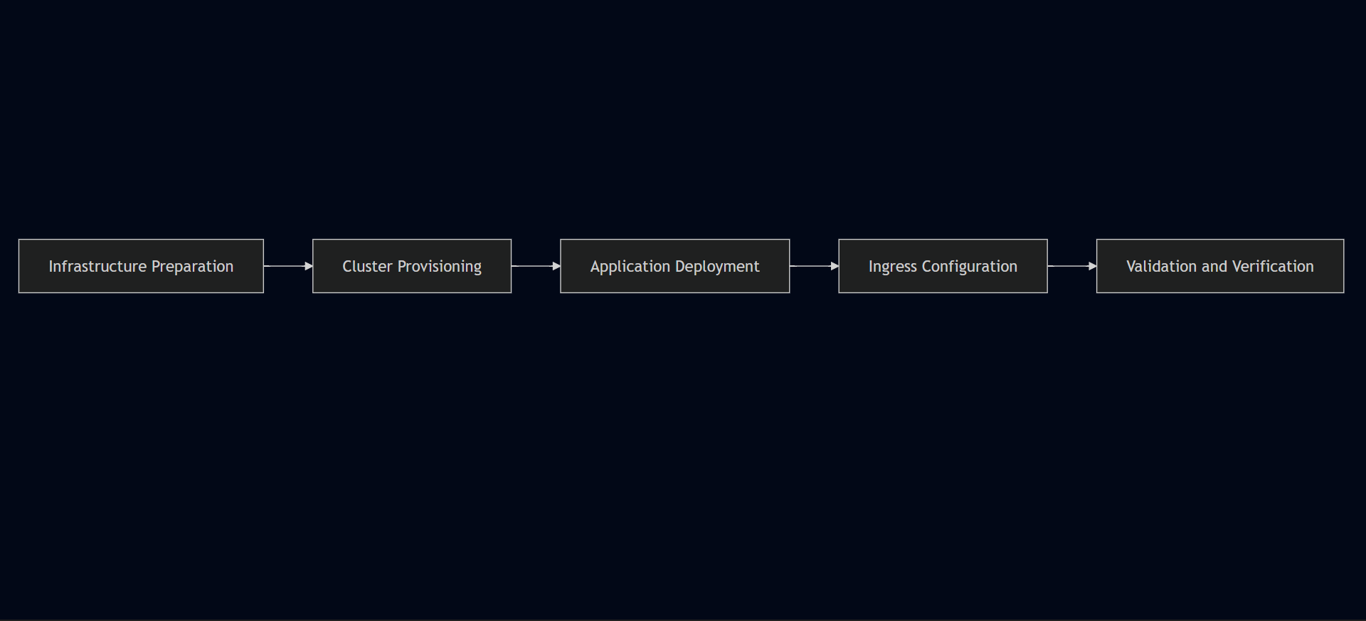

Phase 1 — Infrastructure Readiness
Before provisioning the EKS cluster, the management environment was verified:
bash
# Verify AWS CLI is configured and credentials work
aws sts get-caller-identity

# Verify Docker is running
docker ps

# Verify kubectl is installed
kubectl version --short --client

# Verify eksctl is installed
eksctl version

# Verify Helm is installed
helm version
Each tool had to be confirmed working before starting infrastructure provisioning. A broken tool mid-deployment is harder to debug than catching it upfront.

Phase 2 — EKS Cluster Provisioning and Validation

Cluster Creation
bash
eksctl create cluster \
--name three-tier-cluster \
--region us-west-2 \
--node-type t2.medium \
--nodes-min 2 \
--nodes-max 2
EKS provisioning was the longest single step in the deployment. The managed control plane and worker nodes take several minutes to become operational — no application resources were deployed until this completed.

kubeconfig Update
bash
aws eks update-kubeconfig \
--region us-west-2 \
--name three-tier-cluster
This connected kubectl to the cluster. Before this command, kubectl had no cluster to talk to. After it, all subsequent kubectl commands targeted the EKS cluster.

Worker Node Verification
bash
kubectl get nodes
Expected output — both worker nodes showing Ready:
NAME STATUS ROLES AGE
ip-xxx-xxx-xxx-xxx.us-west-2.compute.internal Ready <none> Xm
ip-xxx-xxx-xxx-xxx.us-west-2.compute.internal Ready <none> Xm
This confirmed the cluster was reachable, authentication was working, and nodes had joined successfully. Only after seeing both nodes in Ready state were application resources deployed.

Phase 3 — Container Image Build and Push

Build Workflow
Docker builds ran on the EC2 management instance. Each service was built independently:
bash
# Navigate to service directory and build
docker build -t <image-name> .

# Verify image was created
docker images
The backend build failed initially — the Dockerfile was misnamed Dockefile. Docker couldn't locate the build definition:
bash
# List directory contents to verify filenames
ls -la
Renaming the file and rebuilding resolved it:
bash
mv Dockefile Dockerfile
docker build -t <backend-image-name> .

ECR Authentication
bash
aws ecr get-login-password --region us-west-2 | docker login \
--username AWS \
--password-stdin \
<AWS_ACCOUNT_ID>.dkr.ecr.us-west-2.amazonaws.com
Expected response:
Login Succeeded

Tag and Push
bash
# Tag image with ECR URI
docker tag <local-image>:latest \
<AWS_ACCOUNT_ID>.dkr.ecr.us-west-2.amazonaws.com/<repository>:latest

# Push to ECR
docker push \
<AWS_ACCOUNT_ID>.dkr.ecr.us-west-2.amazonaws.com/<repository>:latest
Images were verified in ECR before proceeding to Kubernetes deployment.

Phase 4 — Kubernetes Resource Deployment

Namespace Creation
bash
kubectl create namespace workshop

Apply All Manifests
bash
kubectl apply -f .

Immediate Post-Deploy Checks
bash
# Check all Pods are scheduled and starting
kubectl get pods -n workshop

# Check Services are created
kubectl get svc -n workshop

# Check PVC binding status
kubectl get pvc -n workshop

Representative Pod Output
NAME READY STATUS RESTARTS
frontend-deployment-xxxxx 1/1 Running 0
backend-deployment-xxxxx 1/1 Running 0
backend-deployment-yyyyy 1/1 Running 0
mongodb-deployment-xxxxx 1/1 Running 0
Note: Pod name suffixes are generated by Kubernetes and will differ in every deployment. The above shows the expected structure — one frontend Pod, two backend Pods, one MongoDB Pod.
A Pod showing anything other than Running required investigation before proceeding:
bash
# Get detailed resource information including Events
kubectl describe pod <pod-name> -n workshop
The Events section in kubectl describe output was the most useful diagnostic — it shows what Kubernetes actually attempted: image pulls, scheduling decisions, volume binding attempts, probe results.

Phase 5 — Storage Validation
MongoDB's PVC had to reach Bound status before the database Pod could schedule.
bash
kubectl get pvc -n workshop
Expected output:
NAME STATUS VOLUME CAPACITY ACCESS MODES
mongodb-pvc Bound pv-xxxxx Gi RWO
When the PVC showed Pending instead of Bound, the MongoDB Pod couldn't proceed. Investigation:
bash
kubectl describe pvc <pvc-name> -n workshop
The Events section showed the claim waiting for a matching volume. Applying storage resources in the correct order — Persistent Volume before Persistent Volume Claim — resolved the binding.

Phase 6 — Service and Networking Validation
bash
# Verify Services are configured correctly
kubectl get svc -n workshop
Expected output structure:
NAME TYPE CLUSTER-IP PORT(S)
frontend ClusterIP 10.x.x.x 3000/TCP
api ClusterIP 10.x.x.x 8080/TCP
mongodb-svc ClusterIP 10.x.x.x 27017/TCP
The backend Service port mismatch was identified by comparing the Service configuration against the actual container port:
bash
kubectl describe svc api -n workshop
The output showed the TargetPort was not matching the port the Node.js application was listening on (3500). Correcting the Service manifest and reapplying:
bash
kubectl apply -f .
Restored frontend-to-backend communication.

Phase 7 — AWS Load Balancer Controller Installation
bash
# Add EKS Helm repository
helm repo add eks https://aws.github.io/eks-charts
helm repo update eks

# Install the controller
helm install aws-load-balancer-controller \
eks/aws-load-balancer-controller \
-n kube-system \
--set clusterName=three-tier-cluster \
--set serviceAccount.create=false \
--set serviceAccount.name=aws-load-balancer-controller

# Verify controller deployment
kubectl get deployment -n kube-system aws-load-balancer-controller

Apply Ingress Configuration
bash
kubectl apply -f full_stack_lb.yaml

Ingress Status Check
bash
kubectl get ingress -n workshop
Initially the ADDRESS field was empty — the ALB had not been provisioned. Investigation through controller logs revealed an IAM authorization failure — the missing permission elasticloadbalancing:DescribeListenerAttributes was preventing the controller from completing AWS API calls.
After attaching the required IAM policy and restarting the controller:
bash
kubectl rollout restart deployment aws-load-balancer-controller -n kube-system
Running kubectl get ingress again showed the ALB DNS address populated in the ADDRESS field. The ALB was now provisioned and accessible.

Phase 8 — Application Validation
With the ALB DNS endpoint available, the application was tested end to end.
Validation sequence:
- Opened the ALB DNS URL in a browser
- React frontend loaded successfully
- Added a task through the UI
- Task appeared on the page — confirming frontend → backend communication
- Refreshed the page — task still visible, confirming MongoDB persistence
Validation checklist:
Check | Result
EKS cluster operational | ✓
Worker nodes in Ready state | ✓
Images available in ECR | ✓
All Pods in Running state | ✓
PVC bound to Persistent Volume | ✓
Services correctly configured | ✓
ALB provisioned and reachable | ✓
Ingress routing functional | ✓
Frontend accessible through ALB | ✓
Backend API responding | ✓
MongoDB storing data | ✓
Browser-to-database flow verified | ✓

Debugging Command Reference
These were the primary kubectl commands used throughout the deployment for investigation and troubleshooting:
bash
# Check overall cluster and node health
kubectl get nodes

# Check Pod status across the namespace
kubectl get pods -n workshop

# Check Service configuration
kubectl get svc -n workshop

# Check PVC binding status
kubectl get pvc -n workshop

# Check Ingress and ALB address
kubectl get ingress -n workshop

# Get detailed resource information and Events
kubectl describe pod <pod-name> -n workshop
kubectl describe svc <service-name> -n workshop
kubectl describe pvc <pvc-name> -n workshop
kubectl describe ingress <ingress-name> -n workshop

# Check container logs
kubectl logs <pod-name> -n workshop

# Check controller logs
kubectl logs -n kube-system deployment/aws-load-balancer-controller

# Apply updated manifests
kubectl apply -f .

# Remove all deployed resources
kubectl delete -f .

General Debugging Pattern
Something isn't working
↓
kubectl get pods — identify unhealthy or missing resource
↓
kubectl describe <resource> — read Events section
↓
Identify root cause — config, scheduling, networking, IAM, storage
↓
Fix the manifest or configuration
↓
kubectl apply -f .
↓
Verify again with kubectl get / describe

Implementation Highlights
Several real issues were encountered and resolved during setup:
Issue | Layer | Resolution
Dockerfile named Dockefile | Containerization | Renamed file, rebuilt image
PVC stuck in Pending | Kubernetes Storage | Applied PV before PVC
Backend Service port mismatch | Kubernetes Networking | Corrected targetPort to 3500
React build-time env var | Application Config | Switched to relative path /api/tasks
Missing IAM permission | AWS Security | Attached policy, restarted controller
Ingress host-based routing | Networking | Removed host field, used path-based routing
Each issue required checking a different layer — containerization, storage, networking, application behavior, IAM. The debugging pattern was consistent: observe the symptom, identify the layer, check that layer specifically, fix, verify.

Chapter 10 — Challenges, Root Cause Analysis & Engineering Learnings
Getting this deployment to a working state wasn't a straight line. Problems came up across containerization, storage, Kubernetes networking, IAM, and application configuration — sometimes in ways that weren't immediately obvious from the surface symptoms. This chapter documents each issue honestly: what broke, what the investigation showed, and what fixed it.
Most of the debugging happened over SSH on the Ubuntu EC2 management instance, running kubectl, eksctl, the AWS CLI, and Docker from the terminal. The AWS Console ran alongside for verifying infrastructure state — checking load balancer status, IAM role attachments, ECR repositories, and target group health.

Challenge 1 — Docker Image Build Failure
The backend image failed to build during the initial containerization phase. Docker exited without producing an image, which left the ECR repository empty and gave Kubernetes nothing to pull from.
The build error indicated that Docker couldn't locate a valid build definition. Tracing the issue back to the backend project directory showed the file had been named Dockefile instead of Dockerfile — one character off.
Renaming the file and rebuilding resolved it. The image pushed to ECR cleanly after that.
It's a small mistake with a disproportionate effect — the entire pipeline stalls until the build produces a valid image. A quick check of the directory structure before running a build would catch this kind of thing early.

Challenge 2 — Persistent Volume Claim Stuck in Pending
MongoDB wouldn't start. The Pod sat in Pending and the PVC never transitioned to Bound, which meant the database had no storage to attach to and the deployment couldn't proceed.
Investigation of the storage resources showed the PVC had been applied before a matching Persistent Volume was available for binding. Kubernetes held it in pending indefinitely, waiting for something to bind against.
Applying the storage resources in the correct order and redeploying MongoDB resolved it. Once the PV was in place, the PVC bound immediately.
Stateful workloads have infrastructure dependencies that stateless ones don't. The PV has to exist before the PVC can bind — and the PVC has to be bound before the Pod can schedule. Getting that sequence wrong means the whole thing stalls silently.

Challenge 3 — Frontend Couldn't Reach the Backend
The frontend loaded in the browser, but every API call failed. The backend Pods were running and healthy — so the problem wasn't with the application itself, it was somewhere between the Service definition and the container.
Comparing the application's expected listening port against the Kubernetes Service configuration showed the mismatch. The Node.js API was listening on port 3500, but the Service wasn't forwarding traffic to the matching target port.
Correcting the targetPort to 3500 fixed it. Frontend-to-backend communication worked normally after that.
This one is easy to overlook because everything appears healthy at the Pod level. Running Pods don't tell you whether the Service is routing traffic correctly — you have to check the port configuration against what the application actually exposes.

Challenge 4 — React API Requests Going Nowhere
This took more time to understand than the others, because the surface symptoms looked identical to a networking problem.
The frontend was loading, the backend was running, the Service config was correct — but API requests were still failing. The issue turned out to have nothing to do with Kubernetes at all.
I had the backend URL configured through REACT_APP_BACKEND_URL in the frontend source. What I hadn't accounted for is that React resolves environment variables at build time, not at runtime. By the time the container is running, the compiled JavaScript bundle already has whatever value was present when npm run build executed. Updating a Kubernetes environment variable after the fact does nothing — the built asset doesn't change.
The fix was to stop using an environment variable for the URL entirely. I changed taskServices.js to use a relative path instead:
javascript
const apiUrl = "/api/tasks";
The full file after the change:
javascript
import axios from "axios";

const apiUrl = "/api/tasks";

export function getTasks() {
return axios.get(apiUrl);
}

export function addTask(task) {
return axios.post(apiUrl, task);
}

export function updateTask(id, task) {
return axios.put(apiUrl + "/" + id, task);
}

export function deleteTask(id) {
return axios.delete(apiUrl + "/" + id);
}
Verified in place:
bash
ubuntu@ip-172-31-21-175:~/TWSThreeTierAppChallenge/Application-Code/frontend/src/services$ cat taskServices.js
With a relative path, the request goes to whatever host is serving the frontend — the ALB in this case — and Ingress handles routing /api traffic to the backend Service. No hardcoded URL, no build-time configuration dependency.
This was probably the most conceptually interesting issue in the whole deployment. It's not a Kubernetes problem — it's a React behavior that only becomes visible when you're deploying behind a reverse proxy or Ingress controller.

Challenge 5 — AWS Load Balancer Controller Authorization Failure
After installing the AWS Load Balancer Controller and applying the Ingress resource, no ALB appeared. The Ingress sat without an external address and nothing showed up in the AWS Console under load balancers.
The controller itself was running — the problem was that it couldn't complete the AWS API calls it needed. Investigation of the controller error output identified an AWS authorization failure. The IAM role attached to the controller was missing a specific permission:
elasticloadbalancing:DescribeListenerAttributes
Attaching the required IAM policy and restarting the controller deployment resolved it. The ALB provisioned within a few minutes after that.
IAM failures in Kubernetes on AWS tend to look like silent hangs rather than obvious errors. The Ingress resource exists, the controller is running, but nothing happens on the AWS side. Going straight to the controller's error output rather than rechecking Kubernetes configuration saved time here. The 403 pointed directly at the authorization layer, which narrowed the investigation to IAM immediately.

Challenge 6 — Ingress Routing Without a Domain
The initial Ingress manifest included a hostname-based routing rule. Without a registered domain pointing at the ALB, host-based routing couldn't be validated — requests weren't resolving correctly through the configured rules.
The deployment didn't require a custom domain for functional validation, so the hostname dependency was removed from the Ingress configuration entirely. With the host field gone, the ALB's DNS name became the direct entry point, and traffic was routed purely on path:
/ → Frontend Service
/api → Backend Service
For a deployment scoped to functional testing rather than production exposure, path-based routing is simpler and avoids a dependency on external DNS configuration.

What Actually Took the Longest
Across all six challenges, the ALB and IAM configuration consumed the most total time. The Dockerfile typo and port mismatch were quick once identified. The React environment variable issue required understanding a non-obvious build behavior, but the fix itself was straightforward once the root cause was clear.
The Load Balancer Controller authorization failure involved the most back-and-forth — the controller appeared healthy, the Ingress resource was applied correctly, but nothing happened on the AWS side. That kind of silent failure takes longer to debug because the problem isn't visible in Kubernetes at all. It lives in the IAM layer, and you only find it by reading the controller's own error output rather than inspecting cluster state.

Debugging Approach
A few things that helped across all of these:
Check Kubernetes events before changing anything. kubectl describe on the affected resource usually points toward the right layer — whether the issue is scheduling, storage binding, networking, or something else.
Isolate the layer first. Kubernetes config problems, application problems, and AWS permissions problems present differently. Treating them as the same thing wastes time.
Change one thing at a time. When multiple things are wrong simultaneously, fixing them in parallel makes it impossible to know what actually resolved the issue.
Use the AWS Console alongside kubectl. Some things are faster to verify visually — load balancer provisioning state, target group health, IAM role attachments. Terminal and console together give a more complete picture than either alone.

Challenge Summary
Challenge | Category | Severity | Status
Dockerfile naming | Containerization | Medium | Resolved
PVC pending | Kubernetes Storage | High | Resolved
Service port mapping | Kubernetes Networking | High | Resolved
React environment variables | Application Configuration | Medium | Resolved
IAM authorization | AWS Security | Critical | Resolved
Ingress host configuration | Networking | Medium | Resolved

Chapter 11 — Security Architecture

Overview
Security in this deployment wasn't a separate phase — it was part of how the infrastructure was set up from the beginning. IAM roles were scoped to specific workloads, application services were kept off the public internet, credentials were separated from application code, and administration was isolated to a dedicated host.
This is a learning environment, not a production system. The security decisions reflect that — they're practical and appropriate for the scope, and where production would require additional controls, those are called out honestly rather than claimed as implemented.
One of the most concrete security lessons from this deployment came from the IAM authorization failure during ALB provisioning — covered in detail in this chapter because it demonstrates how IAM directly affects infrastructure behavior, not just access control.

Security Architecture Overview

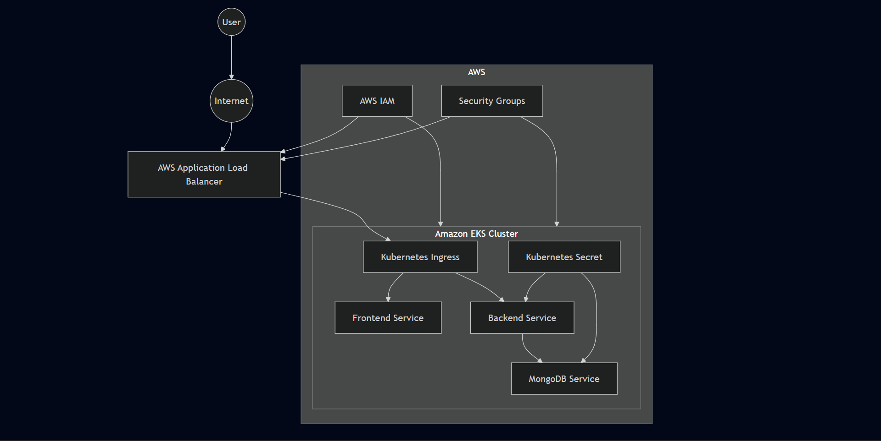

Security Design Principles
Principle | Implementation
Least Privilege | IAM roles scoped to specific workload requirements
Defense in Depth | Multiple security layers across AWS and Kubernetes
Network Isolation | Internal ClusterIP Services for all application components
Controlled Exposure | Single public ALB endpoint
Credential Protection | Kubernetes Secrets for MongoDB credentials
Resource Isolation | Dedicated namespace — workshop
Immutable Infrastructure | Docker images as deployment artifacts
Secure Administration | Dedicated EC2 management host

Identity & Access Management
IAM was the most operationally significant security component in this deployment — not just as an access control mechanism, but as a direct dependency for infrastructure features.

Administrative Access
An IAM user named eks-admin was created with AdministratorAccess attached. This user's credentials were configured on the EC2 management instance via aws configure, providing the permissions needed for cluster provisioning, ECR operations, and EKS management.

AWS Load Balancer Controller — IRSA
Rather than giving the Load Balancer Controller broad node-level AWS permissions, a dedicated IAM role was created and associated specifically with the controller's Kubernetes service account. This is the IRSA pattern — IAM Roles for Service Accounts.
The OIDC provider was first associated with the cluster:
bash
eksctl utils associate-iam-oidc-provider \
--region=us-west-2 \
--cluster=three-tier-cluster \
--approve
Then the service account and its IAM role were provisioned through eksctl:
bash
eksctl create iamserviceaccount \
--cluster=three-tier-cluster \
--namespace=kube-system \
--name=aws-load-balancer-controller \
--role-name=AmazonEKSLoadBalancerControllerRole \
--attach-policy-arn=... \
--approve \
--region=us-west-2
This means the controller authenticates to AWS using its own scoped role rather than inheriting permissions from the worker node. The worker nodes themselves don't need ALB management permissions — only the controller does.

IAM Least Privilege in Practice
Component | Permission Scope
eks-admin user | AdministratorAccess for infrastructure provisioning
Worker Nodes | ECR image pull, basic EKS node operations
ALB Controller | ALB provisioning and management only via IRSA
Application Pods | No direct AWS access

Real Security Finding — IAM Blocked ALB Provisioning
The most concrete security lesson from this deployment was an IAM authorization failure that directly prevented infrastructure from functioning.
The AWS Load Balancer Controller was installed and running. The Ingress resource was applied. But no ALB appeared — the Ingress had no external address and nothing showed up in the AWS Console.
The controller was making AWS API calls it didn't have permission to complete. The missing permission was:
elasticloadbalancing:DescribeListenerAttributes
The controller's error output showed HTTP 403 responses from AWS — not a Kubernetes configuration problem, not a networking issue. A permissions gap in the IAM role.
Attaching the missing permission and restarting the controller resolved it. The ALB provisioned within minutes.
The practical lesson: when an EKS workload interacts with AWS services, IAM policies become part of the application's operational dependency chain. A Kubernetes workload can appear completely healthy while being unable to perform required AWS operations. When something isn't happening on the AWS side, check IAM before rechecking Kubernetes configuration.

Network Isolation
All application Services use ClusterIP — internal to the cluster only. Nothing is directly reachable from the internet except through the ALB.
Internet
↓
AWS Application Load Balancer (public)
↓
Kubernetes Ingress
↓
Frontend Service (ClusterIP — internal only)
↓
Backend Service (ClusterIP — internal only)
↓
MongoDB Service (ClusterIP — internal only)
No Pod receives direct inbound internet traffic. The ALB is the single point of external entry.

Kubernetes Service Exposure
Service | Type | Publicly Accessible
Frontend | ClusterIP | No
Backend | ClusterIP | No
MongoDB | ClusterIP | No
Ingress | ALB | Yes
MongoDB never leaves the cluster network. The backend communicates with it through Kubernetes internal DNS at mongodb-svc:27017 — no external exposure at any point.

Security Groups
Security Groups for the EKS control plane and worker nodes were provisioned automatically as part of the cluster creation through eksctl. The required inbound and outbound rules for Kubernetes control plane communication, ALB traffic forwarding, and internal cluster networking were configured as part of that process.
Management EC2:
- Inbound: SSH (port 22) for remote administration
- The EC2 instance was a temporary administration host used for cluster provisioning and deployment activities
Application Load Balancer:
- Inbound: HTTP (port 80) for public application access
Worker Nodes:
- Traffic from ALB and Kubernetes control plane only
- No unrestricted public internet access
Production improvement: SSH access to the management EC2 should be restricted to trusted source IP ranges, or replaced entirely with AWS Systems Manager Session Manager to eliminate the need for open SSH ports.

Namespace Isolation
All application resources were deployed inside the workshop namespace:
bash
kubectl create namespace workshop
This keeps application workloads logically separated from system-level Kubernetes resources running in kube-system and other namespaces. It also simplifies administration — all resources belonging to the application are visible in one place.
Namespaces are not a complete security boundary on their own — a compromised Pod could still attempt to reach resources in other namespaces depending on network policy configuration. For production, Kubernetes Network Policies would add Pod-to-Pod traffic restrictions that namespaces alone don't provide.

Kubernetes Secrets
MongoDB credentials were stored using a Kubernetes Secret rather than being hardcoded into Deployment manifests or container images. The backend Deployment and MongoDB workload both reference the Secret through environment variables.
Consumer | Purpose
Backend Deployment | MongoDB authentication credentials
MongoDB Deployment | Database initialization credentials
Benefits:
- Credentials separated from application code and manifests
- Credential rotation possible without rebuilding images
- Sensitive values not visible in plain deployment YAML
Production consideration: Kubernetes Secrets are Base64-encoded by default — not encrypted at rest. In a production environment, envelope encryption using AWS KMS or integration with AWS Secrets Manager would provide stronger protection for sensitive credentials.

Container Security
Container images follow an immutable model — once built and pushed to ECR, they are not modified. Updates require building a new image and deploying it through Kubernetes rolling update, not patching running containers.
Practices applied:
- Images built before deployment — no build activity on worker nodes
- Images stored in private Amazon ECR repositories — not public registries
- Immutable image versions deployed — no in-place container modification
- Each application tier runs in its own isolated container
- Application services separated into independent containers with independent lifecycles

Administrative Security
All cluster administration happened from the dedicated Ubuntu EC2 management instance over SSH. Application workloads run exclusively on EKS worker nodes — the management instance has no application runtime role.
This separation means administrative tools, credentials, and operations are isolated from the application environment. A compromise of the application layer doesn't automatically expose the management environment, and vice versa.

Security Assessment
Domain | Status
Identity Management | Implemented — IAM user + IRSA for controller
OIDC Integration | Implemented via eksctl
Namespace Isolation | Implemented — workshop namespace
Internal Service Networking | Implemented — ClusterIP only
Kubernetes Secrets | Implemented — MongoDB credentials
Persistent Storage | Implemented — EBS-backed PV
Load Balancer Security | Implemented — single ALB entry point
HTTPS Encryption | Future Enhancement
Kubernetes RBAC | Future Enhancement
Network Policies | Future Enhancement
AWS WAF | Future Enhancement
Image Vulnerability Scanning | Future Enhancement

Future Security Enhancements
Enhancement | Benefit
AWS Secrets Manager | Centralized secret lifecycle management
AWS KMS | Encryption of Kubernetes Secrets at rest
Kubernetes RBAC | Fine-grained cluster authorization
Network Policies | Pod-to-Pod traffic restrictions
AWS WAF | Protection against common web attacks
TLS/HTTPS | Encrypted client-to-ALB communication
Image Scanning | Vulnerability detection in container images
SSM Session Manager | SSH-free EC2 administration
Admission Controllers | Policy enforcement at deployment time

Chapter 12 — Monitoring & Observability

Overview
This deployment didn't use a full observability stack — no Prometheus, no Grafana, no centralized log aggregation. The monitoring approach was practical and appropriate for the scope: Kubernetes-native diagnostic commands, AWS Console verification, and container logs where needed.
What this chapter documents is what was actually used during the deployment — the specific tools, the specific situations where they helped, and what they revealed. Where production would require additional tooling, that's called out as a future enhancement rather than claimed as implemented.

Observability Architecture
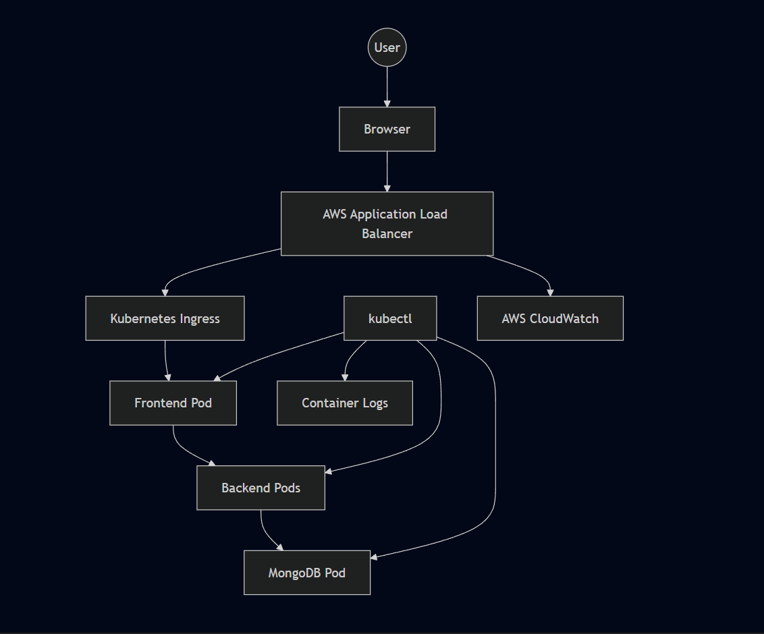

Monitoring Objectives
Objective | Purpose
Cluster Health | Ensure Kubernetes components remain operational
Node Availability | Verify worker node readiness
Pod Health | Detect failed or restarting workloads
Service Availability | Validate internal networking
Ingress Status | Confirm external accessibility
Application Logs | Diagnose runtime issues
Storage Health | Verify persistent volume attachment

What Was Actually Used
Rather than describing monitoring capabilities in the abstract, this section covers the specific tools used during the deployment and what they revealed.

kubectl — Primary Diagnostic Tool
kubectl was the main source of operational information throughout the deployment. The commands used most frequently:
bash
# Node and cluster health
kubectl get nodes

# Pod status across the namespace
kubectl get pods -n workshop

# Service configuration
kubectl get svc -n workshop

# PVC binding status
kubectl get pvc -n workshop

# Ingress and ALB address
kubectl get ingress -n workshop

# Detailed resource information and events
kubectl describe pod <pod-name> -n workshop
kubectl describe svc <service-name> -n workshop
kubectl describe pvc <pvc-name> -n workshop
kubectl describe ingress <ingress-name> -n workshop
The kubectl describe command was particularly useful — its Events section shows what Kubernetes actually attempted, which is often different from what the high-level kubectl get status suggests.

Container Logs — AWS Load Balancer Controller
The most concrete use of container logs during this deployment was investigating why the ALB wasn't provisioning.
The controller was running. The Ingress resource existed. But no ALB appeared in the AWS Console. Rather than continuing to check Kubernetes manifests, the controller logs were the next step:
bash
kubectl logs -n kube-system deployment/aws-load-balancer-controller
The logs showed HTTP 403 responses from AWS — an authorization failure, not a Kubernetes configuration problem. This immediately shifted the investigation from Kubernetes to IAM, where the missing permission elasticloadbalancing:DescribeListenerAttributes was identified and corrected.
This is the most practical observability lesson from the project: a healthy Kubernetes workload does not mean the underlying AWS integration is functioning correctly. Logs were necessary to distinguish a Kubernetes configuration issue from an AWS IAM authorization failure.

AWS Console — Infrastructure Verification
The AWS Console was used alongside kubectl for visual verification of AWS-side resources:
- EKS cluster status and worker node health
- Load balancer provisioning state
- Target group configuration and health
- IAM role attachments
- ECR repository contents
- EBS volume state
Some things are faster to verify visually — whether an ALB exists, whether target groups are healthy, whether an IAM policy is attached. The Console and terminal together gave a more complete picture than either alone.

Browser-Based Validation
The final validation layer was the application itself — opening the ALB DNS endpoint in a browser and testing the complete flow:
- React frontend loaded
- Added a task through the UI
- Task appeared — frontend → backend communication confirmed
- Refreshed the page — task still present, MongoDB persistence confirmed
This end-to-end validation was the definitive check that everything was working correctly. Kubernetes showing healthy Pods is necessary but not sufficient — the application has to actually function from a user's perspective.

Kubernetes Health Monitoring
Resource | What It Reveals
Nodes | Infrastructure readiness — are worker nodes available?
Pods | Application health — are containers running or failing?
Deployments | Desired state compliance — does actual match intended?
Services | Internal connectivity — are ports configured correctly?
Ingress | External routing — does the ALB have a DNS address?
Events (via describe) | Deployment failures, scheduling issues, volume binding
Logs | Runtime diagnostics — what is the application actually doing?

Incremental Validation Approach
Monitoring wasn't saved for after deployment was complete. Each phase was verified before moving to the next:
Infrastructure ready?
↓
kubectl get nodes → both nodes Ready
↓
Images in ECR?
↓
AWS Console → repositories visible
↓
Pods running?
↓
kubectl get pods → all Running
↓
PVC bound?
↓
kubectl get pvc → Bound
↓
ALB provisioned?
↓
kubectl get ingress → ADDRESS populated
↓
Application working?
↓
Browser → task creation → page refresh → data persists
This incremental approach made root cause identification faster. When something broke, the scope of possible causes was already narrowed by what had already been verified.

Observability Layers
InfrastructureKubernetesContainersApplicationUser Experience
Each layer requires different tools:
- Infrastructure — AWS Console, eksctl
- Kubernetes — kubectl get, kubectl describe
- Containers — kubectl logs
- Application — browser testing, API responses
- User Experience — end-to-end functional validation

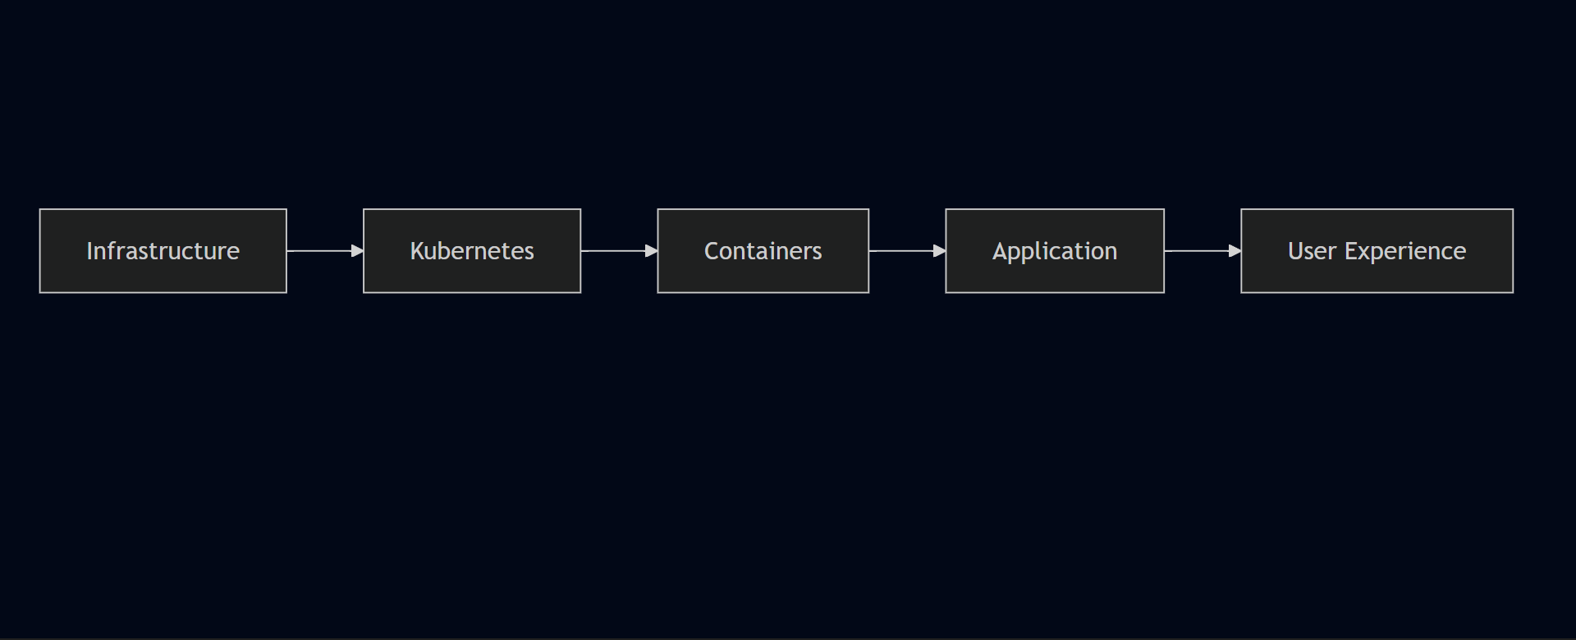

Incident Investigation Workflow
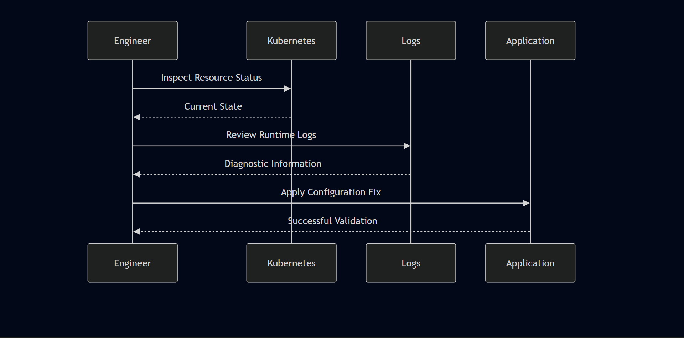

Health Probes
Kubernetes supports liveness and readiness probes for automated workload health management.
Liveness probes detect when a container has entered a failed state and needs to be restarted automatically — without manual intervention.
Readiness probes determine when a container is ready to receive traffic. Pods that fail readiness checks are temporarily removed from Service load balancing, preventing failed requests during startup or rolling updates.
The reference project included health probe configuration for the backend Deployment. The exact probe endpoint should be verified against the Deployment YAML in the repository.

AWS CloudWatch
CloudWatch was available as part of the AWS environment and provides infrastructure-level metrics for ALB, EKS, and EC2 resources automatically. It was not actively used as a primary monitoring tool during this deployment — the kubectl-based workflow and AWS Console were sufficient for the scope of work.
A production deployment would extend CloudWatch usage to include:
- Custom application metrics
- Log aggregation from containers
- CloudWatch Alarms for automated alerting
- Dashboard visualization
- Automated notifications on threshold breaches

Current Monitoring Coverage
Capability | Status
Pod Monitoring | ✓
Deployment Monitoring | ✓
Container Logs (ALB Controller) | ✓
Kubernetes Resource Events | ✓ via kubectl describe
Node Health | ✓
Ingress Status | ✓
Persistent Storage Validation | ✓
AWS Console Infrastructure Verification | ✓
CloudWatch Active Monitoring | Not used — future enhancement
Prometheus Metrics | Future Enhancement
Grafana Dashboards | Future Enhancement
Centralized Log Aggregation | Future Enhancement

Recommended Production Enhancements
Technology | Purpose
Prometheus | Metrics collection from Kubernetes and applications
Grafana | Dashboard visualization for metrics
Alertmanager | Alert routing and notification
Fluent Bit | Log forwarding from containers
Elasticsearch | Centralized log storage
Kibana | Log visualization and search
Jaeger | Distributed tracing across services
OpenTelemetry | Unified telemetry collection
CloudWatch Alarms | Automated AWS infrastructure alerting

Monitoring Best Practices Applied
- Validated infrastructure before deploying application workloads
- Checked node readiness before applying Kubernetes manifests
- Verified PVC binding before expecting MongoDB to start
- Used container logs to identify root cause of ALB provisioning failure
- Combined kubectl and AWS Console for complete operational visibility
- Performed end-to-end browser validation before declaring deployment complete
- Validated each deployment phase independently before proceeding

Chapter 13 — Performance, Scalability & Reliability

Overview
This chapter is honest about scope. No load testing was performed, no benchmarks were run, and no performance metrics were collected during this deployment. The project was validated functionally — the application worked correctly end to end, data persisted, and the infrastructure remained stable throughout testing.
What this chapter covers instead is the architectural decisions that support performance and reliability, what was actually observed during the deployment, and what would need to be added to make this production-ready from a performance standpoint.

Performance Architecture
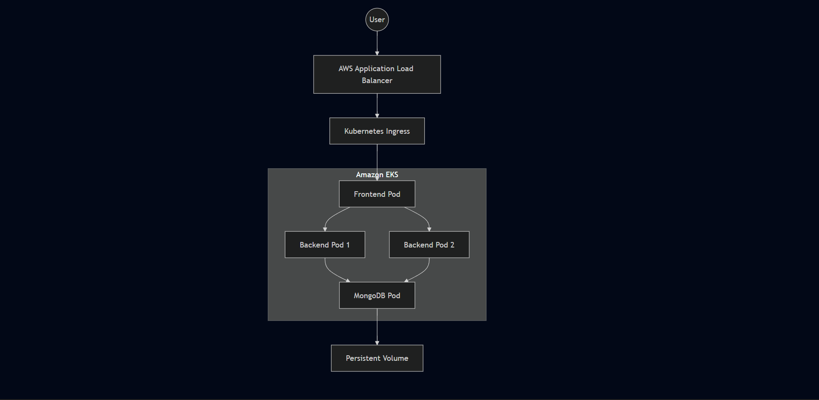

Performance Objectives
Objective | Design Goal
High Availability | Minimize service interruption
Scalability | Support future workload growth
Reliability | Maintain consistent application behavior
Fault Tolerance | Recover automatically from failures
Resource Efficiency | Utilize infrastructure effectively
Operational Stability | Maintain predictable deployments

What Was Actually Validated
The deployment was functionally validated rather than formally benchmarked. Performance testing under sustained or concurrent load was outside the scope of this setup.
What was confirmed during validation:
- Frontend loaded successfully through the ALB DNS endpoint
- Tasks submitted through the React UI reached the Node.js backend
- Data was stored in MongoDB and persisted across page refreshes
- Both backend replicas were running and available as Service endpoints
- No unexpected application failures occurred during functional testing
- The application remained stable throughout the validation period
What was not measured:
- Response time or latency
- Throughput or requests per second
- Concurrent user capacity
- CPU and memory utilization under load
- Pod recovery time after failure
- Load distribution between backend replicas
This is an honest assessment of a portfolio deployment. The architecture is designed for these capabilities — they simply weren't exercised under load during this project.

Scalability Strategy
The deployment separates stateless and stateful workloads, which is the foundation for independent scaling.
Component | Scaling Characteristics
Frontend | Horizontally scalable — stateless
Backend API | Horizontally scalable — stateless
MongoDB | Stateful — requires storage coordination
Stateless workloads like the frontend and backend can be scaled by increasing the Deployment replica count. No application code changes are needed — Kubernetes handles scheduling additional Pods and the Service distributes traffic across them automatically.
MongoDB scaling is more complex. Adding replicas without configuring proper MongoDB replication would create multiple independent database instances rather than a coordinated cluster. For this deployment, a single MongoDB instance with persistent storage was the correct approach.

Backend Availability
The backend Deployment was configured with two replicas from the reference project's manifests. Both Pods were running and registered as Service endpoints throughout the deployment.
Client Request
↓
Backend Service
↓
Replica 1 or Replica 2
The Kubernetes Service distributes traffic across available Pods. If one Pod becomes unavailable, the Service continues routing to the remaining healthy replica while Kubernetes schedules a replacement.
Formal traffic distribution testing — verifying requests were actually reaching both Pods — was not performed. The redundancy was architectural rather than load-tested.

High Availability
Capability | Status
Managed Control Plane | ✓ — EKS handles control plane availability
Multiple Worker Nodes | ✓ — 2 x t2.medium nodes
Multiple Backend Replicas | ✓ — 2 replicas configured
Automatic Pod Recovery | ✓ — via Deployment and ReplicaSet
Load Balanced Traffic | ✓ — via ALB and Kubernetes Services
The managed EKS control plane removes a significant availability concern — AWS is responsible for the API server, scheduler, and etcd. Worker node failures are handled by Kubernetes rescheduling affected Pods to remaining healthy nodes.

Fault Tolerance

Pod Failure
The Kubernetes Deployment and ReplicaSet provide automatic recovery:
- Pod terminates unexpectedly
- ReplicaSet detects actual replica count is below desired
- Kubernetes Scheduler selects an available node
- New Pod is created and starts
- Service routes traffic to healthy Pods during recovery

Node Failure
If a worker node becomes unavailable, Pods scheduled on that node are rescheduled onto remaining healthy nodes where capacity permits. With two worker nodes, a single node failure doesn't take the application offline — though capacity is reduced.

Storage Protection
MongoDB data persists independently of the container lifecycle through Persistent Volumes backed by Amazon EBS. If the MongoDB Pod is restarted or rescheduled, it reattaches to the same EBS volume and the data is intact.

Self-Healing
Pod FailureReplicaSet Detects DriftKubernetes SchedulerNew Pod CreatedDesired State Restored
The Kubernetes Deployment controller continuously reconciles the cluster toward the desired replica count. Deliberate failure testing — deleting a Pod and observing recreation — was outside the scope of this project, but the architecture is configured to benefit from this behavior through standard Deployment configuration.

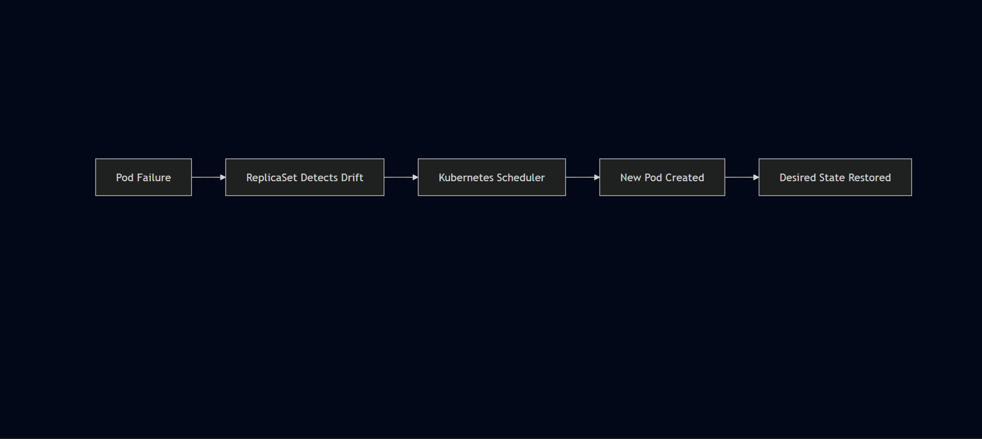

Resource Configuration
Resource | Configuration
Worker Nodes | 2
Instance Type | t2.medium
Backend Replicas | 2
Frontend Replicas | 1
MongoDB Replicas | 1
The t2.medium instance type was used according to the project setup requirements rather than through workload-specific capacity planning. For a functional three-tier deployment with light testing traffic, it was sufficient.
CPU and memory requests and limits were not confirmed as configured in the Deployment manifests. In a production environment, explicitly defining resource requests and limits is important for:
- Predictable Pod scheduling across nodes
- Preventing resource contention between workloads
- Enabling Horizontal Pod Autoscaler to function correctly
- Improving cluster-level capacity management

Rolling Updates
Kubernetes Deployments support rolling updates — replacing Pods incrementally rather than taking all instances offline simultaneously. This capability was available through the Deployment configuration but was not explicitly exercised during this project.
For a production deployment, rolling updates would be the standard update mechanism — pushing a new image to ECR, updating the Deployment image reference, and letting Kubernetes replace Pods progressively with zero downtime.

Network Performance
Traffic follows a direct path with minimal hops:
Browser
↓
AWS Application Load Balancer
↓
Kubernetes Ingress
↓
Frontend Service
↓
Backend Service
↓
MongoDB Service
↓
MongoDB Pod
Internal service communication uses Kubernetes DNS — stable, low-latency, and requiring no external network calls between application tiers.

Storage Performance
MongoDB uses Persistent Volumes backed by Amazon EBS. EBS provides block storage with consistent I/O performance appropriate for a database workload at this scale. The PV/PVC abstraction means storage can be managed independently of the compute layer — the volume persists even if the Pod or node is replaced.

Cost Management
Keeping AWS costs under control after testing was a deliberate part of the deployment lifecycle.
Practices applied:
- Kubernetes resources removed after validation:
bash
kubectl delete -f .
- AWS resources created through the Ingress integration followed controller-managed cleanup when the Ingress was deleted
- EKS cluster decommissioned after project completion
- EC2 management instance stopped after use
- Limited worker node count — 2 nodes rather than over-provisioning
Running EKS worker nodes, load balancers, and EBS volumes continue generating costs even when idle. Cleaning up promptly after validation is part of responsible cloud resource management.

Production Readiness Assessment
Area | Current Status | Production Recommendation
Availability | Good | Multi-AZ worker node groups
Scalability | Good | Horizontal Pod Autoscaler
Storage | Good | Managed database service or StatefulSets
Monitoring | Basic | Prometheus + Grafana
Security | Good | RBAC, Network Policies, AWS WAF
Deployment Strategy | Good | Blue-Green or Canary Deployments
Resource Governance | Not confirmed | Define CPU/memory requests and limits
Performance Testing | Not performed | k6, JMeter, or Locust for load testing

Future Performance Enhancements
Enhancement | Benefit
Horizontal Pod Autoscaler | Automatically scales replicas based on CPU/memory metrics
Cluster Autoscaler | Adds worker nodes when cluster runs out of scheduling capacity
Resource Requests and Limits | Predictable scheduling and resource governance
Node Affinity / Anti-Affinity | Control Pod placement across nodes
Container Image Optimization | Reduce image size and pull time
Load Testing | Validate actual throughput and latency under realistic traffic
Multi-AZ Node Groups | Survive Availability Zone failures

Reliability Assessment
Capability | Result
Cluster Stability | Verified — stable throughout testing
Pod Availability | Verified — all Pods reached Running state
Service Discovery | Verified — internal DNS resolution working
Persistent Storage | Verified — data survived page refreshes
Ingress Routing | Verified — ALB routing traffic correctly
End-to-End Application Flow | Verified — browser to MongoDB confirmed

Chapter 14 — Project Outcome & Engineering Impact

What This Project Actually Was
This wasn't a tutorial where everything worked on the first try. It was a hands-on deployment that required working through real configuration issues across IAM, Kubernetes networking, persistent storage, and application behavior — debugging each one systematically until the complete application was running end to end.
The goal was never just to get containers running. It was to understand how AWS infrastructure, Kubernetes orchestration, and application configuration interact in a real deployment — and to develop the troubleshooting instinct that comes from actually breaking things and fixing them.

Project Objectives vs Outcomes
Project Objective | Outcome | Status
Deploy a three-tier application on Amazon EKS | Successfully deployed | ✅ Completed
Containerize application components | Docker images created and deployed | ✅ Completed
Store images in Amazon ECR | Private repositories configured | ✅ Completed
Configure Kubernetes networking | Services and Ingress implemented | ✅ Completed
Expose application through AWS ALB | Path-based routing operational | ✅ Completed
Configure persistent storage | MongoDB data persisted using PV/PVC | ✅ Completed
Validate end-to-end functionality | Browser → Backend → MongoDB verified | ✅ Completed
Clean up AWS resources | Infrastructure successfully decommissioned | ✅ Completed

What Actually Surprised Me
Two things stood out that I hadn't fully anticipated going in.
The first was the React environment variable behavior. I initially expected that updating the environment variable in Kubernetes would change the backend URL the frontend was targeting. It didn't — because React bakes environment variables into the compiled bundle at build time, not at runtime. The Kubernetes config was irrelevant at that point. The fix was switching to a relative API path in taskServices.js so requests routed through Ingress instead of depending on a hardcoded URL. It's not a complicated fix, but understanding why it was broken required understanding how React builds work, not just how Kubernetes works.
The second was IAM. The AWS Load Balancer Controller was installed, the Ingress resource was applied, and nothing happened — no ALB appeared. Everything looked correct from the Kubernetes side. The problem was a single missing IAM permission: elasticloadbalancing:DescribeListenerAttributes. The controller couldn't complete its AWS API calls and failed silently from the Kubernetes perspective. That experience reinforced something that matters in AWS deployments: when something isn't happening that should be, check the permissions layer before assuming the configuration is wrong.

Technical Achievements

Cloud Infrastructure
- Amazon EKS cluster provisioning
- Worker node deployment
- IAM configuration — eks-admin user and IRSA for Load Balancer Controller
- Amazon ECR integration — private repositories for frontend and backend
- AWS Application Load Balancer deployment via Kubernetes Ingress
- Persistent storage configuration — EBS-backed PV/PVC for MongoDB

Kubernetes Engineering
- Namespace isolation — workshop namespace
- Deployments — frontend, backend, MongoDB
- ReplicaSets — automatic Pod recovery
- ClusterIP Services — internal-only communication
- Kubernetes Ingress — path-based routing
- Secrets — MongoDB credential management
- Persistent Volumes and Persistent Volume Claims
- Health probes — backend workload monitoring
- Rolling update support through Deployment configuration

Containerization
- Multi-container architecture — three independent tiers
- Docker image creation on EC2 management instance
- Private image registry — Amazon ECR
- Immutable deployment model — no in-place container modification

Application Deployment
- React frontend — relative API path configuration
- Node.js backend — port 3500, two replicas
- MongoDB database — stateful workload with persistent storage
- End-to-end API communication verified
- Database persistence validated across Pod lifecycle

Operational Achievements
Activity | Result
Infrastructure Provisioning | Completed
Cluster Administration | Completed
Container Deployment | Completed
Storage Configuration | Completed
Networking Configuration | Completed
Load Balancer Integration | Completed
Application Validation | Completed
Infrastructure Cleanup | Completed

Engineering Skills Demonstrated
Domain | Skills Demonstrated
Cloud Engineering | AWS resource provisioning, networking, IAM
Platform Engineering | Amazon EKS administration via eksctl
Kubernetes | Workload orchestration, networking, storage
Containerization | Docker image lifecycle management
Networking | Ingress, Services, DNS-based discovery
Storage | Persistent Volumes, Persistent Volume Claims
Linux Administration | SSH-based cluster management from Ubuntu EC2
Troubleshooting | Root cause analysis across Kubernetes and AWS layers

Engineering Decisions Validated
Design Decision | Result
Managed Kubernetes via EKS | Reduced control plane overhead
eksctl for provisioning | Automated VPC, subnet, and node group creation
ClusterIP Services | Secure internal communication
ALB Ingress | Simplified external routing — single endpoint
Amazon ECR | Reliable image distribution with IAM-based auth
Persistent Storage | Successful MongoDB data persistence
Backend Replication | Redundancy at the Pod level
Dedicated EC2 management host | Consistent administration environment

Production Readiness Assessment
Capability | Assessment
Declarative Infrastructure | Implemented
Containerized Workloads | Implemented
Managed Kubernetes | Implemented
Persistent Storage | Implemented
Internal Service Discovery | Implemented
External Load Balancing | Implemented
Self-Healing | Implemented via Deployment configuration
Rolling Updates | Supported
Infrastructure Cleanup | Implemented
CI/CD Automation | Future Enhancement
Infrastructure as Code | Future Enhancement
Advanced Monitoring | Future Enhancement
RBAC and Network Policies | Future Enhancement

Operational Metrics
Metric | Value
Kubernetes Cluster | 1
Worker Nodes | 2 x t2.medium
Deployments | 3
ReplicaSets | 3
Running Pods | 4
Services | 3
Ingress Resources | 1
Persistent Volumes | 1
Persistent Volume Claims | 1
Application Load Balancers | 1
Amazon ECR Repositories | 2

Engineering Challenges Overcome
Challenge | Category | Severity | Status
Dockerfile naming — Dockefile | Containerization | Medium | Resolved
PVC stuck in Pending | Kubernetes Storage | High | Resolved
Service port mismatch — 3500 | Kubernetes Networking | High | Resolved
React build-time env vars | Application Config | Medium | Resolved
Missing IAM permission | AWS Security | Critical | Resolved
Ingress host configuration | Networking | Medium | Resolved
These weren't theoretical problems. Each one blocked a real part of the deployment and required actual investigation to resolve — not just applying a fix from documentation.

What I'd Do Differently
I manually created and configured most of the environment to understand how everything worked — which was the right approach for learning, but not for repeatability. If I ran this project again, I'd use Terraform for infrastructure provisioning from the start rather than manual setup, and add a CI/CD pipeline to handle image builds, ECR pushes, and EKS deployments automatically. The manual process made the dependencies between components visible, which helped with troubleshooting. But for anything running beyond a single deployment cycle, automation is the right answer.

Key Takeaways
A few things this project reinforced that aren't obvious from documentation alone:
- Small configuration details have large consequences. A single missing IAM permission stopped the entire load balancer from provisioning. A one-character filename typo blocked the image build pipeline.
- Kubernetes and AWS are separate layers that both need to be correct. Healthy Pods don't mean correct networking. Correct Kubernetes configs don't mean correct AWS permissions.
- React build behavior is different from server-side runtime behavior. Build-time configuration needs to be understood before deployment, not discovered during debugging.
- Incremental validation is faster than end-to-end testing. Checking each layer before moving to the next caught issues earlier and made root causes easier to isolate.

Value to Employers
- Deploy Kubernetes applications on AWS EKS from scratch
- Configure AWS networking, IAM, and managed services
- Manage containerized workloads across multiple tiers
- Implement persistent storage for stateful applications
- Diagnose infrastructure issues across Kubernetes and AWS layers simultaneously
- Apply structured troubleshooting methodologies under real conditions
- Operate and decommission cloud infrastructure responsibly
The goal of this portfolio is straightforward: to show that I can take a complex deployment, work through the problems that come with it, connect the different pieces together, and keep debugging until the complete application actually works. That's what this project demonstrates.

Chapter 15 — Future Enhancements & Platform Evolution

Overview
This deployment works. The application runs, the infrastructure held up under real debugging conditions, and the complete frontend → backend → database flow was verified end to end. But it was built and deployed manually — every resource provisioned through CLI commands, every manifest applied by hand, every update requiring a direct SSH session on the EC2 management instance.
That's the right approach for learning how the pieces fit together. It's not the right approach for a repeatable, Production-Style deployment. This chapter outlines what would need to change to evolve this from a portfolio setup into something closer to an enterprise platform — and which of those improvements are already planned as next steps.

Platform Evolution Roadmap
Current ImplementationInfrastructure as CodeCI/CD AutomationGitOpsObservabilityProduction Platform

Enhancement Roadmap
Phase | Focus Area | Primary Goal
Phase 1 | Infrastructure Automation | Eliminate manual provisioning
Phase 2 | CI/CD | Automated application delivery
Phase 3 | Observability | Centralized monitoring and alerting
Phase 4 | GitOps | Declarative continuous delivery
Phase 5 | Production Operations | Scalability, resilience, and governance

Phase 1 — Infrastructure as Code with Terraform

Current State
The AWS infrastructure for this project — VPC, subnets, EKS cluster, node groups, IAM roles, security groups — was provisioned using eksctl and AWS CLI commands. eksctl automated a significant amount of the cluster setup, but the overall provisioning process is manual and not version-controlled as infrastructure code.

Planned Next Step
Terraform is the next infrastructure tool I want to learn. The goal is to provision the same AWS environment — VPC, EKS cluster, node groups, ECR repositories, IAM roles — through declarative Terraform configuration files rather than CLI commands.
This would mean the entire infrastructure is defined in code, stored in version control, and reproducible from scratch with a single command rather than a sequence of manual steps.

Proposed Terraform Scope
- Amazon VPC and subnet configuration
- Internet Gateway and route tables
- Security Groups
- IAM Roles and policies
- Amazon EKS cluster and managed node groups
- Amazon ECR repositories
- CloudWatch resources

Benefits
- Version-controlled infrastructure — every change tracked in Git
- Repeatable deployments — same environment every time
- Reduced configuration drift between environments
- Easier disaster recovery — rebuild from code rather than memory
- Cleaner separation between infrastructure and application concerns

Phase 2 — CI/CD Pipeline

Current State
Container images are built manually on the EC2 management instance, tagged, and pushed to Amazon ECR by hand. Every application update requires SSHing into the instance, rebuilding the image, and reapplying Kubernetes manifests.

Planned Enhancement
I have hands-on experience with both Jenkins and GitHub Actions from previous CI/CD work — including build automation, SonarQube integration, Nexus Repository, and deployment to AWS EC2. Applying that experience to this EKS deployment would automate the full image build and deployment pipeline.

Proposed CI Workflow
DeveloperGitHubBuildUnit TestsDocker BuildImage ScanAmazon ECR

Pipeline Responsibilities
- Source code validation on every push
- Dependency installation and unit testing
- Docker image build and tagging
- Security scanning before push
- Automated push to Amazon ECR
- Kubernetes Deployment update on successful image push

Benefits
- No manual SSH sessions for application updates
- Every code change goes through the same validated pipeline
- Image scanning catches vulnerabilities before deployment
- Faster, more consistent releases

Phase 3 — Observability Stack

Current State
Monitoring during this project relied on kubectl-based diagnostics, AWS Console verification, and container logs from the Load Balancer Controller. This was sufficient for debugging during setup but doesn't provide ongoing operational visibility.

Planned Enhancement
I'm familiar with Prometheus and Grafana and understand their role in Kubernetes monitoring, but haven't implemented them hands-on in this project. Adding a proper observability stack would be the next meaningful improvement after CI/CD.

Recommended Components
Technology | Purpose
Prometheus | Metrics collection from Kubernetes and applications
Grafana | Dashboard visualization
Alertmanager | Alert routing and notification
Fluent Bit | Log forwarding from containers
Elasticsearch | Centralized log storage
Kibana | Log visualization and search
OpenTelemetry | Unified telemetry collection

What This Would Enable
- Real-time visibility into Pod CPU and memory usage
- Historical trend analysis for capacity planning
- Automated alerting when thresholds are breached
- Centralized log search across all application tiers
- Performance baselines to compare against after changes

Phase 4 — GitOps with Argo CD

Current State
Kubernetes resources are applied manually using kubectl apply -f . from the management instance. There's no automated synchronization between the Git repository and the cluster state.

Planned Enhancement
I have conceptual awareness of Argo CD and GitOps workflows but haven't implemented a full GitOps deployment for this project. The idea is straightforward — the Git repository becomes the single source of truth for cluster state, and Argo CD continuously ensures the cluster matches what's defined in Git.

Proposed Architecture
GitRepositoryArgoCDAmazonEKSKubernetes Resources

Advantages
- Declarative deployments — Git is the audit trail
- Automatic synchronization — cluster drift is detected and corrected
- Rollback is a Git revert, not a manual kubectl operation
- Every deployment change is reviewed through a pull request

Phase 5 — Autoscaling

Current State
Replica counts are statically configured in the Deployment manifests. The backend runs two replicas regardless of actual traffic. Worker node count is fixed at two t2.medium instances.

Horizontal Pod Autoscaler
HPA would automatically adjust replica counts based on CPU or memory metrics:
TrafficIncreaseMetrics ServerHorizontal Pod AutoscalerAdditional Pods
For stateless workloads like the frontend and backend, this means the deployment scales to meet demand automatically rather than requiring manual replica count changes.

Cluster Autoscaler
When the cluster runs out of scheduling capacity — too many Pods for the available nodes — the Cluster Autoscaler adds worker nodes automatically. Combined with HPA, this means the entire infrastructure scales up and down with demand rather than being statically provisioned.

Phase 6 — Advanced Deployment Strategies

Blue-Green Deployment
Maintain two production environments. Traffic switches from the current version to the new version atomically — instant rollback if something goes wrong.
Blue Environment (current)
↓
Validation of Green Environment
↓
Traffic Switch
↓
Green Environment (live)

Canary Deployment
Release new versions to a small percentage of traffic first. Observe behavior before gradually increasing the rollout. Catch issues affecting real users without exposing everyone to a potentially broken release.
Both strategies require more infrastructure than a basic rolling update but significantly reduce deployment risk for production systems.

Phase 7 — Security Enhancements
Enhancement | Benefit
AWS Secrets Manager | Centralized secret lifecycle management
AWS KMS | Encryption of Kubernetes Secrets at rest
Kubernetes RBAC | Fine-grained cluster authorization
Network Policies | Pod-to-Pod traffic restrictions
AWS WAF | Web application protection
Image Scanning | Vulnerability detection in ECR
SSM Session Manager | SSH-free EC2 administration
Admission Controllers | Policy enforcement at deployment time

Phase 8 — Cost Optimization
Beyond the cleanup practices applied in this project, a production deployment would add:
- Spot Instances — significant cost reduction for stateless workloads that can tolerate interruption
- Resource requests and limits — prevent over-provisioning and improve node utilization
- Image lifecycle policies in ECR — automatically expire old image versions
- Scheduled node scaling — reduce capacity during off-peak hours
- Cost allocation tagging — track spending per team, environment, or workload

Recommended Enterprise Architecture
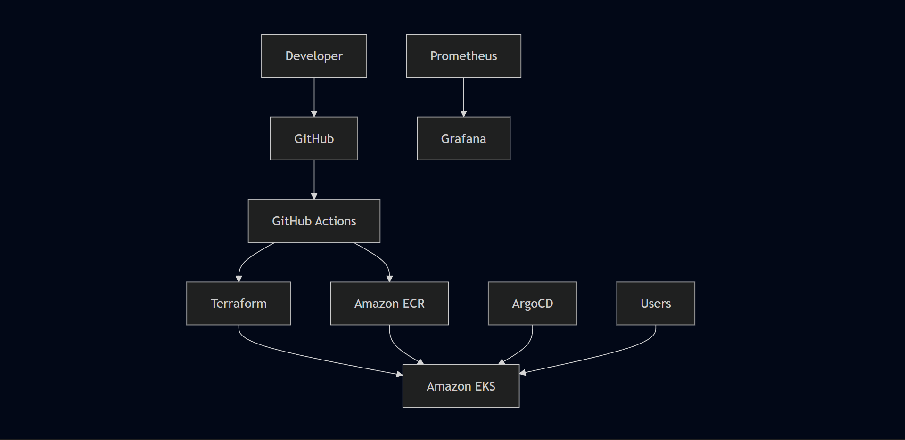

Platform Maturity Assessment
Capability | Current | Future Target
Kubernetes Deployment | ✅ Functional | Production Grade
Infrastructure Automation | Manual — eksctl/CLI | Terraform
CI/CD | Manual — SSH + kubectl | GitHub Actions
Monitoring | kubectl + AWS Console | Prometheus + Grafana
Logging | kubectl logs | ELK Stack
Security | Good — IAM, Secrets, ClusterIP | RBAC, Network Policies, WAF
GitOps | Not implemented | Argo CD
Autoscaling | Static replicas | HPA + Cluster Autoscaler
Service Mesh | Not implemented | Istio
Deployment Strategy | Rolling updates | Blue-Green and Canary

Honest Assessment of Where Things Stand
The current setup demonstrates the core engineering workflow — provisioning infrastructure, containerizing an application, deploying it on Kubernetes, debugging real issues, and validating the result. That foundation is solid.
The next logical steps are clear:
- Terraform — replace manual provisioning with version-controlled infrastructure code. This is the highest priority next learning area.
- CI/CD pipeline — apply existing Jenkins and GitHub Actions experience to automate image builds and EKS deployments.
- Observability — add Prometheus and Grafana to move from reactive debugging to proactive monitoring.
- GitOps — introduce Argo CD to make cluster state declarative and auditable.
These aren't aspirational additions — they're the natural next layer on top of what's already working.

Chapter 16 — Troubleshooting & Debugging Journey

Overview
Deploying this application involved more than writing Kubernetes manifests and applying them to a cluster. The deployment crossed multiple layers — and a failure at any point in that chain could prevent the application from working even when everything above or below it appeared healthy.
Application Code
↓
Docker
↓
Amazon ECR
↓
Amazon EKS
↓
Kubernetes Networking
↓
Persistent Storage
↓
IAM
↓
AWS Load Balancer Controller
↓
Application Load Balancer
↓
Browser
The most useful habit I developed during this project was learning not to treat the deployment as a single system. When something failed, the approach was to isolate the layer first:
Application not working
│
▼
Is the ALB reachable?
│
├── No → Check Ingress / ALB Controller / IAM
│
▼
Does routing reach the Service?
│
├── No → Check Service / Ports / Selectors
│
▼
Are Pods healthy?
│
├── No → Check Pod status / Events / Logs
│
▼
Can the backend reach MongoDB?
│
├── No → Check Service / PVC / Storage
│
▼
Check application-level configuration
This layered debugging approach became more important as the project moved from simple containerization to a complete cloud-native deployment across Kubernetes and AWS.

Debugging Environment
All debugging happened from the dedicated Ubuntu EC2 management instance over SSH.
Tool | Primary Use
kubectl | Inspecting and managing Kubernetes resources
eksctl | Creating and managing the EKS cluster
AWS CLI | Authenticating with and interacting with AWS services
docker | Building and managing container images
helm | Installing the AWS Load Balancer Controller
AWS Console | Verifying EKS, ECR, IAM, and ALB resources
Browser | End-to-end application validation
Application resources were deployed into the workshop namespace throughout the project.
Common validation commands:
bash
kubectl get nodes
kubectl get pods -n workshop
kubectl get svc -n workshop
kubectl get ingress -n workshop
kubectl get pvc -n workshop
kubectl describe <resource-name> -n workshop
The goal was never to redeploy everything when something failed. The better approach was to identify the failing layer first and inspect the resource responsible for that layer.

Incident 01 — Docker Build Blocked by Invalid Dockerfile Name

Symptom
The backend container image failed during the initial build phase. Without a successful image there was nothing to push to ECR, and Kubernetes had nothing to pull. The failure occurred before Kubernetes was involved — which immediately narrowed the problem to the local containerization layer.

Investigation
The backend project directory was checked. Docker expects a build definition named exactly:
Dockerfile
The file in the backend directory was named:
Dockefile
One missing character blocked the entire build.

Root Cause
Incorrectly named Dockerfile — Dockefile instead of Dockerfile.

Resolution
Renamed the file to Dockerfile and reran the image build. The expected workflow resumed:

Dockerfile
↓
docker build
↓
Docker Image
↓
ECR Push
↓
Kubernetes Deployment

Verification
After the rename, the image built successfully and pushed to Amazon ECR cleanly.
Debugging takeaway: Start at the point where the failure first occurs. Kubernetes was not the problem here — the image hadn't even been created yet.

Incident 02 — MongoDB Could Not Start Because Storage Was Not Bound

Symptom
MongoDB couldn't start because the Persistent Volume Claim remained in Pending instead of transitioning to Bound. The storage dependency chain looked like this:
MongoDB Pod
↓
Persistent Volume Claim
↓
Persistent Volume
↓
Amazon EBS-backed Storage
If the claim can't bind to storage, the database workload can't attach the required volume.

Investigation
Storage resources were checked independently from the application Pods:
bash
kubectl get pvc -n workshop
kubectl get pv
The PVC hadn't transitioned to a usable bound state — which shifted the investigation away from MongoDB configuration and toward the Kubernetes storage layer.

Root Cause
The PVC was applied before a matching Persistent Volume was available for binding. The dependency sequence matters:
Persistent Volume
↓
Persistent Volume Claim
↓
MongoDB Deployment / Pod
Applying resources in the wrong order left the claim waiting indefinitely.

Resolution
Storage resources were applied in the correct order — PV before PVC before MongoDB Deployment:
1. Persistent Volume
↓
2. Persistent Volume Claim
↓
3. MongoDB Deployment
↓
4. MongoDB Pod receives storage

Verification
bash
kubectl get pvc -n workshop
Expected state after fix:
STATUS: Bound
Once bound, MongoDB could use the configured persistent storage and the Pod scheduled successfully.
Debugging takeaway: When a stateful workload fails to start, inspect the storage dependency chain before assuming the container configuration is wrong.

Incident 03 — Healthy Backend Pods but Failed API Connectivity

Symptom
The frontend loaded in the browser. Backend Pods showed Running. But API calls were failing. This was an important scenario because:
Pod Status = Running
did not mean:
Application Networking = Correct

Investigation
Two layers were compared separately:
Application layer: The Node.js backend was listening on port 3500.
Kubernetes networking layer: The Service targetPort needed to match that port exactly.
Expected flow:
Ingress
↓
Backend Service
↓
targetPort: 3500
↓
Node.js Application
Any mismatch breaks the chain even if the Pod is healthy.

Root Cause
The Service targetPort didn't match the backend application's listening port (3500).

Resolution
Corrected the Service manifest:
yaml
targetPort: 3500
The corrected traffic path:
/api request
↓
AWS ALB
↓
Kubernetes Ingress
↓
Backend Service
↓
targetPort: 3500
↓
Node.js API

Verification
After correcting the Service, frontend API requests reached the backend successfully.
Debugging takeaway: A healthy Pod only proves the container is running. It doesn't prove traffic can reach the application. Always verify Service port configuration matches what the application actually exposes.

Incident 04 — React API Configuration Failed After Deployment

Symptom
Frontend accessible. Backend Pods running. Service configuration correct. Yet API requests kept failing. This was one of the more interesting problems because the issue wasn't in Kubernetes at all.

Initial Assumption
The frontend originally used a build-time environment variable for the backend URL:
REACT_APP_BACKEND_URL
The natural assumption was that updating this in Kubernetes would change where the frontend sent requests. It didn't — because React resolves environment variables at build time, not runtime:
Environment Variable
↓
npm run build
↓
Compiled JavaScript Bundle
↓
Docker Image
↓
ECR
↓
Kubernetes Deployment
Once the image was built, changing a Kubernetes environment variable had no effect on the already-compiled bundle.

Root Cause
API URL configuration existed at build time rather than being dynamically resolved at runtime. The Kubernetes layer was functioning correctly — the problem was in the frontend source code.

Investigation
The frontend source was checked directly:
bash
cat taskServices.js
The fix was to remove the dependency on a hardcoded or build-time backend host and use a relative API path instead:
javascript
const apiUrl = "/api/tasks";

Resolution
With a relative path, the request goes to whatever host is serving the frontend — the ALB — and Ingress handles routing /api traffic to the backend:
Browser
↓
ALB DNS
↓
/api/tasks
↓
Kubernetes Ingress
↓
Backend Service
↓
Node.js API

Verification
After changing the path and rebuilding the frontend image, the complete workflow validated:
Browser → React UI → /api/tasks → ALB → Ingress → Node.js → MongoDB
Debugging takeaway: Not every deployment problem belongs to Kubernetes. When infrastructure appears healthy but the application still fails, trace the request back into the application configuration.

Incident 05 — AWS Load Balancer Controller Could Not Provision the ALB

Symptom
Kubernetes Ingress created. Controller running. No ALB appeared. The Ingress had no external address.
Ingress Created
↓
AWS Load Balancer Controller Running
↓
ALB Not Created
↓
No External Address
The controller was running successfully while failing to complete the AWS API operations needed to provision infrastructure.

Investigation
The controller logs were the critical step:
bash
kubectl logs -n kube-system deployment/aws-load-balancer-controller
The logs showed HTTP 403 authorization failures from AWS. That immediately changed the direction of investigation — away from Kubernetes manifests and toward IAM.

Root Cause
The IAM role attached to the Load Balancer Controller was missing:
elasticloadbalancing:DescribeListenerAttributes
The controller could reach the Kubernetes API but lacked authorization to complete all required AWS API operations.

Resolution
The missing permission was added to the IAM policy. After correcting permissions and restarting the controller, provisioning resumed:

Kubernetes Ingress
↓
AWS Load Balancer Controller
↓
AWS API Authorization ✓
↓
Application Load Balancer
↓
Target Groups
↓
Ingress Address

Verification
bash
kubectl get ingress -n workshop
After the fix, the Ingress received an external ALB DNS address. The ALB was also visible in the AWS Console.
Debugging takeaway: When an AWS-integrated controller appears healthy but creates no infrastructure, check controller logs and IAM permissions before modifying Kubernetes manifests.

Incident 06 — Ingress Routing Required a Domain That Didn't Exist

Symptom
The initial Ingress configuration included hostname-based routing. But the deployment didn't use a custom domain — just the ALB DNS name directly. The hostname requirement introduced an unnecessary dependency.

Root Cause
The routing model assumed hostname-based access when the actual requirement was simpler — just path-based routing through the ALB DNS endpoint.

Resolution
Removed the host field from the Ingress configuration. Simplified to path-based routing only:
/ → Frontend Service
/api → Backend Service
Final public access model:
Internet
↓
AWS ALB DNS
↓
Kubernetes Ingress
├──────────────────┐
│ │
▼ ▼
/ /api
Frontend Backend

Verification
Opened the ALB DNS directly in a browser. Frontend loaded through /, API requests routed through /api. No custom domain needed.
Debugging takeaway: Infrastructure should match the actual requirement. If a dependency isn't needed for the deployment objective, removing it simplifies both configuration and troubleshooting.

Debugging Command Reference
bash
# Cluster health
kubectl get nodes

# Pod status
kubectl get pods -n workshop

# Service configuration
kubectl get svc -n workshop

# PVC binding status
kubectl get pv
kubectl get pvc -n workshop

# Ingress and ALB address
kubectl get ingress -n workshop

# Detailed resource inspection
kubectl describe pod <pod-name> -n workshop
kubectl describe svc <service-name> -n workshop
kubectl describe pvc <pvc-name> -n workshop
kubectl describe ingress <ingress-name> -n workshop

# Container logs
kubectl logs <pod-name> -n workshop

# Controller logs
kubectl logs -n kube-system deployment/aws-load-balancer-controller

End-to-End Debugging Model
By the end of the project, the deployment could be debugged as a sequence of dependent layers:
┌─────────────────────────────┐
│ Browser Test │
└──────────────┬──────────────┘
↓
┌─────────────────────────────┐
│ Application Load Balancer │
└──────────────┬──────────────┘
↓
┌─────────────────────────────┐
│ Ingress │
└──────────────┬──────────────┘
│
┌───────┴────────┐
↓ ↓
┌──────────────┐ ┌──────────────┐
│ Frontend Svc │ │ Backend Svc │
└──────┬───────┘ └──────┬───────┘
↓ ↓
┌──────────────┐ ┌──────────────┐
│ React Pod │ │ Node.js Pods │
└──────────────┘ └──────┬───────┘
↓
┌──────────────┐
│ MongoDB Svc │
└──────┬───────┘
↓
┌──────────────┐
│ MongoDB Pod │
└──────┬───────┘
↓
┌──────────────┐
│ PV / PVC │
│ Amazon EBS │
└──────────────┘
Layer | Primary Validation
EKS | kubectl get nodes
Workloads | kubectl get pods
Application failures | kubectl logs
Resource configuration | kubectl describe
Internal networking | Services and port validation
Persistent storage | kubectl get pv/pvc
External routing | kubectl get ingress
AWS infrastructure | AWS Console
Controller failures | Controller logs
Authorization | IAM policies and AWS API errors

Key Engineering Lessons
Work from the failing layer. When the Docker image failed, Kubernetes was irrelevant. When the PVC was pending, the frontend was irrelevant. When the ALB didn't provision, the application Pods weren't the first thing to check. Debugging became faster once the problem was isolated to the correct layer.
Running doesn't mean working. A Pod can be healthy while Services route to the wrong port, IAM blocks infrastructure, or application configuration points to the wrong endpoint. Infrastructure health and end-to-end features are related but not the same thing.
Logs are more useful than assumptions. The Load Balancer Controller issue demonstrated this directly. The controller appeared healthy — but its logs showed HTTP 403. That prevented unnecessary Kubernetes manifest changes and pointed straight at IAM.
Stateful workloads have dependency ordering. MongoDB wasn't just a container — it required a Persistent Volume to exist and bind before the Pod could schedule. Application deployment order matters when storage dependencies are involved.
Application configuration can look like an infrastructure problem. The React environment variable issue looked like a Kubernetes networking problem. The real issue was the frontend build process. Tracing the request back into the application source revealed the fix.

The most valuable outcome wasn't resolving six individual problems. It was developing a clearer way to reason about a cloud-native system under failure conditions.

Observe Failure
↓
Identify Affected Layer
↓
Inspect Resource State
↓
Check Logs / Events / Configuration
↓
Validate Dependencies
↓
Correct Root Cause
↓
Redeploy Only What Is Required
↓
Verify End-to-End
This project required debugging across Docker, ECR, Kubernetes workloads, Services, persistent storage, application configuration, Ingress, IAM, the Load Balancer Controller, and ALBs. The deployment worked because each failure was traced back to its responsible layer rather than treating the entire EKS environment as one black box.

Chapter 17 — Deployment Validation & Operational Evidence

Overview
Getting kubectl apply to run without errors was never the finish line. The deployment was validated progressively — each layer checked independently before moving to the next. The principle throughout was simple: a running Pod does not necessarily mean a working application.
Validation covered six distinct layers: infrastructure, Kubernetes resources, AWS integration, frontend accessibility, backend API communication, and database persistence. Each had to pass before the deployment was considered complete.

Validation Strategy
Provision EKS ClusterValidate Worker NodesDeploy KubernetesResourcesValidate PodsValidate ServicesValidate Persistent StorageDeploy IngressValidate AWS Load BalancerAccess Application inBrowserTest Frontend to BackendCommunicationValidate MongoDBPersistenceDeployment SuccessfullyValidated
This sequence made failures easier to isolate:
- Pods not running → investigate container or Kubernetes layer
- Pods healthy but app inaccessible → investigate Services or Ingress
- App loads but API fails → investigate frontend-to-backend path
- Requests succeed but data doesn't persist → investigate storage layer
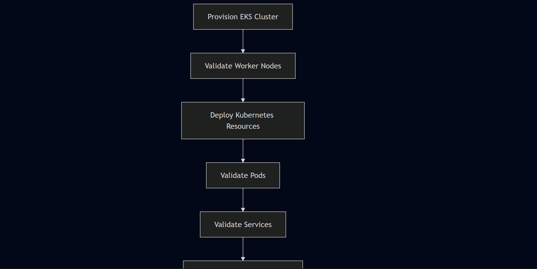
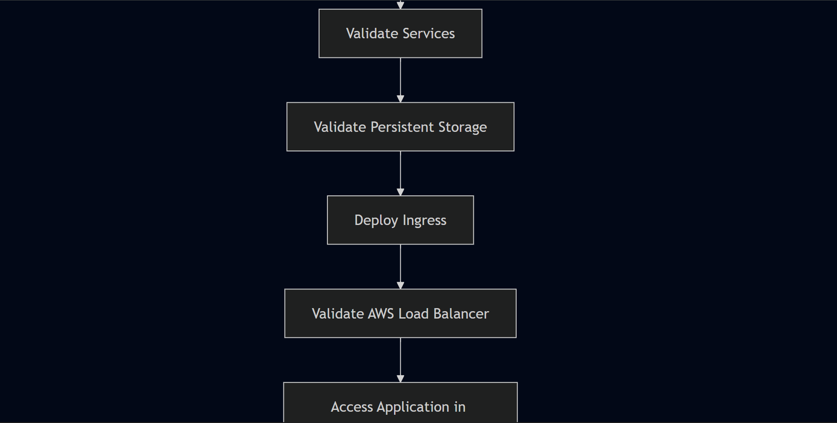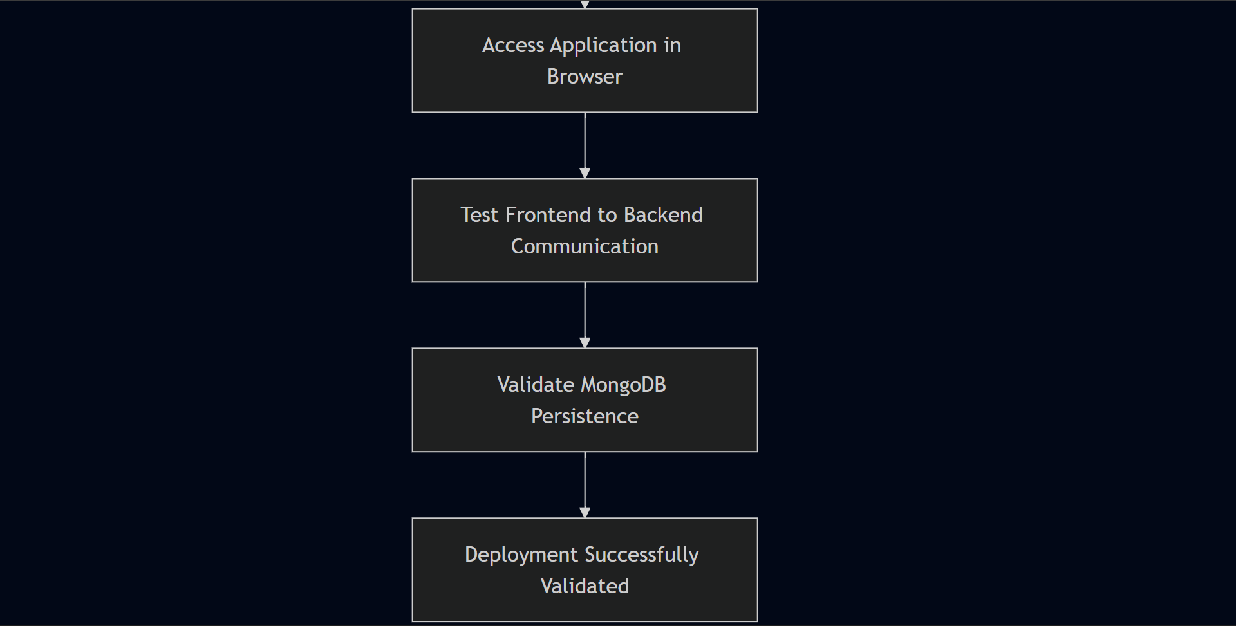

Layer 1 — EKS Cluster Validation
After cluster provisioning, the first check was confirming worker nodes joined the cluster successfully:
bash
kubectl get nodes
Both worker nodes showed Ready status — confirming the control plane was responding, nodes were registered, and kubectl was correctly connected to the cluster.
Validation Area | Expected Result
EKS control plane | Responding to Kubernetes API requests
Worker nodes | Successfully registered with the cluster
Networking | Nodes communicating with control plane
kubeconfig | kubectl correctly connected
Scheduling capability | Cluster ready to accept workloads
Only after both nodes showed Ready were application resources deployed.

Layer 2 — Namespace and Resource Validation
All application resources were deployed into the workshop namespace. A consolidated view of resources:
bash
kubectl get all -n workshop
Individual resource checks:
bash
kubectl get pods -n workshop
kubectl get svc -n workshop
kubectl get deployments -n workshop
kubectl get pvc -n workshop
kubectl get ingress -n workshop

Layer 3 — Pod Health Validation
The expected running workloads were:
- React frontend — 1 Pod
- Node.js backend — 2 Pods
- MongoDB — 1 Pod
Total: 4 running Pods
bash
kubectl get pods -n workshop
All four Pods reached Running status. A Pod not reaching Running required investigation — common causes include image pull failures, missing Secrets, storage binding issues, or application crashes.
kubectl apply accepts a manifest without guaranteeing the workload starts successfully. Pod status was the actual proof.

Layer 4 — Service Connectivity Validation
bash
kubectl get svc -n workshop
kubectl describe svc <service-name> -n workshop
All three Services — frontend, backend (api), MongoDB — were confirmed with correct port mappings.
The backend Service required specific attention. The Node.js application listened on port 3500. The Service targetPort had to match exactly. A mismatch causes frontend API calls to fail even when the backend Pod is healthy — which was one of the issues encountered and resolved during this deployment.
The complete validation chain:
Deployment → Pod → Container Port → Service → Endpoint
A failure at any point makes an otherwise healthy workload inaccessible.

Layer 5 — Persistent Storage Validation
bash
kubectl get pvc -n workshop
kubectl describe pvc <pvc-name> -n workshop
The PVC transitioned to Bound status — confirming Kubernetes completed the storage binding.
Storage dependency chain:
Persistent Volume
↓
Persistent Volume Claim (Bound)
↓
MongoDB Pod (storage attached)
During setup, the PVC initially remained in Pending because it was applied before a matching Persistent Volume was available. Correcting the apply order resolved the binding. Once Bound, MongoDB started with persistent storage attached.

Layer 6 — Ingress Validation
bash
kubectl get ingress -n workshop
kubectl describe ingress <ingress-name> -n workshop
Path-based routing configuration:
Path | Destination
/ | Frontend Service
/api | Backend Service
Initially the Ingress had no external address — the AWS Load Balancer Controller needed to provision the ALB first. After the IAM permission issue was resolved and the controller restarted, the Ingress received an ALB DNS address.

Layer 7 — AWS Load Balancer Validation
Kubernetes IngressAWS Load BalancerControllerAWS APIApplication Load BalancerTarget GroupsKubernetes Workloads
The controller encountered an IAM authorization failure during provisioning — the missing permission elasticloadbalancing:DescribeListenerAttributes prevented it from completing AWS API calls. After attaching the required policy and restarting the controller, the ALB provisioned successfully.
Validation confirmed:
- ALB visible in AWS Console
- Ingress showing external ALB DNS address
- Target groups healthy
- ALB DNS endpoint reachable

Layer 8 — Browser-Level Application Validation
The React frontend loaded successfully through the ALB DNS endpoint in a browser.
Browser
↓
ALB DNS Endpoint
↓
Kubernetes Ingress
↓
Frontend Service
↓
React Application
This confirmed the ALB was reachable, Ingress routing was working, the frontend Service was correctly configured, and the frontend Pod was serving the application.

Layer 9 — API Flow Validation
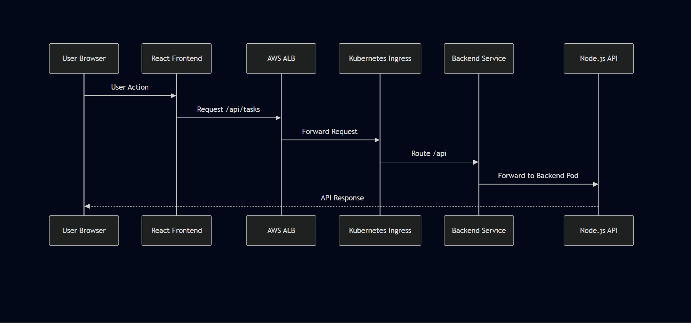
The frontend used a relative API path:
javascript
const apiUrl = "/api/tasks";
This avoided embedding a fixed backend hostname into the compiled bundle. The ALB and Ingress determined where /api traffic went — frontend, backend, and AWS networking aligned correctly.

Layer 10 — End-to-End Data Validation
/api/tasksUserReact FrontendIngressNode.js BackendMongoDBPersistent Storage
A task was submitted through the React UI. The expected flow:
- Frontend sends POST request to /api/tasks
- Request reaches Node.js backend through Ingress
- Backend processes request and writes to MongoDB
- MongoDB stores data to persistent EBS-backed volume
- Frontend receives response and displays the task
- Page refresh — task still visible, confirming persistence
All steps completed successfully. The complete Frontend → Backend → Database path was operational.

Validation Matrix
Layer | Validation Method | Result
EKS Cluster | kubectl get nodes | Worker nodes Ready
Kubernetes Workloads | kubectl get pods | All 4 Pods Running
Deployments | kubectl get deployments | Desired replicas available
Services | kubectl get svc / describe svc | Port mappings correct
Persistent Storage | kubectl get pvc | PVC Bound
Ingress | kubectl get ingress | External ALB address received
AWS Integration | AWS Console | ALB provisioned
Frontend | Browser access | React application loaded
Backend | API routing | Requests reached Node.js
Database | Application interaction | MongoDB data path operational
End-to-End | Browser testing | Complete three-tier flow verified

Evidence Notes
Screenshots from the actual deployment would be the strongest evidence for this chapter — specifically:
- Terminal showing kubectl get nodes with both nodes Ready
- Terminal showing kubectl get pods -n workshop with all Pods Running
- Terminal showing kubectl get pvc -n workshop with PVC Bound
- Terminal showing kubectl get ingress -n workshop with ALB address populated
- AWS Console showing the provisioned Application Load Balancer
- Browser showing the React frontend loaded through the ALB DNS
- Browser showing a task successfully created and persisted
If you rebuild this project or run it again, capturing these screenshots would significantly strengthen the portfolio evidence.

Final Operational Status
EKS Cluster ✓ Operational
Worker Nodes ✓ Ready
Frontend Pod ✓ Running
Backend Pods ✓ Running (×2)
MongoDB Pod ✓ Running
Kubernetes Services ✓ Operational
Persistent Storage ✓ Bound
AWS Load Balancer ✓ Provisioned
Ingress Routing ✓ Operational
Frontend Access ✓ Verified
Backend API Connectivity ✓ Verified
Database Persistence ✓ Verified
End-to-End Application Flow ✓ Successful
Infrastructure Cleanup ✓ Completed

Engineering Takeaway
The deployment required multiple independent systems to work together simultaneously — AWS infrastructure, IAM permissions, Docker images, ECR, Kubernetes scheduling, Service networking, persistent storage, Load Balancer Controller, Ingress routing, and application-level API communication.
A failure in any one of these layers prevented the final application from working. The completed validation demonstrated the full operational path rather than isolated infrastructure components:
Browser → ALB → Ingress → Kubernetes Services → Application Pods → MongoDB → Persistent Storage
That end-to-end verification is the evidence that the deployment functioned as an integrated cloud-native system — not merely as a collection of successfully applied Kubernetes manifests.

Chapter 18 — Architecture Decisions & Engineering Trade-offs

Overview
This chapter documents the key architectural decisions behind the EKS deployment and the reasoning behind each one. The goal isn't to present every choice as the only valid approach — it's to explain why the selected architecture supported the objective of deploying and validating a complete three-tier application on Kubernetes, and what trade-offs came with each decision.
The architecture itself came from the reference project I followed. My contribution was implementing it, understanding why each decision was made, and learning from what happened when things didn't work as expected.

Architecture Decision Overview
The final request path:
End User
│
▼
AWS Application Load Balancer
│
▼
Kubernetes Ingress
│
├───────────────┐
▼ ▼
Frontend Backend
Service Service
│ │
▼ ▼
React Pods Node.js Pods
│
▼
MongoDB Service
│
▼
MongoDB
│
▼
Persistent Storage
Decision | Selected Approach | Primary Reason
Application architecture | Three-tier | Clear separation between UI, API, and data layers
Container orchestration | Amazon EKS | Managed Kubernetes control plane on AWS
Container registry | Amazon ECR | AWS-native registry — native EKS integration
External access | ALB + Kubernetes Ingress | Single entry point for HTTP traffic
Internal networking | ClusterIP Services | Keep application components private
Backend availability | Two replicas | More than one API Pod available
Database access | Internal Kubernetes Service | MongoDB not directly exposed
Database persistence | PV/PVC backed by EBS | Preserve data beyond Pod lifecycle
API routing | Path-based routing | Avoid dependency on a custom domain
Deployment method | Manual Kubernetes manifests | Focus on understanding the underlying workflow

Decision 1 — Three-Tier Application Architecture
The application was divided into three distinct layers:
┌─────────────────────────────────────────┐
│ Presentation Tier │
│ React │
└────────────────────┬────────────────────┘
│ API Requests
▼
┌─────────────────────────────────────────┐
│ Application Tier │
│ Node.js REST API │
└────────────────────┬────────────────────┘
│ Database Requests
▼
┌─────────────────────────────────────────┐
│ Data Tier │
│ MongoDB │
└─────────────────────────────────────────┘
Each layer operates independently — the frontend can be updated without touching the database, the backend can scale without affecting the frontend, and database storage is managed separately from stateless application workloads.
Trade-off: Three tiers means more infrastructure and networking complexity than a single-container application. Each layer needs its own image, Kubernetes resources, and networking configuration. That complexity was acceptable here because the objective was specifically to understand how multiple workloads interact inside Kubernetes.

Decision 2 — Amazon EKS Instead of Self-Managed Kubernetes
EKS provides a managed control plane while still requiring direct work with standard Kubernetes resources — Deployments, Services, Ingress, PV/PVC, Secrets. The managed aspect removes the need to operate the API server, scheduler, and etcd manually.
Amazon EKS | Self-Managed Kubernetes
Managed control plane | Full control plane responsibility
AWS-native integration | Greater infrastructure flexibility
Faster cluster provisioning | More manual setup required
IAM integration built-in | IAM requires custom configuration
Trade-off: EKS simplifies control plane management but Kubernetes itself remains operationally complex. Application networking, IAM integration, storage, and debugging still require direct engineering work — which this project demonstrated clearly.

Decision 3 — Kubernetes Services Instead of Direct Pod Access
Pods are not stable endpoints. They restart, get recreated, receive new IP addresses, and move between nodes. Connecting application components directly to Pod IPs creates an unstable architecture.
Services solve this:
Backend Pod A ──┐
│
▼
Backend Service (stable DNS)
│
▼
Frontend / API
│
Backend Pod B ──┘
The application communicates with a stable Service name rather than a specific Pod IP. Pods can change without requiring application-level networking changes.

Decision 4 — ClusterIP for Internal Services
All three Services — frontend, backend, MongoDB — use ClusterIP. Nothing is directly accessible from outside the cluster except through the ALB.
Internet
↓
Application Load Balancer
↓
Ingress
↓
Frontend Service → Backend Service → MongoDB Service
Trade-off: ClusterIP Services require an additional routing layer for external traffic — provided here by ALB + Ingress. But keeping internal components private reduces the attack surface and eliminates unnecessary public endpoints.

Decision 5 — AWS ALB and Kubernetes Ingress
A single ALB handles all external traffic. The Kubernetes Ingress defines the routing logic:
Internet
↓
AWS Application Load Balancer
↓
Kubernetes Ingress
├── / → Frontend Service
└── /api → Backend Service
This lets the React frontend send requests using /api/tasks rather than requiring a separate public backend URL.
Trade-off: This approach depends on correct coordination between the ALB, Load Balancer Controller, IAM permissions, Ingress configuration, Services, and application ports. This became visible during setup — the controller appeared healthy while the AWS integration layer was failing because of a missing IAM permission. Kubernetes and AWS authorization are tightly coupled in an EKS environment.

Decision 6 — Path-Based Routing Instead of Host-Based Routing
The initial Ingress configuration used hostname-based routing. But the project didn't use a custom domain — just the ALB DNS endpoint directly. The hostname requirement introduced an unnecessary dependency.
Simplified to path-based routing:
Request | Destination
/ | Frontend Service
/api | Backend Service
Trade-off: A larger production system might use separate hostnames (app.example.com, api.example.com) for stronger separation. But for validating this deployment, path-based routing removed an unnecessary dependency without sacrificing features.

Decision 7 — Relative API Paths in the Frontend
The original frontend used a build-time environment variable for the backend URL:
REACT_APP_BACKEND_URL
React resolves environment variables at build time — not runtime. Changing a Kubernetes environment variable after the image was built had no effect on the already-compiled bundle.
The fix was switching to a relative path:
javascript
const apiUrl = "/api/tasks";
Request flow after the change:
React Application
↓
/api/tasks
↓
Application Load Balancer
↓
Ingress Rule
↓
Backend Service
↓
Node.js API Pod
Trade-off: This couples frontend API routing to the Ingress configuration — the /api path must remain correctly configured. But the benefit was significant: no hardcoded backend URL, no domain dependency, no image rebuild just to change the backend hostname.

Decision 8 — Stateless vs Stateful Workloads
Frontend and backend Pods are stateless — if a Pod is replaced, Kubernetes starts another instance from the same image and nothing is lost.
MongoDB is different. Without persistent storage:
MongoDB Pod Deleted
↓
Container Filesystem Lost
↓
Application Data Lost
Storage was therefore decoupled from the Pod lifecycle:
MongoDB Pod
↓
Persistent Volume Claim
↓
Persistent Volume
↓
Amazon EBS Storage
The Pod is replaceable. The data is not. This distinction is fundamental to the architecture.

Decision 9 — Persistent Storage Using PV and PVC
The PV/PVC abstraction separates the application from the underlying storage setup. MongoDB mounts storage through Kubernetes without needing to interact directly with EBS.
Trade-off: Persistent storage introduces operational considerations that stateless workloads don't have — storage must be provisioned correctly, claims must bind successfully, and stateful workloads require careful lifecycle management. This was encountered directly when the PVC remained in Pending until the correct storage configuration was available.

Decision 10 — Two Backend Replicas
The backend ran two replicas — defined in the reference project's manifests rather than a custom scaling decision.
Backend Service
↓
Backend Pod 1 Backend Pod 2
Even though this wasn't a custom scaling strategy, it demonstrated how Kubernetes Services interact with multiple Pods. If one Pod becomes unavailable, the Service continues routing to healthy endpoints while Kubernetes restores the desired state.
Trade-off: Additional replicas consume additional compute resources. For a demo environment one replica would have been sufficient functionally — but two replicas made the architecture more representative of a real distributed deployment.

Decision 11 — Amazon ECR for Image Storage
Images were pushed to ECR because the infrastructure was already running in AWS. ECR integrates natively with EKS — worker nodes authenticate to ECR automatically through IAM without requiring separate registry credentials.
Trade-off: ECR increases dependency on the AWS ecosystem. A multi-cloud deployment would benefit from a cloud-neutral registry. For this single-AWS-region project, native integration was the right choice.

Architecture Trade-off Matrix
Design Area | Selected Approach | Advantage | Trade-off
Kubernetes platform | Amazon EKS | Managed control plane | AWS and Kubernetes complexity
Application design | Three-tier | Separation of responsibilities | More components to manage
Public access | ALB + Ingress | Single controlled entry point | Controller and IAM dependencies
Internal networking | ClusterIP Services | Reduced public exposure | Requires routing layer
API routing | /api path | No custom domain required | Depends on Ingress path config
Backend availability | Two replicas | Basic redundancy | Additional compute usage
Database | MongoDB with PV/PVC | Data survives Pod lifecycle | Stateful workload complexity
Image registry | Amazon ECR | AWS-native integration | Cloud ecosystem dependency
Deployment process | Manual workflow | Better infrastructure understanding | Not repeatable at production scale
Infrastructure provisioning | eksctl | Faster cluster setup | Less declarative than IaC

Engineering Takeaway
The most important outcome wasn't that React, Node.js, and MongoDB were deployed to Kubernetes. The value came from understanding the connections between the layers.
A successful request depended on every layer working correctly simultaneously:
Browser → ALB → Load Balancer Controller → Ingress → Service → Pod → Application → Database → Persistent Storage
A Dockerfile naming error prevented an image from reaching ECR. A Service port mismatch left healthy Pods unreachable. A React build-time configuration decision broke API routing. A missing IAM permission prevented the controller from provisioning AWS infrastructure. A storage dependency issue kept MongoDB pending.
Those weren't isolated problems. They demonstrated a property of cloud-native systems that documentation doesn't fully convey:
The application is only as reliable as the interaction between its infrastructure layers.

Chapter 19 — Engineering Reflection & Professional Takeaways

Overview
This chapter documents the engineering perspective gained from implementing the AWS EKS deployment — not generic Kubernetes theory, but what the project actually revealed during hands-on setup.
Before this project, I had experience with individual technologies — AWS, Docker, Linux, Kubernetes concepts. What I hadn't experienced to the same extent was how quickly a deployment becomes dependent on the interaction between those layers. That's the main thing this project changed.

The Deployment as a Connected System
The project only worked when the complete chain worked:
Source Code
↓
Docker Image
↓
Amazon ECR
↓
Amazon EKS
↓
Kubernetes Deployment
↓
Service Networking
↓
Ingress
↓
AWS Load Balancer Controller
↓
Application Load Balancer
↓
Browser
And after the frontend loaded, another chain still had to work:
React Frontend
↓
/api/tasks
↓
Ingress Path Rule
↓
Backend Service
↓
Node.js API
↓
MongoDB Service
↓
MongoDB Pod
↓
Persistent Storage
Understanding the deployment as one connected system — rather than a collection of independent tools — was the core learning.

Tooling Context
The project involved multiple tools working together:
eksctl → Creates and manages EKS infrastructure
kubectl → Interacts with Kubernetes resources
Helm → Installs packaged Kubernetes applications
Docker → Builds application container images
AWS CLI → Authenticates and interacts with AWS services
Git/GitHub → Manages source code and configuration
Learning individual commands was only part of the challenge. The harder part was understanding where each tool fit into the larger workflow — which layer it controlled, what it depended on, and what depended on it.
The real workflow wasn't:
Learn 7 tools separately
It was:
Understand which tool controls which layer

Observability Was More Important Than Expected
During troubleshooting, a small set of commands became the primary diagnostic toolkit:
Command | Primary Use
kubectl get | Quick resource status
kubectl describe | Events and detailed configuration
kubectl logs | Application and controller output
AWS Console | AWS resource provisioning and status
The debugging pattern that worked consistently:
Something Failed
↓
Check Status (kubectl get)
↓
Check Events (kubectl describe)
↓
Check Logs (kubectl logs)
↓
Identify the Failing Layer
↓
Make One Targeted Change
↓
Validate Again
This is significantly more effective than repeatedly changing YAML files without first understanding what's failing and why.
The controller logs were particularly valuable during the ALB provisioning failure. The controller appeared healthy from the Kubernetes side — but its logs showed HTTP 403 responses from AWS, which immediately pointed toward IAM rather than Kubernetes configuration.

What I Would Do Differently
If rebuilding this project, I would reduce manual infrastructure and deployment steps from the start.
A future architecture would move toward:
Developer
↓
Git Push
↓
CI/CD Pipeline
├── Build
├── Test
├── Security Checks
├── Docker Image
└── Push to ECR
↓
Deployment Update
↓
Amazon EKS
And infrastructure through code:
Terraform
↓
AWS Infrastructure
├── VPC
├── Networking
├── EKS
├── IAM
└── Supporting Resources
These are future improvements — not claimed as part of this setup. The manual workflow was right for learning. It's not right for production scale.

Engineering Growth From the Project

Cloud Infrastructure
- Amazon EKS cluster provisioning via eksctl
- EC2 management environment setup
- ECR image management and authentication
- IAM user and IRSA configuration
- ALB provisioning through Kubernetes
- EBS-backed persistent storage

Containerization
- Dockerfile-based application packaging
- Image building, tagging, and ECR push workflow
- Container image lifecycle management

Kubernetes
- Deployments, ReplicaSets, Pods
- ClusterIP Services and DNS-based discovery
- Ingress with path-based routing
- Persistent Volumes and Persistent Volume Claims
- Secrets for credential management
- Namespace-based resource isolation
- kubectl-based administration and debugging

Operations
- Systematic resource inspection
- Log analysis and event investigation
- Service and networking troubleshooting
- IAM troubleshooting across Kubernetes and AWS layers
- Infrastructure cleanup and cost management

Final Reflection
The biggest difference between understanding this architecture on paper and implementing it was discovering how dependent every layer is on the others.
From the browser, the finished application looked simple:
Open Application → Add Task → Task Appears
Behind that interaction, the request passed through an entire infrastructure chain:
Browser
↓
Application Load Balancer
↓
Kubernetes Ingress
↓
Kubernetes Service
↓
Node.js Backend
↓
MongoDB Service
↓
MongoDB
↓
Persistent Storage
Getting that chain working required more than applying manifests. It required understanding failures, reading logs, checking resource states, correcting configuration mismatches, resolving AWS permission issues, and validating the final result from the user's perspective.
That's the main professional takeaway:
Cloud-native engineering is not about deploying individual technologies. It's about understanding how those technologies behave as one system — and being able to trace, diagnose, and fix the system when one part breaks.

Engineering Portfolio Summary
Item | Detail
Project | Three-Tier Application Deployment on AWS EKS
Cloud Platform | AWS — us-west-2
Container Orchestration | Amazon EKS — three-tier-cluster
Containerization | Docker
Image Registry | Amazon ECR
Networking | AWS ALB + Kubernetes Ingress + ClusterIP Services
Application Stack | React, Node.js, MongoDB
Storage | PV/PVC backed by Amazon EBS
Management Environment | Ubuntu EC2 (t2.micro)
Operational Tooling | kubectl, eksctl, Helm, AWS CLI
Version Control | Git and GitHub
Validated outcome:
User → React Frontend → Node.js API → MongoDB → Persistent Storage
Result: Complete three-tier application deployed on Amazon EKS, end-to-end communication validated, infrastructure cleaned up after completion.

Chapter 20 — Production Readiness Assessment & Architecture Review

Purpose
Completing a deployment successfully and being production-ready are not the same thing. This chapter provides an honest assessment of where the setup stands against production requirements — separating what was actually implemented and validated from what would need to be added before treating this as a production system.

Current Architecture
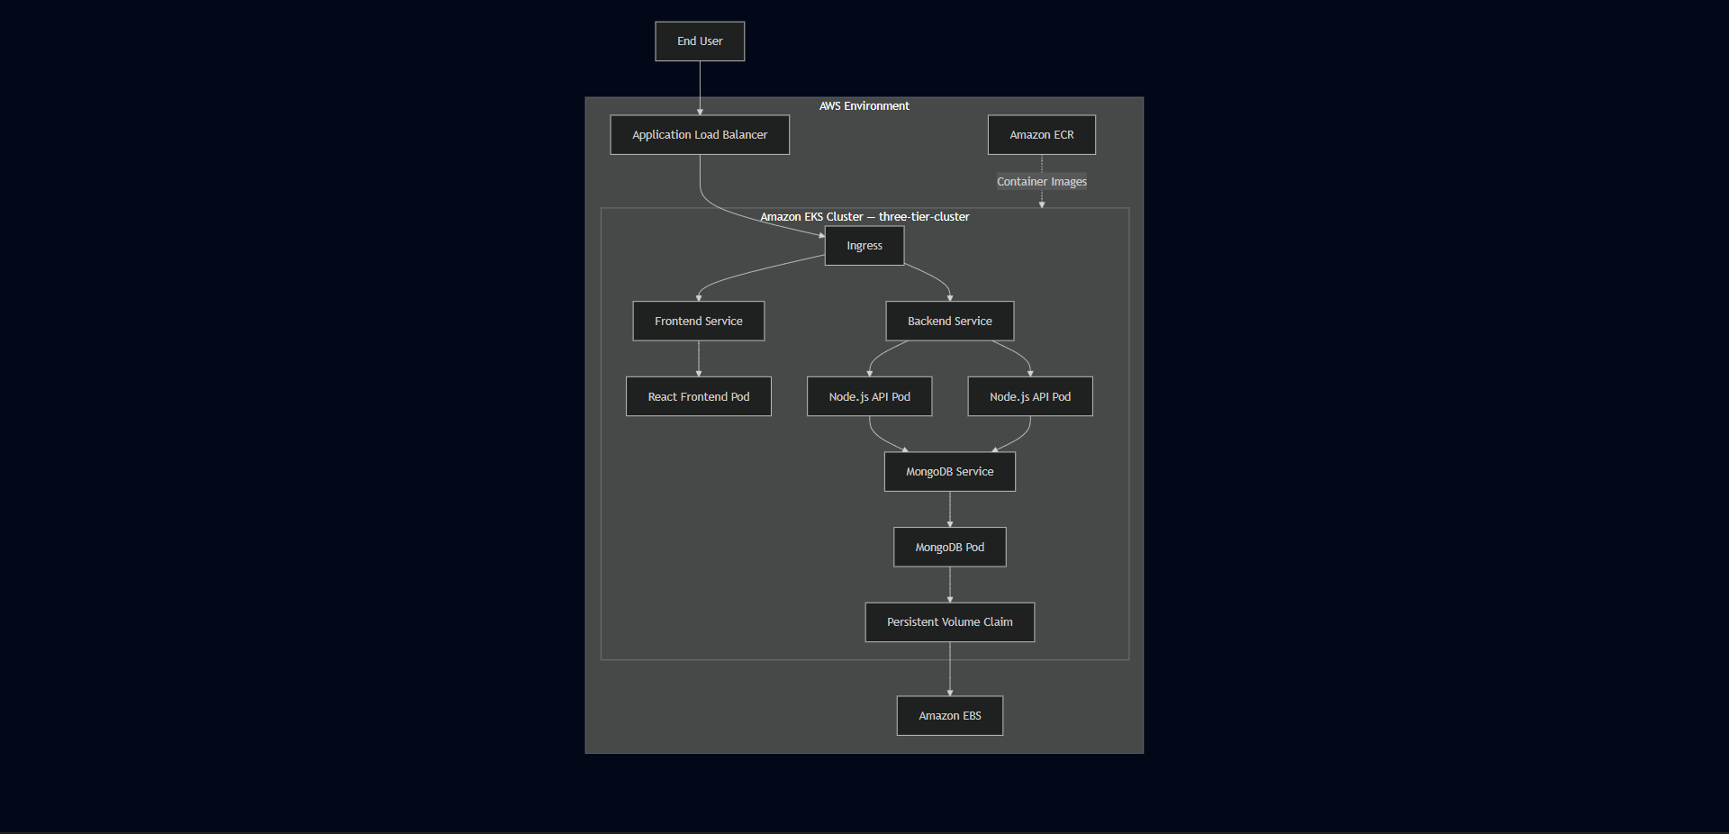

Architecture Status
Area | Current State
Application Deployment | Implemented
Containerization | Implemented
Image Registry | Implemented — Amazon ECR
Kubernetes Orchestration | Implemented — Amazon EKS
External Traffic | Implemented — ALB and Ingress
Internal Networking | Implemented — ClusterIP Services
Persistent Storage | Implemented — PV/PVC backed by EBS
Backend Replication | Two replicas configured
IAM Integration | Implemented and troubleshot
CI/CD | Not implemented
Infrastructure as Code | Not implemented
Production Monitoring Stack | Not implemented
Automated Scaling | Not validated
Disaster Recovery | Not implemented
Multi-Region Availability | Not implemented

Production Readiness Scorecard
Category | Assessment | Current Status
Application Architecture | Strong Foundation | Three-tier separation implemented
Containerization | Ready Foundation | Docker-based images deployed
Kubernetes Deployment | Implemented | Workloads running on EKS
Networking | Implemented | ALB, Ingress, Services configured
Persistent Storage | Implemented | MongoDB persistence configured
High Availability | Partial | Backend uses two replicas
Security | Basic Foundation | IAM, ClusterIP, Secrets used
CI/CD Automation | Not Implemented | Manual deployment workflow
Infrastructure as Code | Not Implemented | Manual provisioning via eksctl
Monitoring | Basic Visibility | kubectl and AWS Console only
Alerting | Not Implemented | No automated alerting
Autoscaling | Not Validated | HPA not implemented
Backup & Recovery | Not Implemented | No automated backup strategy
Disaster Recovery | Not Implemented | No documented recovery plan
Multi-Region | Not Implemented | Single-region deployment
Overall | Development / Portfolio Grade | Requires additional controls for production

What's Already Production-Relevant
Several decisions in this deployment follow patterns used in real environments — not because the project claims to be production-ready, but because the reference architecture reflected sound engineering practices.
Containerized application components — frontend and backend packaged independently, each with its own image lifecycle. A frontend update doesn't require rebuilding the backend.
Managed Kubernetes control plane — EKS removes the need to operate the API server, scheduler, and etcd manually. The focus stays on application deployment, networking, storage, and IAM integration rather than control plane maintenance.
Internal service isolation — backend and MongoDB are not directly exposed to the internet. Only the ALB is public-facing. This creates a clear security boundary between external traffic and internal workloads.
Persistent storage for MongoDB — PV/PVC backed by EBS means data survives Pod restarts and rescheduling. This is significantly more appropriate for a database workload than temporary container filesystem storage.
IAM integration troubleshot under real conditions — the Load Balancer Controller IAM failure demonstrated that cloud-native deployments require both Kubernetes configuration and AWS authorization to be correct simultaneously. That's a production reality, not just a learning exercise.

What's Missing for Production
Being direct about the gaps:
No CI/CD — every deployment step was manual. Consistent, repeatable production releases require automation.
No Infrastructure as Code — the environment was provisioned through eksctl and CLI commands, not version-controlled Terraform configuration. Rebuilding from scratch requires memory rather than code.
No formal monitoring — operational visibility came from kubectl and the AWS Console. A production system needs centralized metrics, dashboards, and automated alerting.
No automated scaling — replica counts are static. HPA and Cluster Autoscaler were not implemented.
No backup strategy — MongoDB persistence was validated at the Pod level but there's no documented plan for storage failure, cluster loss, or data recovery.
No TLS — the deployment used HTTP. Production traffic should be encrypted.
Single region — the entire deployment runs in us-west-2. No cross-region failover.

Production Readiness Roadmap
Current PortfolioDeploymentCI/CD AutomationInfrastructure as CodeCentralized MonitoringSecurity HardeningAutoscalingGitOpsProduction-Style Platform
The sequence matters. There's little value in adding GitOps or autoscaling before the deployment is repeatable and the infrastructure is automated. Each phase builds on the previous one.

Final Production Readiness Verdict
Current status: Production-inspired architecture with a successful end-to-end setup — intentionally not a fully production-ready platform.
What was implemented and validated:
✓ Containerized three-tier application architecture
✓ Amazon EKS deployment — three-tier-cluster, us-west-2
✓ Amazon ECR private image repositories
✓ Kubernetes Services, Ingress, path-based routing
✓ AWS Application Load Balancer integration
✓ Backend replica configuration — 2 × Node.js Pods
✓ MongoDB persistent storage — PV/PVC backed by EBS
✓ IAM configuration and real-world troubleshooting
✓ End-to-end browser-to-database validation
✓ Infrastructure cleanup after testing
What remains as future enhancements:
○ CI/CD automation
○ Infrastructure as Code — Terraform
○ Formal monitoring and alerting — Prometheus, Grafana
○ Automated scaling — HPA and Cluster Autoscaler
○ Backup and disaster recovery
○ TLS and HTTPS
○ Advanced secret management
○ Image security scanning
○ GitOps workflows — Argo CD
○ Progressive deployment strategies

Engineering Perspective
The value of this project is not in claiming equivalence to an enterprise production platform. The value is in having implemented the foundation manually and understanding what happens between each layer — and then being able to look at a working deployment and honestly identify what's still missing.
That ability to assess your own work critically is itself a production engineering skill.
CURRENT STATE

Functional Application
+
Containerization
+
Kubernetes
+
AWS Infrastructure
+
Networking
+
Persistent Storage
+
Hands-On Troubleshooting
=
Strong Cloud-Native Engineering Foundation

NEXT EVOLUTION

Automation
+
Infrastructure as Code
+
Observability
+
Security Hardening
+
Autoscaling
+
GitOps
=
Production-Style Platform
The project established the foundation. The next stage is systematically improving repeatability, security, observability, resilience, and delivery automation — not randomly adding tools, but evolving the architecture in a deliberate sequence.

Chapter 21 — Appendix & References

Project Information
Item | Details
Project Name | Three-Tier Application Deployment using Kubernetes on AWS EKS
Project Type | Cloud-Native Infrastructure Deployment
Architecture | Three-Tier Web Application
Deployment Platform | Amazon Elastic Kubernetes Service (Amazon EKS)
Cluster Name | three-tier-cluster
Region | us-west-2
Namespace | workshop
Deployment Model | Containerized Workloads on Managed Kubernetes
Project Status | Successfully Completed

Project Repository
GitHub Repository:
https://github.com/Nuzairkhan/k8s-three-tier-app-eks
Repository contents:
- Application source code — React frontend, Node.js backend
- Dockerfiles for frontend and backend
- Kubernetes manifests — Deployments, Services, Ingress, Secrets, PV/PVC
- Ingress and ALB configuration
- Project documentation

Project Demonstration
LinkedIn Demo:
https://www.linkedin.com/posts/anwarullah-khan-nuzair_devops-aws-eks-activity-7415357318206418945-DehZ
The demonstration shows the deployed application running through the AWS Application Load Balancer — React frontend loading, API communication working, and task data persisting in MongoDB.

Final Solution Architecture
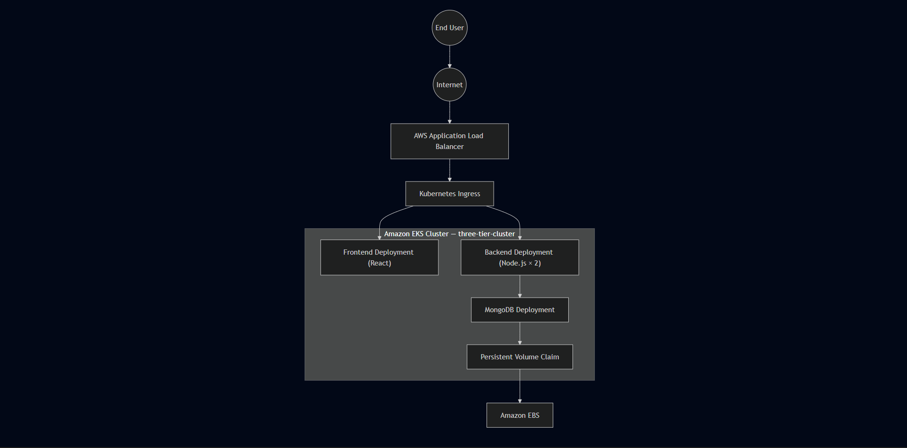

Infrastructure Summary
Resource | Configuration
Amazon EKS Cluster | 1 — three-tier-cluster, us-west-2
Worker Nodes | 2 × t2.medium
Amazon EC2 Management Host | 1 × t2.micro — Ubuntu
Amazon ECR Repositories | 2 — frontend, backend
Application Load Balancer | 1 — provisioned via Kubernetes Ingress
Deployments | 3 — frontend, backend, MongoDB
Services | 3 — all ClusterIP
Ingress | 1 — path-based routing
Persistent Volumes | 1 — Amazon EBS backed
Persistent Volume Claims | 1 — MongoDB storage
Namespaces | 1 — workshop
IAM User | eks-admin with AdministratorAccess

Technology Reference
Category | Technologies
Cloud Platform | AWS
Kubernetes | Amazon EKS
Containers | Docker
Registry | Amazon ECR
Networking | ALB, Kubernetes Ingress, ClusterIP Services
Storage | Amazon EBS, Persistent Volumes, Persistent Volume Claims
Security | AWS IAM, Security Groups, Kubernetes Secrets, IRSA
Package Manager | Helm — used for AWS Load Balancer Controller
Operating System | Ubuntu Linux (EC2 management instance)
Frontend | React.js
Backend | Node.js — port 3500
Database | MongoDB
Version Control | Git, GitHub
Cluster Tools | kubectl, eksctl

Engineering Skills Demonstrated

Cloud Engineering
- Amazon EKS cluster provisioning via eksctl
- IAM user and IRSA configuration
- Amazon ECR private repository management
- AWS Application Load Balancer deployment through Kubernetes
- Amazon EBS persistent storage
- Security Groups and VPC networking

Kubernetes
- Namespace isolation
- Declarative Deployments and ReplicaSets
- ClusterIP Services and DNS-based service discovery
- Kubernetes Ingress with path-based routing
- Persistent Volumes and Persistent Volume Claims
- Kubernetes Secrets for credential management
- Health probe configuration
- kubectl-based cluster administration and debugging

Containerization
- Docker image builds on EC2 management instance
- ECR authentication and image push workflow
- Immutable image model — no in-place container modification
- Multi-container architecture across three independent tiers

DevOps & Platform Engineering
- Linux administration over SSH
- End-to-end deployment lifecycle management
- Systematic root cause analysis across Kubernetes and AWS layers
- Infrastructure cleanup and cost management
- Iterative debugging — kubectl describe, logs, events

Key Engineering Decisions
Decision | Rationale
eksctl for cluster provisioning | Automated VPC, subnet, and node group creation
ClusterIP for all Services | Internal-only communication — single ALB entry point
Path-based Ingress routing | Single public endpoint — / frontend, /api backend
Relative API path /api/tasks | Avoided React build-time environment variable issues
IRSA for Load Balancer Controller | Scoped IAM permissions — no node-level AWS access
PV/PVC for MongoDB | Storage independent of container lifecycle
Dedicated EC2 management host | Consistent administration environment
Separate ECR repositories | Independent versioning per service

Real Issues Resolved
Issue | Root Cause | Fix
Docker build failure | Backend Dockerfile named Dockefile | Renamed file, rebuilt image
PVC stuck in Pending | PVC applied before PV was available | Applied storage resources in correct order
Frontend couldn't reach backend | Service targetPort didn't match container port 3500 | Corrected targetPort in Service manifest
React API requests failing | REACT_APP_BACKEND_URL resolved at build time not runtime | Switched to relative path /api/tasks in taskServices.js
ALB not provisioning | IAM role missing elasticloadbalancing:DescribeListenerAttributes | Attached missing permission, restarted controller
Ingress routing failure | Host-based routing without a registered domain | Removed host field, used path-based routing only

Lessons Learned
- Infrastructure failures don't always originate from Kubernetes. When EKS workloads interact with AWS services, IAM policies become part of the operational dependency chain.
- A healthy Pod doesn't mean a healthy application. Services, ports, storage, Ingress rules, and AWS permissions all have to align simultaneously.
- React environment variables are resolved at build time. Configuration that needs to change across environments should use relative paths or routing-layer abstractions rather than compiled-in values.
- Incremental validation is faster than end-to-end debugging. Verifying each layer independently narrows the scope of possible root causes significantly.
- Responsible cloud engineering includes cleanup. Leaving EKS clusters, load balancers, and EBS volumes running generates costs — decommissioning after validation is part of the workflow.

Glossary
Term | Description
ALB | AWS Application Load Balancer — distributes HTTP traffic to Kubernetes workloads
Amazon ECR | Private container image registry for storing Docker images
Amazon EKS | AWS managed Kubernetes control plane service
ClusterIP | Kubernetes Service type providing internal-only cluster networking
Deployment | Kubernetes controller managing desired Pod state and replica count
Docker Image | Immutable application package containing runtime and dependencies
eksctl | CLI tool for Amazon EKS cluster provisioning and management
Helm | Kubernetes package manager — used here for Load Balancer Controller
Ingress | Kubernetes resource managing external HTTP routing into the cluster
IRSA | IAM Roles for Service Accounts — scoped AWS permissions for Kubernetes workloads
Namespace | Logical isolation boundary for Kubernetes resources
Persistent Volume | Storage resource existing independently of Pod lifecycle
Persistent Volume Claim | Workload request for persistent storage
Pod | Smallest deployable unit in Kubernetes
ReplicaSet | Controller maintaining the required number of running Pod replicas
Service | Stable network endpoint abstracting individual Pod IP addresses

References

AWS Documentation
- Amazon EKS Documentation — https://docs.aws.amazon.com/eks
- Amazon ECR Documentation — https://docs.aws.amazon.com/ecr
- AWS IAM Documentation — https://docs.aws.amazon.com/iam
- AWS Load Balancer Controller — https://kubernetes-sigs.github.io/aws-load-balancer-controller
- Amazon EBS Documentation — https://docs.aws.amazon.com/ebs

Kubernetes Documentation
- Kubernetes Official Documentation — https://kubernetes.io/docs
- Kubernetes Ingress — https://kubernetes.io/docs/concepts/services-networking/ingress
- Kubernetes Storage — https://kubernetes.io/docs/concepts/storage
- Kubernetes Deployments — https://kubernetes.io/docs/concepts/workloads/controllers/deployment

Containerization
- Docker Documentation — https://docs.docker.com
- Docker Best Practices — https://docs.docker.com/develop/dev-best-practices

Portfolio Summary
Category | Outcome
Cloud Infrastructure | Successfully provisioned on AWS — us-west-2
Kubernetes Platform | Operational — three-tier-cluster
Application Deployment | Completed — React, Node.js, MongoDB
Persistent Storage | Validated — PV/PVC with Amazon EBS
Networking | Fully functional — ALB, Ingress, ClusterIP
Security | Implemented — IAM, Secrets, IRSA, ClusterIP isolation
Monitoring | Operational — kubectl diagnostics, AWS Console
Troubleshooting | Six real issues identified and resolved
Documentation | Complete — 21chapters

Final Statement
This project documents the hands-on deployment of a three-tier application on Amazon EKS — from infrastructure provisioning through containerization, Kubernetes orchestration, networking, persistent storage, security, and operational troubleshooting. The setup followed a reference architecture and focused on understanding how the components interact, debugging the real issues that came up, and validating the complete application flow end to end.
The goal was practical engineering experience — not just getting something running, but understanding why it works and what to do when it doesn't.
<div align="center">

END OF DOCUMENT
Three-Tier Application Deployment using Kubernetes on AWS EKS
Version 1.0
Prepared as an Engineering Portfolio Document
Anwarullah Khan Nuzair — Cloud & DevOps Engineer
myselfnuzairkhan@gmail.com
https://github.com/Nuzairkhan
</div>

