Three-Tier Application Deployment on AWS EKS — Part 1 of 3
Cover, Executive Summary, Architecture, Infrastructure, Technology Stack, Containerization, Kubernetes Design, Deployment Workflow

Three-Tier Application Deployment using Kubernetes on AWS Elastic Kubernetes Service (Amazon EKS)
Production-Style Cloud-Native Application Deployment on Amazon Elastic Kubernetes Service

Prepared by: Anwarullah Khan Nuzair — Cloud & DevOps Engineer Email: myselfnuzairkhan@gmail.com LinkedIn: https://www.linkedin.com/in/anwarullah-khan-nuzair GitHub: https://github.com/Nuzairkhan
Production-Style Cloud-Native Application Deployment on Amazon Elastic Kubernetes Service
Prepared by: Anwarullah Khan Nuzair — Cloud & DevOps Engineer Email: myselfnuzairkhan@gmail.com LinkedIn: https://www.linkedin.com/in/anwarullah-khan-nuzair GitHub: https://github.com/Nuzairkhan

Contact
Email: myselfnuzairkhan@gmail.com
LinkedIn: https://www.linkedin.com/in/anwarullah-khan-nuzair
GitHub: https://github.com/Nuzairkhan

Project Overview
This portfolio covers a hands-on deployment of a three-tier application on Amazon EKS — from cluster provisioning through containerization, Kubernetes configuration, networking, persistent storage, and the troubleshooting that came with getting it all working together.
The point wasn't just to deploy containers. It was to work through the complete engineering lifecycle: provision the infrastructure, build and push images, wire up Kubernetes resources, debug what breaks, and then clean everything up responsibly when done.

Technology Domains
Domain | Technologies
Cloud Platform | AWS
Container Platform | Docker
Container Orchestration | Kubernetes, Amazon EKS
Image Registry | Amazon ECR
Compute | Amazon EC2
Networking | VPC, Security Groups, Application Load Balancer, Ingress
Storage | Amazon EBS, Persistent Volumes, Persistent Volume Claims
Identity & Access | AWS IAM
Package Management | Helm
Application Stack | React, Node.js, MongoDB
Operating System | Linux
Version Control | Git, GitHub

Portfolio Objectives
This document demonstrates practical experience with:
- Production-style Kubernetes deployments
- Cloud-native application architecture
- AWS infrastructure provisioning
- Container lifecycle management
- Kubernetes networking
- Persistent storage design
- Secure workload deployment
- Infrastructure troubleshooting
- Operational best practices
- Production readiness considerations

Intended Audience
This portfolio is prepared for:
- Technical Hiring Managers
- Cloud Architects
- DevOps Engineering Teams
- Site Reliability Engineers
- Platform Engineering Teams
- Infrastructure Engineering Teams

Document Information
Item | Value
Version | 1.0
Status | Production Portfolio
Document Type | Engineering Deployment Documentation
Classification | Portfolio / Technical Demonstration
Last Updated | July 2026

Chapter 2 — Executive Summary

Project Context
I picked up this three-tier deployment challenge because it covered the full stack — not just spinning up a single container, but deploying a complete frontend, backend, and database, wiring them together through Kubernetes networking, and exposing everything through AWS. That's the kind of thing that looks simple from the outside and gets complicated fast in practice.
Going in, I had some AWS and DevOps background, but EKS was new to me. I understood the individual pieces — Docker, basic Kubernetes concepts, AWS services — but hadn't put them together in a real deployment. That's what this project fixed.

Business Problem
Managing a multi-service application without an orchestration platform gets messy quickly. You end up manually coordinating deployments across services, dealing with environment inconsistencies between machines, and handling failures by hand. The specific problems this deployment was designed to address:
Consistent deployment across all three application tiers Reliable communication between frontend, backend, and database Persistent storage for MongoDB so data survives container restarts A single, controlled public entry point for external traffic Automatic recovery from failures without manual intervention
- Deploy a production-style Kubernetes environment on Amazon EKS, validate the complete frontend → backend → database flow end to end, and understand how the pieces actually connect — not just in theory, but by working through the issues that come up in a real deployment.
- Specific outcomes: Deploy a multi-tier application using native Kubernetes resources Containerize each application component for consistent runtime behavior Use Amazon EKS as the managed Kubernetes control plane Store images in Amazon ECR Configure internal service discovery using Kubernetes DNS Set up persistent storage for MongoDB through PV/PVC backed by EBS Route external traffic through an AWS Application Load Balancer via Kubernetes Ingress Validate the complete flow from browser request to database write Clean up AWS resources after testing
- The application runs as a standard three-tier setup. Each tier is an independent Kubernetes workload:
- External traffic comes in through an AWS Application Load Balancer and gets routed by a Kubernetes Ingress resource. Services communicate internally using Kubernetes DNS. MongoDB's data persists on EBS-backed Persistent Volumes, independent of Pod lifecycle.
- The end result: opening the ALB URL in a browser loaded the React frontend, and adding a task through the UI stored it in MongoDB — the complete flow working end to end.
- The following were deliberately excluded. They'd matter in production, but the goal here was to understand the deployment before layering automation on top: CI/CD automation Infrastructure as Code Multi-region deployment Production monitoring platforms GitOps workflows

Business Objectives
Yes. Specifically: EKS cluster provisioned and running Frontend, backend, and MongoDB deployed and healthy Inter-service communication working through Kubernetes Services External traffic routed through ALB via Ingress MongoDB data persisted using Persistent Volumes End-to-end flow verified from browser to database All AWS resources decommissioned after testing
This is a portfolio project. The architecture reflects real patterns used in enterprise Kubernetes deployments but is intentionally scoped to a single region, manually applied manifests, and basic monitoring. What it shows is the ability to work through a complete cloud-native deployment, debug real infrastructure issues across multiple layers, and understand how the components connect.
- Deploy a multi-tier application using Kubernetes-native resources
- Containerize application components for consistent runtime environments
- use Amazon EKS as the managed Kubernetes control plane
- Store application images securely within Amazon ECR
- Configure internal service discovery using Kubernetes networking
- Implement persistent storage for database workloads
- Publish application traffic through an AWS Application Load Balancer using Kubernetes Ingress
- Validate complete application functionality from user request through database persistence
- Apply operational troubleshooting and infrastructure cleanup practices throughout the deployment lifecycle

Solution Overview
Before this project, I had experience with individual technologies — AWS, Docker, Linux, Kubernetes concepts. What I hadn't experienced to the same extent was how quickly a deployment becomes dependent on the interaction between those layers. That's the main thing this project changed.
Tier | Implementation | Primary Responsibility
Presentation Layer | React | User interface and client interaction
Application Layer | Node.js REST API | Business logic and request processing
Data Layer | MongoDB | Persistent storage for application data
What follows is not a summary of what Kubernetes does. It's a reflection on what implementing it actually felt like — where the difficulty was, what changed in how I think about cloud systems, and what I'd do differently next time.
The end result I could verify: opening the ALB URL in a browser, the React frontend loaded, and adding a task through the UI resulted in it being stored in MongoDB — the complete frontend → backend → database path working end to end.

Solution Highlights
Capability | Implementation
Container Orchestration | Amazon EKS
Container Runtime | Docker
Image Registry | Amazon ECR
External Traffic Management | AWS Application Load Balancer + Kubernetes Ingress
Internal Networking | Kubernetes Services & DNS
Persistent Storage | Persistent Volume & Persistent Volume Claim
Cluster Management | kubectl, eksctl, Helm
Platform | Linux on Amazon EC2 (administration host)

Project Scope
This portfolio documents the complete engineering lifecycle of the deployment.
Included within scope:
- AWS environment preparation
- Amazon EKS cluster provisioning
- Container image management
- Kubernetes resource design
- Storage configuration
- Networking configuration
- Ingress implementation
- Identity and access configuration
- Application deployment
- Operational validation
- Infrastructure decommissioning
Intentionally outside scope:
- CI/CD automation
- Infrastructure as Code
- Multi-region deployment
- Production monitoring platforms
- GitOps workflows
These are worth adding for a production environment but were deliberately excluded here. The focus was on understanding the deployment itself before layering automation on top.

Key Technologies
Category | Technologies
Cloud Platform | AWS
Compute | Amazon EC2
Container Platform | Docker
Orchestration | Kubernetes, Amazon EKS
Image Management | Amazon ECR
Networking | VPC, Security Groups, AWS Application Load Balancer, Kubernetes Ingress
Storage | Amazon EBS, Persistent Volumes, Persistent Volume Claims
Identity | AWS IAM
Package Management | Helm
Application Stack | React, Node.js, MongoDB
Operations | kubectl, eksctl
Version Control | Git, GitHub

Success Criteria
The deployment was considered complete when:
✓ Kubernetes cluster provisioned and operational on Amazon EKS
✓ Frontend, backend, and MongoDB workloads deployed successfully
✓ Kubernetes Services enabled reliable inter-service communication
✓ Application traffic routed through AWS Application Load Balancer using Kubernetes Ingress
✓ MongoDB data persisted using Persistent Volumes
✓ End-to-end functionality validated from browser request to database storage
✓ AWS resources decommissioned after testing to avoid unnecessary infrastructure costs

Assessment
Completing a deployment successfully and being production-ready are not the same thing. Here's where this implementation actually stands.

Chapter 3 — Cloud Architecture

Overview
The deployment uses a three-tier architecture on Amazon EKS. Each tier — frontend, backend, and database — runs as an independent Kubernetes workload. Internal communication goes through Kubernetes-native networking; external access goes through the AWS Application Load Balancer.
The reference project defined the architecture. My work was implementing it correctly on EKS — not just applying the manifests, but understanding what each component depended on, what order things had to be done in, and what to check when something didn't work.

Architectural Principles
Principle | Design Decision | Engineering Rationale
Separation of Concerns | Independent frontend, backend, and database tiers | Simplifies maintenance and enables independent lifecycle management
Containerization | Docker images for every application component | Ensures environment consistency and reproducible deployments
Managed Control Plane | Amazon EKS | Eliminates Kubernetes control plane administration while preserving Kubernetes flexibility
Internal Service Discovery | Kubernetes Services | Decouples workloads from Pod IP addresses
Persistent Storage | Persistent Volume + Persistent Volume Claim | Preserves MongoDB data independently of Pod lifecycle
External Traffic | AWS Application Load Balancer + Kubernetes Ingress | Provides centralized HTTP entry point with path-based routing

High-Level Architecture
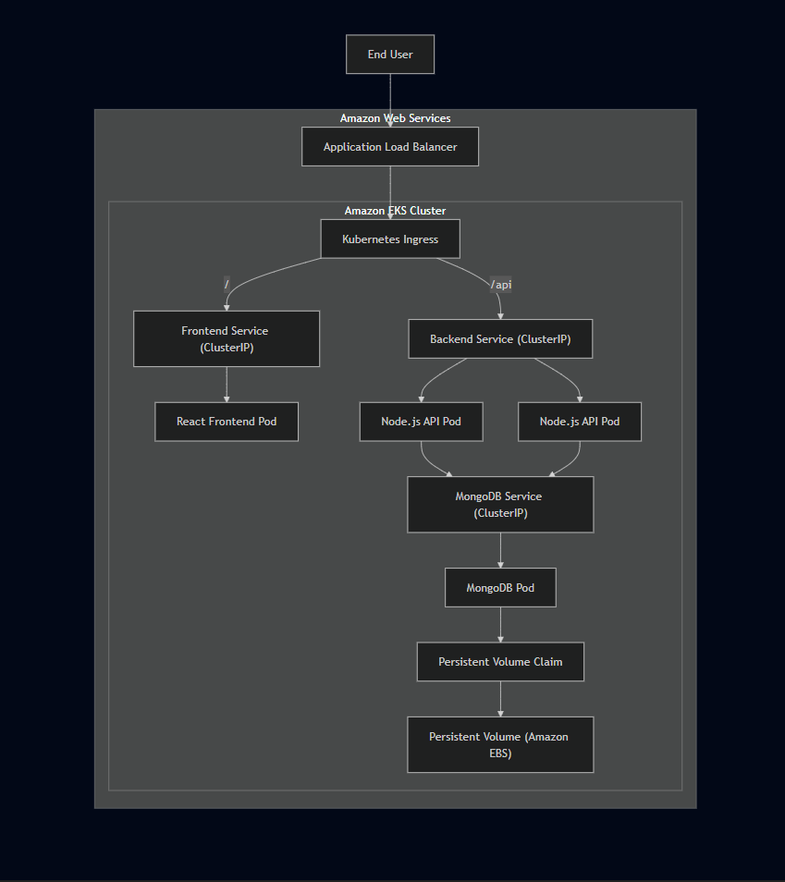
External access: Users reach the application through the ALB DNS endpoint. The ALB is the only public entry point — it forwards HTTP traffic into the cluster through the Ingress resource.

Component Interaction

1. Client Access
Traffic routing: I used path-based routing rather than host-based routing. Since the deployment didn't need a custom domain, routing directly on the ALB DNS name was simpler and sufficient.

2. Traffic Routing
Frontend: The React frontend uses relative API paths — /api/tasks — so requests resolve through the Ingress controller to the backend Service. No hardcoded backend URL in the compiled bundle.
Request Path | Destination
/ | Frontend Service
/api | Backend Service
Backend: Runs as a Kubernetes Deployment with two replicas. The backend Service distributes incoming traffic between them transparently.

3. Frontend Processing
Database: The backend connects to MongoDB through Kubernetes internal DNS at mongodb-svc:27017. MongoDB is never exposed outside the cluster.

4. Backend Processing
Persistent storage: MongoDB's storage is managed through PV/PVC backed by Amazon EBS. If the MongoDB Pod restarts or gets rescheduled, it reattaches to the same volume — the data is still there.

5. Database Communication
External request:
Managed Kubernetes: EKS handles the control plane — API server, etcd, scheduler — so the focus stays on workloads rather than infrastructure maintenance.
ClusterIP Services: All Services are internal-only. The ALB is the only externally reachable component. Internal traffic never leaves the Kubernetes network.

6. Persistent Storage
Path-based routing: One ALB endpoint serves both frontend and API traffic. No custom domain needed for functional validation.

Network Architecture
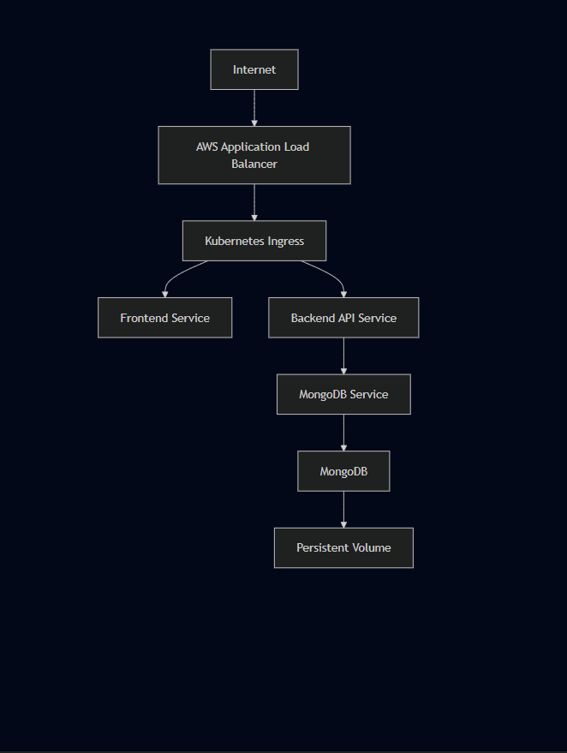

Traffic Flow

External Request Lifecycle
Browser
↓
Stateless vs. stateful: Frontend and backend Pods can be freely recreated without side effects. MongoDB requires persistent storage — the deployment treats them differently by design.
↓
Backend replicas: Two backend Pods means one failing doesn't take down the API. Rolling updates happen without downtime.
↓
Frontend Service
↓
React Frontend
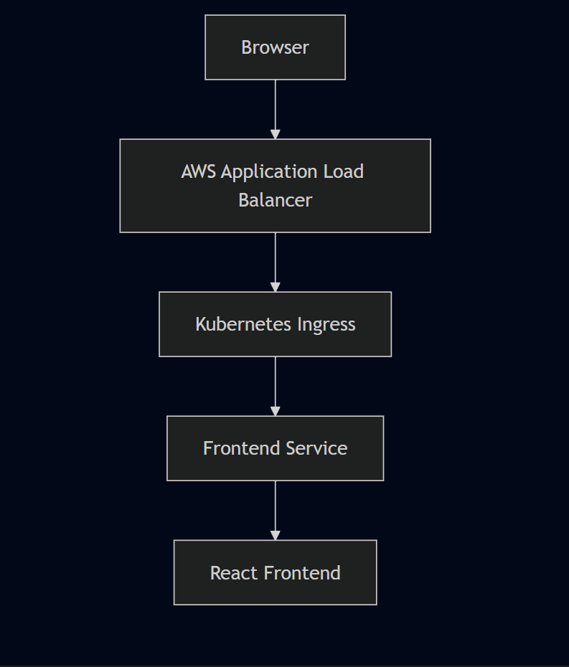

API Request Lifecycle
React Application
↓
/api
↓
Ingress
↓
Backend Service
↓
Node.js API
↓
MongoDB Service
↓
MongoDB
↓
Persistent Volume
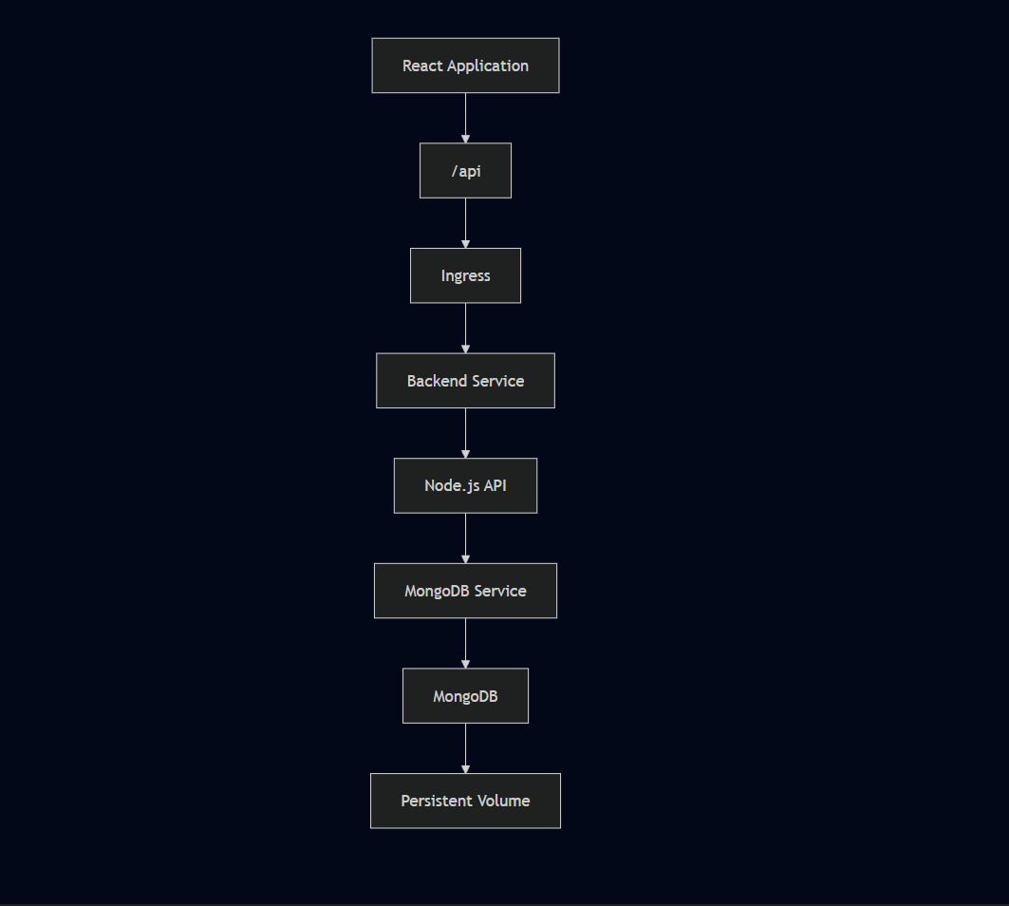

Kubernetes Resource Interaction
Resource | Responsibility
Namespace | Logical isolation of project resources
Deployment | Desired application state management
ReplicaSet | Maintains required Pod count
Pod | Executes application containers
Service | Stable internal networking
Ingress | External HTTP routing
Secret | Stores MongoDB credentials
Persistent Volume | Durable database storage
Persistent Volume Claim | Storage allocation abstraction

Design Decisions

Managed Kubernetes Platform
EKS provides a managed control plane while still requiring direct work with standard Kubernetes resources — Deployments, Services, Ingress, PV/PVC, Secrets. The managed aspect removes the need to operate the API server, scheduler, and etcd manually. Trade-off: EKS simplifies control plane management, but Kubernetes itself remains operationally complex. Application networking, IAM integration, storage, and debugging still require direct engineering work.

ClusterIP Services
All three Services use ClusterIP. Nothing is directly accessible from outside the cluster except through the ALB. Trade-off: ClusterIP Services require an additional routing layer for external traffic — provided here by ALB + Ingress. But keeping internal components private reduces the attack surface and eliminates unnecessary public endpoints.

Path-Based Routing
The initial Ingress used hostname-based routing, but the project didn't use a custom domain. Removing the hostname dependency simplified everything. Path-based routing handled the separation between frontend and API traffic without any external DNS dependency. Trade-off: A larger production system might use separate hostnames for stronger separation. For validating this deployment, path-based routing removed an unnecessary dependency without sacrificing functionality.

Stateless vs Stateful Workloads
Frontend and backend Pods are stateless — Kubernetes can replace them without any impact on application behavior. MongoDB is different. Without persistent storage, a Pod deletion means permanent data loss. Storage was decoupled from the Pod lifecycle through PV/PVC backed by Amazon EBS. The Pod is replaceable. The data is not.

Horizontal Availability
The backend runs two replicas. If one Pod fails, the Service continues routing traffic to the other while Kubernetes schedules a replacement. It also means rolling updates can happen without taking the backend offline.

Operational Validation
Getting kubectl apply to run without errors was never the finish line. The deployment was validated progressively — each layer checked independently before moving to the next. The principle throughout: a running Pod does not necessarily mean a working application.
Validation covered six distinct layers: infrastructure, Kubernetes resources, AWS integration, frontend accessibility, backend API communication, and database persistence. Each had to pass before the deployment was considered complete.
✓ Kubernetes Ingress correctly routing traffic based on request path
✓ Backend Services resolving through Kubernetes DNS
✓ MongoDB connectivity established from the application layer
✓ Persistent storage retaining application data across Pod lifecycle events
✓ Stable communication across all three application tiers

Chapter 4 — Infrastructure Design

Overview
This portfolio covers a hands-on deployment of a three-tier application on Amazon EKS — from cluster provisioning through containerization, Kubernetes configuration, networking, persistent storage, and the troubleshooting that came with getting it all working together.
The point wasn't just to deploy containers. It was to work through the complete engineering lifecycle: provision the infrastructure, build and push images, wire up Kubernetes resources, debug what breaks, and then clean everything up responsibly when done.

Infrastructure Components
Component | AWS Service | Responsibility
Identity | AWS IAM | Authentication and authorization
Compute (Management) | Amazon EC2 (t2.micro) | Cluster administration host
Container Platform | Amazon EKS | Managed Kubernetes control plane
Worker Nodes | EC2 Managed Node Group (t2.medium) | Execute Kubernetes workloads
Image Registry | Amazon ECR | Store Docker images
Load Balancing | AWS Application Load Balancer | Public HTTP entry point
Persistent Storage | Amazon EBS | Durable storage for MongoDB
Networking | Amazon VPC | Network isolation

Infrastructure Overview
Before this project, I had experience with individual technologies — AWS, Docker, Linux, Kubernetes concepts. What I hadn't experienced to the same extent was how quickly a deployment becomes dependent on the interaction between those layers. That's the main thing this project changed.

subgraph AWS["AWS Account"]

What follows is not a summary of what Kubernetes does. It's a reflection on what implementing it actually felt like — where the difficulty was, what changed in how I think about cloud systems, and what I'd do differently next time.

subgraph VPC["Amazon VPC (auto-provisioned by eksctl)"]

IGW["Internet Gateway"]

subgraph PUBLIC["Public Subnets"]

EC2["Management EC2 (t2.micro)"]

ALB["Application Load Balancer"]

end

subgraph PRIVATE["Worker Node Subnets"]

NODE1["EKS Worker Node (t2.medium)"]

NODE2["EKS Worker Node (t2.medium)"]

end

EBS["Amazon EBS"]

end

ECR["Amazon ECR"]

end

Developer --> IAM
Developer --> EC2

EC2 --> EKS
EC2 --> ECR

Internet --> IGW
IGW --> ALB

ALB --> NODE1
ALB --> NODE2

NODE1 --> EBS
NODE2 --> EBS

NODE1 --> ECR
NODE2 --> ECR
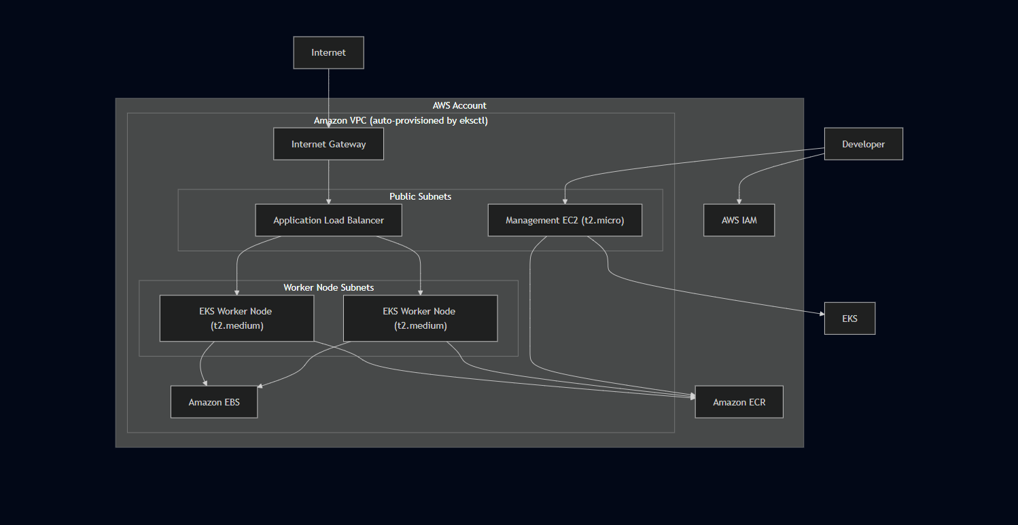

IAM Setup
Before provisioning anything else, I created a dedicated IAM user named eks-admin with AdministratorAccess attached. This gave the management environment the permissions needed to provision EKS, ECR, EC2, IAM roles, and the load balancer controller without hitting authorization errors at each step.
The AWS Load Balancer Controller specifically needed its own IAM Role associated with a Kubernetes Service Account — the IRSA pattern. Rather than giving the controller broad permissions, it gets only what it needs to manage load balancers. This distinction mattered during deployment: the IAM failure we hit (missing elasticloadbalancing:DescribeListenerAttributes) was a specific missing permission, not a broad misconfiguration.
IAM covered: Administrative access for cluster provisioning EKS cluster and node group permissions Worker node permissions for ECR image pulls AWS Load Balancer Controller permissions via IRSA OIDC provider association for service account binding
- Administrative access for cluster provisioning
- EKS cluster and node group permissions
- Worker node permissions for ECR image pulls
- AWS Load Balancer Controller permissions via IRSA
- OIDC provider association for service account binding

EC2 Management Instance
A dedicated Ubuntu EC2 instance (t2.micro) ran everything — cluster creation, image builds, kubectl operations, Helm installations, manifest deployments. It's purely an administration host; no application workloads run on it.
Using a dedicated EC2 instance rather than my local machine kept the environment consistent and avoided local tooling version issues or AWS credential configuration problems.
Tools installed: AWS CLI kubectl eksctl Docker Helm
- AWS CLI
- kubectl
- eksctl
- Docker
- Helm
The AWS Console ran alongside for visual verification: EKS cluster state, load balancer provisioning, target group health, security group configuration, IAM role attachments, ECR repositories, EBS volumes.

VPC and Networking
The VPC wasn't created manually. Running eksctl create cluster automatically provisioned the VPC, subnets, Internet Gateway, and route tables. That's one of the advantages of eksctl — the networking infrastructure comes up correctly without having to configure each component individually.
Cluster deployed in us-west-2.
Worker nodes sit off the public internet. The ALB is in the public subnets and forwards traffic to the nodes.
Subnet Type | Purpose
Public Subnets | Application Load Balancer
Private/Worker Subnets | Kubernetes Worker Nodes
This keeps worker nodes off the public internet. The ALB sits in the public subnets and forwards traffic to the worker nodes, which are only accessible through the load balancer.

Security Groups
Security Groups for the EKS control plane and worker nodes were provisioned automatically through eksctl cluster creation.
Management EC2: Inbound SSH (port 22) for remote administration Application Load Balancer: Inbound HTTP (port 80) for public application access Worker Nodes: Traffic from ALB and Kubernetes control plane only — no unrestricted public internet access
- Inbound: SSH (port 22)
- Purpose: administration access only
> Production improvement: SSH access to the management EC2 should be restricted to trusted source IP ranges, or replaced with AWS Systems Manager Session Manager to eliminate the need for open SSH ports.
- Inbound: HTTP (port 80)
- Purpose: public application traffic
Worker Nodes:
- Inbound: traffic from ALB and Kubernetes control plane
- No direct public internet exposure
Pods themselves are never directly reachable from outside the cluster. All external traffic goes through ALB → Ingress → Service → Pod.

EKS Cluster
This created the managed Kubernetes control plane, a managed node group with two t2.medium worker nodes, and the supporting VPC and networking infrastructure. eksctl handled control plane setup, node registration, and networking — leaving a working cluster ready for workloads.
eksctl create cluster \
--name three-tier-cluster \
--region us-west-2 \
--node-type t2.medium \
--nodes-min 2 \
--nodes-max 2

This created:
- The managed Kubernetes control plane (API server, scheduler, controller manager)
- A managed node group with 2 x t2.medium worker nodes
- The supporting VPC and networking infrastructure
Using eksctl meant I didn't have to manually configure the control plane, node registration, or networking — it handled all of that and left me with a working cluster to deploy into.

Worker Node Design
Configuration | Value
Node Count | 2
Instance Type | t2.medium
Management | EKS Managed Node Group
Operating System | Amazon Linux (Managed by EKS)
Region | us-west-2
Two worker nodes provide basic redundancy — if one node goes down, Kubernetes can reschedule Pods on the other. It also means the backend's two replicas can potentially land on separate nodes, which improves availability.

Amazon ECR
Two private ECR repositories stored the application images:
Repository | Purpose
Frontend Repository | React application image
Backend Repository | Node.js API image
Worker nodes pull images from ECR using IAM-based authentication — no manual credential configuration needed. Separate repositories mean frontend and backend images can be versioned and updated independently.
Separate repositories per service meant frontend and backend images could be versioned and updated independently.

Persistent Storage
MongoDB needs storage that survives Pod restarts:
- The PVC defines what storage the application needs. Kubernetes binds the PVC to an available Persistent Volume. The PV is backed by an EBS block storage device that exists independently of the Pod lifecycle.
- During deployment, the PVC remained in Pending state because the PV wasn't available when the claim was applied. Checking:
- Showed the claim waiting indefinitely. Applying storage resources in the correct order — PV before PVC — resolved it. Once bound, the MongoDB Pod scheduled successfully.
The EBS volume was created through this workflow rather than manually in the AWS Console. This keeps storage lifecycle tied to the Kubernetes configuration rather than requiring separate manual steps in AWS.

Infrastructure Lifecycle
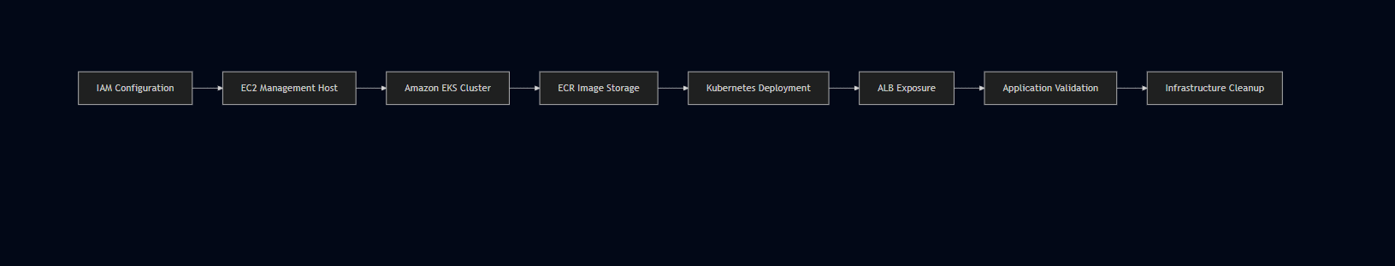

Design Rationale
Design Choice | Rationale
Managed Kubernetes (EKS) | Avoid control plane administration overhead
eksctl for provisioning | Automates VPC, subnet, and node group creation
Dedicated management EC2 | Consistent tooling environment, no local dependency
Amazon ECR | Native EKS integration, no external registry authentication needed
ALB Ingress | Single public endpoint with path-based routing
ClusterIP Services | Internal-only communication, no unnecessary exposure
Persistent Volumes | MongoDB data survives Pod recreation
Two Worker Nodes | Basic redundancy and scheduling flexibility
IAM least privilege | Controller-specific roles via IRSA pattern

Infrastructure Validation
The infrastructure was considered operational after verifying:
✓ Amazon EKS cluster provisioned and showing Active in us-west-2
✓ Worker nodes registered and in Ready state
✓ Docker images available in Amazon ECR repositories
✓ Kubernetes workloads scheduled successfully across nodes
✓ Application Load Balancer provisioned and reachable
✓ Internal service communication functioning via Kubernetes DNS
✓ MongoDB persistent storage bound and validated
✓ All AWS resources decommissioned after testing

Chapter 5 — Technology Stack

Overview
The application stack — React, Node.js, MongoDB — was already part of the challenge project. My focus wasn't on selecting these technologies but on understanding how to containerize them, wire them together through Kubernetes networking, and deploy the complete three-tier architecture on EKS.
The infrastructure and tooling choices around that stack — EKS, ECR, ALB, Helm, IAM — were driven by the AWS deployment context. Using managed AWS services was the natural path when everything was already running in AWS.

Technology Stack Overview
Layer | Technology
Cloud Platform | Amazon Web Services (AWS)
Compute | Amazon EC2
Container Orchestration | Amazon Elastic Kubernetes Service (EKS)
Container Runtime | Docker
Image Registry | Amazon Elastic Container Registry (ECR)
Application Load Balancing | AWS Application Load Balancer
Container Networking | Kubernetes Services & Ingress
Storage | Amazon EBS, Persistent Volumes (PV), Persistent Volume Claims (PVC)
Identity & Access | AWS IAM
Package Management | Helm
Application Framework | React.js
Backend Framework | Node.js
Database | MongoDB
Operating System | Ubuntu Linux
Version Control | Git & GitHub
Cluster Administration | kubectl, eksctl

Technology Evaluation Matrix
Technology | Purpose | Why Selected | Alternative
Amazon EKS | Managed Kubernetes | Native AWS integration, managed control plane | Self-managed Kubernetes, Amazon ECS
Docker | Containerization | Industry standard, reproducible environments | Podman
Amazon ECR | Image Registry | Native EKS integration, same AWS environment | Docker Hub, GitHub Container Registry
Amazon EC2 | Administration Host | Dedicated management environment | AWS CloudShell
AWS IAM | Identity & Access | Fine-grained permission management | Static credentials
Application Load Balancer | External Traffic Routing | Native Kubernetes Ingress support | NGINX Ingress, Network Load Balancer
Helm | Kubernetes Package Manager | Used for AWS Load Balancer Controller installation | Manual manifest installation
MongoDB | Database | Part of the project application stack | MySQL, PostgreSQL
React.js | Frontend | Part of the project application stack | Angular, Vue.js
Node.js | Backend | Part of the project application stack | Spring Boot, ASP.NET Core

Cloud Platform — AWS
Everything in this deployment runs on AWS. EKS, ECR, ALB, EBS, IAM all integrate natively, which simplified deployment significantly. ECR authenticates with EKS automatically through IAM. The Load Balancer Controller provisions ALBs directly from Kubernetes Ingress resources. EBS volumes bind to Persistent Volume Claims without manual provisioning. The value wasn't any single service — it was that they work together without custom integration work.
The Dockerfiles were already in the project repository. My work was building images from those Dockerfiles, pushing to ECR, and debugging issues along the way — including the Dockerfile naming error in the backend (Dockefile instead of Dockerfile), which blocked the entire build until caught.
I used eksctl for cluster creation rather than the AWS Console. The goal was to understand the CLI-based provisioning workflow — how cluster, node group, VPC, and networking all get created from a single command.
- One thing this deployment made clear: a running EKS cluster with healthy Pods isn't enough on its own. IAM permissions, the Load Balancer Controller, Ingress configuration, Service port mappings, and application-level configuration all have to be correct simultaneously for the application to actually work end to end. The cluster is just the foundation.
- ECR was the natural choice because the cluster was already in AWS. Worker nodes pull images using IAM-based authentication — no separate registry credentials needed.
- AWS Application Load Balancer: The single external entry point. The AWS Load Balancer Controller provisions and manages it directly from the Kubernetes Ingress resource.
- Kubernetes Services: All application Services use ClusterIP — internal only. Services provide stable DNS-based endpoints so Pods can communicate without depending on individual Pod IP addresses.
- Storage
- MongoDB needs storage that survives Pod restarts. The PVC defines the storage requirement, Kubernetes binds it to a Persistent Volume, and that volume is backed by Amazon EBS. If the MongoDB Pod restarts or gets rescheduled, it reattaches to the same volume.

Container Runtime — Docker
IAM underpins every AWS service interaction. The eks-admin user had AdministratorAccess for provisioning. The Load Balancer Controller used a dedicated IAM Role via IRSA, scoped only to load balancer management permissions.
The IAM failure during deployment — missing elasticloadbalancing:DescribeListenerAttributes — was a direct reminder that IAM policies have to be exact. The controller was running, the Ingress was applied, but nothing happened on the AWS side until the missing permission was attached.
Helm was used specifically for installing the AWS Load Balancer Controller inside the cluster. The application itself was deployed using standard Kubernetes manifests. A single Helm command handles the chart download, configuration, and deployment rather than manually applying multiple manifest files in order.
- React.js — Frontend: The frontend uses relative API paths (/api/tasks) rather than environment variables. This matters because React resolves environment variables at build time, not at runtime — the backend API URL gets compiled into the JavaScript bundle when npm run build runs. Changing a Kubernetes environment variable after the image is built has no effect on the already-compiled frontend.
- Node.js — Backend: The REST API listens on port 3500 and handles all communication between frontend and MongoDB. Two replicas run in parallel — the Kubernetes Service distributes traffic between them transparently.
- MongoDB — Database: Stores application task data as a stateful workload with persistent storage managed through PV/PVC. The backend reaches it through Kubernetes internal DNS at mongodb-svc:27017. Never exposed outside the cluster.
- The biggest surprise wasn't any individual technology — it was how many layers had to work correctly simultaneously for a simple application to show up in a browser.

Container Orchestration — Amazon EKS
A working EKS cluster wasn't enough. Healthy Pods weren't enough. The IAM permissions, Load Balancer Controller, Ingress configuration, Service port mappings, frontend API paths, and persistent storage configuration all had to be correct at the same time. When something was wrong, the symptom often appeared at a completely different layer from the actual cause — a frontend that couldn't reach the backend turned out to be a React build-time configuration issue, not a Kubernetes networking problem.
That's the practical value of this stack — not just how each tool works individually, but how they interact as a system.
I used eksctl for cluster creation rather than the AWS Console. The goal was to understand the CLI-based provisioning workflow — how cluster, node group, VPC, and networking all get created from a single command.
One thing this deployment made clear: a running EKS cluster with healthy Pods isn't enough on its own. IAM permissions, the Load Balancer Controller, Ingress configuration, Service port mappings, and application-level configuration all have to be correct simultaneously for the application to actually work end to end. The cluster is just the foundation.
- Pod scheduling
- Cluster management
- Control plane availability
- Workload orchestration

Container Registry — Amazon ECR
ECR was the natural choice because the cluster was already in AWS. Worker nodes pull images using IAM-based authentication — no separate registry credentials needed.
Two private repositories were created:
Repository | Purpose
Frontend Repository | React application image
Backend Repository | Node.js API image
Separate repositories per service allow independent versioning and updates without affecting the other tier.

Networking

AWS Application Load Balancer
The AWS Load Balancer Controller is required for Kubernetes Ingress to provision an AWS Application Load Balancer. Without it, the Ingress resource exists in Kubernetes but no ALB gets created.
During this phase, the controller failed to provision the ALB because the IAM role was missing elasticloadbalancing:DescribeListenerAttributes. The Ingress existed in Kubernetes with no external address. Attaching the missing permission and restarting the controller resolved it:
Request Path | Destination
/ | Frontend Service
/api | Backend Service
Responsibilities:
- HTTP request routing
- Path-based routing
- Kubernetes Ingress integration

Kubernetes Services
All three application Services use ClusterIP — internal-only. Nothing is directly reachable from outside except through the ALB. The backend Service port mapping (8080 → 3500) is worth noting. The Service accepts traffic on port 8080 and forwards it to the container's port 3500. That mismatch between external Service port and internal container port caused the frontend-to-backend communication failure during deployment. The Node.js application was listening on 3500, but the Service targetPort wasn't set correctly. Fixing that restored communication. Why ClusterIP? ClusterIP Services are only reachable from within the cluster. External access comes exclusively through Ingress and ALB — no application Pod is directly reachable from the internet.

Storage — Amazon EBS + Kubernetes PV/PVC
MongoDB needs storage that survives Pod restarts. The PVC defines the storage requirement, Kubernetes binds it to a Persistent Volume, and that volume is backed by Amazon EBS. If the MongoDB Pod restarts or gets rescheduled, it reattaches to the same volume.
The EBS volume was created automatically through this workflow rather than manually. If the MongoDB Pod restarts or gets rescheduled, it reattaches to the same volume and the data is still there.

Identity — AWS IAM
IAM underpins every AWS service interaction. The eks-admin user had AdministratorAccess for provisioning. The Load Balancer Controller used a dedicated IAM Role via IRSA, scoped only to load balancer management permissions.
The IAM failure during deployment — missing elasticloadbalancing:DescribeListenerAttributes — was a direct reminder that IAM policies have to be exact. The controller was running, the Ingress was applied, but nothing happened on the AWS side until the missing permission was attached.

Package Management — Helm
Helm was used specifically for installing the AWS Load Balancer Controller inside the cluster. The application itself was deployed using standard Kubernetes manifests. A single Helm command handles the chart download, configuration, and deployment rather than manually applying multiple manifest files in order.
Helm made the controller installation straightforward — a single command handles the chart download, configuration, and deployment rather than manually applying multiple manifest files in the correct order.

Application Stack

React.js — Frontend
React serves as the presentation layer. One non-obvious behavior that surfaced during deployment: React resolves environment variables at build time, not at runtime. The backend API URL gets compiled into the JavaScript bundle when npm run build runs. Changing a Kubernetes environment variable after the image is built has no effect on the already-compiled frontend.
The fix was to use a relative API path /api/tasks instead of an environment variable, letting Ingress handle the routing rather than hardcoding a backend URL.

Node.js — Backend
Node.js powers the REST API. The backend listens on port 3500 and handles all communication between the frontend and MongoDB. Two replicas run in parallel — the Kubernetes Service distributes traffic between them transparently.

MongoDB — Database
MongoDB stores the application's task data. It runs as a stateful workload with persistent storage managed through PV/PVC. The backend reaches it through Kubernetes internal DNS at mongodb-svc:27017 — never exposed outside the cluster.

Development & Administration Tools
Tool | Purpose
kubectl | Kubernetes cluster administration
eksctl | Amazon EKS cluster provisioning
Git | Version control
GitHub | Source code management
Linux | Administration environment

Engineering Trade-offs
Decision | Benefit | Consideration
Amazon EKS | Managed control plane | Higher cost than self-managed clusters
ALB Ingress | Native AWS integration | AWS-specific implementation
Docker | Industry standard | Requires image management
MongoDB | Part of project stack | Less suitable for highly relational workloads
Helm | Simplified controller installation | Additional learning curve

What This Stack Actually Taught Me
The biggest surprise wasn't any individual technology — it was how many layers had to work correctly simultaneously for a simple application to show up in a browser.
A working EKS cluster wasn't enough. Healthy Pods weren't enough. The IAM permissions, Load Balancer Controller, Ingress configuration, Service port mappings, frontend API paths, and persistent storage configuration all had to be correct at the same time. When something was wrong, the symptom often appeared at a completely different layer from the actual cause — a frontend that couldn't reach the backend turned out to be a React build-time configuration issue, not a Kubernetes networking problem.
That's the practical value of this stack — not just how each tool works individually, but how they interact as a system.

Chapter 6 — Containerization

Overview
Containerization was the first major step before anything could run on Kubernetes. Each application tier — React frontend, Node.js backend, and MongoDB — needed to be packaged as a Docker image before EKS could schedule it as a workload. All builds ran on the Ubuntu EC2 management instance.
The Dockerfiles were already in the project repository. My work was working through the build process, fixing the issues that came up, pushing images to ECR, and then referencing those images in the Kubernetes Deployment manifests.

Container Architecture
Each tier runs in its own container, managed independently by Kubernetes. The backend can be updated or scaled without touching the frontend. MongoDB runs as a stateful workload while the application layers stay stateless.

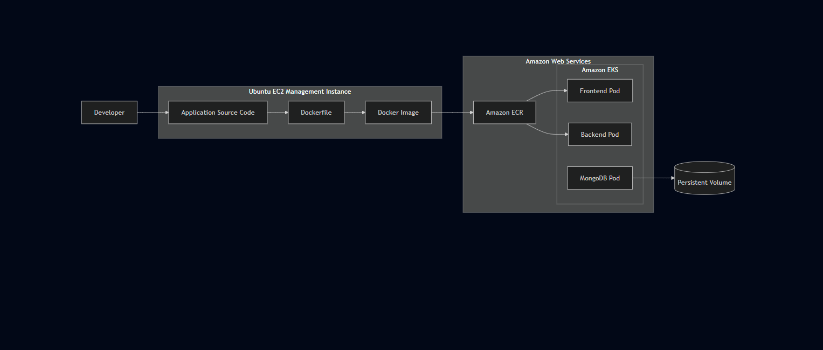

Why Containerization?
All image builds happened on the Ubuntu EC2 management instance. Docker was installed and configured before starting the build process.
That last step matters in practice — without it, every Docker command requires sudo, which adds friction and can cause permission issues when commands are chained together.
Challenge | How Docker Addresses It
Environment inconsistency | Standardized runtime image with bundled dependencies
Dependency conflicts | Each service runs in its own isolated container
Deployment repeatability | Immutable images produce identical runtime behavior
Infrastructure portability | Images run on any Docker-compatible host
Scaling | New containers start from the same image instantly

Containerized Application Components
Component | Runtime | Container Purpose
Frontend | React.js | Serves the user interface
Backend | Node.js | Handles REST API requests and business logic
Database | MongoDB | Persistent data storage — stateful workload
Phase 1 — Source Preparation: The project source code was cloned onto the EC2 management instance. Each application tier was in its own directory, with its own Dockerfile alongside the application source and dependency definitions.

Docker Image Lifecycle
Phase 2 — Image Build: Docker builds ran from inside each service directory. The backend Dockerfile typo (Dockefile instead of Dockerfile) was caught here — Docker couldn't locate the build definition and exited. Finding the misnamed file and correcting it unblocked the build.
Phase 3 — ECR Authentication:
A successful authentication returns:

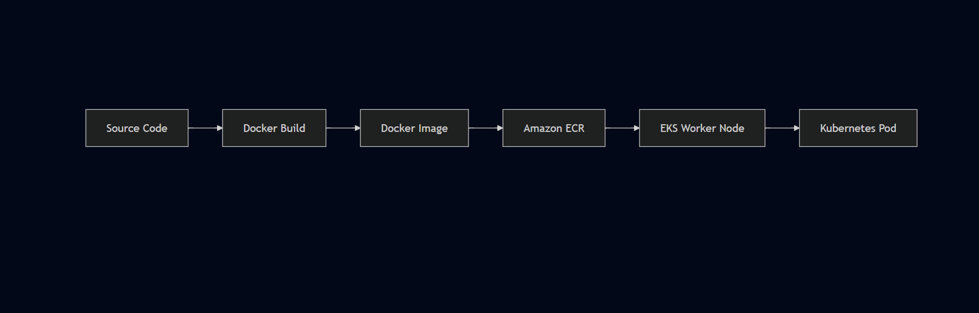

Build Environment Setup
ECR authentication is entirely IAM-based — no separate registry password needed.
Phase 4 — Image Tagging:
bash
Phase 5 — Image Push to ECR:
Separate pushes for frontend and backend. Images were verified in ECR before referencing them in Kubernetes Deployment manifests.
Phase 6 — Kubernetes Deployment: With images in ECR, Deployment manifests reference the full ECR URI:
bash
docker ps
Worker nodes pull images directly from ECR using IAM-based authentication — no manual credential configuration needed on the nodes.
bash
The React frontend uses relative API paths (/api/tasks) rather than a hardcoded backend URL. The original configuration used a build-time environment variable (REACT_APP_BACKEND_URL), which was already compiled into the bundle by the time the container ran. Switching to a relative path let Ingress handle routing instead.
The Node.js backend handles all REST API requests, processes business logic, and communicates with MongoDB.

Container Build Workflow

Phase 1 — Source Preparation
The backend port (3500) had to be correctly reflected in the Kubernetes Service targetPort. When there was a mismatch, frontend API requests failed even though backend Pods were healthy. Correcting targetPort to 3500 restored communication.
MongoDB runs as a containerized database but is treated differently from the stateless frontend and backend. It requires persistent storage that survives container replacement. The container itself is stateless — the data it writes is persisted externally via EBS and reattached when the container restarts.
- MongoDB uses the official public Docker image. No custom build is required.
- Two separate private ECR repositories — one for frontend, one for backend. Keeping them separate enables: Independent image versioning per service Targeted deployments — updating the backend doesn't require rebuilding the frontend image Simplified rollback — each service can be rolled back to a previous image independently
- Container images are treated as immutable artifacts. Running containers are never modified directly. To update: Source code is updated in the repository A new Docker image is built The new image is pushed to ECR The Kubernetes Deployment is updated to reference the new image Kubernetes performs a rolling update
- This ensures what runs in the cluster is always a known, versioned artifact.

Phase 2 — Image Build
Dockerfile naming is exact. Docker looks for a file named exactly Dockerfile. The backend project had Dockefile — one character off — which caused the build to fail immediately. An ls -la in the directory before building would have caught this.
Container ports must match Service configuration. The port a container exposes in its Dockerfile must match the targetPort in the Kubernetes Service. The backend listened on 3500, and the Service had to reflect that exactly. Mismatches cause silent failures where Pods appear healthy but traffic never reaches them.
Images must be in ECR before applying Deployment manifests. Kubernetes will attempt to pull the image as soon as a Deployment is applied. If the image isn't in ECR yet, the Pod enters ImagePullBackOff. The correct sequence is always build → push → deploy.
- Build-time vs. runtime configuration. React environment variables are resolved at build time. Configuration that needs to work across environments should use relative paths or be handled at the routing layer.
- Source code was cloned onto the EC2 management instance and Docker builds ran from there. The backend build failed because the Dockerfile was named Dockefile — one character off. Renaming it unblocked the build. MongoDB used the official public image — no custom build needed.
- The full build, tag, and push command sequence is in Chapter 9.

Phase 3 — ECR Authentication
Before pushing images to Amazon ECR, Docker needs to authenticate with the registry. This is handled through the AWS CLI:
bash
aws ecr get-login-password --region us-west-2 | docker login \
--username AWS \
--password-stdin \
<AWS_ACCOUNT_ID>.dkr.ecr.us-west-2.amazonaws.com
A successful authentication returns:
Login Succeeded
This step uses the IAM credentials configured on the EC2 instance — no separate registry password is needed. ECR authentication is entirely IAM-based, which is one of the reasons ECR integrates cleanly with EKS.

Phase 4 — Image Tagging
Source code was cloned onto the EC2 management instance and Docker builds ran from there. The backend build failed because the Dockerfile was named Dockefile — one character off. Renaming it unblocked the build. MongoDB used the official public image — no custom build needed.
bash
docker tag <local-image-name>:latest \
The full build, tag, and push command sequence is in Chapter 9.
This tag tells Docker exactly where to push the image — which AWS account, which region, and which repository.

Phase 5 — Image Push to ECR
Source code was cloned onto the EC2 management instance and Docker builds ran from there. The backend build failed because the Dockerfile was named Dockefile — one character off. Renaming it unblocked the build. MongoDB used the official public image — no custom build needed.
bash
docker push \
The full build, tag, and push command sequence is in Chapter 9.
Separate pushes were performed for the frontend and backend images. After pushing, the images were verified in ECR to confirm they were available before referencing them in Kubernetes Deployment manifests.

Phase 6 — Kubernetes Deployment
Resources deployed: The PVC remained in Pending state when storage resources weren't available at binding time. Understanding the dependency — PV must exist before PVC can bind, PVC must bind before MongoDB Pod can schedule — was one of the key debugging insights.
yaml
image: <AWS_ACCOUNT_ID>.dkr.ecr.us-west-2.amazonaws.com/frontend:latest
yaml
image: <AWS_ACCOUNT_ID>.dkr.ecr.us-west-2.amazonaws.com/backend:latest
Post-deployment verification: Expected Pod state:

Dockerfile Design
Each application component has a dedicated Dockerfile. The general structure covers:
- Selecting an appropriate base image for the runtime
- Setting the working directory inside the container
- Installing application dependencies
- Copying application source code
- Exposing the port the application listens on
- Defining the startup command
This structure ensures the container is self-contained — everything needed to run the application is baked into the image at build time.

Frontend Container
The React frontend uses relative API paths (/api/tasks) rather than a hardcoded backend URL. The original configuration used a build-time environment variable (REACT_APP_BACKEND_URL), which was already compiled into the bundle by the time the container ran. Switching to a relative path let Ingress handle routing instead.
Rather than using a hardcoded backend URL, the frontend was configured to use relative API paths (/api/tasks), allowing Ingress to handle routing. This was a change made during the deployment — the original configuration used a build-time environment variable (REACT_APP_BACKEND_URL) which was already compiled into the bundle by the time the container ran.

Runtime Characteristics
Property | Value
Framework | React.js
Deployment | Kubernetes Deployment
Replicas | 1
Image Source | Amazon ECR
Note: The exact frontend container port depends on the Dockerfile configuration — either port 3000 (Node dev server) or port 80 (Nginx serving the production build). Verify with cat frontend/Dockerfile from the project repository.
Frontend responsibilities:
- Serve the React application
- Handle client-side routing
- Forward API requests through Kubernetes Ingress path /api

Backend Container
The Node.js backend handles all REST API requests, processes business logic, and communicates with MongoDB. The backend port (3500) had to be correctly reflected in the Kubernetes Service targetPort. When there was a mismatch, frontend API requests failed even though backend Pods were healthy. Correcting targetPort to 3500 restored communication.

Runtime Characteristics
Property | Value
Framework | Node.js
Container Port | 3500
Deployment | Kubernetes Deployment
Replicas | 2
Image Source | Amazon ECR
The backend port (3500) had to be correctly reflected in the Kubernetes Service targetPort. When there was a mismatch between the Service configuration and the actual port the application was listening on, frontend API requests failed even though the backend Pods were healthy. Correcting the targetPort to 3500 resolved the communication failure.
Backend responsibilities:
- Handle REST API requests
- Execute application business logic
- Communicate with MongoDB via Kubernetes internal DNS
- Return JSON responses to the frontend

Database Container
MongoDB runs as a containerized database but is treated differently from the stateless frontend and backend. It requires persistent storage that survives container replacement. The container itself is stateless — the data it writes is persisted externally via EBS and reattached when the container restarts.
MongoDB uses the official public Docker image. No custom build is required.
Database responsibilities:
- Store application task data
- Handle CRUD operations
- Persist data independently of container lifecycle

Image Repository Strategy
Two separate private ECR repositories — one for frontend, one for backend. Keeping them separate enables: Independent image versioning per service Targeted deployments — updating the backend doesn't require rebuilding the frontend image Simplified rollback — each service can be rolled back to a previous image independently
Repository | Purpose
Frontend Repository | React application image
Backend Repository | Node.js API image
MongoDB uses the official public Docker image pulled directly during deployment rather than a custom-built image stored in ECR.
Keeping frontend and backend in separate repositories enables:
- Independent image versioning per service
- Targeted deployments — updating the backend doesn't require rebuilding the frontend image
- Simplified rollback — each service can be rolled back to a previous image independently
- Cleaner separation of concerns at the image management level

Image Pull Flow
Once images are in ECR, the pull flow during Kubernetes Pod scheduling is:
Amazon ECR
↓
EKS Worker Node (IAM-authenticated pull)
↓
Container Runtime
↓
Pod Creation
↓
Application Ready
Worker nodes authenticate to ECR automatically using the IAM role attached to the node group — no manual credential management required.

Immutable Image Model
Container images are treated as immutable artifacts. Running containers are never modified directly. To update: Source code is updated in the repository A new Docker image is built The new image is pushed to ECR The Kubernetes Deployment is updated to reference the new image Kubernetes performs a rolling update
- This ensures what runs in the cluster is always a known, versioned artifact.
- A new Docker image is built
- The new image is pushed to ECR
- The Kubernetes Deployment is updated to reference the new image
- Kubernetes performs a rolling update — replacing old Pods with new ones progressively
This model ensures that what runs in the cluster is always a known, versioned artifact rather than a container that has been modified in place.

Operational Observations
A few practical things that came up during the containerization phase:
Dockerfile naming is exact — Docker looks for a file named exactly Dockerfile. The backend project had a file named Dockefile which caused the build to fail immediately. Renaming it unblocked the build. A simple ls -la in the directory before building would have caught this.
Container ports must match Service configuration — the port a container exposes in its Dockerfile must match the targetPort in the Kubernetes Service definition. The backend listened on 3500, and the Service had to reflect that exactly. Mismatches cause silent failures where Pods appear healthy but traffic doesn't reach them.
Images must be in ECR before applying Deployment manifests — Kubernetes will attempt to pull the image as soon as a Deployment is applied. If the image isn't in ECR yet, the Pod enters ImagePullBackOff state. The correct sequence is always build → push → deploy.
Build-time vs runtime configuration — React environment variables are resolved at build time, not runtime. Configuration that needs to change between environments should use relative paths or be handled at the routing layer rather than embedded in the image.

Benefits of Docker in This Architecture
Capability | Engineering Benefit
Portability | Identical execution across environments
Isolation | Independent runtime for each service
Version Control | Tagged, immutable deployment artifacts
Scalability | New containers start from the same image instantly
Reliability | Repeatable builds and deployments
Integration | Native compatibility with Kubernetes and ECR

Chapter 7 — Kubernetes Design

Overview
The Kubernetes manifests were part of the reference project. My work was deploying them into Amazon EKS, understanding how the resources relate to each other, configuring the environment correctly, and troubleshooting what didn't work.
This chapter documents the Kubernetes resource architecture as deployed, how the resources connect, and what it actually took to get them working together on AWS EKS.

Kubernetes Resource Architecture
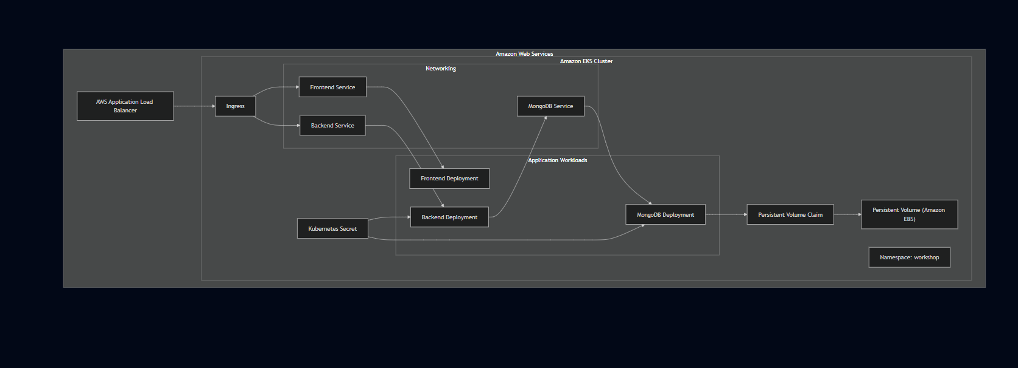

Namespace
The first step before deploying any application resources was creating a dedicated namespace:
bash
kubectl create namespace workshop
All application resources were deployed here — Deployments, Services, Secrets, Persistent Volume Claims, and the Ingress. Keeping everything in a single namespace makes administration straightforward: you can see all application resources in one place and avoid accidental interaction with system-level Kubernetes resources in other namespaces.
Resources deployed in the workshop namespace: Frontend Deployment Backend Deployment MongoDB Deployment ClusterIP Services (frontend, backend, MongoDB) Kubernetes Secret (MongoDB credentials) Persistent Volume Claim Ingress Resource
- This applied all manifest files in the current directory simultaneously. apply is declarative — if a resource already exists, Kubernetes updates it to match the manifest. If it doesn't exist, Kubernetes creates it. That made iterative debugging straightforward: fix the manifest, run kubectl apply -f . again, and Kubernetes updates only what changed.
- The two backend replicas demonstrated how Kubernetes handles multiple instances of the same workload — the backend Service distributes traffic between Pods transparently, and if one Pod fails, traffic continues flowing to the other while Kubernetes schedules a replacement.
- Behind each Deployment, Kubernetes manages a ReplicaSet that maintains the required number of running Pods. If a Pod terminates unexpectedly — container crash, node failure, OOM kill — the ReplicaSet detects the gap between desired and actual state and schedules a replacement automatically. This happened during deployment validation without manual intervention. That's one of the more immediately practical aspects of Kubernetes.
- All three application Services use ClusterIP — internal-only. Nothing is directly reachable from outside except through the ALB.
- The backend Service port mapping (8080 → 3500) is worth noting. The Service accepts traffic on port 8080 and forwards it to the container's port 3500. That mismatch between external Service port and internal container port caused the frontend-to-backend communication failure during deployment. The Node.js application was listening on 3500, but the Service targetPort wasn't set correctly. Fixing that restored communication.
- Why ClusterIP? ClusterIP Services are only reachable from within the cluster. External access comes exclusively through Ingress and ALB — no application Pod is directly reachable from the internet.
- Workloads communicate through Kubernetes DNS rather than Pod IP addresses. The backend reaches MongoDB using:

Applying Resources
This DNS name resolves to the MongoDB Service's ClusterIP. If the MongoDB Pod is replaced and gets a new IP, the DNS name stays the same — the backend configuration doesn't need to change.
bash
kubectl apply -f .
External HTTP traffic enters through a Kubernetes Ingress resource managed by the AWS Load Balancer Controller. The Ingress defines the routing rules:
A single ALB serves both routes. One DNS endpoint for the entire application, with path-based routing handling the separation between frontend and API traffic.

Deployment Strategy
The Ingress only works if the AWS Load Balancer Controller is correctly installed and authorized. During this deployment, the controller's IAM role was missing elasticloadbalancing:DescribeListenerAttributes, which prevented the ALB from provisioning. The Ingress resource existed in Kubernetes but had no external address until the IAM policy was corrected and the controller restarted.
Deployment | Replicas | Purpose
Frontend | 1 | React user interface
Backend | 2 | Node.js REST API
MongoDB | 1 | Persistent database
MongoDB credentials are stored in a Kubernetes Secret rather than hardcoded into application manifests or container images. The backend Deployment references the Secret through environment variables.

ReplicaSets
Keeping credentials in Secrets separates sensitive values from application configuration and makes credential rotation possible without rebuilding images.
> Note: Kubernetes Secrets are base64-encoded by default, not encrypted at rest unless cluster-level encryption is configured. For production, envelope encryption or an external secrets manager would add another layer of protection.
MongoDB needs storage that survives Pod restarts:
- The PVC defines what storage the application needs. Kubernetes binds the PVC to an available Persistent Volume. The PV is backed by an EBS block storage device that exists independently of the Pod lifecycle.
- During deployment, the PVC remained in Pending state because the PV wasn't available when the claim was applied. Checking:
- Showed the claim waiting indefinitely. Applying storage resources in the correct order — PV before PVC — resolved it. Once bound, the MongoDB Pod scheduled successfully.

Pod Design
Scaling stateless workloads is straightforward: increase the replica count in the Deployment and Kubernetes schedules additional Pods. MongoDB scaling is more complex — adding replicas without proper MongoDB replication configuration would create multiple independent database instances rather than a coordinated cluster.
Pod fails — container crash, OOM kill, or node issue ReplicaSet detects actual replica count is below desired Kubernetes Scheduler selects an available node New Pod is created and starts pulling its image Service continues routing to healthy Pods during recovery Once the new Pod passes health checks, it joins the Service load balancing pool
This behavior was observable during deployment validation — terminating a Pod resulted in Kubernetes scheduling a replacement automatically.
The general pattern that worked throughout:
The describe command was particularly useful because the Events section shows what Kubernetes actually attempted — image pulls, scheduling decisions, probe failures, volume binding attempts. Most root causes were visible there before needing to check logs. The full command reference is in Chapter 9.
Running Pods don't guarantee a working application. During this deployment: healthy Pods but frontend couldn't reach backend (Service port mismatch); healthy controller but ALB not provisioning (IAM permission missing); correct manifests but PVC stuck pending (resource ordering); running backend but API requests going nowhere (React build-time configuration).
Each failure looked healthy at the layer above the actual problem. The deployment required iterating through each layer independently — not as one system, but as a stack of discrete concerns.
- A unique cluster-internal IP address
- An isolated container runtime environment
- Health monitoring by Kubernetes
- Access to shared Kubernetes networking
Pod IP addresses are ephemeral — they change when a Pod is replaced. This is why Services exist: they provide stable endpoints that don't change regardless of what happens to individual Pods.

Kubernetes Services
All three application Services use ClusterIP — internal-only. Nothing is directly reachable from outside except through the ALB. The backend Service port mapping (8080 → 3500) is worth noting. The Service accepts traffic on port 8080 and forwards it to the container's port 3500. That mismatch between external Service port and internal container port caused the frontend-to-backend communication failure during deployment. The Node.js application was listening on 3500, but the Service targetPort wasn't set correctly. Fixing that restored communication.
Service | Port | Purpose
frontend | 3000 | React frontend
api | 8080 → 3500 | Backend API
mongodb-svc | 27017 | MongoDB database
Why ClusterIP? ClusterIP Services are only reachable from within the cluster. External access comes exclusively through Ingress and ALB — no application Pod is directly reachable from the internet.

Why ClusterIP?
ClusterIP Services are only reachable from within the cluster. External access comes exclusively through the Ingress and ALB. This keeps the attack surface minimal — there's no way to reach application Pods directly from the internet.
Advantages:
- Internal-only communication by default
- Stable virtual IP that survives Pod replacement
- Automatic traffic distribution across healthy Pods
- Service discovery via Kubernetes DNS

Service Discovery
Workloads communicate through Kubernetes DNS rather than Pod IP addresses. The backend reaches MongoDB using:
This DNS name resolves to the MongoDB Service's ClusterIP. If the MongoDB Pod is replaced and gets a new IP, the DNS name stays the same — the backend configuration doesn't need to change.
This DNS name resolves to the MongoDB Service's ClusterIP. If the MongoDB Pod is replaced and gets a new IP, the DNS name stays the same — the backend configuration doesn't need to change.
This is one of the cleaner aspects of Kubernetes networking — internal services communicate through stable names rather than fragile IP addresses.

Ingress Design
External HTTP traffic enters through a Kubernetes Ingress resource managed by the AWS Load Balancer Controller. The Ingress defines the routing rules: A single ALB serves both routes. One DNS endpoint for the entire application, with path-based routing handling the separation between frontend and API traffic.
Request Path | Destination
/ | Frontend Service
/api | Backend Service
The Ingress only works if the AWS Load Balancer Controller is correctly installed and authorized. During this deployment, the controller's IAM role was missing elasticloadbalancing:DescribeListenerAttributes, which prevented the ALB from provisioning. The Ingress resource existed in Kubernetes but had no external address until the IAM policy was corrected and the controller restarted.

Request Flow
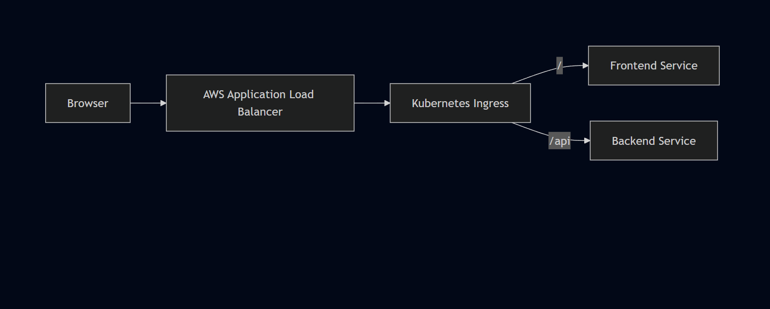
The Ingress only works if the AWS Load Balancer Controller is correctly installed and authorized. During this deployment, the controller's IAM role was missing the elasticloadbalancing:DescribeListenerAttributes permission, which prevented the ALB from provisioning. The Ingress resource existed in Kubernetes but had no external address until the IAM policy was corrected and the controller restarted.

Secret Management
MongoDB credentials are stored in a Kubernetes Secret rather than hardcoded into application manifests or container images. The backend Deployment references the Secret through environment variables.
Keeping credentials in Secrets separates sensitive values from application configuration and makes credential rotation possible without rebuilding images.
│
> Note: Kubernetes Secrets are base64-encoded by default, not encrypted at rest unless cluster-level encryption is configured. For production, envelope encryption or an external secrets manager would add another layer of protection.
│
└── MongoDB Deployment (authentication)
Keeping credentials in Secrets rather than ConfigMaps or manifest files is a baseline security practice — it separates sensitive values from application configuration and makes credential rotation possible without rebuilding images.
Note: Kubernetes Secrets are base64-encoded by default, not encrypted at rest unless additional cluster-level encryption is configured. For a production environment, envelope encryption or an external secrets manager would add another layer of protection.

Persistent Storage
MongoDB needs storage that survives Pod restarts:
The PVC defines what storage the application needs. Kubernetes binds the PVC to an available Persistent Volume. The PV is backed by an EBS block storage device that exists independently of the Pod lifecycle.
↓
During deployment, the PVC remained in Pending state because the PV wasn't available when the claim was applied. Checking:
↓
Showed the claim waiting indefinitely. Applying storage resources in the correct order — PV before PVC — resolved it. Once bound, the MongoDB Pod scheduled successfully.
↓
Amazon EBS
The PVC defines what storage the application needs. Kubernetes binds the PVC to an available Persistent Volume. The PV is backed by an Amazon EBS block storage device that exists independently of the Pod lifecycle.
During deployment, the PVC remained in Pending state because the PV wasn't available when the claim was applied. Checking PVC status:
bash
kubectl get pvc
Showed the claim waiting indefinitely for binding. Applying the storage resources in the correct order — PV before PVC — resolved it. Once bound, the MongoDB Pod scheduled successfully and the database initialized.
Storage benefits:
- Data survives Pod recreation and rescheduling
- Storage lifecycle decoupled from container lifecycle
- EBS volume persists even if the Pod is deleted
- Simplified recovery — new Pod attaches to same volume

Health Management
Kubernetes monitors workload health through probes configured in Deployment manifests. The reference project included health probe configuration for the backend Deployment.
Health probes serve two purposes:
Liveness probes detect when a container has entered a failed state and needs to be restarted. Kubernetes restarts the container automatically when a liveness probe fails repeatedly.
Readiness probes determine when a container is ready to receive traffic. Pods that fail readiness checks are temporarily removed from Service load balancing — they don't receive requests until they pass the probe again. This is particularly useful during startup and rolling updates.
Note: The exact probe endpoint configuration (/ok or otherwise) should be verified against the actual Deployment YAML in the repository before documenting as a confirmed implementation detail.

Scaling
Scaling stateless workloads is straightforward: increase the replica count in the Deployment and Kubernetes schedules additional Pods. MongoDB scaling is more complex — adding replicas without proper MongoDB replication configuration would create multiple independent database instances rather than a coordinated cluster.
Component | Replicas | Scaling Characteristics
Frontend | 1 | Horizontally scalable — stateless
Backend | 2 | Horizontally scalable — stateless
MongoDB | 1 | Stateful — requires storage coordination
Scaling stateless workloads like the frontend and backend is straightforward — increase the replica count in the Deployment and Kubernetes schedules additional Pods. No application code changes required.
MongoDB scaling is more complex because it's stateful. Adding replicas without proper MongoDB replication configuration would result in multiple independent database instances rather than a coordinated cluster. For this deployment, a single MongoDB instance with persistent storage was sufficient.
Future scaling mechanisms worth adding:
- Horizontal Pod Autoscaler (HPA) — automatically adjusts replica count based on CPU/memory metrics
- Cluster Autoscaler — adds worker nodes when the cluster runs out of scheduling capacity

Self-Healing
Pod fails — container crash, OOM kill, or node issue ReplicaSet detects actual replica count is below desired Kubernetes Scheduler selects an available node New Pod is created and starts pulling its image Service continues routing to healthy Pods during recovery Once the new Pod passes health checks, it joins the Service load balancing pool
- This behavior was observable during deployment validation — terminating a Pod resulted in Kubernetes scheduling a replacement automatically.
- ReplicaSet detects the actual replica count is below desired
- Kubernetes Scheduler selects an available node
- New Pod is created and starts pulling its image
- Service continues routing traffic to healthy Pods during recovery
- Once the new Pod passes health checks, it joins the Service load balancing pool
This behavior was observable during deployment validation — deliberately or accidentally terminating a Pod resulted in Kubernetes scheduling a replacement automatically.

Rolling Updates
Kubernetes Deployments support rolling updates — replacing Pods incrementally rather than taking all instances offline simultaneously. The Deployment strategy controls how many Pods can be unavailable during an update and how many extra Pods can be created.
For this deployment, rolling updates were available through the Deployment configuration but were not explicitly validated as a separate activity. The capability exists in the deployment architecture — exercising it would require pushing an updated image and observing the rollout behavior.

Debugging Workflow
The general pattern that worked throughout:
The describe command was particularly useful because the Events section shows what Kubernetes actually attempted — image pulls, scheduling decisions, probe failures, volume binding attempts. Most root causes were visible there before needing to check logs. The full command reference is in Chapter 9.
bash
# Check worker nodes joined the cluster
kubectl get nodes

# Check Pod status across the namespace
kubectl get pods -n workshop

# Check Service configuration
kubectl get svc -n workshop

# Check PVC binding status
kubectl get pvc -n workshop

# Get detailed resource information and events
kubectl describe pod <pod-name> -n workshop
kubectl describe svc <service-name> -n workshop
kubectl describe pvc <pvc-name> -n workshop

# Apply updated manifests
kubectl apply -f .

# Check container logs
kubectl logs <pod-name> -n workshop

# Clean up all resources
kubectl delete -f .
The general debugging pattern:
Something isn't working
↓
kubectl get pods — identify unhealthy resource
↓
kubectl describe <resource> — read Events section
↓
Identify root cause — config, scheduling, networking, IAM
↓
Fix the manifest or configuration
↓
kubectl apply -f .
↓
Verify again
The describe command was particularly useful because the Events section shows what Kubernetes actually attempted — image pulls, scheduling decisions, probe failures, volume binding attempts. Most root causes were visible there before needing to check logs.

Kubernetes Resource Summary
Resource | Quantity
Namespace | 1
Deployments | 3
ReplicaSets | 3
Pods | 4
Services | 3
Ingress | 1
Secrets | 1
Persistent Volumes | 1
Persistent Volume Claims | 1

Operational Workflow
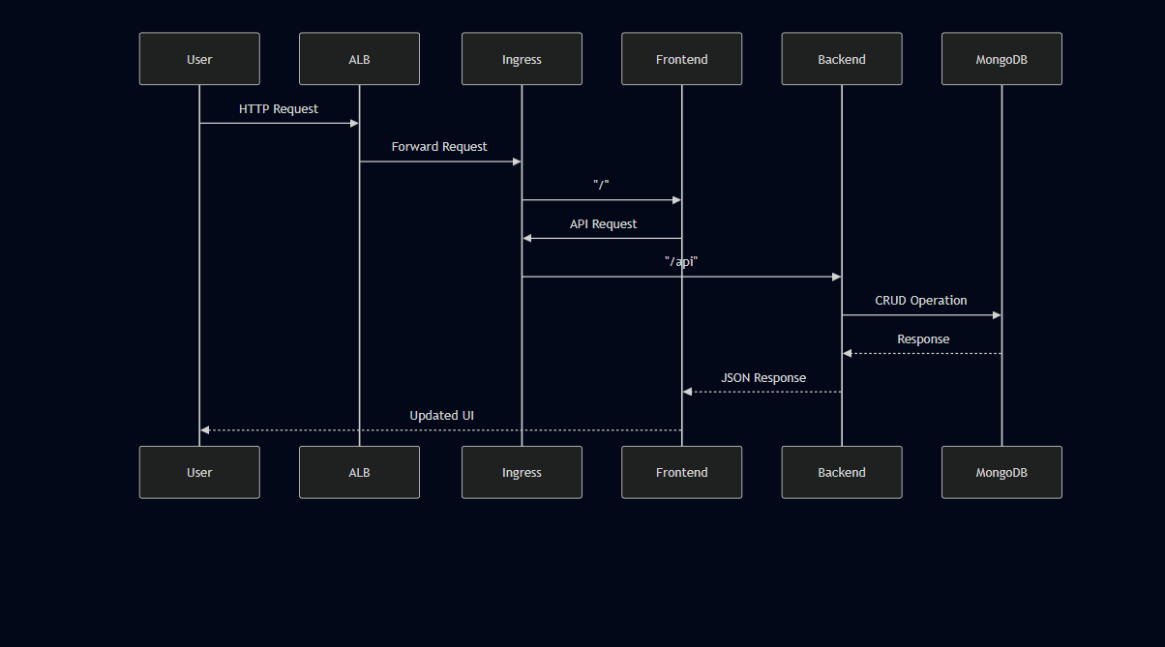

The Biggest Kubernetes Learning
Running Pods don't guarantee a working application. During this deployment: healthy Pods but frontend couldn't reach backend (Service port mismatch); healthy controller but ALB not provisioning (IAM permission missing); correct manifests but PVC stuck pending (resource ordering); running backend but API requests going nowhere (React build-time configuration).
Each failure looked healthy at the layer above the actual problem. The deployment required iterating through each layer independently — not as one system, but as a stack of discrete concerns.
- ✓ EKS cluster running
- ✓ Pods in Running state
- ✓ Containers healthy
And still have:
- ✗ Frontend unable to reach backend (Service port mismatch)
- ✗ PVC stuck in Pending (resource ordering)
- ✗ ALB not provisioning (IAM permission missing)
- ✗ API requests going nowhere (React build-time configuration)
The deployment wasn't a single kubectl apply that produced a working application. It was an iterative process of checking each layer, identifying what was actually wrong, fixing it, and verifying again. Kubernetes abstracts a significant amount of infrastructure complexity, but that abstraction doesn't remove the need to understand what's happening underneath.

Chapter 8 — Deployment Workflow

Overview
No CI/CD, no Terraform, no automation. This was a sequential hands-on deployment performed entirely from the Ubuntu EC2 management instance — provisioning infrastructure, building container images, applying Kubernetes manifests, configuring the ALB integration, and verifying the result end to end.
The deployment happened in stages, not as one uninterrupted run. Infrastructure provisioning, container preparation, Kubernetes configuration, and ALB setup each required troubleshooting before they were stable — and the complete frontend → backend → database flow only worked once all those layers were correct simultaneously. Chapter 9 covers the validation commands at each stage; this chapter covers what was done and why, in the order it was done.

End-to-End Deployment Pipeline
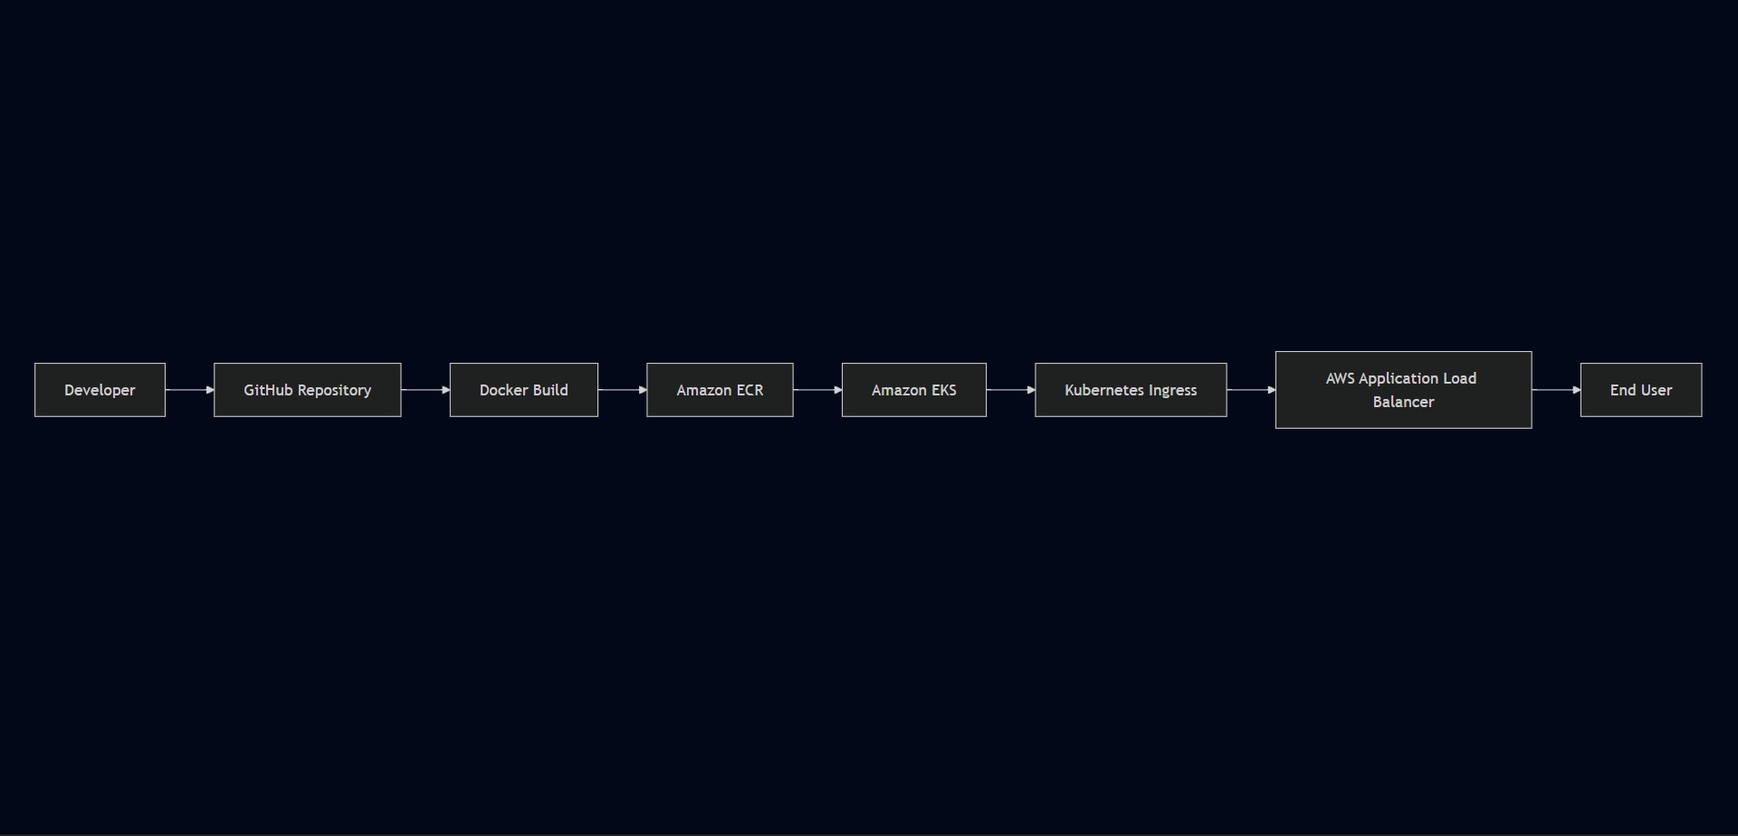

Deployment Lifecycle Overview
Phase | Objective | Primary Tool
Environment Preparation | Configure management host and credentials | EC2, AWS CLI
Cluster Provisioning | Create Kubernetes environment | eksctl
Image Build | Package application components | Docker
Image Distribution | Store images in registry | Amazon ECR
Resource Deployment | Deploy Kubernetes workloads | kubectl
Controller Installation | Enable ALB provisioning | Helm
Traffic Exposure | Publish application externally | AWS ALB + Ingress
Validation | Verify end-to-end functionality | Browser + kubectl
Cleanup | Remove AWS resources after testing | kubectl, AWS Console

Phase 1 — Environment Preparation
All provisioning, image building, and Kubernetes operations ran from a single Ubuntu EC2 instance throughout the project.

Step 1 — IAM User and Credentials
Step 1 — IAM User and Credentials: An IAM user named eks-admin was created with AdministratorAccess attached. Access keys were configured on the EC2 instance via aws configure.
Step 2 — Launch Ubuntu EC2: A dedicated Ubuntu EC2 instance (t2.micro) was launched. All subsequent steps were performed over SSH.
│
│ SSH
▼
Step 3 — AWS CLI Installation:
│
Step 4 — Docker Installation:
Step 5 — kubectl Installation:
Step 6 — eksctl Installation:
Step 7 — Helm Installation:
EKS provisioning was the longest single step — the managed control plane and worker nodes take several minutes to become operational. No application resources were deployed until this completed.

Step 2 — Launch Ubuntu EC2
After provisioning, kubectl was connected to the cluster:

Step 3 — AWS CLI Installation and Configuration
Worker node registration:
bash
Expected output — both worker nodes showing Ready status:
Source code was cloned onto the EC2 management instance and Docker builds ran from there. The backend build failed because the Dockerfile was named Dockefile — one character off. Renaming it unblocked the build. MongoDB used the official public image — no custom build needed.
The full build, tag, and push command sequence is in Chapter 9.
Both images were authenticated, tagged, and pushed to their respective private ECR repositories. Worker nodes pull from ECR automatically through IAM — no separate registry credentials needed. Images were confirmed visible in ECR before any Kubernetes manifests were applied.
Resources deployed:
bash
aws configure
The PVC remained in Pending state when storage resources weren't available at binding time. Understanding the dependency — PV must exist before PVC can bind, PVC must bind before MongoDB Pod can schedule — was one of the key debugging insights.

Step 4 — Docker Installation
Post-deployment verification:
bash
Expected Pod state:
The AWS Load Balancer Controller is required for Kubernetes Ingress to provision an AWS Application Load Balancer. Without it, the Ingress resource exists in Kubernetes but no ALB gets created.
docker ps
During this phase, the controller failed to provision the ALB because the IAM role was missing elasticloadbalancing:DescribeListenerAttributes. The Ingress existed in Kubernetes with no external address. Attaching the missing permission and restarting the controller resolved it:
Once the ALB DNS endpoint appeared on the Ingress resource, the application was tested end to end:

Step 5 — kubectl Installation
kubectl was installed to communicate with the Kubernetes API — applying manifests, checking resource status, reading logs, and debugging:
bash
kubectl version --short --client
Frontend accessible through ALB DNS endpoint React UI loaded in browser Task created through the UI Backend API processed the request Task stored in MongoDB Task visible on page refresh — confirming persistence No unexpected Pod restarts during testing

Step 6 — eksctl Installation
eksctl was installed to handle EKS cluster provisioning. Rather than manually creating every AWS resource involved in an EKS cluster, eksctl orchestrates the entire process from a single command:
bash
eksctl version

Step 7 — Helm Installation
This removed all application resources and triggered cleanup of associated AWS resources — target groups and load balancers managed by the controller.
bash
Remaining infrastructure — the EKS cluster, worker nodes, EC2 management instance, ECR repositories, and EBS volumes — was then decommissioned through the AWS Console.
Cleaning up in the correct order matters. Deleting the EKS cluster before removing Kubernetes-managed AWS resources like the ALB can leave orphaned resources that continue generating costs.
IAM / AWS Credentials
↓
Ubuntu EC2
↓
AWS CLI
↓
Docker
↓
kubectl
↓
eksctl
↓
EKS Cluster
↓
Helm
↓
AWS Load Balancer Controller

Phase 2 — Amazon EKS Cluster Provisioning
EKS provisioning was the longest single step — the managed control plane and worker nodes take several minutes to become operational. No application resources were deployed until this completed.
bash
eksctl create cluster \
After provisioning, kubectl was connected to the cluster:
Worker node registration:
Expected output — both worker nodes showing Ready status:
--nodes-min 2 \
--nodes-max 2
This single command handled a significant amount of AWS-side provisioning automatically — the managed Kubernetes control plane, the worker node group, VPC, subnets, Internet Gateway, security groups, and IAM roles for the nodes.
Parameter | Value
Cluster Name | three-tier-cluster
Region | us-west-2
Worker Node Type | t2.medium
Minimum Nodes | 2
Maximum Nodes | 2
EKS provisioning was the longest single infrastructure step in the deployment — the managed control plane and worker nodes take several minutes to become fully operational. No application resources could be deployed until this completed.

Cluster Validation
Both worker nodes showed Ready status — confirming the control plane was responding, nodes were registered, and kubectl was correctly connected. Only after both nodes showed Ready were application resources deployed.
bash
aws eks update-kubeconfig \
--region us-west-2 \
--name three-tier-cluster
Before this command, kubectl had no connection to the EKS cluster. After it, the local kubeconfig was updated with the cluster endpoint and authentication details.
Worker node registration was verified:
bash
kubectl get nodes
Expected output — both worker nodes showing Ready status:
NAME STATUS ROLES AGE
ip-xxx-xxx-xxx-xxx.ec2... Ready <none> Xm
ip-xxx-xxx-xxx-xxx.ec2... Ready <none> Xm
This confirmed three things: the cluster was reachable, IAM authentication was working, and worker nodes had successfully joined.

Phase 3 — Container Image Build
Source code was cloned onto the EC2 management instance and Docker builds ran from there. The backend build failed because the Dockerfile was named Dockefile — one character off. Renaming it unblocked the build. MongoDB used the official public image — no custom build needed.
The full build, tag, and push command sequence is in Chapter 9.
React Source Code
↓
docker build → Frontend Image

Node.js Source Code
↓
docker build → Backend Image
The backend build failed initially because the Dockerfile was misnamed Dockefile instead of Dockerfile. Docker couldn't locate the build definition and exited. Identifying and renaming the file unblocked the build.
MongoDB used the official public Docker image — no custom build required.

Phase 4 — Image Distribution to Amazon ECR

ECR Authentication
Before pushing images, Docker authenticated to ECR using IAM credentials:
bash
aws ecr get-login-password --region us-west-2 | docker login \
--username AWS \
--password-stdin \
<AWS_ACCOUNT_ID>.dkr.ecr.us-west-2.amazonaws.com
Successful authentication returns:
Login Succeeded

Image Tagging and Push
Each image was tagged with the full ECR repository URI:
bash
docker tag <local-image>:latest \
<AWS_ACCOUNT_ID>.dkr.ecr.us-west-2.amazonaws.com/<repository>:latest

docker push \
<AWS_ACCOUNT_ID>.dkr.ecr.us-west-2.amazonaws.com/<repository>:latest
Separate repositories for frontend and backend:
Repository | Purpose
Frontend | React application image
Backend | Node.js API image
Images were verified in ECR before referencing them in Deployment manifests.

Phase 5 — Kubernetes Resource Deployment

Namespace Creation
bash
kubectl create namespace workshop
The first step before deploying any application resources was creating a dedicated namespace: All application resources were deployed here — Deployments, Services, Secrets, Persistent Volume Claims, and the Ingress. Keeping everything in a single namespace makes administration straightforward: you can see all application resources in one place and avoid accidental interaction with system-level Kubernetes resources in other namespaces. Resources deployed in the workshop namespace: Frontend Deployment Backend Deployment MongoDB Deployment ClusterIP Services (frontend, backend, MongoDB) Kubernetes Secret (MongoDB credentials) Persistent Volume Claim Ingress Resource

Resource Deployment
Resources deployed: The PVC remained in Pending state when storage resources weren't available at binding time. Understanding the dependency — PV must exist before PVC can bind, PVC must bind before MongoDB Pod can schedule — was one of the key debugging insights.
bash
kubectl apply -f .
Post-deployment verification: Expected Pod state:
Resource | Purpose
Namespace | Resource isolation
Secret | MongoDB credentials
Persistent Volume | Durable storage
Persistent Volume Claim | Storage allocation
MongoDB Deployment | Database workload
Backend Deployment (×2) | REST API
Frontend Deployment | User interface
Services (×3) | Internal networking
Ingress | External routing

Deployment Dependency Order
Even though kubectl apply -f . was the deployment command, the resources have dependencies that matter:
NamespaceSecretPersistent VolumePersistent Volume ClaimMongoDB DeploymentBackend DeploymentFrontend DeploymentIngress
The PVC remained in Pending state when storage resources weren't available at binding time. Understanding this dependency — PV must exist before PVC can bind, PVC must bind before MongoDB Pod can schedule — was one of the key debugging insights from this deployment.

Post-Deployment Verification
bash
# Check all Pods are running
kubectl get pods -n workshop

# Check Services are configured
kubectl get svc -n workshop

# Check PVC is bound
kubectl get pvc -n workshop

# Check Ingress has an external address
kubectl get ingress -n workshop
Expected Pod state:
NAME READY STATUS
frontend-xxxxx 1/1 Running
backend-xxxxx 1/1 Running
backend-yyyyy 1/1 Running
mongodb-xxxxx 1/1 Running
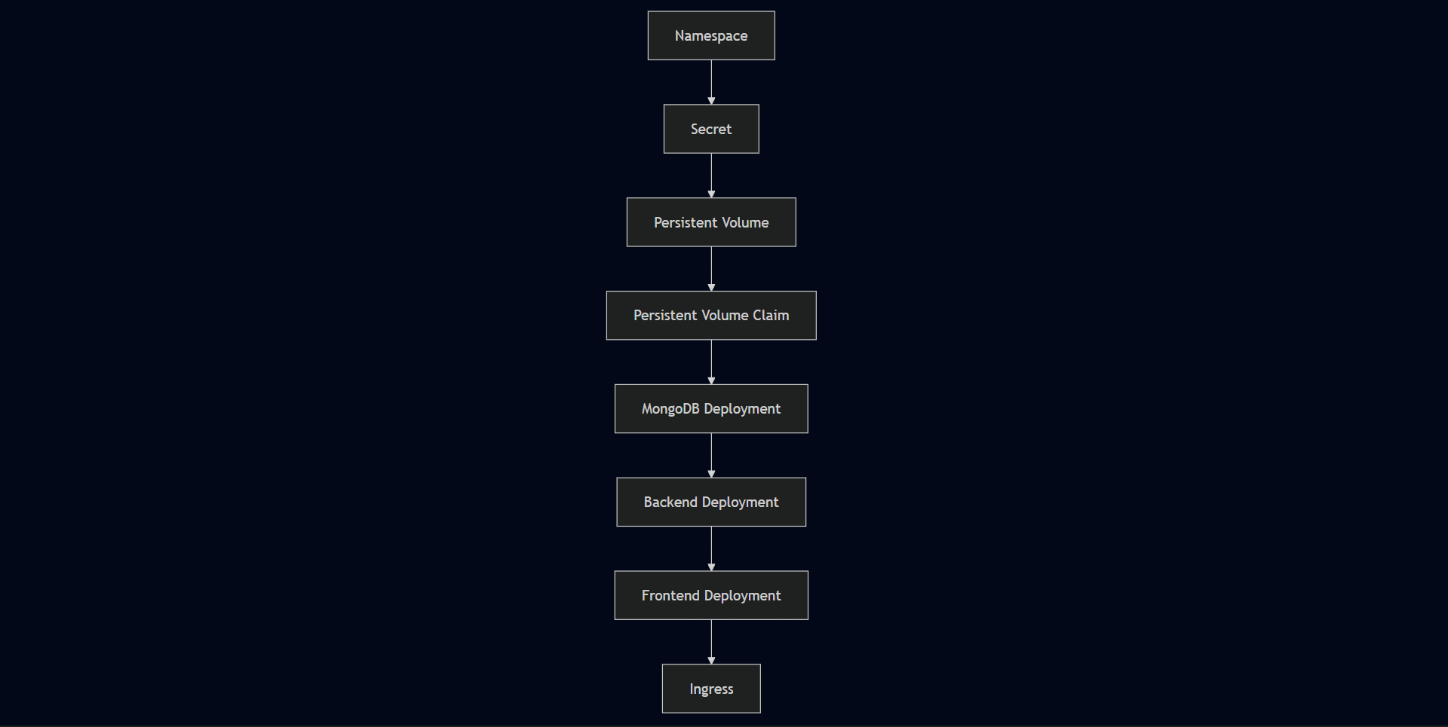

Phase 6 — AWS Load Balancer Controller
The AWS Load Balancer Controller is required for Kubernetes Ingress to provision an AWS Application Load Balancer. Without it, the Ingress resource exists in Kubernetes but no ALB gets created. During this phase, the controller failed to provision the ALB because the IAM role was missing elasticloadbalancing:DescribeListenerAttributes. The Ingress existed in Kubernetes with no external address. Attaching the missing permission and restarting the controller resolved it:

Helm Repository Setup
bash
helm repo add eks https://aws.github.io/eks-charts
helm repo update eks

Controller Installation
bash
helm install aws-load-balancer-controller \
eks/aws-load-balancer-controller \
-n kube-system \
--set clusterName=three-tier-cluster \
--set serviceAccount.create=false \
--set serviceAccount.name=aws-load-balancer-controller

Controller Verification
bash
kubectl get deployment -n kube-system aws-load-balancer-controller

ALB Configuration
bash
kubectl apply -f full_stack_lb.yaml
The controller watches Kubernetes Ingress resources and calls AWS APIs to provision and configure the Application Load Balancer:
Kubernetes Ingress Resource
↓
AWS Load Balancer Controller
↓
AWS API Calls
↓
Application Load Balancer
↓
Target Groups
↓
Kubernetes Services
During this phase, the controller failed to provision the ALB because the IAM role was missing the elasticloadbalancing:DescribeListenerAttributes permission. The Ingress existed in Kubernetes with no external address — the controller was running but couldn't complete its AWS API calls. Attaching the missing permission and restarting the controller resolved it.

Phase 7 — Application Validation
Once the ALB DNS endpoint appeared on the Ingress resource, the application was tested end to end:
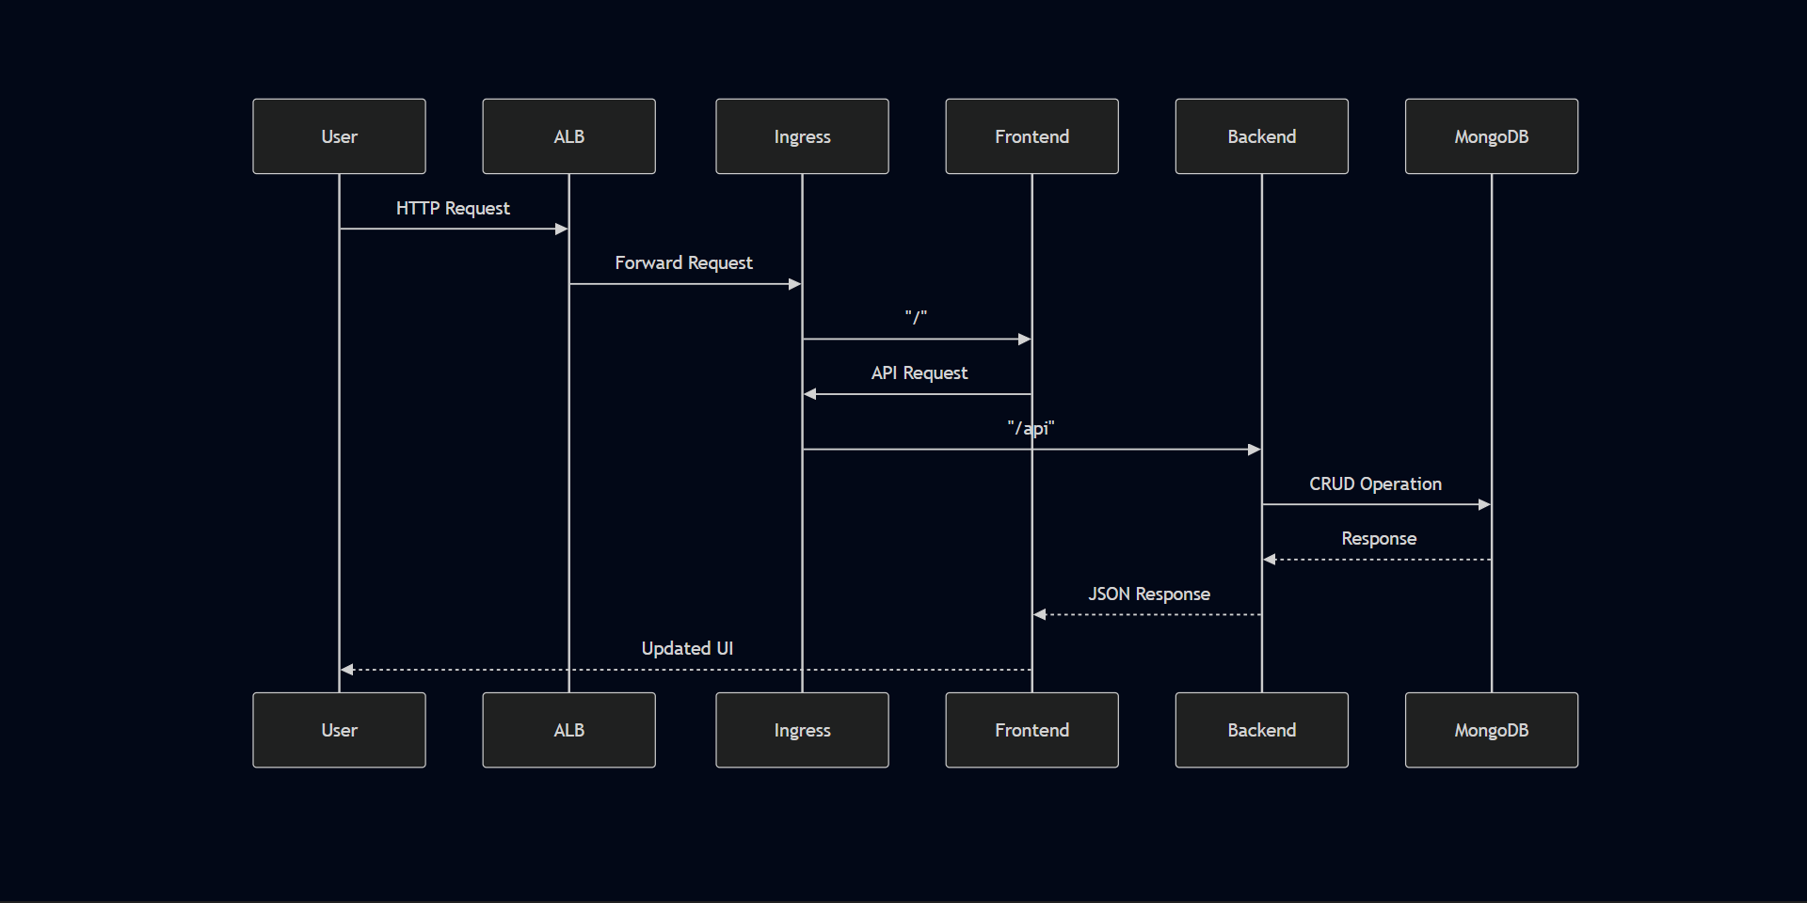
Frontend accessible through ALB DNS endpoint React UI loaded in browser Task created through the UI Backend API processed the request Task stored in MongoDB Task visible on page refresh — confirming persistence No unexpected Pod restarts during testing
✓ Frontend accessible through ALB DNS endpoint
✓ React UI loaded in browser
✓ Task created through the UI
✓ Backend API processed the request
✓ Task stored in MongoDB
✓ Task visible on page refresh — confirming persistence
✓ No unexpected Pod restarts during testing

Phase 8 — Infrastructure Cleanup
This removed all application resources and triggered cleanup of associated AWS resources — target groups and load balancers managed by the controller.
Remaining infrastructure — the EKS cluster, worker nodes, EC2 management instance, ECR repositories, and EBS volumes — was then decommissioned through the AWS Console.
bash
kubectl delete -f .
Cleaning up in the correct order matters. Deleting the EKS cluster before removing Kubernetes-managed AWS resources like the ALB can leave orphaned resources that continue generating costs.
Remaining AWS infrastructure — the EKS cluster, worker nodes, EC2 management instance, ECR repositories, and EBS volumes — was then decommissioned.
Cleaning up in the correct order matters. Deleting the EKS cluster before removing Kubernetes-managed AWS resources like the ALB can leave orphaned AWS resources that continue generating costs.

Deployment Best Practices Applied
- Dedicated management host isolated from application runtime
- IAM least-privilege through named user and IRSA for controller
- Images built and pushed to private ECR before deployment
- kubeconfig verified before applying any Kubernetes resources
- Resource deployment verified at each stage before proceeding
- Systematic kubectl-based debugging — get → describe → logs → fix → apply
- End-to-end functional validation before considering deployment complete
- Infrastructure cleaned up after testing to prevent unnecessary AWS costs

Deployment Dependency Graph
