Three-Tier Application Deployment on AWS EKS — Part 2 of 3
Implementation Validation, Challenges & Debugging, Security, Monitoring, Performance, Project Outcome, Future Enhancements

This document continues the technical portfolio from Part 1.

Chapter 9 — Implementation & Operational Validation

Overview
This chapter is the validation reference — the specific commands I used to confirm each layer was working, what correct output looked like, and how problems were isolated when something wasn't right. Chapter 8 covers the full deployment workflow; this chapter focuses on verification.
The approach throughout was incremental: check each stage before moving to the next. Infrastructure, cluster, images, Kubernetes workloads, storage, networking, load balancer, then end-to-end browser validation — in that order, each confirmed before moving forward.

Implementation Strategy
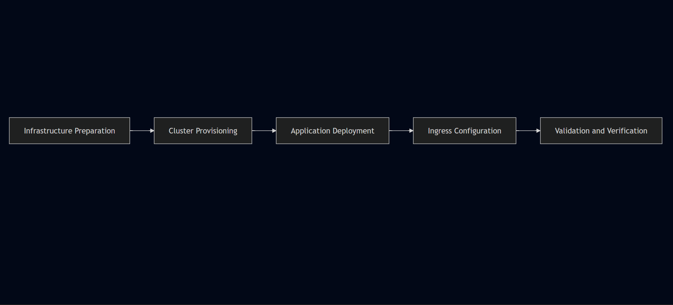

Phase 1 — Infrastructure Readiness
Expected Pod output:
bash
A Pod showing anything other than Running required investigation before proceeding:
aws sts get-caller-identity

The Events section in kubectl describe output was the most useful diagnostic — it shows what Kubernetes actually attempted.
docker ps

Expected output:
kubectl version --short --client

When the PVC showed Pending instead of Bound:
eksctl version

Showed the claim waiting for a matching volume. Applying storage resources in the correct order — PV before PVC — resolved the binding.
helm version
Expected output:

Phase 2 — EKS Cluster Provisioning and Validation

Cluster Creation
bash
eksctl create cluster \
The backend Service port mismatch was identified by comparing the Service configuration against the actual container port:
The output showed the TargetPort was not matching the port the Node.js application was listening on (3500). Correcting the Service manifest and reapplying:
Initially the ADDRESS field was empty. Investigation through controller logs revealed an IAM authorization failure — the missing permission elasticloadbalancing:DescribeListenerAttributes.
After attaching the required IAM policy and restarting the controller:
Running kubectl get ingress again showed the ALB DNS address populated.
Validation sequence: Opened the ALB DNS URL in a browser React frontend loaded successfully Added a task through the UI Task appeared — confirming frontend → backend communication Refreshed the page — task still visible, confirming MongoDB persistence

kubeconfig Update
bash
aws eks update-kubeconfig \
Each issue required checking a different layer. The debugging pattern was consistent: observe the symptom, identify the layer, check that layer specifically, fix, verify.
--name three-tier-cluster
This connected kubectl to the cluster. Before this command, kubectl had no cluster to talk to. After it, all subsequent kubectl commands targeted the EKS cluster.

Worker Node Verification
bash
kubectl get nodes
Expected output — both worker nodes showing Ready:
NAME STATUS ROLES AGE
ip-xxx-xxx-xxx-xxx.us-west-2.compute.internal Ready <none> Xm
ip-xxx-xxx-xxx-xxx.us-west-2.compute.internal Ready <none> Xm
This confirmed the cluster was reachable, authentication was working, and nodes had joined successfully. Only after seeing both nodes in Ready state were application resources deployed.

Phase 3 — Container Image Build and Push

Build Workflow
Phase 1 — Source Preparation: The project source code was cloned onto the EC2 management instance. Each application tier was in its own directory, with its own Dockerfile alongside the application source and dependency definitions. Phase 2 — Image Build: Docker builds ran from inside each service directory. The backend Dockerfile typo (Dockefile instead of Dockerfile) was caught here — Docker couldn't locate the build definition and exited. Finding the misnamed file and correcting it unblocked the build.
bash
Phase 3 — ECR Authentication: A successful authentication returns:
docker build -t <image-name> .

ECR authentication is entirely IAM-based — no separate registry password needed. Phase 4 — Image Tagging:
docker images
Phase 5 — Image Push to ECR:
bash
Separate pushes for frontend and backend. Images were verified in ECR before referencing them in Kubernetes Deployment manifests.
ls -la
Phase 6 — Kubernetes Deployment: With images in ECR, Deployment manifests reference the full ECR URI:
bash
Worker nodes pull images directly from ECR using IAM-based authentication — no manual credential configuration needed on the nodes.
docker build -t <backend-image-name> .

ECR Authentication
bash
aws ecr get-login-password --region us-west-2 | docker login \
--username AWS \
--password-stdin \
<AWS_ACCOUNT_ID>.dkr.ecr.us-west-2.amazonaws.com
Expected response:
Login Succeeded

Tag and Push
bash
# Tag image with ECR URI
docker tag <local-image>:latest \
<AWS_ACCOUNT_ID>.dkr.ecr.us-west-2.amazonaws.com/<repository>:latest

# Push to ECR
docker push \
<AWS_ACCOUNT_ID>.dkr.ecr.us-west-2.amazonaws.com/<repository>:latest
Images were verified in ECR before proceeding to Kubernetes deployment.

Phase 4 — Kubernetes Resource Deployment

Namespace Creation
bash
kubectl create namespace workshop

Apply All Manifests
bash
kubectl apply -f .

Immediate Post-Deploy Checks
bash
# Check all Pods are scheduled and starting
kubectl get pods -n workshop

# Check Services are created
kubectl get svc -n workshop

# Check PVC binding status
kubectl get pvc -n workshop

Representative Pod Output
NAME READY STATUS RESTARTS
frontend-deployment-xxxxx 1/1 Running 0
backend-deployment-xxxxx 1/1 Running 0
backend-deployment-yyyyy 1/1 Running 0
mongodb-deployment-xxxxx 1/1 Running 0
Note: Pod name suffixes are generated by Kubernetes and will differ in every deployment. The above shows the expected structure — one frontend Pod, two backend Pods, one MongoDB Pod.
A Pod showing anything other than Running required investigation before proceeding:
bash
# Get detailed resource information including Events
kubectl describe pod <pod-name> -n workshop
The Events section in kubectl describe output was the most useful diagnostic — it shows what Kubernetes actually attempted: image pulls, scheduling decisions, volume binding attempts, probe results.

Phase 5 — Storage Validation
Expected output:
bash
kubectl get pvc -n workshop
When the PVC showed Pending instead of Bound:
Showed the claim waiting for a matching volume. Applying storage resources in the correct order — PV before PVC — resolved the binding.
mongodb-pvc Bound pv-xxxxx Gi RWO
When the PVC showed Pending instead of Bound, the MongoDB Pod couldn't proceed. Investigation:
bash
kubectl describe pvc <pvc-name> -n workshop
The Events section showed the claim waiting for a matching volume. Applying storage resources in the correct order — Persistent Volume before Persistent Volume Claim — resolved the binding.

Phase 6 — Service and Networking Validation
bash
AWS Application Load Balancer: The single external entry point. The AWS Load Balancer Controller provisions and manages it directly from the Kubernetes Ingress resource.
kubectl get svc -n workshop
Kubernetes Services: All application Services use ClusterIP — internal only. Services provide stable DNS-based endpoints so Pods can communicate without depending on individual Pod IP addresses.
NAME TYPE CLUSTER-IP PORT(S)
frontend ClusterIP 10.x.x.x 3000/TCP
api ClusterIP 10.x.x.x 8080/TCP
mongodb-svc ClusterIP 10.x.x.x 27017/TCP
The backend Service port mismatch was identified by comparing the Service configuration against the actual container port:
bash
kubectl describe svc api -n workshop
The output showed the TargetPort was not matching the port the Node.js application was listening on (3500). Correcting the Service manifest and reapplying:
bash
kubectl apply -f .
Restored frontend-to-backend communication.

Phase 7 — AWS Load Balancer Controller Installation
bash
Initially the ADDRESS field was empty. Investigation through controller logs revealed an IAM authorization failure — the missing permission elasticloadbalancing:DescribeListenerAttributes.
helm repo add eks https://aws.github.io/eks-charts
helm repo update eks

After attaching the required IAM policy and restarting the controller:
helm install aws-load-balancer-controller \
Running kubectl get ingress again showed the ALB DNS address populated.
-n kube-system \
--set clusterName=three-tier-cluster \
--set serviceAccount.create=false \
--set serviceAccount.name=aws-load-balancer-controller

# Verify controller deployment
kubectl get deployment -n kube-system aws-load-balancer-controller

Apply Ingress Configuration
bash
kubectl apply -f full_stack_lb.yaml

Ingress Status Check
bash
kubectl get ingress -n workshop
Initially the ADDRESS field was empty — the ALB had not been provisioned. Investigation through controller logs revealed an IAM authorization failure — the missing permission elasticloadbalancing:DescribeListenerAttributes was preventing the controller from completing AWS API calls.
After attaching the required IAM policy and restarting the controller:
bash
kubectl rollout restart deployment aws-load-balancer-controller -n kube-system
Running kubectl get ingress again showed the ALB DNS address populated in the ADDRESS field. The ALB was now provisioned and accessible.

Phase 8 — Application Validation
Once the ALB DNS endpoint appeared on the Ingress resource, the application was tested end to end:
Frontend accessible through ALB DNS endpoint React UI loaded in browser Task created through the UI Backend API processed the request Task stored in MongoDB Task visible on page refresh — confirming persistence No unexpected Pod restarts during testing
- Opened the ALB DNS URL in a browser
- React frontend loaded successfully
- Added a task through the UI
- Task appeared on the page — confirming frontend → backend communication
- Refreshed the page — task still visible, confirming MongoDB persistence
Validation checklist:
Check | Result
EKS cluster operational | ✓
Worker nodes in Ready state | ✓
Images available in ECR | ✓
All Pods in Running state | ✓
PVC bound to Persistent Volume | ✓
Services correctly configured | ✓
ALB provisioned and reachable | ✓
Ingress routing functional | ✓
Frontend accessible through ALB | ✓
Backend API responding | ✓
MongoDB storing data | ✓
Browser-to-database flow verified | ✓

Debugging Command Reference
These were the primary kubectl commands used throughout the deployment for investigation and troubleshooting:
bash
# Check overall cluster and node health
kubectl get nodes

# Check Pod status across the namespace
kubectl get pods -n workshop

# Check Service configuration
kubectl get svc -n workshop

# Check PVC binding status
kubectl get pvc -n workshop

# Check Ingress and ALB address
kubectl get ingress -n workshop

# Get detailed resource information and Events
kubectl describe pod <pod-name> -n workshop
kubectl describe svc <service-name> -n workshop
kubectl describe pvc <pvc-name> -n workshop
kubectl describe ingress <ingress-name> -n workshop

# Check container logs
kubectl logs <pod-name> -n workshop

# Check controller logs
kubectl logs -n kube-system deployment/aws-load-balancer-controller

# Apply updated manifests
kubectl apply -f .

# Remove all deployed resources
kubectl delete -f .

General Debugging Pattern
Something isn't working
↓
kubectl get pods — identify unhealthy or missing resource
↓
kubectl describe <resource> — read Events section
↓
Identify root cause — config, scheduling, networking, IAM, storage
↓
Fix the manifest or configuration
↓
kubectl apply -f .
↓
Verify again with kubectl get / describe

Implementation Highlights
Several real issues were encountered and resolved during implementation:
Issue | Layer | Resolution
Dockerfile named Dockefile | Containerization | Renamed file, rebuilt image
PVC stuck in Pending | Kubernetes Storage | Applied PV before PVC
Backend Service port mismatch | Kubernetes Networking | Corrected targetPort to 3500
React build-time env var | Application Config | Switched to relative path /api/tasks
Missing IAM permission | AWS Security | Attached policy, restarted controller
Ingress host-based routing | Networking | Removed host field, used path-based routing
Each issue required checking a different layer — containerization, storage, networking, application behavior, IAM. The debugging pattern was consistent: observe the symptom, identify the layer, check that layer specifically, fix, verify.

Chapter 10 — Challenges, Root Cause Analysis & Engineering Learnings
Getting this deployment to a working state wasn't a straight line. Problems came up across containerization, storage, Kubernetes networking, IAM, and application configuration — sometimes in ways that weren't obvious from the surface symptoms. This chapter documents each issue honestly: what broke, what the investigation showed, and what fixed it.
Most debugging happened over SSH on the Ubuntu EC2 management instance, running kubectl, eksctl, the AWS CLI, and Docker from the terminal. The AWS Console ran alongside for verifying infrastructure state — load balancer status, IAM role attachments, ECR repositories, and target group health.

Challenge 1 — Docker Image Build Failure
The backend image failed to build. Docker exited without producing an image, which left the ECR repository empty and gave Kubernetes nothing to pull.
The build error indicated that Docker couldn't locate a valid build definition. Checking the backend project directory revealed the file had been named Dockefile instead of Dockerfile — one character off.
Renaming the file and rebuilding resolved it. The image pushed to ECR cleanly after that.
It's a small mistake with a disproportionate effect — the entire pipeline stalls until the build produces a valid image. An ls -la in the directory before building would have caught this.

Challenge 2 — Persistent Volume Claim Stuck in Pending
MongoDB wouldn't start. The Pod sat in Pending and the PVC never transitioned to Bound, which meant the database had no storage to attach to.
Investigation showed the PVC had been applied before a matching Persistent Volume was available for binding. Kubernetes held it in pending indefinitely, waiting for something to bind against.
Applying storage resources in the correct order and redeploying MongoDB resolved it. Once the PV was in place, the PVC bound immediately.
Stateful workloads have infrastructure dependencies that stateless ones don't. The PV has to exist before the PVC can bind — and the PVC has to be bound before the Pod can schedule. Getting that sequence wrong means the whole thing stalls silently.

Challenge 3 — Frontend Couldn't Reach the Backend
The frontend loaded in the browser, but every API call failed. The backend Pods were running and healthy — so the problem wasn't with the application itself, it was somewhere between the Service definition and the container.
Comparing the application's expected listening port against the Kubernetes Service configuration showed the mismatch. The Node.js API was listening on port 3500, but the Service wasn't forwarding traffic to the matching target port.
Correcting targetPort to 3500 fixed it. This one is easy to overlook because everything appears healthy at the Pod level. Running Pods don't tell you whether the Service is routing traffic correctly — you have to check the port configuration against what the application actually exposes.
This took more time to understand than the others because the surface symptoms looked identical to a networking problem. The frontend was loading, the backend was running, the Service config was correct — but API requests were still failing.

Challenge 4 — React API Requests Going Nowhere
The issue had nothing to do with Kubernetes. I had the backend URL configured through REACT_APP_BACKEND_URL in the frontend source. What I hadn't accounted for is that React resolves environment variables at build time, not at runtime. By the time the container is running, the compiled JavaScript bundle already has whatever value was present when npm run build executed. Updating a Kubernetes environment variable after the fact does nothing.
The fix was to stop using an environment variable for the URL entirely. I changed taskServices.js to use a relative path instead:
The full file after the change:
Verified in place:
With a relative path, the request goes to whatever host is serving the frontend — the ALB in this case — and Ingress handles routing /api traffic to the backend Service. No hardcoded URL, no build-time configuration dependency.
This was probably the most conceptually interesting issue in the whole deployment. It's not a Kubernetes problem — it's a React behavior that only becomes visible when you're deploying behind a reverse proxy or Ingress controller.
After installing the AWS Load Balancer Controller and applying the Ingress resource, no ALB appeared. The Ingress sat without an external address and nothing showed up in the AWS Console under load balancers.
The controller itself was running — the problem was that it couldn't complete the AWS API calls it needed. Investigation of the controller error output identified an AWS authorization failure. The IAM role attached to the controller was missing a specific permission:
Attaching the required IAM policy and restarting the controller resolved it. The ALB provisioned within a few minutes.

IAM failures in Kubernetes on AWS tend to look like silent hangs rather than obvious errors. The Ingress resource exists, the controller is running, but nothing happens on the AWS side. Going straight to the controller's error output rather than rechecking Kubernetes configuration saved time here — the 403 pointed directly at the authorization layer.

export function getTasks() {
The initial Ingress manifest included hostname-based routing. Without a registered domain pointing at the ALB, host-based routing couldn't be validated — requests weren't resolving correctly.
}

export function addTask(task) {
The deployment didn't require a custom domain for functional validation, so the hostname dependency was removed entirely. With the host field gone, the ALB's DNS name became the direct entry point, and traffic was routed purely on path:
}

export function updateTask(id, task) {
For a deployment scoped to functional testing rather than production exposure, path-based routing is simpler and avoids a dependency on external DNS configuration.
}

export function deleteTask(id) {
Across all six challenges, the ALB and IAM configuration consumed the most total time. The Dockerfile typo and port mismatch were quick once identified. The React environment variable issue required understanding a non-obvious build behavior, but the fix itself was straightforward once the root cause was clear.
}
The Load Balancer Controller authorization failure involved the most back-and-forth. The controller appeared healthy, the Ingress was applied correctly, but nothing happened on the AWS side. That kind of silent failure takes longer to debug because the problem isn't visible in Kubernetes at all — it lives in the IAM layer, and you only find it by reading the controller's own error output.
bash
A few things that helped consistently:
Check Kubernetes events before changing anything. kubectl describe on the affected resource usually points toward the right layer — whether the issue is scheduling, storage binding, networking, or something else.
Isolate the layer first. Kubernetes config problems, application problems, and AWS permission problems present differently. Treating them as the same thing wastes time.

Challenge 5 — AWS Load Balancer Controller Authorization Failure
Change one thing at a time. When multiple things are wrong simultaneously, fixing them in parallel makes it impossible to know what actually resolved the issue.
Use the AWS Console alongside kubectl. Some things are faster to verify visually — load balancer provisioning state, target group health, IAM role attachments. Terminal and console together give a more complete picture than either alone.
After installing the AWS Load Balancer Controller and applying the Ingress resource, no ALB appeared. The Ingress sat without an external address and nothing showed up in the AWS Console under load balancers. The controller itself was running — the problem was that it couldn't complete the AWS API calls it needed. Investigation of the controller error output identified an AWS authorization failure. The IAM role attached to the controller was missing a specific permission:
Attaching the required IAM policy and restarting the controller resolved it. The ALB provisioned within a few minutes.
IAM failures in Kubernetes on AWS tend to look like silent hangs rather than obvious errors. The Ingress resource exists, the controller is running, but nothing happens on the AWS side. Going straight to the controller's error output rather than rechecking Kubernetes configuration saved time here — the 403 pointed directly at the authorization layer.

Challenge 6 — Ingress Routing Without a Domain
The initial Ingress manifest included hostname-based routing. Without a registered domain pointing at the ALB, host-based routing couldn't be validated — requests weren't resolving correctly.
The deployment didn't require a custom domain for functional validation, so the hostname dependency was removed entirely. With the host field gone, the ALB's DNS name became the direct entry point, and traffic was routed purely on path:
For a deployment scoped to functional testing rather than production exposure, path-based routing is simpler and avoids a dependency on external DNS configuration.
/api → Backend Service
For a deployment scoped to functional testing rather than production exposure, path-based routing is simpler and avoids a dependency on external DNS configuration.

What Actually Took the Longest
Across all six challenges, the ALB and IAM configuration consumed the most total time. The Dockerfile typo and port mismatch were quick once identified. The React environment variable issue required understanding a non-obvious build behavior, but the fix itself was straightforward once the root cause was clear.
The Load Balancer Controller authorization failure involved the most back-and-forth. The controller appeared healthy, the Ingress was applied correctly, but nothing happened on the AWS side. That kind of silent failure takes longer to debug because the problem isn't visible in Kubernetes at all — it lives in the IAM layer, and you only find it by reading the controller's own error output.

Debugging Approach
A few things that helped consistently:
Check Kubernetes events before changing anything. kubectl describe on the affected resource usually points toward the right layer — whether the issue is scheduling, storage binding, networking, or something else.
Isolate the layer first. Kubernetes config problems, application problems, and AWS permission problems present differently. Treating them as the same thing wastes time.
Change one thing at a time. When multiple things are wrong simultaneously, fixing them in parallel makes it impossible to know what actually resolved the issue.
Use the AWS Console alongside kubectl. Some things are faster to verify visually — load balancer provisioning state, target group health, IAM role attachments. Terminal and console together give a more complete picture than either alone.

Challenge Summary
Challenge | Category | Severity | Status
Dockerfile naming | Containerization | Medium | Resolved
PVC pending | Kubernetes Storage | High | Resolved
Service port mapping | Kubernetes Networking | High | Resolved
React environment variables | Application Configuration | Medium | Resolved
IAM authorization | AWS Security | Critical | Resolved
Ingress host configuration | Networking | Medium | Resolved

Chapter 11 — Security Architecture

Overview
Security wasn't a separate phase in this deployment — it was part of how the infrastructure was set up from the beginning. IAM roles were scoped to specific workloads, application services were kept off the public internet, credentials were separated from application code, and administration was isolated to a dedicated host.
This is a learning environment, not a production system. The security decisions reflect that — they're practical and appropriate for the scope. Where production would require additional controls, those are called out rather than claimed as implemented.
One of the most concrete security lessons came from the IAM authorization failure during ALB provisioning — covered in detail below because it demonstrates how IAM directly affects infrastructure behavior, not just access control.

Security Architecture Overview

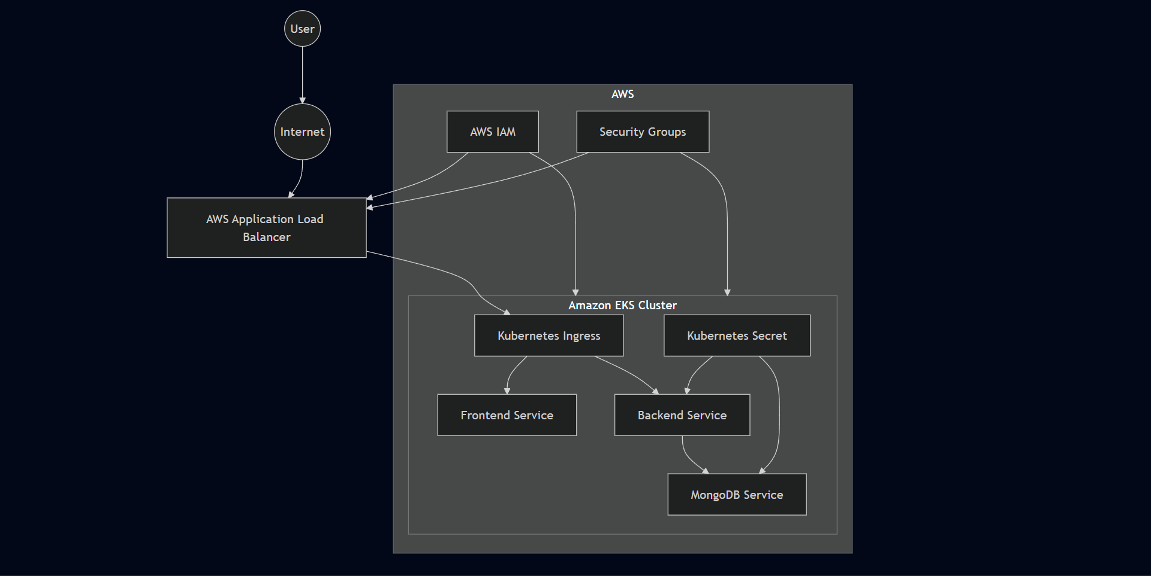

Security Design Principles
Principle | Implementation
Least Privilege | IAM roles scoped to specific workload requirements
Defense in Depth | Multiple security layers across AWS and Kubernetes
Network Isolation | Internal ClusterIP Services for all application components
Controlled Exposure | Single public ALB endpoint
Credential Protection | Kubernetes Secrets for MongoDB credentials
Resource Isolation | Dedicated namespace — workshop
Immutable Infrastructure | Docker images as deployment artifacts
Secure Administration | Dedicated EC2 management host

Identity & Access Management
IAM was the most operationally significant security component — not just as access control, but as a direct dependency for infrastructure functionality.

Administrative Access
Administrative Access: An IAM user named eks-admin was created with AdministratorAccess. This user's credentials were configured on the EC2 management instance via aws configure.

AWS Load Balancer Controller — IRSA
AWS Load Balancer Controller — IRSA: Rather than giving the Load Balancer Controller broad node-level AWS permissions, a dedicated IAM role was created and associated specifically with the controller's Kubernetes Service Account.
First, the OIDC provider was associated with the cluster:
bash
eksctl utils associate-iam-oidc-provider \
Then the service account and its IAM role were provisioned:
The controller authenticates to AWS using its own scoped role rather than inheriting permissions from the worker node. Worker nodes don't need ALB management permissions — only the controller does.
The most concrete security lesson from this deployment was an IAM authorization failure that directly prevented infrastructure from functioning.
The AWS Load Balancer Controller was installed and running. The Ingress was applied. But no ALB appeared — the Ingress had no external address and nothing showed up in the AWS Console.
bash
eksctl create iamserviceaccount \
The controller was making AWS API calls it didn't have permission to complete. The missing permission was:
The controller's error output showed HTTP 403 responses from AWS. Not a Kubernetes configuration problem, not a networking issue — a permissions gap in the IAM role.
Attaching the missing permission and restarting the controller resolved it. The ALB provisioned within minutes.
The practical lesson: when an EKS workload interacts with AWS services, IAM policies become part of the application's operational dependency chain. A Kubernetes workload can appear completely healthy while being unable to perform required AWS operations. When something isn't happening on the AWS side, check IAM before rechecking Kubernetes configuration.
All application Services use ClusterIP — internal to the cluster only. Nothing is directly reachable from the internet except through the ALB.
MongoDB never leaves the cluster network. The backend communicates with it through Kubernetes internal DNS at mongodb-svc:27017.
Security Groups for the EKS control plane and worker nodes were provisioned automatically through eksctl cluster creation.
Management EC2: Inbound SSH (port 22) for remote administration Application Load Balancer: Inbound HTTP (port 80) for public application access Worker Nodes: Traffic from ALB and Kubernetes control plane only — no unrestricted public internet access

IAM Least Privilege in Practice
Component | Permission Scope
eks-admin user | AdministratorAccess for infrastructure provisioning
Worker Nodes | ECR image pull, basic EKS node operations
ALB Controller | ALB provisioning and management only via IRSA
Application Pods | No direct AWS access

Real Security Finding — IAM Blocked ALB Provisioning
> Production improvement: SSH access to the management EC2 should be restricted to trusted source IP ranges, or replaced with AWS Systems Manager Session Manager to eliminate the need for open SSH ports.
This keeps application workloads logically separated from system-level Kubernetes resources. It also simplifies administration — all application resources are visible in one place.
> Namespaces are not a complete security boundary on their own. For production, Kubernetes Network Policies would add Pod-to-Pod traffic restrictions that namespaces alone don't provide.
MongoDB credentials were stored using a Kubernetes Secret rather than being hardcoded into Deployment manifests or container images.
Benefits: Credentials separated from application code and manifests Credential rotation possible without rebuilding images Sensitive values not visible in plain deployment YAML
> Production consideration: Kubernetes Secrets are Base64-encoded by default — not encrypted at rest. In production, envelope encryption using AWS KMS or integration with AWS Secrets Manager would provide stronger protection.
The most concrete security lesson from this deployment was an IAM authorization failure that directly prevented infrastructure from functioning. The AWS Load Balancer Controller was installed and running. The Ingress was applied. But no ALB appeared — the Ingress had no external address and nothing showed up in the AWS Console. The controller was making AWS API calls it didn't have permission to complete. The missing permission was: The controller's error output showed HTTP 403 responses from AWS. Not a Kubernetes configuration problem, not a networking issue — a permissions gap in the IAM role. Attaching the missing permission and restarting the controller resolved it. The ALB provisioned within minutes. The practical lesson: when an EKS workload interacts with AWS services, IAM policies become part of the application's operational dependency chain. A Kubernetes workload can appear completely healthy while being unable to perform required AWS operations. When something isn't happening on the AWS side, check IAM before rechecking Kubernetes configuration.

Network Isolation
All application Services use ClusterIP — internal to the cluster only. Nothing is directly reachable from the internet except through the ALB.
MongoDB never leaves the cluster network. The backend communicates with it through Kubernetes internal DNS at mongodb-svc:27017.
↓
AWS Application Load Balancer (public)
↓
Kubernetes Ingress
↓
Frontend Service (ClusterIP — internal only)
↓
Backend Service (ClusterIP — internal only)
↓
MongoDB Service (ClusterIP — internal only)
No Pod receives direct inbound internet traffic. The ALB is the single point of external entry.

Kubernetes Service Exposure
Service | Type | Publicly Accessible
Frontend | ClusterIP | No
Backend | ClusterIP | No
MongoDB | ClusterIP | No
Ingress | ALB | Yes
MongoDB never leaves the cluster network. The backend communicates with it through Kubernetes internal DNS at mongodb-svc:27017 — no external exposure at any point.

Security Groups
Security Groups for the EKS control plane and worker nodes were provisioned automatically through eksctl cluster creation.
Management EC2: Inbound SSH (port 22) for remote administration Application Load Balancer: Inbound HTTP (port 80) for public application access Worker Nodes: Traffic from ALB and Kubernetes control plane only — no unrestricted public internet access
- Inbound: SSH (port 22) for remote administration
- > Production improvement: SSH access to the management EC2 should be restricted to trusted source IP ranges, or replaced with AWS Systems Manager Session Manager to eliminate the need for open SSH ports.
Application Load Balancer:
- Inbound: HTTP (port 80) for public application access
Worker Nodes:
- Traffic from ALB and Kubernetes control plane only
- No unrestricted public internet access
Production improvement: SSH access to the management EC2 should be restricted to trusted source IP ranges, or replaced entirely with AWS Systems Manager Session Manager to eliminate the need for open SSH ports.

Namespace Isolation
This keeps application workloads logically separated from system-level Kubernetes resources. It also simplifies administration — all application resources are visible in one place.
bash
kubectl create namespace workshop
> Namespaces are not a complete security boundary on their own. For production, Kubernetes Network Policies would add Pod-to-Pod traffic restrictions that namespaces alone don't provide.
Namespaces are not a complete security boundary on their own — a compromised Pod could still attempt to reach resources in other namespaces depending on network policy configuration. For production, Kubernetes Network Policies would add Pod-to-Pod traffic restrictions that namespaces alone don't provide.

Kubernetes Secrets
MongoDB credentials were stored using a Kubernetes Secret rather than being hardcoded into Deployment manifests or container images.
Consumer | Purpose
Backend Deployment | MongoDB authentication credentials
MongoDB Deployment | Database initialization credentials
Benefits: Credentials separated from application code and manifests Credential rotation possible without rebuilding images Sensitive values not visible in plain deployment YAML
- > Production consideration: Kubernetes Secrets are Base64-encoded by default — not encrypted at rest. In production, envelope encryption using AWS KMS or integration with AWS Secrets Manager would provide stronger protection.
- Credential rotation possible without rebuilding images
- Sensitive values not visible in plain deployment YAML
Production consideration: Kubernetes Secrets are Base64-encoded by default — not encrypted at rest. In a production environment, envelope encryption using AWS KMS or integration with AWS Secrets Manager would provide stronger protection for sensitive credentials.

Container Security
Container images follow an immutable model — once built and pushed to ECR, they are not modified. Updates require building a new image and deploying it through Kubernetes rolling update, not patching running containers.
Practices applied:
- Images built before deployment — no build activity on worker nodes
- Images stored in private Amazon ECR repositories — not public registries
- Immutable image versions deployed — no in-place container modification
- Each application tier runs in its own isolated container
- Application services separated into independent containers with independent lifecycles

Administrative Security
All cluster administration happened from the dedicated Ubuntu EC2 management instance over SSH. Application workloads run exclusively on EKS worker nodes — the management instance has no application runtime role.
This separation means administrative tools, credentials, and operations are isolated from the application environment. A compromise of the application layer doesn't automatically expose the management environment, and vice versa.

Security Assessment
Domain | Status
Identity Management | Implemented — IAM user + IRSA for controller
OIDC Integration | Implemented via eksctl
Namespace Isolation | Implemented — workshop namespace
Internal Service Networking | Implemented — ClusterIP only
Kubernetes Secrets | Implemented — MongoDB credentials
Persistent Storage | Implemented — EBS-backed PV
Load Balancer Security | Implemented — single ALB entry point
HTTPS Encryption | Future Enhancement
Kubernetes RBAC | Future Enhancement
Network Policies | Future Enhancement
AWS WAF | Future Enhancement
Image Vulnerability Scanning | Future Enhancement

Future Security Enhancements
Enhancement | Benefit
AWS Secrets Manager | Centralized secret lifecycle management
AWS KMS | Encryption of Kubernetes Secrets at rest
Kubernetes RBAC | Fine-grained cluster authorization
Network Policies | Pod-to-Pod traffic restrictions
AWS WAF | Protection against common web attacks
TLS/HTTPS | Encrypted client-to-ALB communication
Image Scanning | Vulnerability detection in container images
SSM Session Manager | SSH-free EC2 administration
Admission Controllers | Policy enforcement at deployment time

Chapter 12 — Monitoring & Observability

Overview
No Prometheus, no Grafana, no centralized log aggregation. The monitoring toolkit for this deployment was practical and minimal: Kubernetes-native diagnostic commands, AWS Console verification, and container logs when needed.
What follows is what was actually used — the specific commands, the situations where they mattered, and what they revealed. Where a production environment would need more, that's called out directly.

Observability Architecture
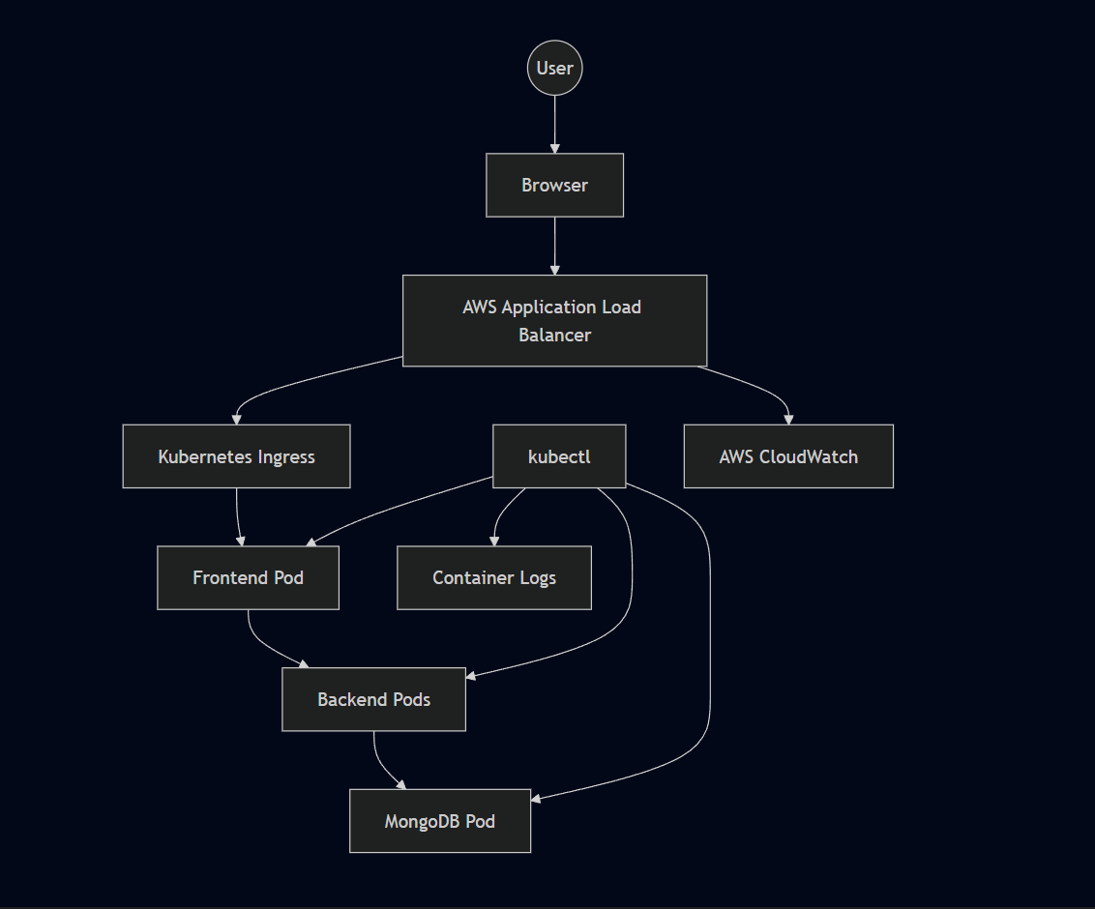

Monitoring Objectives
Objective | Purpose
Cluster Health | Ensure Kubernetes components remain operational
Node Availability | Verify worker node readiness
Pod Health | Detect failed or restarting workloads
Service Availability | Validate internal networking
Ingress Status | Confirm external accessibility
Application Logs | Diagnose runtime issues
Storage Health | Verify persistent volume attachment

What Was Actually Used
kubectl — Primary Diagnostic Tool

kubectl — Primary Diagnostic Tool
kubectl was the main source of operational information throughout the deployment. The commands used most frequently:
bash
The kubectl describe command was particularly useful — its Events section shows what Kubernetes actually attempted, which is often different from what the high-level kubectl get status suggests.
kubectl get nodes

Container Logs — AWS Load Balancer Controller
kubectl get pods -n workshop

The most concrete use of container logs during this deployment was investigating why the ALB wasn't provisioning.
kubectl get svc -n workshop

The controller was running. The Ingress resource existed. But no ALB appeared. Rather than continuing to check Kubernetes manifests, the controller logs were the next step:
kubectl get pvc -n workshop

The logs showed HTTP 403 responses from AWS — an authorization failure, not a Kubernetes configuration problem. This immediately shifted the investigation from Kubernetes to IAM, where the missing permission elasticloadbalancing:DescribeListenerAttributes was identified and corrected.
kubectl get ingress -n workshop

This is the most practical observability lesson from the project: a healthy Kubernetes workload does not mean the underlying AWS integration is functioning correctly. Logs were necessary to distinguish a Kubernetes configuration issue from an AWS IAM authorization failure.
kubectl describe pod <pod-name> -n workshop
kubectl describe svc <service-name> -n workshop
kubectl describe pvc <pvc-name> -n workshop
kubectl describe ingress <ingress-name> -n workshop
AWS Console — Infrastructure Verification

Container Logs — AWS Load Balancer Controller
Used alongside kubectl for visual verification: EKS cluster status and worker node health Load balancer provisioning state Target group configuration and health IAM role attachments ECR repository contents EBS volume state
Some things are faster to verify visually — whether an ALB exists, whether target groups are healthy, whether an IAM policy is attached. The Console and terminal together gave a more complete picture than either alone.
bash
kubectl logs -n kube-system deployment/aws-load-balancer-controller
Browser-Based Validation
The final validation layer was the application itself: React frontend loaded Added a task through the UI Task appeared — frontend → backend communication confirmed Refreshed the page — task still present, MongoDB persistence confirmed

AWS Console — Infrastructure Verification
This end-to-end validation was the definitive check that everything was working correctly. Kubernetes showing healthy Pods is necessary but not sufficient — the application has to actually function from a user's perspective.
- Monitoring wasn't saved for after deployment was complete. Each phase was verified before moving to the next:
- This incremental approach made root cause identification faster. When something broke, the scope of possible causes was already narrowed by what had already been verified.
- Target group configuration and health
- IAM role attachments
- ECR repository contents
- EBS volume state
Some things are faster to verify visually — whether an ALB exists, whether target groups are healthy, whether an IAM policy is attached. The Console and terminal together gave a more complete picture than either alone.

Browser-Based Validation
The React frontend loaded successfully through the ALB DNS endpoint in a browser. This confirmed the ALB was reachable, Ingress routing was working, the frontend Service was correctly configured, and the frontend Pod was serving the application.
- React frontend loaded
- Added a task through the UI
- Task appeared — frontend → backend communication confirmed
- Refreshed the page — task still present, MongoDB persistence confirmed
This end-to-end validation was the definitive check that everything was working correctly. Kubernetes showing healthy Pods is necessary but not sufficient — the application has to actually function from a user's perspective.

Kubernetes Health Monitoring
Resource | What It Reveals
Nodes | Infrastructure readiness — are worker nodes available?
Pods | Application health — are containers running or failing?
Deployments | Desired state compliance — does actual match intended?
Services | Internal connectivity — are ports configured correctly?
Ingress | External routing — does the ALB have a DNS address?
Events (via describe) | Deployment failures, scheduling issues, volume binding
Logs | Runtime diagnostics — what is the application actually doing?

Incremental Validation Approach
Monitoring wasn't saved for after deployment was complete. Each phase was verified before moving to the next:
This incremental approach made root cause identification faster. When something broke, the scope of possible causes was already narrowed by what had already been verified.
↓
kubectl get nodes → both nodes Ready
↓
Images in ECR?
↓
AWS Console → repositories visible
↓
Pods running?
↓
kubectl get pods → all Running
↓
PVC bound?
↓
kubectl get pvc → Bound
↓
ALB provisioned?
↓
kubectl get ingress → ADDRESS populated
↓
Application working?
↓
Browser → task creation → page refresh → data persists
This incremental approach made root cause identification faster. When something broke, the scope of possible causes was already narrowed by what had already been verified.

Observability Layers
InfrastructureKubernetesContainersApplicationUser Experience
Each layer requires different tools:
- Infrastructure — AWS Console, eksctl
- Kubernetes — kubectl get, kubectl describe
- Containers — kubectl logs
- Application — browser testing, API responses
- User Experience — end-to-end functional validation

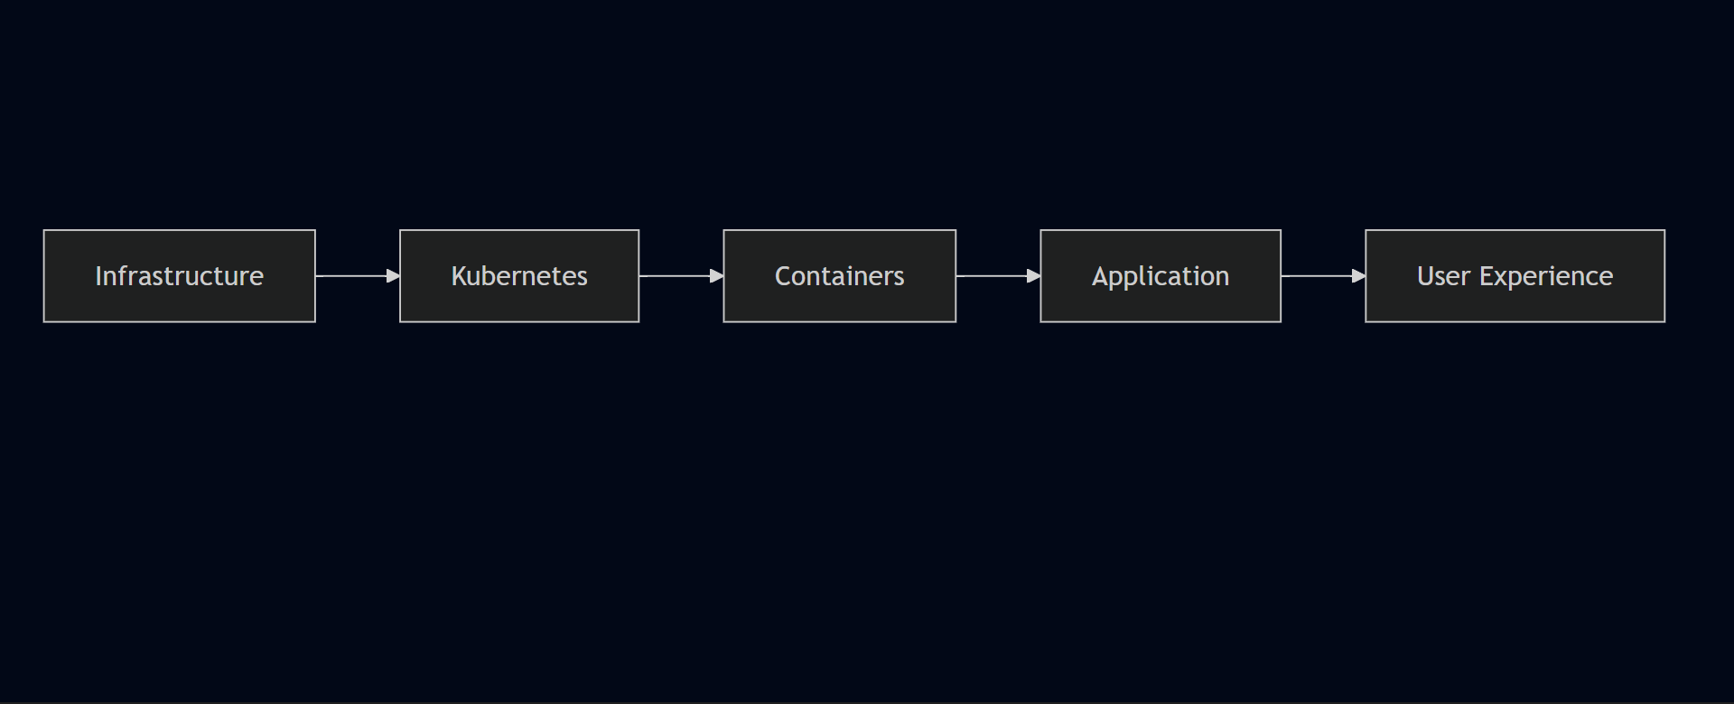

Incident Investigation Workflow
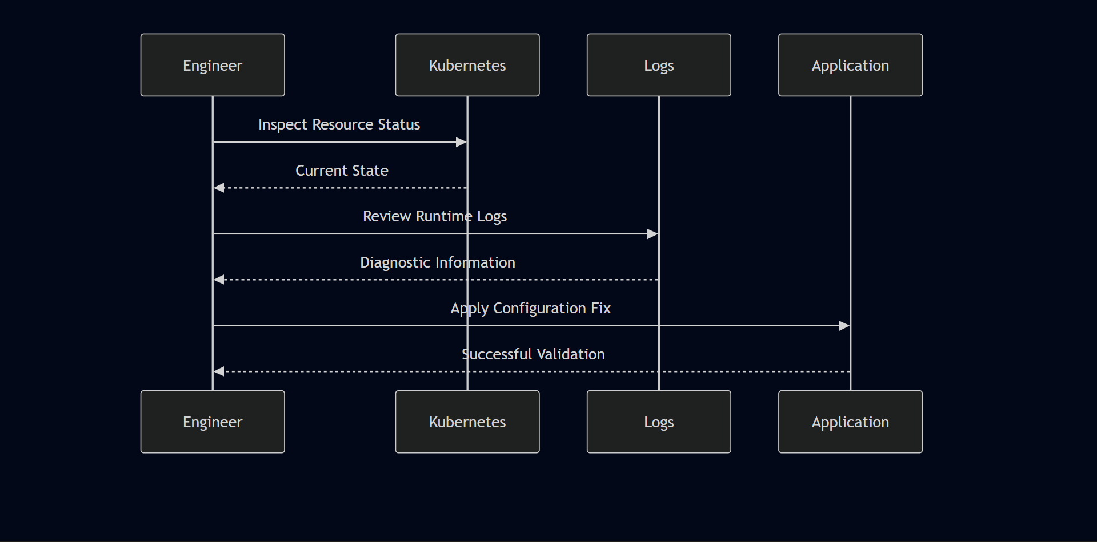

Health Probes
Kubernetes supports liveness and readiness probes for automated workload health management.
Liveness probes detect when a container has entered a failed state and needs to be restarted automatically — without manual intervention.
Readiness probes determine when a container is ready to receive traffic. Pods that fail readiness checks are temporarily removed from Service load balancing, preventing failed requests during startup or rolling updates.
The reference project included health probe configuration for the backend Deployment. The exact probe endpoint should be verified against the Deployment YAML in the repository.

AWS CloudWatch
CloudWatch was available as part of the AWS environment and provides infrastructure-level metrics for ALB, EKS, and EC2 resources automatically. It was not actively used as a primary monitoring tool during this deployment — the kubectl-based workflow and AWS Console were sufficient for the scope of work.
A production deployment would extend CloudWatch usage to include:
- Custom application metrics
- Log aggregation from containers
- CloudWatch Alarms for automated alerting
- Dashboard visualization
- Automated notifications on threshold breaches

Current Monitoring Coverage
Capability | Status
Pod Monitoring | ✓
Deployment Monitoring | ✓
Container Logs (ALB Controller) | ✓
Kubernetes Resource Events | ✓ via kubectl describe
Node Health | ✓
Ingress Status | ✓
Persistent Storage Validation | ✓
AWS Console Infrastructure Verification | ✓
CloudWatch Active Monitoring | Not used — future enhancement
Prometheus Metrics | Future Enhancement
Grafana Dashboards | Future Enhancement
Centralized Log Aggregation | Future Enhancement

Recommended Production Enhancements
Technology | Purpose
Prometheus | Metrics collection from Kubernetes and applications
Grafana | Dashboard visualization for metrics
Alertmanager | Alert routing and notification
Fluent Bit | Log forwarding from containers
Elasticsearch | Centralized log storage
Kibana | Log visualization and search
Jaeger | Distributed tracing across services
OpenTelemetry | Unified telemetry collection
CloudWatch Alarms | Automated AWS infrastructure alerting

Monitoring Best Practices Applied
- Validated infrastructure before deploying application workloads
- Checked node readiness before applying Kubernetes manifests
- Verified PVC binding before expecting MongoDB to start
- Used container logs to identify root cause of ALB provisioning failure
- Combined kubectl and AWS Console for complete operational visibility
- Performed end-to-end browser validation before declaring deployment complete
- Validated each deployment phase independently before proceeding

Chapter 13 — Performance, Scalability & Reliability

Overview
No load testing, no benchmarks, no performance metrics. The project was validated functionally — the application worked correctly end to end, data persisted, and the infrastructure stayed stable throughout testing.
This chapter covers what was actually observed, the architectural decisions that support scalability and reliability, and what would need to change to make this production-ready under real load.

Performance Architecture
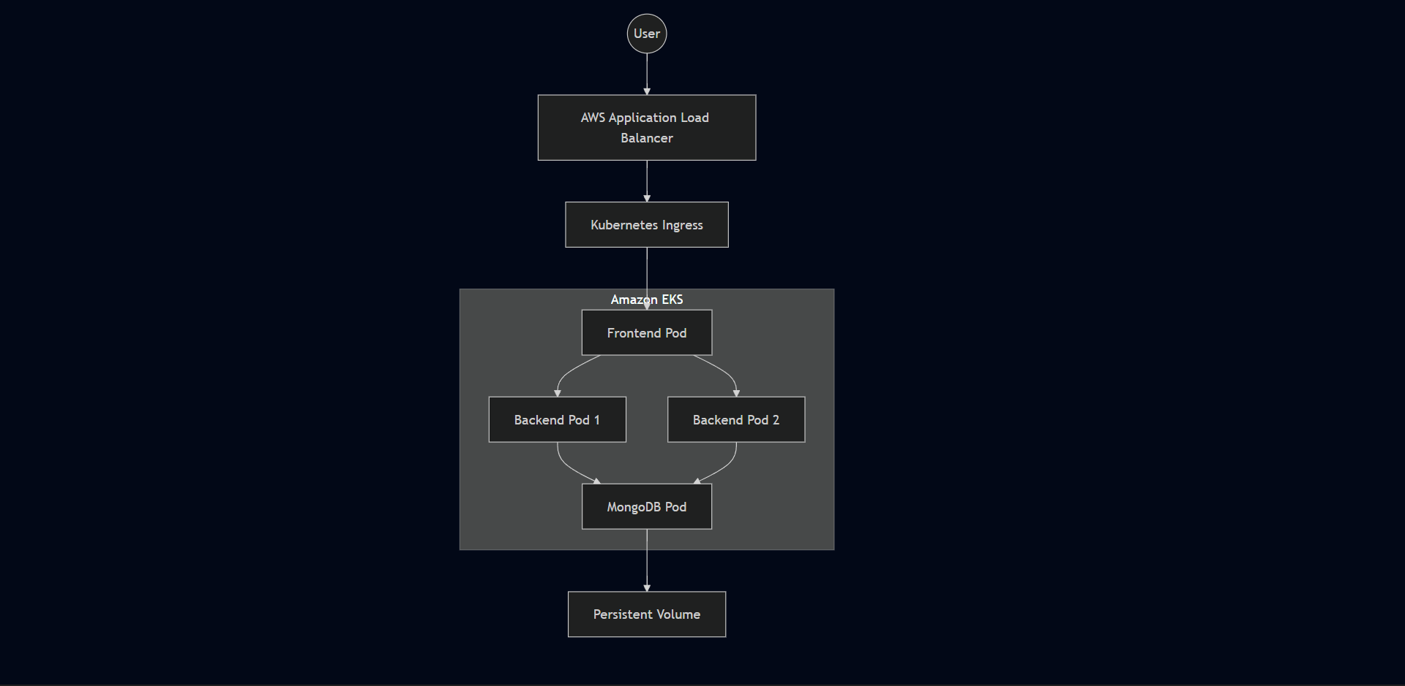

Performance Objectives
Objective | Design Goal
High Availability | Minimize service interruption
Scalability | Support future workload growth
Reliability | Maintain consistent application behavior
Fault Tolerance | Recover automatically from failures
Resource Efficiency | Utilize infrastructure effectively
Operational Stability | Maintain predictable deployments

What Was Actually Validated
Frontend loaded successfully through the ALB DNS endpoint Tasks submitted through the React UI reached the Node.js backend Data stored in MongoDB and persisted across page refreshes Both backend replicas were running and available as Service endpoints No unexpected application failures during functional testing Application remained stable throughout the validation period
What was not measured: Response time or latency Throughput or requests per second Concurrent user capacity CPU and memory utilization under load Pod recovery time after failure Load distribution between backend replicas
- This is an honest assessment of a portfolio deployment. The architecture is designed for these capabilities — they just weren't exercised under load during this project.
- Stateless workloads like the frontend and backend can be scaled by increasing the Deployment replica count. No application code changes needed — Kubernetes handles scheduling additional Pods and the Service distributes traffic automatically.
- MongoDB scaling is more complex. Adding replicas without configuring proper MongoDB replication would create multiple independent database instances rather than a coordinated cluster.
- The managed EKS control plane removes a significant availability concern — AWS is responsible for the API server, scheduler, and etcd.
- Pod Failure: The Kubernetes Deployment and ReplicaSet provide automatic recovery: Pod terminates unexpectedly ReplicaSet detects actual replica count is below desired Kubernetes Scheduler selects an available node New Pod is created and starts Service routes traffic to healthy Pods during recovery
- Node Failure: If a worker node becomes unavailable, Pods scheduled on that node are rescheduled onto remaining healthy nodes. With two worker nodes, a single node failure doesn't take the application offline.
Storage Protection: MongoDB data persists independently of the container lifecycle through Persistent Volumes backed by Amazon EBS. If the MongoDB Pod is restarted or rescheduled, it reattaches to the same EBS volume.
- Keeping AWS costs under control after testing was a deliberate part of the deployment lifecycle:
- AWS resources created through the Ingress integration followed controller-managed cleanup when the Ingress was deleted. The EKS cluster, EC2 management instance, and remaining resources were decommissioned after project completion.
- Running EKS worker nodes, load balancers, and EBS volumes continue generating costs even when idle. Cleaning up promptly after validation is part of responsible cloud resource management.
- Frontend loaded successfully through the ALB DNS endpoint Tasks submitted through the React UI reached the Node.js backend Data stored in MongoDB and persisted across page refreshes Both backend replicas were running and available as Service endpoints No unexpected application failures during functional testing Application remained stable throughout the validation period
- What was not measured: Response time or latency Throughput or requests per second Concurrent user capacity CPU and memory utilization under load Pod recovery time after failure Load distribution between backend replicas
- This is an honest assessment of a portfolio deployment. The architecture is designed for these capabilities — they just weren't exercised under load during this project.
This is an honest assessment of a portfolio deployment. The architecture is designed for these capabilities — they simply weren't exercised under load during this project.

Scalability Strategy
Stateless workloads like the frontend and backend can be scaled by increasing the Deployment replica count. No application code changes needed — Kubernetes handles scheduling additional Pods and the Service distributes traffic automatically.
Component | Scaling Characteristics
Frontend | Horizontally scalable — stateless
Backend API | Horizontally scalable — stateless
MongoDB | Stateful — requires storage coordination
MongoDB scaling is more complex. Adding replicas without configuring proper MongoDB replication would create multiple independent database instances rather than a coordinated cluster.
MongoDB scaling is more complex. Adding replicas without configuring proper MongoDB replication would create multiple independent database instances rather than a coordinated cluster. For this deployment, a single MongoDB instance with persistent storage was the correct approach.

Backend Availability
The backend Deployment was configured with two replicas from the reference project's manifests. Both Pods were running and registered as Service endpoints throughout the deployment.
Client Request
↓
Backend Service
↓
Replica 1 or Replica 2
The Kubernetes Service distributes traffic across available Pods. If one Pod becomes unavailable, the Service continues routing to the remaining healthy replica while Kubernetes schedules a replacement.
Formal traffic distribution testing — verifying requests were actually reaching both Pods — was not performed. The redundancy was architectural rather than load-tested.

High Availability
Capability | Status
Managed Control Plane | ✓ — EKS handles control plane availability
Multiple Worker Nodes | ✓ — 2 x t2.medium nodes
Multiple Backend Replicas | ✓ — 2 replicas configured
Automatic Pod Recovery | ✓ — via Deployment and ReplicaSet
Load Balanced Traffic | ✓ — via ALB and Kubernetes Services
The managed EKS control plane removes a significant availability concern — AWS is responsible for the API server, scheduler, and etcd.

Fault Tolerance

Pod Failure
The Kubernetes Deployment and ReplicaSet provide automatic recovery:
- Pod terminates unexpectedly
- ReplicaSet detects actual replica count is below desired
- Kubernetes Scheduler selects an available node
- New Pod is created and starts
- Service routes traffic to healthy Pods during recovery

Node Failure
If a worker node becomes unavailable, Pods scheduled on that node are rescheduled onto remaining healthy nodes where capacity permits. With two worker nodes, a single node failure doesn't take the application offline — though capacity is reduced.

Storage Protection
MongoDB data persists independently of the container lifecycle through Persistent Volumes backed by Amazon EBS. If the MongoDB Pod is restarted or rescheduled, it reattaches to the same EBS volume and the data is intact.

Self-Healing
Pod fails — container crash, OOM kill, or node issue ReplicaSet detects actual replica count is below desired Kubernetes Scheduler selects an available node New Pod is created and starts pulling its image Service continues routing to healthy Pods during recovery Once the new Pod passes health checks, it joins the Service load balancing pool
This behavior was observable during deployment validation — terminating a Pod resulted in Kubernetes scheduling a replacement automatically.

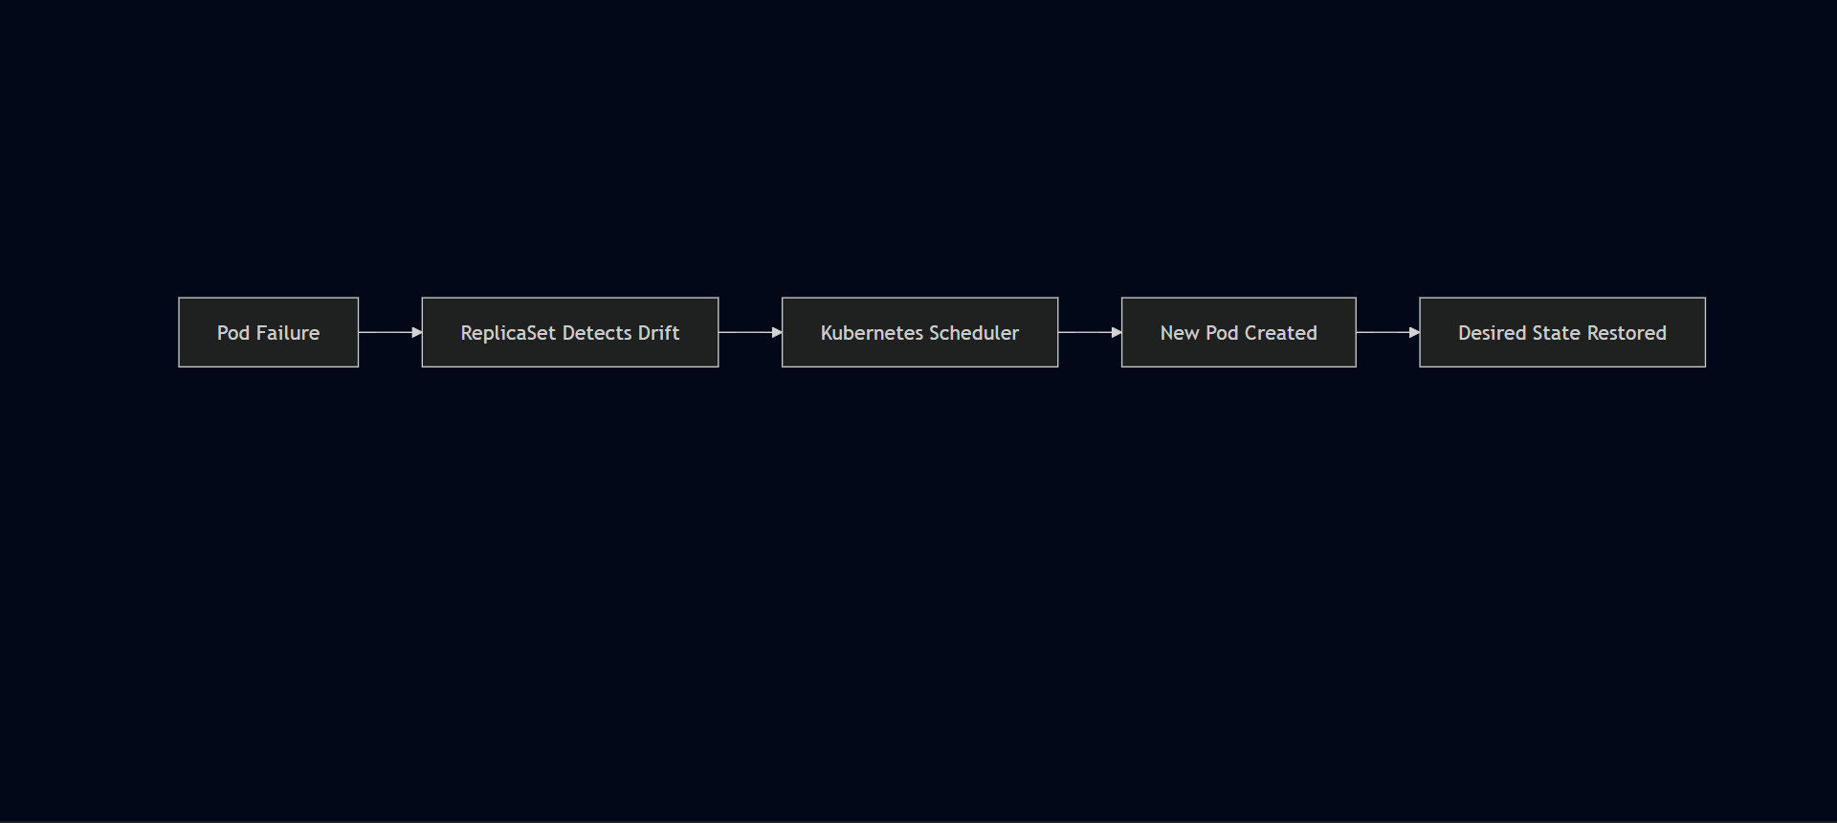

Resource Configuration
Resource | Configuration
Worker Nodes | 2
Instance Type | t2.medium
Backend Replicas | 2
Frontend Replicas | 1
MongoDB Replicas | 1
The t2.medium instance type was used according to the project implementation requirements rather than through workload-specific capacity planning. For a functional three-tier deployment with light testing traffic, it was sufficient.
CPU and memory requests and limits were not confirmed as configured in the Deployment manifests. In a production environment, explicitly defining resource requests and limits is important for:
- Predictable Pod scheduling across nodes
- Preventing resource contention between workloads
- Enabling Horizontal Pod Autoscaler to function correctly
- Improving cluster-level capacity management

Rolling Updates
Kubernetes Deployments support rolling updates — replacing Pods incrementally rather than taking all instances offline simultaneously. This capability was available through the Deployment configuration but was not explicitly exercised during this project.
For a production deployment, rolling updates would be the standard update mechanism — pushing a new image to ECR, updating the Deployment image reference, and letting Kubernetes replace Pods progressively with zero downtime.

Network Performance
Traffic follows a direct path with minimal hops:
Browser
↓
AWS Application Load Balancer
↓
Kubernetes Ingress
↓
Frontend Service
↓
Backend Service
↓
MongoDB Service
↓
MongoDB Pod
Internal service communication uses Kubernetes DNS — stable, low-latency, and requiring no external network calls between application tiers.

Storage Performance
MongoDB uses Persistent Volumes backed by Amazon EBS. EBS provides block storage with consistent I/O performance appropriate for a database workload at this scale. The PV/PVC abstraction means storage can be managed independently of the compute layer — the volume persists even if the Pod or node is replaced.

Cost Management
Keeping AWS costs under control after testing was a deliberate part of the deployment lifecycle:
AWS resources created through the Ingress integration followed controller-managed cleanup when the Ingress was deleted. The EKS cluster, EC2 management instance, and remaining resources were decommissioned after project completion.
Running EKS worker nodes, load balancers, and EBS volumes continue generating costs even when idle. Cleaning up promptly after validation is part of responsible cloud resource management.
bash
kubectl delete -f .
- AWS resources created through the Ingress integration followed controller-managed cleanup when the Ingress was deleted
- EKS cluster decommissioned after project completion
- EC2 management instance stopped after use
- Limited worker node count — 2 nodes rather than over-provisioning
Running EKS worker nodes, load balancers, and EBS volumes continue generating costs even when idle. Cleaning up promptly after validation is part of responsible cloud resource management.

Production Readiness Assessment
Area | Current Status | Production Recommendation
Availability | Good | Multi-AZ worker node groups
Scalability | Good | Horizontal Pod Autoscaler
Storage | Good | Managed database service or StatefulSets
Monitoring | Basic | Prometheus + Grafana
Security | Good | RBAC, Network Policies, AWS WAF
Deployment Strategy | Good | Blue-Green or Canary Deployments
Resource Governance | Not confirmed | Define CPU/memory requests and limits
Performance Testing | Not performed | k6, JMeter, or Locust for load testing

Future Performance Enhancements
Enhancement | Benefit
Horizontal Pod Autoscaler | Automatically scales replicas based on CPU/memory metrics
Cluster Autoscaler | Adds worker nodes when cluster runs out of scheduling capacity
Resource Requests and Limits | Predictable scheduling and resource governance
Node Affinity / Anti-Affinity | Control Pod placement across nodes
Container Image Optimization | Reduce image size and pull time
Load Testing | Validate actual throughput and latency under realistic traffic
Multi-AZ Node Groups | Survive Availability Zone failures

Reliability Assessment
Capability | Result
Cluster Stability | Verified — stable throughout testing
Pod Availability | Verified — all Pods reached Running state
Service Discovery | Verified — internal DNS resolution working
Persistent Storage | Verified — data survived page refreshes
Ingress Routing | Verified — ALB routing traffic correctly
End-to-End Application Flow | Verified — browser to MongoDB confirmed

Chapter 14 — Project Outcome & Engineering Impact

What This Project Actually Was
This wasn't a tutorial where everything worked on the first try. It was a hands-on deployment that required working through real configuration issues across IAM, Kubernetes networking, persistent storage, and application behavior — debugging each one systematically until the complete application was running end to end.
The goal was never just to get containers running. It was to understand how AWS infrastructure, Kubernetes orchestration, and application configuration interact in a real deployment — and to develop the troubleshooting instinct that comes from actually breaking things and fixing them.

Project Objectives vs Outcomes
Project Objective | Outcome | Status
Deploy a three-tier application on Amazon EKS | Successfully deployed | ✅ Completed
Containerize application components | Docker images created and deployed | ✅ Completed
Store images in Amazon ECR | Private repositories configured | ✅ Completed
Configure Kubernetes networking | Services and Ingress implemented | ✅ Completed
Expose application through AWS ALB | Path-based routing operational | ✅ Completed
Configure persistent storage | MongoDB data persisted using PV/PVC | ✅ Completed
Validate end-to-end functionality | Browser → Backend → MongoDB verified | ✅ Completed
Clean up AWS resources | Infrastructure successfully decommissioned | ✅ Completed

What Actually Surprised Me
Two things stood out that I hadn't fully anticipated going in.
React environment variables. I initially expected that updating the environment variable in Kubernetes would change the backend URL the frontend was targeting. It didn't — because React bakes environment variables into the compiled bundle at build time, not at runtime. The Kubernetes config was irrelevant at that point. The fix was switching to a relative API path in taskServices.js so requests routed through Ingress instead of depending on a hardcoded URL. It's not a complicated fix, but understanding why it was broken required understanding how React builds work, not just how Kubernetes works.
IAM and silent failures. The AWS Load Balancer Controller was installed, the Ingress was applied, and nothing happened — no ALB appeared. Everything looked correct from the Kubernetes side. The problem was a single missing IAM permission: elasticloadbalancing:DescribeListenerAttributes. The controller couldn't complete its AWS API calls and failed silently from the Kubernetes perspective. That experience reinforced something that matters in AWS deployments: when something isn't happening that should be, check the permissions layer before assuming the configuration is wrong.

Technical Achievements

Cloud Infrastructure
Six real problems blocked the deployment across six different layers — containerization, storage, networking, application configuration, IAM, and Ingress routing. Chapter 10 covers each one in detail. The critical one was IAM: a single missing permission (elasticloadbalancing:DescribeListenerAttributes) silently blocked ALB provisioning, and finding it required reading controller logs rather than rechecking Kubernetes manifests.
These weren't theoretical problems. Each one blocked a real part of the deployment and required actual investigation to resolve.
I manually created and configured most of the environment to understand how everything worked — which was the right approach for learning, but not for repeatability. If I ran this project again, I'd use Terraform for infrastructure provisioning from the start rather than manual setup, and add a CI/CD pipeline to handle image builds, ECR pushes, and EKS deployments automatically. The manual process made the dependencies between components visible, which helped with troubleshooting. But for anything running beyond a single deployment cycle, automation is the right answer.
- Amazon ECR integration — private repositories for frontend and backend
- AWS Application Load Balancer deployment via Kubernetes Ingress
- Persistent storage configuration — EBS-backed PV/PVC for MongoDB

Kubernetes Engineering
- Namespace isolation — workshop namespace
- Deployments — frontend, backend, MongoDB
- ReplicaSets — automatic Pod recovery
- ClusterIP Services — internal-only communication
- Kubernetes Ingress — path-based routing
- Secrets — MongoDB credential management
- Persistent Volumes and Persistent Volume Claims
- Health probes — backend workload monitoring
- Rolling update support through Deployment configuration

Containerization
Containerization was the first major step before anything could run on Kubernetes. Each application tier — React frontend, Node.js backend, and MongoDB — needed to be packaged as a Docker image before EKS could schedule it as a workload. All builds ran on the Ubuntu EC2 management instance.
The Dockerfiles were already in the project repository. My work was working through the build process, fixing the issues that came up, pushing images to ECR, and then referencing those images in the Kubernetes Deployment manifests.
- Private image registry — Amazon ECR
- Immutable deployment model — no in-place container modification

Application Deployment
Production-Style Cloud-Native Application Deployment on Amazon Elastic Kubernetes Service
Prepared by: Anwarullah Khan Nuzair — Cloud & DevOps Engineer Email: myselfnuzairkhan@gmail.com LinkedIn: https://www.linkedin.com/in/anwarullah-khan-nuzair GitHub: https://github.com/Nuzairkhan
- MongoDB database — stateful workload with persistent storage
- End-to-end API communication verified
- Database persistence validated across Pod lifecycle

Operational Achievements
Activity | Result
Infrastructure Provisioning | Completed
Cluster Administration | Completed
Container Deployment | Completed
Storage Configuration | Completed
Networking Configuration | Completed
Load Balancer Integration | Completed
Application Validation | Completed
Infrastructure Cleanup | Completed

Engineering Skills Demonstrated
Domain | Skills Demonstrated
Cloud Engineering | AWS resource provisioning, networking, IAM
Platform Engineering | Amazon EKS administration via eksctl
Kubernetes | Workload orchestration, networking, storage
Containerization | Docker image lifecycle management
Networking | Ingress, Services, DNS-based discovery
Storage | Persistent Volumes, Persistent Volume Claims
Linux Administration | SSH-based cluster management from Ubuntu EC2
Troubleshooting | Root cause analysis across Kubernetes and AWS layers

Engineering Decisions Validated
Design Decision | Result
Managed Kubernetes via EKS | Reduced control plane overhead
eksctl for provisioning | Automated VPC, subnet, and node group creation
ClusterIP Services | Secure internal communication
ALB Ingress | Simplified external routing — single endpoint
Amazon ECR | Reliable image distribution with IAM-based auth
Persistent Storage | Successful MongoDB data persistence
Backend Replication | Redundancy at the Pod level
Dedicated EC2 management host | Consistent administration environment

Production Readiness Assessment
Capability | Assessment
Declarative Infrastructure | Implemented
Containerized Workloads | Implemented
Managed Kubernetes | Implemented
Persistent Storage | Implemented
Internal Service Discovery | Implemented
External Load Balancing | Implemented
Self-Healing | Implemented via Deployment configuration
Rolling Updates | Supported
Infrastructure Cleanup | Implemented
CI/CD Automation | Future Enhancement
Infrastructure as Code | Future Enhancement
Advanced Monitoring | Future Enhancement
RBAC and Network Policies | Future Enhancement

Operational Metrics
Metric | Value
Kubernetes Cluster | 1
Worker Nodes | 2 x t2.medium
Deployments | 3
ReplicaSets | 3
Running Pods | 4
Services | 3
Ingress Resources | 1
Persistent Volumes | 1
Persistent Volume Claims | 1
Application Load Balancers | 1
Amazon ECR Repositories | 2

Engineering Challenges Overcome
Challenge | Category | Severity | Status
Dockerfile naming — Dockefile | Containerization | Medium | Resolved
PVC stuck in Pending | Kubernetes Storage | High | Resolved
Service port mismatch — 3500 | Kubernetes Networking | High | Resolved
React build-time env vars | Application Config | Medium | Resolved
Missing IAM permission | AWS Security | Critical | Resolved
Ingress host configuration | Networking | Medium | Resolved
Six real problems blocked the deployment across six different layers — containerization, storage, networking, application configuration, IAM, and Ingress routing. Chapter 10 covers each one in detail. The critical one was IAM: a single missing permission (elasticloadbalancing:DescribeListenerAttributes) silently blocked ALB provisioning, and finding it required reading controller logs rather than rechecking Kubernetes manifests. These weren't theoretical problems. Each one blocked a real part of the deployment and required actual investigation to resolve.

What I'd Do Differently
I manually created and configured most of the environment to understand how everything worked — which was the right approach for learning, but not for repeatability. If I ran this project again, I'd use Terraform for infrastructure provisioning from the start rather than manual setup, and add a CI/CD pipeline to handle image builds, ECR pushes, and EKS deployments automatically. The manual process made the dependencies between components visible, which helped with troubleshooting. But for anything running beyond a single deployment cycle, automation is the right answer.

Key Takeaways
A few things this project reinforced that aren't obvious from documentation alone:
- Small configuration details have large consequences. A single missing IAM permission stopped the entire load balancer from provisioning. A one-character filename typo blocked the image build pipeline.
- Kubernetes and AWS are separate layers that both need to be correct. Healthy Pods don't mean correct networking. Correct Kubernetes configs don't mean correct AWS permissions.
- React build behavior is different from server-side runtime behavior. Build-time configuration needs to be understood before deployment, not discovered during debugging.
- Incremental validation is faster than end-to-end testing. Checking each layer before moving to the next caught issues earlier and made root causes easier to isolate.

Value to Employers
- Deploy Kubernetes applications on AWS EKS from scratch
- Configure AWS networking, IAM, and managed services
- Manage containerized workloads across multiple tiers
- Implement persistent storage for stateful applications
- Diagnose infrastructure issues across Kubernetes and AWS layers simultaneously
- Apply structured troubleshooting methodologies under real conditions
- Operate and decommission cloud infrastructure responsibly
The goal of this portfolio is straightforward: to show that I can take a complex deployment, work through the problems that come with it, connect the different pieces together, and keep debugging until the complete application actually works. That's what this project demonstrates.

Chapter 15 — Future Enhancements & Platform Evolution

Overview
This deployment works. The application runs, the infrastructure held up under real debugging conditions, and the complete frontend → backend → database flow was verified end to end. But it was built and deployed manually — every resource provisioned through CLI commands, every manifest applied by hand.
That's the right approach for learning. It's not the right approach for a repeatable, production-scale deployment. This chapter outlines what would need to change to evolve this from a portfolio implementation into something closer to an enterprise platform.

Platform Evolution Roadmap
The AWS infrastructure for this project was provisioned using eksctl and AWS CLI commands. eksctl automated a significant amount of cluster setup, but the overall provisioning process is manual and not version-controlled as infrastructure code.

Enhancement Roadmap
Phase | Focus Area | Primary Goal
Phase 1 | Infrastructure Automation | Eliminate manual provisioning
Phase 2 | CI/CD | Automated application delivery
Phase 3 | Observability | Centralized monitoring and alerting
Phase 4 | GitOps | Declarative continuous delivery
Phase 5 | Production Operations | Scalability, resilience, and governance

Phase 1 — Infrastructure as Code with Terraform

Current State
Terraform is the next infrastructure tool I want to learn. The goal is to provision the same AWS environment — VPC, EKS cluster, node groups, ECR repositories, IAM roles — through declarative Terraform configuration files rather than CLI commands.

Planned Next Step
Proposed scope: Amazon VPC and subnet configuration Internet Gateway and route tables Security Groups IAM Roles and policies Amazon EKS cluster and managed node groups Amazon ECR repositories CloudWatch resources
Container images are currently built manually on the EC2 management instance and pushed to Amazon ECR by hand. Every application update requires SSHing into the instance, rebuilding the image, and reapplying Kubernetes manifests.

Proposed Terraform Scope
- I have hands-on experience with both Jenkins and GitHub Actions from previous CI/CD work — including build automation, SonarQube integration, Nexus Repository, and deployment to AWS EC2. Applying that experience to this EKS deployment would automate the full image build and deployment pipeline.
- Proposed CI workflow: Source code validation on every push Dependency installation and unit testing Docker image build and tagging Security scanning before push Automated push to Amazon ECR Kubernetes Deployment update on successful image push
- I'm familiar with Prometheus and Grafana conceptually and have read enough about Kubernetes monitoring to understand the patterns — metrics scraping via exporters, alerting through Alertmanager, log forwarding with Fluent Bit. But I haven't implemented any of it hands-on yet. That's the gap. Adding a real observability stack — something beyond kubectl get pods and the AWS Console — would be the next meaningful step after CI/CD is sorted.
- The current implementation demonstrates the core engineering workflow — provisioning infrastructure, containerizing an application, deploying it on Kubernetes, debugging real issues, and validating the result. That foundation is solid.
- The next logical steps are clear: Terraform — replace manual provisioning with version-controlled infrastructure code. Highest priority next learning area. CI/CD pipeline — apply existing Jenkins and GitHub Actions experience to automate image builds and EKS deployments. Observability — add Prometheus and Grafana to move from reactive debugging to proactive monitoring. GitOps — introduce Argo CD to make cluster state declarative and auditable.
- These aren't aspirational additions — they're the natural next layer on top of what's already working.
- CloudWatch resources

Benefits
- Version-controlled infrastructure — every change tracked in Git
- Repeatable deployments — same environment every time
- Reduced configuration drift between environments
- Easier disaster recovery — rebuild from code rather than memory
- Cleaner separation between infrastructure and application concerns

Phase 2 — CI/CD Pipeline

Current State
Container images are built manually on the EC2 management instance, tagged, and pushed to Amazon ECR by hand. Every application update requires SSHing into the instance, rebuilding the image, and reapplying Kubernetes manifests.

Planned Enhancement
I have hands-on experience with both Jenkins and GitHub Actions from previous CI/CD work — including build automation, SonarQube integration, Nexus Repository, and deployment to AWS EC2. Applying that experience to this EKS deployment would automate the full image build and deployment pipeline.

Proposed CI Workflow
DeveloperGitHubBuildUnit TestsDocker BuildImage ScanAmazon ECR

Pipeline Responsibilities
- Source code validation on every push
- Dependency installation and unit testing
- Docker image build and tagging
- Security scanning before push
- Automated push to Amazon ECR
- Kubernetes Deployment update on successful image push

Benefits
- No manual SSH sessions for application updates
- Every code change goes through the same validated pipeline
- Image scanning catches vulnerabilities before deployment
- Faster, more consistent releases

Phase 3 — Observability Stack

Current State
Monitoring during this project relied on kubectl-based diagnostics, AWS Console verification, and container logs from the Load Balancer Controller. This was sufficient for debugging during implementation but doesn't provide ongoing operational visibility.

Planned Enhancement
I'm familiar with Prometheus and Grafana and understand their role in Kubernetes monitoring, but haven't implemented them hands-on in this project. Adding a proper observability stack would be the next meaningful improvement after CI/CD.

Recommended Components
Technology | Purpose
Prometheus | Metrics collection from Kubernetes and applications
Grafana | Dashboard visualization
Alertmanager | Alert routing and notification
Fluent Bit | Log forwarding from containers
Elasticsearch | Centralized log storage
Kibana | Log visualization and search
OpenTelemetry | Unified telemetry collection

What This Would Enable
- The biggest surprise wasn't any individual technology — it was how many layers had to work correctly simultaneously for a simple application to show up in a browser.
- A working EKS cluster wasn't enough. Healthy Pods weren't enough. The IAM permissions, Load Balancer Controller, Ingress configuration, Service port mappings, frontend API paths, and persistent storage configuration all had to be correct at the same time. When something was wrong, the symptom often appeared at a completely different layer from the actual cause — a frontend that couldn't reach the backend turned out to be a React build-time configuration issue, not a Kubernetes networking problem.
- That's the practical value of this stack — not just how each tool works individually, but how they interact as a system.
- Centralized log search across all application tiers
- Performance baselines to compare against after changes

Phase 4 — GitOps with Argo CD

Current State
Kubernetes resources are applied manually using kubectl apply -f . from the management instance. There's no automated synchronization between the Git repository and the cluster state.

Planned Enhancement
I have conceptual awareness of Argo CD and GitOps workflows but haven't implemented a full GitOps deployment for this project. The idea is straightforward — the Git repository becomes the single source of truth for cluster state, and Argo CD continuously ensures the cluster matches what's defined in Git.

Proposed Architecture
GitRepositoryArgoCDAmazonEKSKubernetes Resources

Advantages
- Declarative deployments — Git is the audit trail
- Automatic synchronization — cluster drift is detected and corrected
- Rollback is a Git revert, not a manual kubectl operation
- Every deployment change is reviewed through a pull request

Phase 5 — Autoscaling

Current State
Replica counts are statically configured in the Deployment manifests. The backend runs two replicas regardless of actual traffic. Worker node count is fixed at two t2.medium instances.

Horizontal Pod Autoscaler
HPA would automatically adjust replica counts based on CPU or memory metrics:
TrafficIncreaseMetrics ServerHorizontal Pod AutoscalerAdditional Pods
For stateless workloads like the frontend and backend, this means the deployment scales to meet demand automatically rather than requiring manual replica count changes.

Cluster Autoscaler
When the cluster runs out of scheduling capacity — too many Pods for the available nodes — the Cluster Autoscaler adds worker nodes automatically. Combined with HPA, this means the entire infrastructure scales up and down with demand rather than being statically provisioned.

Phase 6 — Advanced Deployment Strategies

Blue-Green Deployment
Maintain two production environments. Traffic switches from the current version to the new version atomically — instant rollback if something goes wrong.
Blue Environment (current)
↓
Validation of Green Environment
↓
Traffic Switch
↓
Green Environment (live)

Canary Deployment
Release new versions to a small percentage of traffic first. Observe behavior before gradually increasing the rollout. Catch issues affecting real users without exposing everyone to a potentially broken release.
Both strategies require more infrastructure than a basic rolling update but significantly reduce deployment risk for production systems.

Phase 7 — Security Enhancements
Enhancement | Benefit
AWS Secrets Manager | Centralized secret lifecycle management
AWS KMS | Encryption of Kubernetes Secrets at rest
Kubernetes RBAC | Fine-grained cluster authorization
Network Policies | Pod-to-Pod traffic restrictions
AWS WAF | Web application protection
Image Scanning | Vulnerability detection in ECR
SSM Session Manager | SSH-free EC2 administration
Admission Controllers | Policy enforcement at deployment time

Phase 8 — Cost Optimization
Beyond the cleanup practices applied in this project, a production deployment would add:
- Spot Instances — significant cost reduction for stateless workloads that can tolerate interruption
- Resource requests and limits — prevent over-provisioning and improve node utilization
- Image lifecycle policies in ECR — automatically expire old image versions
- Scheduled node scaling — reduce capacity during off-peak hours
- Cost allocation tagging — track spending per team, environment, or workload

Recommended Enterprise Architecture
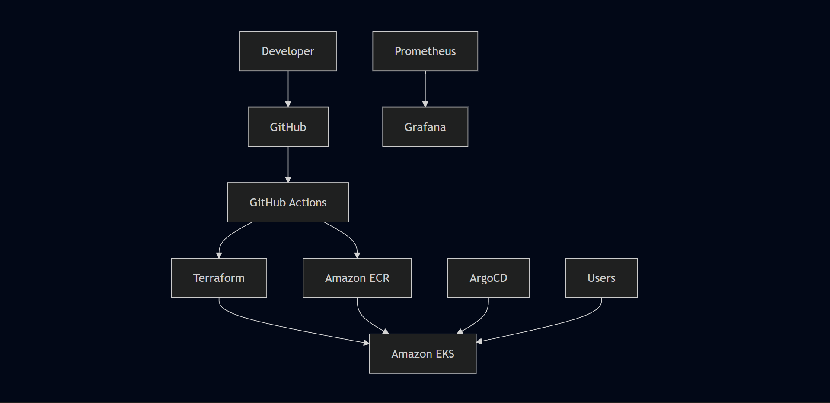

Platform Maturity Assessment
Capability | Current | Future Target
Kubernetes Deployment | ✅ Functional | Production Grade
Infrastructure Automation | Manual — eksctl/CLI | Terraform
CI/CD | Manual — SSH + kubectl | GitHub Actions
Monitoring | kubectl + AWS Console | Prometheus + Grafana
Logging | kubectl logs | ELK Stack
Security | Good — IAM, Secrets, ClusterIP | RBAC, Network Policies, WAF
GitOps | Not implemented | Argo CD
Autoscaling | Static replicas | HPA + Cluster Autoscaler
Service Mesh | Not implemented | Istio
Deployment Strategy | Rolling updates | Blue-Green and Canary

Honest Assessment of Where Things Stand
Completing a deployment successfully and being production-ready are not the same thing. Here's where this implementation actually stands.
The next logical steps are clear:
- Terraform — replace manual provisioning with version-controlled infrastructure code. This is the highest priority next learning area.
- CI/CD pipeline — apply existing Jenkins and GitHub Actions experience to automate image builds and EKS deployments.
- Observability — add Prometheus and Grafana to move from reactive debugging to proactive monitoring.
- GitOps — introduce Argo CD to make cluster state declarative and auditable.
These aren't aspirational additions — they're the natural next layer on top of what's already working.

