Three-Tier Application Deployment on AWS EKS — Part 3 of 3
Troubleshooting Journey, Deployment Validation, Architecture Decisions, Engineering Reflection, Production Readiness, Appendix

This document continues the technical portfolio from Part 1.

Chapter 16 — Troubleshooting & Debugging Journey

Overview
Deploying this application involved more than writing Kubernetes manifests and applying them to a cluster. The deployment crossed multiple layers — and a failure at any point in that chain could prevent the application from working even when everything above or below it appeared healthy.
The narrative analysis of each problem — what broke, what the investigation showed, what fixed it — is in Chapter 10. This chapter records the same six incidents as a structured incident log: symptom, root cause, resolution, and the specific debugging insight that applied.
↓
Docker
↓
The approach throughout was to isolate the failing layer first, not assume a generic configuration problem:
↓
All debugging happened from the dedicated Ubuntu EC2 management instance over SSH.
↓
Common validation commands:
↓
Symptom: The backend container image failed during the initial build phase. Without a successful image there was nothing to push to ECR, and Kubernetes had nothing to pull. The failure occurred before Kubernetes was involved — which immediately narrowed the problem to the local containerization layer.
↓
IAM
↓
Root Cause: The file in the backend directory was named Dockefile instead of Dockerfile. One missing character blocked the entire build.
↓
Resolution: Renamed the file to Dockerfile and reran the image build. The image built successfully and pushed to Amazon ECR cleanly.
↓
Browser
Debugging takeaway: Start at the point where the failure first occurs. Kubernetes was not the problem here — the image hadn't even been created yet.
Symptom: MongoDB couldn't start because the Persistent Volume Claim remained in Pending instead of transitioning to Bound. The storage dependency chain:
│
▼
If the claim can't bind to storage, the database workload can't attach the required volume.
│
Root Cause: The PVC was applied before a matching Persistent Volume was available for binding. The dependency sequence matters:
│
▼
Resolution: Applied storage resources in the correct order — PV before PVC before MongoDB Deployment. Once the PV was in place, the PVC bound immediately:
│
Debugging takeaway: When a stateful workload fails to start, inspect the storage dependency chain before assuming the container configuration is wrong.
│
▼
Symptom: The frontend loaded in the browser. Backend Pods showed Running. But API calls were failing.
│
Pod Status = Running did not mean Application Networking = Correct.
│
▼
Root Cause: The Service targetPort didn't match the backend application's listening port (3500).
│
Resolution: Corrected the Service manifest:
│
▼
Debugging takeaway: A healthy Pod only proves the container is running. It doesn't prove traffic can reach the application. Always verify Service port configuration matches what the application actually exposes.
Symptom: Frontend accessible. Backend Pods running. Service configuration correct. API requests still failing.

Debugging Environment
Root Cause: The frontend was using REACT_APP_BACKEND_URL as an environment variable. React resolves environment variables at build time — changing the Kubernetes environment variable after the image was built had no effect on the already-compiled JavaScript bundle.
Tool | Primary Use
kubectl | Inspecting and managing Kubernetes resources
eksctl | Creating and managing the EKS cluster
AWS CLI | Authenticating with and interacting with AWS services
docker | Building and managing container images
helm | Installing the AWS Load Balancer Controller
AWS Console | Verifying EKS, ECR, IAM, and ALB resources
Browser | End-to-end application validation
Resolution: Changed taskServices.js to use a relative path (const apiUrl = "/api/tasks") so the request routes through the ALB and Ingress handles the /api path — no compiled-in URL needed.
Debugging takeaway: Not every deployment problem belongs to Kubernetes. When infrastructure appears healthy but the application still fails, trace the request back into the application configuration itself.
bash
kubectl get nodes
kubectl get pods -n workshop
kubectl get svc -n workshop
kubectl get ingress -n workshop
kubectl get pvc -n workshop
kubectl describe <resource-name> -n workshop
Symptom: Kubernetes Ingress created. Controller running. No ALB appeared in AWS Console. The Ingress ADDRESS field remained empty.

Incident 01 — Docker Build Blocked by Invalid Dockerfile Name

Symptom
Root Cause: The IAM role attached to the Load Balancer Controller was missing elasticloadbalancing:DescribeListenerAttributes. Controller logs showed HTTP 403 responses from AWS — an authorization failure, not a Kubernetes configuration problem.

Investigation
Resolution: Attached the missing permission to the IAM policy and restarted the controller. The Ingress received an ALB DNS address within a few minutes.
Debugging takeaway: When an AWS-integrated controller appears healthy in Kubernetes but nothing happens on the AWS side, check the controller logs before touching any Kubernetes manifest.
Symptom: The initial Ingress configuration included hostname-based routing, but the deployment didn't use a custom domain — just the ALB DNS name directly.
Root Cause: The routing model assumed hostname-based access when the actual requirement was simpler.
Resolution: Removed the host field from the Ingress configuration. Simplified to path-based routing only:

Root Cause
Debugging takeaway: Infrastructure should match the actual requirement. If a dependency isn't needed for the deployment objective, removing it simplifies both configuration and troubleshooting.

Resolution
Work from the failing layer. When the Docker image failed, Kubernetes was irrelevant. When the PVC was pending, the frontend was irrelevant. When the ALB didn't provision, the application Pods weren't the first thing to check.

Running doesn't mean working. A Pod can be healthy while Services route to the wrong port, IAM blocks infrastructure, or application configuration points to the wrong endpoint.
↓
docker build
↓
Logs are more useful than assumptions. The Load Balancer Controller issue demonstrated this directly. The controller appeared healthy — but its logs showed HTTP 403. That prevented unnecessary Kubernetes manifest changes and pointed straight at IAM.
↓
Stateful workloads have dependency ordering. MongoDB wasn't just a container — it required a Persistent Volume to exist and bind before the Pod could schedule.
↓
Application configuration can look like an infrastructure problem. The React environment variable issue looked like a Kubernetes networking problem. The real issue was the frontend build process.

Verification
The most valuable outcome wasn't resolving six individual problems. It was developing a clearer way to reason about a cloud-native system under failure conditions:
This project required debugging across Docker, ECR, Kubernetes workloads, Services, persistent storage, application configuration, Ingress, IAM, the Load Balancer Controller, and ALBs. The deployment worked because each failure was traced back to its responsible layer rather than treating the entire EKS environment as one black box.

Incident 02 — MongoDB Could Not Start Because Storage Was Not Bound

Symptom
MongoDB couldn't start because the Persistent Volume Claim remained in Pending instead of transitioning to Bound. The storage dependency chain looked like this:
MongoDB Pod
↓
Persistent Volume Claim
↓
Persistent Volume
↓
Amazon EBS-backed Storage
If the claim can't bind to storage, the database workload can't attach the required volume.

Investigation
Storage resources were checked independently from the application Pods:
bash
kubectl get pvc -n workshop
kubectl get pv
The PVC hadn't transitioned to a usable bound state — which shifted the investigation away from MongoDB configuration and toward the Kubernetes storage layer.

Root Cause
Getting this deployment to a working state wasn't a straight line. Problems came up across containerization, storage, Kubernetes networking, IAM, and application configuration — sometimes in ways that weren't obvious from the surface symptoms. This chapter documents each issue honestly: what broke, what the investigation showed, and what fixed it.
Most debugging happened over SSH on the Ubuntu EC2 management instance, running kubectl, eksctl, the AWS CLI, and Docker from the terminal. The AWS Console ran alongside for verifying infrastructure state — load balancer status, IAM role attachments, ECR repositories, and target group health.
↓
Persistent Volume Claim
↓
MongoDB Deployment / Pod
Applying resources in the wrong order left the claim waiting indefinitely.

Resolution
Storage resources were applied in the correct order — PV before PVC before MongoDB Deployment:
1. Persistent Volume
↓
2. Persistent Volume Claim
↓
3. MongoDB Deployment
↓
4. MongoDB Pod receives storage

Verification
bash
kubectl get pvc -n workshop
Expected state after fix:
STATUS: Bound
Once bound, MongoDB could use the configured persistent storage and the Pod scheduled successfully.
Debugging takeaway: When a stateful workload fails to start, inspect the storage dependency chain before assuming the container configuration is wrong.

Incident 03 — Healthy Backend Pods but Failed API Connectivity

Symptom
The frontend loaded in the browser. Backend Pods showed Running. But API calls were failing. This was an important scenario because:
Pod Status = Running
did not mean:
Application Networking = Correct

Investigation
Two layers were compared separately:
Application layer: The Node.js backend was listening on port 3500.
Kubernetes networking layer: The Service targetPort needed to match that port exactly.
Expected flow:
Ingress
↓
Backend Service
↓
targetPort: 3500
↓
Node.js Application
Any mismatch breaks the chain even if the Pod is healthy.

Root Cause
Getting this deployment to a working state wasn't a straight line. Problems came up across containerization, storage, Kubernetes networking, IAM, and application configuration — sometimes in ways that weren't obvious from the surface symptoms. This chapter documents each issue honestly: what broke, what the investigation showed, and what fixed it. Most debugging happened over SSH on the Ubuntu EC2 management instance, running kubectl, eksctl, the AWS CLI, and Docker from the terminal. The AWS Console ran alongside for verifying infrastructure state — load balancer status, IAM role attachments, ECR repositories, and target group health.

Resolution
Corrected the Service manifest:
yaml
targetPort: 3500
The corrected traffic path:
/api request
↓
AWS ALB
↓
Kubernetes Ingress
↓
Backend Service
↓
targetPort: 3500
↓
Node.js API

Verification
After correcting the Service, frontend API requests reached the backend successfully.
Debugging takeaway: A healthy Pod only proves the container is running. It doesn't prove traffic can reach the application. Always verify Service port configuration matches what the application actually exposes.

Incident 04 — React API Configuration Failed After Deployment

Symptom
Frontend accessible. Backend Pods running. Service configuration correct. Yet API requests kept failing. This was one of the more interesting problems because the issue wasn't in Kubernetes at all.

Initial Assumption
The frontend originally used a build-time environment variable for the backend URL:
REACT_APP_BACKEND_URL
The natural assumption was that updating this in Kubernetes would change where the frontend sent requests. It didn't — because React resolves environment variables at build time, not runtime:
Environment Variable
↓
npm run build
↓
Compiled JavaScript Bundle
↓
Docker Image
↓
ECR
↓
Kubernetes Deployment
Once the image was built, changing a Kubernetes environment variable had no effect on the already-compiled bundle.

Root Cause
Getting this deployment to a working state wasn't a straight line. Problems came up across containerization, storage, Kubernetes networking, IAM, and application configuration — sometimes in ways that weren't obvious from the surface symptoms. This chapter documents each issue honestly: what broke, what the investigation showed, and what fixed it. Most debugging happened over SSH on the Ubuntu EC2 management instance, running kubectl, eksctl, the AWS CLI, and Docker from the terminal. The AWS Console ran alongside for verifying infrastructure state — load balancer status, IAM role attachments, ECR repositories, and target group health.

Investigation
The frontend source was checked directly:
bash
cat taskServices.js
The fix was to remove the dependency on a hardcoded or build-time backend host and use a relative API path instead:
javascript
const apiUrl = "/api/tasks";

Resolution
With a relative path, the request goes to whatever host is serving the frontend — the ALB — and Ingress handles routing /api traffic to the backend:
Browser
↓
ALB DNS
↓
/api/tasks
↓
Kubernetes Ingress
↓
Backend Service
↓
Node.js API

Verification
After changing the path and rebuilding the frontend image, the complete workflow validated:
Browser → React UI → /api/tasks → ALB → Ingress → Node.js → MongoDB
Debugging takeaway: Not every deployment problem belongs to Kubernetes. When infrastructure appears healthy but the application still fails, trace the request back into the application configuration.

Incident 05 — AWS Load Balancer Controller Could Not Provision the ALB

Symptom
Kubernetes Ingress created. Controller running. No ALB appeared. The Ingress had no external address.
Ingress Created
↓
AWS Load Balancer Controller Running
↓
ALB Not Created
↓
No External Address
The controller was running successfully while failing to complete the AWS API operations needed to provision infrastructure.

Investigation
The controller logs were the critical step:
bash
kubectl logs -n kube-system deployment/aws-load-balancer-controller
The logs showed HTTP 403 authorization failures from AWS. That immediately changed the direction of investigation — away from Kubernetes manifests and toward IAM.

Root Cause
Getting this deployment to a working state wasn't a straight line. Problems came up across containerization, storage, Kubernetes networking, IAM, and application configuration — sometimes in ways that weren't obvious from the surface symptoms. This chapter documents each issue honestly: what broke, what the investigation showed, and what fixed it.
Most debugging happened over SSH on the Ubuntu EC2 management instance, running kubectl, eksctl, the AWS CLI, and Docker from the terminal. The AWS Console ran alongside for verifying infrastructure state — load balancer status, IAM role attachments, ECR repositories, and target group health.
The controller could reach the Kubernetes API but lacked authorization to complete all required AWS API operations.

Resolution
The missing permission was added to the IAM policy. After correcting permissions and restarting the controller, provisioning resumed:

Kubernetes Ingress
↓
AWS Load Balancer Controller
↓
AWS API Authorization ✓
↓
Application Load Balancer
↓
Target Groups
↓
Ingress Address

Verification
bash
kubectl get ingress -n workshop
After the fix, the Ingress received an external ALB DNS address. The ALB was also visible in the AWS Console.
Debugging takeaway: When an AWS-integrated controller appears healthy but creates no infrastructure, check controller logs and IAM permissions before modifying Kubernetes manifests.

Incident 06 — Ingress Routing Required a Domain That Didn't Exist

Symptom
The initial Ingress configuration included hostname-based routing. But the deployment didn't use a custom domain — just the ALB DNS name directly. The hostname requirement introduced an unnecessary dependency.

Root Cause
Getting this deployment to a working state wasn't a straight line. Problems came up across containerization, storage, Kubernetes networking, IAM, and application configuration — sometimes in ways that weren't obvious from the surface symptoms. This chapter documents each issue honestly: what broke, what the investigation showed, and what fixed it. Most debugging happened over SSH on the Ubuntu EC2 management instance, running kubectl, eksctl, the AWS CLI, and Docker from the terminal. The AWS Console ran alongside for verifying infrastructure state — load balancer status, IAM role attachments, ECR repositories, and target group health.

Resolution
Removed the host field from the Ingress configuration. Simplified to path-based routing only:
/ → Frontend Service
/api → Backend Service
Final public access model:
Internet
↓
AWS ALB DNS
↓
Kubernetes Ingress
├──────────────────┐
│ │
▼ ▼
/ /api
Frontend Backend

Verification
Opened the ALB DNS directly in a browser. Frontend loaded through /, API requests routed through /api. No custom domain needed.
Debugging takeaway: Infrastructure should match the actual requirement. If a dependency isn't needed for the deployment objective, removing it simplifies both configuration and troubleshooting.

Debugging Command Reference
bash
# Cluster health
kubectl get nodes

# Pod status
kubectl get pods -n workshop

# Service configuration
kubectl get svc -n workshop

# PVC binding status
kubectl get pv
kubectl get pvc -n workshop

# Ingress and ALB address
kubectl get ingress -n workshop

# Detailed resource inspection
kubectl describe pod <pod-name> -n workshop
kubectl describe svc <service-name> -n workshop
kubectl describe pvc <pvc-name> -n workshop
kubectl describe ingress <ingress-name> -n workshop

# Container logs
kubectl logs <pod-name> -n workshop

# Controller logs
kubectl logs -n kube-system deployment/aws-load-balancer-controller

End-to-End Debugging Model
By the end of the project, the deployment could be debugged as a sequence of dependent layers:
┌─────────────────────────────┐
│ Browser Test │
└──────────────┬──────────────┘
↓
┌─────────────────────────────┐
│ Application Load Balancer │
└──────────────┬──────────────┘
↓
┌─────────────────────────────┐
│ Ingress │
└──────────────┬──────────────┘
│
┌───────┴────────┐
↓ ↓
┌──────────────┐ ┌──────────────┐
│ Frontend Svc │ │ Backend Svc │
└──────┬───────┘ └──────┬───────┘
↓ ↓
┌──────────────┐ ┌──────────────┐
│ React Pod │ │ Node.js Pods │
└──────────────┘ └──────┬───────┘
↓
┌──────────────┐
│ MongoDB Svc │
└──────┬───────┘
↓
┌──────────────┐
│ MongoDB Pod │
└──────┬───────┘
↓
┌──────────────┐
│ PV / PVC │
│ Amazon EBS │
└──────────────┘
Layer | Primary Validation
EKS | kubectl get nodes
Workloads | kubectl get pods
Application failures | kubectl logs
Resource configuration | kubectl describe
Internal networking | Services and port validation
Persistent storage | kubectl get pv/pvc
External routing | kubectl get ingress
AWS infrastructure | AWS Console
Controller failures | Controller logs
Authorization | IAM policies and AWS API errors

Key Engineering Lessons
Work from the failing layer. When the Docker image failed, Kubernetes was irrelevant. When the PVC was pending, the frontend was irrelevant. When the ALB didn't provision, the application Pods weren't the first thing to check.
Running doesn't mean working. A Pod can be healthy while Services route to the wrong port, IAM blocks infrastructure, or application configuration points to the wrong endpoint.
Logs are more useful than assumptions. The Load Balancer Controller issue demonstrated this directly. The controller appeared healthy — but its logs showed HTTP 403. That prevented unnecessary Kubernetes manifest changes and pointed straight at IAM.
Stateful workloads have dependency ordering. MongoDB wasn't just a container — it required a Persistent Volume to exist and bind before the Pod could schedule.
Application configuration can look like an infrastructure problem. The React environment variable issue looked like a Kubernetes networking problem. The real issue was the frontend build process.

Chapter Summary
The most valuable outcome wasn't resolving six individual problems. It was developing a clearer way to reason about a cloud-native system under failure conditions.

Observe Failure
↓
Identify Affected Layer
↓
Inspect Resource State
↓
Check Logs / Events / Configuration
↓
Validate Dependencies
↓
Correct Root Cause
↓
Redeploy Only What Is Required
↓
Verify End-to-End
This project required debugging across Docker, ECR, Kubernetes workloads, Services, persistent storage, application configuration, Ingress, IAM, the Load Balancer Controller, and ALBs. The deployment worked because each failure was traced back to its responsible layer rather than treating the entire EKS environment as one black box.

Chapter 17 — Deployment Validation & Operational Evidence

Overview
Getting kubectl apply to run without errors was never the finish line. The deployment was validated progressively — each layer checked independently before moving to the next. The principle throughout: a running Pod does not necessarily mean a working application.
Validation covered six distinct layers: infrastructure, Kubernetes resources, AWS integration, frontend accessibility, backend API communication, and database persistence. Each had to pass before the deployment was considered complete.

Validation Strategy
Both worker nodes showed Ready status — confirming the control plane was responding, nodes were registered, and kubectl was correctly connected. Only after both nodes showed Ready were application resources deployed.
Expected running workloads: 1 React frontend Pod, 2 Node.js backend Pods, 1 MongoDB Pod — 4 total.
- All four Pods reached Running status. A Pod not reaching Running required investigation. kubectl apply accepts a manifest without guaranteeing the workload starts successfully — Pod status was the actual proof.
- All three Services — frontend, backend (api), MongoDB — were confirmed with correct port mappings.
- The backend Service required specific attention: the Node.js application listened on port 3500, and the Service targetPort had to match exactly. A mismatch causes frontend API calls to fail even when the backend Pod is healthy.
- The PVC transitioned to Bound status — confirming Kubernetes completed the storage binding.
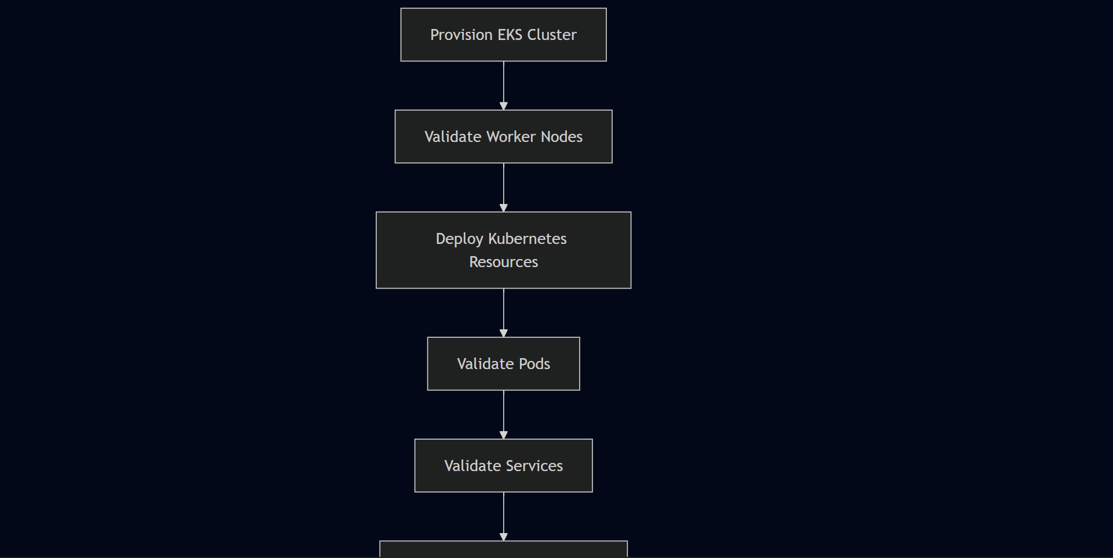
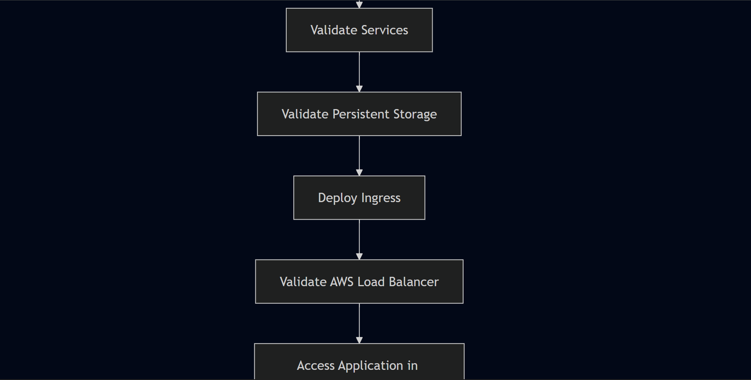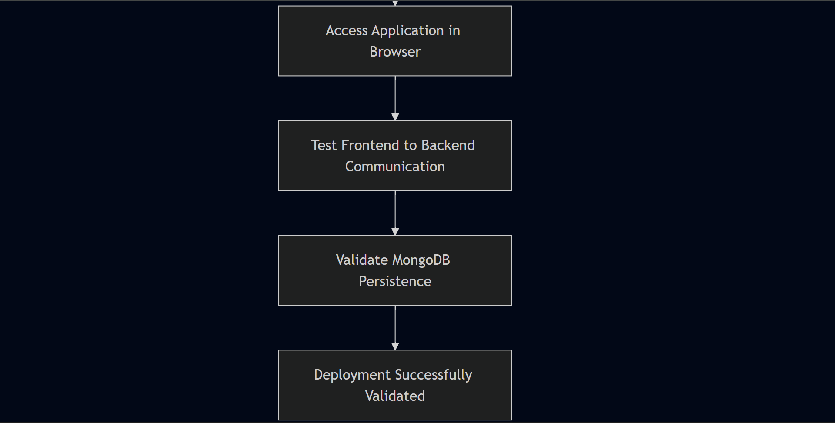

Layer 1 — EKS Cluster Validation
During implementation, the PVC initially remained in Pending because it was applied before a matching Persistent Volume was available. Correcting the apply order resolved the binding. Once Bound, MongoDB started with persistent storage attached.
bash
kubectl get nodes
Initially the Ingress had no external address — the AWS Load Balancer Controller needed to provision the ALB first. After the IAM permission issue was resolved and the controller restarted, the Ingress received an ALB DNS address.
Validation Area | Expected Result
EKS control plane | Responding to Kubernetes API requests
Worker nodes | Successfully registered with the cluster
Networking | Nodes communicating with control plane
kubeconfig | kubectl correctly connected
Scheduling capability | Cluster ready to accept workloads
The controller encountered an IAM authorization failure during provisioning — the missing permission elasticloadbalancing:DescribeListenerAttributes prevented it from completing AWS API calls. After attaching the required policy and restarting the controller, the ALB provisioned successfully.

Layer 2 — Namespace and Resource Validation
Validation confirmed: ALB visible in AWS Console Ingress showing external ALB DNS address Target groups healthy ALB DNS endpoint reachable
bash
kubectl get all -n workshop
The React frontend loaded successfully through the ALB DNS endpoint in a browser. This confirmed the ALB was reachable, Ingress routing was working, the frontend Service was correctly configured, and the frontend Pod was serving the application.
bash
kubectl get pods -n workshop
kubectl get svc -n workshop
kubectl get deployments -n workshop
kubectl get pvc -n workshop
kubectl get ingress -n workshop

Layer 3 — Pod Health Validation
The frontend used a relative API path:
- This avoided embedding a fixed backend hostname into the compiled bundle. The ALB and Ingress determined where /api traffic went — frontend, backend, and AWS networking aligned correctly.
- A task was submitted through the React UI: Frontend sends POST request to /api/tasks Request reaches Node.js backend through Ingress Backend processes request and writes to MongoDB MongoDB stores data to persistent EBS-backed volume Frontend receives response and displays the task Page refresh — task still visible, confirming persistence
- All steps completed successfully. The complete Frontend → Backend → Database path was operational.
Total: 4 running Pods
bash
kubectl get pods -n workshop
Expected running workloads: 1 React frontend Pod, 2 Node.js backend Pods, 1 MongoDB Pod — 4 total. All four Pods reached Running status. A Pod not reaching Running required investigation. kubectl apply accepts a manifest without guaranteeing the workload starts successfully — Pod status was the actual proof.
kubectl apply accepts a manifest without guaranteeing the workload starts successfully. Pod status was the actual proof.

Layer 4 — Service Connectivity Validation
bash
kubectl get svc -n workshop
kubectl describe svc <service-name> -n workshop
All three Services — frontend, backend (api), MongoDB — were confirmed with correct port mappings.
The backend Service required specific attention: the Node.js application listened on port 3500, and the Service targetPort had to match exactly. A mismatch causes frontend API calls to fail even when the backend Pod is healthy.
The complete validation chain:
Deployment → Pod → Container Port → Service → Endpoint
A failure at any point makes an otherwise healthy workload inaccessible.

Layer 5 — Persistent Storage Validation
bash
kubectl get pvc -n workshop
kubectl describe pvc <pvc-name> -n workshop
The PVC transitioned to Bound status — confirming Kubernetes completed the storage binding.
During implementation, the PVC initially remained in Pending because it was applied before a matching Persistent Volume was available. Correcting the apply order resolved the binding. Once Bound, MongoDB started with persistent storage attached.
Persistent Volume
↓
Persistent Volume Claim (Bound)
↓
MongoDB Pod (storage attached)
During implementation, the PVC initially remained in Pending because it was applied before a matching Persistent Volume was available. Correcting the apply order resolved the binding. Once Bound, MongoDB started with persistent storage attached.

Layer 6 — Ingress Validation
bash
kubectl get ingress -n workshop
kubectl describe ingress <ingress-name> -n workshop
Initially the Ingress had no external address — the AWS Load Balancer Controller needed to provision the ALB first. After the IAM permission issue was resolved and the controller restarted, the Ingress received an ALB DNS address.
Path | Destination
/ | Frontend Service
/api | Backend Service
Initially the Ingress had no external address — the AWS Load Balancer Controller needed to provision the ALB first. After the IAM permission issue was resolved and the controller restarted, the Ingress received an ALB DNS address.

Layer 7 — AWS Load Balancer Validation
The controller encountered an IAM authorization failure during provisioning — the missing permission elasticloadbalancing:DescribeListenerAttributes prevented it from completing AWS API calls. After attaching the required policy and restarting the controller, the ALB provisioned successfully.
Validation confirmed: ALB visible in AWS Console Ingress showing external ALB DNS address Target groups healthy ALB DNS endpoint reachable
Validation confirmed:
- ALB visible in AWS Console
- Ingress showing external ALB DNS address
- Target groups healthy
- ALB DNS endpoint reachable

Layer 8 — Browser-Level Application Validation
The React frontend loaded successfully through the ALB DNS endpoint in a browser. This confirmed the ALB was reachable, Ingress routing was working, the frontend Service was correctly configured, and the frontend Pod was serving the application.
Browser
↓
ALB DNS Endpoint
↓
Kubernetes Ingress
↓
Frontend Service
↓
React Application
This confirmed the ALB was reachable, Ingress routing was working, the frontend Service was correctly configured, and the frontend Pod was serving the application.

Layer 9 — API Flow Validation
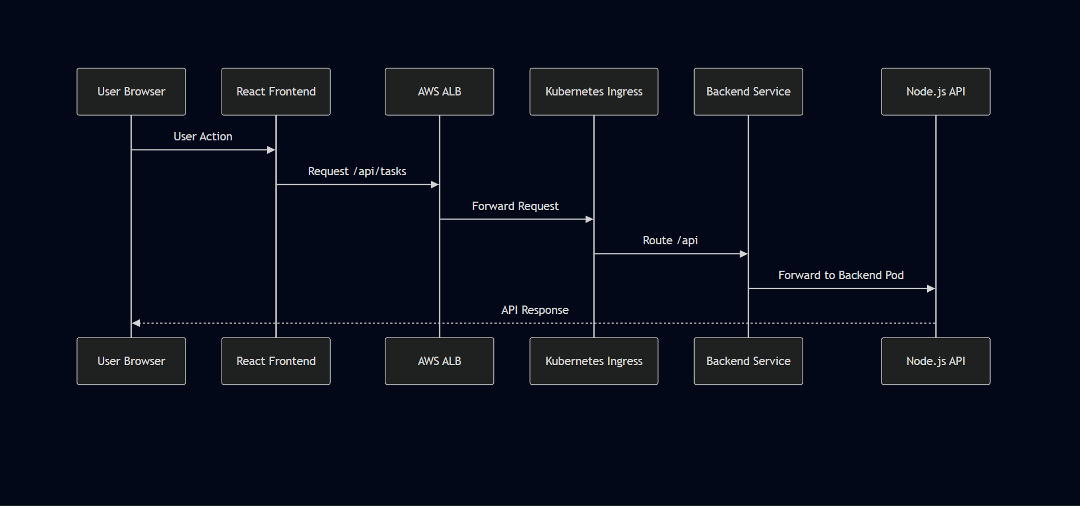
The frontend used a relative API path:
This avoided embedding a fixed backend hostname into the compiled bundle. The ALB and Ingress determined where /api traffic went — frontend, backend, and AWS networking aligned correctly.
const apiUrl = "/api/tasks";
This avoided embedding a fixed backend hostname into the compiled bundle. The ALB and Ingress determined where /api traffic went — frontend, backend, and AWS networking aligned correctly.

Layer 10 — End-to-End Data Validation
A task was submitted through the React UI: Frontend sends POST request to /api/tasks Request reaches Node.js backend through Ingress Backend processes request and writes to MongoDB MongoDB stores data to persistent EBS-backed volume Frontend receives response and displays the task Page refresh — task still visible, confirming persistence
All steps completed successfully. The complete Frontend → Backend → Database path was operational.
- Frontend sends POST request to /api/tasks
- Request reaches Node.js backend through Ingress
- Backend processes request and writes to MongoDB
- MongoDB stores data to persistent EBS-backed volume
- Frontend receives response and displays the task
- Page refresh — task still visible, confirming persistence
All steps completed successfully. The complete Frontend → Backend → Database path was operational.

Validation Matrix
Layer | Validation Method | Result
EKS Cluster | kubectl get nodes | Worker nodes Ready
Kubernetes Workloads | kubectl get pods | All 4 Pods Running
Deployments | kubectl get deployments | Desired replicas available
Services | kubectl get svc / describe svc | Port mappings correct
Persistent Storage | kubectl get pvc | PVC Bound
Ingress | kubectl get ingress | External ALB address received
AWS Integration | AWS Console | ALB provisioned
Frontend | Browser access | React application loaded
Backend | API routing | Requests reached Node.js
Database | Application interaction | MongoDB data path operational
End-to-End | Browser testing | Complete three-tier flow verified

Evidence Notes
Screenshots from the actual deployment would be the strongest evidence for this chapter — specifically:
- Terminal showing kubectl get nodes with both nodes Ready
- Terminal showing kubectl get pods -n workshop with all Pods Running
- Terminal showing kubectl get pvc -n workshop with PVC Bound
- Terminal showing kubectl get ingress -n workshop with ALB address populated
- AWS Console showing the provisioned Application Load Balancer
- Browser showing the React frontend loaded through the ALB DNS
- Browser showing a task successfully created and persisted
If you rebuild this project or run it again, capturing these screenshots would significantly strengthen the portfolio evidence.

Final Operational Status
EKS Cluster ✓ Operational
Worker Nodes ✓ Ready
Frontend Pod ✓ Running
Backend Pods ✓ Running (×2)
MongoDB Pod ✓ Running
Kubernetes Services ✓ Operational
Persistent Storage ✓ Bound
AWS Load Balancer ✓ Provisioned
Ingress Routing ✓ Operational
Frontend Access ✓ Verified
Backend API Connectivity ✓ Verified
Database Persistence ✓ Verified
End-to-End Application Flow ✓ Successful
Infrastructure Cleanup ✓ Completed

Engineering Takeaway
The architecture decisions here weren't complex — they were pragmatic. eksctl over manual VPC setup, ECR over DockerHub, Ingress over NodePort. Each choice made the deployment simpler to validate without adding unnecessary complexity for a single-region project.
A failure in any one of these layers prevented the final application from working. The completed validation demonstrated the full operational path rather than isolated infrastructure components:
Browser → ALB → Ingress → Kubernetes Services → Application Pods → MongoDB → Persistent Storage
That end-to-end verification is the evidence that the deployment functioned as an integrated cloud-native system — not merely as a collection of successfully applied Kubernetes manifests.

Chapter 18 — Architecture Decisions & Engineering Trade-offs

Overview
Every deployment involves choices. Some are obvious, some are forced by constraints, and some only reveal their trade-offs after the fact. This chapter covers the ten decisions that shaped this deployment — why each was made, what it cost, and what alternative would make more sense in a different context.
Each layer operates independently — the frontend can be updated without touching the database, the backend can scale without affecting the frontend, and database storage is managed separately from stateless application workloads.

Architecture Decision Overview
Trade-off: Three tiers means more infrastructure and networking complexity than a single-container application. That complexity was acceptable here because the objective was specifically to understand how multiple workloads interact inside Kubernetes.
EKS provides a managed control plane while still requiring direct work with standard Kubernetes resources — Deployments, Services, Ingress, PV/PVC, Secrets. The managed aspect removes the need to operate the API server, scheduler, and etcd manually.
│
▼
Trade-off: EKS simplifies control plane management, but Kubernetes itself remains operationally complex. Application networking, IAM integration, storage, and debugging still require direct engineering work.
│
▼
Pods are not stable endpoints. They restart, get recreated, receive new IP addresses, and move between nodes. Services solve this — the application communicates with a stable Service name rather than a specific Pod IP. Pods can change without requiring application-level networking changes.
│
All three Services use ClusterIP. Nothing is directly accessible from outside the cluster except through the ALB.
Trade-off: ClusterIP Services require an additional routing layer for external traffic — provided here by ALB + Ingress. But keeping internal components private reduces the attack surface and eliminates unnecessary public endpoints.
A single ALB handles all external traffic. The Kubernetes Ingress defines the routing logic, letting the React frontend send requests using /api/tasks rather than requiring a separate public backend URL.
Trade-off: This approach depends on correct coordination between the ALB, Load Balancer Controller, IAM permissions, Ingress configuration, Services, and application ports. This became visible during implementation — the controller appeared healthy while the AWS integration layer was failing because of a missing IAM permission.
The initial Ingress used hostname-based routing, but the project didn't use a custom domain. Removing the hostname dependency simplified everything. Path-based routing handled the separation between frontend and API traffic without any external DNS dependency.
Trade-off: A larger production system might use separate hostnames for stronger separation. For validating this deployment, path-based routing removed an unnecessary dependency without sacrificing functionality.
React resolves environment variables at build time — not runtime. Changing a Kubernetes environment variable after the image was built had no effect on the already-compiled bundle.
│
▼
Switching to a relative path:
│
▼
MongoDB
│
▼
Trade-off: This couples frontend API routing to the Ingress configuration — the /api path must remain correctly configured. But the benefit was significant: no hardcoded backend URL, no domain dependency, no image rebuild just to change the backend hostname.
Decision | Selected Approach | Primary Reason
Application architecture | Three-tier | Clear separation between UI, API, and data layers
Container orchestration | Amazon EKS | Managed Kubernetes control plane on AWS
Container registry | Amazon ECR | AWS-native registry — native EKS integration
External access | ALB + Kubernetes Ingress | Single entry point for HTTP traffic
Internal networking | ClusterIP Services | Keep application components private
Backend availability | Two replicas | More than one API Pod available
Database access | Internal Kubernetes Service | MongoDB not directly exposed
Database persistence | PV/PVC backed by EBS | Preserve data beyond Pod lifecycle
API routing | Path-based routing | Avoid dependency on a custom domain
Deployment method | Manual Kubernetes manifests | Focus on understanding the underlying workflow

Decision 1 — Three-Tier Application Architecture
Frontend and backend Pods are stateless — Kubernetes can replace them without any impact on application behavior. MongoDB is different. Without persistent storage, a Pod deletion means permanent data loss.
Storage was decoupled from the Pod lifecycle through PV/PVC backed by Amazon EBS. The Pod is replaceable. The data is not.
The backend ran two replicas. This demonstrated how Kubernetes Services interact with multiple Pods. If one Pod becomes unavailable, the Service continues routing to healthy endpoints while Kubernetes restores the desired state.
Trade-off: Additional replicas consume additional compute resources. For a demo environment one replica would have been sufficient functionally — but two replicas made the architecture more representative of a real distributed deployment.
Images were pushed to ECR because the infrastructure was already running in AWS. ECR integrates natively with EKS — worker nodes authenticate to ECR automatically through IAM without requiring separate registry credentials.
Trade-off: ECR increases dependency on the AWS ecosystem. A multi-cloud deployment would benefit from a cloud-neutral registry. For this single-AWS-region project, native integration was the right choice.
▼
The architecture decisions here weren't complex — they were pragmatic. eksctl over manual VPC setup, ECR over DockerHub, Ingress over NodePort. Each choice made the deployment simpler to validate without adding unnecessary complexity for a single-region project.
Each layer operates independently — the frontend can be updated without touching the database, the backend can scale without affecting the frontend, and database storage is managed separately from stateless application workloads.
Trade-off: Three tiers means more infrastructure and networking complexity than a single-container application. That complexity was acceptable here because the objective was specifically to understand how multiple workloads interact inside Kubernetes.
└────────────────────┬────────────────────┘
│ Database Requests
▼
┌─────────────────────────────────────────┐
│ Data Tier │
│ MongoDB │
└─────────────────────────────────────────┘
Each layer operates independently — the frontend can be updated without touching the database, the backend can scale without affecting the frontend, and database storage is managed separately from stateless application workloads.
Trade-off: Three tiers means more infrastructure and networking complexity than a single-container application. Each layer needs its own image, Kubernetes resources, and networking configuration. That complexity was acceptable here because the objective was specifically to understand how multiple workloads interact inside Kubernetes.

Decision 2 — Amazon EKS Instead of Self-Managed Kubernetes
EKS provides a managed control plane while still requiring direct work with standard Kubernetes resources — Deployments, Services, Ingress, PV/PVC, Secrets. The managed aspect removes the need to operate the API server, scheduler, and etcd manually.
Amazon EKS | Self-Managed Kubernetes
Managed control plane | Full control plane responsibility
AWS-native integration | Greater infrastructure flexibility
Faster cluster provisioning | More manual setup required
IAM integration built-in | IAM requires custom configuration
Trade-off: EKS simplifies control plane management, but Kubernetes itself remains operationally complex. Application networking, IAM integration, storage, and debugging still require direct engineering work.

Decision 3 — Kubernetes Services Instead of Direct Pod Access
Pods are not stable endpoints. They restart, get recreated, receive new IP addresses, and move between nodes. Services solve this — the application communicates with a stable Service name rather than a specific Pod IP. Pods can change without requiring application-level networking changes.
Services solve this:
Backend Pod A ──┐
│
▼
Backend Service (stable DNS)
│
▼
Frontend / API
│
Backend Pod B ──┘
The application communicates with a stable Service name rather than a specific Pod IP. Pods can change without requiring application-level networking changes.

Decision 4 — ClusterIP for Internal Services
All three Services use ClusterIP. Nothing is directly accessible from outside the cluster except through the ALB.
Trade-off: ClusterIP Services require an additional routing layer for external traffic — provided here by ALB + Ingress. But keeping internal components private reduces the attack surface and eliminates unnecessary public endpoints.
↓
Application Load Balancer
↓
Ingress
↓
Frontend Service → Backend Service → MongoDB Service
Trade-off: ClusterIP Services require an additional routing layer for external traffic — provided here by ALB + Ingress. But keeping internal components private reduces the attack surface and eliminates unnecessary public endpoints.

Decision 5 — AWS ALB and Kubernetes Ingress
A single ALB handles all external traffic. The Kubernetes Ingress defines the routing logic, letting the React frontend send requests using /api/tasks rather than requiring a separate public backend URL.
Trade-off: This approach depends on correct coordination between the ALB, Load Balancer Controller, IAM permissions, Ingress configuration, Services, and application ports. This became visible during implementation — the controller appeared healthy while the AWS integration layer was failing because of a missing IAM permission.
↓
AWS Application Load Balancer
↓
Kubernetes Ingress
├── / → Frontend Service
└── /api → Backend Service
This lets the React frontend send requests using /api/tasks rather than requiring a separate public backend URL.
Trade-off: This approach depends on correct coordination between the ALB, Load Balancer Controller, IAM permissions, Ingress configuration, Services, and application ports. This became visible during implementation — the controller appeared healthy while the AWS integration layer was failing because of a missing IAM permission. Kubernetes and AWS authorization are tightly coupled in an EKS environment.

Decision 6 — Path-Based Routing Instead of Host-Based Routing
The initial Ingress used hostname-based routing, but the project didn't use a custom domain. Removing the hostname dependency simplified everything. Path-based routing handled the separation between frontend and API traffic without any external DNS dependency.
Trade-off: A larger production system might use separate hostnames for stronger separation. For validating this deployment, path-based routing removed an unnecessary dependency without sacrificing functionality.
Request | Destination
/ | Frontend Service
/api | Backend Service
Trade-off: A larger production system might use separate hostnames (app.example.com, api.example.com) for stronger separation. But for validating this deployment, path-based routing removed an unnecessary dependency without sacrificing functionality.

Decision 7 — Relative API Paths in the Frontend
React resolves environment variables at build time — not runtime. Changing a Kubernetes environment variable after the image was built had no effect on the already-compiled bundle.
Switching to a relative path:
Trade-off: This couples frontend API routing to the Ingress configuration — the /api path must remain correctly configured. But the benefit was significant: no hardcoded backend URL, no domain dependency, no image rebuild just to change the backend hostname.
The fix was switching to a relative path:
javascript
const apiUrl = "/api/tasks";
Request flow after the change:
React Application
↓
/api/tasks
↓
Application Load Balancer
↓
Ingress Rule
↓
Backend Service
↓
Node.js API Pod
Trade-off: This couples frontend API routing to the Ingress configuration — the /api path must remain correctly configured. But the benefit was significant: no hardcoded backend URL, no domain dependency, no image rebuild just to change the backend hostname.

Decision 8 — Stateless vs Stateful Workloads
Frontend and backend Pods are stateless — Kubernetes can replace them without any impact on application behavior. MongoDB is different. Without persistent storage, a Pod deletion means permanent data loss.
Storage was decoupled from the Pod lifecycle through PV/PVC backed by Amazon EBS. The Pod is replaceable. The data is not.
MongoDB Pod Deleted
↓
Container Filesystem Lost
↓
Application Data Lost
Storage was therefore decoupled from the Pod lifecycle:
MongoDB Pod
↓
Persistent Volume Claim
↓
Persistent Volume
↓
Amazon EBS Storage
The Pod is replaceable. The data is not. This distinction is fundamental to the architecture.

Decision 9 — Persistent Storage Using PV and PVC
MongoDB needs storage that survives Pod restarts: The PVC defines what storage the application needs. Kubernetes binds the PVC to an available Persistent Volume. The PV is backed by an EBS block storage device that exists independently of the Pod lifecycle.
During deployment, the PVC remained in Pending state because the PV wasn't available when the claim was applied. Checking: Showed the claim waiting indefinitely. Applying storage resources in the correct order — PV before PVC — resolved it. Once bound, the MongoDB Pod scheduled successfully.

Decision 10 — Two Backend Replicas
The backend ran two replicas. This demonstrated how Kubernetes Services interact with multiple Pods. If one Pod becomes unavailable, the Service continues routing to healthy endpoints while Kubernetes restores the desired state.
Trade-off: Additional replicas consume additional compute resources. For a demo environment one replica would have been sufficient functionally — but two replicas made the architecture more representative of a real distributed deployment.
↓
Backend Pod 1 Backend Pod 2
Even though this wasn't a custom scaling strategy, it demonstrated how Kubernetes Services interact with multiple Pods. If one Pod becomes unavailable, the Service continues routing to healthy endpoints while Kubernetes restores the desired state.
Trade-off: Additional replicas consume additional compute resources. For a demo environment one replica would have been sufficient functionally — but two replicas made the architecture more representative of a real distributed deployment.

Decision 11 — Amazon ECR for Image Storage
Two private ECR repositories stored the application images:
Worker nodes pull images from ECR using IAM-based authentication — no manual credential configuration needed. Separate repositories mean frontend and backend images can be versioned and updated independently.

Architecture Trade-off Matrix
Design Area | Selected Approach | Advantage | Trade-off
Kubernetes platform | Amazon EKS | Managed control plane | AWS and Kubernetes complexity
Application design | Three-tier | Separation of responsibilities | More components to manage
Public access | ALB + Ingress | Single controlled entry point | Controller and IAM dependencies
Internal networking | ClusterIP Services | Reduced public exposure | Requires routing layer
API routing | /api path | No custom domain required | Depends on Ingress path config
Backend availability | Two replicas | Basic redundancy | Additional compute usage
Database | MongoDB with PV/PVC | Data survives Pod lifecycle | Stateful workload complexity
Image registry | Amazon ECR | AWS-native integration | Cloud ecosystem dependency
Deployment process | Manual workflow | Better infrastructure understanding | Not repeatable at production scale
Infrastructure provisioning | eksctl | Faster cluster setup | Less declarative than IaC

Engineering Takeaway
The architecture decisions here weren't complex — they were pragmatic. eksctl over manual VPC setup, ECR over DockerHub, Ingress over NodePort. Each choice made the deployment simpler to validate without adding unnecessary complexity for a single-region project.
A successful request depended on every layer working correctly simultaneously:
Browser → ALB → Load Balancer Controller → Ingress → Service → Pod → Application → Database → Persistent Storage
A Dockerfile naming error prevented an image from reaching ECR. A Service port mismatch left healthy Pods unreachable. A React build-time configuration decision broke API routing. A missing IAM permission prevented the controller from provisioning AWS infrastructure. A storage dependency issue kept MongoDB pending.
Those weren't isolated problems. They demonstrated a property of cloud-native systems that documentation doesn't fully convey:
The application is only as reliable as the interaction between its infrastructure layers.

Chapter 19 — Engineering Reflection & Professional Takeaways

Overview
Before this project, I had experience with individual technologies — AWS, Docker, Linux, Kubernetes concepts. What I hadn't experienced to the same extent was how quickly a deployment becomes dependent on the interaction between those layers. That's the main thing this project changed.
What follows is not a summary of what Kubernetes does. It's a reflection on what implementing it actually felt like — where the difficulty was, what changed in how I think about cloud systems, and what I'd do differently next time.

The Deployment as a Connected System
During troubleshooting, a small set of commands became the primary diagnostic toolkit:
The debugging pattern that worked consistently:
↓
This is significantly more effective than repeatedly changing YAML files without first understanding what's failing and why.
↓
If rebuilding this project, I would reduce manual infrastructure and deployment steps from the start.
↓
A future architecture would move toward:
↓
And infrastructure through code:
↓
These are future improvements — not claimed as part of this implementation. The manual workflow was right for learning. It's not right for production scale.
↓
Ingress
↓
The biggest difference between understanding this architecture on paper and implementing it was discovering how dependent every layer is on the others.
↓
From the browser, the finished application looked simple:
↓
Browser
Behind that interaction, the request passed through an entire infrastructure chain. Getting that chain working required more than applying manifests — it required understanding failures, reading logs, checking resource states, correcting configuration mismatches, resolving AWS permission issues, and validating the final result from the user's perspective.
That's the main professional takeaway:
↓
> Cloud-native engineering is not about deploying individual technologies. It's about understanding how those technologies behave as one system — and being able to trace, diagnose, and fix the system when one part breaks.
↓
Ingress Path Rule
↓
Backend Service
↓
Node.js API
↓
MongoDB Service
↓
MongoDB Pod
↓
Persistent Storage
Understanding the deployment as one connected system — rather than a collection of independent tools — was the core learning.

Tooling Context
The project involved multiple tools working together:
eksctl → Creates and manages EKS infrastructure
kubectl → Interacts with Kubernetes resources
Helm → Installs packaged Kubernetes applications
Docker → Builds application container images
AWS CLI → Authenticates and interacts with AWS services
Git/GitHub → Manages source code and configuration
Learning individual commands was only part of the challenge. The harder part was understanding where each tool fit into the larger workflow — which layer it controlled, what it depended on, and what depended on it.
The real workflow wasn't:
Learn 7 tools separately
It was:
Understand which tool controls which layer

Observability Was More Important Than Expected
During troubleshooting, a small set of commands became the primary diagnostic toolkit:
Command | Primary Use
kubectl get | Quick resource status
kubectl describe | Events and detailed configuration
kubectl logs | Application and controller output
AWS Console | AWS resource provisioning and status
The debugging pattern that worked consistently:
This is significantly more effective than repeatedly changing YAML files without first understanding what's failing and why.
↓
Check Status (kubectl get)
↓
Check Events (kubectl describe)
↓
Check Logs (kubectl logs)
↓
Identify the Failing Layer
↓
Make One Targeted Change
↓
Validate Again
This is significantly more effective than repeatedly changing YAML files without first understanding what's failing and why.
The controller logs were particularly valuable during the ALB provisioning failure. The controller appeared healthy from the Kubernetes side — but its logs showed HTTP 403 responses from AWS, which immediately pointed toward IAM rather than Kubernetes configuration.

What I Would Do Differently
If rebuilding this project, I would reduce manual infrastructure and deployment steps from the start.
A future architecture would move toward:
And infrastructure through code:
↓
These are future improvements — not claimed as part of this implementation. The manual workflow was right for learning. It's not right for production scale.
↓
CI/CD Pipeline
├── Build
├── Test
├── Security Checks
├── Docker Image
└── Push to ECR
↓
Deployment Update
↓
Amazon EKS
And infrastructure through code:
Terraform
↓
AWS Infrastructure
├── VPC
├── Networking
├── EKS
├── IAM
└── Supporting Resources
These are future improvements — not claimed as part of this implementation. The manual workflow was right for learning. It's not right for production scale.

Engineering Growth From the Project

Cloud Infrastructure
- Amazon EKS cluster provisioning via eksctl
- EC2 management environment setup
- ECR image management and authentication
- IAM user and IRSA configuration
- ALB provisioning through Kubernetes
- EBS-backed persistent storage

Containerization
- Containerization was the first major step before anything could run on Kubernetes. Each application tier — React frontend, Node.js backend, and MongoDB — needed to be packaged as a Docker image before EKS could schedule it as a workload. All builds ran on the Ubuntu EC2 management instance.
- The Dockerfiles were already in the project repository. My work was working through the build process, fixing the issues that came up, pushing images to ECR, and then referencing those images in the Kubernetes Deployment manifests.
- Container image lifecycle management

Kubernetes
- MongoDB needs storage that survives Pod restarts. The PVC defines the storage requirement, Kubernetes binds it to a Persistent Volume, and that volume is backed by Amazon EBS. If the MongoDB Pod restarts or gets rescheduled, it reattaches to the same volume.
- ClusterIP Services and DNS-based discovery
- Ingress with path-based routing
- Persistent Volumes and Persistent Volume Claims
- Secrets for credential management
- Namespace-based resource isolation
- kubectl-based administration and debugging

Operations
- Systematic resource inspection
- Log analysis and event investigation
- Service and networking troubleshooting
- IAM troubleshooting across Kubernetes and AWS layers
- Infrastructure cleanup and cost management

Final Reflection
The biggest difference between understanding this architecture on paper and implementing it was discovering how dependent every layer is on the others.
From the browser, the finished application looked simple:
Behind that interaction, the request passed through an entire infrastructure chain. Getting that chain working required more than applying manifests — it required understanding failures, reading logs, checking resource states, correcting configuration mismatches, resolving AWS permission issues, and validating the final result from the user's perspective.
That's the main professional takeaway:
Browser
↓
> Cloud-native engineering is not about deploying individual technologies. It's about understanding how those technologies behave as one system — and being able to trace, diagnose, and fix the system when one part breaks.
↓
Kubernetes Ingress
↓
Kubernetes Service
↓
Node.js Backend
↓
MongoDB Service
↓
MongoDB
↓
Persistent Storage
Getting that chain working required more than applying manifests. It required understanding failures, reading logs, checking resource states, correcting configuration mismatches, resolving AWS permission issues, and validating the final result from the user's perspective.
That's the main professional takeaway:
Cloud-native engineering is not about deploying individual technologies. It's about understanding how those technologies behave as one system — and being able to trace, diagnose, and fix the system when one part breaks.

Engineering Portfolio Summary
Item | Detail
Project | Three-Tier Application Deployment on AWS EKS
Cloud Platform | AWS — us-west-2
Container Orchestration | Amazon EKS — three-tier-cluster
Containerization | Docker
Image Registry | Amazon ECR
Networking | AWS ALB + Kubernetes Ingress + ClusterIP Services
Application Stack | React, Node.js, MongoDB
Storage | PV/PVC backed by Amazon EBS
Management Environment | Ubuntu EC2 (t2.micro)
Operational Tooling | kubectl, eksctl, Helm, AWS CLI
Version Control | Git and GitHub
Validated outcome:
User → React Frontend → Node.js API → MongoDB → Persistent Storage
Result: Complete three-tier application deployed on Amazon EKS, end-to-end communication validated, infrastructure cleaned up after completion.

Chapter 20 — Production Readiness Assessment & Architecture Review

Purpose
Completing a deployment successfully and being production-ready are not the same thing. Here's where this implementation actually stands.

Current Architecture
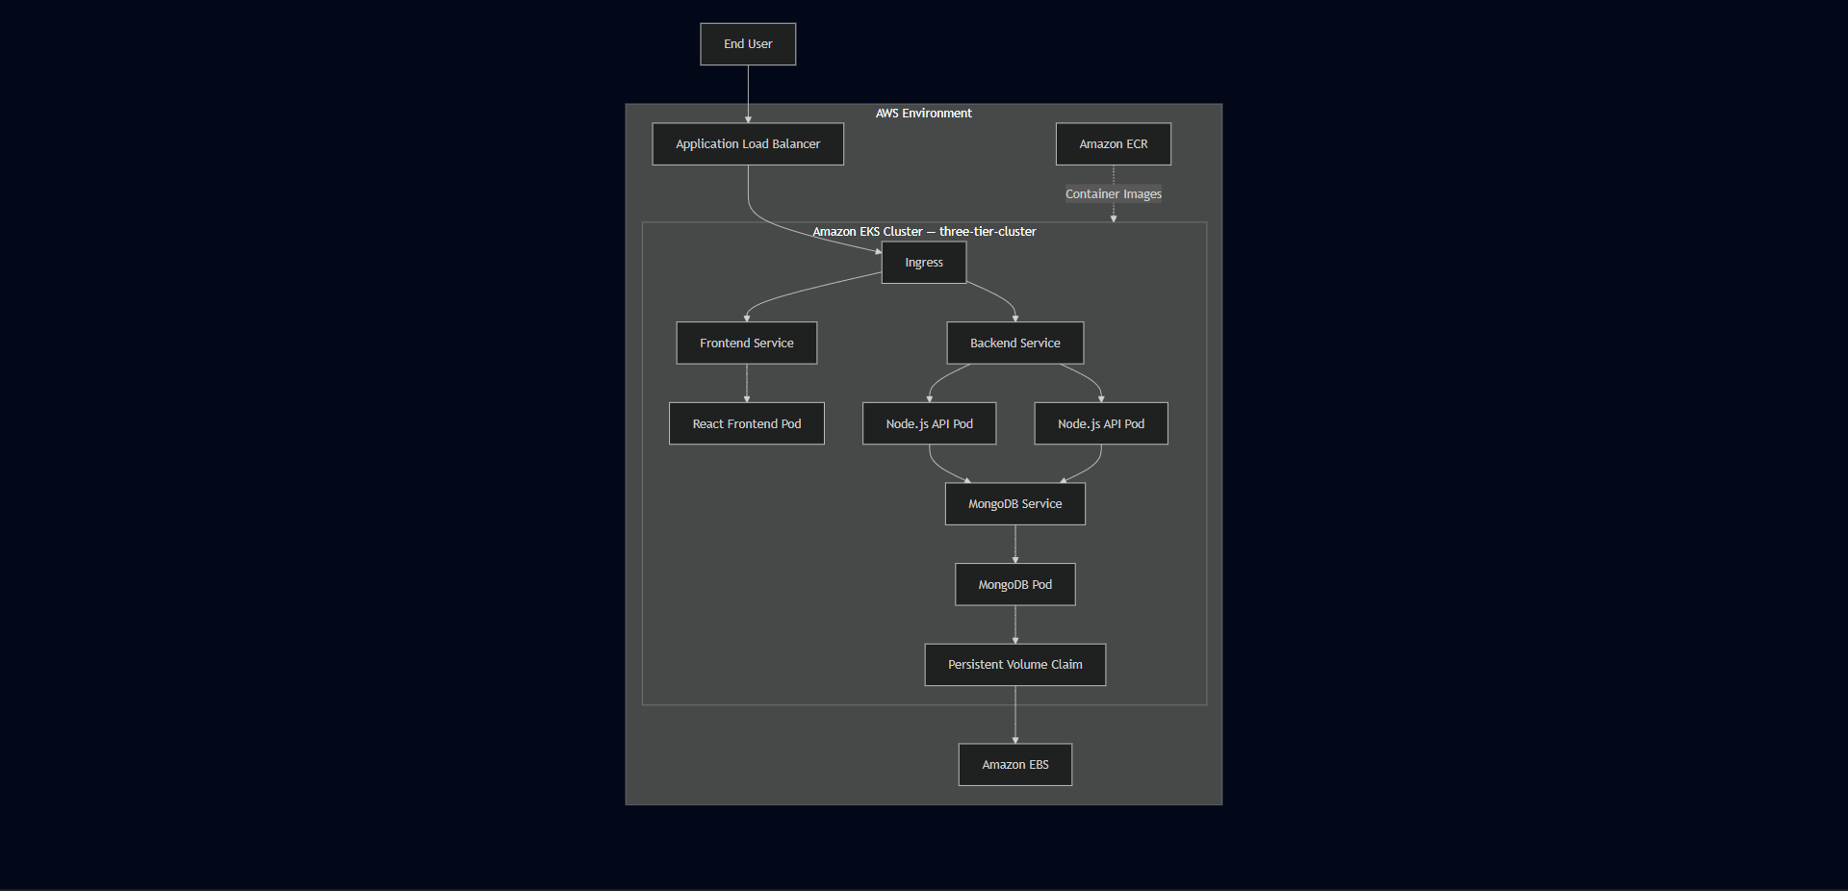

Architecture Status
Area | Current State
Application Deployment | Implemented
Containerization | Implemented
Image Registry | Implemented — Amazon ECR
Kubernetes Orchestration | Implemented — Amazon EKS
External Traffic | Implemented — ALB and Ingress
Internal Networking | Implemented — ClusterIP Services
Persistent Storage | Implemented — PV/PVC backed by EBS
Backend Replication | Two replicas configured
IAM Integration | Implemented and troubleshot
CI/CD | Not implemented
Infrastructure as Code | Not implemented
Production Monitoring Stack | Not implemented
Automated Scaling | Not validated
Disaster Recovery | Not implemented
Multi-Region Availability | Not implemented

Production Readiness Scorecard
Category | Assessment | Current Status
Application Architecture | Strong Foundation | Three-tier separation implemented
Containerization | Ready Foundation | Docker-based images deployed
Kubernetes Deployment | Implemented | Workloads running on EKS
Networking | Implemented | ALB, Ingress, Services configured
Persistent Storage | Implemented | MongoDB persistence configured
High Availability | Partial | Backend uses two replicas
Security | Basic Foundation | IAM, ClusterIP, Secrets used
CI/CD Automation | Not Implemented | Manual deployment workflow
Infrastructure as Code | Not Implemented | Manual provisioning via eksctl
Monitoring | Basic Visibility | kubectl and AWS Console only
Alerting | Not Implemented | No automated alerting
Autoscaling | Not Validated | HPA not implemented
Backup & Recovery | Not Implemented | No automated backup strategy
Disaster Recovery | Not Implemented | No documented recovery plan
Multi-Region | Not Implemented | Single-region deployment
Overall | Development / Portfolio Grade | Requires additional controls for production

What's Already Production-Relevant
Several decisions in this deployment follow patterns used in real environments — not because the project claims to be production-ready, but because the reference architecture reflected sound engineering practices.
Containerized application components: Frontend and backend packaged independently, each with its own image lifecycle. A frontend update doesn't require rebuilding the backend.
Managed Kubernetes control plane: EKS removes the need to operate the API server, scheduler, and etcd manually. The focus stays on application deployment, networking, storage, and IAM integration.
Internal service isolation: Backend and MongoDB are not directly exposed to the internet. Only the ALB is public-facing. This creates a clear security boundary.
Persistent storage for MongoDB: PV/PVC backed by EBS means data survives Pod restarts and rescheduling. This is significantly more appropriate for a database workload than temporary container filesystem storage.
IAM integration troubleshot under real conditions: The Load Balancer Controller IAM failure demonstrated that cloud-native deployments require both Kubernetes configuration and AWS authorization to be correct simultaneously. That's a production reality, not just a learning exercise.

What's Missing for Production
Being direct about the gaps:
No CI/CD — every deployment step was manual. Consistent, repeatable production releases require automation. No Infrastructure as Code — the environment was provisioned through eksctl and CLI commands, not version-controlled Terraform. Rebuilding from scratch requires memory rather than code. No formal monitoring — operational visibility came from kubectl and the AWS Console. A production system needs centralized metrics, dashboards, and automated alerting. No automated scaling — replica counts are static. HPA and Cluster Autoscaler were not implemented. No backup strategy — MongoDB persistence was validated at the Pod level but there's no documented plan for storage failure, cluster loss, or data recovery. No TLS — the deployment used HTTP. Production traffic should be encrypted. Single region — the entire deployment runs in us-west-2. No cross-region failover.
Current status: Production-inspired architecture with a successful end-to-end implementation — intentionally not a fully production-ready platform.
What was implemented and validated: Containerized three-tier application architecture Amazon EKS deployment — three-tier-cluster, us-west-2 Amazon ECR private image repositories Kubernetes Services, Ingress, path-based routing AWS Application Load Balancer integration Backend replica configuration — 2 × Node.js Pods MongoDB persistent storage — PV/PVC backed by EBS IAM configuration and real-world troubleshooting End-to-end browser-to-database validation Infrastructure cleanup after testing
What remains as future enhancements: CI/CD automation Infrastructure as Code — Terraform Formal monitoring and alerting — Prometheus, Grafana Automated scaling — HPA and Cluster Autoscaler Backup and disaster recovery TLS and HTTPS Advanced secret management Image security scanning GitOps workflows — Argo CD Progressive deployment strategies
Being direct about the gaps:
No CI/CD — every deployment step was manual. Consistent, repeatable production releases require automation. No Infrastructure as Code — the environment was provisioned through eksctl and CLI commands, not version-controlled Terraform. Rebuilding from scratch requires memory rather than code. No formal monitoring — operational visibility came from kubectl and the AWS Console. A production system needs centralized metrics, dashboards, and automated alerting. No automated scaling — replica counts are static. HPA and Cluster Autoscaler were not implemented. No backup strategy — MongoDB persistence was validated at the Pod level but there's no documented plan for storage failure, cluster loss, or data recovery. No TLS — the deployment used HTTP. Production traffic should be encrypted. Single region — the entire deployment runs in us-west-2. No cross-region failover.
Single region — the entire deployment runs in us-west-2. No cross-region failover.

Production Readiness Roadmap
Current status: Production-inspired architecture with a successful end-to-end implementation — intentionally not a fully production-ready platform. What was implemented and validated: Containerized three-tier application architecture Amazon EKS deployment — three-tier-cluster, us-west-2 Amazon ECR private image repositories Kubernetes Services, Ingress, path-based routing AWS Application Load Balancer integration Backend replica configuration — 2 × Node.js Pods MongoDB persistent storage — PV/PVC backed by EBS IAM configuration and real-world troubleshooting End-to-end browser-to-database validation Infrastructure cleanup after testing
What remains as future enhancements: CI/CD automation Infrastructure as Code — Terraform Formal monitoring and alerting — Prometheus, Grafana Automated scaling — HPA and Cluster Autoscaler Backup and disaster recovery TLS and HTTPS Advanced secret management Image security scanning GitOps workflows — Argo CD Progressive deployment strategies

Final Production Readiness Verdict
Current status: Production-inspired architecture with a successful end-to-end implementation — intentionally not a fully production-ready platform.
What was implemented and validated: Containerized three-tier application architecture Amazon EKS deployment — three-tier-cluster, us-west-2 Amazon ECR private image repositories Kubernetes Services, Ingress, path-based routing AWS Application Load Balancer integration Backend replica configuration — 2 × Node.js Pods MongoDB persistent storage — PV/PVC backed by EBS IAM configuration and real-world troubleshooting End-to-end browser-to-database validation Infrastructure cleanup after testing
What remains as future enhancements: CI/CD automation Infrastructure as Code — Terraform Formal monitoring and alerting — Prometheus, Grafana Automated scaling — HPA and Cluster Autoscaler Backup and disaster recovery TLS and HTTPS Advanced secret management Image security scanning GitOps workflows — Argo CD Progressive deployment strategies
✓ Amazon EKS deployment — three-tier-cluster, us-west-2
✓ Amazon ECR private image repositories
✓ Kubernetes Services, Ingress, path-based routing
✓ AWS Application Load Balancer integration
✓ Backend replica configuration — 2 × Node.js Pods
✓ MongoDB persistent storage — PV/PVC backed by EBS
✓ IAM configuration and real-world troubleshooting
✓ End-to-end browser-to-database validation
✓ Infrastructure cleanup after testing
What remains as future enhancements:
○ CI/CD automation
○ Infrastructure as Code — Terraform
○ Formal monitoring and alerting — Prometheus, Grafana
○ Automated scaling — HPA and Cluster Autoscaler
○ Backup and disaster recovery
○ TLS and HTTPS
○ Advanced secret management
○ Image security scanning
○ GitOps workflows — Argo CD
○ Progressive deployment strategies

Engineering Perspective
The value of this project is not in claiming equivalence to an enterprise production platform. The value is in having implemented the foundation manually and understanding what happens between each layer — and then being able to look at a working deployment and honestly identify what's still missing.
That ability to assess your own work critically is itself a production engineering skill.
CURRENT STATE

Functional Application
+
Containerization
+
Kubernetes
+
AWS Infrastructure
+
Networking
+
Persistent Storage
+
Hands-On Troubleshooting
=
Strong Cloud-Native Engineering Foundation

NEXT EVOLUTION

Automation
+
Infrastructure as Code
+
Observability
+
Security Hardening
+
Autoscaling
+
GitOps
=
Production-Style Platform
The project established the foundation. The next stage is systematically improving repeatability, security, observability, resilience, and delivery automation — not randomly adding tools, but evolving the architecture in a deliberate sequence.

Chapter 21 — Appendix & References

Project Information
Item | Details
Project Name | Three-Tier Application Deployment using Kubernetes on AWS EKS
Project Type | Cloud-Native Infrastructure Deployment
Architecture | Three-Tier Web Application
Deployment Platform | Amazon Elastic Kubernetes Service (Amazon EKS)
Cluster Name | three-tier-cluster
Region | us-west-2
Namespace | workshop
Deployment Model | Containerized Workloads on Managed Kubernetes
Project Status | Successfully Completed

Project Repository
GitHub Repository: https://github.com/Nuzairkhan/k8s-three-tier-app-eks
Repository contents: Application source code — React frontend, Node.js backend Dockerfiles for frontend and backend Kubernetes manifests — Deployments, Services, Ingress, Secrets, PV/PVC Ingress and ALB configuration Project documentation
LinkedIn Demo: https://www.linkedin.com/posts/anwarullah-khan-nuzair_devops-aws-eks-activity-7415357318206418945-DehZ
- The demonstration shows the deployed application running through the AWS Application Load Balancer — React frontend loading, API communication working, and task data persisting in MongoDB.
- Infrastructure failures don't always originate from Kubernetes. When EKS workloads interact with AWS services, IAM policies become part of the operational dependency chain.
- A healthy Pod doesn't mean a healthy application. Services, ports, storage, Ingress rules, and AWS permissions all have to align simultaneously.
- React environment variables are resolved at build time. Configuration that needs to change across environments should use relative paths or routing-layer abstractions rather than compiled-in values.
- Incremental validation is faster than end-to-end debugging. Verifying each layer independently narrows the scope of possible root causes significantly.

Project Demonstration
Responsible cloud engineering includes cleanup. Leaving EKS clusters, load balancers, and EBS volumes running generates costs — decommissioning after validation is part of the workflow.
AWS Documentation Amazon EKS Documentation — https://docs.aws.amazon.com/eks Amazon ECR Documentation — https://docs.aws.amazon.com/ecr AWS IAM Documentation — https://docs.aws.amazon.com/iam AWS Load Balancer Controller — https://kubernetes-sigs.github.io/aws-load-balancer-controller Amazon EBS Documentation — https://docs.aws.amazon.com/ebs
Kubernetes Documentation Kubernetes Official Documentation — https://kubernetes.io/docs Kubernetes Ingress — https://kubernetes.io/docs/concepts/services-networking/ingress Kubernetes Storage — https://kubernetes.io/docs/concepts/storage Kubernetes Deployments — https://kubernetes.io/docs/concepts/workloads/controllers/deployment

Final Solution Architecture
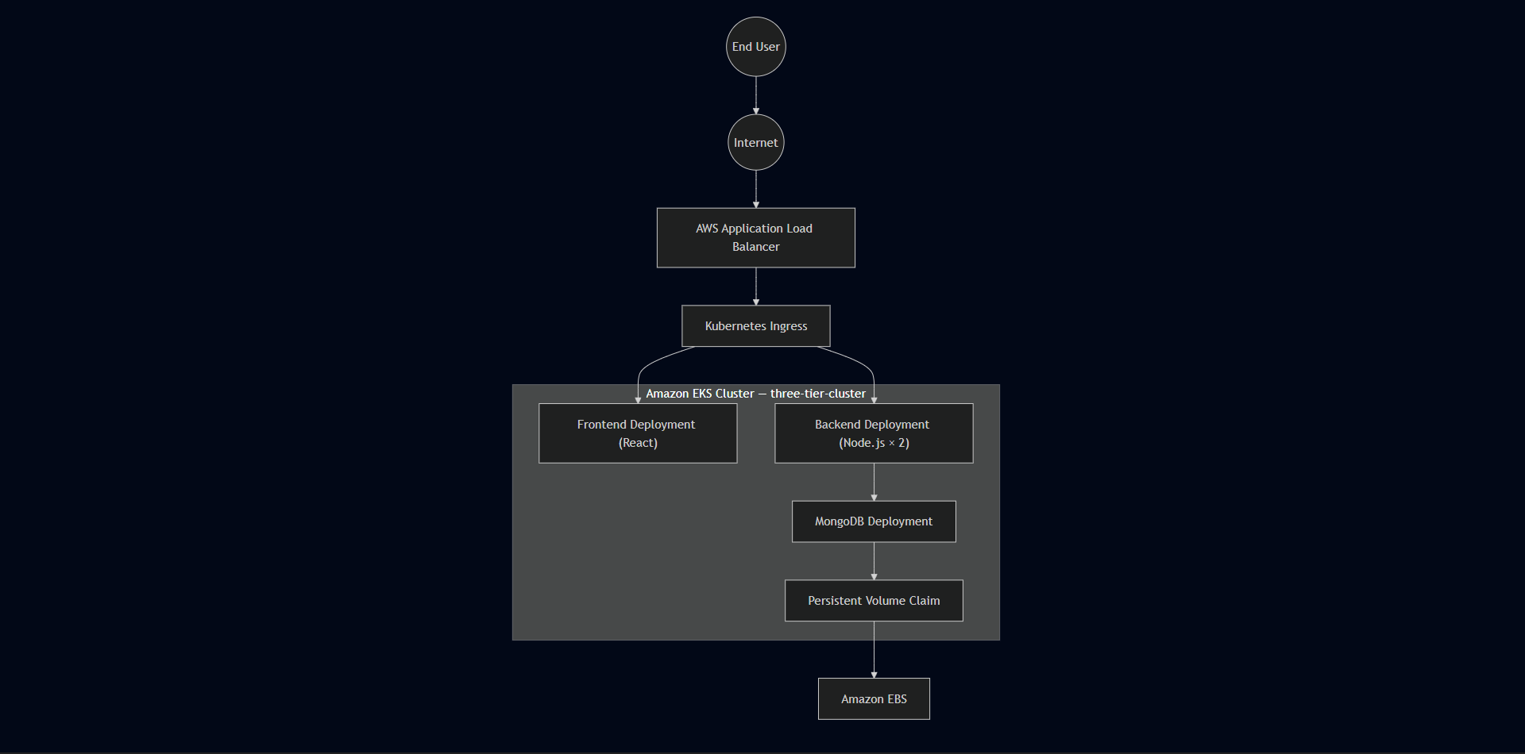

Infrastructure Summary
Resource | Configuration
Amazon EKS Cluster | 1 — three-tier-cluster, us-west-2
Worker Nodes | 2 × t2.medium
Amazon EC2 Management Host | 1 × t2.micro — Ubuntu
Amazon ECR Repositories | 2 — frontend, backend
Application Load Balancer | 1 — provisioned via Kubernetes Ingress
Deployments | 3 — frontend, backend, MongoDB
Services | 3 — all ClusterIP
Ingress | 1 — path-based routing
Persistent Volumes | 1 — Amazon EBS backed
Persistent Volume Claims | 1 — MongoDB storage
Namespaces | 1 — workshop
IAM User | eks-admin with AdministratorAccess

Technology Reference
Category | Technologies
Cloud Platform | AWS
Kubernetes | Amazon EKS
Containers | Docker
Registry | Amazon ECR
Networking | ALB, Kubernetes Ingress, ClusterIP Services
Storage | Amazon EBS, Persistent Volumes, Persistent Volume Claims
Security | AWS IAM, Security Groups, Kubernetes Secrets, IRSA
Package Manager | Helm — used for AWS Load Balancer Controller
Operating System | Ubuntu Linux (EC2 management instance)
Frontend | React.js
Backend | Node.js — port 3500
Database | MongoDB
Version Control | Git, GitHub
Cluster Tools | kubectl, eksctl

Engineering Skills Demonstrated

Cloud Engineering
- Containerization Docker Documentation — https://docs.docker.com Docker Best Practices — https://docs.docker.com/develop/dev-best-practices
- IAM user and IRSA configuration
- Amazon ECR private repository management
- AWS Application Load Balancer deployment through Kubernetes
- Amazon EBS persistent storage
- Security Groups and VPC networking

Kubernetes
- MongoDB needs storage that survives Pod restarts. The PVC defines the storage requirement, Kubernetes binds it to a Persistent Volume, and that volume is backed by Amazon EBS. If the MongoDB Pod restarts or gets rescheduled, it reattaches to the same volume.
- Declarative Deployments and ReplicaSets
- ClusterIP Services and DNS-based service discovery
- Kubernetes Ingress with path-based routing
- Persistent Volumes and Persistent Volume Claims
- Kubernetes Secrets for credential management
- Health probe configuration
- kubectl-based cluster administration and debugging

Containerization
- Containerization was the first major step before anything could run on Kubernetes. Each application tier — React frontend, Node.js backend, and MongoDB — needed to be packaged as a Docker image before EKS could schedule it as a workload. All builds ran on the Ubuntu EC2 management instance.
- The Dockerfiles were already in the project repository. My work was working through the build process, fixing the issues that came up, pushing images to ECR, and then referencing those images in the Kubernetes Deployment manifests.
- Immutable image model — no in-place container modification
- Multi-container architecture across three independent tiers

DevOps & Platform Engineering
- Linux administration over SSH
- End-to-end deployment lifecycle management
- Systematic root cause analysis across Kubernetes and AWS layers
- Infrastructure cleanup and cost management
- Iterative debugging — kubectl describe, logs, events

Key Engineering Decisions
Decision | Rationale
eksctl for cluster provisioning | Automated VPC, subnet, and node group creation
ClusterIP for all Services | Internal-only communication — single ALB entry point
Path-based Ingress routing | Single public endpoint — / frontend, /api backend
Relative API path /api/tasks | Avoided React build-time environment variable issues
IRSA for Load Balancer Controller | Scoped IAM permissions — no node-level AWS access
PV/PVC for MongoDB | Storage independent of container lifecycle
Dedicated EC2 management host | Consistent administration environment
Separate ECR repositories | Independent versioning per service

Real Issues Resolved
Issue | Root Cause | Fix
Docker build failure | Backend Dockerfile named Dockefile | Renamed file, rebuilt image
PVC stuck in Pending | PVC applied before PV was available | Applied storage resources in correct order
Frontend couldn't reach backend | Service targetPort didn't match container port 3500 | Corrected targetPort in Service manifest
React API requests failing | REACT_APP_BACKEND_URL resolved at build time not runtime | Switched to relative path /api/tasks in taskServices.js
ALB not provisioning | IAM role missing elasticloadbalancing:DescribeListenerAttributes | Attached missing permission, restarted controller
Ingress routing failure | Host-based routing without a registered domain | Removed host field, used path-based routing only

Lessons Learned
- Infrastructure failures don't always originate from Kubernetes. When EKS workloads interact with AWS services, IAM policies become part of the operational dependency chain.
- A healthy Pod doesn't mean a healthy application. Services, ports, storage, Ingress rules, and AWS permissions all have to align simultaneously.
- React environment variables are resolved at build time. Configuration that needs to change across environments should use relative paths or routing-layer abstractions rather than compiled-in values.
- Incremental validation is faster than end-to-end debugging. Verifying each layer independently narrows the scope of possible root causes significantly.
- Responsible cloud engineering includes cleanup. Leaving EKS clusters, load balancers, and EBS volumes running generates costs — decommissioning after validation is part of the workflow.

Glossary
Term | Description
ALB | AWS Application Load Balancer — distributes HTTP traffic to Kubernetes workloads
Amazon ECR | Private container image registry for storing Docker images
Amazon EKS | AWS managed Kubernetes control plane service
ClusterIP | Kubernetes Service type providing internal-only cluster networking
Deployment | Kubernetes controller managing desired Pod state and replica count
Docker Image | Immutable application package containing runtime and dependencies
eksctl | CLI tool for Amazon EKS cluster provisioning and management
Helm | Kubernetes package manager — used here for Load Balancer Controller
Ingress | Kubernetes resource managing external HTTP routing into the cluster
IRSA | IAM Roles for Service Accounts — scoped AWS permissions for Kubernetes workloads
Namespace | Logical isolation boundary for Kubernetes resources
Persistent Volume | Storage resource existing independently of Pod lifecycle
Persistent Volume Claim | Workload request for persistent storage
Pod | Smallest deployable unit in Kubernetes
ReplicaSet | Controller maintaining the required number of running Pod replicas
Service | Stable network endpoint abstracting individual Pod IP addresses

References

AWS Documentation
- Amazon EKS Documentation — https://docs.aws.amazon.com/eks
- Amazon ECR Documentation — https://docs.aws.amazon.com/ecr
- AWS IAM Documentation — https://docs.aws.amazon.com/iam
- AWS Load Balancer Controller — https://kubernetes-sigs.github.io/aws-load-balancer-controller
- Amazon EBS Documentation — https://docs.aws.amazon.com/ebs

Kubernetes Documentation
- Kubernetes Official Documentation — https://kubernetes.io/docs
- Kubernetes Ingress — https://kubernetes.io/docs/concepts/services-networking/ingress
- Kubernetes Storage — https://kubernetes.io/docs/concepts/storage
- Kubernetes Deployments — https://kubernetes.io/docs/concepts/workloads/controllers/deployment

Containerization
- Containerization was the first major step before anything could run on Kubernetes. Each application tier — React frontend, Node.js backend, and MongoDB — needed to be packaged as a Docker image before EKS could schedule it as a workload. All builds ran on the Ubuntu EC2 management instance. https://docs.docker.com
- The Dockerfiles were already in the project repository. My work was working through the build process, fixing the issues that came up, pushing images to ECR, and then referencing those images in the Kubernetes Deployment manifests. https://docs.docker.com/develop/dev-best-practices

Portfolio Summary
Category | Outcome
Cloud Infrastructure | Successfully provisioned on AWS — us-west-2
Kubernetes Platform | Operational — three-tier-cluster
Application Deployment | Completed — React, Node.js, MongoDB
Persistent Storage | Validated — PV/PVC with Amazon EBS
Networking | Fully functional — ALB, Ingress, ClusterIP
Security | Implemented — IAM, Secrets, IRSA, ClusterIP isolation
Monitoring | Operational — kubectl diagnostics, AWS Console
Troubleshooting | Six real issues identified and resolved
Documentation | Complete — 21chapters

Final Statement
This project documents the hands-on deployment of a three-tier application on Amazon EKS — from infrastructure provisioning through containerization, Kubernetes orchestration, networking, persistent storage, security, and operational troubleshooting. The implementation followed a reference architecture and focused on understanding how the components interact, debugging the real issues that came up, and validating the complete application flow end to end.
The goal was practical engineering experience — not just getting something running, but understanding why it works and what to do when it doesn't. Validated outcome: User → React Frontend → Node.js API → MongoDB → Persistent Storage Result: Complete three-tier application deployed on Amazon EKS, end-to-end communication validated, infrastructure cleaned up after completion.
<div align="center"> Three-Tier Application Deployment using Kubernetes on AWS EKS Version 1.0 — Engineering Portfolio Document Anwarullah Khan Nuzair — Cloud & DevOps Engineer myselfnuzairkhan@gmail.com | https://github.com/Nuzairkhan

END OF DOCUMENT
Three-Tier Application Deployment using Kubernetes on AWS EKS
Version 1.0
Prepared as an Engineering Portfolio Document
Anwarullah Khan Nuzair — Cloud & DevOps Engineer
myselfnuzairkhan@gmail.com
https://github.com/Nuzairkhan
</div>

