**LIBRARY MANAGEMENT SYSTEM**

**Higher National Diploma in Software Engineering**

**EAD-2 Project Documentation**

**24.1F**

National Institute of Business Management

Kandy Regional Center

No 2, Asgiriya Road,

Kandy

**Declaration**

“We certify that this project does not incorporate without acknowledgement, any material previously submitted for a Diploma in any institution n and to the best of my knowledge and belief, it does not contain any material previously published or written by another person or myself expect where due reference is made in the text. We also hereby give consent for our project report, if accepted, to be made available for photocopying and for interlibrary loans, and for the title and summary to be made available to outside organizations”

**Project Title:** Restaurant Management System

**Group Members:**

|  |  |
| --- | --- |
| **Name** | **Index Number** |
| M.F.M. Nuzki | KAHDSE231F-025 |
| P.D. Wijesooriya | KAHDSE231F-067 |
| G.C. Vishan | KAHDSE231F-024 |
| R.A.M. Dilruwan | KAHDSE231F-027 |

Contents

Overview 4

1. Items API Endpoints 4

GET /api/items 4

GET /api/items/{id} 4

POST /api/items 5

PUT /api/items/{id} 5

DELETE /api/items/{id} 6

2. Payments API Endpoints 6

GET /api/payments 6

GET /api/payments/{id} 6

POST /api/payments 6

PUT /api/payments/{id} 7

DELETE /api/payments/{id} 7

Summary 7

## Overview

This document outlines the REST API endpoints for managing items and payments in a Restaurant Management System. The system allows for basic CRUD (Create, Read, Update, and Delete) operations on restaurant items and payments. The following are the available endpoints categorized into two sections: **Items** and **Payments**.

## 1. **Items API Endpoints**

These endpoints are used for managing restaurant menu items such as food, beverages, or other products available in the restaurant.

### **GET /api/items**

* **Description**: Retrieves all items in the restaurant.
* **Method**: GET
* **Response**:

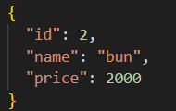

### **GET /api/items/{id}**

* **Description**: Retrieves a specific item by its unique ID.
* **Method**: GET
* **Path Parameter**:
  + id: The unique identifier of the item to retrieve.
* **Response**:



### **POST /api/items**

* **Description**: Creates a new item in the restaurant menu.
* **Method**: POST
* **Response**:
* 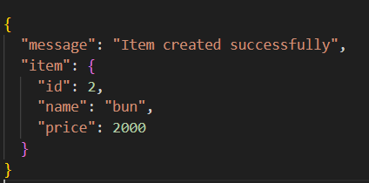

### **PUT /api/items/{id}**

* **Description**: Updates an existing item by its unique ID.
* **Method**: PUT
* **Path Parameter**:
  + id: The unique identifier of the item to update.
* **Response**:

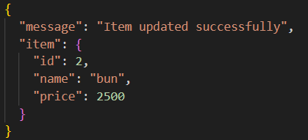

### **DELETE /api/items/{id}**

* **Description**: Deletes an item from the restaurant menu by its unique ID.
* **Method**: DELETE
* **Path Parameter**:
  + id: The unique identifier of the item to delete.
* **Response**:

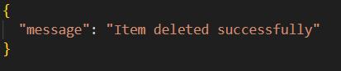

## 2. **Payments API Endpoints**

These endpoints are used for managing payments in the restaurant system, including customer payments for orders.

### **GET /api/payments**

* **Description**: Retrieves all payment records made in the restaurant.
* **Method**: GET
* **Response**: A list of all payment records with details

### **GET /api/payments/{id}**

* **Description**: Retrieves a specific payment record by its unique ID.
* **Method**: GET
* **Path Parameter**:
  + id: The unique identifier of the payment to retrieve.
* **Response**: The details of the requested payment record.

### **POST /api/payments**

* **Description**: Creates a new payment record.
* **Method**: POST
* **Response**: A confirmation message along with the created payment record's details.

### **PUT /api/payments/{id}**

* **Description**: Updates an existing payment record by its unique ID.
* **Method**: PUT
* **Path Parameter**:
  + id: The unique identifier of the payment to update.
* **Response**: A confirmation message with the updated payment details.

### **DELETE /api/payments/{id}**

* **Description**: Deletes a payment record by its unique ID.
* **Method**: DELETE
* **Path Parameter**:
  + id: The unique identifier of the payment to delete.
* **Response**: A confirmation message indicating successful deletion.

## Summary

The Restaurant Management System API provides two primary sets of functionalities:

1. **Item Management**: Operations for creating, retrieving, updating, and deleting restaurant items.
2. **Payment Management**: Operations for managing customer payments.

Each endpoint is designed to be straightforward, with standard HTTP methods and simple URL structures, ensuring easy integration with front-end systems or external applications for managing restaurant operations.