Practical 1A

Qn 4d

The row cannot be delete as it is a parent. It will result in a foreign key constraint fails. The product table is referencing to the row, thus it will cause an error.

Qn 4e

It is successful as there is no items that are referencing to the prod_num, thus it is able to be delete as there are no fails in the foreign key constraints.

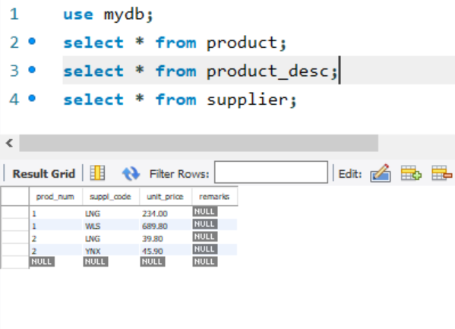

Practical 1B

Qn1c

Create user ‘adminStudent’ identified by ‘adminStufPa55’

Grant grant option on dbmsAdmin * to adminStudent

Grant all on dbmsAdmin to adminStudent

Create view Gx_Paris_Suppliers (SNo, SName)

as select SNo, SName

from Gx_supplier

where city = 'Paris';

grant select on gx_paris_suppliers to ddlstudent;

revoke select on gx_paris_suppliers from ddlstudent