**Manage MySQL Database with MySQL Workbench**

# Objectives:

This lab aims to get student familiar with MySQL Workbench and be able to :

* Create schema (database), create user, create connection
* Create tables, use the appropriate data type for table columns
* Query database tables, insert, update and delete data
* Reverse Engineer to generate database diagram for the schema generated

# Task 1. Create database connection, user, and schema.

## Start up MySQL Workbench. You will see the welcome page.

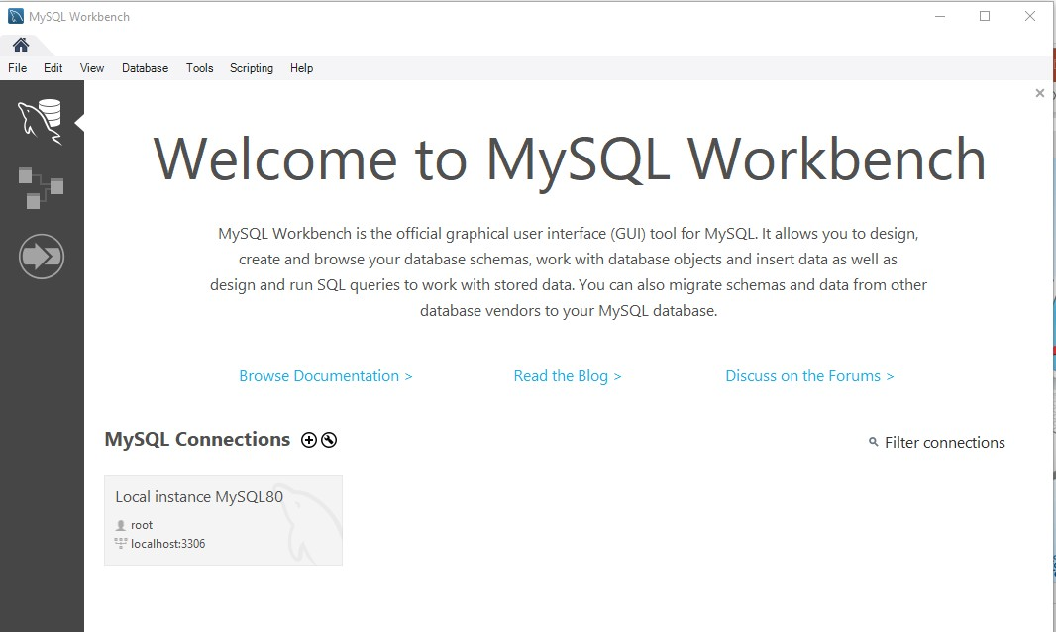

Data Migration

Data Modeling

Development

## Connect as *root* user. This is the only account available to you after installation.

## You will see the following interface. Get familiar with the various icons and tools available. You will use them to perform the following operations:

dbms: mysql

## Create a schema (database) : mydb

connection

## Create a user : dbmsuser

## Create a connection : dbmsuserconn

Database (schema): mydb

User: dbmsuser

Tables: product, product_desc, supplier

## Connect to database using dbmsuserconn connection

## Create 3 tables in mydb : product, product_desc, supplier

## Generate the EER for mydb

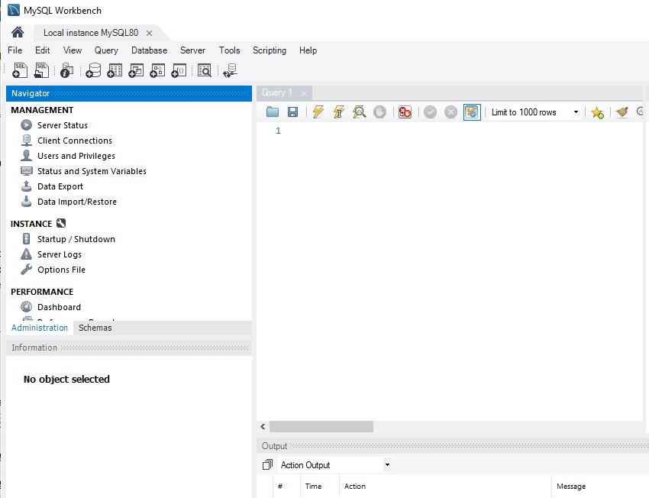

## 

## Create a new Schema (database) named *mydb*.

* 1. Click “Create New Schema” icon  , enter name “**mydb**”, Then Apply.

## Create a new user named *dbmsuser*, and grant the user with ALL access right to mydb database.

* 1. In the Administration tab, Management Section, Select Users and Privileges.
  2. Click Add Account Button, Enter **dbmsuser** in the Login, and give a password like **dbmsPa55**.   
     DO NOT click Apply.
  3. Click **Schema Privileges** tab. Click Add Entry. In the pop up window use Selected schema option and select **mydb**. Then click OK.

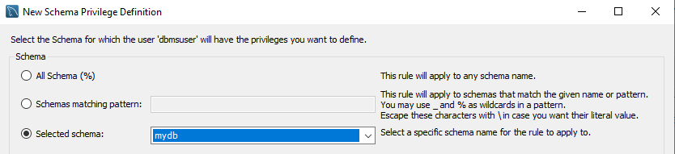

* 1. Check all the Object Rights as shown below and click Apply. Note. If there is a **Select “All”** button in your interface, you can use it to select all the object rights instead.

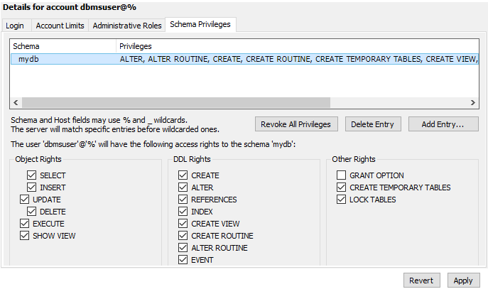

* 1. Now you are ready for the next task.

# Task 2. Create database tables, manipulate data, and create ERD

## Create a new connection named dbmsuserconn.

1. Click on Database -> Manage Connections -> Click New
2. Set the connection name to **dbmsuserconn**, username to **dbmsuser** and default schema to **mydb.**

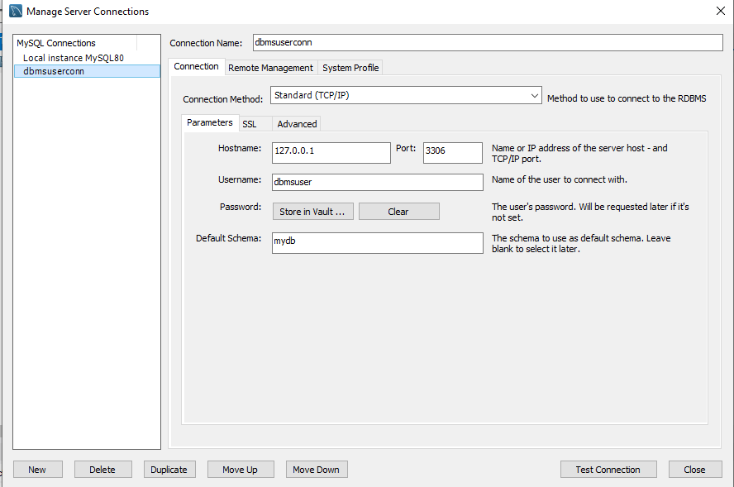

1. Click Test Connection. Key in ‘dbmsPa55’ when prompt for password. If test connection is successful, click OK, click close. The new connection has been created.

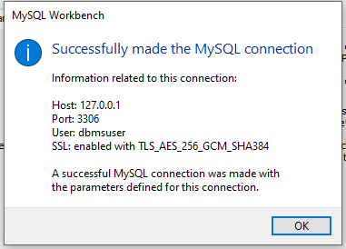

## Connect to the database with dbmsuserconn connection.

1. We have initially logged in as root. Now we will change connection to dbmsuserconn for the table creation tasks.
2. Click Database -> Connect to Database, select **dbmsuserconn**. Click Ok

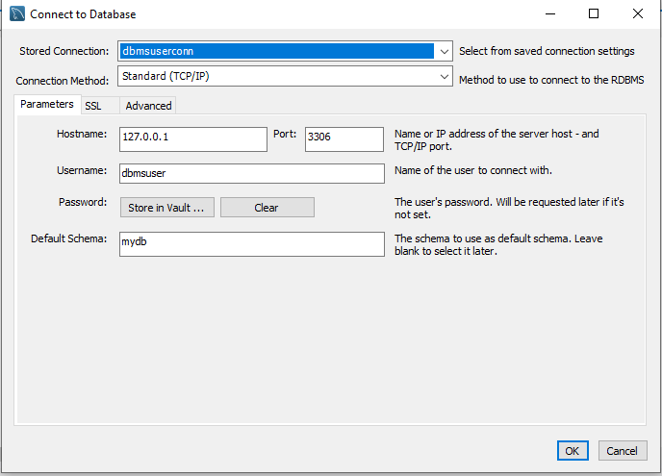

## Create 3 tables (product_desc, supplier, product)

* 1. Create table **product_desc** with prod_num and prod_desc.

From navigator pane. Open **mydb** schema, right click Tables -> create table. In the table Name box, enter **product_desc**. Add 2 columns prod_num, prod_desc as shown below. Click Apply

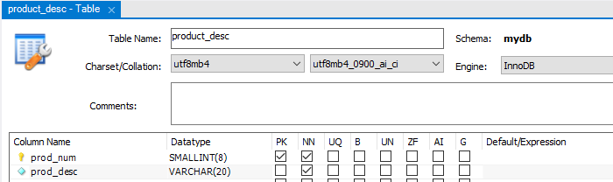

* 1. Create table **supplier** with suppl_code and suppl_name as shown below. Click Apply

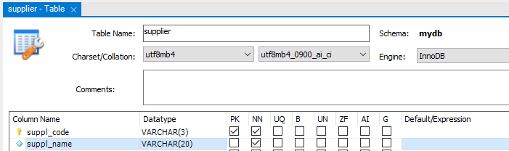

* 1. Create table **product** as shown below.

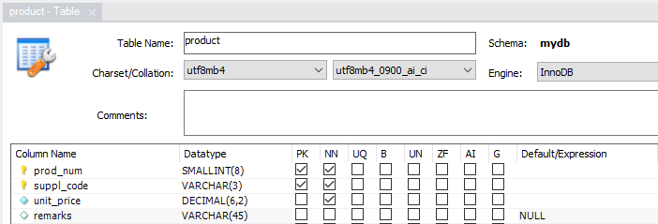

* 1. Add the foreign key constraints for **product** table. Click Apply

In the table design window, select Foreign Keys tab. Create 2 foreign keys as shown below.

|  |  |  |  |
| --- | --- | --- | --- |
| **Foreign Key name** | **Referenced Table** | **Column** | **Referenced Column** |
| fk_prod_num | product_desc | prod_num | prod_num |
| fk_suppl_code | supplier | suppl_code | suppl_code |

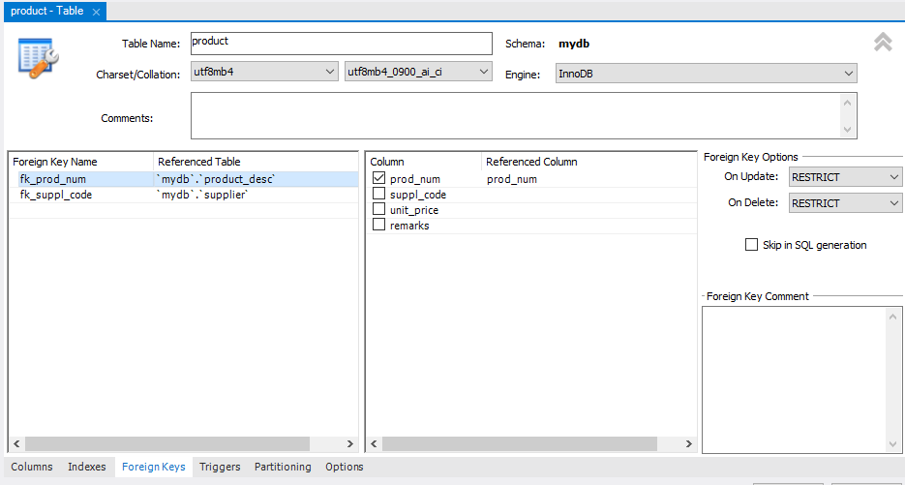

## Insert some data

1. Insert data to **product_desc** table. Right click on the product_desc table from navigator pane. Click on “**Select Rows – Limit 1000**”. In the Result Grid, key in data as shown. Then click **Apply**. Review the SQL query generated. Click Apply.

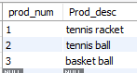

1. 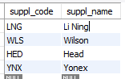Insert following data to **supplier** table.
2. 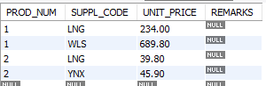Insert following data to **product** table
3. Remove 1st row from **product_desc** table

Right click the table click on Select Rows. From the Result Grid, right click the first row and Delete Rows. Click on Apply button.

You should get an error: delete operation failed. Can you explain why?

1. Remove 3rd row from **product_desc** table. Can you remove the row successfully? Why?

## Query Database tables

1. Open and new Query Tab, from File ->New Query Tab.

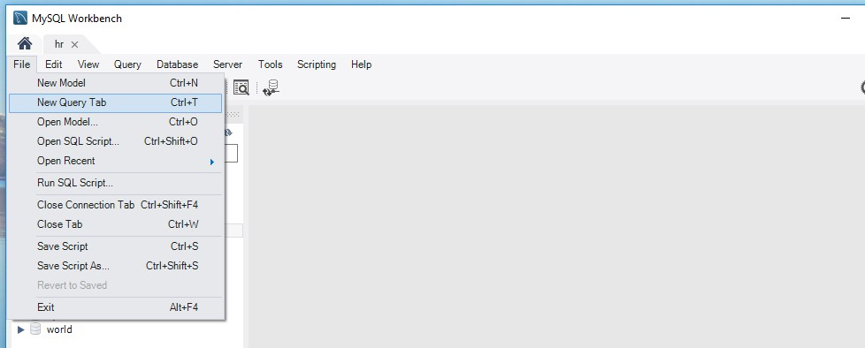

1. In the query window, enter the following SQL statement: select * from product;

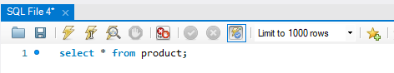

Execute all or selected statement

Execute the statement where the cursor is in.

## Create a EER diagram using Reverse Engineer.

1. From menu bar, select Database->Reverse Engineer…

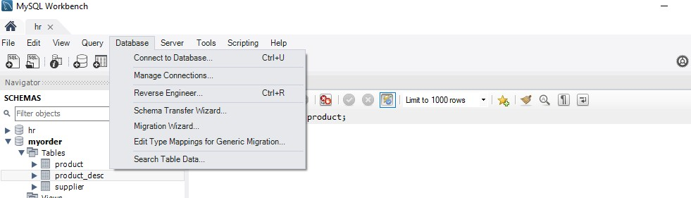

1. In “Set Parameters for connecting to a DBMS” step, make sure you select **dbmsuserconn** for stored connection and **dbmsuser** for username input box.

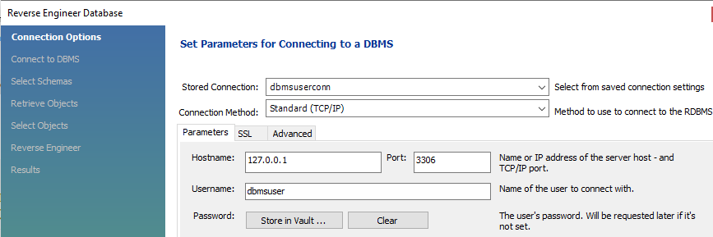

1. In “Select Schemas to Reverse Engineer” step, select **mydb** schema.
2. Execute the job. You should be able to see the diagram generated. You can make some adjustment on the table positions to make it look neater.

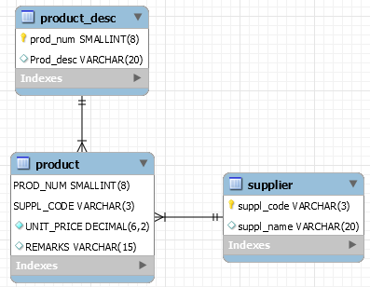

# Task 3. Checking (Show the following outputs to your tutor)

1. In the query window, type following SQL statement to let your tutor check that you have created the table and entered some data correctly.

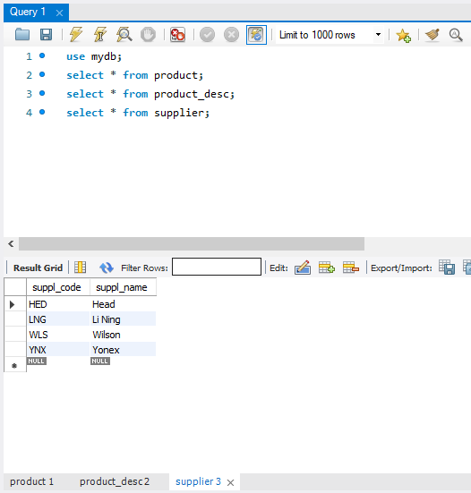

1. Show your tutor the EER diagram generated.

**------ The End ------**