We all learn to write a letter sooner or later; it is also a useful example to test our text formatting skills. In this assignment, you'll have a letter to mark up as a test for your HTML text formatting skills, as well as hyperlinks and proper use of the HTML <head> element.

|  |  |
| --- | --- |
| **Prerequisites:** | Before attempting this assessment you should have already worked through [Getting started with HTML](https://developer.mozilla.org/en-US/docs/Learn/HTML/Introduction_to_HTML/Getting_started), [What's in the head? Metadata in HTML](https://developer.mozilla.org/en-US/docs/Learn/HTML/Introduction_to_HTML/The_head_metadata_in_HTML), [HTML text fundamentals](https://developer.mozilla.org/en-US/docs/Learn/HTML/Introduction_to_HTML/HTML_text_fundamentals), [Creating hyperlinks](https://developer.mozilla.org/en-US/docs/Learn/HTML/Introduction_to_HTML/Creating_hyperlinks), and [Advanced text formatting](https://developer.mozilla.org/en-US/docs/Learn/HTML/Introduction_to_HTML/Advanced_text_formatting). |
| **Objective:** | Test basic and advanced HTML text formatting, use of hyperlinks, and use of HTML <head>. |

**Starting point**

To begin, get the [raw text you need to mark up](https://github.com/mdn/learning-area/blob/master/html/introduction-to-html/marking-up-a-letter-start/letter-text.txt), and the [the CSS  to style the HTML](https://github.com/mdn/learning-area/blob/master/html/introduction-to-html/marking-up-a-letter-start/css.txt). Create a new .html file using your text editor or use an online tool such as [CodePen](https://codepen.io/), [jsFiddle](https://jsfiddle.net/), or [Glitch](https://glitch.com/) to complete the tasks.

**Note**: If you get stuck, then ask us for help. See the [Assessment or further help](https://developer.mozilla.org/en-US/docs/Learn/HTML/Introduction_to_HTML/Marking_up_a_letter" \l "Assessment_or_further_help) section at the bottom of this page.

**Project brief**

For this project, your task is to mark up a letter that needs to be hosted on a university intranet. The letter is a response from a research fellow to a prospective PhD student concerning their application to the university.

Block/structural semantics

* Use appropriate document structure including doctype, and [<html>](https://developer.mozilla.org/en-US/docs/Web/HTML/Element/html" \o "The HTML <html> element represents the root (top-level element) of an HTML document, so it is also referred to as the root element. All other elements must be descendants of this element.), [<head>](https://developer.mozilla.org/en-US/docs/Web/HTML/Element/head" \o "The HTML <head> element contains machine-readable information (metadata) about the document, like its title, scripts, and style sheets.) and [<body>](https://developer.mozilla.org/en-US/docs/Web/HTML/Element/body" \o "The HTML <body> Element represents the content of an HTML document. There can be only one <body> element in a document.) elements.
* In general, the letter should be marked up as an organization of headings and  paragraphs, with the following exception. There is one top level heading (the "Re:" line) and three second level headings.
* Use an appropriate list type to mark up the semester start dates, study subjects, and exotic dances.
* Put the two addresses inside [<address>](https://developer.mozilla.org/en-US/docs/Web/HTML/Element/address" \o "The HTML <address> element indicates that the enclosed HTML provides contact information for a person or people, or for an organization.) elements. Each line of the address should sit on a new line, but not be in a new paragraph.

Inline semantics

* The names of the sender and receiver (and *Tel* and *Email*) should be marked up with strong importance.
* The four dates in the document should be have appropriate elements containing machine-readable dates.
* The first address and first date in the letter should have a class attribute value of *sender-column*. The CSS you'll add later will cause these to be right aligned, as it should be in the case in a classic letter layout.
* Mark up the five acronyms/abbreviations in the main text of the letter to provide expansions of each acronym/abbreviation.
* The six sub/superscripts should be marked up appropriately — in the chemical formulae,  and the numbers 103 and 104 (they should be 10 to the power of 3 and 4, respectively).
* Try to mark up at least two appropriate words in the text with strong importance/emphasis.
* There are two places where the letter should have a hyperlink. Add appropriate links with titles. For the location that the links point to, you may use http://example.com as the URL.
* Mark up the university motto quote and citation with appropriate elements.

The head of the document

* The character set of the document should be set as utf-8 using the appropriate meta tag.
* The author of the letter should be specified in an appropriate meta tag.
* The provided CSS should be included inside an appropriate tag.

**Hints and tips**

* Use the [W3C HTML validator](https://validator.w3.org/) to validate your HTML. Award yourself bonus points if it validates.
* You don't need to know any CSS to do this assignment.  You just need to put the provided CSS inside an HTML element.

**Example**

The following screenshot shows an example of what the letter might look like after being marked up.

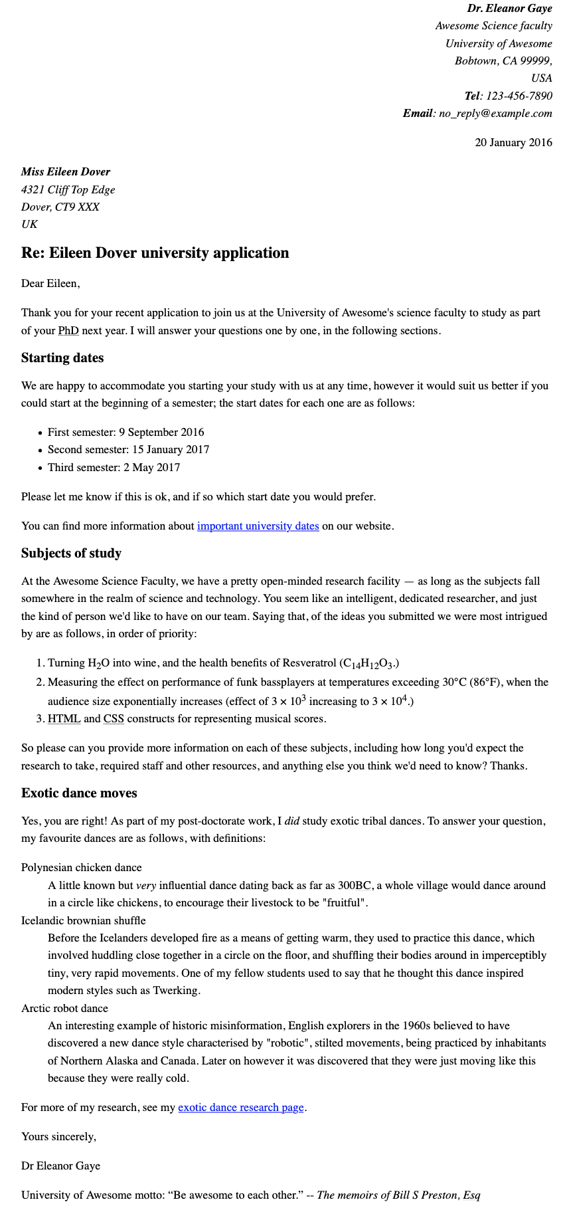

**Assessment or further help**

If you would like your work assessed, or if you get stuck and want to ask for help:

1. Put your work in an online shareable editor such as [CodePen](https://codepen.io/), [jsFiddle](https://jsfiddle.net/), or [Glitch](https://glitch.com/).
2. Write a post asking for assessment and/or help at the [MDN Discourse forum Learning category](https://discourse.mozilla.org/c/mdn/learn). Your post should include:
   * A descriptive title such as "Assessment wanted for Marking up a letter".
   * Details of what you have already tried, and what you would like us to do (if you are stuck and need help, or if you want an assessment).
   * A link to the example you want evaluated or need help with, in an online shareable editor (as mentioned in step 1 above). This is a good habit to develop. It's very hard to help someone with a coding problem without seeing their code.
   * A link to the actual task or assessment page, so we can read the exact wording of the relevant question(s).