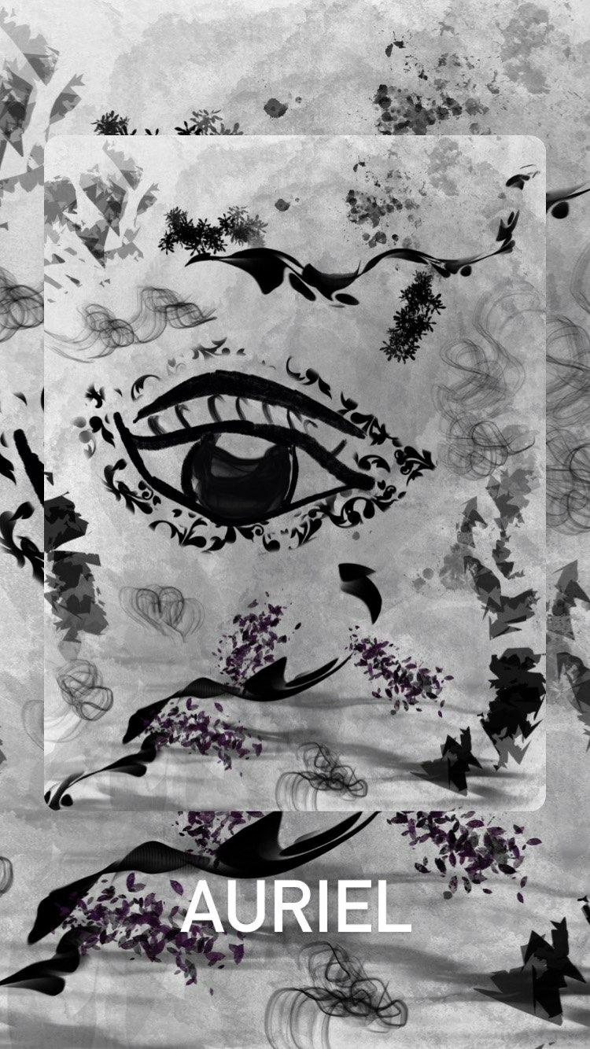

Contents

**Overview** 2

**1.** **Who are we?** 2

**2.** **Webpage Details** 2

**3.** **Visual Hierarchy and Grouping** 3

# **Overview**

## **Who are we?**

Auriel is a creative design business that offers unique and abstract artwork for discerning individuals to view and purchase. Our website provides a virtual art exhibit that is accessible 24/7, allowing consumers to peruse and shop at their leisure. Our website's minimalist design is designed to enhance the browsing experience and provide the feeling of visiting an art museum or showcase.

## **Webpage Details**

* The art gallery can be easily accessed by scrolling through the webpage, where all the artwork is elegantly displayed in one section.
* While consumers cannot search for specific artwork, they can view all the artwork and decide whether they wish to purchase it.
* Our website eliminates the need for consumers to conduct research or explore further information about the artwork. Instead, every piece is presented on the screen, allowing users to decide whether or not they wish to make a purchase.
* Our unique Gallery page combines browsing and shopping. It showcases the art with a sleek display method while providing a platform for consumers to make purchases.
* Consumers can contact us through the contact us page for any special requests, returns, or order information.
* Consumers should be familiar with basic online shopping and browsing.
* What distinguishes us from other art galleries and online art stores is that we are the exclusive owners of everything we publish. We serve as the creative directors, publishers, and proprietors of any pieces featured on our site.
* Once users have accomplished their objectives on our website, the most frequently asked questions typically pertain to our artwork. For example, they may have personal queries or inquiries about the creative process behind a particular piece.

## **Visual Hierarchy and Grouping**

* Our website is categorized into four main sections: Home, Gallery, About, and Contact Us.
* The Home page highlights two of our most popular artworks and two buttons, one directing to the Gallery page, and the other to the About page.
* The About page summarizes our brand and its purpose.
* The Contact Us page provides a platform for consumers to make special requests or general inquiries.
* The Contact Us page features a submission button and two text boxes where consumers can enter their full name and message.
* The Gallery page is the heart of our website, showcasing our artwork and offering prices for each item.
* The Gallery page features a sleek horizontal scroll and a cart button that allows consumers to view the items in their cart, quantity, and price for both the total and per item.