Walltest1

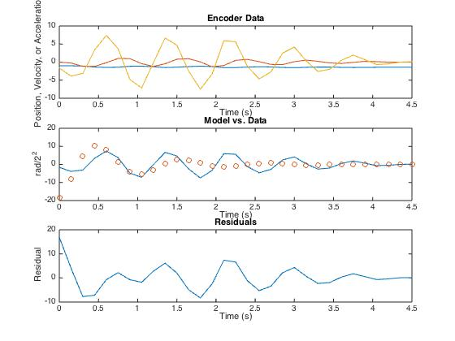

I =

0.0181

B =

0.0575

Walltest2

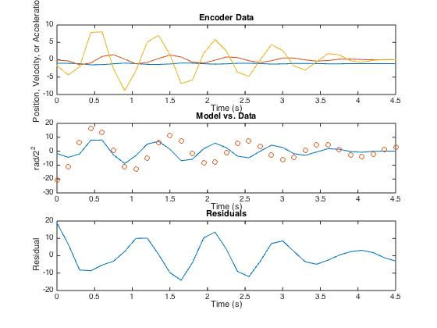

I =

0.0159

B =

0.0177

Walltest3

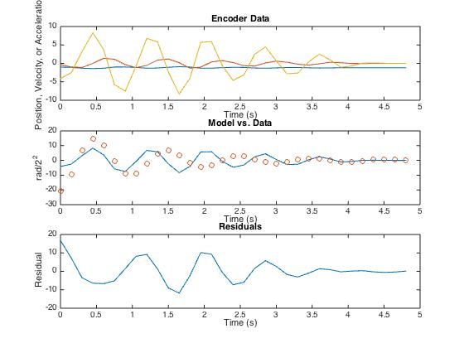I =

0.0155

B =

0.0325

Walltest4

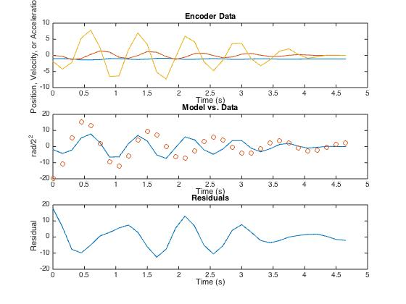I =

0.0167

B =

0.0215

Walltest5

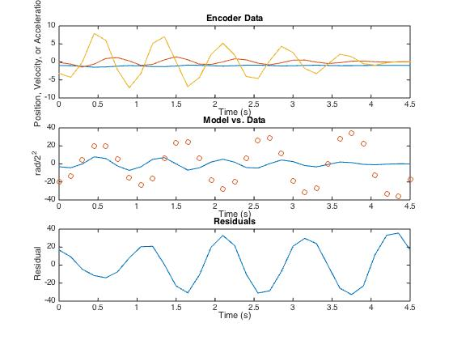

I =

0.0165

B =

-0.0078

Iavg = 0.01654

Bavg = 0.0248

Bavg(w/o negative test 5 answer) = 0.0323