Henrot 12/10/2023
Adrien
M1 CHPS
adrien.henrot@gmail.com

Lab Report :
C Programming and performance measures

Table of Contents :

1- Introduction : p.3

2- Details on the Architecture : p.3

3- Summary Table : p.3

4- C Programming and Other : p.4

5- Performances Measures and Results Analysis : p.5

6- Dotprod Results : p.6

- Flag -O0 for different compilers : p.6

- Flag -O1 for different compilers : p.7

- Flag -O2 for different compilers : p.8

- Flag -O3 for different compilers : p.9

- Flag -Ofast for different compilers : p.10

7- Reduc Results : p.11

- Flag -O0 for different compilers : p.11

- Flag -O1 for different compilers : p.12

- Flag -O2 for different compilers : p.13

- Flag -O3 for different compilers : p.14

- Flag -Ofast for different compilers : p.15

8- Conclusion : p.16

9- Annexes : p.16

1- Introduction :

The goal of this lab was to test the performances of different algorithms and their different compilation optimizations on three different types of matrices operations such as a DGEMM, a dot product and a reduction. With that in mind we had to use benchmarking technics and take care of our computer stability in order to get viable and exact datas. At least it is what was done for the mesured performances with the Debian computer in the following report as Mac OS does not give you the possibility of manipulation the system as you wish (for instance it has no equivalent of the “taskset” command).

2- Details on the architecture :

First of all we had to extract the information about the computer we were working on. For this lab I’ve worked on two different PCs.

The first one I started on is a x86_64 Mac with an Intel i7 CPU with 6 cores and 16 Go of DDR4 Ram. For the cache line it has : 32Ko for L1 instruction cache and 32Ko for the L1 Data cache, 262Ko for the L2 cache and 9473Ko for the L3 cache (the unit were not precised so they were supposed after the one you find on a classical Linux). On this particular computer I did not find a way to fix the CPU frequency nor how to pin a process to a specified computing core, so with that in mind we have to use the given results as a comparison base knowing that they do not have a particularly value for the performance measuring.

After that I started working on a x86_64 Dell Inspiron with an AMD Ryzen 7 CPU with 16 cores and 16 Go of DDR4 Ram. For the cache line it has a 32Ko L1 data cache, a 32Ko L1 instruction cache a 512 L2 cache and finally a 4096Ko (~4Mo) L3 cache. This PC is running Debian 12 so there was no more problem with fixing the CPU frequency, pinning a process on a core or even verifying the stability of the CPU frequency. So the measurements done with this are more accurate than the one done with the Mac and can be taken into consideration.

3- Summary table :

Computer | Mac | Dell Inspiron
OS | Mac OS Ventura | Debian 12
Architechture | x86_64 | x86_64
CPU | Intel i7 | AMD Ryzen 7
Cores | 6 | 16
Ram | 16 Go DDR4 | 16 Go DDR4
L1 Data Cache | 32 Ko | 32 Ko
L1 Instruction Cache | 32 Ko | 32 Ko
L2 Cache | 262 Ko | 512 Ko
L3 Cache | 9437 Ko (~9.4 Mo) | 4096Ko (~4Mo)
4- C Programming and other :

For the C programming part there was no particular difficulties, we had to implement for each operation types an algorithm called unroll eight, the aim of which is to fully load the pipeline. To do so instead of doing multiple loop iteration with one operation each, we divide the number of iteration by eight and we do eight operations at a time. Then if the number of iteration cannot be divided in blocs of eight you have a second loop which ultimately compute the remaining operations.

Then we had to work with GNUplot and that was more difficult as the documentation is not really accessible/well done. The following plots are not necessarily the prettiest ones but they are functional and they show the wanted information. The script used to make them is given as a “plot.p” file for each operation type (it actually is the same script).

Finally we had at some point to modify the given Makefile to test different type of optimization flags and several compiler (such as gcc and clang). In order to do it you can directly change the arguments of the Makefile in the shell with a simple command, instead of juste writing make you can write “make CC=gcc OFLAGS=-O3” for instance to compile the program with gcc and O3 as a flag. For this lab I worked with clang (mac and debian versions) and gcc.
Compiler version | gcc | clang
Mac OS | - | 11.0.3
Debian 12 | 12.2.0 | 14.0.6

5- Performances Measures and Results Analysis :

In this chapter we had to get the performances measures and analyze them, in order to do so the computer needs to be stable. For the tests done on the Mac I was unable to verify this but I did what I could to assure some sort of stability. Indeed every application was closed, WiFi was off and it was connected to mains power.

For the Dell on the opposite I was able to do so with the use of the “cpupower-frequency-info” Linux command which let the user sets the frequency of the CPU or the governor mode. In my case I used the governor interface to fix it. With the components I have the maximum frequency that can be settled is 1.80 GHz and that corresponds to the performance mode of the governor. So I fixed these values for CPU 1 and then used this CPU to pin the process to perform the different Benchmarks.

Before diving into the results I might as well explain briefly the differences of -O0 to -Ofast optimizations :

- So -O0 means no optimization, it is how you program is normally compiled if you do not specify anything, but it reduces compilation time. It is generally really under-performing for performances.

- Then we have -O1 flag which is the most basic optimization level, the compiler will just try to produce faster and “smaller” code without taking to much compilation time.

- The next one is -O2, it generally is a recommended level of optimization, it has the same flags activated than -O1 but a few more on top. SSE (Streaming SIMD Extension) and AVX (Advanced Vector Extension) might be used at this level. It attempt to increase code performance without compromising on size and without taking to long to compile.

- With -O3 optimization level you have the benefits of the -O2 flag with few expensive optimization on compile time and memory usage. It enables the -ftree-vectorize flag so that loops in our code are getting vectorized and will use AVX YMM registers.

- And finally we have -Ofast which consists of -O3 with -ffast-math and other flags to be really fast but it looses numerical precision in the end.

6- DOTPROD RESULTS :

Flag -O0 for different compilers : (programm is running on DRAM)

PC | title | KiB | MiB | GiB | n | r | d | min | max | Mean | Stddev (%) | MiB/s
Mac  gcc | Base | 9.375 | 0.009 | 0 | 600 | 500 | 32211.179 | 1597.146 | 2451.492 | 1740.660 | 9.139 | 2629.829
Mac gcc | Unroll 8 | 9.375 | 0.009 | 0 | 600 | 500 | 27157.129 | 1257.244 | 1623.340 | 1475.261 | 8.426 | 3102.934
Debian  clang | Base | 9.375 | 0.009 | 0 | 600 | 500 | 23075.926 | 1513.278 | 2949.470 | 1563.257 | 15.933 | 2928.268
Debian  clang | Unroll 8 | 9.375 | 0.009 | 0 | 600 | 500 | 47703.039 | 1515.340 | 1530.430 | 1518.920 | 0.280 | 3013.745
Debian gcc | Base | 9.375 | 0.009 | 0 | 600 | 500 | 48603.146 | 1513.058 | 2967.282 | 1560.838 | 16.178 | 2932.808
Debian  gcc | Unroll 8 | 9.375 | 0.009 | 0 | 600 | 500 | 42034.874 | 1512.254 | 1533.796 | 1514.797 | 0.302 | 3021.947

Graph :
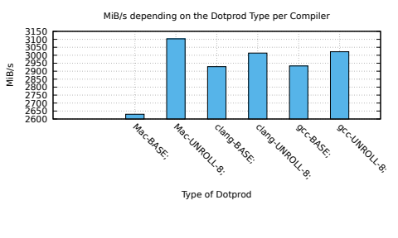

Observations :

On this first graph we can see that the mac versions are not really coherent with what we can observe about clang and gcc versions. This is probably based on the fact that the computer wasn’t stable. Except that we see that gcc and clang versions seems to have more or less the same performances (and even the same error margin if we refer to the table above). This can be explained thanks to -O0 flag which does not make any optimization.

Flag -O1 for different compilers : (programm is running on DRAM)

PC | title | KiB | MiB | GiB | n | r | d | min | max | Mean | Stddev (%) | MiB/s
Mac  gcc | Base | 9.375 | 0.009 | 0 | 600 | 500 | 46161.550 | 769.156 | 1032.232 | 802.411 | 6.499 | 5704.856
Mac gcc | Unroll 8 | 9.375 | 0.009 | 0 | 600 | 500 | 48195.433 | 745.682 | 776.394 | 1475.261 | 2.521 | 5896.020
Debian  clang | Base | 9.375 | 0.009 | 0 | 600 | 500 | 60029.575 | 403.096 | 1257.718 | 462.408 | 41.732 | 9899.567
Debian  clang | Unroll 8 | 9.375 | 0.009 | 0 | 600 | 500 | 29612.187 | 392.756 | 402.334 | 393.250 | 0.488 | 11640.52
Debian gcc | Base | 9.375 | 0.009 | 0 | 600 | 500 | 97656.747 | 403.778 | 1255.152 | 434.835 | 34.197 | 10527.30
Debian  gcc | Unroll 8 | 9.375 | 0.009 | 0 | 600 | 500 | 19591.888 | 393.436 | 400.252 | 393.799 | 0.355 | 11624.29

Graph :
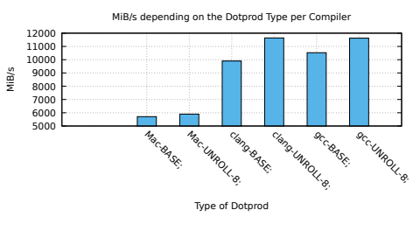

Observations :

On this graph we can still see that mac performances are totally out. For the rest of the report we will just take that as granted. On the other hand we can see that here we got some differences between gcc and clang optimizations on the Base algorithm, gcc computes it slightly faster 9899 MiB/s for clang vs 10527 for gcc and the error margin is higher for clang to, 41% vs 34% for gcc. On the unroll algorithm they both perform almost the same but gcc is still better in term of error.

Flag -O2 for different compilers : (programm is running on DRAM)

PC | title | KiB | MiB | GiB | n | r | d | min | max | Mean | Stddev (%) | MiB/s
Mac  gcc | Base | 9.375 | 0.009 | 0 | 600 | 500 | 18514.750 | 769.204 | 842.934 | 779.613 | 2.408 | 5871.682
Mac gcc | Unroll 8 | 9.375 | 0.009 | 0 | 600 | 500 | 46178.256 | 738.466 | 925.740 | 768.483 | 4.784 | 5956.722
Debian  clang | Base | 9.375 | 0.009 | 0 | 600 | 500 | 28883.707 | 393.436 | 499.636 | 397.788 | 4.629 | 11507.72
Debian  clang | Unroll 8 | 9.375 | 0.009 | 0 | 600 | 500 | 133828.076 | 392.756 | 400.772 | 393.721 | 0.621 | 11626.59
Debian gcc | Base | 9.375 | 0.009 | 0 | 600 | 500 | 19357.162 | 403.096 | 1193.438 | 427.948 | 32.118 | 10696.71
Debian  gcc | Unroll 8 | 9.375 | 0.009 | 0 | 600 | 500 | 25446.147 | 392.756 | 401.372 | 393.616 | 0.508 | 11629.71

Graph :
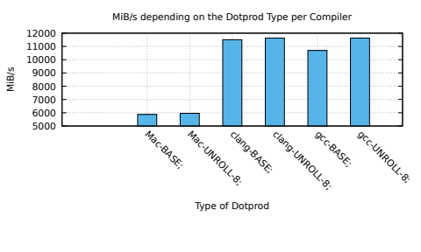

Observations :

Here things are changing a bit, clang is starting to perform better than gcc on the Base algorithm and is doing way less error, where gcc as a 32% standard deviation we only have 4.6% on clang. So for -O2 on the base algorithm we can say that clang does a better job in order to optimize and vectorize the code. On the other hand they bot perform equally on the Unroll 8 one, “errors” are inferior to 1% and they run at equal speeds.

Flag -O3 for different compilers : (programm is running on DRAM)

PC | title | KiB | MiB | GiB | n | r | d | min | max | Mean | Stddev (%) | MiB/s
Mac  gcc | Base | 9.375 | 0.009 | 0 | 600 | 500 | 15535.367 | 770.602 | 884.672 | 780.901 | 3.110 | 5861.996
Mac gcc | Unroll 8 | 9.375 | 0.009 | 0 | 600 | 500 | 143525.400 | 745.316 | 865.640 | 776.867 | 3.013 | 5892.432
Debian  clang | Base | 9.375 | 0.009 | 0 | 600 | 500 | 43474.420 | 393.436 | 859.752 | 408.678 | 19.825 | 11201.09
Debian  clang | Unroll 8 | 9.375 | 0.009 | 0 | 600 | 500 | 25567.225 | 392.756 | 400.190 | 393.376 | 0.474 | 11636.78
Debian gcc | Base | 9.375 | 0.009 | 0 | 600 | 500 | 26604.832 | 392.776 | 1253.690 | 421.753 | 35.484 | 10853.84
Debian  gcc | Unroll 8 | 9.375 | 0.009 | 0 | 600 | 500 | 24961.061 | 392.756 | 401.754 | 394.107 | 0.718 | 11615.21

Graph :

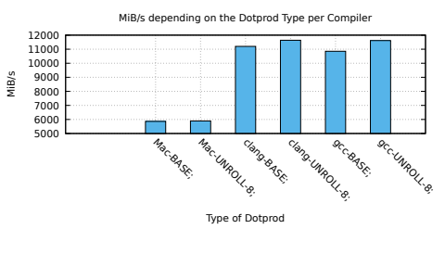

Observations :

The same phenomenon as -O2 happens here, gcc is under-performing on the Base algorithm and is doing way more errors. To be able to interpret correctly these results and understand what’s really going on we could take a look at the assembly versions that the compilers are generating. Again for an Unroll type of algorithm they both perform almost equally here clang is still slightly faster and more accurate.

Flag -Ofast for different compilers : (programm is running on DRAM)

PC | title | KiB | MiB | GiB | n | r | d | min | max | Mean | Stddev (%) | MiB/s
Debian  clang | Base | 9.375 | 0.009 | 0 | 600 | 500 | 21585.813 | 99.766 | 311.746 | 162.565 | 59.350 | 28158.73
Debian  clang | Unroll 8 | 9.375 | 0.009 | 0 | 600 | 500 | 48015.202 | 140.764 | 184.286 | 143.277 | 5.231 | 31949.64
Debian gcc | Base | 9.375 | 0.009 | 0 | 600 | 500 | 26923.291 | 198.130 | 615.614 | 259.139 | 53.700 | 17664.77
Debian  gcc | Unroll 8 | 9.375 | 0.009 | 0 | 600 | 500 | 49945.976 | 253.254 | 261.050 | 254.163 | 0.873 | 18010.66

Graph :

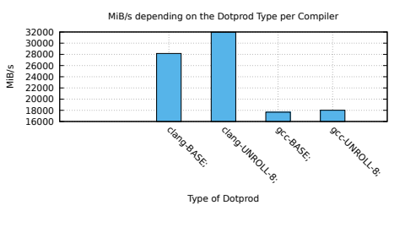

Observations :

This is a result that I found funny to add, we can see that for -Ofast gcc is not really that fast compared to it’s -O3 version (only 4k MiB/s more) and does not loose that much accuracy on the unroll algorithm. Whereas on the Base algorithm it gained 20% of standard deviation. Clang for it’s part is indeed much faster than it’s -O3 version but multiplies by 3 it’s standard deviation for the Base algorithm and by ten for then Unroll one. So gcc seems a bit more stable in term of accuracy but is way slower.

7- REDUC RESULTS :

Flag -O0 for different compilers : (programm is running on DRAM)

PC | title | KiB | MiB | GiB | n | r | d | min | max | Mean | Stddev (%) | MiB/s
Mac  gcc | Base | 9.375 | 0.009 | 0 | 600 | 500 | 32211.179 | 1597.146 | 2451.492 | 1740.660 | 9.139 | 2629.829
Mac gcc | Unroll 8 | 9.375 | 0.009 | 0 | 600 | 500 | 27157.129 | 1257.244 | 1623.340 | 1475.261 | 8.426 | 3102.934
Debian  clang | Base | 9.375 | 0.009 | 0 | 600 | 500 | 23075.926 | 1513.278 | 2949.470 | 1563.257 | 15.933 | 2928.268
Debian  clang | Unroll 8 | 9.375 | 0.009 | 0 | 600 | 500 | 47703.039 | 1515.340 | 1530.430 | 1518.920 | 0.280 | 3013.745
Debian gcc | Base | 9.375 | 0.009 | 0 | 600 | 500 | 48603.146 | 1513.058 | 2967.282 | 1560.838 | 16.178 | 2932.808
Debian  gcc | Unroll 8 | 9.375 | 0.009 | 0 | 600 | 500 | 42034.874 | 1512.254 | 1533.796 | 1514.797 | 0.302 | 3021.947

Graph :

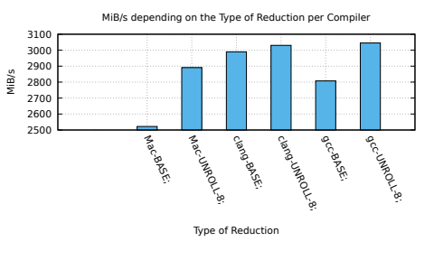

Observations :

Here we start on a new type of algorithm but we have the same sort of results (thankfully). Gcc is still under-performing on the base algorithm for -O0. Just like the results for the dotprod we can see that both compilers are equally accurate. Mac is still totally off in the results.

Flag -O1 for different compilers : (programm is running on DRAM)

PC | title | KiB | MiB | GiB | n | r | d | min | max | Mean | Stddev (%) | MiB/s
Mac  gcc | Base | 9.375 | 0.009 | 0 | 600 | 500 | 46161.550 | 769.156 | 1032.232 | 802.411 | 6.499 | 5704.856
Mac gcc | Unroll 8 | 9.375 | 0.009 | 0 | 600 | 500 | 48195.433 | 745.682 | 861.148 | 776.394 | 2.521 | 5896.020
Debian  clang | Base | 9.375 | 0.009 | 0 | 600 | 500 | 60029.575 | 403.096 | 1257.718 | 462.408 | 41.732 | 9899.567
Debian  clang | Unroll 8 | 9.375 | 0.009 | 0 | 600 | 500 | 29612.187 | 392.756 | 402.334 | 393.250 | 0.488 | 11640.52
Debian gcc | Base | 9.375 | 0.009 | 0 | 600 | 500 | 97656.747 | 403.778 | 1255.152 | 434.835 | 34.197 | 10527.30
Debian  gcc | Unroll 8 | 9.375 | 0.009 | 0 | 600 | 500 | 19591.888 | 393.436 | 400.252 | 393.799 | 0.355 | 11624.29

Graph :

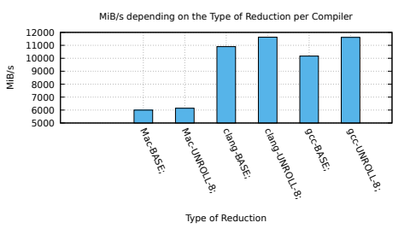

Observations :

Here we still have coherent results if we compare to the one on the dotprod. Gcc is not that good for the Base algorithm but is doing less errors than clang. And the still perfom equally when it comes to unrolling.

Flag -O2 for different compilers : (programm is running on DRAM)

PC | title | KiB | MiB | GiB | n | r | d | min | max | Mean | Stddev (%) | MiB/s
Mac  gcc | Base | 9.375 | 0.009 | 0 | 600 | 500 | 18514.750 | 769.204 | 842.934 | 779.613 | 2.408 | 5871.682
Mac gcc | Unroll 8 | 9.375 | 0.009 | 0 | 600 | 500 | 46178.256 | 738.466 | 925.740 | 768.483 | 4.784 | 5956.722
Debian  clang | Base | 9.375 | 0.009 | 0 | 600 | 500 | 28883.707 | 393.436 | 499.636 | 397.788 | 4.629 | 11507.72
Debian  clang | Unroll 8 | 9.375 | 0.009 | 0 | 600 | 500 | 133828.076 | 392.756 | 400.772 | 393.721 | 0.621 | 11626.59
Debian gcc | Base | 9.375 | 0.009 | 0 | 600 | 500 | 19357.162 | 403.096 | 1193.438 | 427.948 | 32.118 | 10696.71
Debian  gcc | Unroll 8 | 9.375 | 0.009 | 0 | 600 | 500 | 25446.147 | 392.756 | 401.372 | 393.616 | 0.508 | 11629.71

Graph :

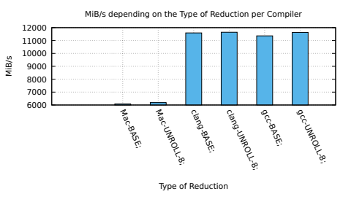

Observations :

Surprisingly with -O2 gcc is performing well on the base algorithm but when we look in details we find something even more surprising : it’s not accurate at all for this level of optimization. Clang seems to be way more stable globally for now. They still perform equally for Unrolling.

Flag -O3 for different compilers : (programm is running on DRAM)

PC | title | KiB | MiB | GiB | n | r | d | min | max | Mean | Stddev (%) | MiB/s
Mac  gcc | Base | 9.375 | 0.009 | 0 | 600 | 500 | 15535.367 | 770.602 | 884.672 | 780.901 | 3.110 | 5861.996
Mac gcc | Unroll 8 | 9.375 | 0.009 | 0 | 600 | 500 | 143525.400 | 745.316 | 865.640 | 776.867 | 3.013 | 5892.432
Debian  clang | Base | 9.375 | 0.009 | 0 | 600 | 500 | 43474.420 | 393.436 | 859.752 | 408.678 | 19.825 | 11201.09
Debian  clang | Unroll 8 | 9.375 | 0.009 | 0 | 600 | 500 | 25567.225 | 392.756 | 400.190 | 393.376 | 0.474 | 11636.78
Debian gcc | Base | 9.375 | 0.009 | 0 | 600 | 500 | 26604.832 | 392.776 | 1253.690 | 421.753 | 35.484 | 10853.84
Debian  gcc | Unroll 8 | 9.375 | 0.009 | 0 | 600 | 500 | 24961.061 | 392.756 | 401.754 | 394.107 | 0.718 | 11615.21

Graph :
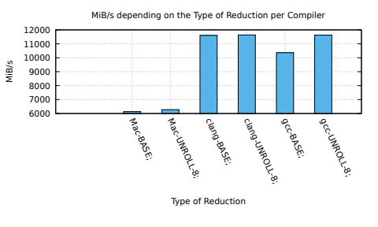

Observations :

We can observe the exact same thing as for -O2 in terms of performances. Clang is catching up with gcc in term of errors, it has for times the standard deviation it had for -O2. On the other hand gcc is almost equivalent to it’s -O2 version.

Flag -Ofast for different compilers : (programm is running on DRAM)

PC | title | KiB | MiB | GiB | n | r | d | min | max | Mean | Stddev (%) | MiB/s
Debian  clang | Base | 9.375 | 0.009 | 0 | 600 | 500 | 21585.813 | 99.766 | 311.746 | 162.565 | 59.350 | 28158.73
Debian  clang | Unroll 8 | 9.375 | 0.009 | 0 | 600 | 500 | 48015.202 | 140.764 | 184.286 | 143.277 | 5.231 | 31949.64
Debian gcc | Base | 9.375 | 0.009 | 0 | 600 | 500 | 26923.291 | 198.130 | 615.614 | 259.139 | 53.700 | 17664.77
Debian  gcc | Unroll 8 | 9.375 | 0.009 | 0 | 600 | 500 | 49945.976 | 253.254 | 261.050 | 254.163 | 0.873 | 18010.66

Graph :
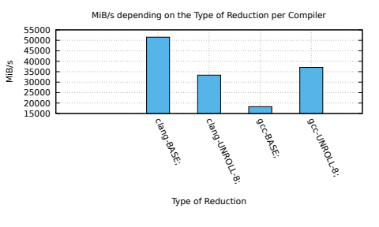

Observations :

Here we have still clang performing way better than gcc on the Base algorithm for almost the same error margin but gcc works better and is quit accurate at unrolling under -Ofast.

8- Conclusion :

For every result we got here we have observed that gcc is generally less efficient when it comes to optimizing the Base algorithm and after -O2 flag it’s accuracy become really messed up. It does on the other hand perform better than clang with the -Ofast flag in term of accuracy (not by much but it’s still something to be noted). For -O0 and -O1 the results do not differ that much from one compiler to the other. From -O2 things start to go in two different ways, gcc compile code is having a better accuracy when it comes to unrolling code and keep the same sort of performance than the clang one. Then for -O3 things shifts, gcc compiled code is less accurate than the clang one but no by much (both are under 1% of standard deviation) and they actually keep the same performances. To conclude I think that what we can say after these observations is that clang is good when it comes to optimizing simple algorithms (such as the base one for reduction and dot product) and gcc is better at optimizing unrolling sort of algorithms and is pretty consistent in term of performance and accuracy for those one.

9- Annexes :

Results of benchmarks and plots for DGEMM :
TD2/dgemm/Results/…

Results of benchmarks and plots for dotprod :
TD2/dotprod/Results/…

Results of benchmarks and plots forreduc :
TD2/reduc/Results/...

