**Administration Module:**

Administration Home:

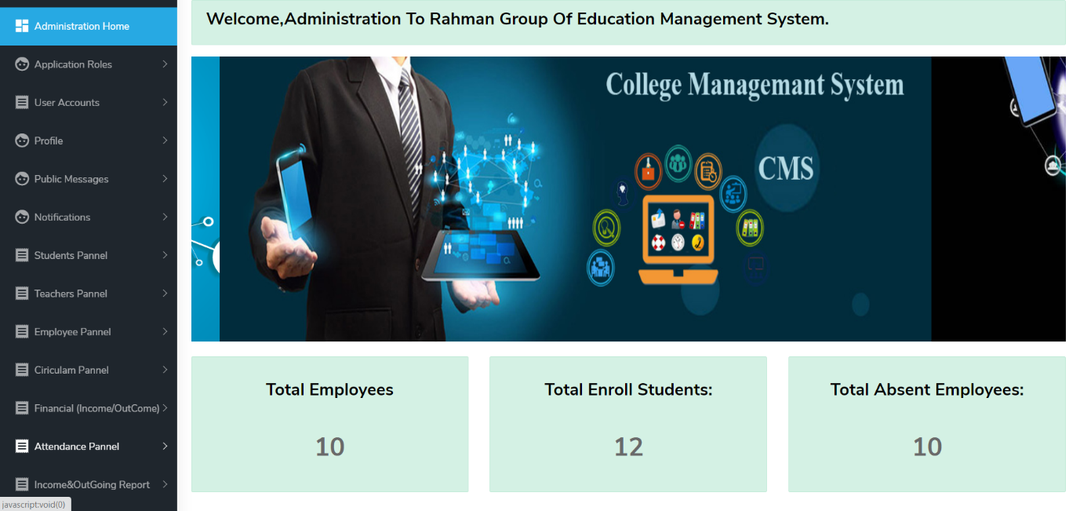

Application Users:

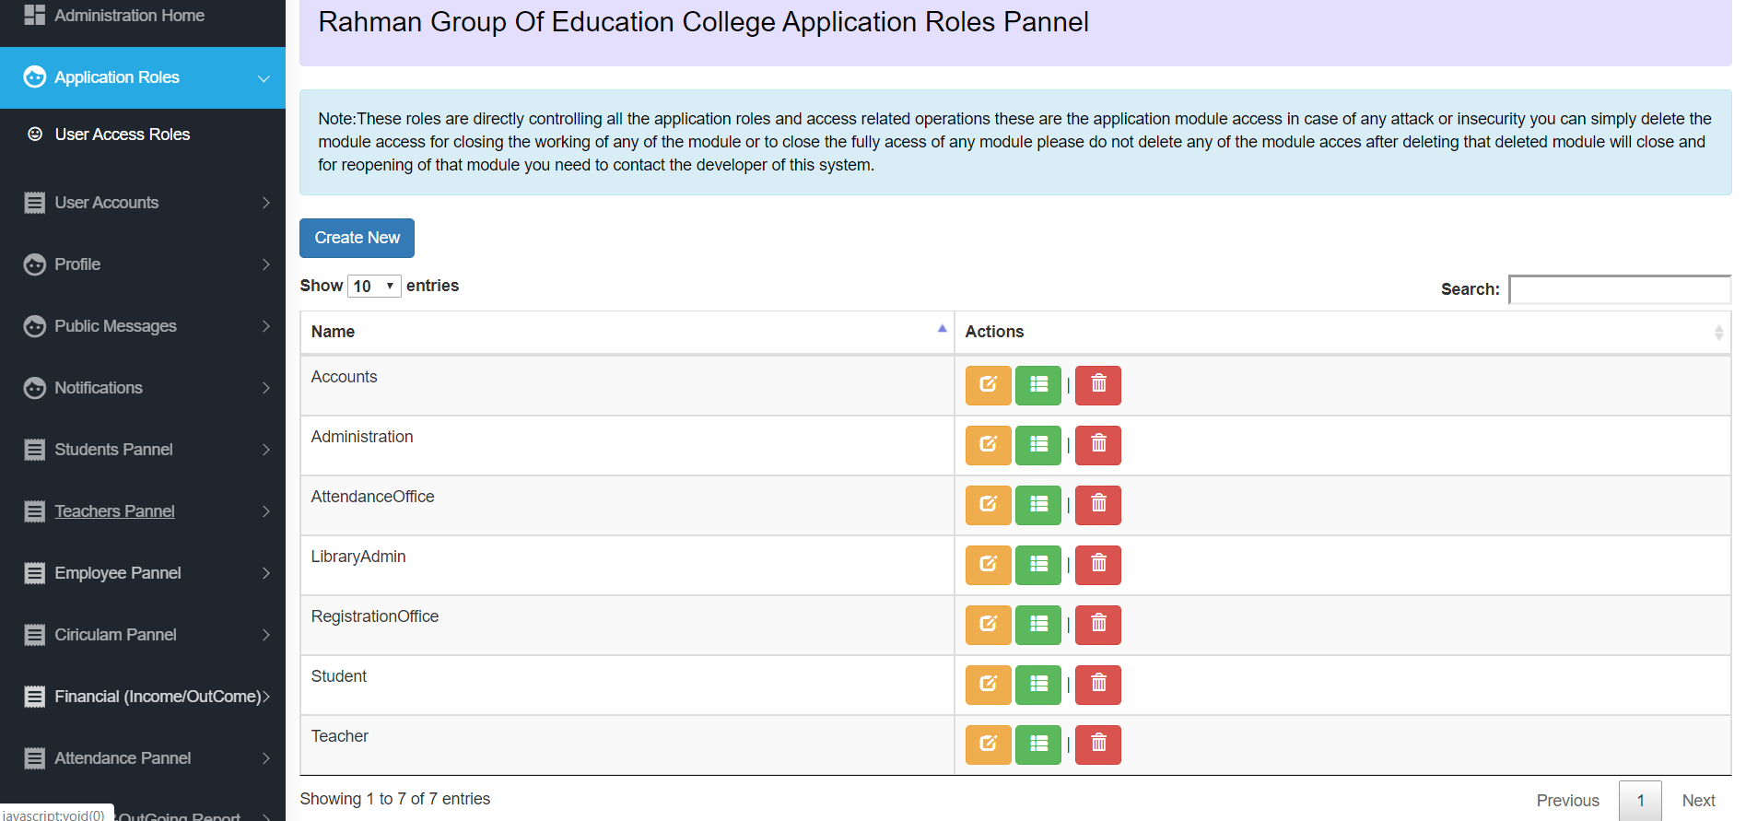

Profile:

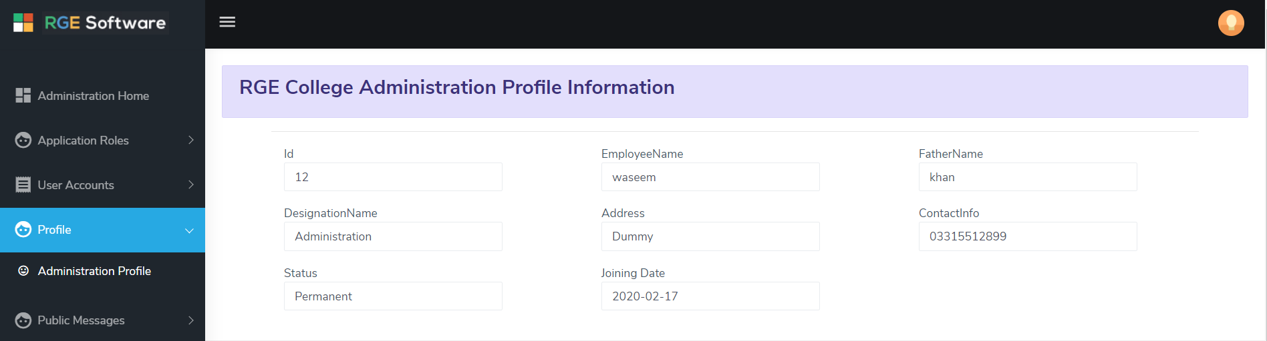

Notification:

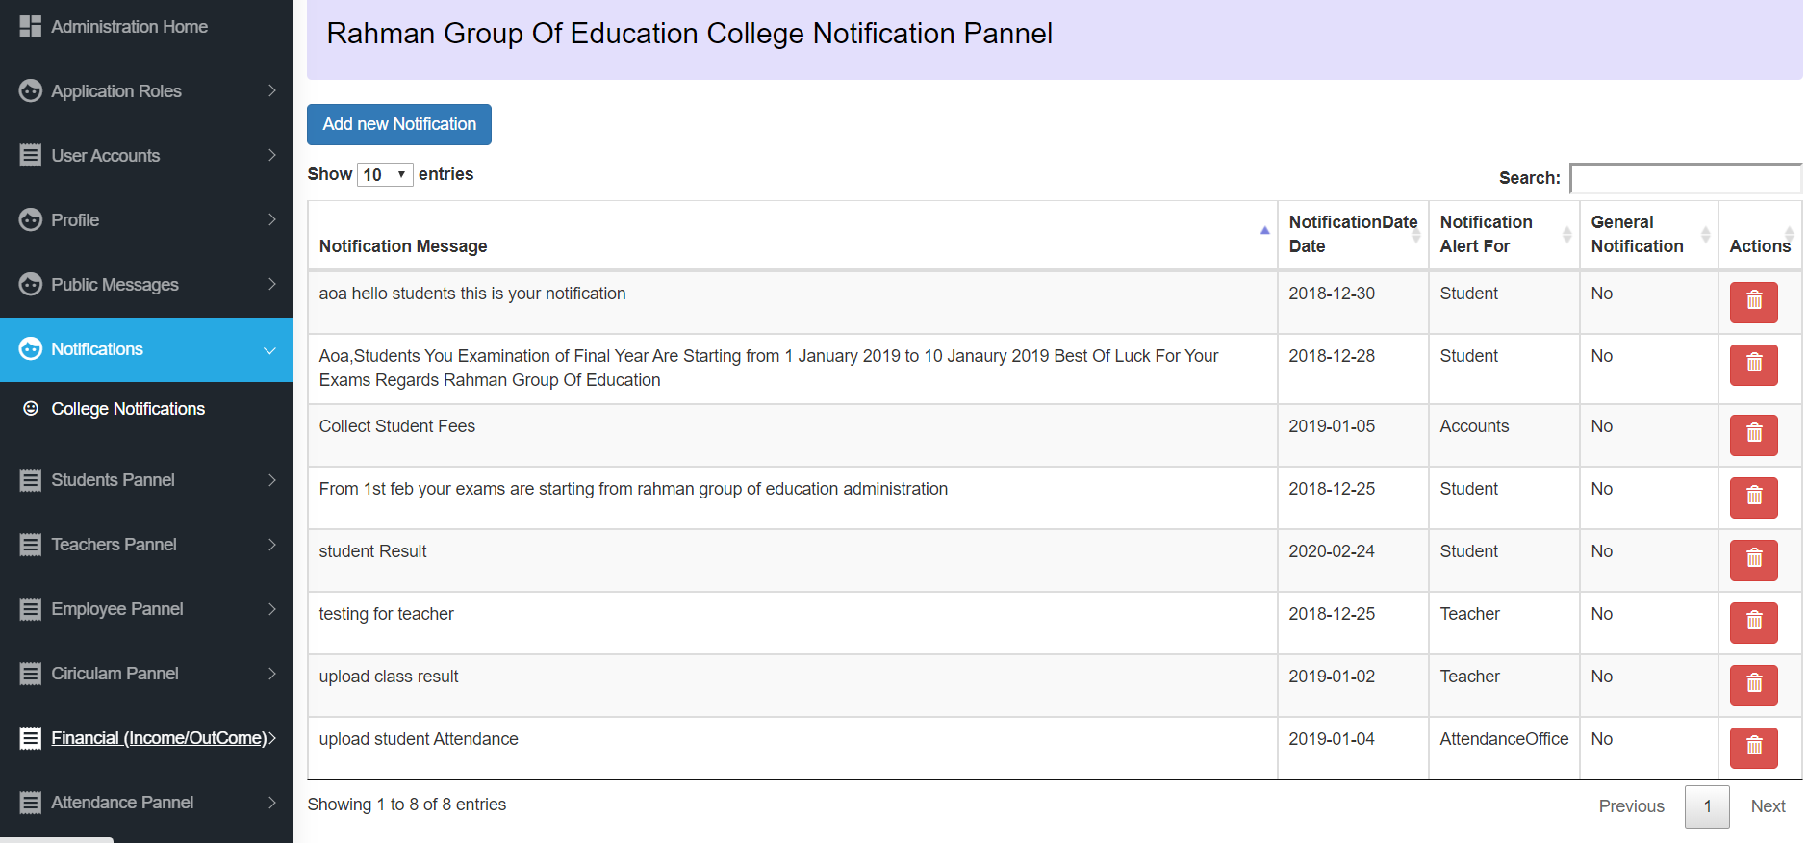

**Student Panel:**

Register student Records:

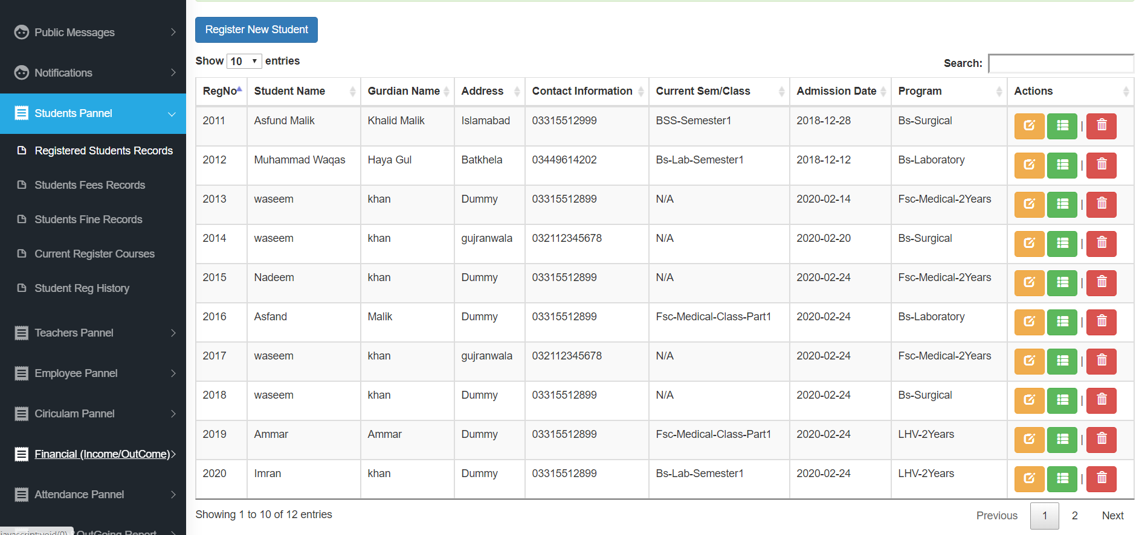

Student Register Edit View:

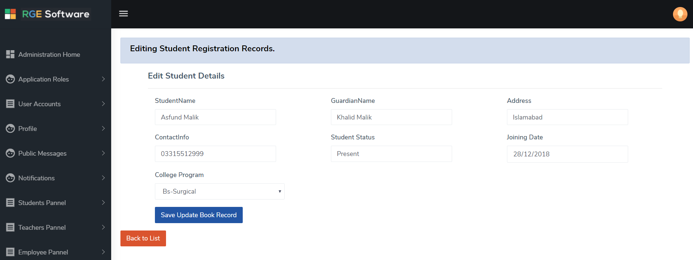

Student Register Create View:

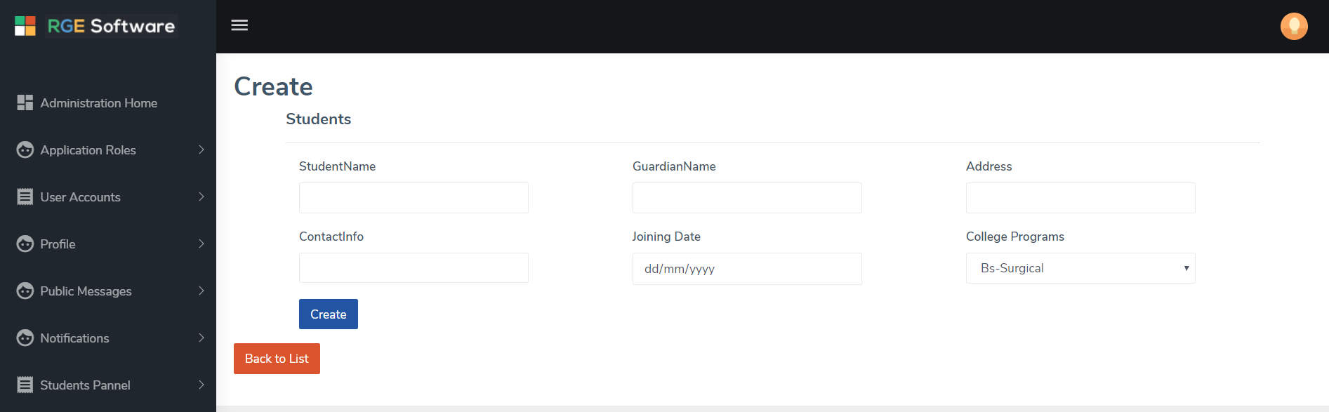

Student Register Detail View:

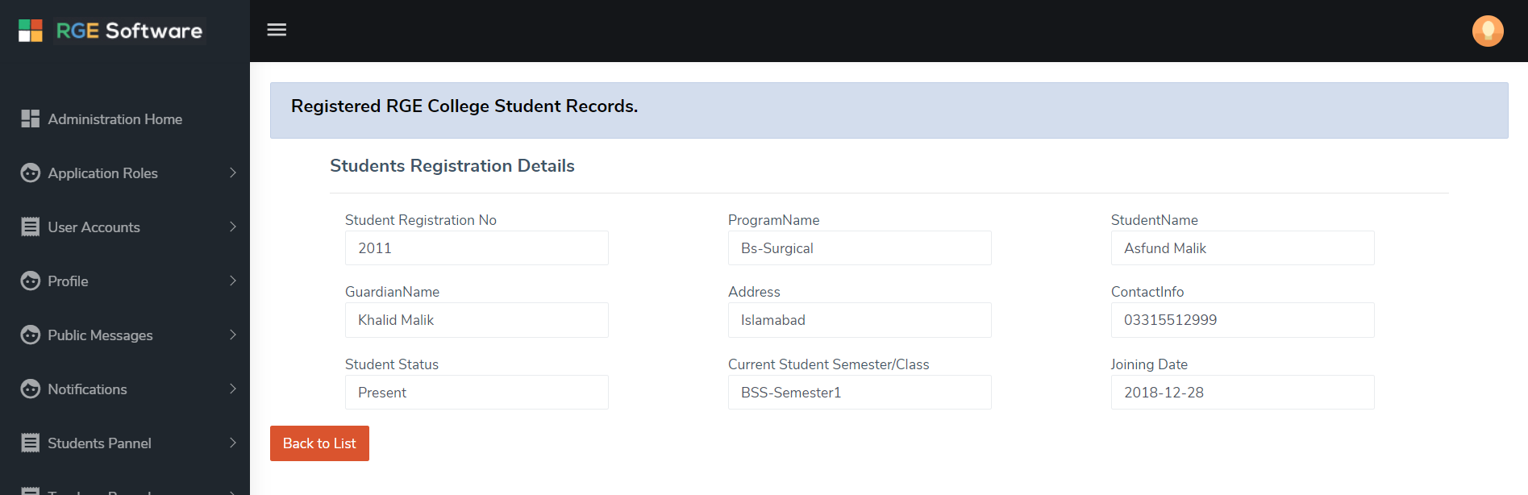

Student Register Delete View:

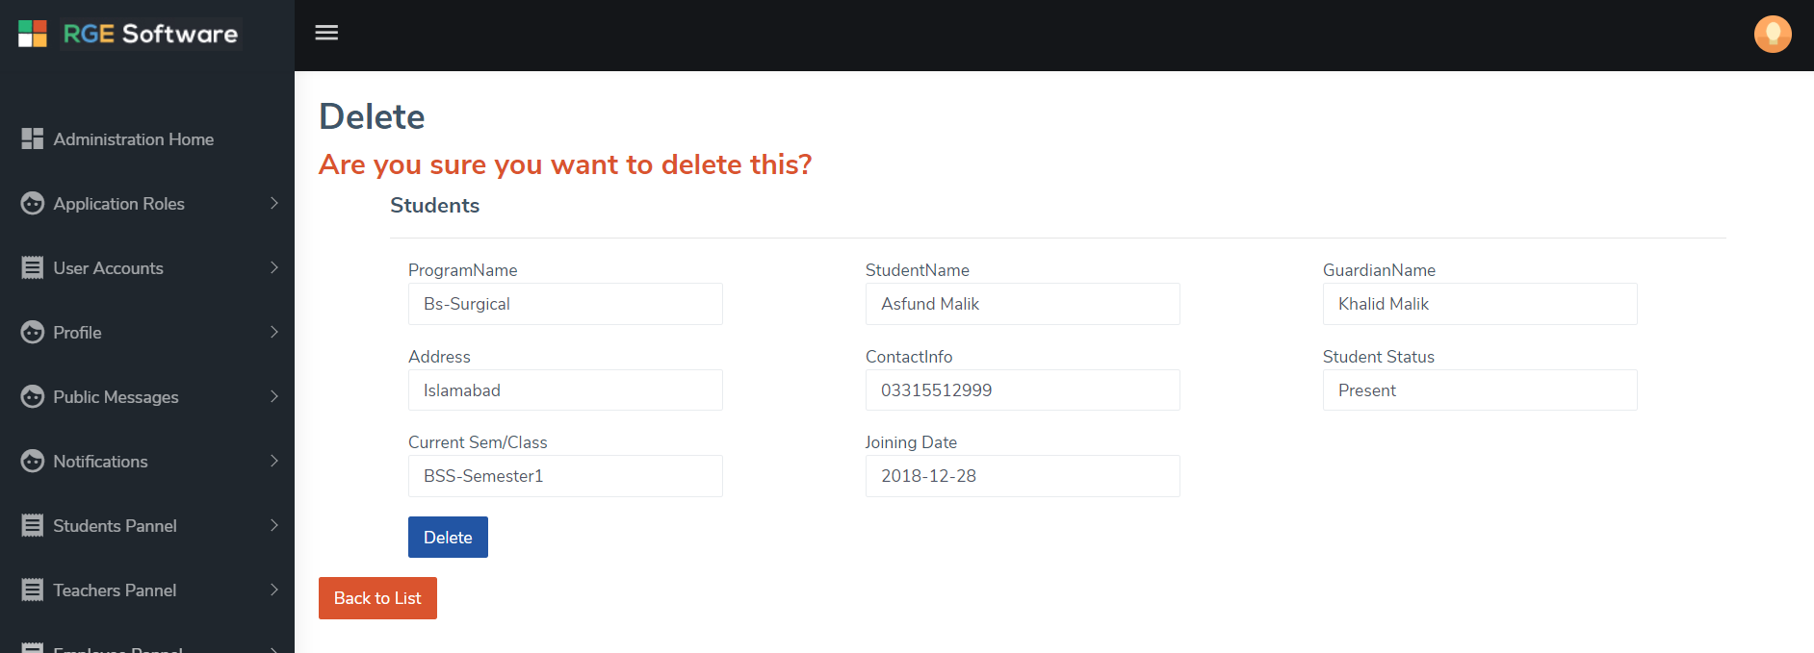

Student Fees Records:

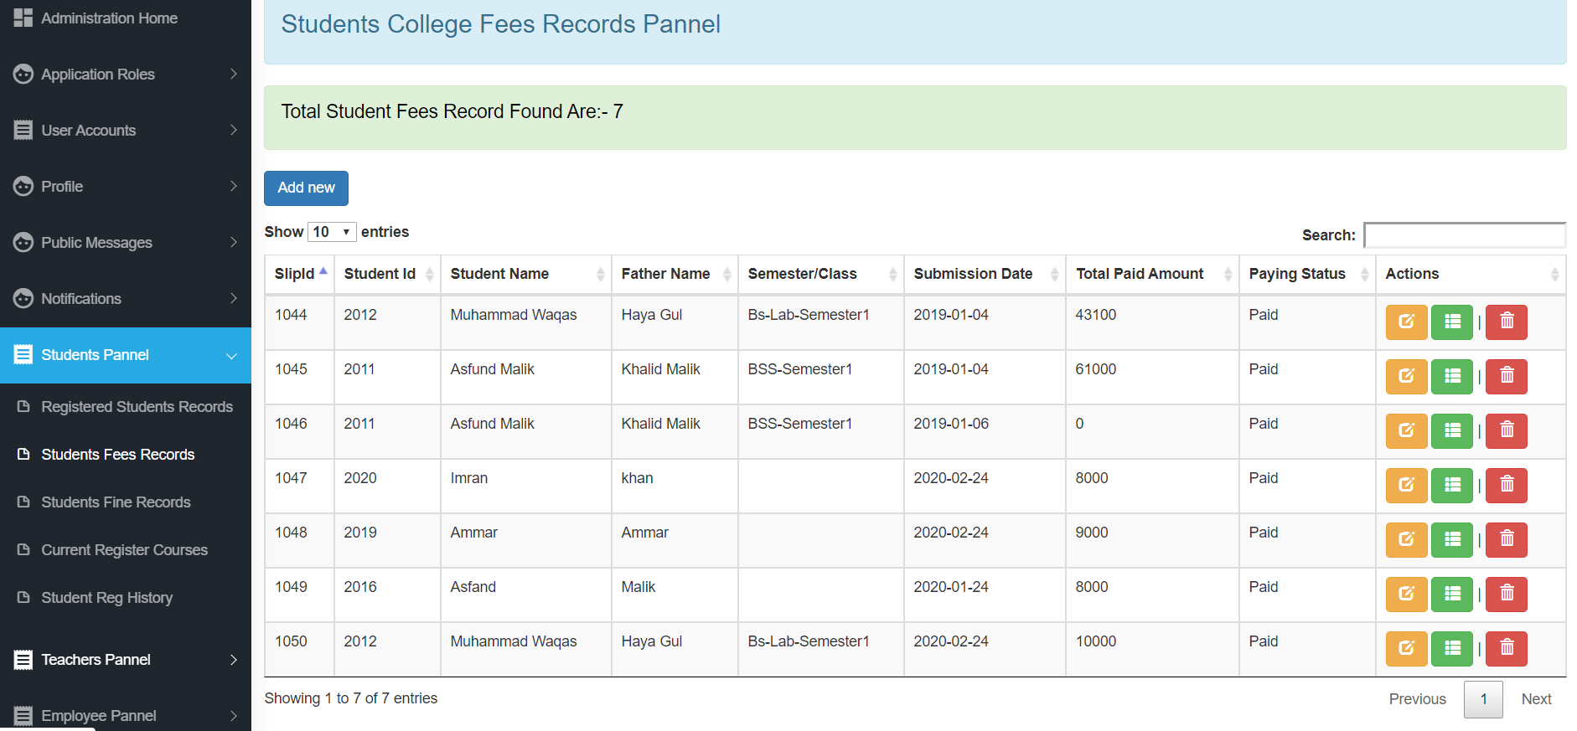

Current Courses:



**Teacher panel:**

Teacher Register:

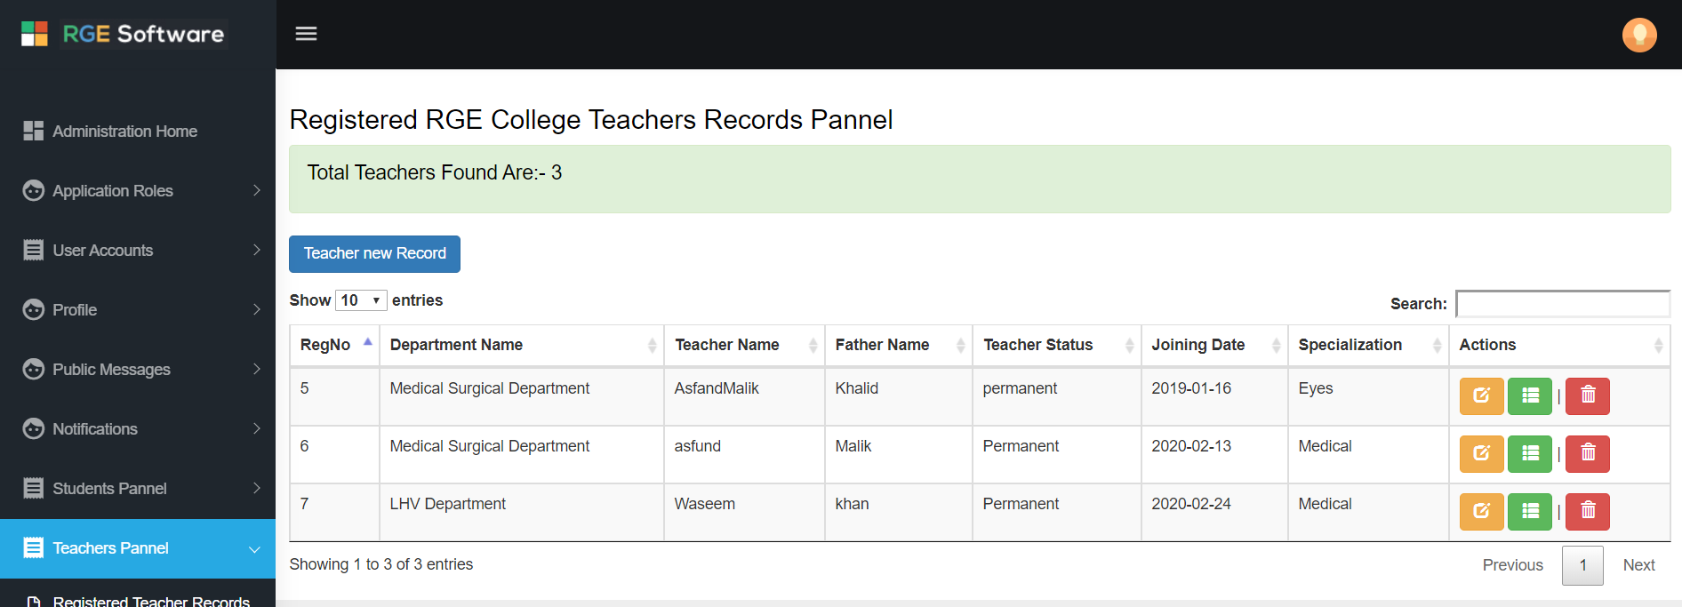

Teacher Department:

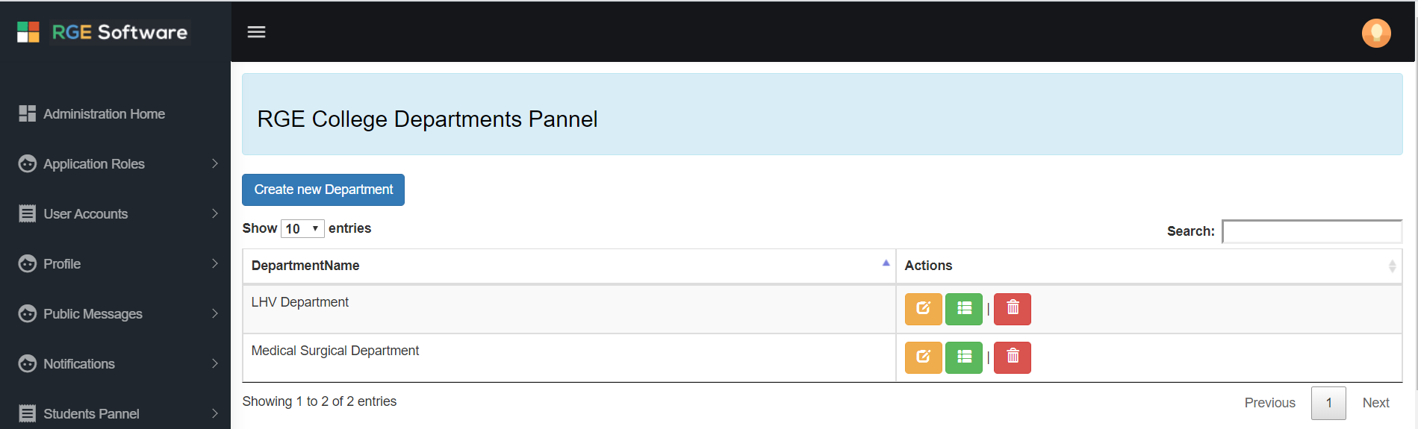

Teacher Current Assigned Course:

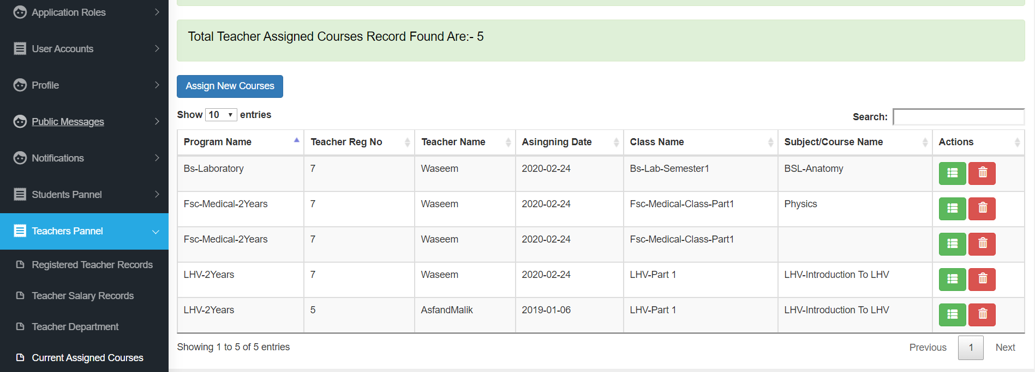

**Teacher Current Assigned Course history:**

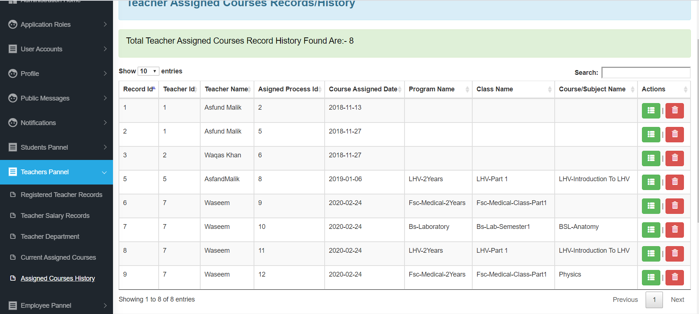

**Employee Panel:**

**Employee Regis**ter Records:

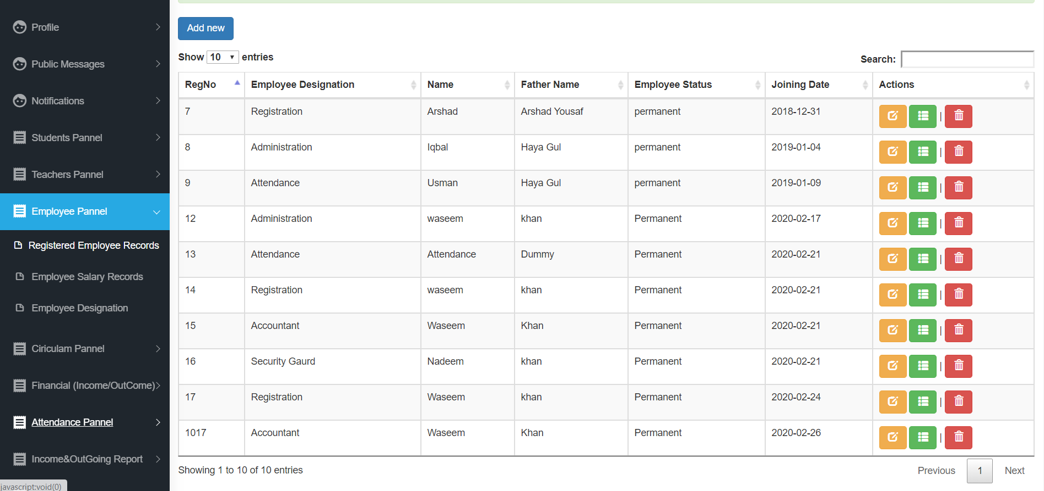

Employee Salary Records:

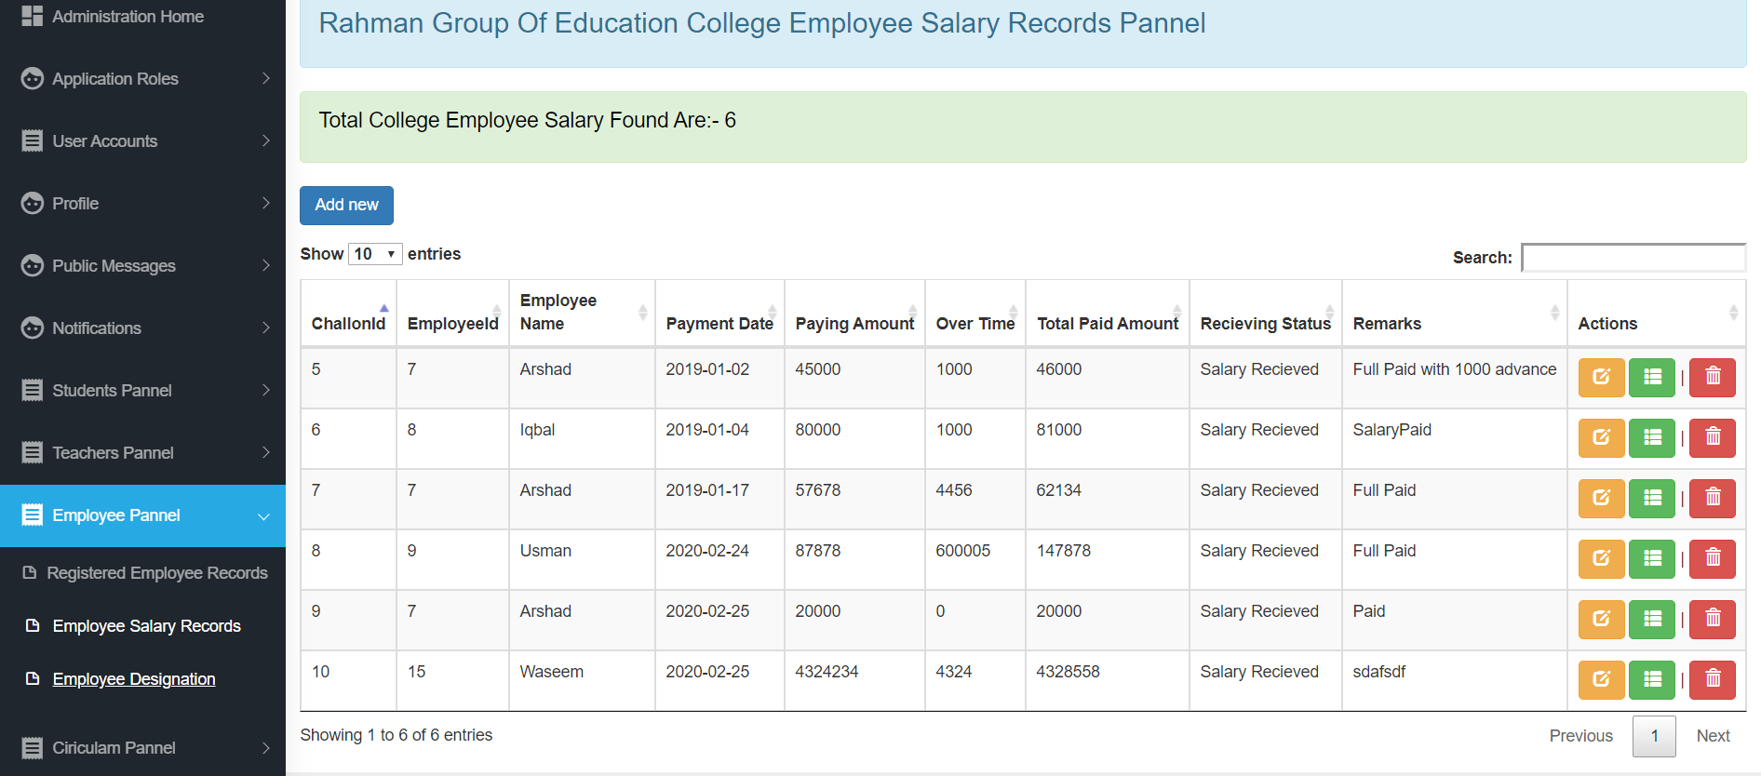

Employee Designation:

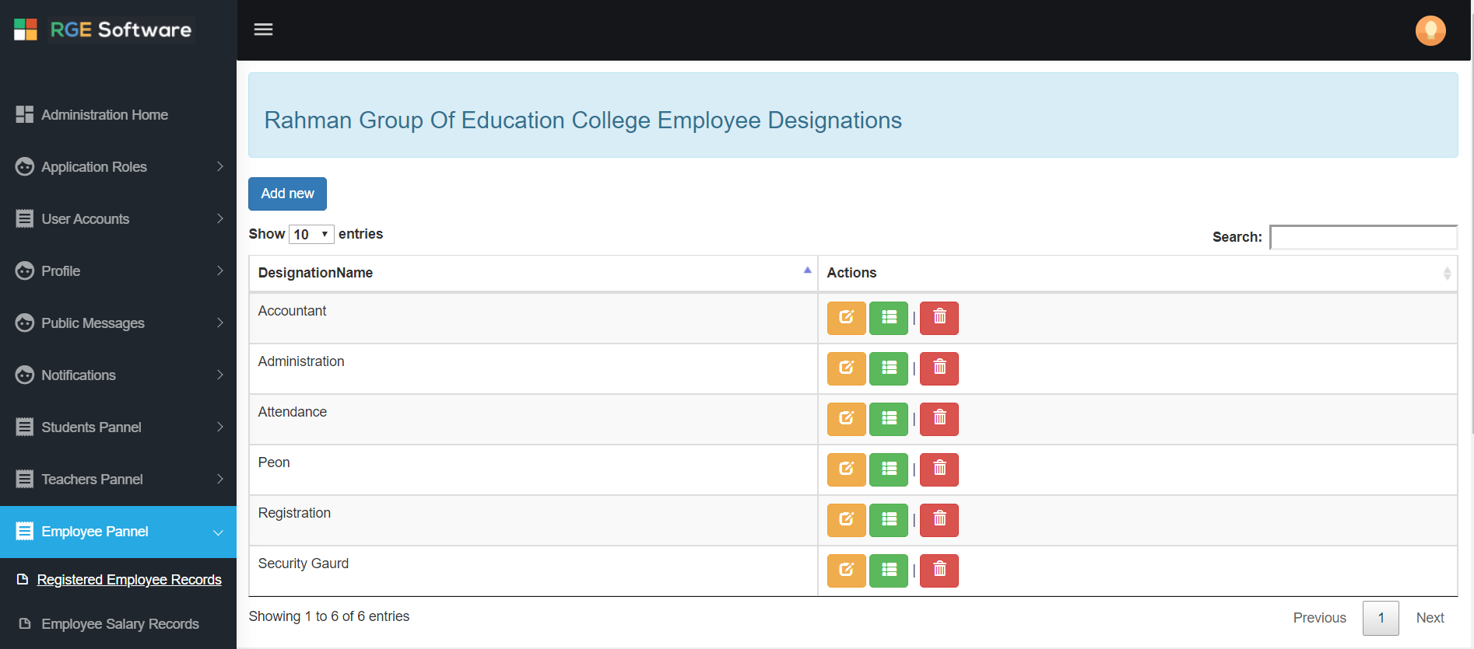

**Curriculum Panel:**

Register Programs:

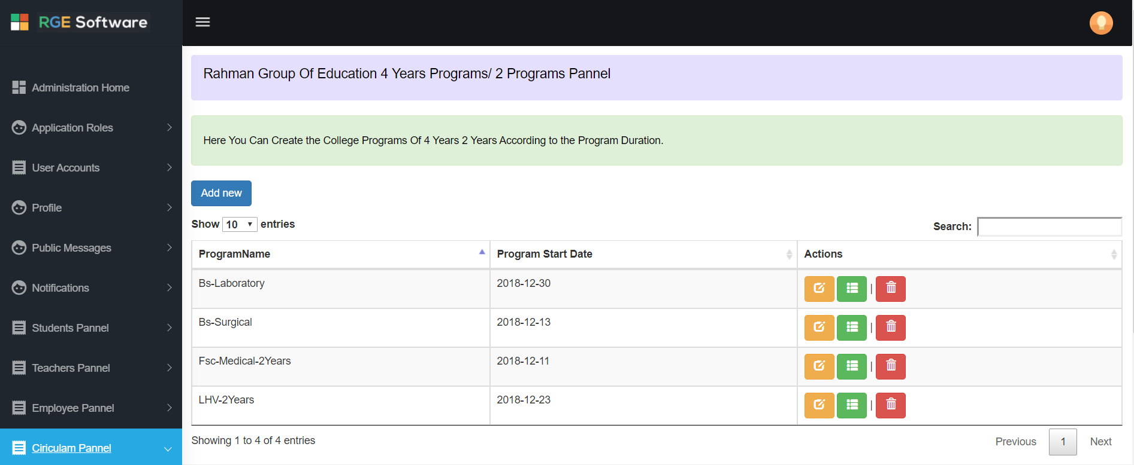

Register Classes and Semester:

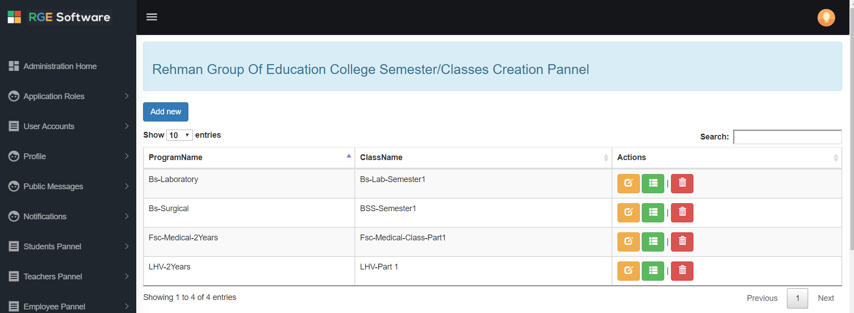

Register Subject:



**Financial (income and outcome):**

Income Transaction Record:

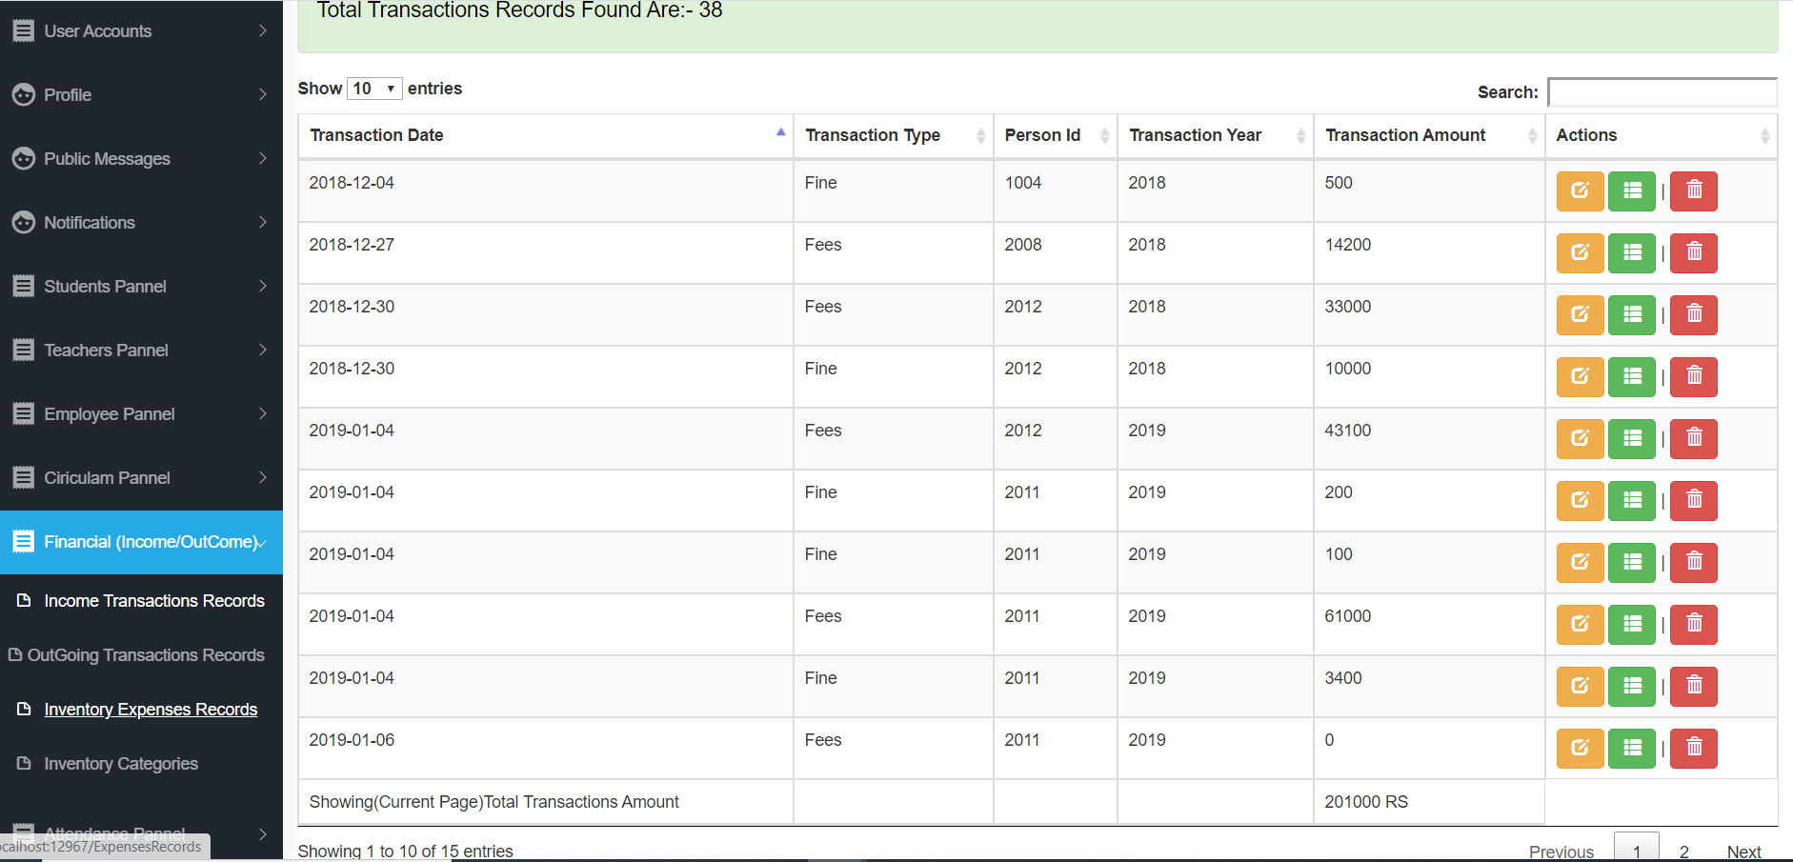

Outgoing Transaction:

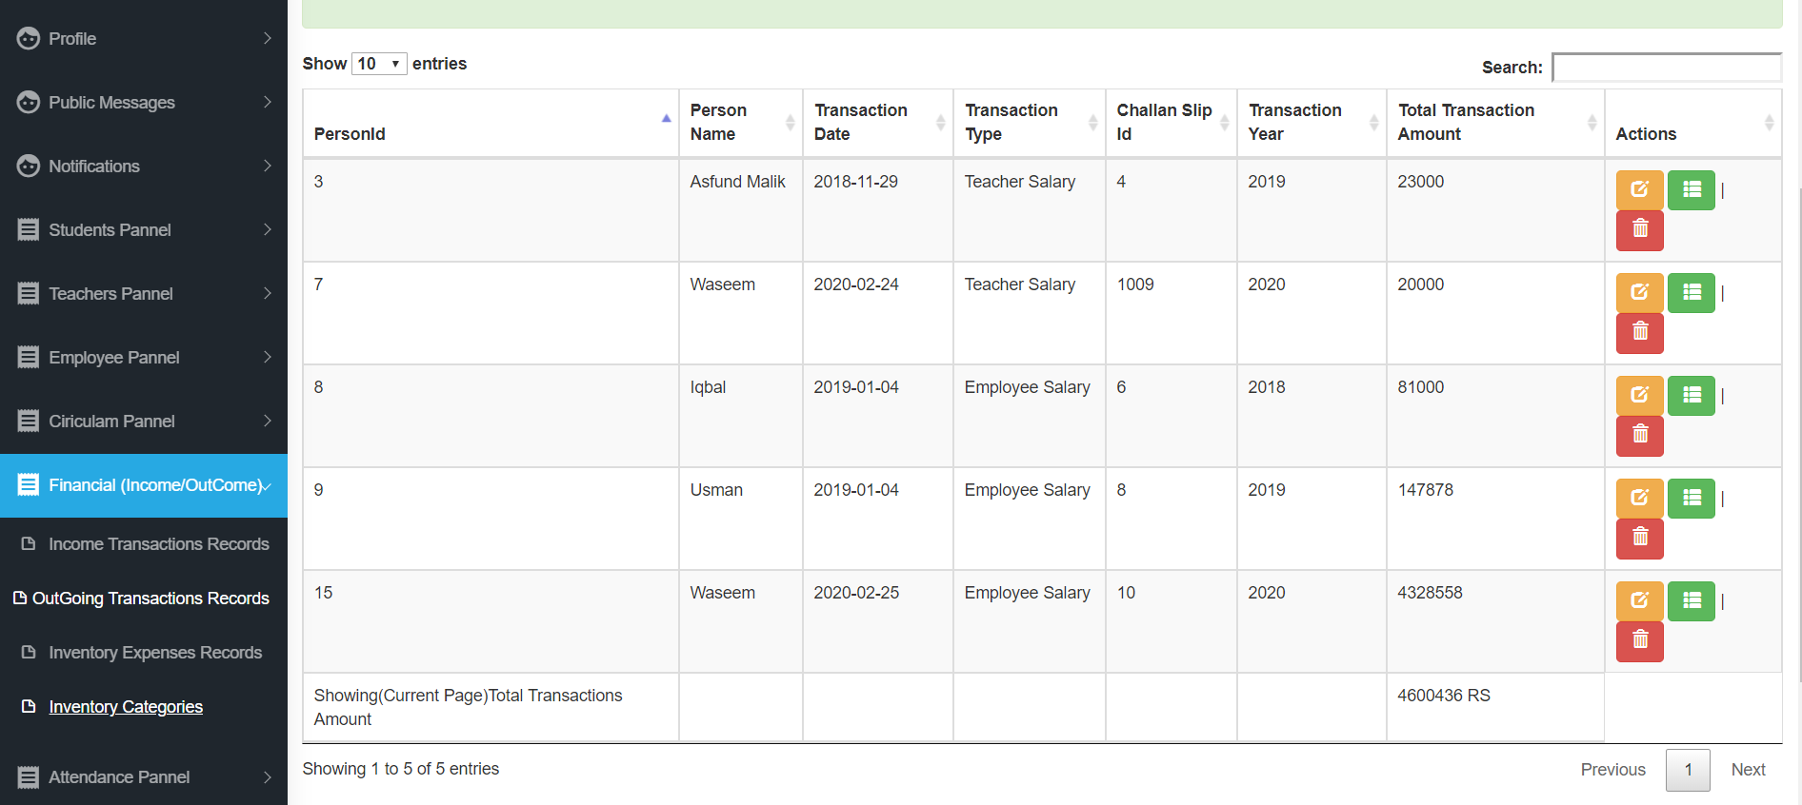

Inventory Expense:

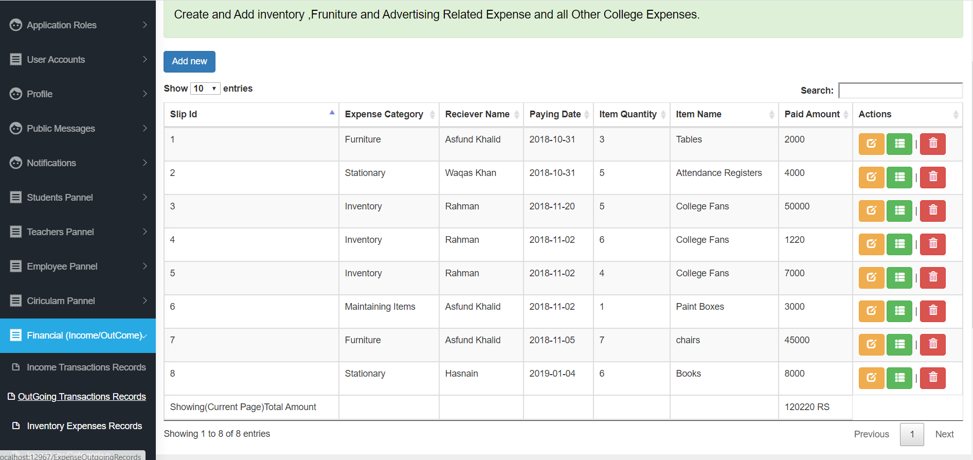

Inventory Categories:

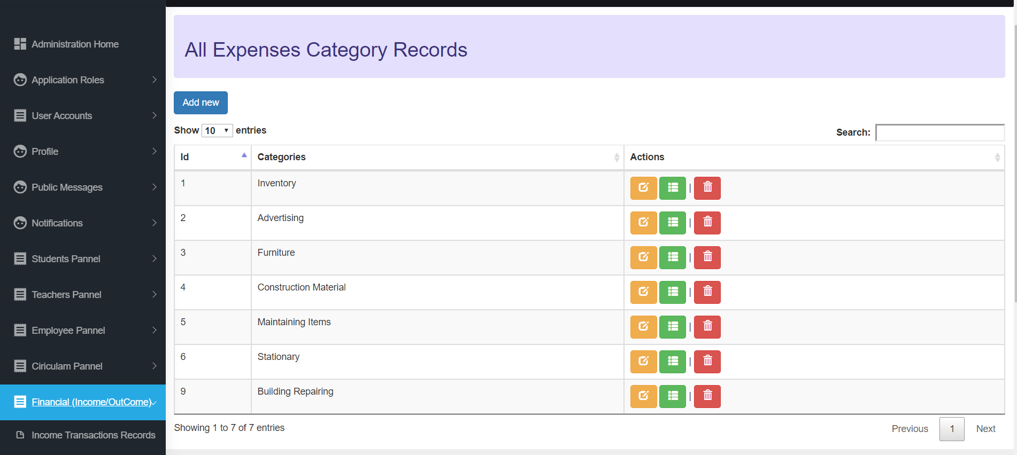

**Attendance Panel:**

Attendance Record:

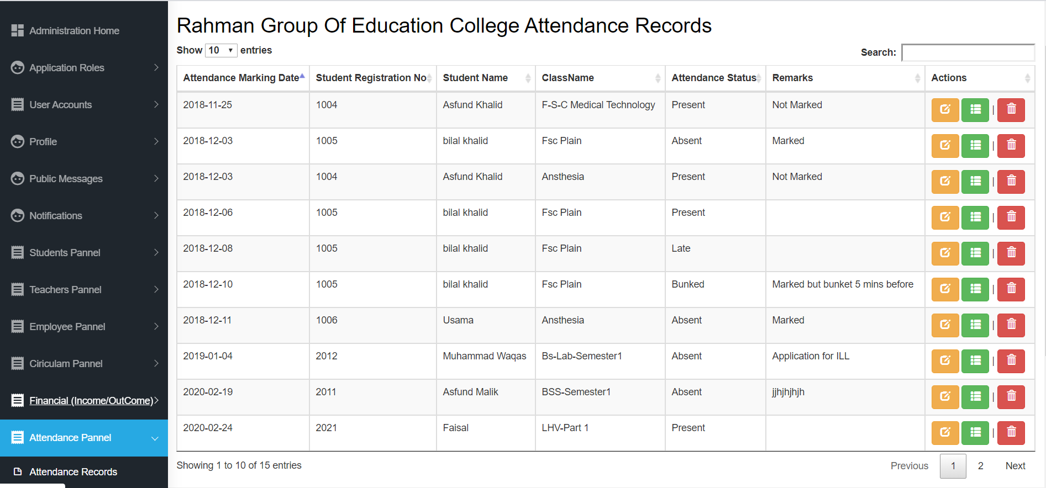

Create Attendance Field:

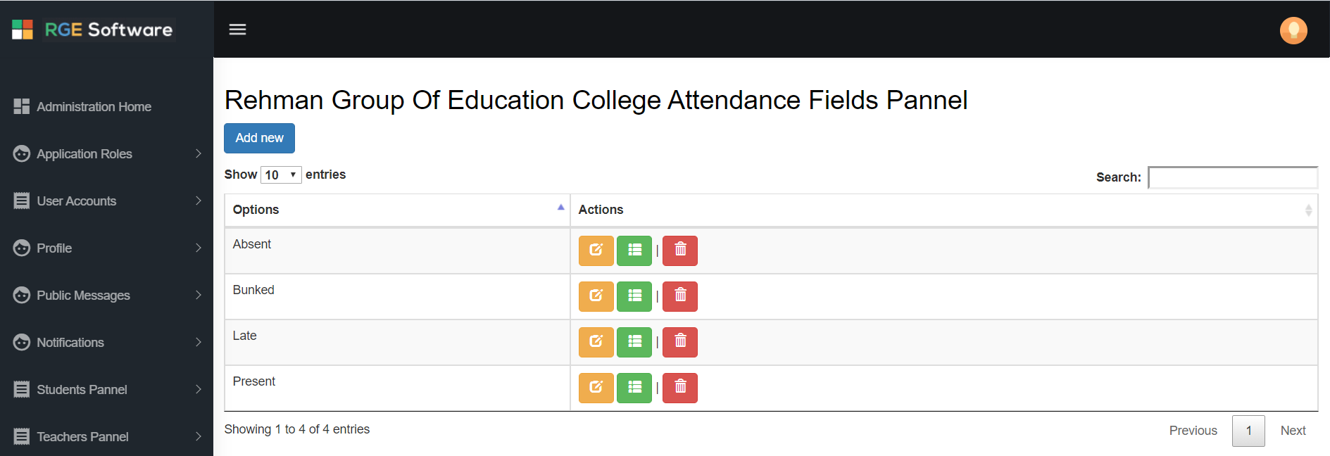

**Registration Controlling:**

Control Registration:

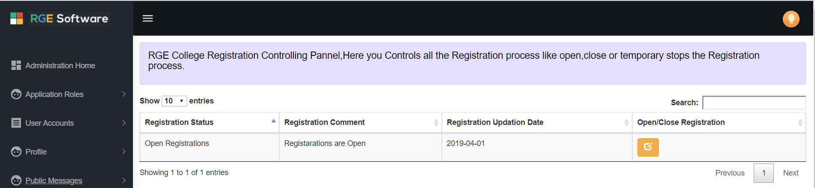

Upload file panel:

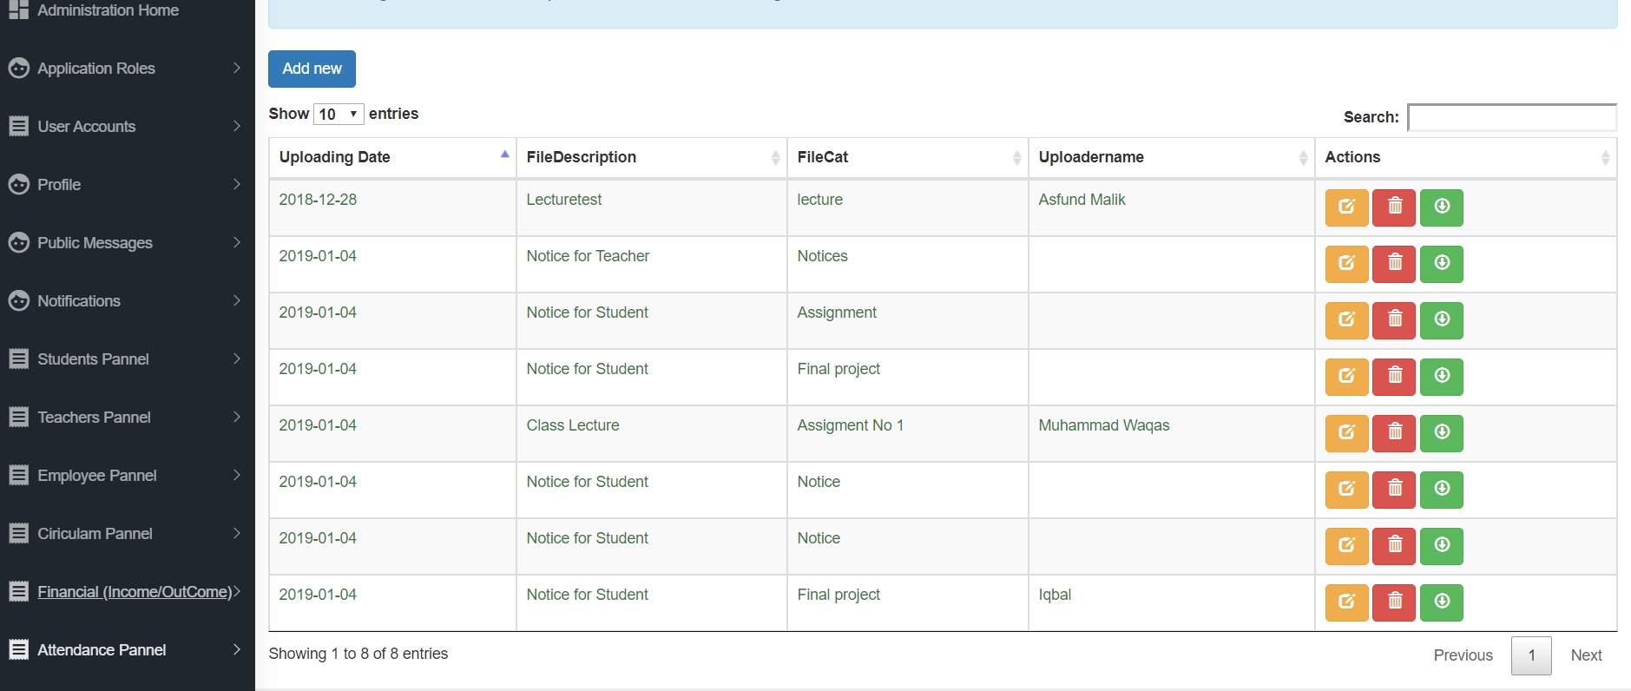

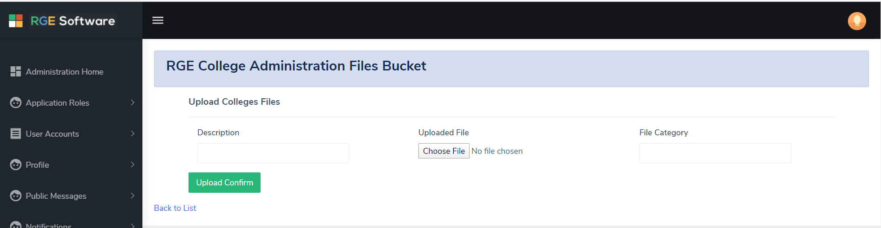

**College Users:**

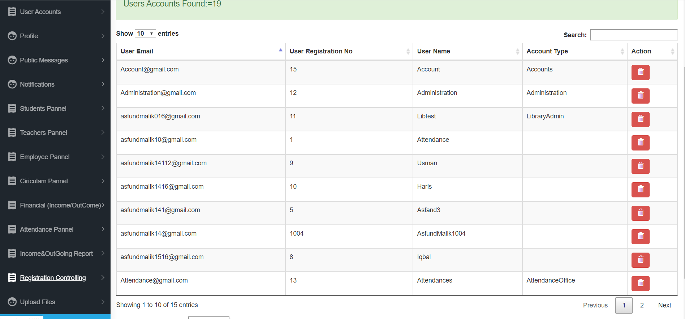

**Library Management System:**

Book Assign:

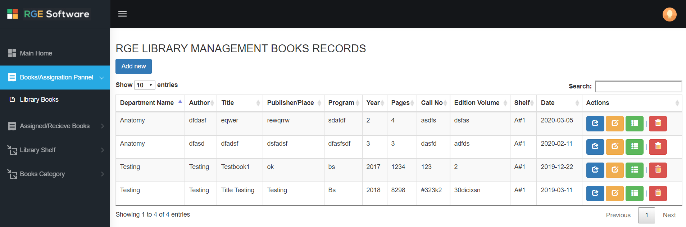

Assign Received Book:

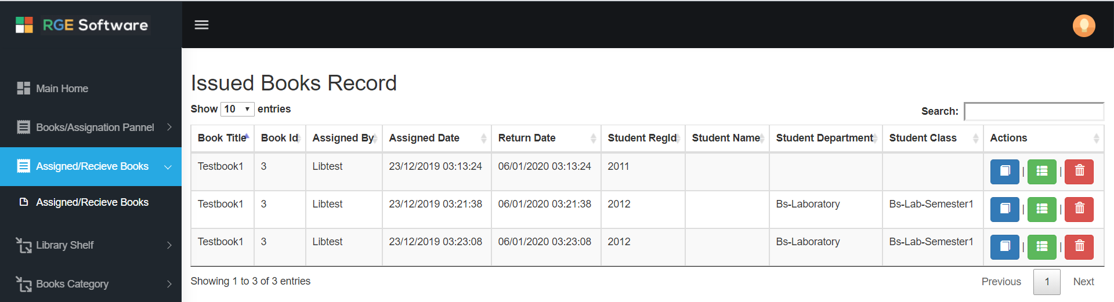

Book category:

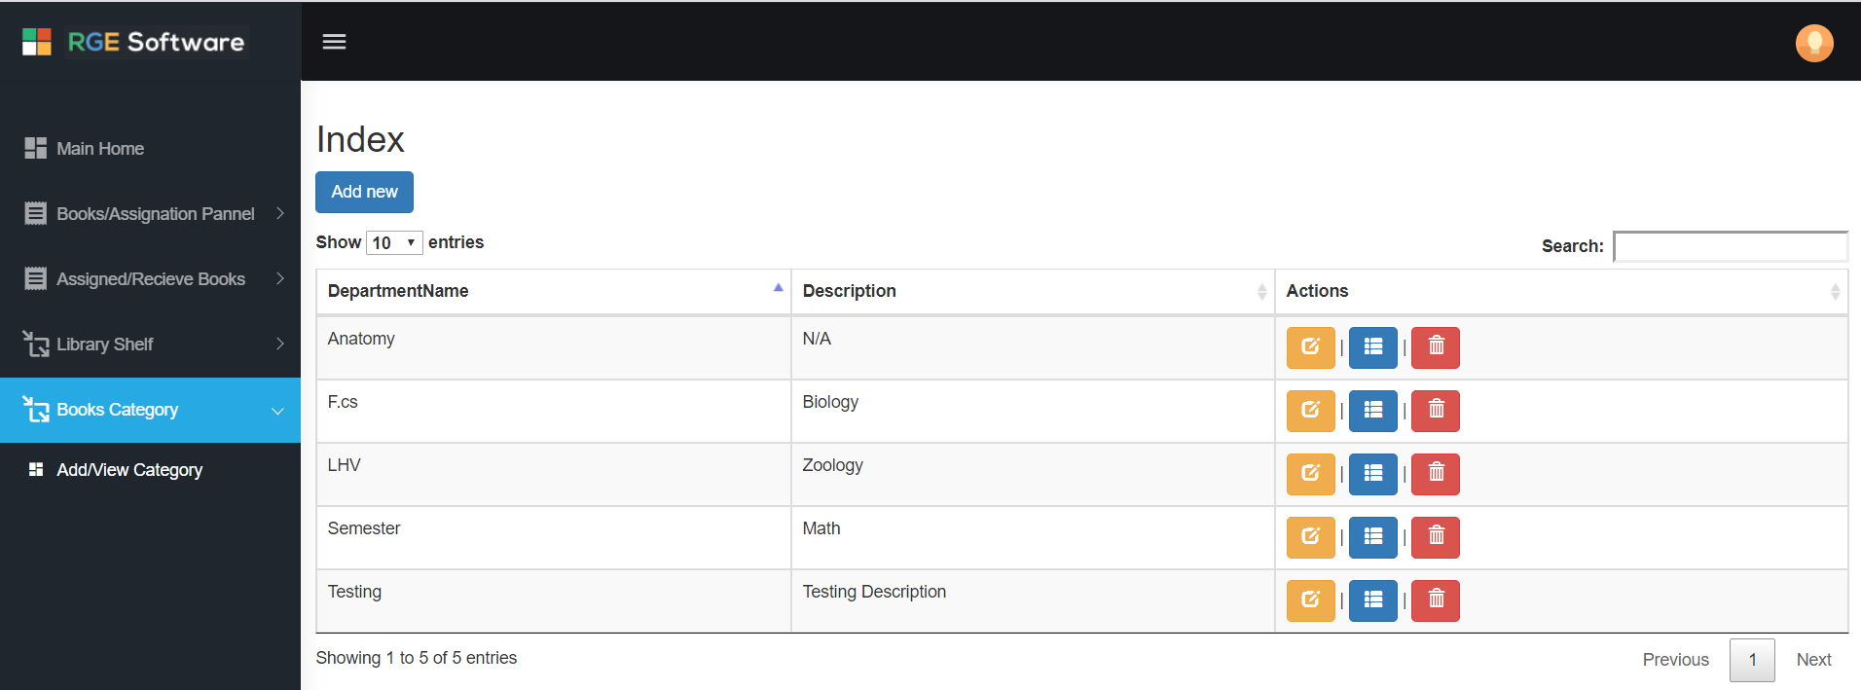

**Attendance Module:**

Attendance Profile:

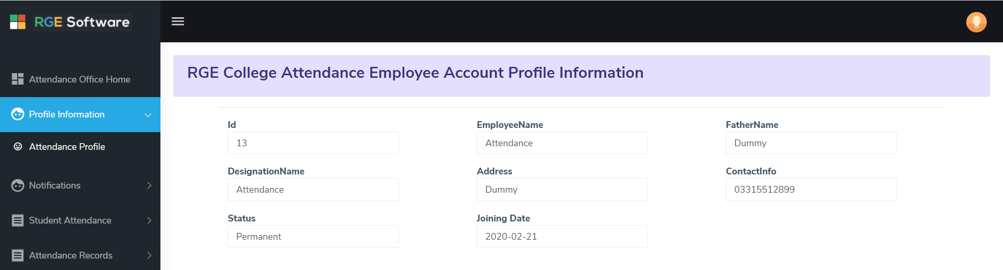

Attendance Records:

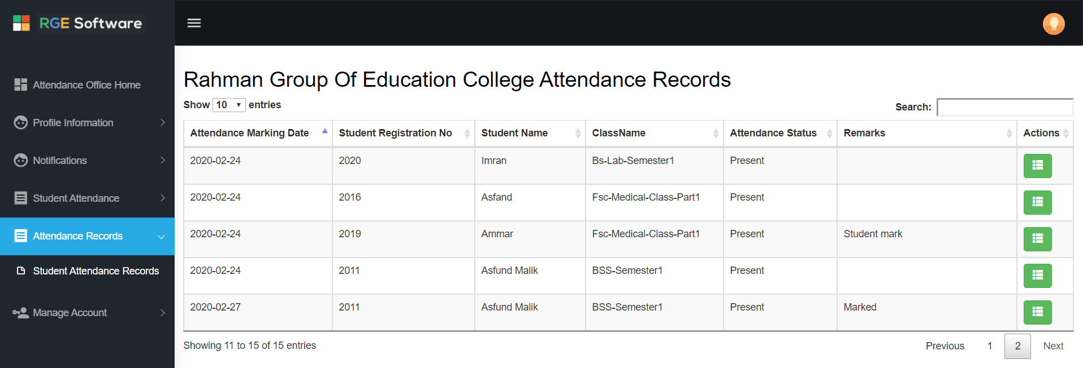

Mark Attendance:

