GROUP ASSIGNMENT - SERVICE-DRIVEN SYSTEM DEVELOPMENT

Group A
Name | Surname | Student Number
Ikho | Nogemane | 202301434
Gift | Nemakonde
Kgotsofalang | Kakudi
True Love | Moloi
Phemelo | Mashome
Due Date : 28 August 2026
Table of Contents
1. Problem Definition 2
Why it matters in ICT 2
Plan &Resources: 2
2. System Design 4
System Architecture 4
Data Flow 5
Context diagram 6
REST API Endpoints 6
Security 7

1. Problem Definition
Universities provide carious student support services such as finance, ICT help desk, faculty administration, and student affairs. Students often spend long periods waiting in physical queues without knowing how long they will wait or whether they will be assisted or whether they will be assisted before office hours end. This leads to overcrowding, lost productivity, and poor service delivery. A Smart Queue Management System provides a centralized platform where students join queues remotely, monitor their queue position in real time, and receive updates while staff efficiently manage the flow of students.
Proposed solution:
SPU SmartQueue is a web-based queue management system developed for Sol Plaatje University. The system enables students to join queues remotely for university service departments while allowing staff members to efficiently manage queues through a centralized dashboard.

Why it matters in ICT
- Digitizes a manual process,
- Reduces congestion
- Improves service efficiency
- Demonstrates RESTful service development
- Can scale to multiple departments

Plan &Resources:
- Frontend: Next/ React.js
- Backend: Django REST Framework
- Database: PostgreSQL
- Version Control: GitHub
- Testing: Postman
- Possible users:
- Student
- Staff member
- Administrator
Departments
- SPU Printing Room
- ICT Helpdesk
- Finance Helpdesk
Users
User | Responsibilities
Student | Register, login, join queue, view queue status, leave queue
Staff | Manage queue, call next student, serve students
Administrator | Manage departments, staff, reports and system settings

Development Environment and Tools
Component | Technology
Frontend | React.js
Backend | Django
API Framework | Django REST Framework
Database | PostgreSQL
API Testing | Postman
IDE | Visual Studio Code
Version Control | Git & GitHub

Setup
The frontend is developed using React.js. The backend is developed using Django and Django REST Framework, which exposes RESTful API endpoints. PostgreSQL stores the application data. API testing is performed using Postman, while Git and GitHub are used for version control and collaboration.

2. System Design

System Architecture
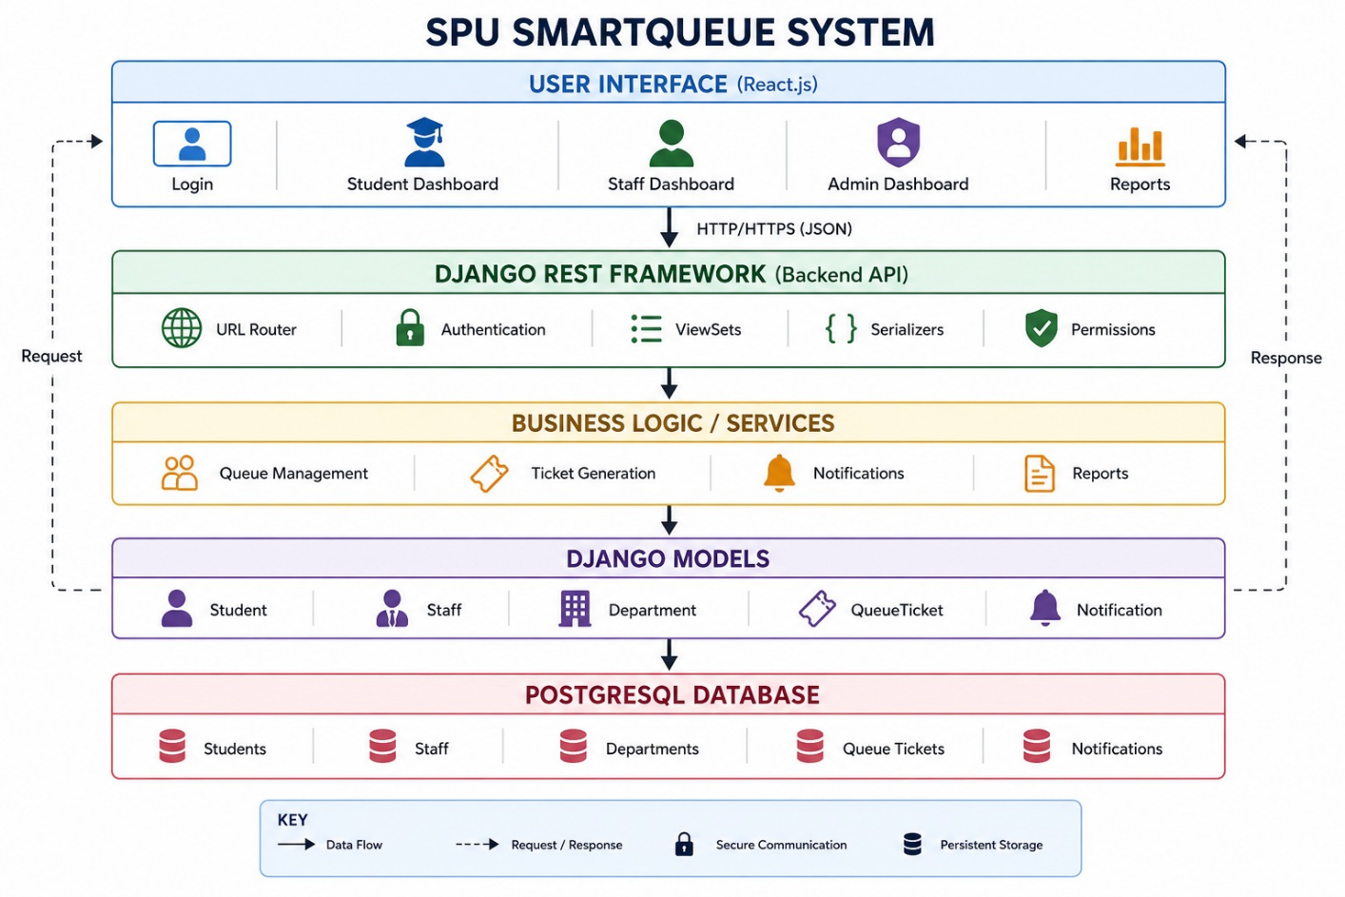
Architecture Explanation
The architecture consists of five layers:
- User Interface Layer: Built with React.js and provides dashboards for students, staff, and administrators.
- API Layer: Django REST Framework receives requests, authenticates users, validates data, and routes requests to the correct service.
- Business Logic Layer: Implements queue management, ticket generation, notifications, and reporting.
- Model Layer: Contains Django models representing the system entities.
- Database Layer: PostgreSQL stores all application data.

Data Flow
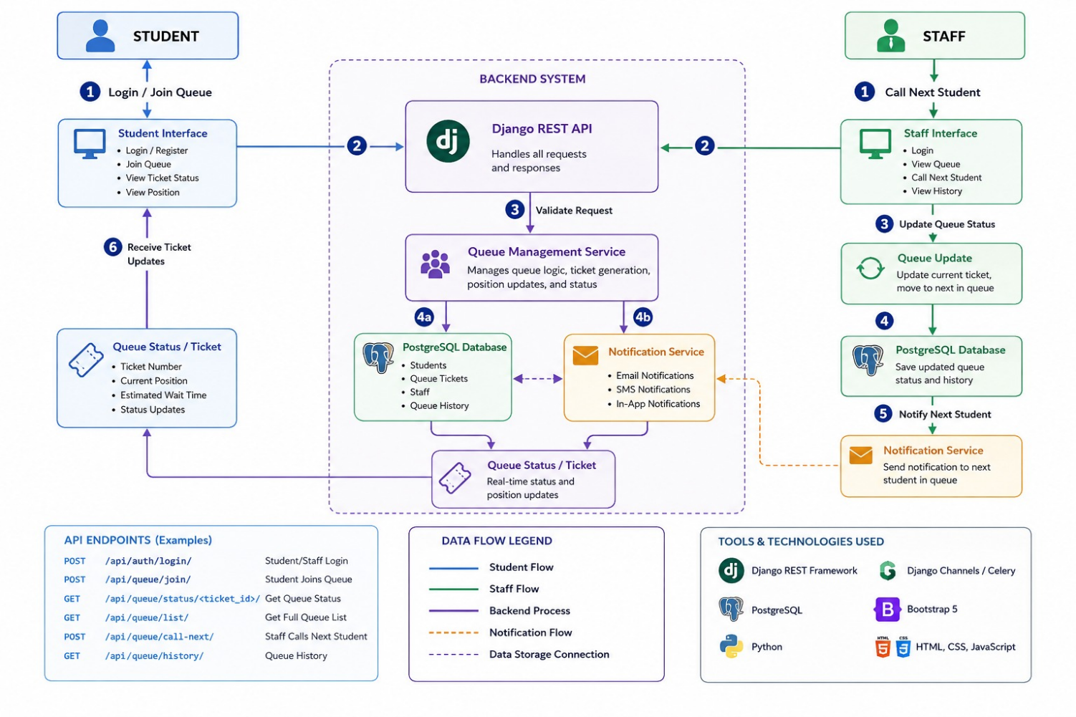

Data Flow Explanation
- A student logs in and selects a department.
- The request is sent to the Django REST API.
- The API validates the request and processes it through the Queue Management Service.
- A queue ticket is created and stored in the PostgreSQL database.
- A notification containing the ticket number and queue position is sent to the student.
- Staff members manage the queue by calling the next student or updating ticket statuses.

Contecxt diagram
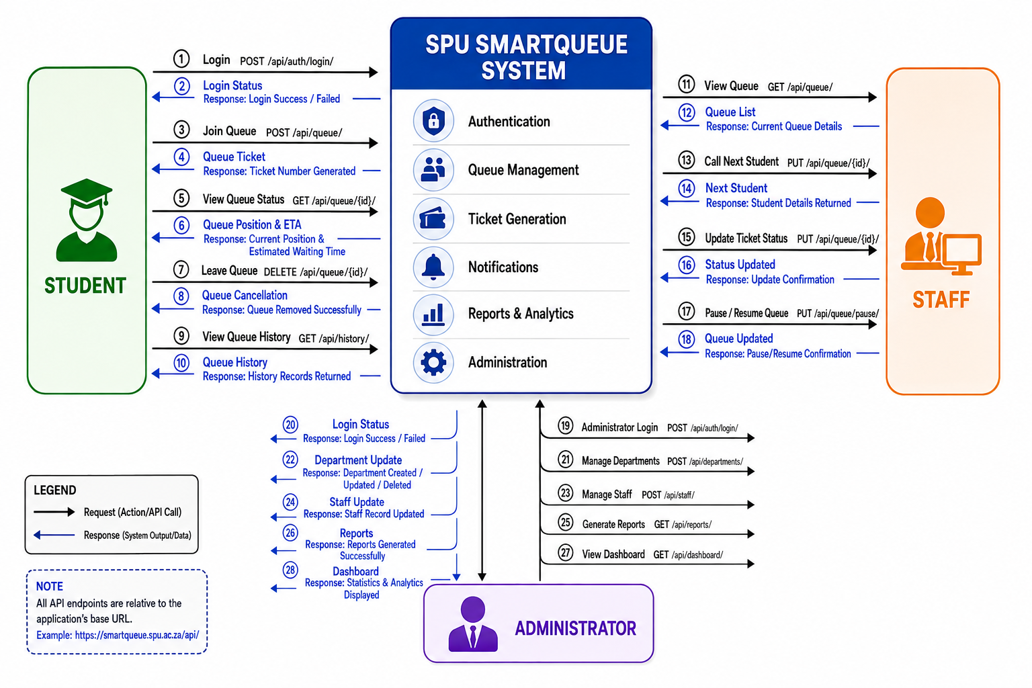

REST API Endpoints
The backend exposes RESTful API endpoints using Django REST Framework.
Authentication
Method | Endpoint | Description
POST | /api/auth/register/ | Register a new student
POST | /api/auth/login/ | Login
POST | /api/auth/logout/ | Logout
GET | /api/auth/profile/ | View logged-in user profile

Departments
Method | Endpoint | Description
GET | /api/departments/ | Retrieve all departments
GET | /api/departments/{id}/ | Retrieve one department
POST | /api/departments/ | Create a department
PUT | /api/departments/{id}/ | Update department
DELETE | /api/departments/{id}/ | Delete department

Queue Tickets
Method | Endpoint | Description
GET | /api/queue/ | View queue
GET | /api/queue/{id}/ | View a ticket
POST | /api/queue/ | Join queue
PUT | /api/queue/{id}/ | Update ticket status
DELETE | /api/queue/{id}/ | Cancel queue ticket

Staff
Method | Endpoint | Description
GET | /api/staff/ | Retrieve staff
POST | /api/staff/ | Create staff member
PUT | /api/staff/{id}/ | Update staff member
DELETE | /api/staff/{id}/ | Delete staff member

Security
To protect user data and ensure secure access to the system, the following security measures will be implemented:
- Authentication: Users must log in before accessing protected resources.
- Role-Based Access Control: Students, staff, and administrators have different permissions.
- Password Hashing: Passwords are securely hashed using Django's built-in authentication system.
- HTTPS: All communication between the frontend and backend is encrypted.
- Input Validation: Django REST Framework serializers validate all incoming data before it is processed.
- SQL Injection Protection: Django's ORM uses parameterized queries, reducing the risk of SQL injection attacks.

