要求：
1 提交纸质版，中文作答即可，可手写或打印（涉及找数据画图的题必须打印）；
2. 作业命名：学号+姓名+作业25。
3 提交时间：下周二15:30前（延迟上交会酌情扣分）
4 提交方式：下周二上课时给课代表
5 注意：须注明数据来源，图表需要有图表标题和编号，作业整体表意需要明确。
6 助教邮箱：chenxi98@ruc.edu.cn
7 答疑：明商0201 每周一19:40到21:30，不强制参加。在学习过程中遇到问题之后，推荐首先看书、与同学讨论，还是想不清可以找我答疑

- Consider the production function Y=4F(L,K,H,N). Suppose F(10, 8, 6, 5) = 100 and F(30, 24, 18, 15) = 300. Does the production function have the property of constant returns to scale? Why or why not?

Figure 25-2
​
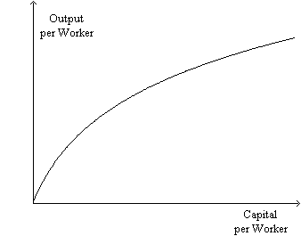
​
- Refer to Figure 25-2. What does the figure represent?
- Refer to Figure 25-2. In order for the figure to make sense, do we have to assume that capital is the only determinant of output? Briefly explain.
- Refer to Figure 25-2. In what way is the figure relevant to the catch-up effect?

- Consider the nations of China, India, and Japan. In the last 30 years, which of these three nations has experienced, by far, more rapid economic growth than the other two nations?
Hint: data is required, figures are recommended.

