# Fuzzing Lab

This lab comprises two parts, Fuzzing Intro and Fuzzing Coverage. Full instructions are in the README files included with each replit.com link.

## Fuzzing Intro

Part 1 and 2: Add code to the provided Python script for the tasks.

Part 3:

ADD YOUR SCREENSHOT OF BUFFER OVERFLOW CAUSING PROGRAM TO CRASH:

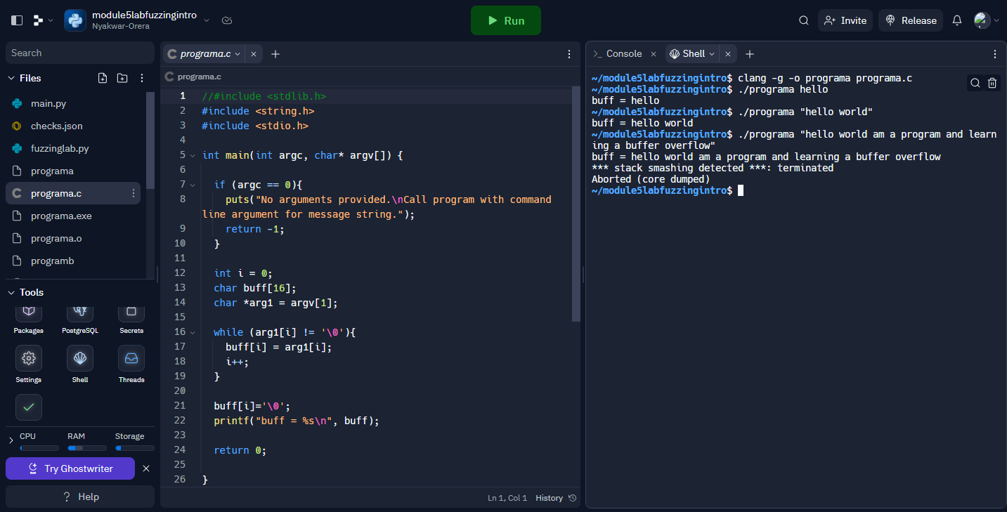

Part 4:

ADD YOUR SCREENSHOT OF MEMORY CRASH:

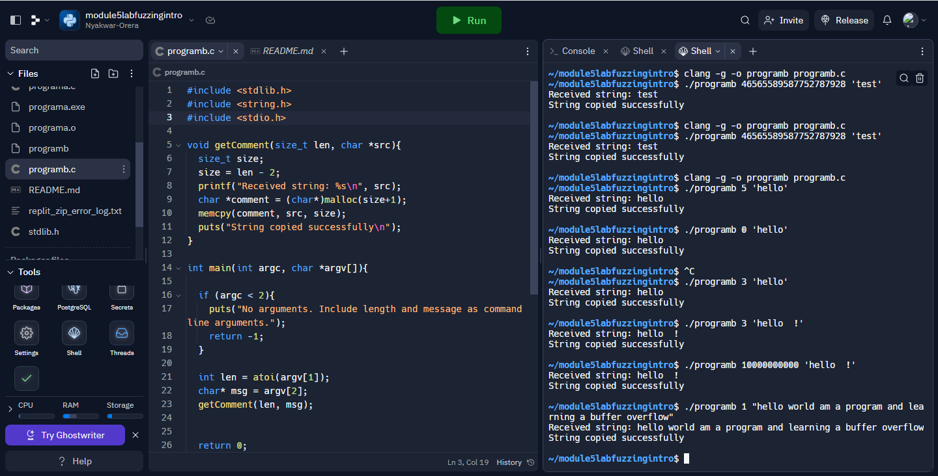

## Fuzzing Coverage

For all parts, modify the given script according to the instructions.

## Submission

Your modified Python scripts and this lab report.