Marby Coin and Bill Acceptor Wiring
TB74 bill acceptor and Allan 1239 coin acceptor through the HY M158
Keep the working active LOW pulse circuits below. The software now uses separate exact pulse maps for coins and bills. Acceptance control remains a separate commissioning step; the bill inhibit proposal and the Allan inhibit limitation are on page 3.
Disconnect Pi power and the external 12 V supply before changing wires. Use the terminal labels on your actual acceptors; harness colors can vary.

TB74 power and pulse connections
From | Connect to
TB74 power +12 V | External supply +12 V
TB74 power GND | External supply negative
External +12 V input feed | HY channel 1 IN1 through existing input current limiting
TB74 METER+ | HY channel 1 input side G
TB74 METER− | External supply negative
HY channel 1 output side G | Pi GND physical pin 6
HY channel 1 V1 | Pi GPIO27 physical pin 13
47 kΩ pull up resistor | Between V1 GPIO27 junction and Pi 3.3 V pin 1

Allan power and pulse connections
From | Connect to
Allan power +12 V | External supply +12 V
Allan power GND | External supply negative
External +12 V input feed | HY channel 2 IN2 through existing input current limiting
Allan COIN or PULSE output | HY channel 2 input side G
HY channel 2 output side G | Pi GND physical pin 6
HY channel 2 V2 | Pi GPIO17 physical pin 11
47 kΩ pull up resistor | Between V2 GPIO17 junction and Pi 3.3 V pin 1

These input connections apply to the sinking COIN and METER outputs used in the working bench setup. Retain the HY input resistors and any fitted series resistor in each +12 V feed. Leave unidentified extra Allan wires individually insulated.

Pullup resistors and calibrated pulse counts
Each pulse output connects directly to its assigned GPIO. The 47 kΩ resistor is a separate branch from that signal junction to 3.3 V. It holds the line HIGH at idle; the optocoupler pulls the line LOW for a pulse.
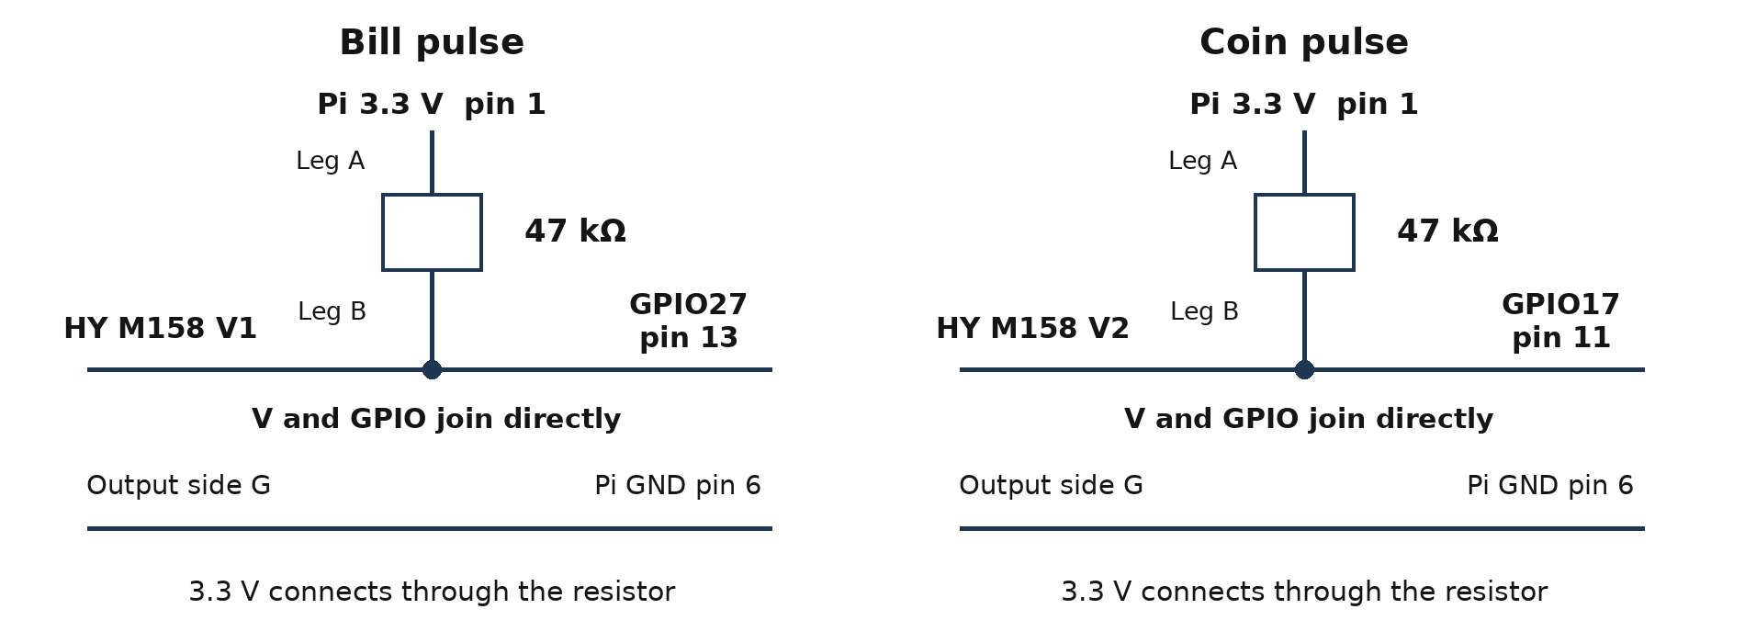
Figure 1 Separate bill and coin signal junctions on the Pi side
Resistor end | Bill channel 1 | Coin channel 2
End A | Pi 3.3 V physical pin 1 only | Pi 3.3 V physical pin 1 only
End B | V1 and GPIO27 together | V2 and GPIO17 together

Do not insert the resistor between V2 and GPIO17, or between V1 and GPIO27. Do not join a GPIO directly to the 3.3 V supply. Each V terminal and its GPIO form one shared signal point, while the supply reaches that point through its resistor.

Isolation and ground connections
Both acceptors use the external 12 V supply negative. HY pulse output G terminals use Pi GND. Keep those two domains separate in this arrangement. On the disconnected HY board, verify input to output isolation and independent pulse channel inputs. The model name alone does not establish a jumper position.

Exact pulse maps
Acceptor | Pulse count | Credit in pesos
Allan coin | 1 | 1
Allan coin | 5 | 5
Allan coin | 10 | 10
Allan coin | 20 | 20
TB74 bill | 5 | 50
TB74 bill | 10 | 100

The source is part of the mapping: 5 coin pulses mean PHP 5; 5 bill pulses mean PHP 50. Only the listed exact counts are recognized. Pulse ranges are not enabled.

Acceptance control and inhibit verification
Pulse counting does not physically prevent a second insertion. Both inhibit_verified flags remain false. Complete the acceptance control checks before enabling real money mode.

TB74 inhibit proposal through a spare HY channel
Channel 3 is a proposed route, pending verification of the actual HY board. Its input must support reliable 3.3 V operation and its output must carry the TB74 inhibit loop current. Similar PC817 boards specify a 3.6 V minimum input. A lit indicator LED alone does not prove adequate drive. Do not power this added circuit until its compatibility and jumper function are established. [1] [3]
From | Connect to only after verification
Pi GPIO23 physical pin 16 | HY channel 3 IN3
HY channel 3 input side G | Pi GND
Additional 47 kΩ pull down | Between IN3 GPIO23 and Pi GND
Pi 5 V physical pin 2 | 1 kΩ resistor then TB74 INHIBIT+
TB74 INHIBIT− | HY channel 3 V3
HY channel 3 output side G | Pi GND

Configure the channel to conduct from V3 to output G when activated. Its input G must be independent of the pulse channel input G terminals. Retain the external 12 V supply for TB74 power; Pi 5 V supplies only this isolated inhibit input loop. Use a 1/4 W or higher rated 1 kΩ resistor.
Select the TB74 option labelled Inhibit Active LOW on the unit's own DIP chart. For a verified noninverting driver, GPIO23 LOW disables acceptance and GPIO23 HIGH enables it. This matches inhibit_active_high.bill = true in the supplied backend. The flag describes the external enable command, not the DIP label by itself. [1]

Allan coin acceptance control
GPIO24 physical pin 18 is reserved only. Leave it and any proposed channel 4 control wiring unconnected until the exact Allan inhibit input, allowable voltage and polarity are documented. Do not assume a CNT or counter terminal is an inhibit input. The TB74 INHIBIT+ and INHIBIT− arrangement must not be copied onto unidentified Allan wires.

Check the complete transaction
With a verified interface, confirm that acceptance is disabled at startup, while counting and during payout. After the first pulse, the current item must still emit its complete pulse group, and the next item must be rejected. Check both coin and bill paths.
A 21 pulse bill group causes an operator fault and receives no inferred value. Pulse counts cannot identify every note boundary: 10 pulses could also be two PHP 50 notes. If another note can enter before the first pulse, a verified busy signal, supported protocol or physical intake control is required.

Apply the code update and test the inputs
Back up the current Marby folder and stop the kiosk. Extract Marby_Update.zip into ~/Marby. Preserve inventory.json, transaction_state.json, your local servo calibration and any other machine specific settings when merging the supplied configuration. The update archive contains neither inventory nor transaction journals.

Pulse reader settings
Setting | Bill | Coin
Pulse GPIO | 27 pin 13 | 17 pin 11
Quiet period | 3 seconds | 2 seconds
Minimum falling edge spacing | 0 seconds | 0 seconds
Maximum frame duration | 45 seconds | 60 seconds
Acceptance control status | Pending verification | Pending terminal identification

Zero minimum spacing reproduces the successful counter with no debounce filter. The backend waits for HIGH and quiet after either edge; the simple counter times quiet after falling edges only. Idle counts must remain zero. A gap timeout by itself cannot separate quickly inserted items.

Run one pulse counter at a time
cd ~/Marby
.venv/bin/python count_acceptor_pulses.py --source coin
Leave idle for 10 seconds, insert one known coin, wait for its pulse count, then stop with Ctrl+C. Repeat each supported denomination. Stop this counter before starting the bill counter.
.venv/bin/python count_acceptor_pulses.py --source bill
Test one PHP 50 or PHP 100 bill per reading. These counters read the GPIO only and do not operate acceptance control, credit the UI or move servos.

Verify the software and decoded groups
.venv/bin/python -m unittest -v test_marby.py
.venv/bin/python calibrate_acceptors.py --source coin --diagnostic-only
.venv/bin/python calibrate_acceptors.py --source bill --diagnostic-only
Run each diagnostic separately. Real hardware startup remains blocked until both acceptance controls, the coin exit sensor and all five servo channels have been verified. See DEPLOYMENT.md for deployment and payout checks. Software tests use simulated GPIO and do not certify the physical wiring.

Reference documents
[1] TOPVME TB Series manual Harness page 9 and I O circuit page 12
[2] Raspberry Pi documentation GPIO pinout and 3.3 V logic
[3] ADIY PC817 module datasheet Input rating example for compatibility checks

