Cos 10026, Lab 6 part 2
Nyan Phyo Aung
Creating a database name blog_site
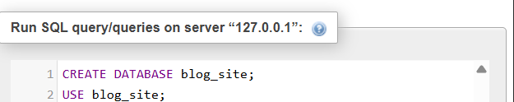
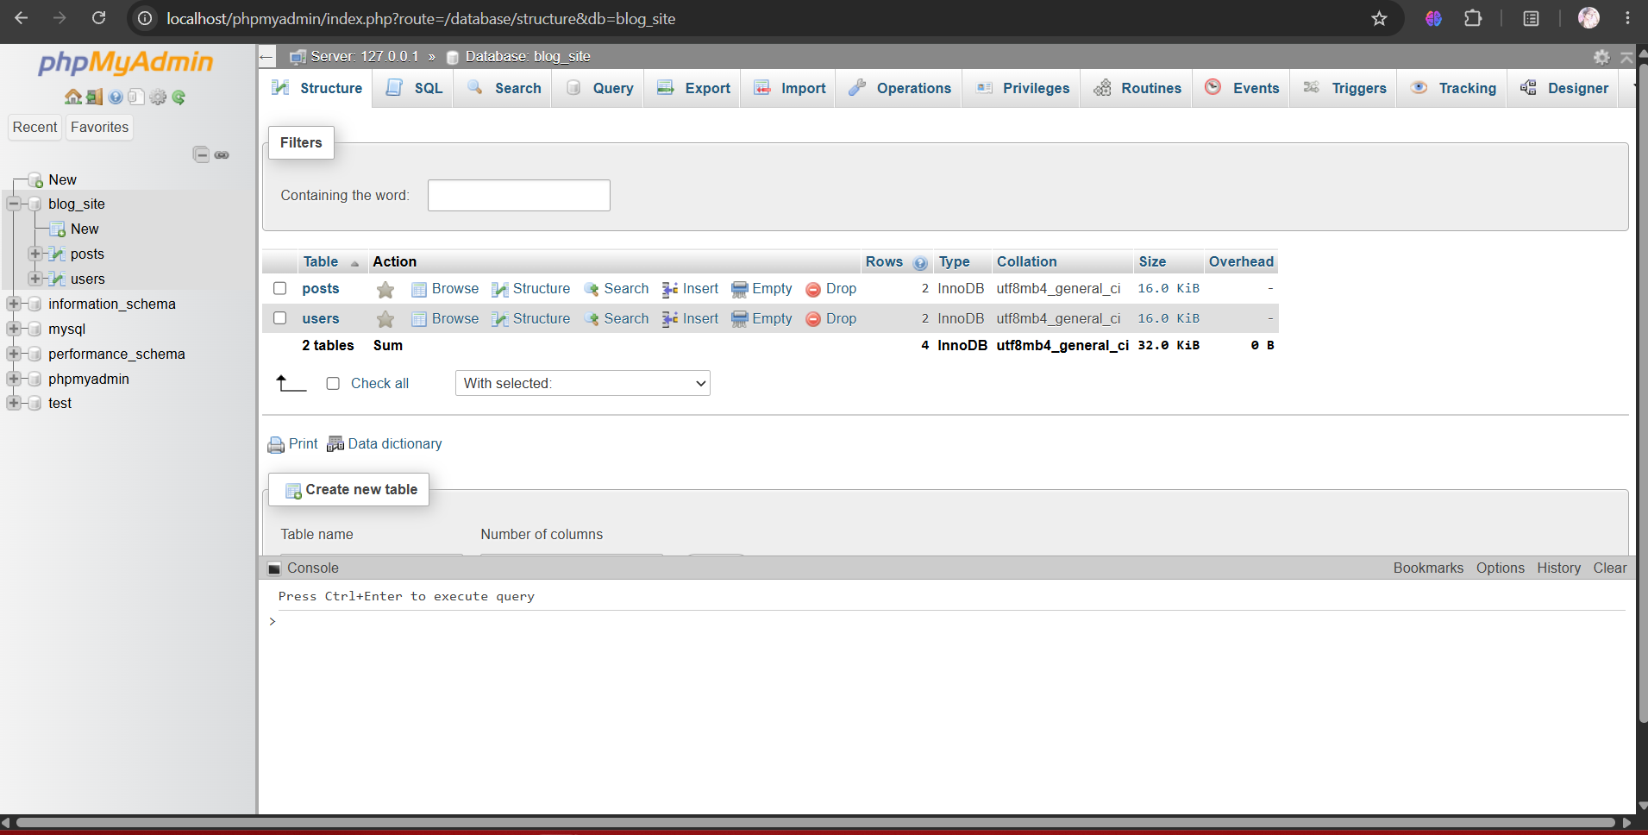

Creating 2 tables named “users” and “posts”
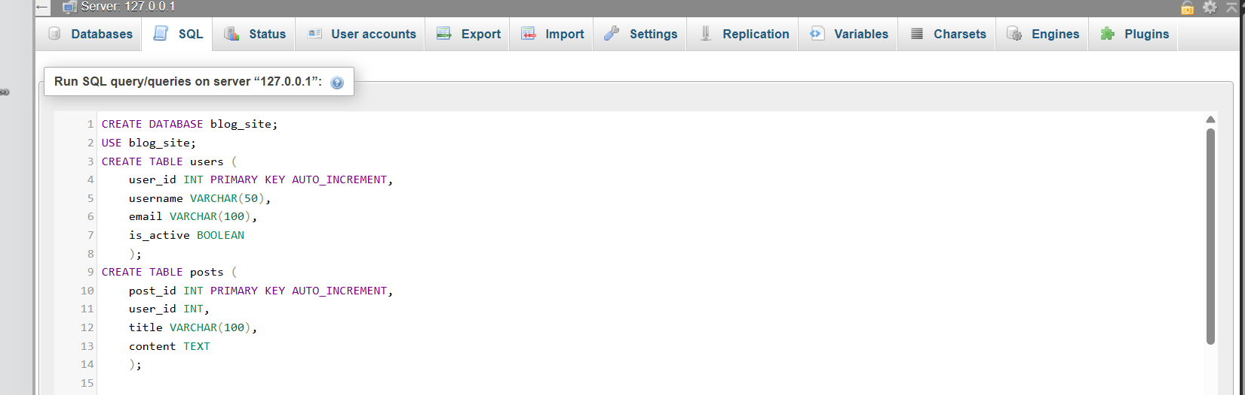
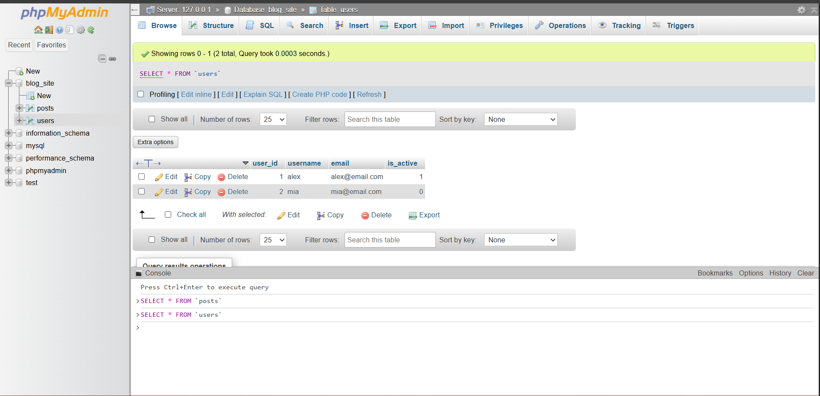

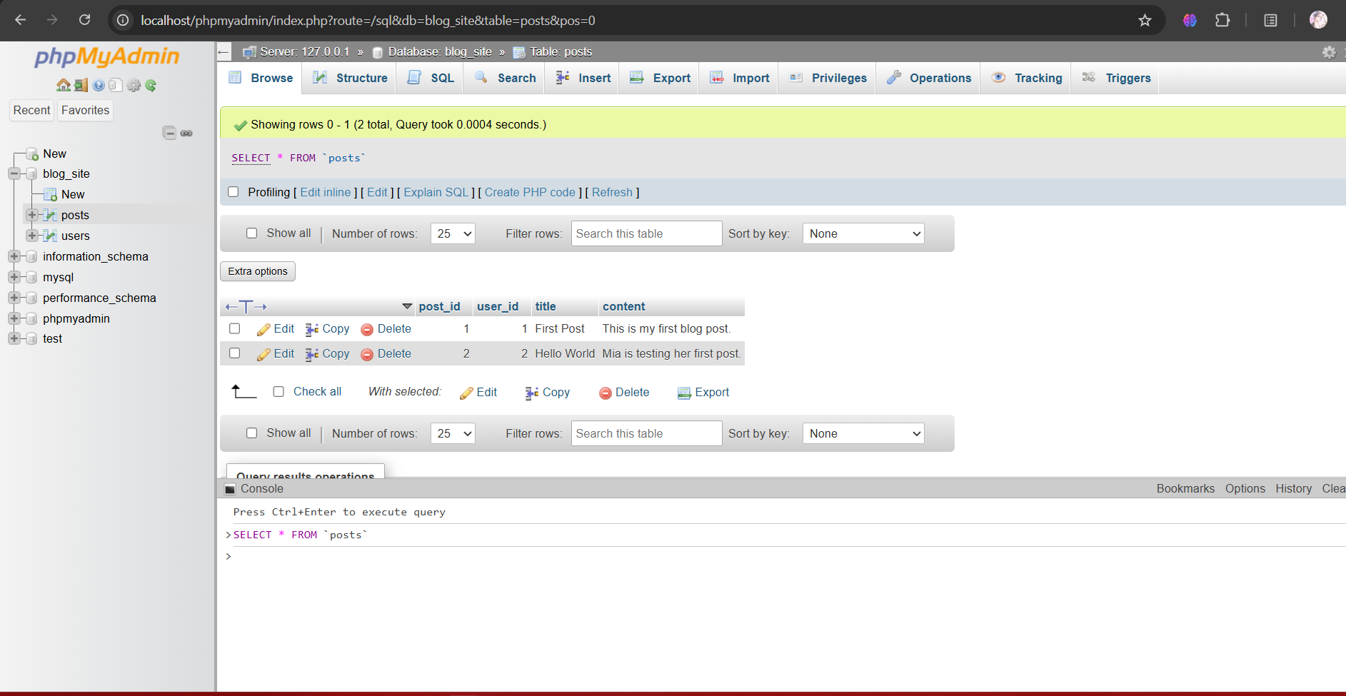

Inserting data into tables


