

**Formula Hybrid+Electric ESF -- Part 1**

**INTRODUCTION**

Part 1 of the Formula Hybrid+Electric ESF is intended to help teams solidify those design decisions that need to be made early in the program. This will also help the technical reviewers identify possible areas of concern early.

Many of the fields in this form will also be found in the ESF Part 2 and the information in those fields will need to be reentered when the ESF Part 2 is submitted.

It is expected that some of the information will change during the development of the vehicle. Teams should not feel “locked in” by the data provided here, however data entered in the ESF Part 2 will be considered final.

The information in this form will also be provided to the design judges, so teams may expect questions during the design event relating to why a particular aspect of the vehicle was changed during development.

**INSTRUCTIONS AND REQUIREMENTS**

.

1. Enter the information requested as accurately as possible. If a particular portion of the design has not been finalized, give a short description of the options being considered.
2. Please submit any questions, corrections and suggestions for improvement to:

https://ticket.formula-hybrid.org/level4/osticket/

1. When completed, this document must be submitted in Microsoft Word format (“docx”) – NOT PDF - at:

<https://ticket.formula-hybrid.org/level6/upload/index.php>

**Table of Contents**

**Section 1** **Vehicle Overview 2**

**Section 2** **Frame and Body 3**

**Section 3** **Engine 4**

3.1 Engine Data 4

3.2 Architecture 4

**Section 4** **Electrical System Overview 5**

4.1 Block Diagram 5

4.2 Vehicle Layout 5

4.3 Electrical System Parameters 6

4.4 Firewall(s) 6

**Section 5** **Tractive System 7**

5.1 Motor(s) 7

5.2 Motor Controller 7

**Section 6** **Accumulator System 8**

6.1 Accumulator Pack 8

6.2 Cell Description - Batteries 8

6.3 Cell Description - Capacitors 9

6.4 Cell Configuration 9

6.5 Lithium-Ion Pouch Cells 9

6.6 Accumulator Management System (AMS) 10

6.7 Charging 10

6.8 Accumulator Container/Housing 11

6.9 Shutdown Circuit 11

6.10 IMD 11

**Section 7** **GLV System 13**

7.1 GLV System Data 13

**List of Figures**

Figure 1- Electrical System Block Diagram 5

Figure 2 - Locations of major TS components 5

Figure 3 – Safety Shutdown Circuit Schematic 11

*Must be hyperlinked!*

**List of Tables**

Table 1 - Engine Data 4

Table 2 - General Electrical System Parameters 6

Table 3 - Motor Specifications 7

Table 4 - Motor Controller Specifications 7

Table 5 - Main Accumulator Parameters 8

Table 6 - Main Cell Specification 9

Table 7 - Capacitor Specifications 9

Table 8 - AMS Data 10

Table 9 - Accumulator Charging Data 10

Table 10 - IMD parameters 12

Table 11 - GLV Data 13

*Must be hyperlinked*!

**TITLE PAGE**

*Please include team logo, car picture, team picture, etc..*

|  |  |
| --- | --- |
| University Name: | University of Vermont |
| Team Name: | AERO(Alternative Energy Racing Organization) |
| Car Number: | 208 |

Main Team Contact for ESF related questions:

|  |  |
| --- | --- |
| Name: | Colin Grund |
| e-mail: | cgrund@uvm.edu |

# Vehicle Overview

Check the appropriate boxes:

**Vehicle is**

☐New (built on an entirely new frame)

☐New, but built on a pre-existing frame (FSAE, FS, FH electric-only, etc.)

X Updated from a previous year vehicle

**Architecture**

☐Hybrid

☐Series

☐Parallel

☐Hybrid in Progress (HIP)

X Electric-only

**Drive**

☐Front wheel

X Rear wheel

☐All-wheel

**Regenerative braking**

☐Front wheels

X Rear wheels

☐All wheels

☐None

# Frame and Body

List the materials used and the construction methodology for the frame and body. Include CAD drawings, photos or sketches as appropriate.

**Frame**

Materials

Steel 4130 tube

Joining Methods and Construction

Tig welding

**Body**

Materials

1/32nd in FR-4 as fire wall

1/8th in Acrylic as body panels.

Construction

DZUS clips

Zip ties

# Engine

*Skip this section if electric-only*

## Engine Data

|  |  |
| --- | --- |
| Manufacturer |  |
| Model Number |  |
| Modified? (Per **IC1.1(a))** | ☐Yes ☐No |
| Number of Cylinders |  |
| Bore | mm |
| Stroke | mm |
| Displacement | liters |
| Fuel type | ☐Gasoline ☐E-85 |
| Max. Power | kW @ RPM |
| Max. Torque | N⋅m @ RPM |
| Weight (Approximate) | kg |

*Table 1 - Engine Data*

## Architecture

Describe how the outputs from the I.C. engine and electric drive systems are merged:

# Electrical System Overview

## Block Diagram

Figure 1 – include an electrical system block diagram showing all major parts associated with the tractive-system. (Not detailed wiring).

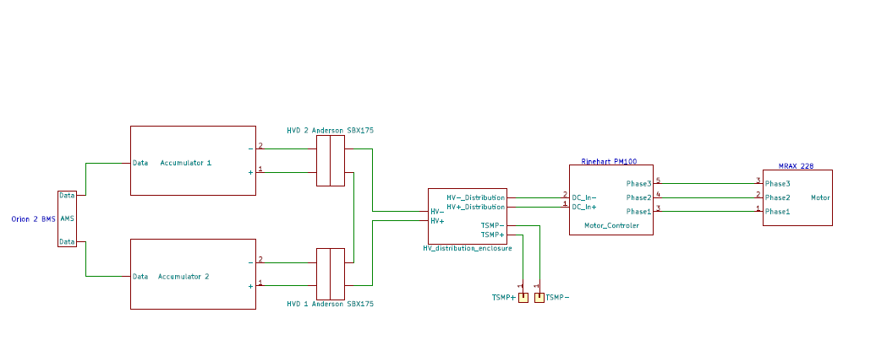

*Figure 1- Electrical System Block Diagram*

## Vehicle Layout

Figure 2 – include a diagram showing the location of all major parts associated with the tractive-system superimposed on a top view of the vehicle.

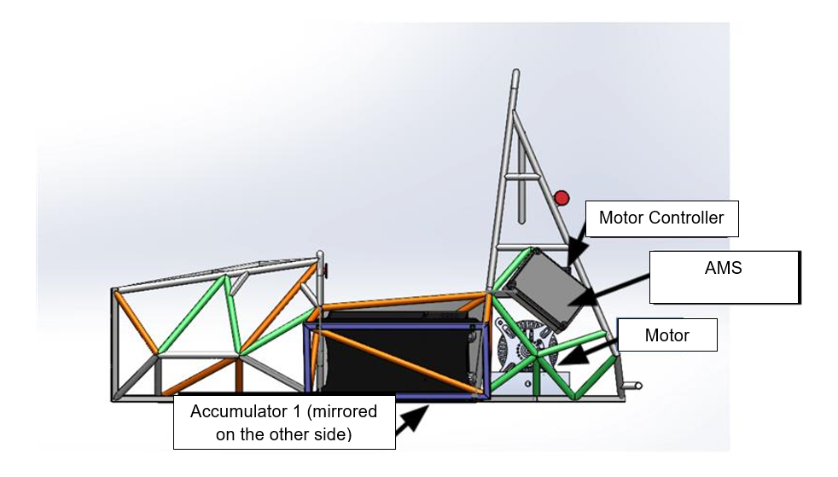

*Figure 2 - Locations of major TS components*

## Electrical System Parameters

Fill out the following table:

|  |  |
| --- | --- |
| Nominal Tractive System Voltage (TSV) | 260 VDC |
| Max. TSV (typically this is during charging) | 295 VDC |
| Control System voltage (GLV) | 12 VDC |
| Total Accumulator capacity | 4147.2 Wh |
| Accumulator type (Lead-acid, Li-Ion, NiMH, Ultracap…) | Li-ion |
| Number of electric motors. (Total) | 1 |
| Are wheel motors used? | ☐Yes X No |

*Table 2 - General Electrical System Parameters*

## Firewall(s)

**Description/materials**

Describe the concept, layer structure and the materials used for the firewalls.

The material used as firewall on the car is sheets of 1/32-inch FR-4(equivalency test can be provided). The material is a composite of woven fiberglass and epoxy resin that is fire resistant. We use 1/32-inch-thick sheets around the car to separate the driver from any possible exposure to flames. The material lines the cockpit, on their right and left side to separate the driver from the accumulators, behind the driver as well to separate them from the HV distribution, motor controller and motor. It is also within the accumulator packaging to add extra fire safety and insolation to them.

**Position in car**

Provide CAD-rendering or sketches showing the planned location of the firewall(s).

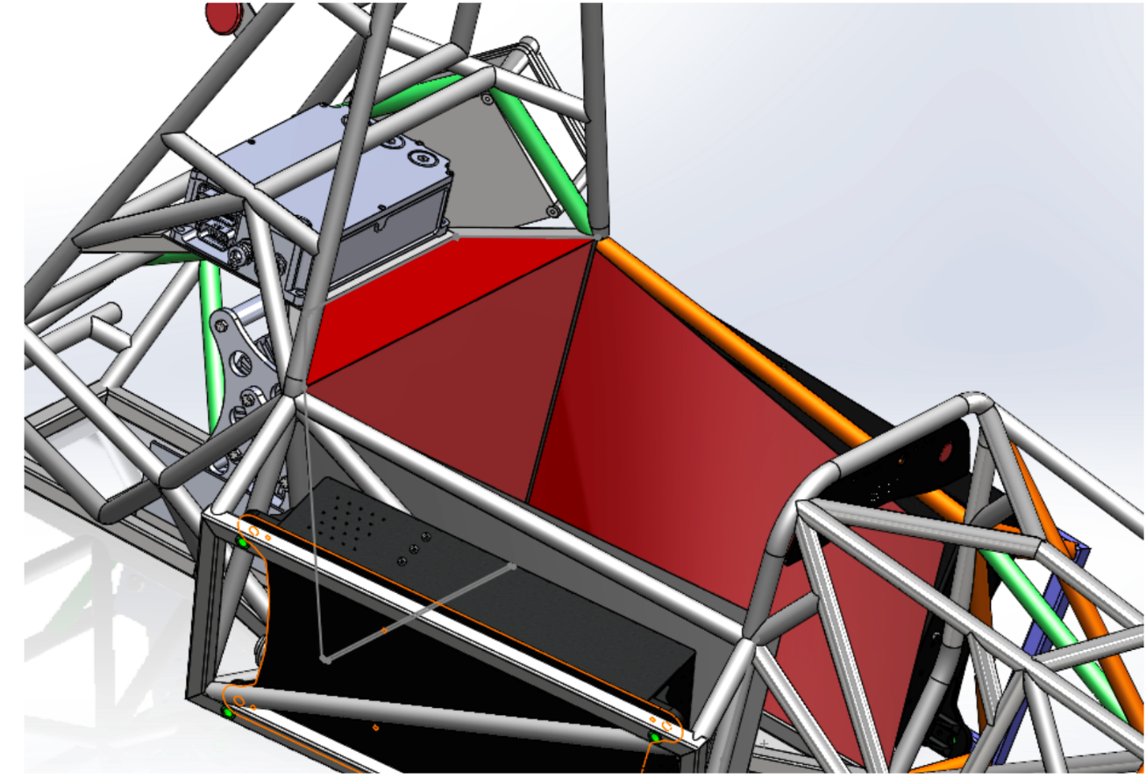

Firewall location noted by red material. Tractive System

## Motor(s)

Add additional tables if multiple motor types are used

|  |  |
| --- | --- |
| Manufacturer | Enstroj |
| Model Number | EMRAX 228 MV |
| Motor Type (PM, Induction, DC Brush…) | PMAC |
| Number of motors of this type used | 1 |
| Nominal motor voltage (Vrms l-l or Vdc) | 204 Vrms |
| Nominal / Peak motor current (A or A/phase) | Nom: 106 Arms Peak: 255Arms |
| Nominal / Peak motor power | Nom: 26.3 kW Peak: 63.1kW |

*Table 3 - Motor Specifications*

## Motor Controller

|  |  |
| --- | --- |
| Manufacturer | Rinehart Motion Systems |
| Model Number | PM100DX |
| Number of controllers of this type used: | 1 |
| Maximum Input voltage: | 360 V |
| Nominal Input Current: | 150 A |
| Output voltage (Vac l-l or Vdc) | 204 Vrms |
| Isolation voltage rating between GLV and TS connections | 1000 V |
| Is motor controller accelerator input isolated from TSV? | X Yes ☐No |

*Table 4 - Motor Controller Specifications*

# Accumulator System

## Accumulator Pack

Provide a narrative design of the accumulator system and complete the following tables.

The vehicle has two battery packs one on each side of the vehicle, wired in series. Each pack has two AIRs one on the positive side and one on the negative side of the pack. Each pack contains 36 Energus cells wires in series.

|  |  |
| --- | --- |
| Maximum Voltage (during charging): | 150 VDC |
| Nominal Voltage: | 260 VDC |
| Total number of cells: | 576 |
| Are packs commercially or team constructed? | Commercial cell modules, team built pack |
| Total Capacity: | 4.147 kWh |
| Maximum Segment Capacity: | 4.67 MJ |

*Table 5 - Main Accumulator Parameters*

*Note: each accumulator container(half of the pack) is charged separately off of the car thus the charging voltage is for half of the pack.

## Cell Description - Batteries

|  |  |
| --- | --- |
| Cell Manufacturer | Samsung(cell)/ Energus (module) |
| Model Number | INR18650-25R / Li2x4P25RT |
| Cell type (prismatic, cylindrical, pouch, etc.) | cylindrical |
| Are these pouch cells | ☐Yes X No |
| Cell nominal capacity: | 2.55 Ah |
| Discharge rate for nominal capacity (e.g. 1C, 2C etc.) | 2C |
| Maximum Voltage: | 4.2 V |
| Nominal Voltage: | 3.6 V |
| Minimum Voltage: | 2.5 V |
| Maximum Cell Temperature (charging) | 45 °C |
| Maximum Cell Temperature (discharging) | 60 °C |
| Cell chemistry: | Li-ion |

*Table 6 - Main Cell Specification*

## Cell Description - Capacitors

|  |  |
| --- | --- |
| Capacitor Manufacturer: |  |
| Model Number: |  |
| Rated Capacitance: | F |
| Rated Voltage: | V |
| Stored Energy[1] | Wh |
| Maximum Temperature | °C |

*Table 7 - Capacitor Specifications*

## Cell Configuration

Describe configuration: e.g., *N* cells in parallel then *M* packs in series, or *N* cells in series then *M* strings in series.

The vehicle has two battery packs one on each side of the vehicle, wired in series. Each pack has 36 Energus LI2x4P25RT modules in series, split into two segments of 18. Each Energus module has 8 Samsung INR18650 25R cells in parallel. The parallel cells of the Energus module are connected with fusible links that are designed to open after a 10 second pulse of 360 amps. These fuses are described in the datasheet.

## Lithium-Ion Pouch Cells

The vehicle accumulator ☐DOES / X DOES NOT use individual pouch cells. (Check one)

*Note: Designing an accumulator system utilizing pouch cells is a substantial engineering undertaking which may be avoided by using prismatic or cylindrical cells.*

If your team has designed your accumulator system using individual Lithium-Ion pouch cells, include drawings and calculations demonstrating compliance with all sections of **Article EV11** If your system has been issued a variance to **Article EV11** by the Formula Hybrid+Electric rules committee, include the required documentation from the cell manufacturer.

## Accumulator Management System (AMS)

|  |  |
| --- | --- |
| AMS Manufacturer | Orion |
| Model Number | BMS 2 |
| Number of AMSs | 1 |
| Upper Cell Voltage Trip | 4.2 V |
| Lower Cell Voltage Trip | 2.5V |
| Temperature Trip | 50°C |

*Table 8 - AMS Data*

## Charging

|  |  |
| --- | --- |
| Charger Manufacturer | Elcon |
| Model Number | PFC 1500 |
| Maximum Charging Power: | 1.5 kW |
| GLV/TS isolation location:  (i.e. cell boards, main unit, etc.) | Main unit |
| UL Certification? | ☐Yes X No |
| Maximum Charging Voltage: | 162 V |
| Maximum Charging Current: | 11.2 A |
| Input Voltage: | 120 VAC single phase |
| Input Current: | 12.5 A |

*Table 9 - Accumulator Charging Data*

## Accumulator Container/Housing

Describe the design of the accumulator container. Include the housing material specifications and construction methods.

The accumulator housing is constructed of a steel container lined internally with FR4 to isolate conductivity of the steel. The cells are press fit into the housing as well as held in place by a polycarbonate spacer that sits on top of the cells and presses on them from the lid with a piece of dense foam to ensure a tight even fit.

Where will the accumulators be located?

One on each side of the driver’s cell.

Will you be using a virtual accumulator housing? (**EV2.12**)

Yes.

## Shutdown Circuit

Include a schematic of the shutdown circuit for your vehicle including all major components in the loop.

***Note:*** *The design of the shutdown circuit and team members understanding of how it works is extremely important. Take the time to be sure it is right.*

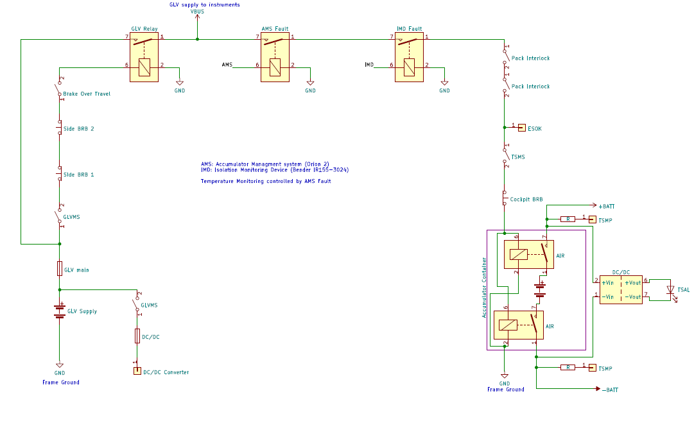

Figure 3 – Safety Shutdown Circuit Schematic

## IMD

Describe the IMD used and complete the following table:

The IMD is a bender IR155-3904-200kΩ-0V wired directly to HV inside the HV distribution enclosure.

|  |  |
| --- | --- |
| Manufacturer | Bender |
| Model Number | IR155-3904-200kΩ-0V |
| Set response value: | 200 kΩ  ( 694 Ω/Volt) |

*Table 10 - IMD parameters*

# GLV System

## GLV System Data

Provide a brief description of the GLV system and complete the following table.

GLV is powered primarily by a 400W Vicor DC-DC converter connected to TSV, but is supplemented with a small lead acid battery which is mostly used for startup. The GLV system is 12V and must supply a maximum of 30A, which is primarily drawn by the cooling system.

|  |  |
| --- | --- |
| GLV System Voltage | 12 V |
| GLV Main Fuse Rating | 30 A |
| GLV Accumulator type | Lead acid battery |
| How is the GLV storage recharged? | Off car with a car battery charger |

*Table 11 - GLV Data*

1. Use the formula given in Appendix A of the Formula Hybrid+Electric rules. This will differ slightly from the manufacturer’s rating.