

**CAPSTONE PROJECT REPORT**

**SMOKING  
(Smoking Cessation Support Platform)**

# **II. Software Requirement Specification**

### **1. Overall Description**

#### **1.1 Product Overview**

**Smoking Cessation Platform** is a comprehensive web-based system designed to help users quit smoking through personalized guidance and community support. There are two main components:

* **Member & Coach Portal** (ReactJS frontend + Node.js/Express backend, SQL database), where Members can track their progress, earn achievements, schedule and hold online coaching sessions, participate in community discussions, read educational blog posts and complete surveys; Coaches can manage their schedules, assign quit plans, review survey results and monitor assigned Members.
* **Administration Console**, where Admins manage users, subscription packages, achievements, surveys, blog/community content and view system analytics.

#### **1.2 Product Background**

In Vietnam, the demand for smoking cessation is steadily increasing. However, most existing platforms only offer basic information or simple tracking tools, lacking personalized interaction, in-depth support from coaches, and community features. This project was developed to fill that gap, providing a comprehensive solution with functionalities such as progress tracking, achievement management, online counseling, community sharing.

#### **1.3 Existing Systems**

General health apps and informational websites today typically lack:

* Integrated coach-to-member workflows with in-system scheduling and feedback
* Achievement and reward mechanisms that motivate continued engagement
* Interactive community forums closely tied to personal progress data

By embedding these features directly into our architecture, we deliver a stronger, more engaging cessation experience.

#### **1.4 Business Opportunity**

Rising health awareness and demand for personalized quitting programs create an opportunity to become Vietnam's preferred cessation platform. Organizations, clinics and individual users seek a solution that:

* Connects them with qualified coaches
* Provides clear progress-tracking and milestone rewards
* Fosters a supportive peer community
* Offers data-driven insights through surveys and analytics

#### **1.5 Software Product Vision**

Our goal is to lead the Vietnamese market by offering:

* A modern, responsive web interface that guides Members step-by-step
* Robust achievement, progress and reward management
* Role-based administration tools for managing content, users and coaches
* Dashboards and reports to analyze engagement, survey outcomes and overall program effectiveness

#### **1.6 Project Scope & Limitations**

**Scope:**

* Web app supporting user registration/login, profile management, progress tracking, achievement viewing, coaching booking, community participation, blog reading and surveys
* Backend services for role-based access (Member, Coach, Admin), management of achievements, packages, content and analytics

**Limitations:**

* No real payment gateway integration (all transactions are simulated)
* Basic logistics/inventory modules (future enhancements required)

## **2. User Requirements**

### **2.1 System Actors**

| # | Actor | Description |
| --- | --- | --- |
| 1 | Member | | A registered user who tracks progress, books coaching, joins the community, reads blogs, and chats with AI. | | --- |  |  | | --- | |
| 2 | Coach | | A support agent who monitors members’ progress, manages schedules, and provides consultations. | | --- |  |  | | --- | |
| 3 | Admin | | A system manager who oversees users, content, rewards, surveys, and AI configurations. | | --- |  |  | | --- | |

### **2.2 Use Cases Diagram**

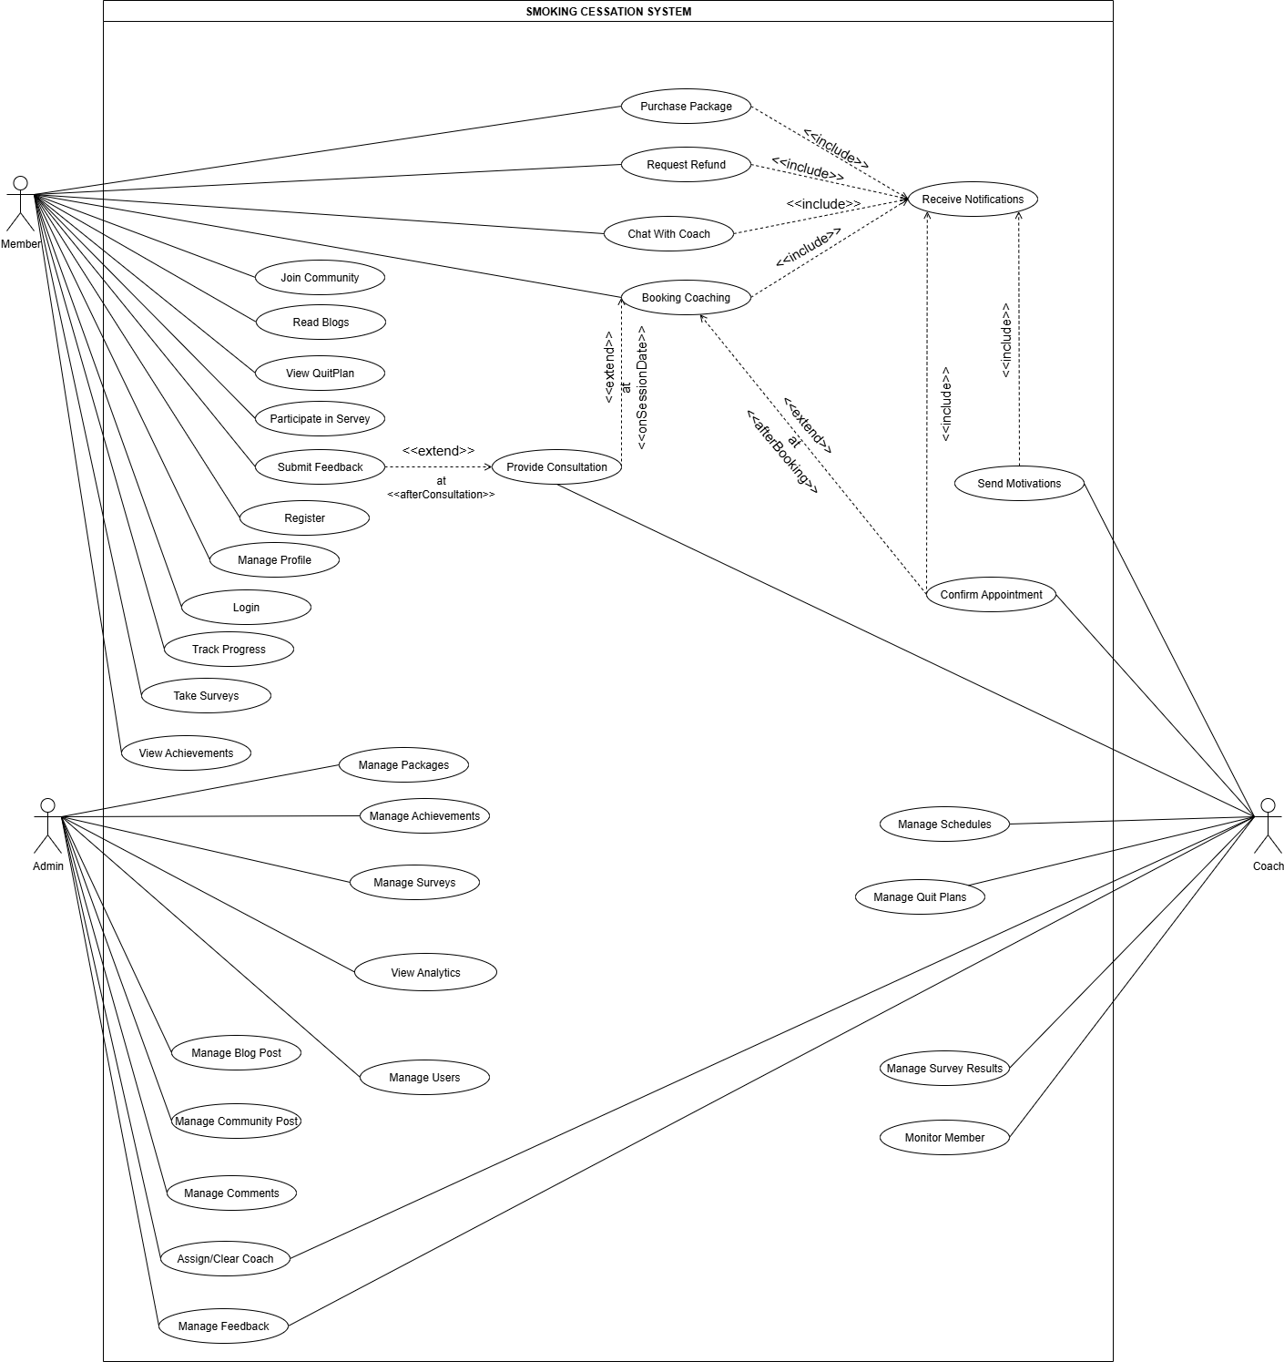

ERD Diagram:  
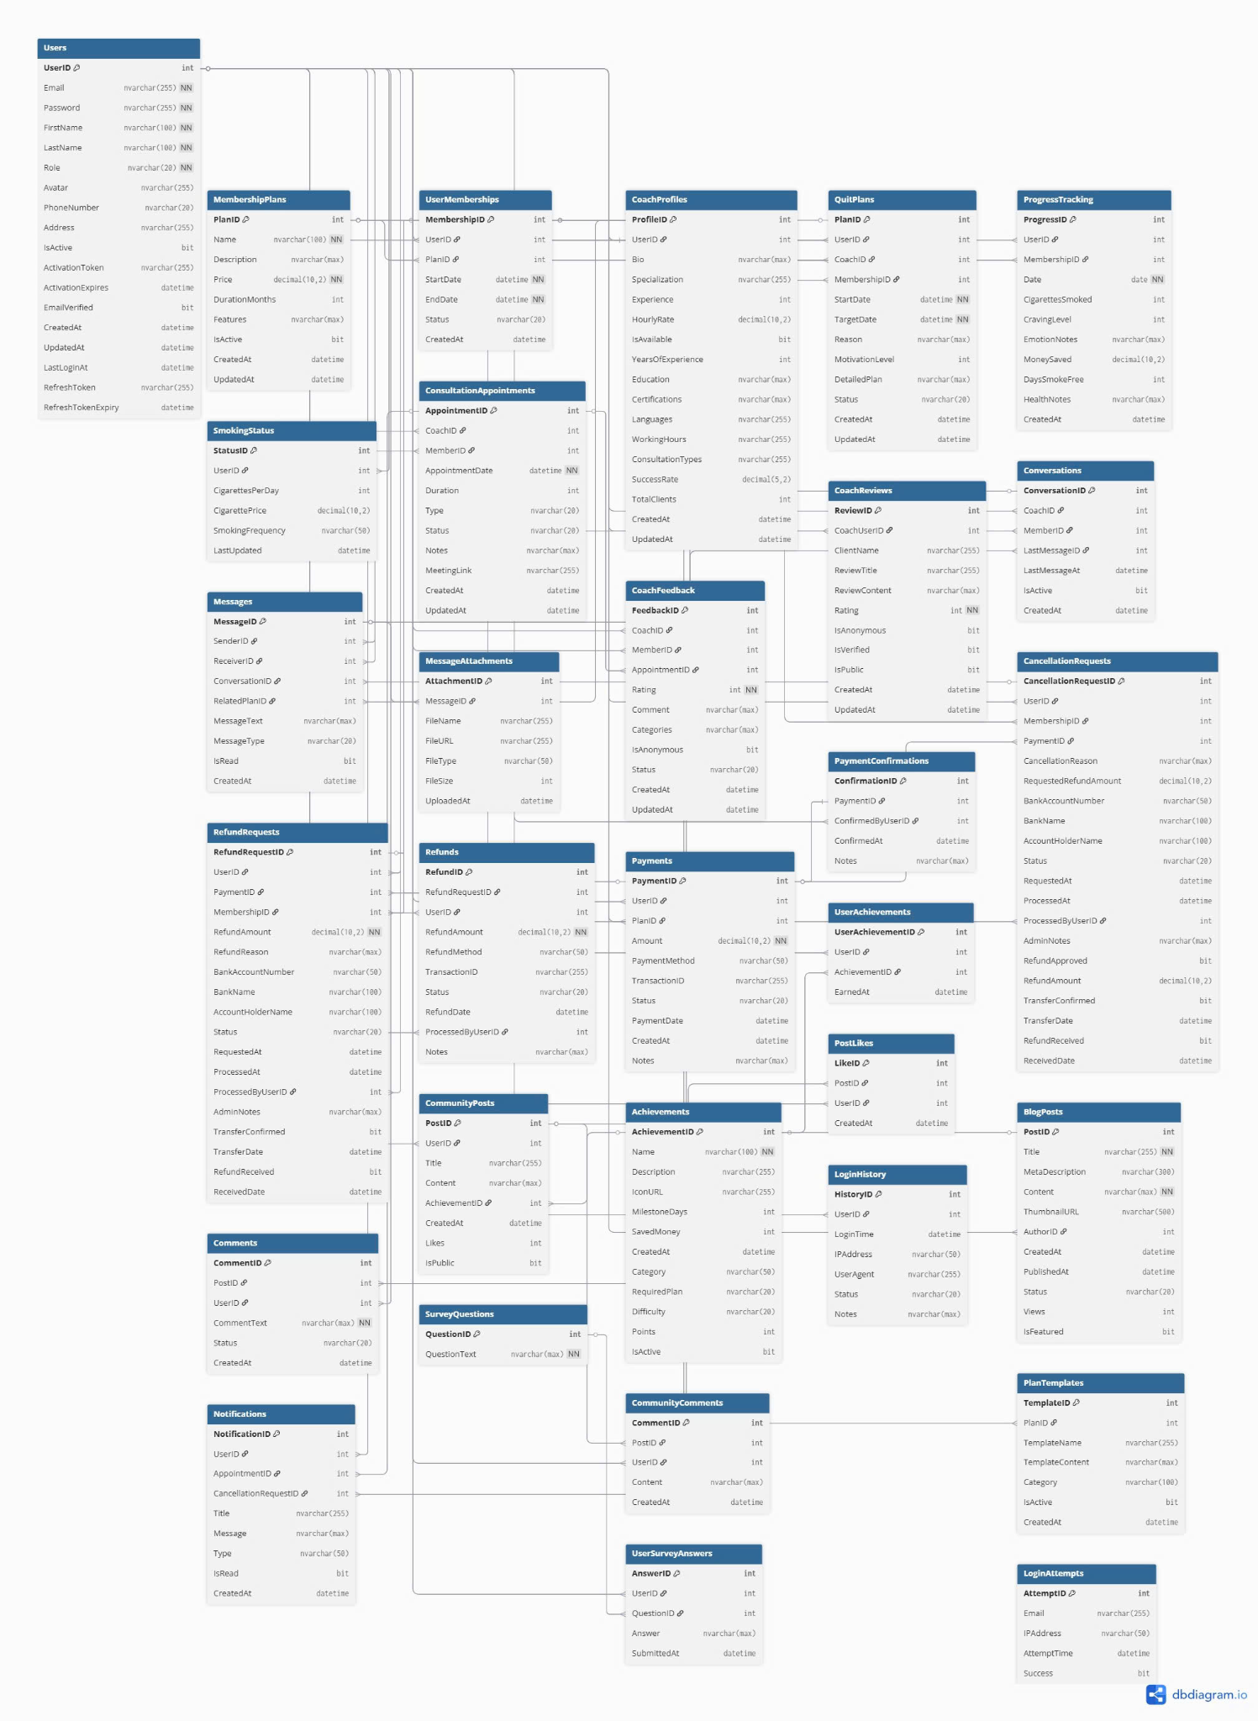

2.2.2 Descriptions

| **ID** | **Use Case** | **Actors** | **Use Case Description** |
| --- | --- | --- | --- |
| UC_01 | Register | Member | Members can register a new account and log in to the system. |
| UC_02 | Login | Member | Members can log in to the system. |
| UC_03 | Manage Profile | Member | The Member can view and update their personal information, settings, and goals.( Để sửa lại cái này, sai lè ở update =)) ) |
| UC_04 | Track Progress | Member | The Member can track their smoking cessation progress, view reduction charts, and history statistics. |
| UC_05 | Take Surveys | Member | The Member can complete surveys related to smoking habits and personal motivations. |
| UC_06 | View Achievements | Member | The Member can view earned badges, milestones, and accumulated reward points. |
| UC_07 | Booking Coaching | Member | The Member can schedule a coaching session with a Coach at a desired time. |
| UC_08 | Chat With Coach | Member, Coach | The Member and Coach can exchange messages and communicate directly through the system. |
| UC_09 | Receive Notifications | Member, Coach | The system notifies users of important events (e.g. appointment confirmations, survey reminders). |
| UC_10 | Purchase Package | Member | The Member can purchase a subscription package to access premium features. |
| UC_11 | Refund Money | Member | The Member can request a refund for a purchased package. |
| UC_12 | Join Community | Member | The Member can join discussion forums or community groups to share experiences. |
| UC_13 | Read Blogs | Member | The Member can browse and read blog posts with tips and guidance on smoking cessation. |
| UC_14 | Send Motivation | Coach | The Coach can send motivational messages and encouragement to Members. |
| UC_15 | Provide Consultations | Coach | The Coach conducts scheduled consultation sessions, offers guidance, and collects feedback. |
| UC_16 | Monitor Members | Coach | The Coach can view progress reports, analyze activity, and manage their assigned Members. |
| UC_17 | Manage Schedules | Coach | Coach defines and maintains their availability time slots for coaching sessions. |
| UC_18 | Manage Quit Plans | Coach | Coach creates and customizes smoking-cessation quit plans (steps, timelines) and assigns them to Members. |
| UC_19 | Manage Survey Results | Coach | Coach views and analyzes individual and aggregated survey responses from Members to guide coaching. |
| UC_20 | Manage Packages | Admin | Admin creates, updates or deletes subscription packages offered to Members. |
| UC_21 | Manage Achievements | Admin | Admin defines badges, milestones and reward-point rules for Member achievements. |
| UC_22 | Manage Surveys | Admin | Admin designs, edits and maintains survey questionnaires for assessing Member habits and motivations. |
| UC_23 | View Analytics | Admin | Admin reviews system-wide usage and performance metrics via dashboards and reports. |
| UC_24 | Manage Users | Admin | Admin activates, deactivates or changes roles of Member and Coach accounts. |
| UC_25 | Manage Blog Posts | Admin | Admin creates, edits, schedules or deletes blog articles on cessation tips and guidance. |
| UC_26 | Manage Community Posts | Admin | Admin moderates forum posts—approving, editing or removing content in community groups. |
| UC_27 | Manage Comments | Admin | Admin removes or flags inappropriate comments on blogs and forums. |
| UC_28 | Assign/Clear Coach | Admin | Admin assigns or removes a Coach for a Member and manages those associations. |
| UC_29 | Manage Feedback | Admin | Admin reviews session feedback, marks items as addressed or escalates issues to the support team. |
| UC_30 | Rate Coaching | Member | After each coaching session, Members can rate their Coach and leave feedback to help improve service quality. |
| UC_31 | View Appointment History | Member | Member reviews a list of past and canceled coaching appointments, including date, assigned Coach, duration, status, and notes. |

#### ***2.3 Use Case Specification***

#### ***2.3.1 Member***

##### **2.3.1.1: Register**

| **Use Case Specification** | | | |
| --- | --- | --- | --- |
| **Use Case ID and Name:** | UC_01 – Register | | |
| **Created By:** |  | **Date Created:** |  |
| **Primary Actor:** | Member | **Secondary Actors:** | **N/A** |
| **Description:** | The system allows a Member to create a new account. | | |
| **Pre-conditions:** | PRE-1: The user does not have an existing account. | | |
| **Post–conditions:** | POST-1: A new account is created, and the user can log in. | | |
| **Normal Flow:** | 1. The Customer accesses the registration page. 2. The Customer enters information: email, password, full name, phone number. 3. The System validates the input (e.g., email not already registered, password strength). 4. The System sends a verification code (if applicable). 5. The Customer confirms the code (if applicable). 6. The System creates a new account and notifies of successful registration. | | |
| **Alternative Flows:** | 3a. Email already exists: The System displays an error and prompts for a different email.  3b. Invalid data: The System displays an error and prompts for re-entry.  4a. Incorrect/Expired verification code: The System displays an error and allows resending the code. | | |
| **Exceptions:** | Email/SMS delivery failure or database error → display generic error, ask to retry. | | |
| **Priority:** | **High** | | |
| **Frequency of Use:** | Low | | |
| **Business Rules:** | **BR-1: Password must be at least 8 characters, include uppercase, lowercase, and numeric.** | | |
| **Other Information:** | Email/SMS verification can be added. | | |
| **Assumptions:** | A-1: Users have an internet connection to access the registration page.  A-2: The system has the capability to send email/SMS verification codes. | | |

##### **2.3.1.2: Login**

| **Use Case Specification** | | | |
| --- | --- | --- | --- |
| **Use Case ID and Name:** | UC_02 – Login | | |
| **Created By:** |  | **Date Created:** |  |
| **Primary Actor:** | Member | **Secondary Actors:** | **N/A** |
| **Description:** | The system allows a Member to authenticate and access personalized features. | | |
| **Pre-conditions:** | PRE-1: Member has a valid account.  PRE-2: Member has an active internet connection. | | |
| **Post–conditions:** | POST-1: The customer will be logged in.  POST-2: Member lands on the Dashboard. | | |
| **Normal Flow:** | 1. The Customer accesses the login page. 2. The Customer enters email and password. 3. The System authenticates the provided information. 4. If authentication is successful, the Customer is redirected to the home page. | | |
| **Alternative Flows:** | 3a. Incorrect credentials: The System displays an error and allows re-entry.  3b. Account locked/unverified: The System displays an error and provides instructions for resolution. | | |
| **Exceptions:** | 1-EF: At any time, the app cannot communicate with the server/core system (due to network malfunction/technical issues), the system displays an error message.  2-EF: The data in the registration form is in the wrong format. | | |
| **Priority:** | **High** | | |
| **Frequency of Use:** | **High** | | |
| **Business Rules:** | **BR-2: After 5 failed attempts, lock account for 30 minutes.** | | |
| **Other Information:** | “Forgot Password” link available. | | |
| **Assumptions:** | A-3: Users remember their passwords or a password recovery mechanism is in place.  A-4: The system has a mechanism to handle consecutive failed login attempts (e.g., temporary lockout). | | |

##### **2.3.1.3: Manage Profile**

| **Use Case Specification** | | | |
| --- | --- | --- | --- |
| **Use Case ID and Name:** | UC_03 – Manage Profile | | |
| **Created By:** |  | **Date Created:** |  |
| **Primary Actor:** | Member | **Secondary Actors:** | **N/A** |
| **Description:** | Members can view and update personal information, settings, and goals. | | |
| **Pre-conditions:** | PRE-1: Member is logged in. | | |
| **Post–conditions:** | POST-1: Updated profile is persisted. | | |
| **Normal Flow:** | 1. Member navigates to Profile. 2. The system displays current profile data. 3. Members edit fields (name, avatar, target quit date, etc.). 4. Member clicks Save. 5. System validates and saves changes, displays “Update successful.” | | |
| **Alternative Flows:** | 3a.Invalid input (e.g., unsupported image size, date format) → display error, highlight field. | | |
| **Exceptions:** | Database error → display “Unable to save profile, please try again.” | | |
| **Priority:** | **Medium** | | |
| **Frequency of Use:** | **Medium** | | |
| **Business Rules:** | **BR-3: Avatar file size must not exceed 2 MB.** | | |
| **Other Information:** | N/A | | |
| **Assumptions:** | N/A | | |

##### 

##### 

##### 

##### 

##### 

##### 

##### 

##### **2.3.1.4: Track Progress**

| **Use Case Specification** | | | |
| --- | --- | --- | --- |
| **Use Case ID and Name:** | UC_04 – Track Progress | | |
| **Created By:** |  | **Date Created:** |  |
| **Primary Actor:** | Member | **Secondary Actors:** | **N/A** |
| **Description:** | Members can view charts and statistics of their smoking-cessation journey. | | |
| **Pre-conditions:** | PRE-1: Member is logged in.  PRE-2: There is at least one day of usage data. | | |
| **Post–conditions:** | POST-1:Progress data is displayed. | | |
| **Normal Flow:** | 1. Member opens Track Progress. 2. System retrieves usage history. 3. System renders reduction chart (daily/weekly). 4. System shows summary metrics (days smoke-free, cigarettes avoided) | | |
| **Alternative Flows:** | 1a. No data available → display “No progress recorded yet.” | | |
| **Exceptions:** | Data retrieval error → display “Unable to load progress.” | | |
| **Priority:** | **High** | | |
| **Frequency of Use:** | **High** | | |
| **Business Rules:** | **BR-4: Usage data is logged once per day.** | | |
| **Other Information:** | N/A | | |
| **Assumptions:** | N/A | | |

##### **2.3.1.5: Take Surveys**

| **Use Case Specification** | | | |
| --- | --- | --- | --- |
| **Use Case ID and Name:** | UC_05 – Take Surveys | | |
| **Created By:** |  | **Date Created:** |  |
| **Primary Actor:** | Member | **Secondary Actors:** | **N/A** |
| **Description:** | Members complete surveys on smoking habits and motivations. | | |
| **Pre-conditions:** | PRE-1: Member is logged in.  PRE-2: At least one active survey exists. | | |
| **Post–conditions:** | POST-1:Survey responses are saved. | | |
| **Normal Flow:** | 1. Members select a survey. 2. System displays questions. 3. Member answers required questions. 4. Members submit responses. 5. System saves responses, showing “Thank you for completing the survey.” | | |
| **Alternative Flows:** | 1a. Required question left blank → display “Please answer all required questions.” | | |
| **Exceptions:** | Save failure → display “Unable to save responses.” | | |
| **Priority:** | **Medium** | | |
| **Frequency of Use:** | **Low** | | |
| **Business Rules:** | **BR-5: All mandatory questions must be answered.** | | |
| **Other Information:** | N/A | | |
| **Assumptions:** | N/A | | |

##### 

##### 

##### 

##### **2.3.1.6: View Achievements**

| **Use Case Specification** | | | |
| --- | --- | --- | --- |
| **Use Case ID and Name:** | UC_06 – View Achievements | | |
| **Created By:** |  | **Date Created:** |  |
| **Primary Actor:** | Member | **Secondary Actors:** | **N/A** |
| **Description:** | Member views earn badges, milestones, and reward points. | | |
| **Pre-conditions:** | PRE-1: Member is logged in. | | |
| **Post–conditions:** | POST-1:Achievement view updated; no data changes. | | |
| **Normal Flow:** | 1. Members select "Achievements." 2. System retrieves achievement data. 3. The system displays badges, milestones, and points. | | |
| **Alternative Flows:** | 2a. No achievements: System encourages Member to start progress. | | |
| **Exceptions:** | Retrieval error: display error message. | | |
| **Priority:** | **Low** | | |
| **Frequency of Use:** | **Low** | | |
| **Business Rules:** | **BR-6: Points expire after 1 year of inactivity.** | | |
| **Other Information:** | Achievements linked to surveys and progress events. | | |
| **Assumptions:** | Achievement rules defined. | | |

##### 

##### 

##### 

##### 

##### 

##### **2.3.1.7: Booking Coaching**

| **Use Case Specification** | | | |
| --- | --- | --- | --- |
| **Use Case ID and Name:** | UC_07 – Booking Coaching | | |
| **Created By:** |  | **Date Created:** |  |
| **Primary Actor:** | Member | **Secondary Actors:** | **Coach** |
| **Description:** | Member schedules a coaching session at a desired time. | | |
| **Pre-conditions:** | PRE-1: Member is logged in and has an active subscription. | | |
| **Post–conditions:** | POST-1: The lesson has been scheduled; the coach has been notified. | | |
| **Normal Flow:** | 1. Member opens "Book Coaching." 2. The system shows available slots. 3. Member selects date/time and Coach. 4. System confirms availability and books session. 5. The system sends booking confirmation to Member and Coach. | | |
| **Alternative Flows:** | 3a. Slot taken: System suggests alternate slots. | | |
| **Exceptions:** | Notification failure: log error, inform Member. | | |
| **Priority:** | **Medium** | | |
| **Frequency of Use:** | **Low** | | |
| **Business Rules:** | **BR-7: Must be booked at least 24 hours in advance.** | | |
| **Other Information:** | Rescheduling handled via separate flow. | | |
| **Assumptions:** | Coach availability managed in system. | | |

##### **2.3.1.8: Chat WIth Coach**

| **Use Case Specification** | | | |
| --- | --- | --- | --- |
| **Use Case ID and Name:** | UC_08 – Chat WIth Coach | | |
| **Created By:** |  | **Date Created:** |  |
| **Primary Actor:** | Member | **Secondary Actors:** | **Coach** |
| **Description:** | Members and Coach exchange messages in real time. | | |
| **Pre-conditions:** | PRE-1: Both are logged in and have an active session. | | |
| **Post–conditions:** | POST-1: Messages stored in conversation history. | | |
| **Normal Flow:** | 1. Member selects a Coach chat. 2. System opens chat window. 3. Member and Coach send messages. 4. System displays messages instantly. | | |
| **Alternative Flows:** | 3a. Offline: System queues message for later delivery. | | |
| **Exceptions:** | Delivery error: retry mechanism. | | |
| **Priority:** | **Medium** | | |
| **Frequency of Use:** | **Low** | | |
| **Business Rules:** | **BR-8: Messages retained for 1 year.** | | |
| **Other Information:** | Notifications sent on new messages. | | |
| **Assumptions:** | Both parties online for real-time. | | |

##### **2.3.1.9: Receive Notifications**

| **Use Case Specification** | | | |
| --- | --- | --- | --- |
| **Use Case ID and Name:** | UC_09 – Receive Notifications | | |
| **Created By:** |  | **Date Created:** |  |
| **Primary Actor:** | Member, Coach | **Secondary Actors:** | **Coach** |
| **Description:** | System notifies users of important events. | | |
| **Pre-conditions:** | PRE-1: User has enabled notifications | | |
| **Post–conditions:** | POST-1: Notifications are sent via the selected channel. | | |
| **Normal Flow:** | 1. System detects events (e.g., booking confirmation). 2. System generates notifications. 3. System sends via email/app push. 4. User views notification. | | |
| **Alternative Flows:** | 3a. Delivery failure: System retries or logs error. | | |
| **Exceptions:** | External service down: queue notification. | | |
| **Priority:** | **Medium** | | |
| **Frequency of Use:** | **Medium** | | |
| **Business Rules:** | **BR-9: Users can opt in/out by category.** | | |
| **Other Information:** | Notification options can be configured. | | |
| **Assumptions:** | Integrated notification service. | | |

##### **2.3.1.10: Purchase Package**

| **Use Case Specification** | | | |
| --- | --- | --- | --- |
| **Use Case ID and Name:** | UC_10 – Purchase Package | | |
| **Created By:** |  | **Date Created:** |  |
| **Primary Actor:** | Member | **Secondary Actors:** | **Payment Gateway** |
| **Description:** | Member buys subscription to access premium features. | | |
| **Pre-conditions:** | PRE-1: Member is logged in | | |
| **Post–conditions:** | POST-1: Subscription activated; billing record created. | | |
| **Normal Flow:** | 1. Member selects a package. 2. System displays package details and price. 3. Member enters payment information. 4. System submits to Payment Gateway. 5. Payment Gateway approves. 6. System activates subscription and confirms to Member. | | |
| **Alternative Flows:** | 4a. Payment declined: System shows error, prompts retry. | | |
| **Exceptions:** | Gate timeout: notify Member, retry option. | | |
| **Priority:** | **High** | | |
| **Frequency of Use:** | **Low** | | |
| **Business Rules:** | **BR-10: Prices include applicable taxes.** | | |
| **Other Information:** | Supports multiple payment methods | | |
| **Assumptions:** | PCI compliance in place. | | |

##### 

##### **2.3.1.11: Refund Money**

| **Use Case Specification** | | | |
| --- | --- | --- | --- |
| **Use Case ID and Name:** | UC_11 – Refund Money | | |
| **Created By:** |  | **Date Created:** |  |
| **Primary Actor:** | Member | **Secondary Actors:** | **Admin** |
| **Description:** | Member requests refund for a purchased package. | | |
| **Pre-conditions:** | PRE-1: The member has an active or recently expired subscription.  PRE-2: The package is still within the refundable period (≤ 30 days from purchase). | | |
| **Post–conditions:** | POST-1: The refund is successfully processed.  POST-2: The member's subscription is canceled if the refund is approved. | | |
| **Normal Flow:** | 1. Member navigates to the “Request Refund” section. 2. Member selects the package and provides a reason for the request. 3. The system validates the eligibility for refund (time, package status…). 4. Admin reviews and approves or rejects the refund request. 5. If eligible, the system forwards the request to Admin for review. 6. The system notifies the member of the result. | | |
| **Alternative Flows:** | 3a. The system displays a message informing the member that the request does not meet the refund policy. | | |
| **Exceptions:** | The system notifies the member of the error and logs or creates a support ticket. | | |
| **Priority:** | **Low** | | |
| **Frequency of Use:** | **Low** | | |
| **Business Rules:** | **BR-11: Refunds are only allowed within 7 days of the purchase date.** | | |
| **Other Information:** | Refunds may take 1 to 2 business days after approval. | | |
| **Assumptions:** | An admin interface is available for refund review and processing.  Members have access to the refund request function from the system. | | |

##### **2.3.1.12: Join Community**

| **Use Case Specification** | | | |
| --- | --- | --- | --- |
| **Use Case ID and Name:** | UC_12 – Join Community | | |
| **Created By:** |  | **Date Created:** |  |
| **Primary Actor:** | Member | **Secondary Actors:** | Community Moderator ( Admin) |
| **Description:** | Member enrolls in discussion forums/groups. | | |
| **Pre-conditions:** | PRE-1:Member is logged in. | | |
| **Post–conditions:** | POST-1: Member added to community group. | | |
| **Normal Flow:** | 1. Member selects "Community." 2. System lists available forums. 3. Member chooses forum and requests to join. 4. System adds Member and confirms. | | |
| **Alternative Flows:** | 3a. Approval required: System flags pending and notifies Moderator. | | |
| **Exceptions:** | Service error: display error message. | | |
| **Priority:** | **Low** | | |
| **Frequency of Use:** | **Low** | | |
| **Business Rules:** | **BR-12: Forums may have access restrictions.** | | |
| **Other Information:** | Private forums require moderator approval. | | |
| **Assumptions:** | Community feature enabled. | | |

#### 

##### **2.3.1.13: Read Blogs**

| **Use Case Specification** | | | |
| --- | --- | --- | --- |
| **Use Case ID and Name:** | UC_13 – Read Blogs | | |
| **Created By:** |  | **Date Created:** |  |
| **Primary Actor:** | Member | **Secondary Actors:** |  |
| **Description:** | Member browses and reads blog posts with tips on cessation. | | |
| **Pre-conditions:** | PRE-1: Member is logged in or guest. | | |
| **Post–conditions:** | POST-1: Viewed blog content; no changes. | | |
| **Normal Flow:** | 1. User selects "Blogs." 2. System displays list of posts. 3. User selects a post. 4. System displays full articles and media. | | |
| **Alternative Flows:** | 2a. No post: notify user and suggest alternative content | | |
| **Exceptions:** | Content load error: retry option. | | |
| **Priority:** | **Low** | | |
| **Frequency of Use:** | **Low** | | |
| **Business Rules:** | **BR-13: Content updated monthly.** | | |
| **Other Information:** | Comments available via community. | | |
| **Assumptions:** | Blog content managed by Admin. | | |

#### ***2.3.2 Coach***

##### **2.3.2.1: Send Motivation**

| **Use Case Specification** | | | |
| --- | --- | --- | --- |
| **Use Case ID and Name:** | UC_14 – Send Motivation | | |
| **Created By:** |  | **Date Created:** |  |
| **Primary Actor:** | Coach | **Secondary Actors:** | Member |
| **Description:** | Coach sends motivational messages to assigned Members. | | |
| **Pre-conditions:** | PRE-1: Coach is logged in and has assigned Members. | | |
| **Post–conditions:** | POST-1: Message delivered; stored in Member inbox. | | |
| **Normal Flow:** | 1. Coach opens "Send Motivation." 2. System shows list of Members. 3. Coach selects Member(s) and composes message. 4. Coach submits. 5. System sends messages and logs record. | | |
| **Alternative Flows:** | 3a. No Members assigned: inform Coach. | | |
| **Exceptions:** | Delivery failure: retry or log issue. | | |
| **Priority:** | **Low** | | |
| **Frequency of Use:** | **Low** | | |
| **Business Rules:** | **BR-14: Messages limited to 200 characters.** | | |
| **Other Information:** | Scheduled sends possible. | | |
| **Assumptions:** | Messaging channel active. | | |

##### **2.3.2.2: Provide Consultations**

| **Use Case Specification** | | | |
| --- | --- | --- | --- |
| **Use Case ID and Name:** | UC_15 – Provide Consultations | | |
| **Created By:** |  | **Date Created:** |  |
| **Primary Actor:** | Coach | **Secondary Actors:** | Member |
| **Description:** | Coach conducts scheduled sessions, offers guidance, and collects feedback. | | |
| **Pre-conditions:** | PRE-1: Session is booked and time has arrived. | | |
| **Post–conditions:** | POST-1: Session notes and feedback recorded.. | | |
| **Normal Flow:** | 1. Coach reviews today's sessions. 2. Coach starts consulting with Member. 3. Coach provides guidance. 4. Coach wraps up and asks for feedback. 5. Members submit feedback. 6. System stores session notes and feedback. | | |
| **Alternative Flows:** | 2a. Member no-show: Coach marks no-show and system notifies Member. | | |
| **Exceptions:** | System error saving notes: retry. | | |
| **Priority:** | **Medium** | | |
| **Frequency of Use:** | **Low** | | |
| **Business Rules:** | **BR-15: Feedback mandatory for session completion.** | | |
| **Other Information:** | Session recordings optional. | | |
| **Assumptions:** | Recording feature available. | | |

##### **2.3.2.3: Member monitoring**

| **Use Case Specification** | | | |
| --- | --- | --- | --- |
| **Use Case ID and Name:** | UC_16 – Member monitoring | | |
| **Created By:** |  | **Date Created:** |  |
| **Primary Actor:** | Coach | **Secondary Actors:** | N/A |
| **Description:** | Coach views progress reports, analyzes activity, and manages assigned Members. | | |
| **Pre-conditions:** | PRE-1: Coach is logged in. | | |
| **Post–conditions:** | POST-1: Reports viewed; no data modification. | | |
| **Normal Flow:** | 1. Coach selects "Monitor Members." 2. System lists assigned Members. 3. Coach selects a Member. 4. System displays progress charts, survey results, and session history. | | |
| **Alternative Flows:** | 2a. No assigned Members: system suggests assigning via admin | | |
| **Exceptions:** | Data load error: show message. | | |
| **Priority:** | **Medium** | | |
| **Frequency of Use:** | **Medium** | | |
| **Business Rules:** | **BR-16: Reports refresh daily at 00:00 UTC.** | | |
| **Other Information:** | Export to PDF available | | |
| **Assumptions:** | Analytics module operational. | | |

##### **2.3.2.4: Manage Schedules**

| **Use Case Specification** | | | |
| --- | --- | --- | --- |
| **Use Case ID and Name:** | UC_17 – Manage Schedules | | |
| **Created By:** |  | **Date Created:** |  |
| **Primary Actor:** | Coach | **Secondary Actors:** | N/A |
| **Description:** | Coach defines availability slots for coaching sessions. | | |
| **Pre-conditions:** | PRE-1: Coach is logged in. | | |
| **Post–conditions:** | POST-1:Availability schedule updated. | | |
| **Normal Flow:** | 1. Coach opens "Manage Schedules." 2. System displays current availability. 3. Coach adds, edits, or removes time slots. 4. System validates (no overlaps) and saves. 5. System confirmations. | | |
| **Alternative Flows:** | 3a. Overlapping slot: system prompts for adjustment. | | |
| **Exceptions:** | Schedule service down: show error. | | |
| **Priority:** | **Medium** | | |
| **Frequency of Use:** | **Low** | | |
| **Business Rules:** | **BR-17: Slots must be in 30-minute increments.** | | |
| **Other Information:** | N/A | | |
| **Assumptions:** | Time zone handling correct. | | |

##### **2.3.2.5: Manage Quit Plans**

| **Use Case Specification** | | | |
| --- | --- | --- | --- |
| **Use Case ID and Name:** | UC_18 – Manage Quit Plans | | |
| **Created By:** |  | **Date Created:** |  |
| **Primary Actor:** | Coach | **Secondary Actors:** | N/A |
| **Description:** | Coach builds and customizes quit plans for Members. | | |
| **Pre-conditions:** | PRE-1: Coach is logged in. | | |
| **Post–conditions:** | POST-1: Quit plan assigned and visible to Member. | | |
| **Normal Flow:** | 1. Coach selects "Manage Quit Plans." 2. System lists templates and existing plans. 3. Coach creates or modifies a plan (steps, timeline). 4. Coach assigns plans to Members. 5. System saves and notifies Member. | | |
| **Alternative Flows:** | 3a. Invalid timeline: system flags error. | | |
| **Exceptions:** | Database error: allow retry. | | |
| **Priority:** | **Medium** | | |
| **Frequency of Use:** | **Low** | | |
| **Business Rules:** | **BR-18: Plans must span at least 7 days.** | | |
| **Other Information:** | N/A | | |
| **Assumptions:** | Plan template library exists. | | |

##### **2.3.2.6: Manage Survey Results**

| **Use Case Specification** | | | |
| --- | --- | --- | --- |
| **Use Case ID and Name:** | UC_19 – Manage Survey Results | | |
| **Created By:** |  | **Date Created:** |  |
| **Primary Actor:** | Coach | **Secondary Actors:** | N/A |
| **Description:** | Coach reviews and analyzes survey responses of Members. | | |
| **Pre-conditions:** | PRE-1: Coach is logged in. | | |
| **Post–conditions:** | POST-1: Survey insights reviewed; no data changes. | | |
| **Normal Flow:** | 1. Coach opens "Manage Survey Results." 2. System lists surveys with response counts. 3. Coach selects a survey and members. 4. System displays individual and aggregated results. | | |
| **Alternative Flows:** | 2a. No responses: system notifies Coach. | | |
| **Exceptions:** | Reporting error: show message. | | |
| **Priority:** | **Medium** | | |
| **Frequency of Use:** | **Low** | | |
| **Business Rules:** | **BR-19: Survey results anonymized in aggregate view.** | | |
| **Other Information:** | N/A | | |
| **Assumptions:** | Reporting engine available. | | |

#### 

#### ***2.3.3 Admin***

##### **2.3.3.1: Member monitoring**

| **Use Case Specification** | | | |
| --- | --- | --- | --- |
| **Use Case ID and Name:** | UC_20 – Manage Packages | | |
| **Created By:** |  | **Date Created:** |  |
| **Primary Actor:** | Admin | **Secondary Actors:** | N/A |
| **Description:** | can create, update, and remove subscription packages available to Members. | | |
| **Pre-conditions:** | PRE-1: Admin is logged in with management privileges.. | | |
| **Post–conditions:** | POST-1: Package catalog reflects Admin's changes | | |
| **Normal Flow:** | 1. Admin navigates to "Manage Packages." 2. System lists existing packages. 3. Admin selects "Create New," "Edit," or "Delete." 4. Admin enters or modifies package details (name, price, features). 5. System validates input (e.g., unique name, valid price). 6. System saves changes and confirms success. | | |
| **Alternative Flows:** | 4a. Duplicate name: System displays error and prompts for a different name | | |
| **Exceptions:** | Database error: display message and allow retry. | | |
| **Priority:** | **High** | | |
| **Frequency of Use:** | **Low** | | |
| **Business Rules:** | **BR-20: Package names must be unique.**  **BR-21: Price must be a positive value.** | | |
| **Other Information:** | Bulk import via CSV supported. | | |
| **Assumptions:** | Admin has access to pricing and feature settings. | | |

##### **2.3.3.2: Manage Achievements**

| **Use Case Specification** | | | |
| --- | --- | --- | --- |
| **Use Case ID and Name:** | UC_21 – Manage Achievements | | |
| **Created By:** |  | **Date Created:** |  |
| **Primary Actor:** | Admin | **Secondary Actors:** | N/A |
| **Description:** | Admin defines badges, milestones, and reward-point rules. | | |
| **Pre-conditions:** | PRE-1: Admin is logged in. | | |
| **Post–conditions:** | POST-1: Achievement definitions updated. | | |
| **Normal Flow:** | 1. Admin opens "Manage Achievements." 2. System displays achievements list. 3. Admin creates, edits, or deletes an achievement. 4. Admin specifies criteria (e.g., survey completed, milestone reached). 5. System validates and saves. 6. System confirms action. | | |
| **Alternative Flows:** | 3a. Invalid criteria: System highlights errors.Exceptions: Service unavailable: display error. | | |
| **Exceptions:** | Database error: display message and allow retry. | | |
| **Priority:** | **Medium** | | |
| **Frequency of Use:** | **Low** | | |
| **Business Rules:** | **BR-22: Achievements must have clear, measurable criteria.** | | |
| **Other Information:** | N/A | | |
| **Assumptions:** | Criteria engine supports new definitions. | | |

##### **2.3.3.3: Manage Surveys**

| **Use Case Specification** | | | |
| --- | --- | --- | --- |
| **Use Case ID and Name:** | UC_22 – Manage Surveys | | |
| **Created By:** |  | **Date Created:** |  |
| **Primary Actor:** | Admin | **Secondary Actors:** | N/A |
| **Description:** | Admin creates and maintains surveys for Members. | | |
| **Pre-conditions:** | PRE-1: Admin is logged in. | | |
| **Post–conditions:** | POST-1: Survey library updated | | |
| **Normal Flow:** | 1. Admin opens "Manage Surveys." 2. System lists current surveys. 3. Admin selects "New Survey" or edits an existing one. 4. Admin adds questions, types (e.g., multiple choice), and scoring rules. 5. System validates and saves surveys. 6. System confirms action. | | |
| **Alternative Flows:** | 4a. Question validation fails: prompt correction. | | |
| **Exceptions:** | Content service down: display error. | | |
| **Priority:** | **Medium** | | |
| **Frequency of Use:** | **Low** | | |
| **Business Rules:** | **BR-23: Surveys must have at least one question.** | | |
| **Other Information:** | N/A | | |
| **Assumptions:** | Question bank exists. | | |

##### **2.3.3.4: View Analytics**

| **Use Case Specification** | | | |
| --- | --- | --- | --- |
| **Use Case ID and Name:** | UC_23 – View Analytics | | |
| **Created By:** |  | **Date Created:** |  |
| **Primary Actor:** | Admin | **Secondary Actors:** | N/A |
| **Description:** | Admin reviews system-wide usage and performance metrics. | | |
| **Pre-conditions:** | PRE-1: Admin is logged in. | | |
| **Post–conditions:** | POST-1: Analytics dashboards displayed. | | |
| **Normal Flow:** | 1. Admin selects "View Analytics." 2. System retrieves metrics (e.g., user growth, session counts). 3. System displays charts and reports. | | |
| **Alternative Flows:** | 2a. No data: the system indicates that no data is available. | | |
| **Exceptions:** | Analytics service error: display notification. | | |
| **Priority:** | **Medium** | | |
| **Frequency of Use:** | **Medium** | | |
| **Business Rules:** | **BR-24: Data refreshes daily** | | |
| **Other Information:** | N/A | | |
| **Assumptions:** | Analytics pipeline operations. | | |

##### **2.3.3.5: Manage Users**

| **Use Case Specification** | | | |
| --- | --- | --- | --- |
| **Use Case ID and Name:** | UC_24 – Manage Users | | |
| **Created By:** |  | **Date Created:** |  |
| **Primary Actor:** | Admin | **Secondary Actors:** | N/A |
| **Description:** | Admin manages user accounts and roles. | | |
| **Pre-conditions:** | PRE-1: Admin is logged in. | | |
| **Post–conditions:** | POST-1: User records updated. | | |
| **Normal Flow:** | 1. Admin opens "Manage Users." 2. System lists all Members and Coaches. 3. Admin selects a user to activate, deactivate, or change role. 4. Admin applies changes. 5. System validates and saves. 6. System confirms action. | | |
| **Alternative Flows:** | 3a. Attempt to modify own account: system prohibitions. | | |
| **Exceptions:** | Database error: show message. | | |
| **Priority:** | **High** | | |
| **Frequency of Use:** | **Low** | | |
| **Business Rules:** | **BR-25: Admin cannot demote themselves.** | | |
| **Other Information:** | N/A | | |
| **Assumptions:** | Role-based access control implemented. | | |

##### **2.3.3.6: Manage Blog Posts**

| **Use Case Specification** | | | |
| --- | --- | --- | --- |
| **Use Case ID and Name:** | UC_25 – Manage Blog Posts | | |
| **Created By:** |  | **Date Created:** |  |
| **Primary Actor:** | Admin | **Secondary Actors:** | N/A |
| **Description:** | Admin creates, edits, and deletes blog content. | | |
| **Pre-conditions:** | PRE-1: Admin is logged in. | | |
| **Post–conditions:** | POST-1: Blog content updated. | | |
| **Normal Flow:** | 1. Admin selects "Manage Blog Posts." 2. System lists posts. 3. Admin creates or edits post content (text, images). 4. Admin publishes or schedules post. 5. System validates formats and publishes. | | |
| **Alternative Flows:** | 4a. Validation errors: prompt correction. | | |
| **Exceptions:** | CMS error: display message. | | |
| **Priority:** | **Low** | | |
| **Frequency of Use:** | **Low** | | |
| **Business Rules:** | **BR-26: Posts must include title and body.** | | |
| **Other Information:** | N/A | | |
| **Assumptions:** | WYSIWYG editor available. | | |

##### **2.3.3.7: Manage Community Posts**

| **Use Case Specification** | | | |
| --- | --- | --- | --- |
| **Use Case ID and Name:** | UC_26 – Manage Community Posts | | |
| **Created By:** |  | **Date Created:** |  |
| **Primary Actor:** | Admin | **Secondary Actors:** | N/A |
| **Description:** | Admin oversees forum content, approving or removing posts. | | |
| **Pre-conditions:** | PRE-1: Admin is logged in. | | |
| **Post–conditions:** | POST-1: Community content moderated. | | |
| **Normal Flow:** | 1. Admin opens "Manage Community Posts." 2. System shows pending and published posts. 3. Admin approves, edits, or deletes posts. 4. System applies changes and notifies authors. | | |
| **Alternative Flows:** | 3a. Mass censorship: mass action confirmation system. | | |
| **Exceptions:** | Moderation service down: show error. | | |
| **Priority:** | **Medium** | | |
| **Frequency of Use:** | **Low** | | |
| **Business Rules:** | **BR-27: Removed posts retained for audit.** | | |
| **Other Information:** | N/A | | |
| **Assumptions:** | Notification service active. | | |

##### **2.3.3.8: Manage Comments**

| **Use Case Specification** | | | |
| --- | --- | --- | --- |
| **Use Case ID and Name:** | UC_27 – Manage Comments | | |
| **Created By:** |  | **Date Created:** |  |
| **Primary Actor:** | Admin | **Secondary Actors:** | N/A |
| **Description:** | Admin can remove inappropriate comments on blogs and forums. | | |
| **Pre-conditions:** | PRE-1: Admin is logged in. | | |
| **Post–conditions:** | POST-1: Comment has been deleted or flagged. | | |
| **Normal Flow:** | 1. Admin navigates to comments section. 2. System lists recent comments. 3. Admin selects comments to delete or flag. 4. System records moderation action. 5. System confirmations. | | |
| **Alternative Flows:** | 3a. Author appeals: system logs appeals. | | |
| **Exceptions:** | Moderation service down: show error. | | |
| **Priority:** | **Low** | | |
| **Frequency of Use:** | **Low** | | |
| **Business Rules:** | **BR-28: Flagged comments reviewed within 24 hours.** | | |
| **Other Information:** | N/A | | |
| **Assumptions:** | Audit logs enabled. | | |

##### **2.3.3.9:Assign/Clear Coach**

| **Use Case Specification** | | | |
| --- | --- | --- | --- |
| **Use Case ID and Name:** | UC_28 – Assign/Clear Coach | | |
| **Created By:** |  | **Date Created:** |  |
| **Primary Actor:** | Admin | **Secondary Actors:** | N/A |
| **Description:** | Admin assigns or removes a Coach for a Member. | | |
| **Pre-conditions:** | PRE-1: Admin is logged in. | | |
| **Post–conditions:** | POST-1: Member–Coach associations updated. | | |
| **Normal Flow:** | 1. Admin opens "Assign/Clear Coach." 2. System lists Members and available Coaches. 3. Admin selects Member and assigns or clears Coach. 4. System updates association and notifies both parties. | | |
| **Alternative Flows:** | 3a. Coach unavailable: system prompts to select another. | | |
| **Exceptions:** | Notification failure: log error. | | |
| **Priority:** | **High** | | |
| **Frequency of Use:** | **Low** | | |
| **Business Rules:** | **BR-29: A Member can have only one Coach at a time.** | | |
| **Other Information:** | N/A | | |
| **Assumptions:** | Coach capacity limits are limited. | | |

##### **2.3.3.10: Manage Feedback**

| **Use Case Specification** | | | |
| --- | --- | --- | --- |
| **Use Case ID and Name:** | UC_29 – Manage Feedback | | |
| **Created By:** |  | **Date Created:** |  |
| **Primary Actor:** | Admin | **Secondary Actors:** | N/A |
| **Description:** | Admin reviews session feedback and can escalate issues. | | |
| **Pre-conditions:** | PRE-1: Admin is logged in. | | |
| **Post–conditions:** | POST-1: Feedback status updated. | | |
| **Normal Flow:** | 1. Admin opens "Manage Feedback." 2. System lists feedback entries. 3. Admin reviews content and marks as addressed or escalated. 4. System logs action and notifies relevant parties. | | |
| **Alternative Flows:** | 3a. Feedback flagged for follow-up: system creates ticket. | | |
| **Exceptions:** | Service error: display error. | | |
| **Priority:** | **Medium** | | |
| **Frequency of Use:** | **Low** | | |
| **Business Rules:** | **BR-30: All negative feedback must be addressed within 48 hours.** | | |
| **Other Information:** | N/A | | |
| **Assumptions:** | Ticketing integration available. | | |

##### 

2.3.4: Additional & High-Priority Use Cases

##### 

2.3.4.1: Rate Coaching Session

| **Use Case Specification** | | | |
| --- | --- | --- | --- |
| **Use Case ID and Name:** | UC_30 – Rate Coaching Session | | |
| **Created By:** |  | **Date Created:** |  |
| **Primary Actor:** | Member | **Secondary Actors:** | Coach |
| **Description:** | After a completed session, Members can rate their Coach and leave feedback. | | |
| **Pre-conditions:** | PRE-1: Coaching session status is "Completed." | | |
| **Post–conditions:** | POST-1:Ratings and comments are saved. | | |
| **Normal Flow:** | 1. System prompts Member to rate after session ends. 2. Member selects a star rating and enters optional comments. 3. Members submit feedback. 4. System saves rating and feedback. 5. System updates Coach average rating. | | |
| **Alternative Flows:** | 2a. Member skips rating: No action, system logs skip. | | |
| **Exceptions:** | Save error: System displays error, allows retry. | | |
| **Priority:** | **Medium** | | |
| **Frequency of Use:** | **Low** | | |
| **Business Rules:** | **BR-3: Ratings are 1–5 stars; comments limited to 500 characters.** | | |
| **Other Information:** | N/A | | |
| **Assumptions:** | Coach profile displays aggregated ratings. | | |

##### 

2.3.4.2: View Appointment History

##### 

| **Use Case Specification** | | | |
| --- | --- | --- | --- |
| **Use Case ID and Name:** | UC_31 – View Appointment History | | |
| **Created By:** |  | **Date Created:** |  |
| **Primary Actor:** | Member | **Secondary Actors:** | N/A |
| **Description:** | Member reviews a list of past and canceled coaching appointments, including date, assigned Coach, duration, status, and notes. | | |
| **Pre-conditions:** | PRE-1:Member is logged in and has at least one appointment with status "Completed" or "Cancelled." | | |
| **Post–conditions:** | POST-1:Appointment history is displayed; no data is modified. | | |
| **Normal Flow:** | 1. Member navigates to the "Appointment History" section on their dashboard. 2. System queries the database for all appointments where MemberID = current user and Status ∈ {Completed, Cancelled}. 3. System returns a sorted (descending by date) list of appointment records. 4. System displays the list in a paginated table with columns: Date/Time, Coach Name, Duration, Status, Notes. 5. Member scrolls through or searches the history by date or coach. 6. Member clicks an appointment row to view details. 7. System displays a detail dialog showing appointment summary, session notes, and if eligible, a "Rate Session" button. | | |
| **Alternative Flows:** | 2a. No history records: If the query returns zero records, System displays a message: "You have no past or canceled appointments."  4a. Filter search: Member uses search/filter controls (by date range or coach name) and System re-displays matching subset. | | |
| **Exceptions:** | Data retrieval error: System shows an error banner "Unable to load appointment history. Please try again." and logs the exception. | | |
| **Priority:** | **High** | | |
| **Frequency of Use:** | **Low** | | |
| **Business Rules:** | **BR-A1: History must include appointments up to 1 year prior from current date.** | | |
| **Other Information:** | N/A | | |
| **Assumptions:** | * Appointment records are retained for at least one year. * Pagination defaults to 10 records per page. | | |

##### 

# **III. Software Design Document**

## **1. System Design**

## **2. Database Design**

## **3. System Detail Design**

### **3.1 User Registration and Membership Purchase Flow**

##### **3.1.1:** Activity Diagram

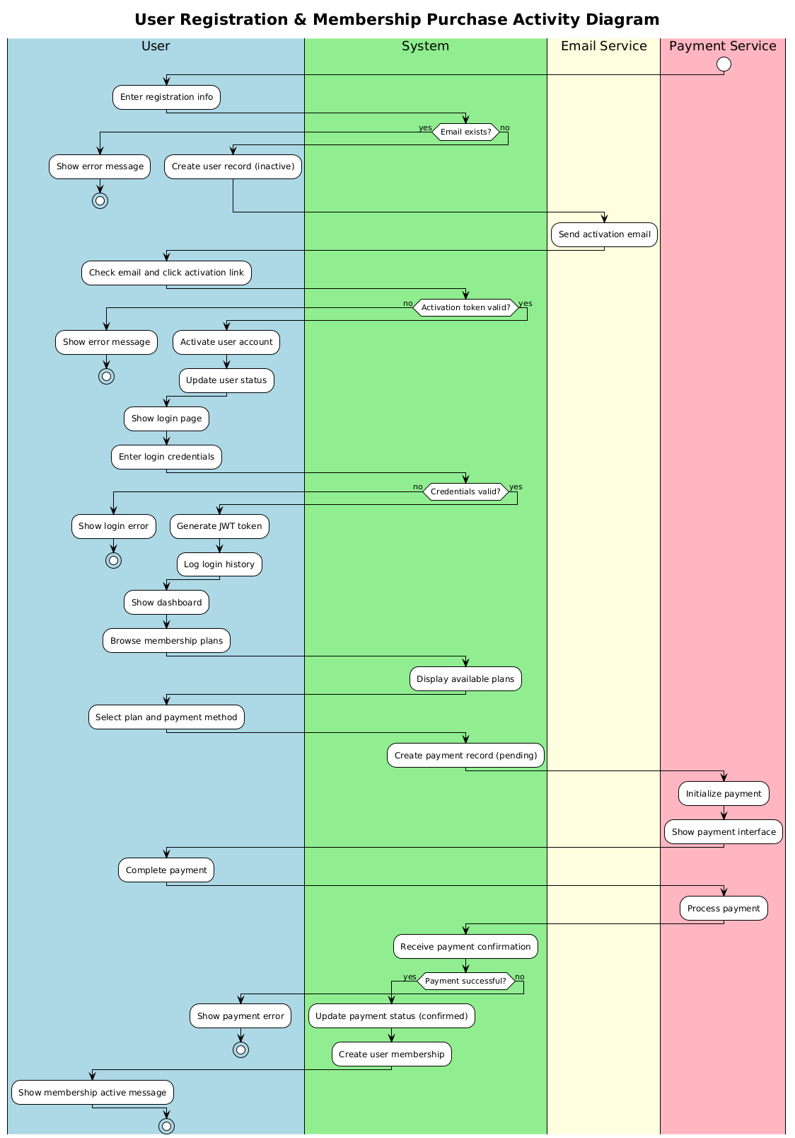

##### **3.1.2:** Sequence Diagram

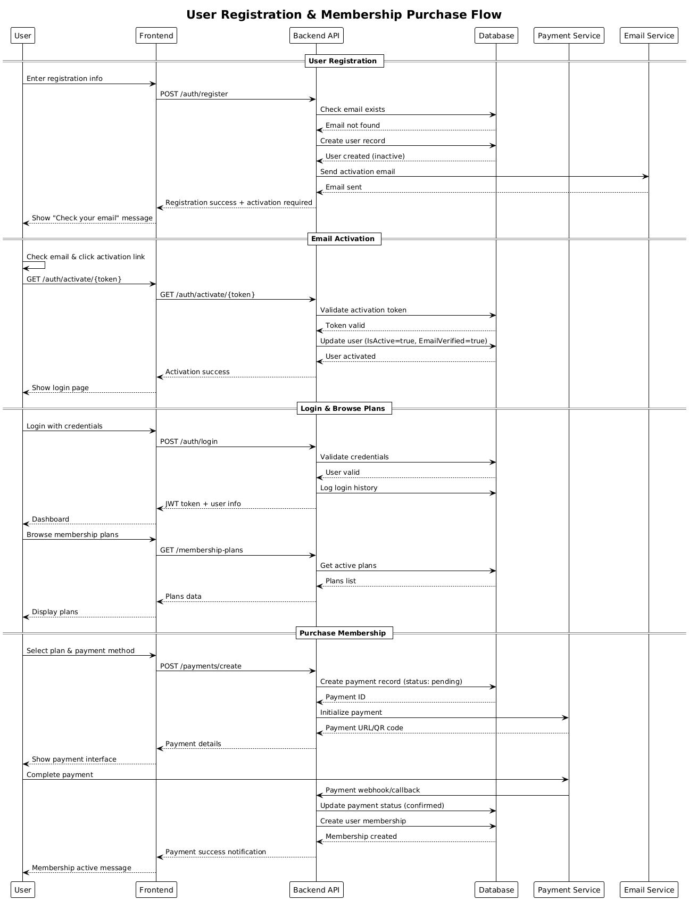

### **3.2 Coach Consultation Booking Flow**

##### **3.2.1:** Activity Diagram

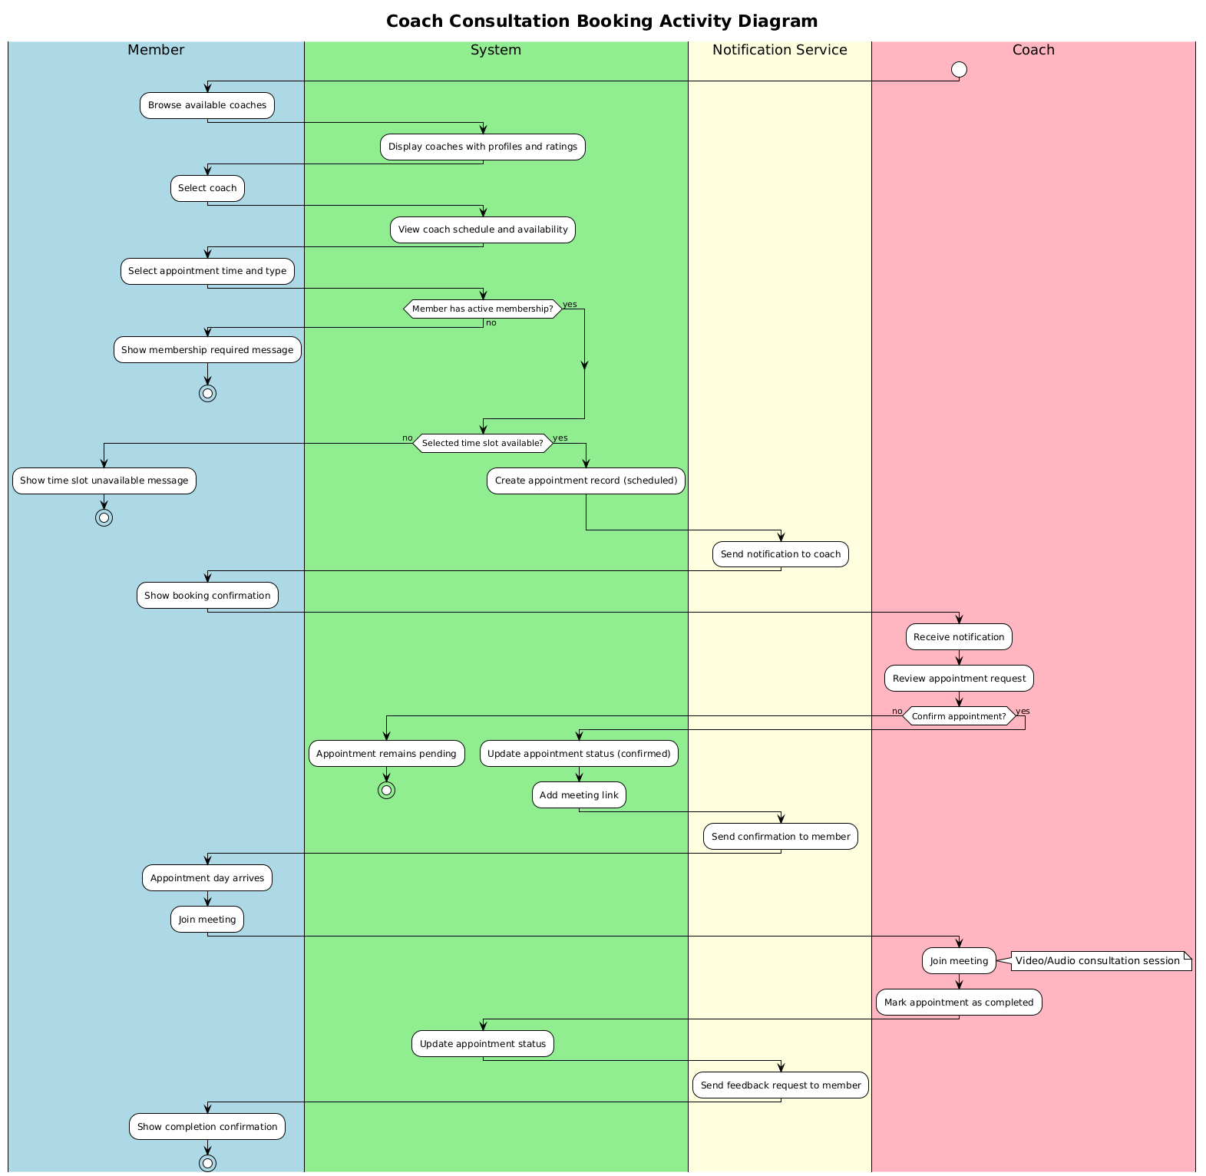

##### **3.2.2:** Sequence Diagram

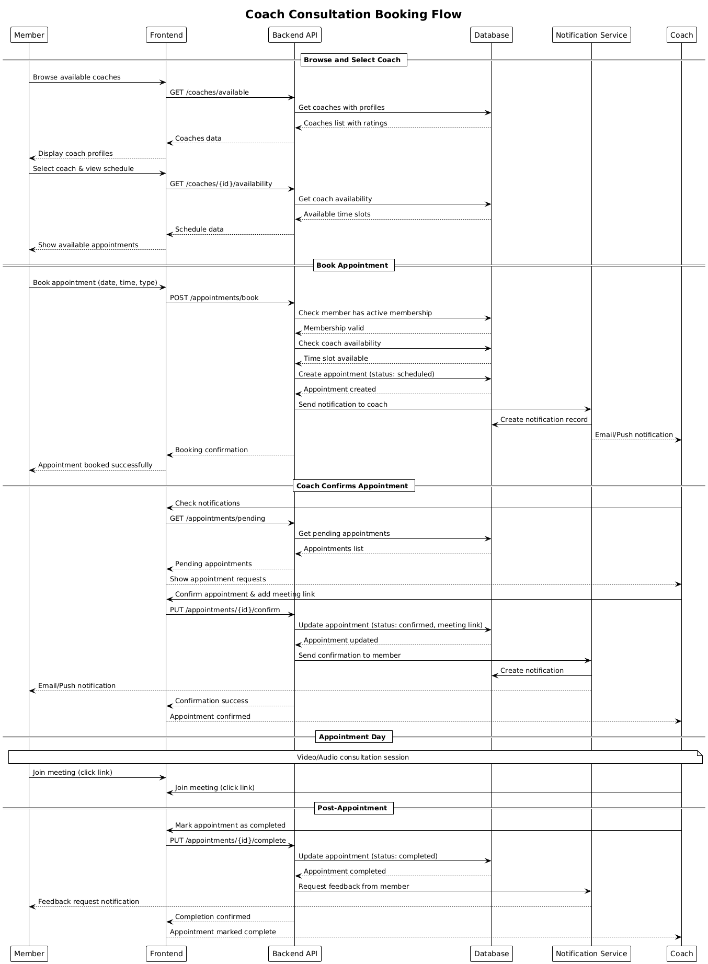

### **3.3 Progress Tracking and Quit Plan Flow**

##### **3.3.1:** Activity Diagram

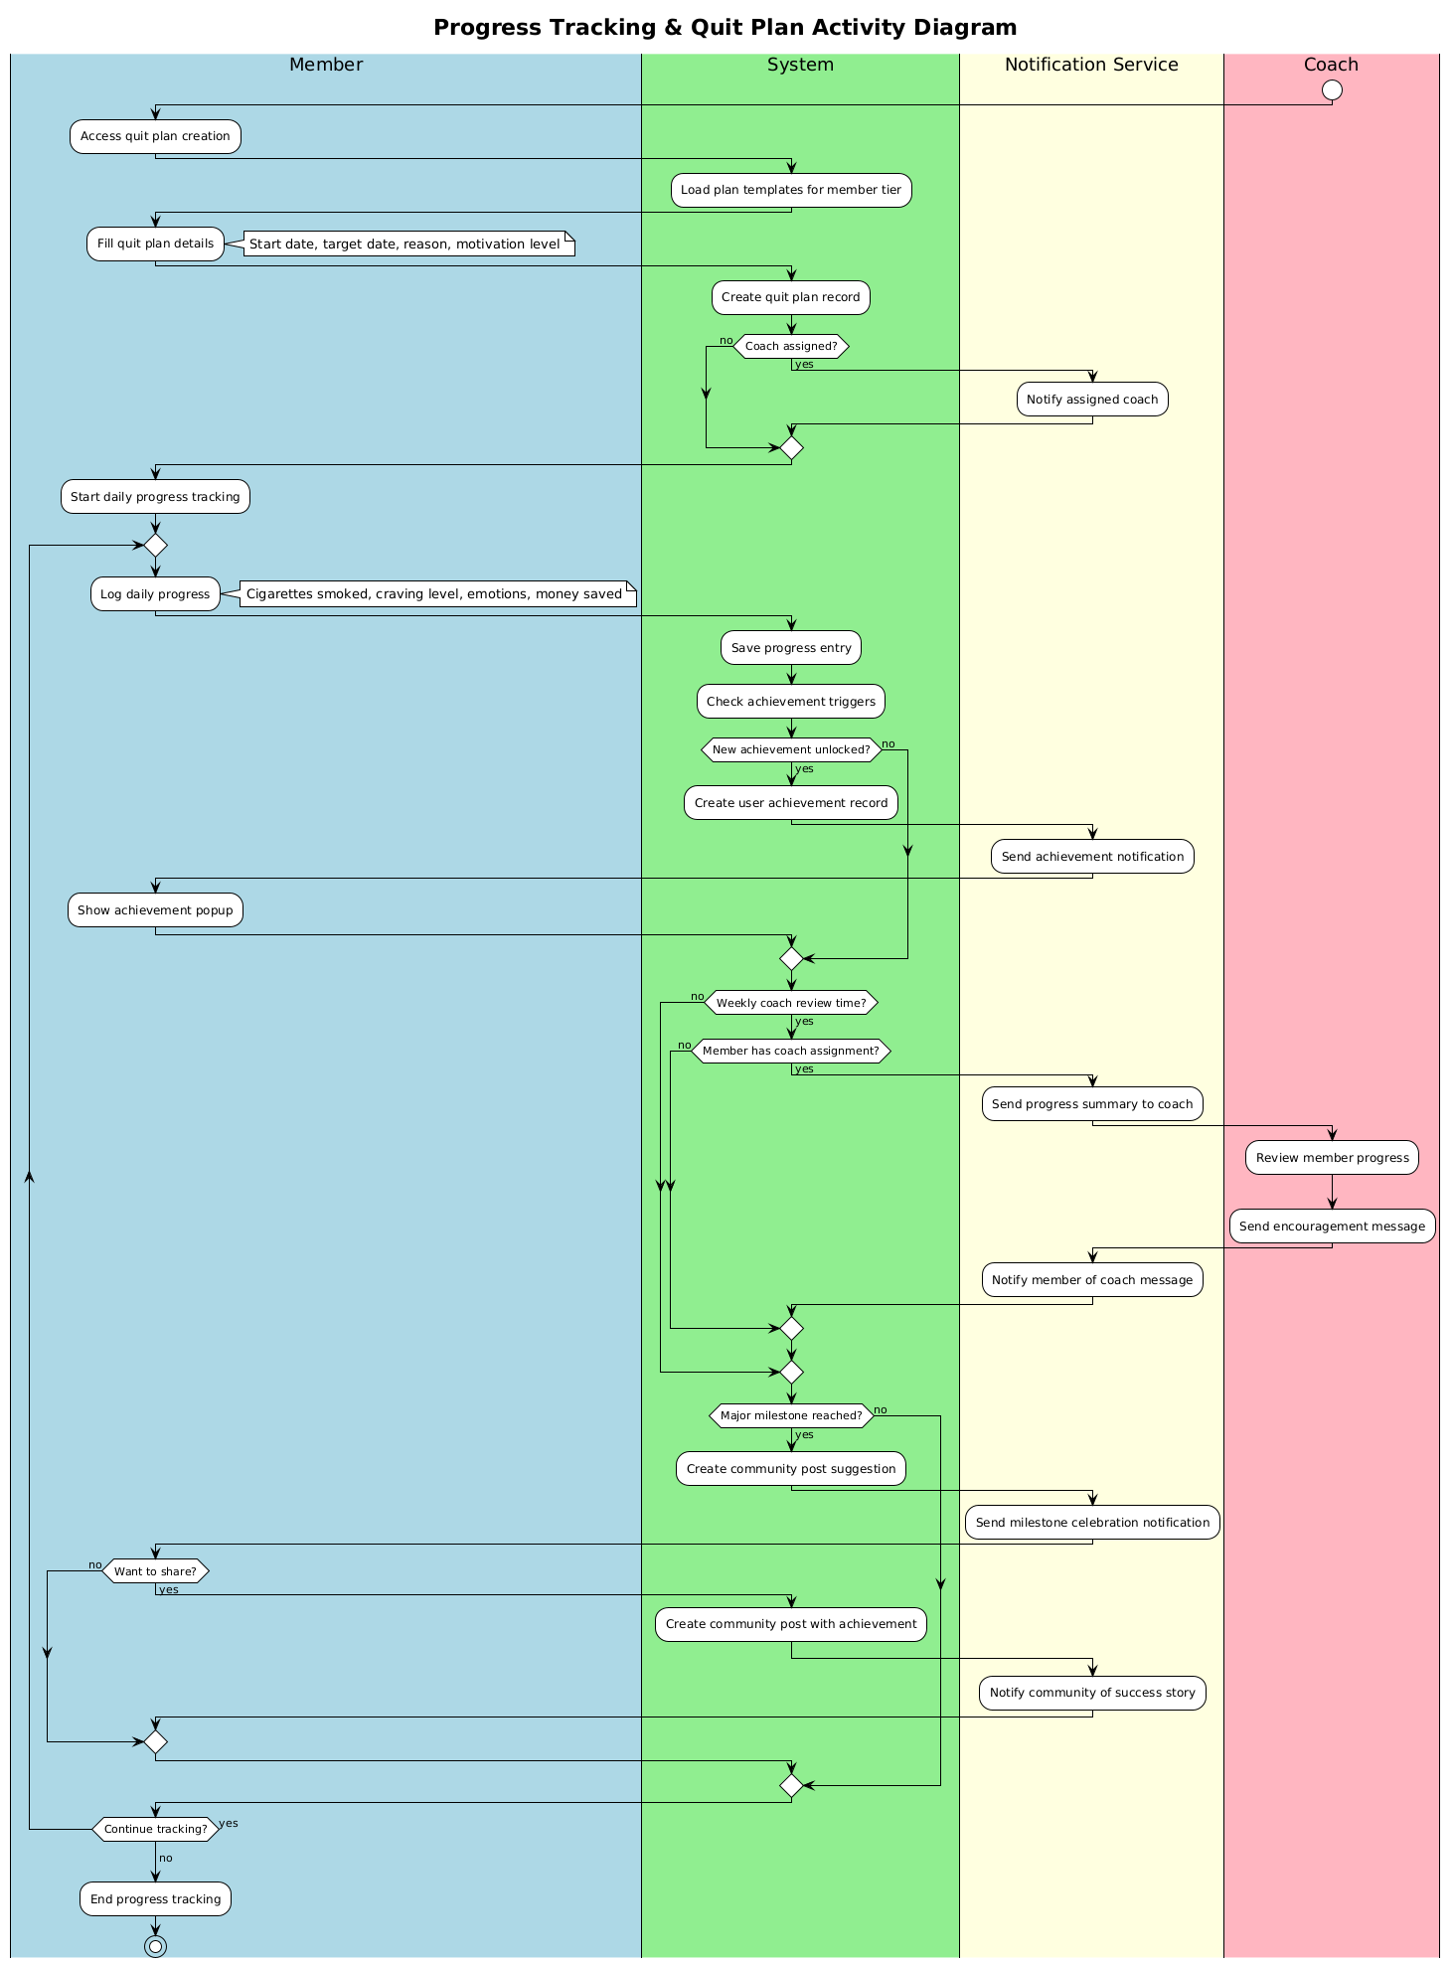

##### **3.3.2:** Sequence Diagram

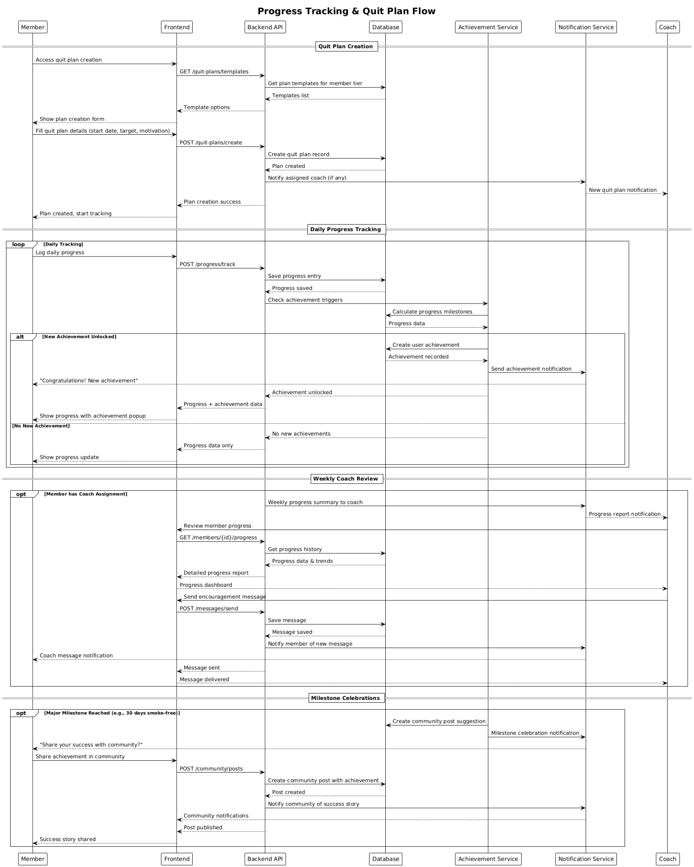

### **3.4 Membership Cancellation Flow**

##### **3.4.1:** Activity Diagram

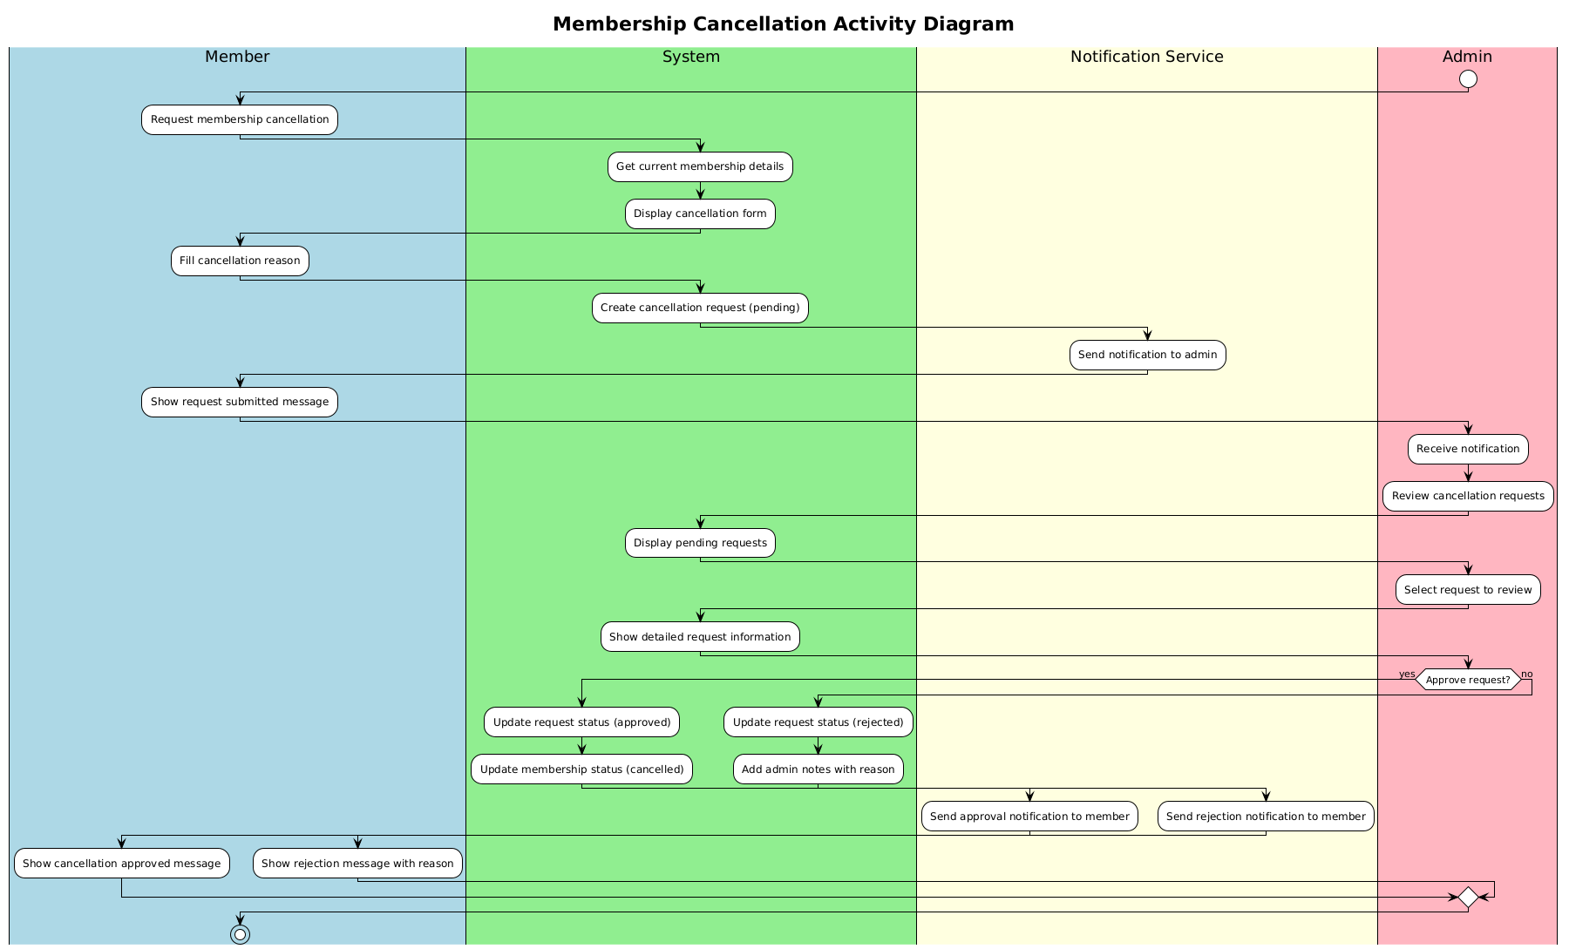

##### **3.4.2:** Sequence Diagram

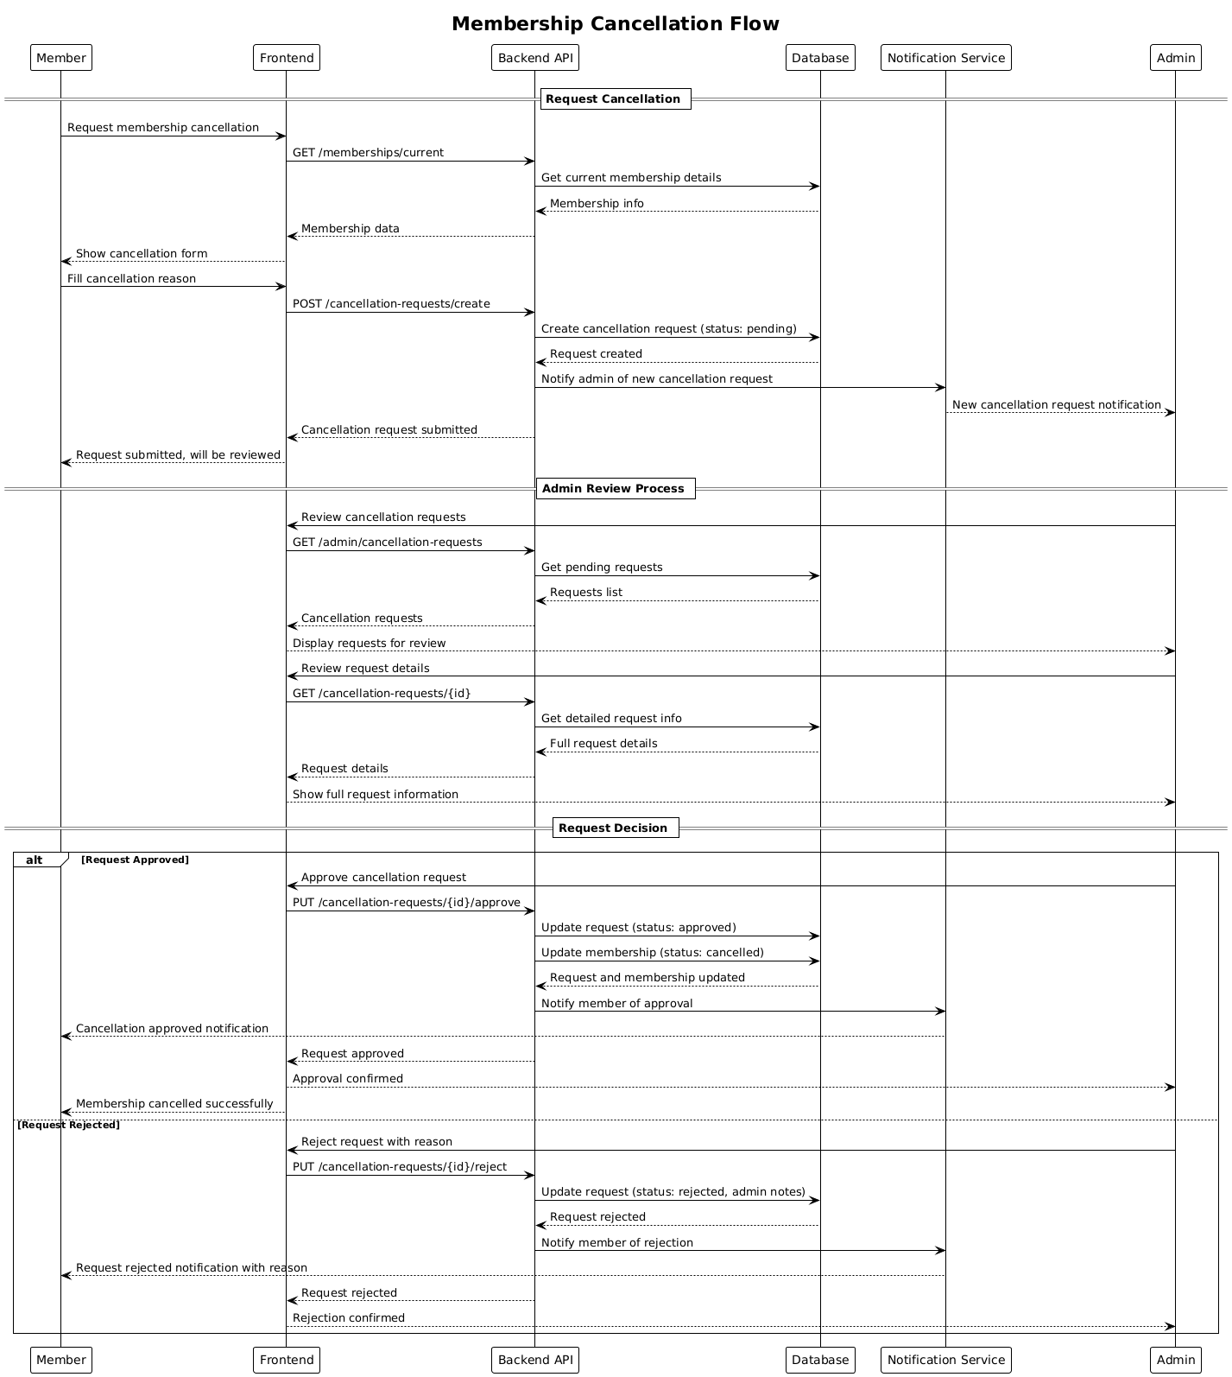

### **3.5 Coach Feedback and Rating Flow**

##### **3.5.1:** Activity Diagram

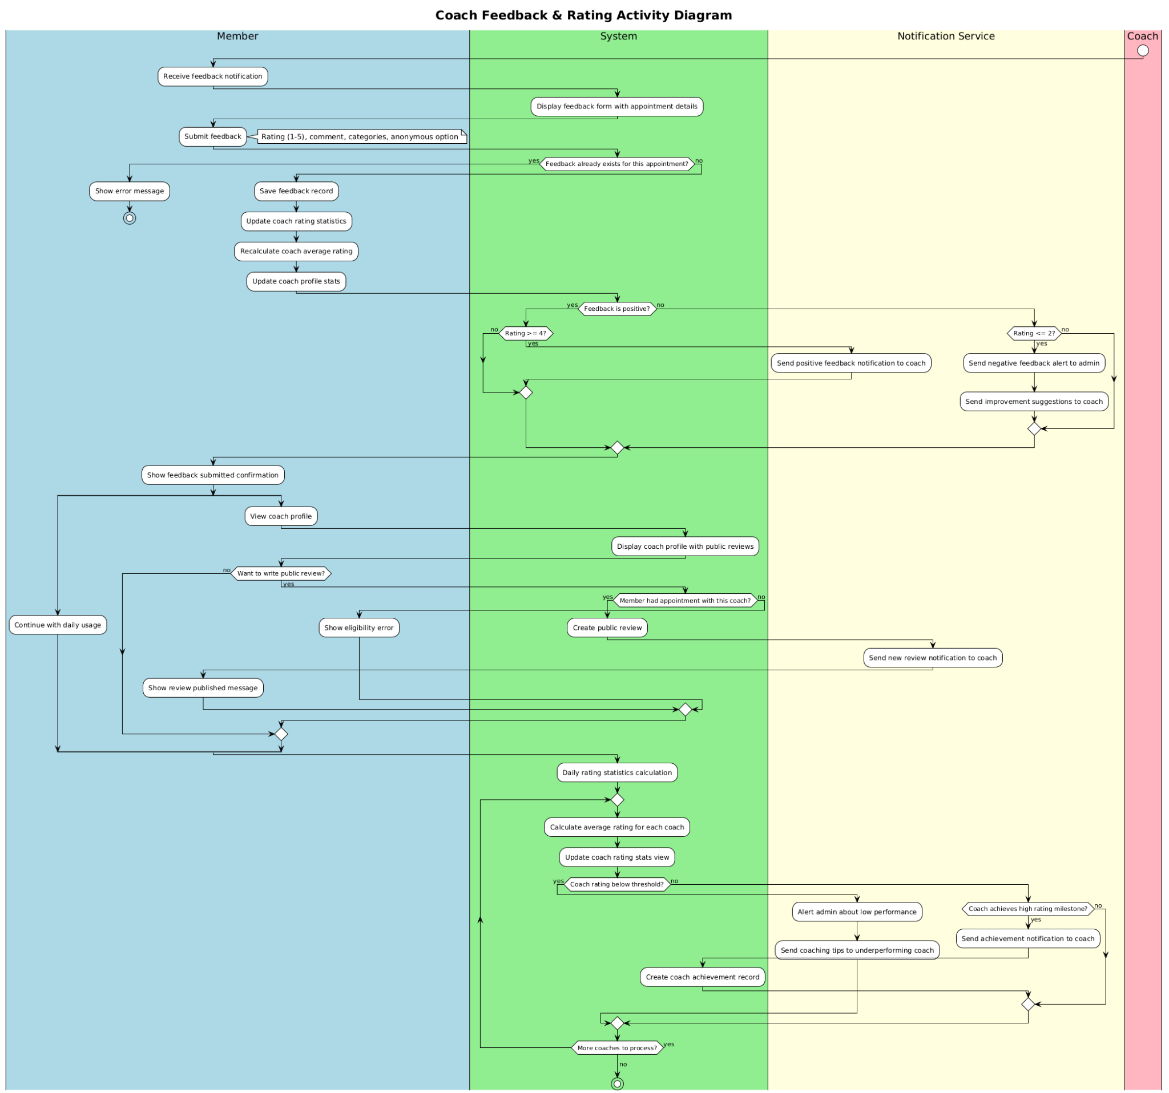

##### **3.5.2:** Sequence Diagram

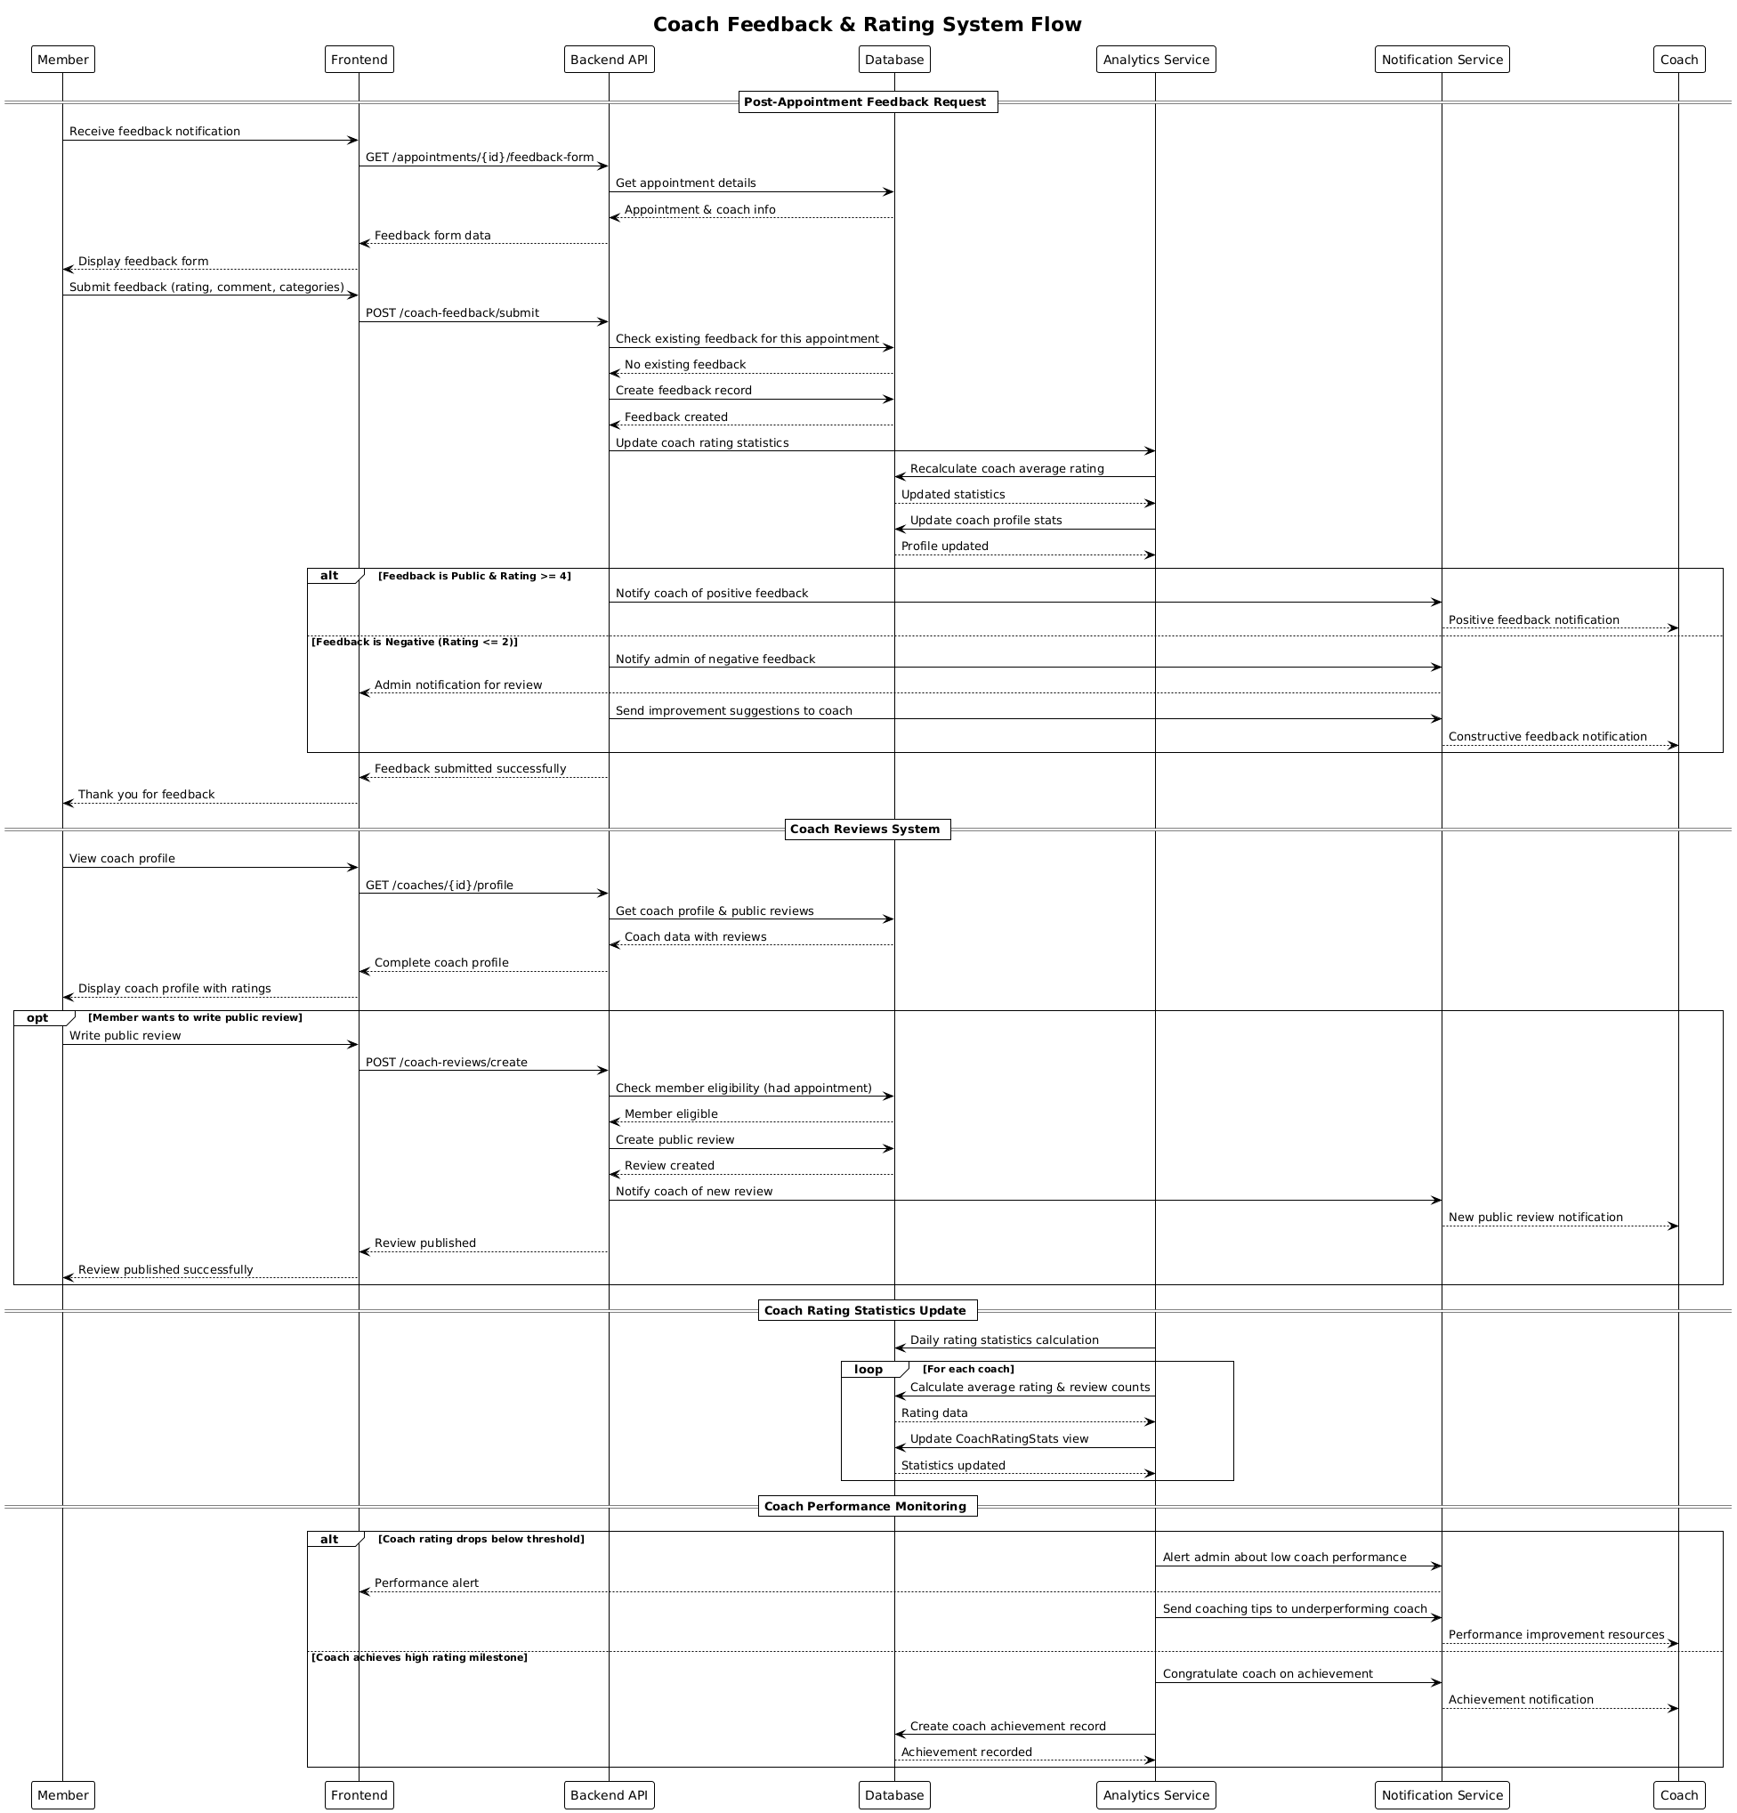

Sơ Đồ Kiến Trúc

